**IoT-Based Industrial Automation Using LabVIEW and PLC**

**Padmanabhan N1, Dr J Vijayakumar2, Dr R Maheswaran 3**

1Student, Electronics and Instrumentation, Bharathiar University, Coimbatore, Tamil Nadu, India

2Associate Professor & Head, Electronics and Instrumentation, Bharathiar University, Coimbatore, Tamil Nadu, India

3ATO, Electronics and Instrumentation, Bharathiar University, Coimbatore, Tamil Nadu, India

**ABSTRACT**

In first and foremost problem with existing industrial automation is fought to integrate classic PLCs with today's IoT driving systems, for all its real-time control and monitoring. To realize the real-time communication between PLC and process devices through command way. Modbus is a serial communications protocol. It is mainly used for connecting industrial electronic devices. Modbus is heavily used in the industry today. This research tells an integrating bidirectional communication architecture enhances supervisory control and monitoring capabilities to the modern industries and automation systems. The framework employs Modbus ASCII serial communication protocol, as data transmission standard, with Kepware OPC server serving as a strong middle layer to ensure trust and systematic data interoperable between the PLC and the supervisory system. The framework employs Modbus ASCII serial communication protocol, as data transmission standard. Kepware OPC server serving as a strong middle layer to ensure trust and systematic data interoperable between the PLC and the supervisory system. This architecture, the Delta PLC functions as a deterministic control unit. Transmitting binary sensor state signals (logical 0 or 1) to LabVIEW SCADA. The master interface, which performs real-time visualization, and analytical processing that is LabVIEW, which generate commands that transmit to the PLC for actuator control. This qualifies closed-loop feedback control, where LabVIEW dynamically set actuator outputs based on processed sensor logics. This system allows notifications and remote access and cloud data logging in user friendly way.

**Keywords:** Delta PLC, LabVIEW SCADA , Modbus, Real-Time Systems.

# INTRODUCTION

They Modern industry, where making the goal to meet the target of the pulse of tomorrow, this the integration of classic Delta PLC with LabVIEW as SCADA. Yet a persist challenge remains here is classic PLC. with robust and lack inherent capabilities for data connectivity, user friendly visualization and cloud integration. These limitations create a technical crack between industrial hardware and growing ecosystem of a IoT driven automation. To bridge the divide to a framework that communicate real time closed loop transformation. This integrates DVP16ES2 PLC with LabVIEW that make evolve the stand-alone PLC into fully networked like smart automation. This system uses the Modbus ASCII protocol because it’s reliable and works well with Delta’s built-in communication ports. Used an RS-232 connection, which create wired link through a simple USB converter. OPC technology is a hardware and software interface standard using client/server mode based on COM (component object model)/DCOM (distributed component object model), which offers a general standard mechanism for client’s and server’s data communication, exchange, and supports the network distributional application procedure communication as well as the application procedure communication in different platforms. To meet these needs, Modbus was designed as a request-response protocol with a flexible data and function model—features that are part of the reason it is still in use today (Introduction to Modbus Using LabVIEW, n.d.). In the system **Kepware OPC Server** used to smoothly manage and organize data flow and provides a wide data infrastructure. It allows SCADA systems, HMIs, MES, and even cloud-based applications to collect and process data.

**LabVIEW (Laboratory Virtual Instrument Engineering Workbench)** is a graphical programming and development environment created by National Instruments. Unlike traditional text-based languages, LabVIEW uses a visual approach where developers “wire” together functions nodes to process and transfer data. LabVIEW is an application platform used in many R&D environments and be interfaced to other systems such as Delta V, MySQL/MSQL, MATLAB, iOS, Android, etc (Halvorsen et al., n.d.). The central control function of LabVIEW becomes possible because it integrates three additional tools (DSC Module, DataSocket, and Modbus support) which allows users to monitor live data and control devices efficiently while also logging important information. A supervisory control and data acquisition (SCADA) system provides a good platform for remote monitoring of data (Ahmed_et_al-Libre.Pdf, n.d.). dstp is an application-layer protocol for transferring measurement data to and from a dstp server called a DataSocket server. dstp is implemented on top of TCP, and hence provides connection-oriented communication between the server and the client (DataSocket Transfer Protocol (Dstp) Overview, n.d.).

A **Programmable Logic Controller (PLC)** is also microprocessor-based industrial computer is used for automating electromechanical processes It executes real-time sensor control tasks that are Reading Inputs, Executing Logic, Updating Outputs, Communication and Diagnostics. A PLC may be programmed to sense, activate, and management industrial instrumentation and, therefore, incorporates variety of I/O points, which permit electrical signals to be interfaced (Srinivasan & Subash, n.d.). PLCs equipment have built-in support for Modbus (*Modbus*, n.d.).

LabVIEW functions as the central processing unit which handles data analysis through proximity sensor readings and sends effective commands based on implemented logic test combinations. Real-time connection between Delta PLC and LabVIEW established successful operation of Modbus ASCII over RS-232 for sensor and actuator management. This protocol built a message frame that controllers will visualize and use, regardless of the type of networks over which they need to communicate. It describes the process a controller uses to request access to another device, how it will respond to requests fro m the other devices, and how errors will be detected and reported (Panchal & Patel, n.d.). The developed LabVIEW monitoring system functioned according to design specifications by tracing sensor data and making Realtime actuator modifications which confirmed its ability to automate feedback control operations. The Kepware OPC server functioned as a powerful intermediary which provided verified bidirectional data flow together with smooth protocol translation between the PLC and LabVIEW environment. The system displays capability to execute IoT features such as remote data logging and automatic alert dispatch through email capabilities. The system performed without delay and error which demonstrates its effectiveness for industrial sensor monitoring and IoT transformation when using legacy PLCs.

|  |  |
| --- | --- |
| **Component** | **Function** |
| Delta DVP16ES2T PLC | Accepts digital sensors inputs (such as 0/1) and execute deterministic control. |
| RS-232 Serial Port | Physical channel for communication (PLC Port 1) |
| Modbus ASCII Protocol | Protocol for communication in request-response data exchange |
| Kepware OPC Server | PLC data translation middleware for LabVIEW (OPC connection layer) |
| LabVIEW (with DSC) | Software for managing communication failures and carrying out Modbus orders |
| NI Modbus Library | Software tool for executing Modbus commands and handling communication errors |
| SMTP Protocol | Allows LabVIEW to send email notifications automatically for remote monitoring based on the Internet of Things. |

Table:1 Components used and its Functions

# METHODOLOGY

The system functions through a structure where one component acts as the master while other components operate as slaves. The data source consists of two main components namely Sensor inputs along with Output control logic which combines within Delta PLC. The SCADA interface takes the form of LabVIEW which handles visualization alongside logging and control functions and IoT applications. Conventional communication works by communicating every each end connection. Every end-to-end connection required a custom driver to facilitate communications between specific endpoints (Pranowo et al., 2020). OPC Server from Kepware operates as the translation link that converts Modbus ASCII format into OPC protocol. The communication channel uses Modbus ASCII protocol over RS-232 through COM Port.

## Hardware Configuration

DELTA DVP6ES200R is the plc which used here that is Programable Logic Control connected via RS-232 (USB to Serial adapter). This is a digital PLC which has 8 digital input and 8 digital outputs. Proximity sensor is wired to Digital input of the terminal mentioned as (X0, X1). And an actuator is connected in the Digital output terminal to the PLC (Y0, Y1).

## PLC Programming (WPLSoft)

Ladder logic is designed to read sensors value and send them regularly, assigning Modbus registers. Bothe for direct connection and via Kepware. That brings the status of the input, output, memory bit, memory register to the clint and also get back the control values to the PLC. Connect the Delta plc to the Com port of the System (e.g. COM 3).

* Open WPLSoft – File –New – Select the PLC Model dialog box appear.
* Enter program title – select Model type as PLC – Select communication Setting (COM 3) - OK.
* Ladder Diagram mode is used to program the PLC.
* Go to Options – Communication Settings - for ASCII mode
* After your program completed use / Ctrl+F7 to make the compiling (ladder to instruction).



* If there is no error, then use to download the program to the PLC.

## OPC Server (Kepware) Configuration

* File – New -Add new channel under Project Connectivity - Protocol = Modbus ASCII, Device = Delta DVP, COM ID = (COM 4), Baud Rate = 9600.
* Add Device Wizard = Name, then next – Finish.
* After select all the tag and click  and then the OPC Quick Client gets to start there verifying the status quality = Good. It means the Modbus is Exciting. - closes it.
* Click to add an alias – add alias and click ok.

## LabVIEW SCADA Design using DataSocket

* Open LabVIEW – Create Front Panel: Place indicators for monitoring and Controls for Controlling the PLC.
* Right click- Property - Data Binging – Data Binding Section = DataSocket – Access Type = Read/Write - select DSTP Server in the Browser – Select URL dialog Box Appear.
* Here Select the OPC server – Channel – Device – and select tie Tag.
* Direct Connection Between Delta PLC and LabVIEW

## LabVIEW SCADA using Modbus

To implement Modbus communication within the LabVIEW environment, the NI Modbus Library is first installed. This library enables LabVIEW to function as a Modbus master and directly interface with the PLC using the RS-232 serial protocol.

The communication begins with the Modbus Open node, followed by a sequence of functional nodes for data exchange, and concludes with the Modbus Close node. Within this structure, specific Modbus functions are employed, including:

* Read/Write Single Coil
* Read/Write Multiple Coils
* Read/Write Single Holding Register
* Read/Write Multiple Holding Registers

These functions allow LabVIEW to read real-time input data from the PLC for monitoring purposes and write control signals back to the PLC to influence process operations. (Mahmoud et al., 2015).

## IOT and Data Logging

LabVIEW as SCADA uses datalogger and that Dates are used to transmit Deta as Excel format or as email or as Graphs for Visualizing the Data and for storing in the Cloud Platform. Here I use SMTP protocol to send the data on datalogging file to the Email.

* Used to uploaded in cloud database or remote server using HTTP API requests.
* Time-based Automation for emailed to supervisors through LabVIEW's SMTP functions.

## Testing & Validation

The system should receive input changes through switches while real-time output verification occurs simultaneously. Register mapping validation requires a comparison between WPLSoft and Kepware platforms. Multiple I/O events must be triggered during stress testing combined with real-time testing of imaging systems. The system needs to activate both alerts and emergency stop mechanisms when safe protection devices activate.

# MODELING AND ANALYSIS

Here the delta PLC can be directly connected to LabVIEW using Modbus protocol because Delta PLC port had inbuilt Modbus protocol and other than Modbus library to install in LabVIEW.

Other way to connect the Delta PLC to LabVIEW is using Kepware. It is an Object linking Embedding Process it uses middle protocol translator and give to PLC. It gets data from the PLC and send to the LabVIEW as well vice versa.

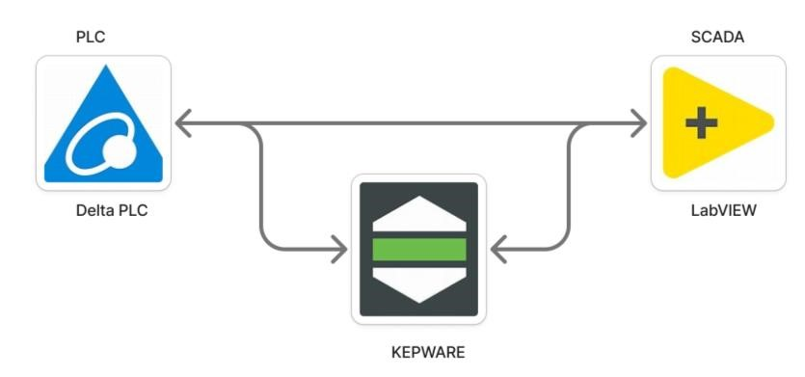

**Figure 1:** Pycnometer Test Procedure.

OPC requires an OPC server that communicates with one or more OPC clients. OPC allows “plug-and-play”, gives benefits as reduces installation time and the opportunity to choose products from different manufactures (Datalogging in LabVIEW, n.d.).

OPC provides a good interpretability option between different systems (Mahmoud et al., 2015).

.

# RESULTS AND DISCUSSION

The successful implementation linked Delta DVP16ES2T PLC with LabVIEW through Modbus ASCII communication protocol. The sensor output data was successfully acquired through Kepware OPC in LabVIEW while the PLC received appropriate control instructions from LabVIEW. The proximity sensor showed proper functionality by creating instant updates that displayed on the SCADA interface. The system performed according to plan by logging sensor information and control activities into Excel files yet it also displayed IoT functionality through email notifications The implemented system operates in the process of monitoring and controlling operations in real time.

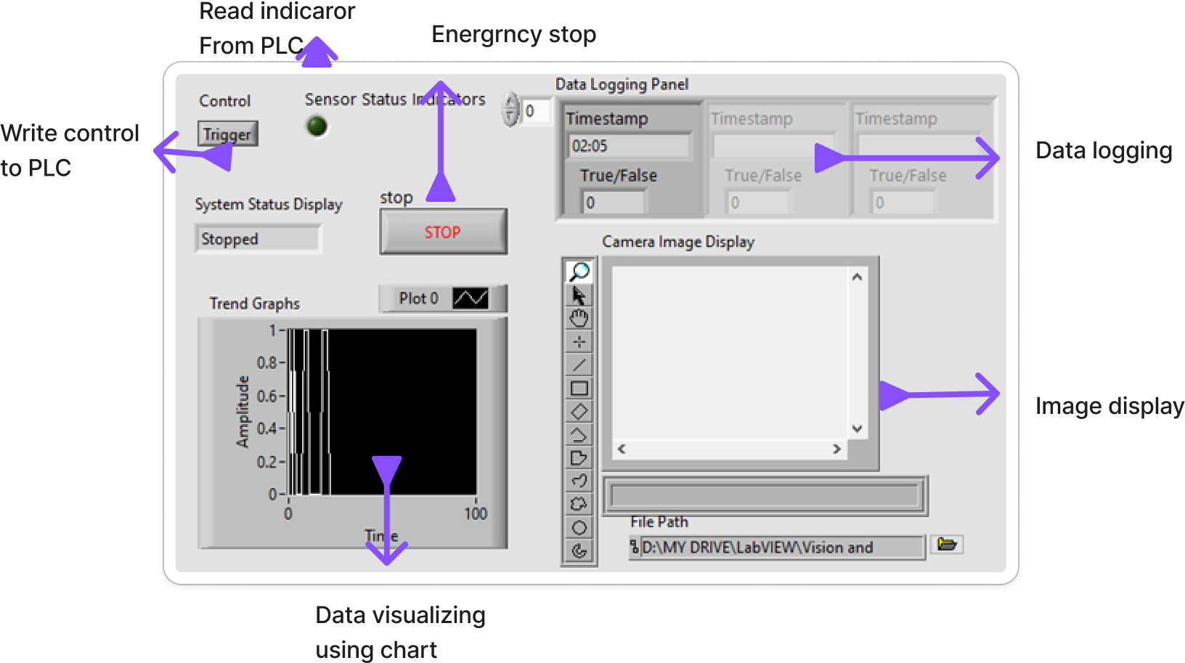

**Figure 1: LabVIEW Controls and Indicators**

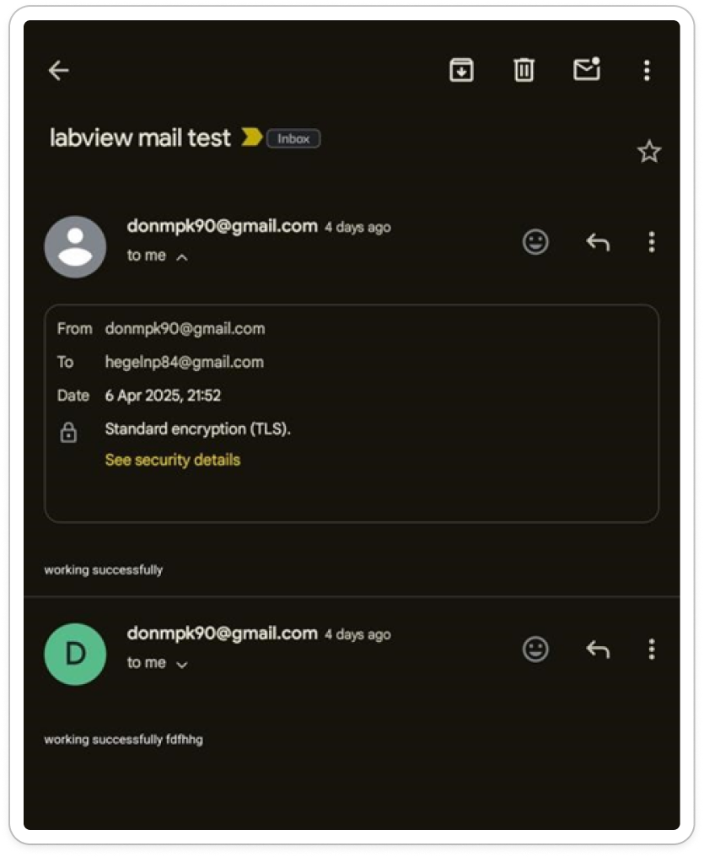



**Figure 2: SMTP EMAIL TEST**

The implementation tells viable for real-world supervisory control applications and especially in heritage Delta PLC systems direct IoT capabilities. The integration with LabVIEW plays a wide crucial role integrating many more applications for automate the industry even in the case of network and in hardware.

# CONCLUSION

This research has closely created an effective way for intelligent communication between LabVIEW and the Delta DVP16ES2 PLC. By bringing control access into the LabVIEW’s world, also enabled more than just basic data acquisition and opened the door to real-time monitoring, automated alarm triggering for enhanced security, and structured data logging for report generation. All this builds to the formation of a complete SCADA application. It is a very user friendly SCADA software (Krishnan, n.d.).  The research potential is to develop and test control algorithm for distributed and interconnected systems.

What matters most now is how this configuration updates the Delta PLC. We have successfully expanded its capabilities with Modbus ASCII over RS-232, with LabVIEW serving as a smart SCADA layer, despite the fact that it lacks native features like Ethernet or sophisticated data handling. This implies that even antiquated gear can now be used in modern automation settings.

# ACKNOWLEDGEMENTS

I’m are heartly indebted to my mentor, parents and friends and all well-wishers for what I’m today, because this research would have been a reality with their love and support. I extend my sincere gratitude to the Department of Electronics and Instrumentation for providing exceptional facilities.

# REFERENCES

Ahmed_et_al-libre.pdf. (n.d.). Ahmed, G. I., Abdulrahman, B. B., & Idris, M. Design and implementation of a SCADA system for renewable energy Micro Generation.

Datalogging in LabVIEW. (n.d.). Retrieved April 24, 2025, from https://www.halvorsen.blog/documents/teaching/courses/labview_automation/labview_datalogging.php

DataSocket Transfer Protocol (dstp) Overview. (n.d.). Retrieved April 24, 2025, from https://www.ni.com/en/shop/labview/datasocket-transfer-protocol--dstp--overview.html

Halvorsen, H.-P., Jonsaas, A., Eikehaug, L., Mogård, S., Viumdal, H., & Andersen, R. (n.d.). Remote control of a robotic arm—A cross-platform study using LabVIEW and DeltaV.

Introduction to Modbus using LabVIEW. (n.d.). Retrieved April 24, 2025, from https://www.ni.com/en/shop/labview/introduction-to-modbus-using-labview.html

Krishnan, M. S. (n.d.). REAL TIME MONITORING AND CONTROLLING OF NEONATAL INCUBATOR USING PLC.

Mahmoud, M. S., Sabih, M., & Elshafei, M. (2015). Using OPC technology to support the study of advanced process control. ISA Transactions, 55, 155–167. https://doi.org/10.1016/j.isatra.2014.07.013

Modbus. (n.d.). Retrieved April 24, 2025, from https://www.halvorsen.blog/documents/technology/modbus/modbus.php

Panchal, P., & Patel, A. (n.d.). Interfacing of PLC with NI-LabVIEW using Modbus Protocol. International Journal of Advance Engineering and Research Development.

Pranowo, I. D., Bagastama, Y. T., & Wibisono, T. A. (2020). Communication between PLC different vendors using OPC server improved with application device. ℡KOMNIKA (Telecommunication Computing Electronics and Control), 18(3), 1491–1498.

Srinivasan, E., & Subash, M. (n.d.). A SERVER BASED MULTIPLE PARAMETERS CONTROLLING USING PLC AND LABVIEW IN INDUSTRIAL AUTOMATION. International Journal of Advanced Engineering Research and Science, 2(4).