**Performance Enhancement of Substrate Integrated Waveguide Antenna for Wi-Fi Application**

**ArulKumar.M1,**

**Bharath Kumar.V2, Chandru.M3, Thiyagarajan.K4, Logeswaran.J5**

1,2,3,4 STUDENT, ELECTRONICS AND COMMUNICATION ENGINEERING, SRM VALLIAMMAI ENGINEERING COLLEGE.

5ASSISTANTPROFESSOR & HEAD, ELECTRONICS AND COMMUNICATION ENGINEERING, SRM VALLIAMMAI ENGINEERING COLLEGE.

**Email:** 1arulkumararulkumar984@gmail.com,2bharathmanismart1@gmail.com,

3chandruchan308@gmail.com , 4thiyagarajan61096@gmail.com , 5komalaj.ece@srmvalliammai.ac.in

**Abstract**

A single-band, linearly polarized Substrate Integrated Waveguide (SIW) antenna is designed specifically for WLAN 802.11a of the applications. The SIW design consists of four rectangular slots adjacent to each other through the SIW wall, with appropriate rectangular patch elements inserted in the two vertical slots for bandwidth enhancement. The structure is optimized to radiate at a frequency of 5.22 GHz, resulting in linear polarization caused by the excitation of the fundamental mode (likely TE120 mode). The simulated design offers a gain of 7.275 dB and a bandwidth of 47 MHz, their radiation pattern of the proposed fabricated antenna is measured in test environments where it is found to be unidirectional. The proposed design is compact and minimal in complexity, offering a higher gain. We design a substrate-integrated waveguide slotted antenna. Coaxial feeding ensures perfect impedance matching and minimizes radiation losses, parasitic effects, etc.

To enhance gain and bandwidth effectively, rectangular slots, patch elements within the vertical slots, and L-shaped slots in the ground plane are used. A simulated antenna with a frequency of 5.22 GHz offers a bandwidth of 47 MHz and a peak gain of 8.406 dBi in sub-6 GHz band. This design is ideal for Wi-Fi applications because it is entirely symmetrical. Compared to recent work on SIW antennas, this design involves minimal complexity.

.

# Keywords

Bandwith, Substrate Integrated Waveguide Antenna, Impedance Matching, Return Loss

# 1. Introduction

The advancements in wireless communication systems have demanded the development of low-profile, high-frequency devices for efficient communication. Antenna is an essential component in this network that ensures efficient linking between the devices. There is a need for high-gain antennas offering maximum bandwidth to overcome interference resulting from the signal traffic in the environment. In Wireless Local Area Networks (WLAN), antennas with linear polarization emerge as a suitable option as they are simple in design and less prone to multipath interferences between transmitters and receivers [1,2]. However, antenna designers prefer using microstrip patch antennas citing their wider bandwidth and smaller profile [3–5]. Such antennas operating at higher frequencies exhibit problems such as unwanted radiation and crosstalk enhancements. While waveguides are efficient at higher frequencies, they are complex and expensive to manufacture to support planar de vices [6]. To address such challenges, cavity-backed antennas emerge as a reliable option offering a higher gain, Q-factor, density design, and directionality for smaller dimensions [7].

IoT to optimize water usage efficiently. It includes:DHT11 sensors to measure temperature and humidity, key factors influencing crop hydration.Soil moisture sensors to assess water retention capacity and determine irrigation needs.Rainsensors to prevent unnecessary watering by detecting natural precipitation.Water level sensors to manage water resource availability effectively.ESP32 microcontroller to process sensor data, execute machine learning models, and control irrigation automation.Relay module and a water pump motor is employed to automate the irrigation process using real-time input from sensors.ThingSpeak cloud platform to collect, analyze, and remotely monitor irrigation data.

By leveraging the Random Forest Algorithm, the system provides ideal irrigation plan and guarantees that crops receive the exact amount of water at the appropriate moment.This adaptive irrigation approach dynamically adjusts water distribution based on changing soil and weather conditions, reducing dependency on manual methods while maximizing productivity. Furthermore, the integration of IoT and cloud computing enables farmers to remotely monitor and manage irrigation, making the system highly scalable, cost-effective, and efficient in promoting long-term water conservation and sustainable agricultural practices.

# 2. Literature Survey

The study by [1] provides a comprehensive review of emerging technologies for sustainable agriculture. It emphasizes the critical role of human intervention alongside technological advancements and highlights the challenges in implementing real-time data-driven farming solutions, especially in large-scale scenarios.

Research in [2] discusses the integration of Artificial Intelligence and the Internet of Things (IoT) for sustainable and smart farming. It introduces a deep learning-based irrigation prediction model, which, while accurate, demands significant computational power and is less suitable for small-scale or resourceconstrained farms.

The review in [3] evaluates various machine learning models used in precision farming. It provides a detailed comparison of techniques like decision trees, SVMs, and ensemble models. The paper emphasizes that ensemble models such as Random Forest yield better results in predictive analytics but also require more computing resources and efficient data handling.

The work in [4] proposes an adaptive hybrid (1D-

2D) Convolution-Based ShuffleNetV2 architecture for irrigation level prediction. It shows promising results in smart agriculture when integrated with IoT systems, but its complexity may not be ideal for farms with limited processing capabilities.

Research in [5] introduces a survey of machine learning models used in smart agriculture.It notes that many of the existing smart irrigation frameworks work well in controlled environments but face scalability and adaptability challenges in real-world field conditions.

The systematic review in [6] analyzes intelligent irrigation systems using various machine learning techniques. It finds that traditional models like decision trees and SVMs struggle with scalability and accuracy, especially when dealing with large datasets. Ensemble models outperform them but require proper optimization and tuning.

The study in [7] presents an IoT-based smart autoirrigation system using low-cost sensors and microcontrollers. While cost-effective and suitable for small farms, the system relies on free platforms, raising concerns about data security and long-term maintenance.

Research in [8] evaluates different machine learning algorithms in smart irrigation systems. It highlights the effectiveness of ML models but also points out that poor network connectivity in rural areas can cause delays or failures in realtime decision-making and water control.

The work in [9] proposes a machine learningbased smart irrigation system that uses low-cost IoT platforms. It focuses on accurate water distribution, but also stresses the need for proper sensor calibration and adaptation to varying environmental conditions to maintain accuracy.

Study [10] explores a smart irrigation system integrating IoT and machine learning techniques like neural networks. It shows that while deep learning models improve irrigation scheduling and water use efficiency, they introduce significant computational overhead, limiting their feasibility in power- and resource-constrained environments. In papers [11] and [12], the significance of combining IoT with AI-driven predictive models to achieve efficient irrigation and resource management was understood.

The proposed project addresses the gaps created by the conventional methods by integrating Random Forest for improved predictive accuracy, ESP32 for efficient processing, and ThingSpeak for optimized remote monitoring while ensuring energy efficiency and cost-effectiveness.

# 3. Proposed System

The suggested framework integrates IoT and AI- driven smart irrigation to optimize water usage and enhance crop yield. It utilizes an ESP32 microcontroller connected to DHT11

(temperature and humidity), soil moisture, water level, and rain sensors for real-time environmental monitoring. The system employs the Random Forest Algorithm to analyze collected data and predict irrigation needs, ensuring efficient water distribution while preventing wastage. A relay module controls the water pump motor based on sensor inputs, enabling automated irrigation. Additionally, the system transmits data to the ThingSpeak cloud platform for distant supervision and decisionmaking. Apart from saving water, this strategy also reduces operational costs, elevates farming efficiency, and adapts to changing environmental conditions, making it a scalable and sustainable solution for modern agriculture. The developed solution further enhances its adaptability by incorporating a user-friendly web-based dashboard for real-time monitoring and manual control when needed. The ThingSpeak cloud platform not only stores sensor data but also provides visualization tools to track trends in soil moisture levels, temperature fluctuations, and water consumption over time. The system is designed to support modular expansion, enabling the integration of additional sensors, such as pH and nutrient sensors, to further optimize soil health management. Moreover, by leveraging the power of AI and IoT, the model can learn from past irrigation patterns, improving prediction accuracy over time and making it a highly efficient and sustainable solution for smart agriculture.

This system's adaptive intelligence, which allows it to modify irrigation choices in response to shifting crop requirements and environmental conditions, is one of its primary characteristics. Because of this flexibility, less human tweaks are required, improving the system's usability and effectiveness. By enabling remote monitoring and analysis, the integration with an IoT platform expands its capabilities and gives farmers the ability to better control their irrigation techniques from any place. Furthermore, decision-making and operational optimization are greatly enhanced by the system's capacity to use both historical and real-time data. One of the most urgent issues in agricultural water management is addressed by the suggested system, which reduces water waste by precisely estimating irrigation requirements. The ultimate goal of this effort is to help resource conservation and sustainable agricultural development by offering a scalable, effective solution for contemporary irrigation techniques.

**3.1** **Block Diagram of the Proposed System** The given figure 1 describes an IoT and AI-based smart system that is crafted to ensure optimal water distribution and promote better agricultural outcomes. It integrates four sensors, including DHT11 (temperature and humidity), soil moisture, water level, and rain sensors, which collect real-time environmental data and send it to the ESP32 microcontroller. The ESP32

transmits this data to the ThingSpeak cloud for

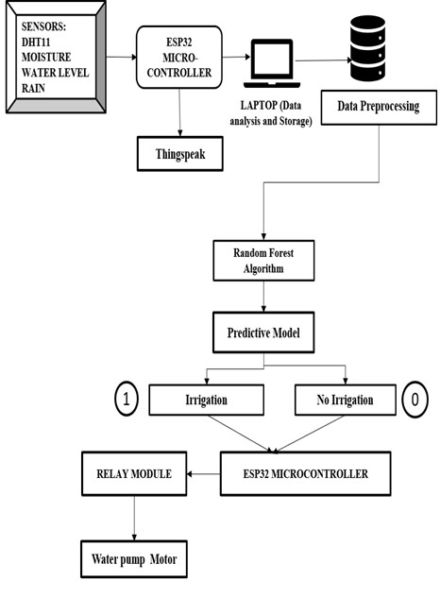

Fig 1.Block Diagram

off-site tracking and also forwards it to a laptop for preprocessing, where noise removal and normalization occur. The preprocessed data is then analyzed using the Random Forest

Algorithm, which predicts whether irrigation is required. If the model determines that irrigation is necessary (represented by 1), the ESP32 activates the relay module, turning on the water pump motor to irrigate the field; otherwise, the pump remains off (represented by 0) to prevent water wastage.

# 4. Methodology

**4.1. Sensor Data Collection:** Using a number of sensors, the system first gathers environmental data in real time. The DHT11 sensor measures temperature and humidity, the soil moisture sensor determines the soil's moisture content, the water level sensor monitors the water level in the storage tank , and the rain sensor detects rainfall to prevent needless irrigation. The sensors transmit data to the ESP32 microcontroller for further analysis and interpretation. after continuously monitoring the surrounding environment. **4.2. Data Transmission and Storage** The ESP32 microcontroller is instrumental in handling sensor readings. It transmits the collected values to the ThingSpeak cloud platform for continuous observation.

Simultaneously, the data is sent to a laptop for preprocessing and storage, ensuring that all past and present information is available for analysis. **4.3. Data Preprocessing and Analysis** The stored data undergoes preprocessing to remove inconsistencies, missing values, and noise, ensuring accuracy in predictions. After data collection, the next step is preprocessing.This may include filling in or removing missing data points to avoid bias in the model. missing_data = df.isnull().sum() and

data encoding. Once the data is cleaned, it is collected from the ESP32 microcontroller via a serial connection.The function scaler = StandardScaler() ensures that data is properly retrieved from the ESP32, eliminating any potential corruption or misinterpretation of sensor values. The cleaned dataset is then fed into the Random Forest Algorithm, which is chosen for its high accuracy and ability to handle multiple variables affecting irrigation decisions. **4.4. Predictive Model for Irrigation Decision**

The Random Forest Algorithm processes the

input data and classifies it into two possible outcomes: 1 (Irrigation Required) – if the soil moisture level is low and there is no rainfall, the system decides to irrigate, and 0 (No Irrigation Needed) – if the soil moisture is sufficient or there is rainfall, the system avoids unnecessary irrigation to conserve water. **4.5. Automated Irrigation Control** If the predictive model determines that irrigation is required (output = 1), To provide water to the crops, the ESP32 microcontroller turns on the relay module, which in turn drives the water pump motor. If irrigation is not required (output = 0), the system remains inactive, preventing water wastage.

**4.6. Real-time Monitoring and Efficiency** The entire process is continuously monitored through ThingSpeak, allowing farmers or users to track real-time environmental conditions and irrigation status. By integrating IoT-based automation with AI-driven decision-making, the system ensures efficient water management, minimizes human intervention, and promotes sustainable agriculture.

# 5.Implentation

## 5.1 Hardware Implementation

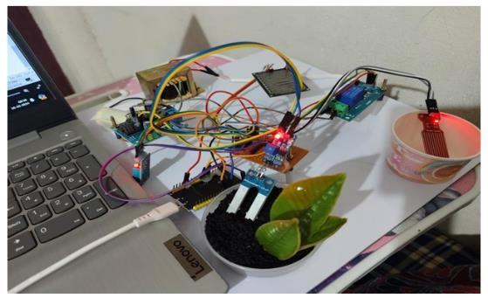

Fig 2. Hardware Setup

An overview of the hardware components is provided in Figure2.The hardware implementation of this smart irrigation system involves integrating multiple sensors, a microcontroller, a relay module, and a water pump motor to regulate watering schedules through immediate environmental feedback. The primary sensing components include the DHT11 sensor (for temperature and humidity), soil moisture sensor, water level sensor, and rain sensor. These sensors continuously monitor the environmental and soil conditions and transmit data to the ESP32 microcontroller. The DHT11 sensor is a digital sensor that provides temperature and humidity readings through a

single-wire digital signal. The soil moisture sensor typically functions using analog voltage variations, where it measures the resistance or capacitance of the soil and converts it into a corresponding voltage. Similarly, the water level sensor operates on either analog or digital signals, depending on its type, to indicate the water availability in the reservoir. The rain sensor, which detects rainfall, works as a resistive sensor, where its resistance changes when water droplets come in contact with it, generating an analog signal that is also fed into the ESP32’s ADC. With this, the hardware setup discussion concludes. The subsequent section will delve into the software implementation, including the use of the ThingSpeak platform for remote monitoring and the integration of the Random Forest algorithm for predictive irrigation decision-making.

**5.2. Software Implementation** The digital framework of the smart irrigation system consists of several interconnected stages—sensor data acquisition, preprocessing, machine learning-based prediction, cloud integration, and automated actuation. The ESP32 microcontroller collects data from various sensors and these inputs are read via GPIO or ADC pins and transmitted to a cloud platform (ThingSpeak) using Wi-Fi. For local verification, data is also sent to a connected system using UART serial communication.The raw data undergoes preprocessing in Python to manage missing values, standardize formats, and encode categorical information, preparing it for model training.A Random Forest Algorithm is employed due to its robustness and accuracy in handling multiple environmental parameters. The model is trained to classify irrigation requirements (ON/OFF) based on historical sensor patterns. Real-time sensor readings are then fed to the model to determine appropriate irrigation actions.

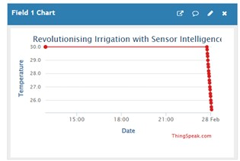

Fig 3a.DHT11 Sensor Output(Temperature)

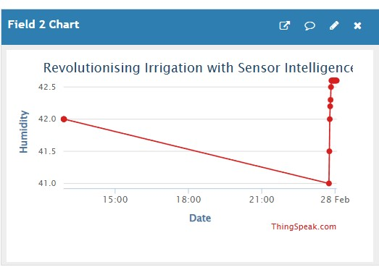For visualization, ThingSpeak displays the live data: Figure 3a shows temperature trends, figure 3b for humidity, figure 3c for soil moisture,figure 3d for rainfall, and figure 3e for water level. Figure 4 presents the model’s irrigation prediction output as observed in the Python IDLE shell. This end-to-end integration ensures intelligent,

automated irrigation, maximizing resource Fig 3b.DHT11 sensor Output (Humidity) efficiency and supporting sustainable farming

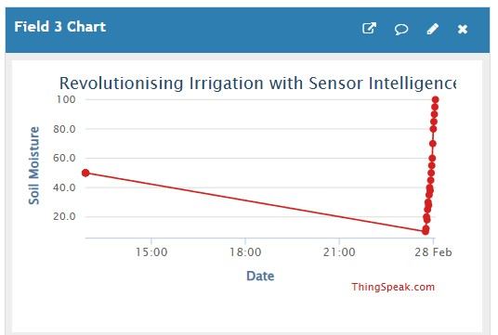practices.

**6. Results and Discussion**

The implemented smart irrigation system effectively integrates IoT and AI to enhance water conservation, optimize irrigation, and support precision agriculture. Real-time data from

multiple sensors is processed by the ESP32 and

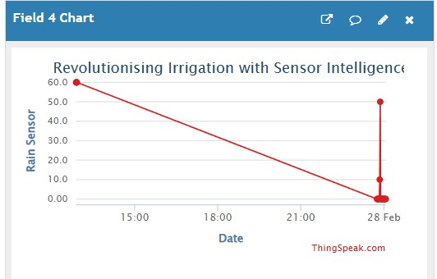 Fig 3c.Soil Moisture sensor Output analyzed using the Random Forest algorithm, enabling accurate irrigation decisions. The system ensures automated water control, reduces manual effort, and improves resource utilization. Cloud connectivity via ThingSpeak allows remote monitoring and access to historical trends. Despite minor limitations like internet dependency and sensor calibration, the solution

proved efficient, scalable, and cost-effective.

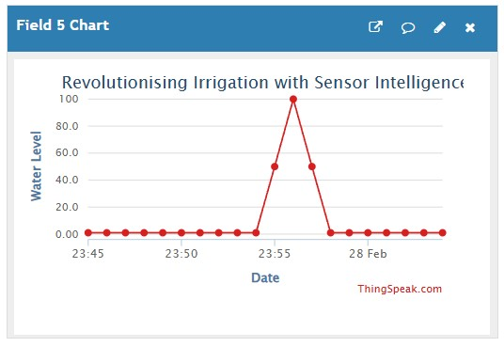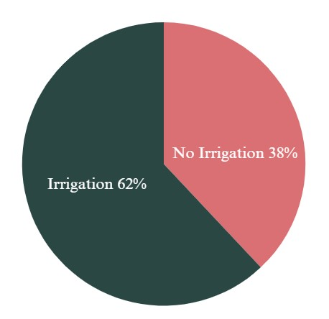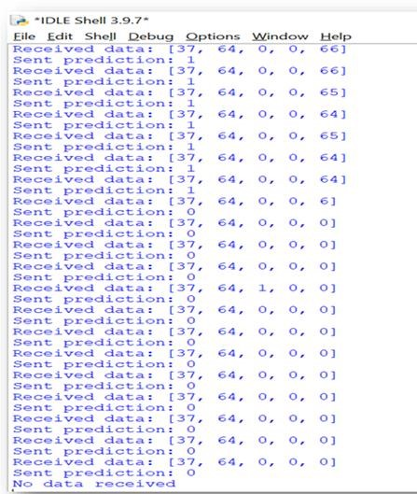 Fig 3d. Rain sensor Output With future enhancements, it holds strong potential for advancing sustainable farming practices through intelligent automation.

Fig 3e.Water level sensor Output

Fig 5 Distribution of Irrigate Decision

Figure 5 depicts the predictive analysis output, indicating that irrigation is required in 62% of cases and not required in 38%, based on the realtime sensor data processed through the Random Forest algorithm.

**7. Conclusion**

The IoT and AI-driven smart irrigation system developed in this project represents a transformative approach to modern agriculture by integrating real-time environmental monitoring, intelligent decision-making, and automated water management. By leveraging ESP32, advanced sensors, and the Random Forest Algorithm, the system ensures precise irrigation, conserves water, and enhances crop yield while reducing human intervention and operational costs. The seamless cloud integration with ThingSpeak

enables remote monitoring.Despite minor Fig 4. Predictive Output for irrigation challenges like connectivity issues and sensor

calibration, the system's scalability and adaptability make it a viable solution for both small-scale and large-scale farming. This project not only contributes to sustainable agriculture by optimizing water usage but also lays a strong foundation for future advancements, such as integrating renewable energy sources, refining predictive models, and expanding sensor networks. Ultimately, this smart irrigation system serves as a step toward revolutionizing farming practices, making agriculture more efficient, ecofriendly, and resilient in the face of climate change.

# References

1. [Malamati Louta;](https://ieeexplore.ieee.org/author/37266184300) [Konstantina Banti;](https://ieeexplore.ieee.org/author/37086351724) [Ioanna](https://ieeexplore.ieee.org/author/37089001408)

[Karampelia,](https://ieeexplore.ieee.org/author/37089001408) “Emerging Technologies for Sustainable Agriculture: The Power of Humans and the Way Ahead”, [IEEE Access,](https://ieeexplore.ieee.org/xpl/RecentIssue.jsp?punumber=6287639) Volume: 12 (2024): 98492 – 98529.

1. [Ahmad Ali AlZubi;](https://ieeexplore.ieee.org/author/37088230389) [Kalda Galyna,](https://ieeexplore.ieee.org/author/37089974609) “Artificial Intelligence and Internet of Things for Sustainable Farming and Smart Agriculture”, [IEEE Access,](https://ieeexplore.ieee.org/xpl/RecentIssue.jsp?punumber=6287639) Volume: 11 (2023): 78686 – 78692.
2. [Ghulam MohyuddinGhulam Mohyuddin;](https://ieeexplore.ieee.org/author/212297477782069)

[Muhammad Adnan Khan;](https://ieeexplore.ieee.org/author/37087133795) [Abdul](https://ieeexplore.ieee.org/author/37088561658)  [Haseeb;](https://ieeexplore.ieee.org/author/37088561658)

[Shahzadi Mahpara;](https://ieeexplore.ieee.org/author/594796580704661) [Muhammad Waseem;](https://ieeexplore.ieee.org/author/38258244300)

[Ahmed Mohammed Saleh,](https://ieeexplore.ieee.org/author/37089589048) “Evaluation of Machine Learning Approaches for Precision Farming in Smart Agriculture System: A

Comprehensive Review”, [IEEE Access,](https://ieeexplore.ieee.org/xpl/RecentIssue.jsp?punumber=6287639) Volume: 12 (2024): 60155 – 60184.

1. [Xuehui](https://ieeexplore.ieee.org/author/37087477351)  [Xu;](https://ieeexplore.ieee.org/author/37087477351) [R.](https://ieeexplore.ieee.org/author/37089035121)  [S.](https://ieeexplore.ieee.org/author/37089035121)  [M.](https://ieeexplore.ieee.org/author/37089035121)  [Lakshmi](https://ieeexplore.ieee.org/author/37089035121)

[Patibandla;](https://ieeexplore.ieee.org/author/37089035121) [Amit Arora;](https://ieeexplore.ieee.org/author/38488086500) [Muna Al-Razgan;](https://ieeexplore.ieee.org/author/37061614900) [Emad Mahrous Awwad;](https://ieeexplore.ieee.org/author/37086805821) [Vincent Omollo Nyangaresi,](https://ieeexplore.ieee.org/author/37088552595)

“An Adaptive Hybrid (1D-2D) Convolution- Based ShuffleNetV2 Mechanism for Irrigation Levels Prediction in Agricultural Fields With Smart IoTs”, [IEEE Access,](https://ieeexplore.ieee.org/xpl/RecentIssue.jsp?punumber=6287639) Volume: 12 (2024): 71901 – 71918

1. M. Rezwanul Mahmoo[d;](https://ieeexplore.ieee.org/author/37088962674) [Mohammad](https://ieeexplore.ieee.org/author/38236354700)

[Abdul Matin;](https://ieeexplore.ieee.org/author/38236354700) [Sotirios K.](https://ieeexplore.ieee.org/author/37332605900)  [Goudos](https://ieeexplore.ieee.org/author/37332605900)[; George](https://ieeexplore.ieee.org/author/37271227900)

[Karagiannidis,](https://ieeexplore.ieee.org/author/37271227900) “Machine Learning for Smart

Agriculture: A Comprehensive Survey”, [IEEE Transactions on Artificial Intelligence](https://ieeexplore.ieee.org/xpl/RecentIssue.jsp?punumber=9078688) Volume: 5, [Issue: 6](https://ieeexplore.ieee.org/xpl/tocresult.jsp?isnumber=10571778&punumber=9078688) (2024): 2568 – 2588.

1. Hajar Hammouc[h;](https://ieeexplore.ieee.org/author/37089339880) Mounim A. E[l- Yacoubi;](https://ieeexplore.ieee.org/author/38181364500) [Huafeng Qin;](https://ieeexplore.ieee.org/author/37086110301) [Hassan Berbia,](https://ieeexplore.ieee.org/author/940359556052039) “A Systematic Review and Meta-Analysis of

Intelligent Irrigation Systems”, [IEEE Access,](https://ieeexplore.ieee.org/xpl/RecentIssue.jsp?punumber=6287639) Volume: 12 (2024): 128285 – 128304.

1. [Ramya Vijay;Yedupati Vishnu Priy](https://ieeexplore.ieee.org/author/37089288894)[a;Praveen Chandra Reddy;S Monish](https://ieeexplore.ieee.org/author/37089844259)[a;Vijay Ramasamy,](https://ieeexplore.ieee.org/author/37089844616) “A

IoT based Smart Auto Irrigation system”, [2023](https://ieeexplore.ieee.org/xpl/conhome/10128170/proceeding) International Conference on Compute[r Communication and Informatics (ICCCI).](https://ieeexplore.ieee.org/xpl/conhome/10128170/proceeding)

1. Amina Yahi[a;Wahiba](https://ieeexplore.ieee.org/author/37089619600)  [Menasr](https://ieeexplore.ieee.org/author/37089619600)[i;Dalila](https://ieeexplore.ieee.org/author/38271238300)

[Cherifi;](https://ieeexplore.ieee.org/author/38271238300)Abderrezak Gacemi[,](https://ieeexplore.ieee.org/author/38271238300)  [“Performance](https://ieeexplore.ieee.org/document/10419485/)

[Evaluation of Machine Learning Algorithms for](https://ieeexplore.ieee.org/document/10419485/)

[Smart Irrigation Systems”](https://ieeexplore.ieee.org/document/10419485/), [2023 2nd International Conference on Electronics, Energy and Measurement (IC2EM).](https://ieeexplore.ieee.org/xpl/conhome/10419379/proceeding)

1. [Hakam Youness;Gaga Ahme](https://ieeexplore.ieee.org/author/37089679384)[d;Benachir](https://ieeexplore.ieee.org/author/37089678403)

[El Haddadi,](https://ieeexplore.ieee.org/author/37089678403)  [“Machine](https://ieeexplore.ieee.org/document/10005419/)

[Learning- based Smart Irrigation Monitoring System for Agriculture Applications Using Free and Low- Cost IoT Platform”](https://ieeexplore.ieee.org/document/10005419/), [2022 International Conference on Microelectronics (ICM).](https://ieeexplore.ieee.org/xpl/conhome/10005313/proceeding)

1. [Ahmed A. Esmail;Manar A. Ibrahi](https://ieeexplore.ieee.org/author/37090061983)[m;Sayed](https://ieeexplore.ieee.org/author/37090067260)

M. Abdalla[h;](https://ieeexplore.ieee.org/author/37090067260)Ahmed E. Radwa[n;](https://ieeexplore.ieee.org/author/37090064450)Haya k[. Elsonbaty;](https://ieeexplore.ieee.org/author/37090064450)Mohamed A. Elsaye[d;](https://ieeexplore.ieee.org/author/37090065604)Noure A[.](https://ieeexplore.ieee.org/author/37090065604)

[Elnakeib;](https://ieeexplore.ieee.org/author/37090065604)Merit Samir Dawou[d;](https://ieeexplore.ieee.org/author/37088427894)Amir E[l-](https://ieeexplore.ieee.org/author/37088427894)

[Ghamry;Khaled M. Foua](https://ieeexplore.ieee.org/author/37088427894)[d;Ibrahim F. Moawad,](https://ieeexplore.ieee.org/author/37085584442) [“Smart irrigation system usingIoT and machine learning methods”](https://ieeexplore.ieee.org/document/10296736/), [2023 5th Novel Intelligent and Leading Emerging Sciences Conference (NILES).](https://ieeexplore.ieee.org/xpl/conhome/10296538/proceeding)

1. [Kemal Cagri Serdaroglu;Cem One](https://ieeexplore.ieee.org/author/37088838508)[l;Sebnem](https://ieeexplore.ieee.org/author/37869825500)

[Baydere,](https://ieeexplore.ieee.org/author/37869825500)  [“IoT](https://ieeexplore.ieee.org/document/9398892/)

[Based Smart Plant Irrigation System with](https://ieeexplore.ieee.org/document/9398892/)

[Enhanced learning”](https://ieeexplore.ieee.org/document/9398892/), [2020 IEEE Computing,c](https://ieeexplore.ieee.org/xpl/conhome/9398868/proceeding)ommunications and IOT applications (ComComApp)

1. Pankaj [Pankaj Kumar Kashyap;Sushil](https://ieeexplore.ieee.org/author/37085781670) [Kumar;Ankita Jaiswa](https://ieeexplore.ieee.org/author/38667299900)[l;Mukesh Prasad;Amir H.](https://ieeexplore.ieee.org/author/37085438007) [Gandomi,”](https://ieeexplore.ieee.org/author/37681044500)Towards Precision agriculture:Iot enabled intelligent irrigation system using Deep learning neural network”, IEEE, Volume: 21, [Issue: 16](https://ieeexplore.ieee.org/xpl/tocresult.jsp?isnumber=10571778&punumber=9078688) (2021): 17479 - 17491.