AI FOR VISUALLY IMPAIRED
Shubham Solse Yash Jain Ms. Dipalee Borse
PG Student PG Student Assistant Professor
H V Desai College H V Desai College H V Desai College
Pune, Maharashtra, India Pune, Maharashtra, India Pune, Maharashtra, India
shubhamsolse618@gmail.com yashj3643@gmail.com dipa.borse@gmail.com

ABSTRACT

According to The World Health Organization (WHO) the worldwide population with some degree of eyesight impairment reaches 1.3 billion people. This substantial number showcases why contemporary technology should serve as an important solution for enhancing the daily life quality of people who experience visual problems. The increasing worldwide population maintains the demand for this equipment. Technology companies developed new equipment to provide visually impaired individuals with restricted independence in daily activities which addresses current demands for visual assistance. The purpose of innovative equipment design matches user accessibility requirements for both fully and partially disabled users. These technologies achieve their main purpose by connecting between visual disability limitations in users and their requirement of greater independence for completing daily activities. These devices need the capability to monitor and decode the surrounding environments as their primary operational requirement. A system operates by joining advanced sensors with cameras supported through machine learning software as its primary operational component. The system links to hearing aids or earbuds using its user-friendly operating interface. Through its main operational feature the device generates instant environmental data about the things surrounding users. The application performs object identification through commands before alerting users with sound and touch-based feedback which links to wait times until completion. The capability is essential for devices operating in unknown areas because it ensures user safety and finds object collisions. A voice-activated virtual adjunct in this device functions the same way as popular AI interfaces like Virus and Alexa.
Keywords: Artificial Intelligence (AI), Assistive Technology, Visually Impaired, Object Recognition.

INTRODUCTION

The growing demand for autonomous living has become a significant problem for people who either fully or partially lack vision in the present ultramodern world. Increased modern technology creates significant opportunities to aid visual disability sufferers and create better life quality for them. World Health

Organization data reveal that visual impairment affects 285 million people globally resulting in 39 million people being completely blind. The problem of visual impairment has become a major concern throughout the global community since it affects three people from every country.
Totally the most challenging issue for visually impaired persons concerns their ability to navigate environments and engage in social activities. The navigation process of unassisted travel remains challenging for blind people whose social connections get limited due to their requirement for help from others to function.
Although friendship with animals and support from others can help blind people navigate their environment it becomes difficult to depend on either of these methods consistently. The positive development of artificial intelligence alongside assistive technology creates potential solutions to overcome these issues and enhance significant improvements in the lives of visually impaired people. Here are methods by which modern technological tools support visually bloodied people
Bloodied visual individuals find navigation much more manageable through modern technology innovations such as GPS systems and smartphone apps. Eyeless people receive current information from these systems about environmental obstacles and directional markers and route markers while they navigate independently.
Technology enables speech expansion from written text to verbal audio along with written text conversion from spoken speech.
Advanced technologies that convert written work into spoken language along with spoken language into written content allow visually challenged people to interact with digital resources. They receive audiobook content through written auditory but they also convert text into spoken audiobooks that enable simple information and communication access.
The software applications of screen reading enable people without eyes to manipulate computers and navigate online by converting the computer display into speech or braille output for reading purposes.
Assistive bias technology combines innovative widgets and bias devices like intelligent nightsticks that use sensors to provide stoners object detection together with haptic feedback capabilities. People wearing wearable technology that relies on AI can experience real-time object descriptions to enhance their situational awareness.
Visual Recognition AI systems apply AI-based technologies to identify and describe objects as well as people and environmental sceneries for visually impaired users. The service enables better environmental comprehension while allowing for educated individual opinions.
Smartphones and computers with the Android and iOS operating systems offer availability features through voice guidance and screen reading and exaggeration support thus improving accessibility for users who have vision problems.
Proficient Braille readers can access digital information better through the combination of Braille displays with screen compendiums which provide haptic feedback.

Literature Review:

Smart assistive technology development requires researchers to address the global visual impairment population exceeding 1.3 billion because these users need technology to achieve self-mobility and safeguard against potential threats. Real-time performance alongside environment versatility along with budget viability are still not achievable among commercial technology products like OrCam My Eye Google Seeing AI and Microsoft Soundscape despite their object detection and audio description along with spatial navigation features [1][2].
Scientific researchers select artificial intelligence technology as their predominant solution against these problems. Research in the scientific field continues developing AI tech in wearable devices to combine environmental identification functions with multiple sensory feedback features [3][4]. Medical staff who work in academia confirm in [3] that Artificial Intelligence technology enhances the connection between users and environments through Visible light communication applications. Factors leading to predictive and adaptive operations in machine learning systems develop from applications that use behavioral data and environmental data to generate responses [4].
Research shows that context-aware systems require strong assistance from identification systems which recognize barriers and faces and emotional tracking and crowd detection functionality. Modern system adjustments help blind individuals navigate unknown environments more effectively by improving their quality of life to cross busy streets as well as access unfamiliar indoor spaces [5]. Modern systems function autonomously from one another since they perform either single functions or double functions yet they lack integrated interfaces which consumers can use easily [7].
Assistive solutions exist mostly at the experimental stage because they struggle to scale up and require better battery management and affordable production costs. Cost remains a critical barrier. People at lower resource levels cannot easily afford the expensive prices of accessibility technologies which creates digital barriers that reduce their accessibility possibilities [8]. Users cannot achieve long-term usability testing or benefit from adaptive systems which adjust according to individual needs because such capabilities are missing from assistive technology systems [2].

PROBLEM DEFINITION
Eyeless individualities encounter numerous obstacles during their daily routines and insufficient support often makes various tasks insurmountable. People with no eyes face several daily challenges which include moving around, communicating and obtaining information and performing necessary daily activities. People who are blind face numerous difficulties during day-to-day activities without help from others according to this section.
Being alone in traveling presents major challenges to people who are blind. Individuals who are blind lack the ability to see or avoid obstacles and cannot interpret signs together with business or pedestrian signals or street lights. Moving without any support or mobility assistance such as nightsticks or companion tykes leads to dangerous and uncertain journeys from place to place.
The use of public transit poses major difficulties for people who are challenged by blindness. Reading schedules and operating machines manually while getting on and off buses one by one represent difficult procedures for many users. When there is no available support system their limited access to transport services stops them from completing work tasks and prevents social interactions and vital service usage.

The printed material that blind people encounter constitutes their basic obstacle to obtain knowledge and information and remains particularly difficult to overcome. The inability to read books along with journals and papers becomes impossible until blanket support technologies provide alternatives such as braille and screen compendiums or audiobooks. The consumption of online sites in combination with digital forms and operations proves exceptionally tiring for users.
People who are eyeless typically find it difficult to interpret body language signals which appear in social interactions. Task completion through noting and visual expressions can present difficulties to persons in this condition.
Visual impairment makes it hard for people to accomplish regular daytime activities which most sighted individuals perform without trouble because of the challenge of cooking while laundry sorting and locating specific items.
When lacking adaptive equipment or support systems such tasks create time usage problems and higher error rates.

AIM
AI technology along with new emerging technologies requires development to enhance the living conditions of people without eyesight by enabling them to lead independent and productive lives. AI serves two distinct noble functions through which it operates.
Eyeless people gain real-time directions with the help of smartphone navigation software connected to wearable devices to navigate safely without obstacle encounters and track important locations.
The present environment becomes recognizable to systems using Object Recognition AI technology to enable grocery shopping and facial expression identification.
Users can obtain access to information by converting both published and digital content into speech and Braille formats through an AI-based technology named Reading and Access.
Voice sidekicks
Hand-free AI-powered voice sidekicks act as access points to information to enable users to execute smart bias management and monument settings operations.

SOLUTION
The preface of intelligent spectacles for the visually impaired represents a massive vault forward in technology to improve the independence and quality of life for sightless individualities. Such advanced bias possess the potential to reform the daily gests of the visually impaired by providing real-time information and support. Let's discuss further the advantages and functionality of such smart spectacles Comprehensive Environment Scanning Smart spectacles are fitted with cameras and sensors that are able to scan over the stoner's environment, producing a 3D map of the landscape. Scanning is constant and interactive, icing that the stoner is in permanent fear of what is around him.
Real- time Direction The most important aspect of these goggles is the voice- over direction system. As the goggles are looking over the landscape, the AI- powered voice- over system gives voice directions to the stoner. For example, it can direct the stoner as they walk, alert them to obstructions or edges when crossing streets, and provide step- by- step directions for grasping objects or moving around their house.
Improved Safety These goggles improve safety by translating hidden dangers and steering the stoner away from them. This is especially important for road safety, where the system can recognize business lights, rambler crossings, and other vital information to ensure safe travels.
Reading support Smart glasses can also assist in reading. Through scanning published textbook, whether it's a book, review, or product marker, the AI can translate it into audio in real-time. This enables the stoner to break through vast amounts of information without relying on external support.

EXISTING TECHNOLOGIES

1. AI GLASS FIGURE :
The AI Glass, as it is defined, is a wonderful piece of technology that has immense eventuality to empower visually bloodied individualities by providing them with improved perception and navigation abilities. Let's claw deeper into the colorful functionalities and advantages of the AI Glass.
Directions and Navigation The AI Glass has GPS technology, which allows it to provide accurate directions and real-time navigation support. This is extremely valuable for visually bloodied individualities, as it enables them to move on their own, whether walking in a megacity, riding on public transport, or venturing into unfamiliar terrain.
Color Identification The ability of the AI Glass to identify colors is an important assistance to individualities who might be challenged in perceiving differences between colorful nuances. This aspect allows them to form educated opinions concerning fashion, choosing objects, and celebrating business indicators based on color.
Subscribe Recognition The ability of the AI Glass to celebrate signs is a paramount safety feature. It can alert druggies to significant signage, such as rambler crosswalks, road signs, or model signs, towards safer mobility and enhanced awareness of their environment.
Currency Recognition currency recognition is another critical application of the AI Glass, especially for financial transactions and trade. Through scanning and celebrating various designations of bills, it enables druggies to manage their finances more independently.
Place and Object Recognition The ability of the AI Glass to celebrate places and objects contributes to its versatility. It can provide contextual detail on the ground, just like referring milestones, public buildings, and particular objects, that way enabling druggies to better perceive their environment. Translucent Object Perception The ability to perceive translucent objects is a significant innovation in supporting the visually impaired. Translucent objects, just like glass doors, windows, or other walls, can be difficult in matters of navigation. With this point, the AI Glass can alert druggies to the existence of equivalent hurdles, assisting them in evading bumps and driving securely.
Voice Assistance Besides its vision recognition feature, the AI Glass will probably feature voice support, providing real-time audio cueing and directions. This point augments the stoner's awareness of the environment and takes them through vivid scenarios.
Customization druggies may have the option to customize the AI Glass to meet their specific requirements and preferences.
They can acclimate the settings for voice volume, speech speed, and other parameters, icing an acclimatized and comfortable stoner experience.
Wearable and Featherlight The AI Glass is made to be worn comfortably as glasses, icing that it's featherlight, invisible, and simple to integrate into daily life. Its invisible nature makes it possible for druggies to pierce information discreetly while engaging with their environment.

2. ARIANNA :
Arianna, a pioneering mobile phone application for the visually bloodied, presents a revolutionary method to increase navigation and handicap discovery. By targeting the camera of the smartphone at the floor and utilising the application, druggies are able to penetrate real- time data regarding their environment through touch feedback, namely climate. Below is an extended explanation of how the application functions and its implied advantages
Real- time handicap Discovery Arianna uses the camera of the smartphone and AI- driven algorithms to constantly scan the stoner's surrounding terrain in real- time, focusing mainly on the ground. The real- time scanning enables the app to recognize and detect obstacles, whether above or on the ground, just like checks, obstacles, or tripping hazards.
Tactile Feedback- climate When a handicap is sensed, the app sends tactile feedback to the stoner via climate. The pattern and strength of climate can be altered to communicate different information regarding the propinquity and location of the handicap. For example, a sequence of rapid-fire, intense climate could signal a actually close handicap, whereas slower and softer climate could indicate an implicit handicap farther away.
Increased Mobility and Security Arianna's ability to detect hazards in real time increases the mobility and security of the stoner. It aids in preventing unintended cascade, tripping, or impacts with objects that may otherwise pass without notice, providing a lesser degree of security when moving through unfamiliar or disorganized environments.
Personalized Settings druggies possess the rigidity to personalize the app's settings to meet their inclination and needs. They can acclimate the sensitivity of handicap detection, vibration patterns, and other parameters to create an individualized experience that fashionably meets their conditions.
Audio Feedback Besides haptic feedback via climate, the app can also provide audio feedback, such as verbal warnings or tones, to provide new information regarding the identified handicap. This multimodal feedback guarantees that druggies accept holistic guidance and awareness.
Integration with Navigation Arianna can integrate smoothly with navigation capabilities, leading druggies along pre-set routes and alerting them to upcoming obstacles or route detours. This integration adds to the app's mileage in navigating druggies from one location to another with ease.
Availability of Smartphone The app takes advantage of the smartphone, a gadget that most druggies previously possess, making it an affordable and accessible outcome for handicap discovery and improved navigation.
Arianna Nonstop Development is an extreme example of the way in which the technology of assistive continues to progress. Constant improvement and development can refine its delicacy, efficiency, and flexibility in supporting individualities with visual impairment.

CONCLUSION

Artificial Intelligence (AI) has emerged as a powerful tool in enhancing the daily lives of visually impaired individuals by providing innovative and practical assistive solutions. In this research, our objective was to study and analyze the current landscape of AI-driven technologies rather than to develop new tools. We examined how applications such as text-to-speech conversion, optical character recognition (OCR), smart navigation systems, object and facial recognition, and AI-powered voice assistants are revolutionizing access to information, mobility, and social interaction for the visually impaired.
Our findings highlight that while existing technologies offer substantial benefits, there are still notable gaps in affordability, real-time adaptability, and user-friendly integration. Many tools require further refinement to meet the diverse needs of users across different environments and socio-economic backgrounds.
This research emphasizes the importance of ongoing academic and technical inquiry into how AI can be more effectively harnessed in assistive technology. Future studies and collaborative efforts across disciplines are essential to drive inclusive innovation that ensures no one is left behind in the digital age. By continuing to evaluate these systems, we can help shape a more accessible and independent future for individuals with visual impairments.

Future Scope of Research and Limitations:

Future Scope:

The future of AI in assisting visually impaired individuals holds significant promise, particularly with advancements in smart city infrastructure. In the coming years, future smart glasses could seamlessly interact with urban elements such as traffic lights, street signs, and other smart city features to enhance urban mobility. These glasses would provide real-time, context-sensitive information, further supporting independent navigation. Additionally, advancements in machine learning models will continue to refine object recognition and contextual understanding, leading to more accurate and intuitive user experiences. As AI evolves, the integration of multi-lingual support will allow these technologies to become more accessible globally, enabling visually impaired individuals to use AI solutions in a wide range of languages and regions. Furthermore, the incorporation of health monitoring sensors within wearable devices is expected to provide real-time health tracking, offering visually impaired individuals valuable insights into their well-being. This integration of health data with AI could contribute to personalized health management and emergency response systems, making daily life safer and more efficient.
Limitations:

Despite the potential benefits of AI technologies for visually impaired individuals, several limitations must be addressed. One of the primary challenges is the cost and accessibility of advanced AI wearables, which can be prohibitively expensive. This makes it difficult for people in developing regions or those with limited financial resources to access these technologies, hindering their widespread adoption. Another limitation lies in battery and hardware constraints. High-performance AI processing demands significant power, which can lead to shorter battery life and the need for frequent recharging. Additionally, the hardware required to support such advanced processing can be bulky, making it less convenient for everyday use. Lastly, privacy and data security concerns are a critical issue, particularly with real-time scanning and data collection. The continuous gathering of sensitive information, such as a person's location or daily activities, raises potential risks related to user privacy and the security of their personal data. As AI technologies become more integrated into daily life, ensuring robust security protocols and transparent data handling practices will be essential to address these concerns.

DIAGRAM :

ARIANNA :

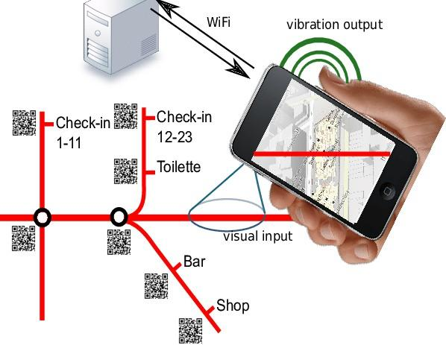
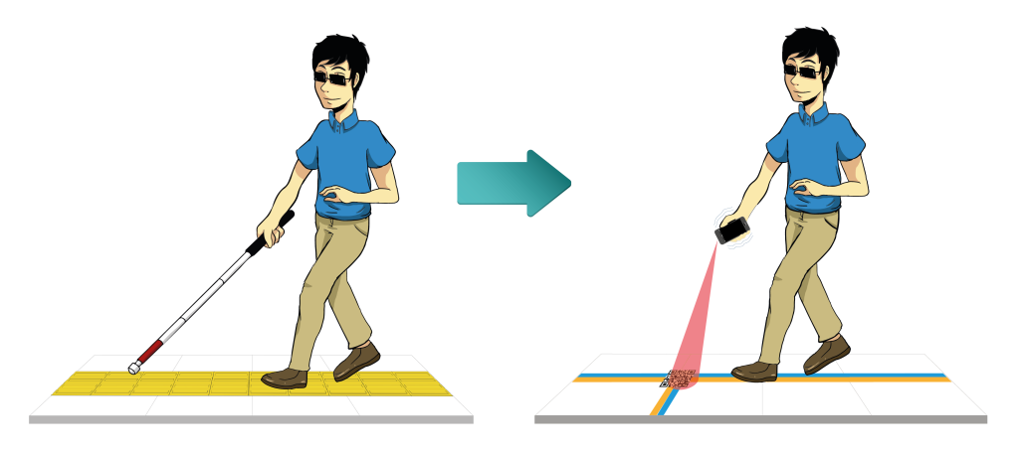

AI GLASS FIGURE :

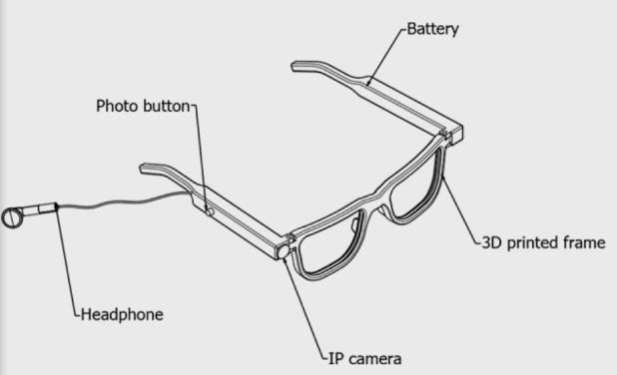

REFERENCES

- Kathiria, P., Mankad, S. H., Patel, J., Kapadia, M., & Lakdawala, N. (2024). Assistive systems for visually impaired people: A survey on current requirements and advancements. Neurocomputing, 606, 128284.
- Wang, J., Wang, S., & Zhang, Y. (2023). Artificial intelligence for visually impaired. Displays, 77, 102391.
- Lavric, A., Beguni, C., Zadobrischi, E., Căilean, A. M., & Avătămăniței, S. A. (2024). A comprehensive survey on emerging assistive technologies for visually impaired persons: lighting the path with visible light communications and artificial intelligence innovations. Sensors, 24(15), 4834.
- Kumar, S., Mishra, D. N., Ganie, S. M., Bharathikannan, R., & Vijayakanthan, K. (2023). Artificial intelligence solutions for the visually impaired: a review. Handbook of Research on AI and Knowledge Engineering for Real-Time Business Intelligence, 198-207.
- Naayini, P., Myakala, P. K., Bura, C., Jonnalagadda, A. K., & Kamatala, S. (2025). AI-Powered Assistive Technologies for Visual Impairment. arXiv preprint arXiv:2503.15494.
- Sethuraman, S. C., Tadkapally, G. R., Mohanty, S. P., Galada, G., & Subramanian, A. (2023). MagicEye: An Intelligent Wearable Towards Independent Living of Visually Impaired. arXiv preprint arXiv:2303.13863.
- Sandaruwan, M. G. T., Madushanka, M. K. P., & Hettige, B. (2025). Artificial Intelligence Based Solution for Navigating Vision Impaired Individuals: A Review. machine learning, 7, 8.
- Al-Muqbali, F., Al-Tourshi, N., Al-Kiyumi, K., & Hajmohideen, F. (2020, April). Smart Technologies for Visually Impaired: Assisting and conquering infirmity of blind people using AI Technologies. In 2020 12th annual undergraduate research conference on applied computing (URC) (pp. 1-4). IEEE.

