IOT based Railway Track Fault Detection

**Disha Pandurang Chalke, Rohit Kanya Gavit, Aminisha Kamalakar Natekar, M.K.Alam**

# ABSTRACT

Out of many transportation services provided to people railways are the most economical and energy efficient. In the countries like India where population is more therefore for serving the public transportation requirements in addition to the reliability of common people rail is quintessential for long transportations and travelling among all. Periodic inspection and examination of railway tracks are essential for efficient and safe train operations. The main aim of this project is to develop an Internet of things (IOT) based Railway track fault identification, faulty track localization as well as real time and date analyzation prototype model through IOT based technologies to minimize the frequencies of faults which are leading to the accidents therefore helping in minimizing accidents.

# INDEX TERMS

Railway track fault, Internet of things, Fault examination, localization, Analysis, Identification, Energy efficient, Reliability, Programming.

# INTRODUCTION

In developing nations, for serving the public transportation needs railways are one of the most commonly used and energy efficient mode of transportation. Market of railways has strengthen over the period of time thereby providing better opportunities to strengthening countries economy. Among all the other modes of transportation includes private automobiles and airlines, Railways uses 10 times less energy, making it more efficient means of public transportation. Daily local people, tourists travels by trains. Although railways is most commonly used mode of transportation but it does not match global standards, key factors including cracks, poor fitting, delayed in fault detection, no real time data collection led to unaccountable accidents in the world. As numerous severe accidents have occurred over the period of so many years which resulted in significant human and financial damage.

Railway tracks require period and adequate maintenance in addition to the periodic overhauling of each part of rail. The detection of fault, real time data collection and localization of fault are critical for proper operation and reducing the fault frequencies.

# LITERATURE REVIEW

The main purpose of IOT based Railway Track Fault Detection is for predictive periodic maintenance of tracks and components of trains, fastest fault identification, real time required data acquisition through IOT technology simultaneously minimizing the possibility of train accidents. Frequent and periodic analysis and examination of railway lines anonymous operations is critical for resisting the fault occurrence as well as for proper operation of system.

Traditional methods of human inspection of railway track faults sprawling over the long distances are time consuming, unsafe, labor intensive and lead to the human and instrumental errors. Due to instrumental and human errors, manual driven technologies are insufficient to adequate monitoring the health of railway track and its components. In order to overcome such factors automatic identification and monitoring of track fault is mandatory.

As a result, several automated systems have been introduced to reduce labor efforts, time consumption, human error. One of those technologies are IOT based Railway Track Fault Detection.

# METHODOLOGY

**HARDWARE REQUIREMENTS-** Power supply, ESP8266 Microcontroller NODEMCU, Relay, IR Sensors, DC motors, Motor Drives.

**SOFTWARE COMPONENTS-** Arduino IDE, Blynk Application, Programming logic (coded in C++ core programming language)

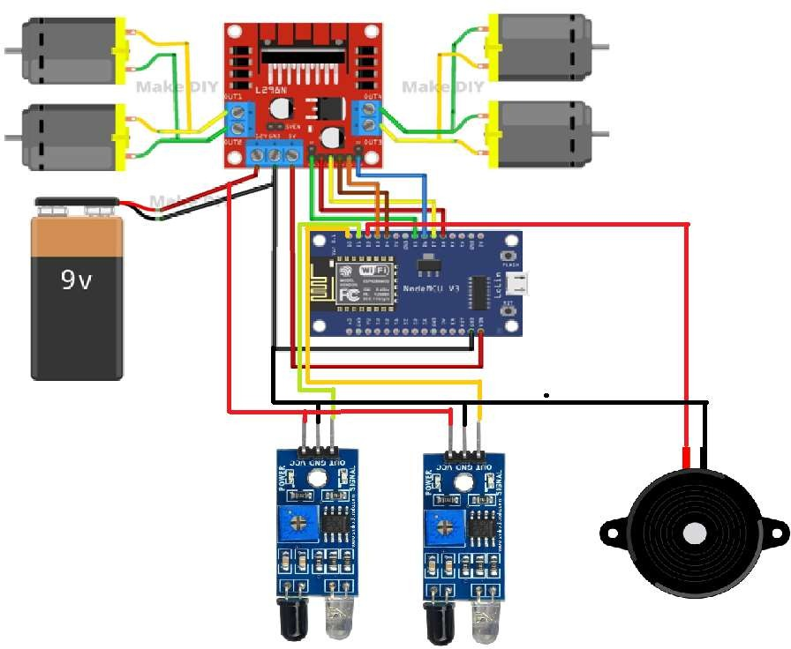

## FIGURE 1: BASIC SYSTEM ARCHITECTURE OF MODEL

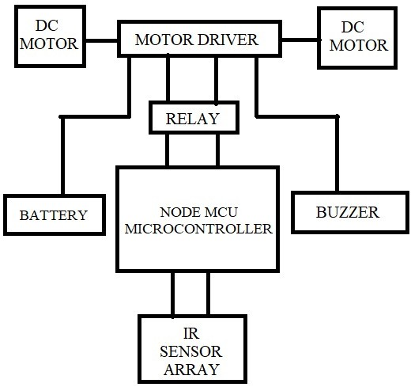

FIGURE 02: BASIC BLOCK DIAGRAM OF SYSTEM.

Due to advancement in various technologies, the prototype is based on IOT (Internet Of Things) including the software aspects such as Arduino IDE, Blynk application for notifications of fault occurrence locations (needs Wifi for operation), programming logics coded in core C++ language for commands and controls. Hardware requirements include DC motor (minimum 2 wheels drive or maximum 4 wheels drive), motor driver, DC battery, IR sensors, microcontroller, buzzer.

Rechargeable lithium cell battery will provide power supply to motor drive to move in forward direction (on the track). In prototype, the track is made by using PVC

tapes and fault is shown by black spots (indication of crack or obstacles) on simultaneous locations of tracks. IR sensors are situated at wheels (90 degree,normal to the earth) which will detect white area and once it find black spot (indication of fault) it will send signals to the microcontroller. As microcontroller receives signals of fault from IR sensors, it proceeds further by interrupting the mechanism of motor drive.

Once motor drive stops after getting indications from microcontroller simultaneous actions will get perform by buzzing the alert fault buzz and by receiving notification on blynk application with exact time, date and location of track (either left or right track indication) regardless of distance.

IR sensors have three terminals: VCC (Voltage at common collector) which is indicated by red wire to provide power supply to IR sensors, GND (Ground) indicated by black wire to complete the electrical circuit and providing point of common reference, OUT (Out signals) indicated by yellow and green wire for indicating detection of object or the distance of object.

For signal transmission purpose, there are analog pins for analog sensors and digitals pin for digital sensors (D0 to D7) including transmitter and receiving terminals. Motors are connected to motor driver and sensors are connected to Microcontroller.

# COMPONENT PARAMETER

Given section provides operating parameters of components used in prototype model: ESP 8266 Microcontroller NODEMCU - 3V to 7V, IR sensors - 3V to 5V, Motor Driver - 9V to 12V, DC motors - 3V to 12V, Battery - 9V to 12V, Buzzer - 3V to 5V

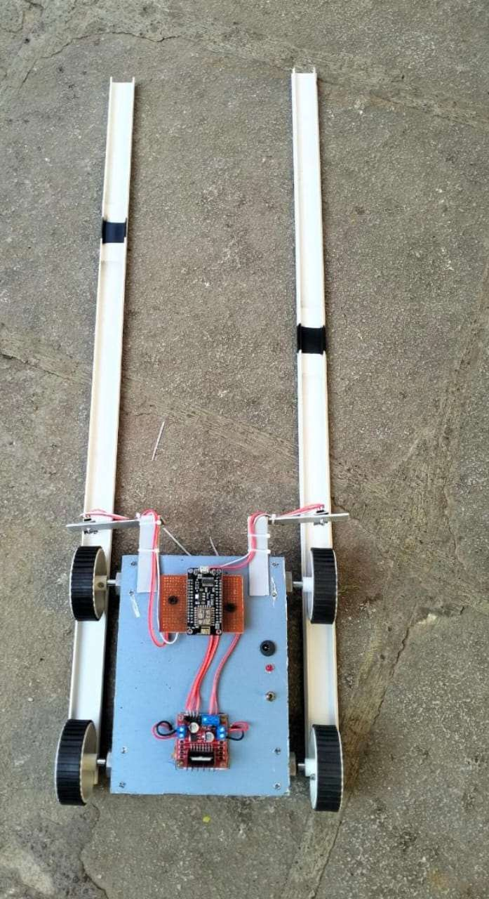

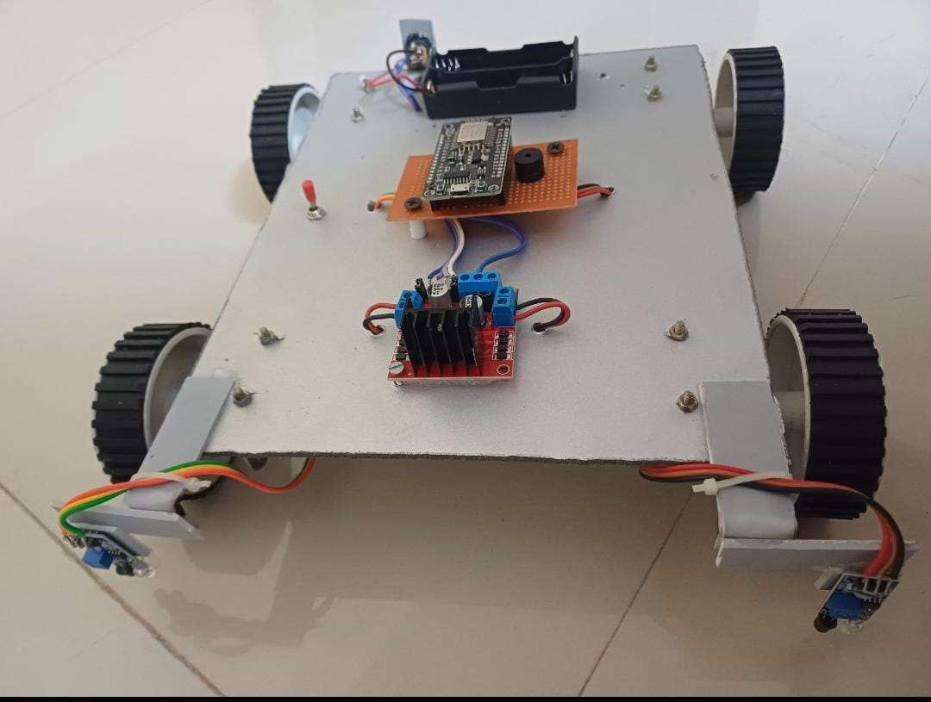

## FIGURE 03: PROPOSED SYSTEM

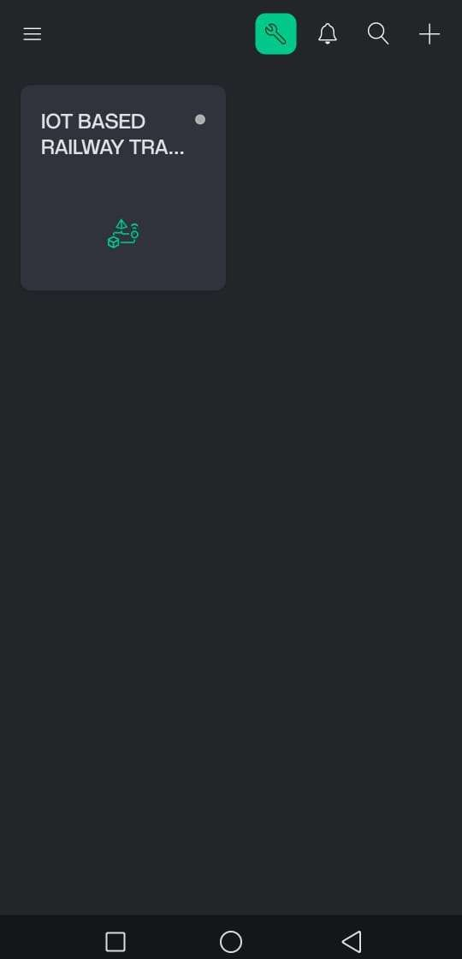

FIGURE 04: INTERFACE OF BLYNK APPLICATION.

Blynk application is available on playstore. After process of installing in your mobile devices, we get the access to it by creating account on it. It needs WIFI for the device connectivity which is possible through NODE MCU WIFI model. As internet is stable and we provide hotspot to the device it will automatically get ON.

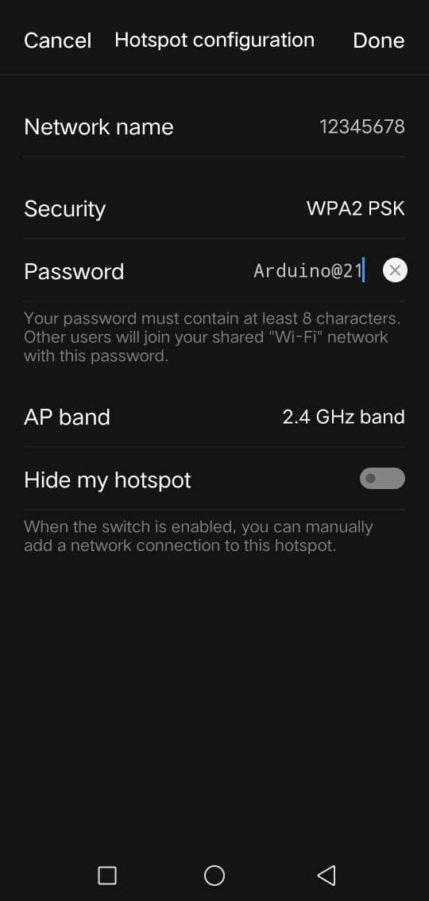

## FIGURE 05: BLYNK APPLICATION CONNECTIVITY WITH THE DEVICE.

For connectivity we have given a network name as 12345678 and set the password as Arduino@21.

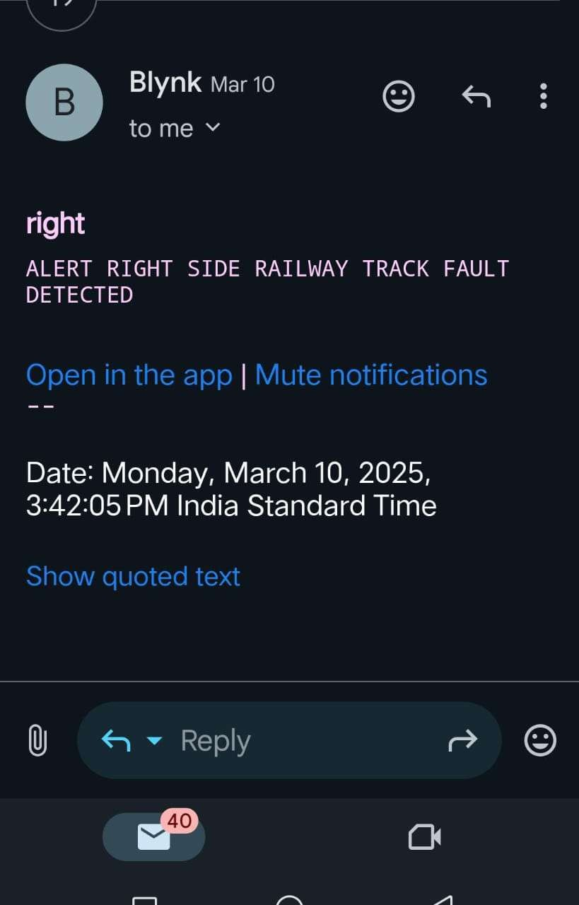

## FIGURE 06: REAL TIME DATA ACQUISITION THROUGH BLYNK APPLICATION

Once the device is connected to stable network, blynk application does the data acquisition on created account by sending the notification with real time, date and the faulty track indication either left or right as shown in figure 06.

# CONCLUSION

For the efficient and safe operation of rails, monitoring and periodic maintenance or railway tracks is essential factor. Data acquisition, fault detection, fault interruption, detecting fault location are critical components for reducing frequencies of accidents. An IOT based Railway Track Fault Detection model is merely an initiative for analyzation, detection and monitoring of fault, real time data acquisition, localization of fault, periodic maintenance of tracks and rail components to reducing accidents which causing human loss, economical loss.

# REFERENCE

1. https://ieeexplore.ieee.org
2. https://[www.researchgate.net/publication](http://www.researchgate.net/publication)
3. An Introduction to Electric Traction by an Author Sachidanand Mallick.