**“Prevention of Mother-To-Child Transmission of HIV”**

**Abstract: -**

This article "Cradling Hope: The Science and Soul of HIV Prevention at Birth" explores the remarkable progress in preventing mother-to-child transmission (PMTCT) of HIV—an achievement that has reduced transmission rates from 45% to less than 1% with comprehensive care. This article provides an in-depth review of prevention strategies spanning from preconception to postpartum, emphasizing the role of early HIV testing, antiretroviral therapy (ART), and safe delivery practices. Notably, maintaining maternal viral suppression throughout pregnancy has been shown to lower transmission risk to under 1%, and a scheduled cesarean section at 38 weeks can reduce perinatal transmission by 80% in high-risk cases. The article also examines breastfeeding-related risks, where exclusive breastfeeding combined with ART reduces transmission to below 1%, compared to a 15–20% risk without treatment. Global data highlight substantial progress—such as a reduction in transmission rates from 22% in 2010 to 10% in 2023—and the impact of international efforts like PEPFAR, which has helped 7.8 million babies be born HIV-free. Despite this success, challenges remain in resource-limited regions. The article concludes by calling for improved early diagnosis, integrated maternal-child health services, and continued research to eliminate pediatric HIV globally.

**Introduction: -**

HIV transmission from mother to child has decreased by over 95% when proper preventive measures are implemented. This remarkable success in the prevention of mother-to-child transmission of HIV represents one of the most significant achievements in public health over the past decades.

The comprehensive approach to PMTCT involves multiple strategies across different stages - from pregnancy planning through delivery and breastfeeding. While HIV-positive mothers naturally worry about transmission risks during pregnancy and through breast milk, current medical protocols significantly reduce these risks. Understanding and following these prevention guidelines is crucial for expecting mothers living with HIV.

This complete guide explores every aspect of preventing mother-to-child HIV transmission, from pre-pregnancy planning to postnatal care. You will learn about essential prevention strategies, treatment protocols, and evidence-based recommendations that have helped countless mothers deliver and raise healthy babies.

**Understanding Mother-to-Child Transmission of HIV**

Mother-to-child transmission (MTCT) of HIV occurs through three primary routes. Understanding these pathways serves as the foundation for effective prevention strategies.

**When Can HIV Be Transmitted to the Baby?**

HIV transmission from mother to child happens at specific periods throughout pregnancy and early infancy. The virus can pass to the baby in three distinct timeframes:

* **During pregnancy (in utero)**: The virus crosses the placenta despite the absence of CD4 receptors on placental trophoblasts.
* **At labor/delivery (intrapartum)**: This represents the most common transmission route, accounting for 15-20% of cases without intervention.
* **After birth (postpartum)**: Primarily through breastfeeding, with an estimated transmission rate of 16% without treatment.

Without any preventive measures, the overall transmission rate ranges from 15% to 45% across these periods.

**Risk Factors for Transmission**

Several factors increase the likelihood of HIV passing from mother to child:

High maternal viral load remains the strongest predictor of transmission risk. Additionally, women with low CD4 counts face elevated risks. Coexisting infections notably impact transmission rates - chorioamnionitis (placental inflammation), sexually transmitted infections, malaria, and tuberculosis all increase MTCT risk.

Genetic factors also play a role, as mother-child HLA concordance (sharing similar immune markers) increases transmission likelihood. Furthermore, acquiring HIV during pregnancy or breastfeeding dramatically heightens transmission risk due to extremely high initial viral loads.

**Global Statistics on Mother-to-Child Transmission**

Approximately 1.3 million women and girls living with HIV become pregnant annually. Before widespread prevention efforts, transmission rates reached 25-30%. By comparison, current global rates have improved substantially.

As of 2023, about 84% of HIV-positive pregnant women worldwide received antiretroviral medications. The global MTCT rate has consequently dropped from 22% in 2010 to 10% in 2023. However, this remains above the elimination threshold of 5% for breastfeeding countries and 2% for non-breastfeeding countries.

In higher-resource settings, the transmission rate has plummeted to approximately 0.3%. Conversely, across 21 African countries, rates varied between 2% and 25% in 2019, highlighting persistent regional disparities.

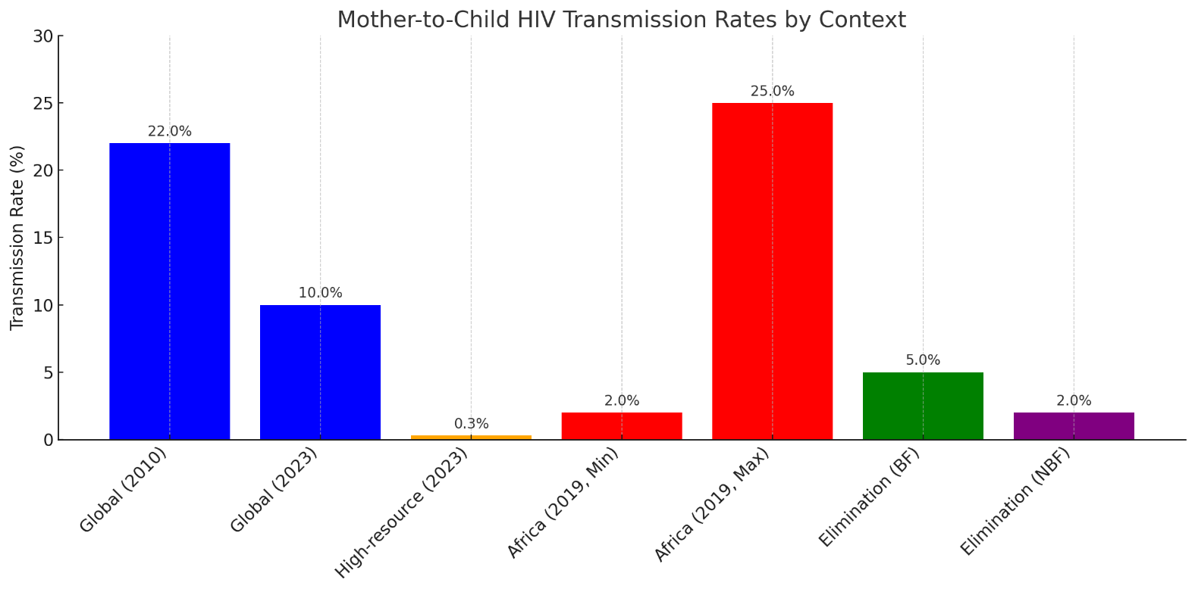

**Here's the bar graph comparing HIV mother-to-child transmission rates across different contexts and years.**

**​​**

**Prevention Strategies Before** Effective prevention of mother-to-child transmission of HIV begins well before conception. For women living with HIV, preconception planning presents a crucial opportunity to optimize health outcomes for both mother and child.

**HIV Testing and Counselling**

All individuals of reproductive age should receive HIV testing as part of routine care. The Centres for Disease Control and Prevention (CDC) specifically recommends that all women get tested before becoming pregnant. Early detection enables timely initiation of treatment, giving women the chance to achieve viral suppression prior to conception. Testing also creates opportunities for partner screening, allowing Sero discordant couples (where one partner has HIV and the other does not) to explore appropriate prevention strategies.

**Antiretroviral Therapy (ART)**

Starting antiretroviral therapy before pregnancy offers substantial benefits. Women should ideally achieve viral suppression (undetectable viral load) before attempting conception. This approach not only preserves maternal health but also virtually eliminates the risk of HIV transmission to both sexual partners and future infants. In fact, when HIV-positive women maintain viral suppression throughout pregnancy, the transmission rate drops to less than 1%.

Healthcare providers should discuss the safety and efficacy of different ART regimens with women considering pregnancy. Most medications are safe during pregnancy, and women typically do not need to switch medications when they become pregnant. Nevertheless, the selection process should involve shared decision-making that considers the woman’s health needs and the medication’s safety profile.

**Family Planning for HIV-Positive Women**

Studies indicate that women living with HIV have fertility desires similar to uninfected women. Approximately half of pregnancies among HIV-positive women are unintended, underscoring the need for comprehensive family planning services.

All contraceptive methods available to HIV-negative women can generally be used by women living with HIV, though certain considerations exist regarding drug interactions between hormonal contraceptives and antiretroviral medications. Current evidence suggests that the contraceptive methods least affected by HIV treatment are DMPA (Depo-Provera), Nexplanon implants, and IUDs.

For couples seeking to conceive, options vary based on HIV status. When both partners have HIV, both should achieve viral suppression before attempting conception. For Sero discordant couples, strategies include timed intercourse, pre-exposure prophylaxis (PrEP), and sperm washing techniques.

**Prevention During Pregnancy**

Proper medical care throughout pregnancy represents the cornerstone of preventing HIV transmission to babies. For expecting mothers with HIV, a structured care approach dramatically reduces the risk of perinatal transmission to less than 1% when protocols are carefully followed.

**Early and Regular Prenatal Care**

Pregnant women should be tested for HIV as early as possible during each pregnancy. Women diagnosed with HIV should immediately be linked to care, including support to remain virally suppressed. Initial assessment should include current CD4 count, plasma HIV RNA level, and screening for opportunistic infections. Regular prenatal visits enable coordination among HIV specialists, obstetricians, and other healthcare providers—an essential aspect of maintaining treatment adherence.

**Antiretroviral Treatment Protocols**

Antiretroviral therapy should begin as soon as possible during pregnancy if not already initiated. Women already taking HIV medications when pregnancy occurs should generally continue their regimen, as interruption raises the risk of viral rebound and resistance. Current guidelines recommend two nucleoside reverse-transcriptase inhibitors plus a third drug from another class. Preferred regimens include tenofovir disoproxil fumarate (or tenofovir alafenamide) plus emtricitabine (or lamivudine) combined with either dolutegravir or darunavir/ritonavir.

**Monitoring Viral Load**

Viral load monitoring follows a specific schedule during pregnancy:

* At initial prenatal visit
* 2–4 weeks after starting or changing ART
* Monthly until viral load becomes undetectable
* At least every 3 months throughout pregnancy
* Additionally at 34-36 weeks to inform delivery decisions

More frequent monitoring (every 1-2 months) may be needed for women taking antiretrovirals with reduced drug levels in later trimesters, such as cobicistat, elvitegravir, and rilpivirine. Achieving and maintaining an undetectable viral load remains the primary goal, as this substantially reduces transmission risk. Access to routine viral load testing is crucial for identifying unsuppressed viral loads early and providing timely interventions.

**Prevention During Labor and Delivery**

Labor and delivery represent a critical window for preventing HIV transmission from mother to child. Careful planning of delivery methods and specialized medical interventions during this period significantly reduce transmission risks.

**Delivery Method Considerations**

The recommended delivery method depends primarily on the mother’s viral load near the time of delivery. For women with HIV RNA levels **greater than 1,000 copies/mL** or unknown viral load, a scheduled caesarean delivery is recommended at 38 weeks gestation (2 weeks before the expected due date). This approach reduces perinatal transmission risk by approximately 80% compared to vaginal delivery, according to randomized trial results.

Alternatively, women with viral loads **at or below 1,000 copies/mL** can safely deliver vaginally. Current evidence suggests that for these women, caesarean delivery offers no additional benefit in preventing transmission. These recommendations should be discussed early in pregnancy to allow women time to consider their options.

**Medications During Labor**

Intravenous (IV) zidovudine administration remains a key component of intrapartum care for women with viral loads exceeding 1,000 copies/mL. The recommended protocol includes:

* A 1-hour IV loading dose (2 mg/kg)
* Followed by continuous infusion (1 mg/kg/hour) until delivery

Ideally, IV zidovudine should begin 3 hours before cesarean delivery. Women already taking antiretroviral medications should continue their regular regimen during labor and delivery. Importantly, some medications used to treat HIV may interact with medications used during labor, especially uterotonics like methergine.

**Reducing Exposure to Maternal Blood**

Several practices help minimize fetal exposure to maternal blood:

First, fatal scalp electrodes should generally be avoided, particularly when the mother’s viral load is not suppressed or unknown. Similarly, operative vaginal delivery with forceps or vacuum extractors should follow standard obstetric indications but avoided, when possible, in women with unsuppressed viral loads.

Regarding membrane rupture, artificial rupture should be limited for women with unsuppressed viral loads. Moreover, healthcare providers should be aware that for women originally scheduled for cesarean who present in labor, management must be individualized based on labor duration, viral load, and overall health.

For urgent assistance with delivery decisions, consultation with perinatal HIV experts is available through 24-hour hotlines.

**Prevention After Birth**

The first hours and weeks after delivery are crucial for preventing HIV transmission in exposed infants. Postnatal interventions serve as the final line of defense against vertical transmission, with carefully timed procedures offering substantial protection.

**Infant Antiretroviral Prophylaxis**

All newborns exposed to HIV should receive antiretroviral prophylaxis ideally within six hours after birth. The medication regimen depends on maternal viral suppression status and transmission risk factors. Infants whose mothers maintained viral suppression throughout pregnancy typically receive zidovudine (ZDV) for four weeks. Conversely, newborns at higher risk—whose mothers had unsuppressed viral loads or newly diagnosed HIV during labor—require more intensive three-drug regimens for up to six weeks.

For infants receiving combination antiretroviral therapy, healthcare providers should monitor hemoglobin and neutrophil counts at baseline and after four weeks of treatment. Throughout this period, medications should continue without interruption, as adherence significantly reduces transmission risk.

**Early Infant Diagnosis**

Accurate diagnosis requires specific testing methods, since maternal antibodies persist in infant blood for up to 18 months. HIV nucleic acid tests (NAT) that detect viral DNA or RNA are essential for early diagnosis. The recommended testing schedule includes:

* Initial test at 14-21 days of life
* Follow-up testing at 1-2 months
* Final testing at 4-6 months

Early diagnosis dramatically improves outcomes, as untreated HIV progresses rapidly in infants—with peak mortality occurring between 2-3 months of age. Point-of-care testing has transformed diagnosis in resource-limited settings, with studies showing 72% of caregivers receiving same-day results, leading to six times higher treatment initiation rates for positive infants.

**Follow-up Care for HIV-Exposed Infants**

Comprehensive care extends beyond medication. Starting at 4-6 weeks of age, all HIV-exposed infants should receive co-trimoxazole prophylaxis to prevent Pneumocystis pneumonia until HIV infection has been definitively excluded. These infants require consistent monitoring for growth, development, and potential signs of HIV infection.

Regular follow-up appointments facilitate coordination between healthcare providers, with the first visit typically scheduled two weeks after birth. Throughout this period, parents need counselling about safe feeding practices—including complete avoidance of premasticated (pre-chewed) food regardless of the infant’s HIV status.

**Breastfeeding and HIV Transmission**

Breastfeeding presents unique considerations for HIV transmission risk and prevention. Understanding these risks alongside proper guidelines enables mothers to make informed decisions about infant feeding practices.

**Can HIV Be Transmitted Through Breast Milk?**

HIV can indeed be transmitted through breast milk as it contains both cell-free and cell-associated virus. The cumulative risk of transmission through breastfeeding without any intervention ranges from 15-20%. This transmission occurs because breast milk is one of the body fluids that can carry HIV, alongside blood and genital secretions.

Several factors influence transmission risk through breastfeeding:

* High maternal viral load in plasma and breast milk
* Low maternal CD4+ count, even independent of viral load
* Primary HIV infection occurring during lactation (risk increases to approximately 30%)
* Breast health issues including mastitis, nipple bleeding, abscesses, or fissures
* Duration of breastfeeding (cumulative risk increases over time)
* Mixed feeding versus exclusive breastfeeding

Data reveals that transmission risk is highest in early months and decreases thereafter—approximately 0.7% monthly during months 1-5, declining to 0.2% by months 18-23.

**Guidelines for Breastfeeding with HIV**

In high-resource settings, replacement feeding has traditionally been recommended, thus eliminating transmission risk entirely. At present, significant guidance differences exist between regions:

* **High-resource settings**: The primary focus remains on safety, with formula or banked donor milk recommended for mothers without viral suppression.
* **Low-resource settings**: WHO recommends exclusive breastfeeding for the first 6 months with continued breastfeeding to 12-24 months, alongside maternal ART.

For mothers achieving and maintaining viral suppression through ART, breastfeeding transmission risk drops to less than 1%, although not zero. The most recent guidelines advise healthcare providers to support individual decision-making through comprehensive counseling.

**Alternative Feeding Options**

Complete replacement feeding options that eliminate HIV transmission risk include:

* Infant formula (most nutritionally adequate but often costly)
* Pasteurized donor human milk from milk banks
* Alternative milks (cow’s milk, soy milk) with appropriate preparation

Replacement feeding decisions must consider what is “Acceptable, Feasible, Affordable, Sustainable and Safe” (AFASS conditions). In low-resource settings, formula feeding challenges include cost, unreliable electricity, poor access to safe water, and inadequate storage facilities.

**Global PMTCT Programs and Success Rates**

Global cooperation and coordinated initiatives have dramatically changed the landscape of HIV prevention efforts for mothers and infants worldwide. International organizations, governments, and NGOs collaborate on policies and programs that have saved millions of young lives.

**WHO and CDC Guidelines**

The World Health Organization leads development of global health sector strategy on eliminating HIV as a public health threat. In 2007, WHO/UNICEF created guidelines specifically for scaling up PMTCT in resource-constrained settings. These evidence-based recommendations, once implemented, can reduce mother-to-child transmission to less than 5% in breastfeeding populations.

Meanwhile, the Centers for Disease Control and Prevention (CDC) supports comprehensive prevention services through pregnancy, labor, and delivery. Their efforts have contributed to more than 5.5 million babies being born HIV-free to mothers living with HIV. Beyond guidelines, both organizations provide technical assistance and training resources for healthcare workers implementing PMTCT programs worldwide.

**PEPFAR and Other Initiatives**

The U.S. President’s Emergency Plan for AIDS Relief (PEPFAR) stands as the largest commitment by any nation to address a single disease. This program has:

* Invested over $110 billion in the global HIV/AIDS response
* Enabled 7.8 million babies to be born HIV-free to mothers with HIV
* Prevented 5.5 million babies from being born with HIV
* Supported testing services for 71.1 million people in fiscal year 2023

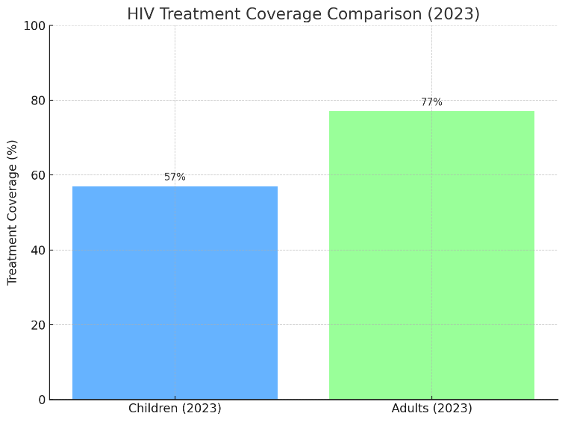PEPFAR’s impact is evident in countries like Uganda, where mother-to-child transmission rates dropped from over 20% in 2000 to 2.8% in 2021. Worth noting is PEPFAR’s DREAMS program, now in its 10th year, which continues to reduce new infections through comprehensive interventions.

**Progress and Challenges**

Global scale-up of PMTCT services led to a 52% worldwide

decline in new HIV infections among children between

2001-2012. At present, transmission rates in resource-

rich countries have reached historic lows of

approximately 1%.

In reality, significant disparities persist. Even as four African

countries (Botswana, Ghana, Namibia and Zambia)

achieved 90% PMTCT coverage, globally only 57% of

children living with HIV received treatment in 2023,

compared to 77% of adults. Major obstacles include

*Here's a bar graph comparing HIV treatment coverage between children and adults in 2023. It clearly shows the gap—only 57% of children received treatment, compared to 77% of adults.*

limited healthcare infrastructure, workforce shortages,

and competing health priorities within restricted budgets.

**Future Directions and Recommendations**

To further improve PMTCT outcomes, future efforts should focus on:

1. **Enhanced Early Detection**: Increasing access to and uptake of early HIV testing during pregnancy.
2. **Improved Support Systems**: Developing better adherence support mechanisms for pregnant and breastfeeding women on ART.
3. **Integration of Services**: Further integrating PMTCT services with routine maternal and child health care.
4. **Research Priorities**: Conducting long-term outcome studies and evaluating new drug protocols for PMTCT.
5. **Healthcare Provider Training**: Updating clinical guidelines and enhancing cultural competency among healthcare workers.

**Conclusion:-**

Prevention of mother-to-child HIV transmission stands as one of modern medicine’s greatest achievements. Medical advances have transformed what was once a significant risk into a largely preventable outcome, reducing transmission rates from 45% to less than 1% with proper care.

Success depends on several key factors. Comprehensive prenatal care, consistent antiretroviral therapy, and careful monitoring throughout pregnancy provide essential protection. Labor and delivery protocols, along with appropriate feeding choices, further safeguard infant health. These combined approaches have saved millions of young lives worldwide.

Healthcare systems globally continue making remarkable progress. Through coordinated efforts between organizations like WHO, CDC, and PEPFAR, mother-to-child transmission rates have plummeted across many regions. Though challenges remain, particularly in resource-limited settings, current medical protocols offer HIV-positive mothers real hope for delivering and raising healthy babies.

Most importantly, expectant mothers living with HIV should remember they are not alone. Medical teams, support services, and clear treatment guidelines exist to help navigate each stage of pregnancy and beyond. Through proper medical care and adherence to prevention protocols, mothers can significantly protect their children from HIV transmission while maintaining their own health.

**References:-**

[1] - <https://pmc.ncbi.nlm.nih.gov/articles/PMC3382106/>  
[2] - <https://pmc.ncbi.nlm.nih.gov/articles/PMC9292699/>  
[3] - <https://www.ajog.org/article/S0002-9378(07)00270-0/fulltext>  
[4] - <https://hivinfo.nih.gov/understanding-hiv/fact-sheets/preventing-perinatal-transmission-hiv>  
[5] - <https://www.acog.org/clinical/clinical-guidance/committee-opinion/articles/2018/09/labor-and-delivery-management-of-women-with-human-immunodeficiency-virus-infection>  
[6] - <https://pedaids.org/resource/breastfeeding-antiretroviral-therapy-hiv-transmission-and-the-hiv-reservoir/>  
[7] - <https://pmc.ncbi.nlm.nih.gov/articles/PMC2650837/>  
[8] - <https://www.cdc.gov/global-hiv-tb/php/our-approach/briefbook-pmtct.html>  
[9] - <https://www.uptodate.com/contents/hiv-and-pregnancy-beyond-the-basics/print>  
[10] - <https://www.state.gov/pepfar/>  
[11] - <https://pubmed.ncbi.nlm.nih.gov/23097595/>  
[12] - <https://pmc.ncbi.nlm.nih.gov/articles/PMC5963879/>  
[13] - <https://www.thewellproject.org/hiv-information/contraception-and-hiv>  
[14] - <https://clinicalinfo.hiv.gov/en/guidelines/perinatal/prepregnancy-counseling-childbearing-age-reproductive-options-partners>  
[15] - <https://www.cdc.gov/mmwr/volumes/66/wr/mm6621a2.htm>  
[16] - <https://www.hiv.gov/hiv-basics/hiv-prevention/reducing-mother-to-child-risk/preventing-mother-to-child-transmission-of-hiv>  
[17] - <https://www.who.int/teams/global-hiv-hepatitis-and-stis-programs/hiv/prevention/mother-to-child-transmission-of-hiv>  
[18] - <https://clinicalinfo.hiv.gov/en/guidelines/perinatal/antepartum-care-individuals-hiv>  
[19] - <https://www.uptodate.com/contents/hiv-and-pregnancy-beyond-the-basics>  
[20] - <https://pmc.ncbi.nlm.nih.gov/articles/PMC10390091/>  
[21] - <https://clinicalinfo.hiv.gov/en/guidelines/perinatal/antepartum-care-initial-evaluation-monitoring-hiv-assessments-during-pregnancy-full>  
[22] - <https://clinicalinfo.hiv.gov/en/guidelines/perinatal/intrapartum-care>  
[23] - <https://www.ncbi.nlm.nih.gov/books/NBK304139/>  
[24] - <https://www.aafp.org/pubs/afp/issues/2021/0700/p58.html>  
[25] - <https://clinicalinfo.hiv.gov/en/guidelines/perinatal/management-infants-initial-postnatal-neonate-exposed-hiv>  
[26] - <https://hivinfo.nih.gov/understanding-hiv/fact-sheets/preventing-perinatal-transmission-hiv-after-birth>  
[27] - <https://www.clintonhealthaccess.org/blog/point-of-care-early-infant-diagnosis-of-hiv-improves-treatment-initiation/>  
[28] - <https://www.cdc.gov/breastfeeding-special-circumstances/hcp/illnesses-conditions/hiv.html>  
[29] - <https://jamanetwork.com/journals/jama/fullarticle/191323>  
[30] - <https://clinicalinfo.hiv.gov/en/guidelines/perinatal/infant-feeding-individuals-hiv-united-states>  
[31] - <https://publications.aap.org/pediatrics/article/153/6/e2024066843/197305/Infant-Feeding-for-Persons-Living-With-and-at-Risk>  
[32] - <https://www.who.int/news-room/questions-and-answers/item/hiv-aids-infant-feeding-and-nutrition>  
[33] - <https://www.who.int/tools/elena/interventions/hiv-infant-feeding>  
[34] - <https://www.ennonline.net/fex-article/infant-feeding-alternatives-hiv-positive-mothers-kenya>  
[35] - <https://pmc.ncbi.nlm.nih.gov/articles/PMC6860690/>  
[36] - <https://applications.emro.who.int/aiecf/prevention_mother_Trainers_Manual.pdf>  
[37] - <https://apps.who.int/iris/bitstream/handle/10665/44268/9789241599030_eng.pdf>  
[38] - <https://www.hiv.gov/federal-response/pepfar-global-aids/pepfar>  
[39] - <https://www.kff.org/global-health-policy/fact-sheet/the-u-s-presidents-emergency-plan-for-aids-relief-pepfar/>  
[40] - <https://www.cdc.gov/global-hiv-tb/php/success-stories/uganda-pmtct.html>  
[41] - <https://publichealthreviews.biomedcentral.com/articles/10.1186/s40985-017-0072-5>