**"Healing Young Lives”**

**The Role of ART in Pediatric HIV Care and Survival**

Abstract:-

This review examines the current state of antiretroviral therapy (ART) for HIV-infected children, highlighting recent advancements, ongoing challenges, and future directions. Despite significant progress in expanding access to pediatric ART globally, children continue to experience disparities in treatment coverage compared to adults. Current guidelines recommend immediate ART initiation for all HIV-infected children regardless of clinical or immunological status, with preference for integrase strand transfer inhibitor (INSTI)-based regimens Perpetration of these recommendations faces substantial walls including poor delectability of pediatric phrasings, complex administration procedures, and limited vacuity of child-friendly phrasings. Global treatment content for children reached roughly 57 by 2023, which remains vastly lower than the 77-content achieved in grown-ups. Recent developments include the preface of alternate- generation INSTIs similar as dolutegravir and bictegravir, which have been approved for youngish children and show bettered efficacity and tolerability. This review discusses the unique considerations in pediatric ART including age-specific dosing, experimental pharmacokinetics, adherence support strategies, and the operation of treatment failure. Addressing the patient gaps in pediatric HIV care requires innovative approaches to medicine expression, simplified treatment rules, and family- centered care models.

**Keywords Pediatric HIV; Antiretroviral remedy; medicine phrasings; Treatment guidelines; Adherence; Pediatric pharmacokinetics; Treatment issues; Perinatal infection; Integrase impediments; Viral repression**

1. Introduction:-

Despite remarkable progress in precluding mama - to- child transmission( MTCT) of HIV and expanding access to antiretroviral remedy( ART), pediatric HIV infection remains a significant global health challenge. According to the World Health Organization( WHO), roughly 1.4 million children progressed 0- 14 times were living with HIV at the end of 2023, with 120,000 children recently infected and 76,000 children dying from AIDS- related ails. Without access to testing and treatment, HIV infection in children progresses fleetly, with mortality rates of 50 by age 2 and 80 by age 5. This underscores the critical significance of early opinion and prompt inauguration of ART in pediatric populations.

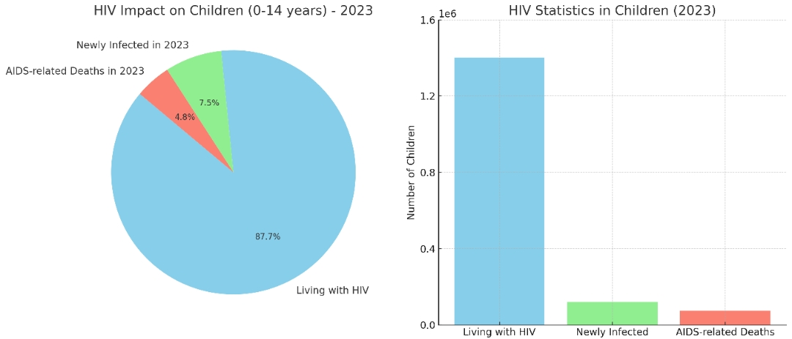

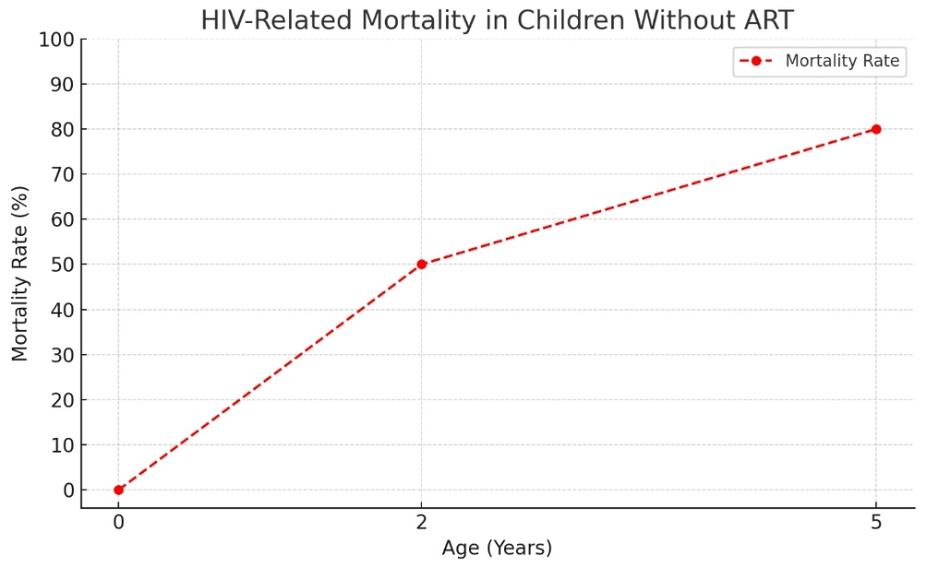

*Here is a visual summary emphasizing both the global burden of paediatrics HIV in 2023 and the*

*critical need for early opinion and treatment due to high mortality rates without intervention.*

The geography of pediatrics HIV operation has evolved significantly over the once decade. In 2015, the WHO removed CD4- grounded clinical staging criteria for ART inauguration, enforcing a “Treat All” approach that recommended immediate ART for all individualities diagnosed with HIV, including children. This policy change aimed to simplify treatment decision- timber, reduce morbidity and mortality, and help close the treatment gap between children and grown-ups. While this approach has contributed to bettered issues, significant challenges remain in achieving optimal ART content and issues for children living with HIV.

This review examines the current approaches to ART in HIV- infected children, with a focus on recent guideline updates, treatment considerations specific to pediatric populations, challenges in perpetration, and arising strategies to ameliorate issues. By synthesizing current substantiation and pressing patient gaps, this paper aims to inform ongoing sweats to optimize the care of HIV- infected children encyclopedically.

2. Epidemiology of Pediatric HIV Infection

**2.1 Global Burden**

The global geography of paediatrics HIV has changed dramatically with the perpetration of forestalment of mama - to- child transmission (PMTCT) programs. nonetheless, HIV infection in children remains a significant public health challenge, particularly in resource- limited settings. As of 2023, an estimated 1.4 million children under 15 times of age were living with HIV encyclopaedically, with roughly 120,000 new infections being annually. Sub-Saharan Africa continues to bear the disproportionate burden of the paediatrics HIV epidemic, counting for over 90 of children living with HIV worldwide.

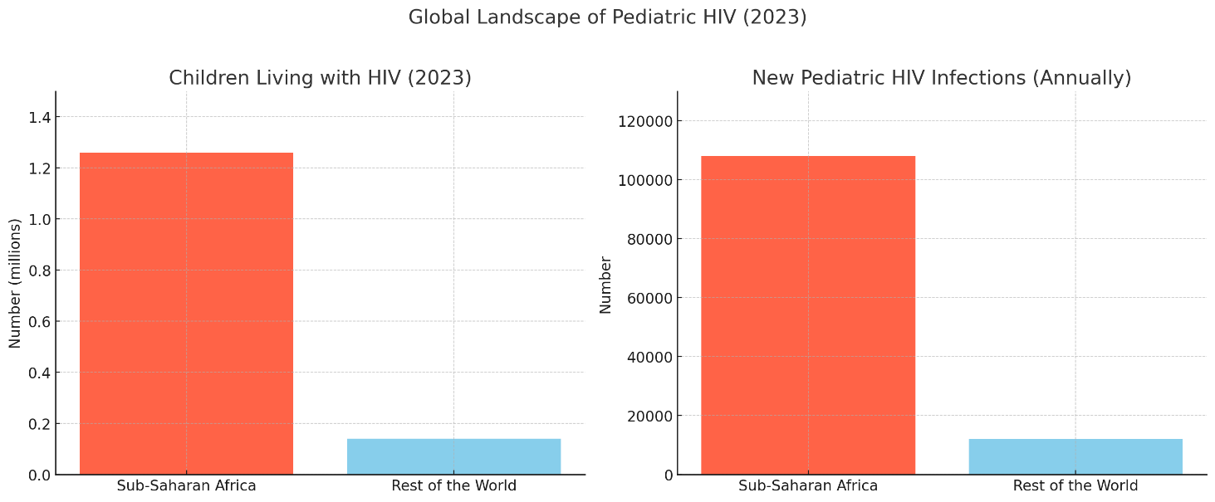

*Here is a visual breakdown of the global paediatrics HIV geography in 2023, pressing the significant impact in Sub-Saharan Africa.*

**2.2 Treatment Coverage**: **-**

Despite the universal “Treat All” policy perpetration, treatment content for children lags significantly behind that of grown-ups. In 2023, only 57 of children living with HIV were entering ART, compared to 77 of grown-ups. From 2010 to 2020, paediatrics ART content tripled from 16 to 54, while AIDS- related deaths were halved from 240,000 to 99,000. still, a concerning trend has surfaced following the perpetration of “Treat All” programs the rate of increase in ART content for children has declined by 6 in the post-implementation period compared to pre-implementation trends.

This patient treatment gap highlights the unique challenges in diagnosing and treating HIV in children, including walls to early child opinion, limited vacuity of paediatrics medicine phrasings, and complications in administering treatment to children. This persistent treatment gap highlights the unique challenges in diagnosing and treating HIV in children, including barriers to early infant diagnosis, limited availability of paediatrics drug formulations, and complexities in administering treatment to children.

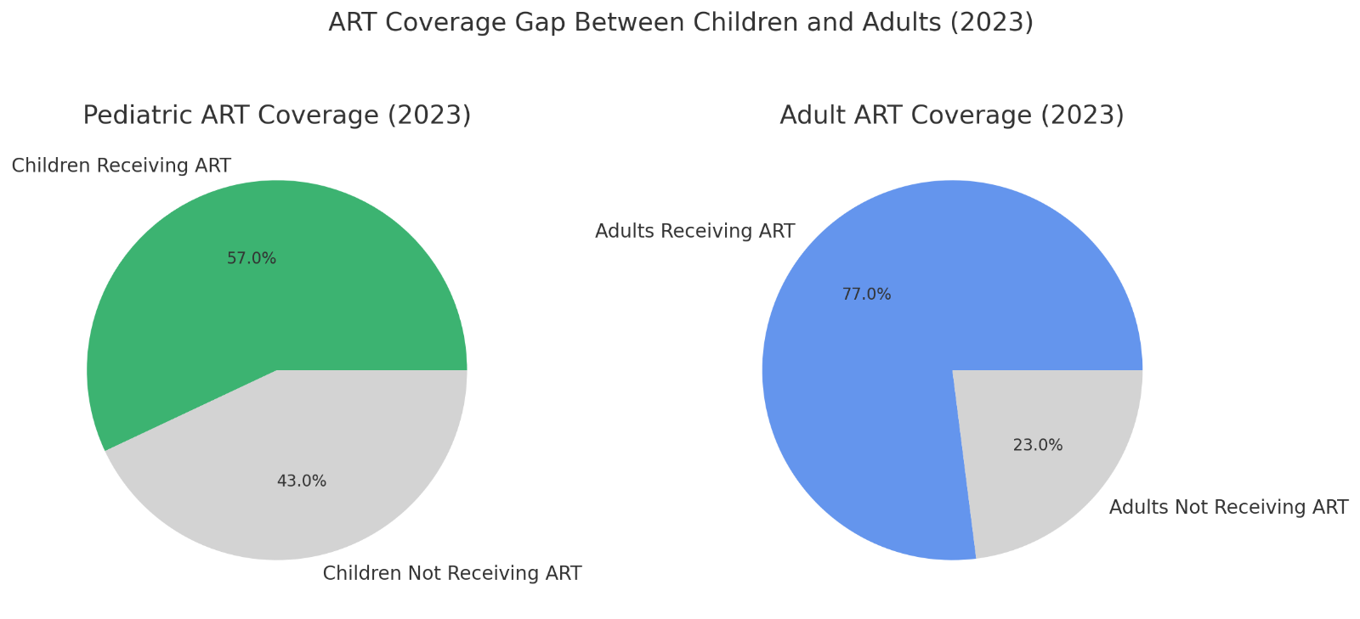

*Here are the pie maps showing the ART content gap in 2023*

*while a maturity of grown-ups living with HIV are entering*

*treatment, a much lower proportion of children are.*

3. Current Treatment Guidelines

**3.1 Elaboration of Treatment Recommendations: -**

Pediatric ART guidelines have evolved substantially over time, moving from CD4- predicated treatment induction criteria to a universal “Treat All” approach. Current guidelines from the Panel on Antiretroviral remedy and Medical Management of Children Living with HIV (the Panel) recommend immediate ART induction for all HIV- infected children, anyhow of clinical symptoms or immunologic status. This recommendation is predicated on validation that early ART induction is associated with reduced mortality, bettered neurodevelopmental issues, and preservation of vulnerable function.

**3.2 Preferred Antiretroviral rules**

As of 2024, the Panel recommends second- generation integrase beachfront transfer asset (INSTI)- predicated rules with dolutegravir (DTG) or bictegravir (BIC) as the preferred anchor drugs for original ART in babies and children progressed ≥ 30 days and importing ≥ 3 kg whenever possible. DTG is approved for children progressed ≥ 30 days and importing ≥ 3 kg, while BIC is approved for children progressed ≥ 2 times and importing ≥ 14 kg. Protease asset (PI)- predicated rules are recommended as necessary options, and non- nucleoside hinder transcriptase asset (NNRTI)- predicated rules are only recommended as necessary options if resistance or sectarianism to INSTIs and PIs is present.

For babies Youngish than 30 days, nevirapine- and raltegravir- predicated rules continue to be the favoured treatment options, with lopinavir/ ritonavir (LPV/ r) recommended as a volition for babies who have reached a postmenstrual age of 42 weeks and a postnatal age of at least 14 days.

**3.3 Age-Specific Considerations**

The Panel has revised its presentation of initial ART recommendations to be organized by age group rather than by antiretroviral drug class, reflecting the importance of age-specific considerations in pediatric HIV treatment. The four age groups addressed in the guidelines are:

1. Birth to <30 days
2. ≥30 days to <2 years
3. ≥2 to <12 years
4. ≥12 years

This approach acknowledges the distinct physiological, pharmacokinetic, and formulation considerations that apply to children at different developmental stages.

4. Pharmacological Considerations in Pediatric ART

**4.1 Drug Formulations and Administration**

A major challenge in pediatric ART is the limited availability of appropriate drug formulations for children. Current pediatric formulations often present significant barriers to adherence due to poor palatability, complex preparation requirements, and storage issues. Liquid formulations, while necessary for infants and young children, frequently have bitter tastes that lead to medication refusal, anxiety around medication times, and strained relationships between caregivers and children.

In many resource-limited settings, adult tablets must be crushed and dissolved in water as part of the treatment regimen, which adds complexity to the administration process and potential for dosing errors. These preparation challenges can also compromise confidentiality, as the process is difficult to conceal during travel or in shared living situations.

**4.2 Pharmacokinetics and Dosing**

Children experience significant developmental changes in drug absorption, distribution, metabolism, and elimination, necessitating careful consideration of dosing across different age groups. When approving drugs for use in children, regulatory authorities often extrapolate efficacy data from adult trials, supplemented with safety and pharmacokinetic data from pediatric studies.

This approach is considered appropriate when:

* Supplemental data exist on the pharmacokinetics of the drug in children, indicating that systemic exposure in adults and children is similar
* Studies support the safety of using the drug in pediatric patients
* If concentration-response relationships might differ between children and adults, pharmacodynamic data relating drug activity to drug levels in children are provided

Dosing regimens must be adjusted as children grow, requiring frequent reassessment and adjustment based on weight or body surface area.

**4.3 Drug Interactions and Comorbidities**

Potential drug interactions must be carefully considered when selecting ART regimens for children, particularly in the context of treatment for comorbid conditions such as tuberculosis, malaria, and other opportunistic infections that are common in HIV-infected children. Additionally, the presence of comorbidities may affect drug choices, necessitating individualized approaches to ART selection.

5. Clinical Management and Monitoring

**5.1 Initial Assessment and Baseline Monitoring**

Comprehensive baseline assessment of children diagnosed with HIV should include:

* Clinical evaluation for HIV-related symptoms and opportunistic infections
* Immunological assessment (CD4 count and percentage)
* Virological evaluation (HIV RNA viral load)
* Resistance testing (where available)
* Assessment of growth and development
* Screening for comorbid conditions

These assessments inform the selection of the initial ART regimen and establish baseline parameters for monitoring treatment response.

**5.2 Treatment Monitoring and Follow-up**

Regular monitoring is essential to assess treatment effectiveness, detect adverse effects, and identify treatment failure. The frequency and components of monitoring may vary based on age, treatment regimen, and clinical status, but typically include:

* Clinical evaluation for disease progression and treatment-related complications
* Growth and developmental assessment
* Immunological monitoring (CD4 count/percentage)
* Virological monitoring (HIV RNA viral load)
* Adherence assessment
* Drug toxicity screening

**5.3 Management of Treatment Failure**

Despite advances in ART, treatment failure remains a significant challenge in pediatric HIV management. Treatment failure may be defined virologically (persistent detectable viral load despite adequate therapy), immunologically (decline in CD4 count or percentage), or clinically (disease progression despite therapy).

Causes of treatment failure include poor adherence, inadequate drug concentrations, pre-existing or acquired drug resistance, and drug interactions. Management strategies for treatment failure include:

* Addressing adherence issues
* Resistance testing to guide regimen modification
* Selection of at least two fully active agents for the new regimen
* Consideration of newer drug classes if available

6. Challenges in Pediatric ART Implementation

**6.1 Adherence Barriers**

Adherence to ART is critical for treatment success but presents significant challenges in pediatric populations. Key adherence barriers identified in research include:

* Regimen-related factors: Poor palatability of medications, complex preparation and administration procedures, pill burden, and dosing frequency.
* Child factors: Medication refusal, developmental stage, understanding of illness, and treatment fatigue.
* Caregiver factors: Knowledge, beliefs about treatment, psychological distress, and competing responsibilities.
* Healthcare system factors: Medication availability, frequency of refill appointments, and healthcare access.

**6.2 Formulation and Administration Challenges**

Current pediatric ART formulations present numerous challenges that impede successful treatment. Caregivers and healthcare providers report significant issues with:

* Poor taste leading to child anxiety, medication refusal, and administration difficulties: “The palatability is not good, and as you know, children love tasteful things and when you give them drugs that are not tasteful, they spit it out. It becomes difficult to administer the drug, so you don’t even know whether the child or children have gotten the correct dosage.”
* Complex preparation procedures that compromise privacy and confidentiality, especially during travel.
* Storage requirements that may be difficult to maintain in resource-limited settings.
* Frequent refill appointments that disrupt work and school schedules and may lead to unwanted disclosure.

**6.3 Healthcare System and Structural Barriers**

Broader structural barriers to effective pediatric ART implementation include:

* Limitations in healthcare workforce capacity and training
* Disruptions in medication supply chains
* Inadequate laboratory infrastructure for monitoring
* Stigma and discrimination within healthcare settings
* Socioeconomic constraints affecting healthcare access
* Limited integration of HIV services with other pediatric health services

7. Treatment Outcomes and Effectiveness

**7.1 Virologic and Immunologic Response**

Studies of pediatric ART outcomes in resource-limited settings have shown promising results. A meta-analysis of treatment outcomes found that after 12 months of ART, the pooled proportion of children achieving virologic suppression (HIV RNA <400 copies/ml) was 70% (95% CI: 67-73%), and the mean increase in CD4 percentage was 13.7% (95% CI: 11.8-15.7%). These outcomes are comparable to those observed among children in developed settings, suggesting that effective pediatric ART is achievable across diverse healthcare contexts.

However, when considering children lost to follow-up in an intention-to-treat analysis, the pooled estimates fell to 53% for virologic suppression and 8.5% for CD4 percentage increase, highlighting the impact of retention challenges on treatment effectiveness.

**7.2 Mortality and Morbidity Reduction**

Early initiation of ART has been shown to significantly reduce mortality and morbidity in HIV-infected children. The Children with HIV Early Antiretroviral Therapy (CHER) trial demonstrated a 76% reduction in infant mortality and a 75% reduction in HIV progression with early treatment initiation.

Following the implementation of “Treat All” policies, AIDS-related deaths in children have declined substantially, from approximately 240,000 in 2010 to 99,000 in 2020. However, the rate of decline in AIDS mortality has decreased by 8% in the post-“Treat All” implementation period compared to pre-implementation trends, suggesting persistent challenges in translating policy into effective clinical practice.

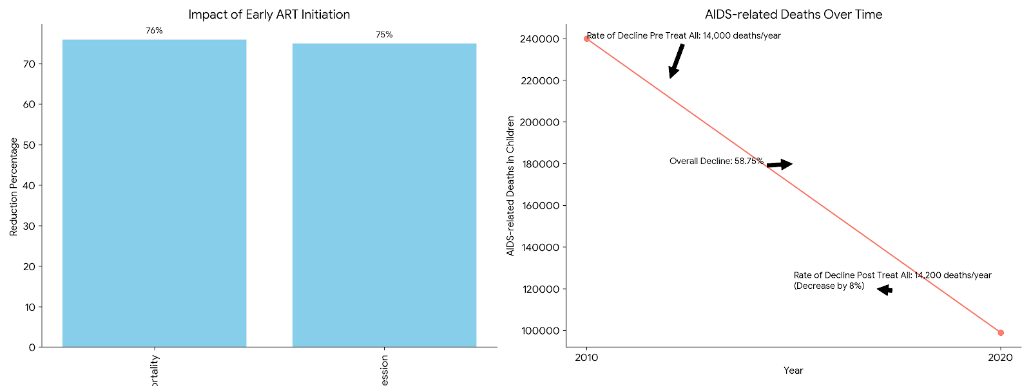

*Here are the graphs illustrating Mortality and Morbidity Reduction in HIV-infected children:*

*Chart 1: Impact of Early ART Initiation*

*This bar chart shows the significant reduction in infant mortality and HIV progression due to early antiretroviral therapy (ART) initiation, based on the CHER trial data.*

*Chart 2: AIDS-related Deaths Over Time*

*This line chart illustrates the trend in AIDS-related deaths in children from 2010 to 2020, highlighting the overall decline and the changes in the rate of decline before and after the implementation of "Treat All" policies.*

**7.3 Growth and Developmental Outcomes**

HIV infection in children, if untreated, can significantly impact physical growth and neurodevelopmental outcomes. ART has been shown to improve growth parameters, with clinically significant improvements typically observed after 12 months of treatment. Recent data provide additional evidence supporting the neurodevelopmental and immune benefits associated with early initiation of ART.

8. Special Considerations for Adolescents

**8.1 Transitioning from Pediatric to Adult Care**

As perinatally infected children survive into adolescence and young adulthood, transition from pediatric to adult HIV care becomes an important consideration. This transition involves shifts in healthcare providers, care settings, expectations for self-management, and sometimes treatment regimens. Successful transition requires preparation, coordination between pediatric and adult care providers, and support for the adolescent in developing self-management skills.

**8.2 Adherence Support for Adolescents**

Adolescence presents unique adherence challenges related to developmental changes, increasing autonomy, identity formation, and peer influence. Recent guidelines recommend discussing the option of long-acting injectable ART to facilitate and support adherence with eligible adolescent patients. Additionally, the high prevalence of trauma experience among youth with perinatally acquired HIV has led to interest in the adoption of trauma-informed care practices, though research evaluating these interventions is still limited.

**8.3 Mental Health and Psychosocial Support**

Mental health issues, including depression, anxiety, and behavioral disorders, are common among adolescents living with HIV and can significantly impact treatment adherence and outcomes. Comprehensive care for adolescents should include regular mental health screening, access to mental health services, and peer support opportunities. Social, economic, and psychological factors may impair the ability of HIV-infected children and their parents to attend regular clinic appointments, potentially requiring substantial use of social and child protective services.

9. Future Directions and Emerging Strategies

**9.1 Novel Drug Formulations**

Addressing the challenges associated with current pediatric ART formulations is a priority for improving treatment outcomes. Research efforts are focused on developing:

* Taste-masked formulations to improve palatability
* Fixed-dose combinations to simplify administration
* Long-acting formulations to reduce dosing frequency
* Age-appropriate formulations that eliminate the need for complex preparation

**9.2 Simplified Treatment Approaches**

Simplified treatment approaches that reduce pill burden, dosing frequency, and monitoring requirements could significantly improve adherence and outcomes. Strategies under investigation include:

* Two-drug regimens that maintain efficacy while reducing toxicity
* Long-acting injectable or implantable formulations
* Simplified monitoring approaches that reduce healthcare visits

**9.3 Integrated and Family-Centered Care Models**

Recognition of the interconnected nature of pediatric HIV with family dynamics has led to increased interest in family-centered care models that address the needs of the child within the context of the family unit. These models integrate:

* Services for HIV-infected children and their caregivers
* Psychosocial support for the entire family
* Community-based approaches to care delivery
* Peer support networks for children and caregivers

10. Conclusion:-

Significant progress has been made in expanding access to ART for HIV-infected children, with treatment coverage tripling from 16% to 54% between 2010 and 2020 and AIDS-related deaths halving during the same period. However, children continue to experience disparities in treatment coverage and outcomes compared to adults, highlighting the persistent challenges in pediatric HIV management.

Current guidelines recommend immediate ART initiation for all HIV-infected children, with preference for INSTI-based regimens. Implementation of these recommendations faces substantial barriers related to drug formulations, administration challenges, healthcare system limitations, and social factors affecting adherence.

Addressing these challenges requires continued investment in pediatric drug development, simplified treatment approaches, integrated care models, and supportive interventions for children and their caregivers. By combining biomedical advances with attention to the social and structural determinants of treatment success, we can work toward closing the persistent gaps in pediatric HIV care and improving outcomes for all children living with HIV.

**References**

1. Panel on Antiretroviral Therapy and Medical Management of Children Living with HIV. Guidelines for the Use of Antiretroviral Agents in Pediatric HIV Infection. Updated December 19, 2024. Available at: <https://clinicalinfo.hiv.gov/en/guidelines/pediatric-arv/whats-new>
2. Guidelines for the Use of Antiretroviral Agents in Pediatric HIV Infection. Introduction: Antiretroviral Clinical Guidelines Used in Pediatrics. Updated June 27, 2024. Available at: <https://clinicalinfo.hiv.gov/en/guidelines/pediatric-arv/introduction>
3. HHS Panel on Antiretroviral Therapy and Medical Management of Children Living with HIV—A Working Group of the Office of AIDS Research Advisory Council (OARAC). Guidelines for the Use of Antiretroviral Agents in Pediatric HIV Infection. Updated 2024 Dec 19. Available at: <https://www.ncbi.nlm.nih.gov/books/NBK586303/>
4. World Health Organization. HIV treatment and care in children and adolescents. Available at: <https://www.who.int/teams/global-hiv-hepatitis-and-stis-programmes/hiv/treatment/treatment-and-care-in-children-and-adolescents>
5. Kariminia A, Law M, Davies MA, et al. Pediatric Antiretroviral Therapy Coverage and AIDS Deaths in the Universal Test and Treat Era: A Global Pooled Analysis. Pediatrics. 2023;146(4):e2022060606. Available at: <https://pmc.ncbi.nlm.nih.gov/articles/PMC10829847/>
6. Sutcliffe CG, van Dijk JH, Bolton C, Persaud D, Moss WJ. Effectiveness of antiretroviral therapy among HIV-infected children in sub-Saharan Africa. Lancet Infect Dis. 2008;8(8):477-489. Available at: <https://pmc.ncbi.nlm.nih.gov/articles/PMC2787758/>
7. Crutchfield Z, Akello H, Oliech J, et al. Challenges with pediatric antiretroviral therapy administration: A qualitative study in Kenya. PLoS One. 2023;18(2):e0282235. Available at: <https://pmc.ncbi.nlm.nih.gov/articles/PMC10775971/>
8. Pediatric HIV Infection Treatment & Management. Available at: <https://emedicine.medscape.com/article/965086-treatment>
9. Newell ML, Coovadia H, Cortina-Borja M, Rollins N, Gaillard P, Dabis F; Ghent International AIDS Society (IAS) Working Group on HIV Infection in Women and Children. Mortality of infected and uninfected infants born to HIV-infected mothers in Africa: a pooled analysis. Lancet. 2004;364(9441):1236–1243.
10. Abrams EJ, Ananworanich J, Archary M, Ngongondo M, Brouwers P. Propelling the pediatric HIV therapeutic agenda with science, innovation, and collaboration. J Acquir Immune Defic Syndr. 2018; 78 Supp l(1):S32–S39.
11. Burrage A, Patel M, Mirkovic K, et al. Trends in antiretroviral therapy eligibility and coverage among children aged <15 years with HIV infection - 20 PEPFAR-supported Sub-Saharan African Countries, 2012–2016. MMWR Morb Mortal Wkly Rep. 2018;67(19):552–555.
12. Violari A, Cotton MF, Gibb DM, et al. Early antiretroviral therapy and mortality among HIV-infected infants. N Engl J Med. 2008;359(21):2233-2244.