# STUDY OF WORK-LIFE CONFLICTS AND STRESS EFFECTS OF WHATSAPP USAGES DURING NON-WORK TIME

Tina M. Punse

P. R. Pote Patil College of Engineering and Management, Amravati tinapunse@gmail.com +91 7758029453

Dr. S. K. Singh

P. R. Pote Patil College of Engineering and Management, Amravati

# Abstract

The rapid development in communication technology is gradually blurring the boundary between work and personal life with mobile messaging apps like WhatsApp being used on an ever-growing basis. This study investigates the impact of WhatsApp usage by employees after working hours on stress levels and work life conflict. It discusses how work-related communication in the nonworking hours interrupts the process of winding down into personal time, which may then analyse psychological stress and detract from work life balance. Evidence is provided to illustrate how expectations for constant availability create stress, emotional exhaustion, and diminish job satisfaction through surveys and interviews with professionals in the workplace. The study aims to provide employers with data useful for developing policies to ensure their employees have a digital well-being balance and better work-life balance.

**Keywords:**

Work-Life Conflict, Stress, WhatsApp Usage, After-Hours Communication, Work-Life Balance.

# Introduction

In the modern world, where work and its related functions have gone digital through smartphones-and other devices, employees now tend to use their cell phones and other messaging apps like WhatsApp to keep in touch with their work even outside office hours. This flexibility would create ease in communication. Unfortunately, it has also blurred the borders of personal and professional life. A constant barrage of messages and notifications related to work outside working hours causes conflicts in life between work and personal life, which is nothing but stress.

The study is intended to find out how use of WhatsApp for work during personal time impacts employees' stress levels in trying to strike an appropriate work-life balance. The study investigates the means by which employees manage this pressure as well as the overall implications of this experience for wellbeing and performance.

# Review Literature

(SCHOUTEN, JANUARY, 2017) The current study proposes that MMA usage with professional contacts during non-work time will affect work-life conflict. In this study, we focus on WhatsApp, the most popular MMA. The always-on connectivity of WhatsApp increases information flow between employees. Employees are expected to interact and collaborate with professional contacts from home, which leads to overlap of different roles. Studies pointed out that the use of office-home-smartphones (OHS) and social networking tools in professional settings forms a challenge for the separation of work and family domains and can even lead to work overload and influence work-life balance (Yun et al., 2012; Wang et al., 2016). Moreover, Liu, Zhang, Chen, Guo, and Yu (2015) found that the use of Enterprise WeChat groups, a MMA similar to WhatsApp, is associated with increasing work-life conflict. More specific to the use of technologies during non-work time, Boswell and Olson Buchanan (2007) found a positive association between the usage of communication technologies during non-work time, and work-life conflict. This increasing amount of work that creeps into private life, might affect leisure time with family and might even deteriorate relationships with professional contacts. Therefore, when the blurred boundaries between work and life domains caused by the use of WhatsApp, are not managed, there might occur an imbalance between work and family roles, which might lead to work-life conflict.

(Bao, 31 July 2024) SMUNW was defined as “social media use for work during non-work hours” (Wang and Li, 2023, p. 2). Due to the popularity of instant messaging, employees not only use social media extensively during working hours but are also often required to use social media to stay in touch and handle work matters during non-work hours. It was also reported that the use of social media at work can cause stress to employees and lead to turnover intention (Bizzi, 2018; Cho et al., 2019; Califf et al., 2020; Harris et al., 2022; Sparidans et al., 2023).

**Objectives:**

1. To study the employee perception towards WhatsApp usage during work and non-work time.
2. To study of work-life conflict due to WhatsApp usages.

# Conceptual framework

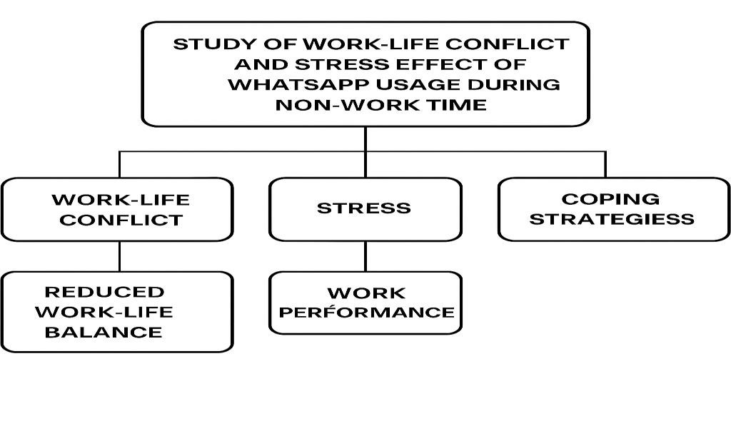

# Methodology

The study adopts a descriptive research approach to explore the impact of WhatsApp usage during non-work hours on work-life conflict and stress among working professionals in Amravati. Primary data was collected through a structured survey questionnaire, while secondary data was sourced from books, journals, research articles, and credible online resources. A sample of 100 working professionals, who regularly engage in work-related communication via WhatsApp, was selected using a simple random sampling technique to ensure objectivity. The collected data was analysed using the percentage method and represented visually through bar graphs, pie charts, and line graphs. Microsoft Excel was used to organize and interpret the data effectively, providing clear insights into how after-hours digital communication affects employees’ personal lives and stress levels.

# Data Analysis and Interpretation

|  |  |  |
| --- | --- | --- |
| **Category** | **Detail** | **Percentage** |
| Gender | 1. MALE 2. FEMALES | 53%  47% |
| Age Group | 1. A) 18-25 years 2. B) 26-35 years 3. C) 36-45 years 4. D) 46 years and above | 41%  41%  15%  3% |
| Educational Qualification | 1. A) Up to 12th 2. B) UG 3. C) PG and above | 10%  43%  47% |
| How do you feel about using WhatsApp for work during personal time? | 1. A) Very Positive 2. B) Positive 3. C) Neutral 4. D) Negative 5. E) Very Negative | 53%  31%  13%  2%  1% |
| How does using WhatsApp during personal time affect your work performance? | 1. A) It significantly enhances my performance 2. B) It somewhat improves my performance 3. C) It has no impact on my performance 4. D) It negatively impacts my performance | 36%  37%  21%  6% |
| What kind of work WhatsApp messages disturb your personal time the most? | 1. A) Urgent work tasks or requests 2. B) Routine work updates or information 3. C) Requests for meetings, calls, or follow-ups 4. D) Emergency notifications or alerts 5. E) None of the above | 35%  22%  13%  8%  22% |

Graph No 1: How Employees Feel About Using WhatsApp for Work Outside Office Hours

INTERPRETATION:

Most respondents (53%) feel very positive about using WhatsApp for work-related communication during personal time, while 31% feel positive. About 13% have a neutral opinion, and only a small portion feel negative (2%) or very negative (1%). This shows that the majority of people view work-related WhatsApp use after hours in a positive light.

Graph No. 2: Graph showing perceive the impact of using WhatsApp during personal time on your work performance of respondent



**36**

**%**

**37**

**%**

**21**

**%**

**6**

**%**



**1**

**A) It significantly enhances my performance**



**2**

**B) It somewhat improves my performance**



**3**

**C) It has no impact on my performance**



**4**

**D) It negatively impacts my performance**

INTERPRETATION:

The majority of respondents feel that using WhatsApp during personal time somewhat improves (37%) or significantly enhances (36%) their work performance. A smaller group (21%) believe it has no impact on their performance, while only 6% feel it negatively impacts their work. This indicates that most people perceive WhatsApp use during personal time as a positive factor for their work performance.

Graph No 3: Graph showing frequently employee receive work-related WhatsApp messages during your

personal or non-work hours of respondent



**1**

**A) Urgent work**

**tasks or requests**

**2**

**B) Routine work**

**updates or**

**information**

**3**

**C) Requests for**

**meetings, calls, or**

**follow**

**-**

**ups**

**4**

**D) Emergency**

**notifications or**

**alerts**

**5**

**E) None of the**

**above**

**CHART 3**

INTERPRETATION:

Most respondents (35%) felt that urgent work tasks or requests disrupt their personal time the most, as these often demand immediate attention. Routine work updates (22%) and meeting or follow-up requests (13%) were also seen as interruptions, though to a lesser extent. Only 8% found emergency alerts most disruptive, possibly due to their rarity or importance. Interestingly, 22% of respondents felt that none of these messages affect their personal time, suggesting better boundaries or less work-related communication outside office hours.

**Findings:**

Slightly more males (53%) than females (47%) comprise the respondent population. Most of these people (82%) belong to the age bracket of between 18 and 35, representing a young employee group. Most have postgraduate qualifications (47%), followed by undergraduates (43%). The findings in the usage of WhatsApp for work-related communication outside office hours would be received favourably by the majority: 53 percent very positive and 31 percent positive-A mere 3% expresses negative sentiments. When asked on the influence it has on work performance, 36% argue that it greatly improves performance, while 37% state that it moderately improves it, 21% find no improvement, and finally 6% perceive that it negatively affects their performance. Urgent tasks (35%) and routine updates (22%) can be named as mostly disturbing messages during personal time. Coping with the stress, 29% respond immediately to reduce anxiety while 30% admit they lack any strategy. A sizeable 19% will ignore messages until they resume work, while just 8 set boundaries actively.

**Conclusions:**

It implies that even though WhatsApp is considered a good channel of communication among a young educated workforce, it is also loaded with challenges concerning boundaries between work and home. Although many feel it improves performance, they are generally disrupted during personal time, especially by urgent tasks. Stress management strategies differ among individuals, as many lack a specific approach, which might lead to burnout. Hence, there is a need for organizations to advocate healthy communications as well as the maintenance of clear boundaries into the lives of the employees.

# References

Bao, Y. (2024, July 31). *Social media use for work during non-work hours: Implications for stress and turnover intention*. Journal of Digital Work-Life Studies, 12(3), 45–59.

Bizzi, L. (2018). The dark side of social media: Job burnout and work-family conflict due to social media use. *Journal of Management & Organization*, 24(3), 456–474.

Boswell, W. R., & Olson-Buchanan, J. B. (2007). The use of communication technologies after hours: The role of work attitudes and work-life conflict. *Journal of Management*, 33(4), 592–610.

Califf, C. B., Sarker, S., & Sarker, S. (2020). The bright and dark sides of technostress: An empirical study of social media use and stress. *Information Systems Journal*, 30(1), 60–89.

Cho, E., Park, J., & Han, S. J. (2019). Work–family conflict and turnover intention: Testing the mediation of social media use at work. *Social Behaviour and Personality: An International Journal*, 47(7), e8201.