Tour And Travel Management System

**Ritika Choudhary , Jaruri Mahajan**

**Department of Computer Science & Engineering**

**Thakur Shivkumar Singh Memorial Engineering College, Burhanpur (Affiliated to RGPV Bhopal), India**

# ABSTRACT

This project is a detailed review of the tour and travel management system. The main objective of this website is to know the package related to the trip and journey with the best facility and current offer. Searching will be very easy. Nowadays, multiple travel packages exist from various websites to approximately all locations all over the world. A customer demonstrates that it is extremely complicated to search for multiple packages as for significant websites, contact, and communication with the travel agents and more options that exist in it which is a passive method and time-consuming. This project will assist travelers in recommending the best Travel Package among all the packages relevant information such as image, hotel facility, Google map facility, transport facility, and description about the places where they want to visit. The tour and travel management system will be helpful for tourism.

## INTRODUCTION

The main purpose of the Tour and travel management system is to provide the best facility and traveling services for a customer to book hotels, flights, and bus tickets for trip purposes. We have developed a tour and travel management system to provide a search platform to find tour places according to their choices. This is instead of providing the best traveling services to the customers and travel agents. We have expanded our tours and travel administration strategy to provide an exploration platform where a tourist can find their trip spots according to their choices. This method further assists in promoting reliable and fascinating tourism so that people can celebrate their vacations in their favorite places. This system moreover provides a better way to connect with various events.

## Motivation

* Nowadays the craze of tourism is increasing day by day in the whole world. And Indian Holly Places are also involved in this trend.
* Due to such increments in tourism nowadays made with a very large amount of tourist visits here.
* So, there is a very high opportunity for Software Engineers to develop such type of Application software.
* In tourism, there is a problem that arises in how we connect with the users to take their opinions and feedback.

## INCREMENTALMODEL

The incremental model is a software development methodology that can be used to build large and complex systems. It's based on the idea of adding new features, or “increments,” to an existing system instead of building the entire thing from scratch at once.

**Fig. Incremental Model**

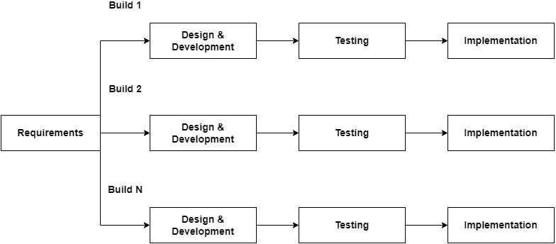

# Use Case Diagram

A use case diagram is one of the visualized diagrams of all the services our project or system provides. This diagram shows the interaction of no fuser with the system or project. This shows the relationship between the user and the different use cases in which the user is being involved. This diagram shows our application's interaction with the users or any other external system.

**Fig. Use Case**

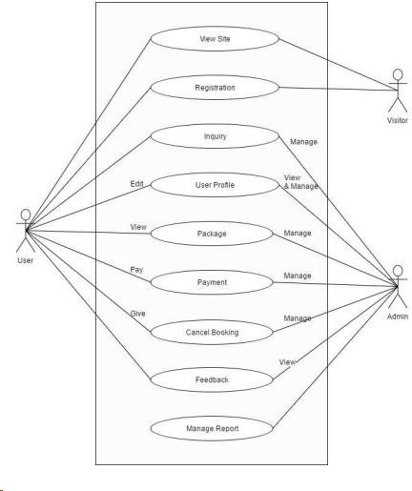

# Sequence Diagram

In the sequence diagram how the objects interact with the other objects is shown. There are sequences of events that are represented by a sequence diagram.

**Fig. Sequence Diagram**

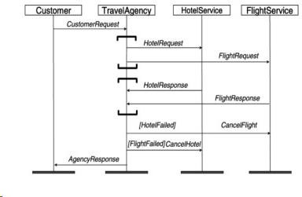

# Activity Diagram

Activity diagram is one of the important diagram of the unified modeling language, which shows the activity of the whole project.

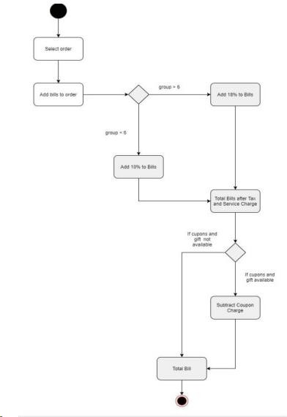

## Connectivity steps with Database

* Import the database.
* Execute the query.
* Process the results.
* Close the connection.

## Modules

* + Login, Logout Module
  + User Module
  + Admin Module
  + Booking Management Module
  + Feedback Module
  + Report Module
  + Trip Package Management Module
  + Route Management Module

## Languages

We use Java as a backend language. Java is a general-purpose scripting language geared toward web development. They generally include a web server that hosts an application, where we use Apache which communicates with a database (using MYSQL) to serve up the information that the front end presents.

## Admin Features:

* Administrator Role of the entire application
* Only registered admin with valid session tokens can add/update/delete Packages, Hotel, Routes, or customers from the main database.
* Admin can access the details of different Ro Bus, Packages, Ticket Details, Feedback, Customer, Reports, etc.

## User Features:

* A user can register himself or herself on the platform.
* He /She can check the Packages and Hotels availability.
* If a Trip Package is available, can book the trip package by providing payment details.
* After booking, he will get booking details for the whole Package inside this there will be all details regarding the ticket details, total cost, etc.
* If the customer wants can cancel the booking.

## Future Scope

* Logical and technical errors will be less found in the future.
* The system will be more user-friendly as compared to today’s system.
* . The system will have more detailed information about the different places and other new routes.

## Conclusion

Travelers continue to seek authentic experiences. The tools they use to research and book these experiences are constantly changing due to innovations in technology. Destinations are also challenged by limited financial resources and strong competition for tourist dollars from other iconic and even lesser-known locations. The personalization of travel suggests that independent travel will have a stronger presence than group travel, however, we must always consider the type of traveler.

## References

1. https:/[/www.java.org/](http://www.java.org/)
2. https://code.visualstudio.com/
3. [https://www.w3schools.com/bootstrap](https://www.w3schools.com/bootstrap/)
4. https:/[/www.youtube.com/homepage](http://www.youtube.com/homepage)
5. https://fontawesome.com/
6. <https://pngtree.com/>
7. https://firebase.google.com/
8. System Analysis And Design In A Changing World - Sat zinger, Jackson and Bard
9. https://developer.android.com/
10. SQL 2 - James Groff
11. Software Engineering – A Parishioner Approach - Roger S. Pressman