A REVIEW STUDY ON SQL INJECTION PREVENTION SYSTEM
Singampalli Haritha (MSc Student)¹, R. Shweta Balkrishna (Asst.Professor)²
1. Department of Information Technology and Computer Applications, Andhra University, Visakhapatnam, AP
2. Department of Computer Science and System Engineering, Andhra University, Visakhapatnam, AP
Author’s Email ID: singampalliharitha10@gmail.com

ABSTRACT
SQL injection is a code injection technique used to attack applications based on data allowing attackers to manipulate database queries and gain unauthorized access to confidential data. By injecting code into database, the hackers can gain access to database where they can alter, update, add and delete the important information. Many techniques have been improved and proposed to detect and mitigate such attacks. This paper presents a robust SQL injection prevention system that integrates multiple security techniques which are input validation, parametrized queries and bcrypt-based password hashing algorithms to ensure secure authentication and data security. The implementation was carried out using python programming language, MySQL and HTML. Results obtained revealed that the proposed technique was able to successfully prevent the attacks by treating user input as data not as executable SQL code with parametrized queries and bcrypt hashing which gives more security. The main goal of this system is to give better web security and to prevent the web applications from SQL injection threats.
Keywords: SQL Injection, Cybersecurity, Parametrized queries, Bcrypt password hashing, Web Security, Secure authentication

- INTRODUCTION
In today's digital world, web applications handle large amounts of important user data, making database security a major concern. Many web applications store databases on their systems, requiring increased security. However, there are a few attacks against databases. One of the most common threats to database security is “SQL injection (SQLi)”, in which attackers manipulate SQL queries to gain unauthorized access to data, modify records, or even delete entire databases. This vulnerability occurs when user input is embedded directly into SQL queries without proper validation or sanitization. These studies demonstrate that SQL injection is code that attacks databases and web pages. OWASP Top 10 considers injection attacks a significant safety risk. According to the report of Verizon Data Breach Investigations, the attacks are responsible for a significant number of child violations all over the world. 75% of web operations are vulnerable to SQL injections due to weak input validation. The case of a child violation caused by SQL attacks can cost you millions of dollars. Automated attack tools are powered by SQLi but accessible to cybercriminals.
So, I am writing this paper to prevent the databases and web applications from SQL injection. To address this critical security risk, an “SQL
Injection Prevention System” is designed to secure database interactions by implementing parameterized queries, input validation, and password hashing. The SQL injection prevention system is a security related web application where it
designed to prevent the risk of SQL injection attacks by utilizing algorithms such as parametrized queries and input validation to prevent malicious code injecting into the database. And also, it ensures password hashing which secures the user credentials. This system ensures that user input is treated as data and not as executable SQL commands, thus preventing attackers from modifying database queries.
By integrating Flask (Python) and MySQL, this project provides a secure, scalable, and efficient approach to protecting web applications from SQL injection threats. The system includes a secure login and registration mechanism, ensuring that sensitive data remains protected against unauthorized access. This system provides a secured approach to prevent the databases from SQL injection code.
Even the SQL injection attacks can prevent by the security mechanisms such as Firewall, intrusion detection system, randomization, PHP, KMP String matching algorithm. Even these all providing web-based services, the SQL injection vulnerability is likely to increase access to the database that underlie web applications and the most worrying aspect of SQL injection attacks. It is happening mainly because of input validation issues. Input validation troubles ought to permit attackers to advantage complete get admission to those databases.
Researchers have proposed many techniques to provide a solution for SQL injection attack but based on defence coding practice, but it is not much efficient, because it particularly focusses on difficult problem and also because of the cost and complexity of this code.
So, there are many techniques to prevent SQL injection attacks but this system gives the input validation to the website by parametrized queries and bcrypt password hashing which gives more security to the website and one can encrypt their details with enhanced security.

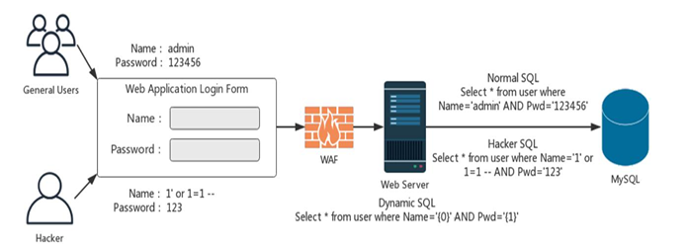
Fig 1. SQL Injection attacks [13]

By the above picture we can understand, when the user wants to enter his details to login to the website or any person want to access his or her details hacker or attacker can access that data or database details by using ‘1’=’1’ into the website.
This code is very dangerous where the hacker can enter into the website without knowing the details of user and change or update the details.
But this project aims to provide a practical, easy-to-implement solution for developers to enhance web application security and prevent SQL injection attacks.
By adopting this prevention system, developers can significantly improve the security of web applications by preventing unauthorized access and data breaches, as well as ensuring compliance with security standards. To access data on the web server, the user must enter their username and password. If the entered values are as expected, access is granted; otherwise, it will be denied. However, the user may enter data with special symbols that can damage the logic or even the structure of the database.
In this project we are discussing about the methods that prevent the SQL injection in databases and web applications that is showed in the part 4 and the result of the sample code is in part 5 that can be observed clearly.

- PROBLEM STATEMENT
I am designing this system to prevent the databases and web applications from SQL injection. There are some prevention methods and algorithms to solve this issue. The main problem is arriving here due to the improper validation, use of dynamic SQL queries, lack of security and weak database permissions.
Many researchers used many methods to solve this issue using randomization, PHP, Machine learning algorithms, Input validation, KMP string matching algorithm and Green SQL database firewall etc. But I am using Parametrized Queries and Bcrypt password hashing can give more security to the system. It is different from other researchers where the methods do not provide direct values and also protect from SQL injection attacks by hashing password.

- LITERATURE REVIEW
SQL Injection (SQLi) is a critical vulnerability in web applications that allows attackers to manipulate backend databases through malicious input. This threat has been widely studied in both academic and industry literature, with extensive efforts directed at detection and prevention mechanisms.
[1] Halfond, W. G., Viegas, J., & Orso, A. (2006). "A Classification of SQL Injection Attacks and Countermeasures." Proceedings of the IEEE International Symposium on Secure Software
Drawbacks: Provided a comprehensive classification of SQL injection attacks, prevention by defence coding which is not much effective.
Advantages of this system: This System provide better security to the user credentials.
[2] The OWASP SQL Injection Prevention Cheat Sheet
Drawbacks: It is widely used resource offering detailed, updated strategies to prevent injection attacks at the code level. But the insecure coding practices will lead to retrieve the details by hackers.
Advantages of this system: This System provides parametrized queries which store the values as data but in the form code.
[3] Stuttard, D., & Pinto, M. (2011). The Web Application Hacker’s Handbook: Finding and Exploiting Security Flaws (2nd ed.). Wiley.
Drawbacks: They explored SQLi in depth through real-world case studies and penetration testing techniques. But they have not showed how it works where just explained about it.
Advantages of this project: It explains and also it shows how it prevents the SQL injection attacks.
[4] Understanding SQL Injection (26.06.2016) http://www.cisco.com/c/en/us/about/security-center/sql-injection.html.
Drawbacks: Understanding sql injections cannot provide the better prevention techniques where it gives the idea about Sql injection.
Advantages of this project: It gives the clear idea about the prevention with two algorithms which remove the issue of input validation.
Despite the availability of tools and frameworks, SQLi remains prevalent, as documented by MITRE’s CWE-89, which consistently ranks it among the most dangerous software weaknesses due to poor input validation and insecure coding practices.
So, the literature emphasizes a multi-layered approach to SQLi prevention—combining secure coding, anomaly detection, runtime monitoring, and adherence to best practices. Continued research and developer education remain crucial to combating this evolving threat.

- ALGORITHMS
Two methods are presented in this framework, which are parameterized query and bcrypt hashing algorithms.
1. Parametrized Queries:
Parameter queries are a safe way to interact with data by separating SQL code from user input. Instead of passing the user value directly to the SQL query, the field (? or %s) are used and the results are separated. This prevents SQL injection by ensuring that user input is treated as data and not as code.
Algorithm:

Input: User-provided values
Process:
Use placeholders (? or %s) in the SQL statement.
Pass user input separately so it's treated as data
but not the executable code.
Output: Secure execution of queries.

Flowchart:

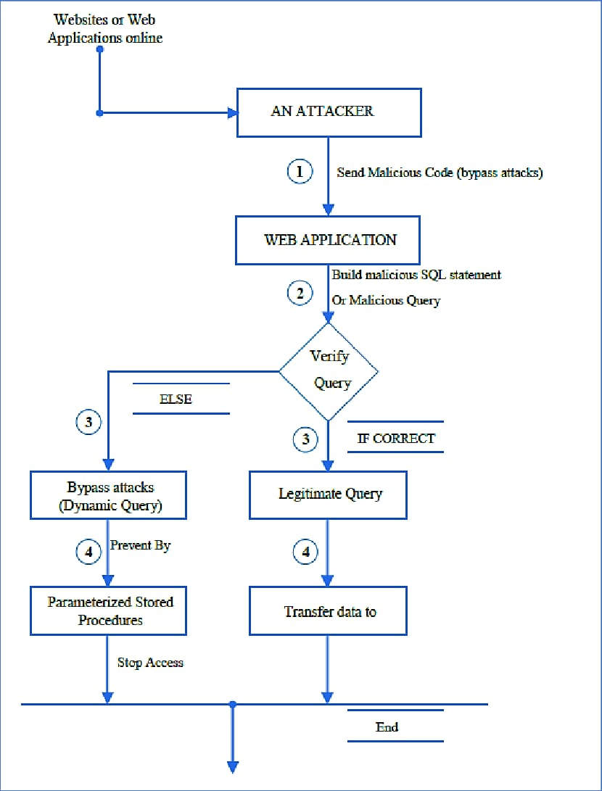
Fig.2: Steps for Parametrized queries [14]
The above flow chart describes about preventing sql injection from parametrized queries.

Sample Pseudo code:
FUNCTION secure_login (username, password):
CONNECT TO database
# Prepare SQL query with placeholders
query = "select * from users where username =? AND password =?"
# Execute with parameters
EXECUTE query WITH (username, password)
FETCH result
IF result IS NOT EMPTY:
RETURN "Login Successful"
ELSE:
RETURN "Login Failed"
CLOSE database connection

2. Bcrypt Password Hashing:
Bcrypt also uses a hashing algorithm to encrypt passwords. It is resistant to brute-force attacks and automatically handles salting, making it a more secure option than traditional hashing algorithms like MD5 or SHA-1.
Algorithm:
Input: Plain text password
Process: Generate a random salt. Hash the password and salt using bcrypt. Store that hashed password instead of raw text.
Output: A hashed password, cannot possible to retrieve by anyone which are secure.
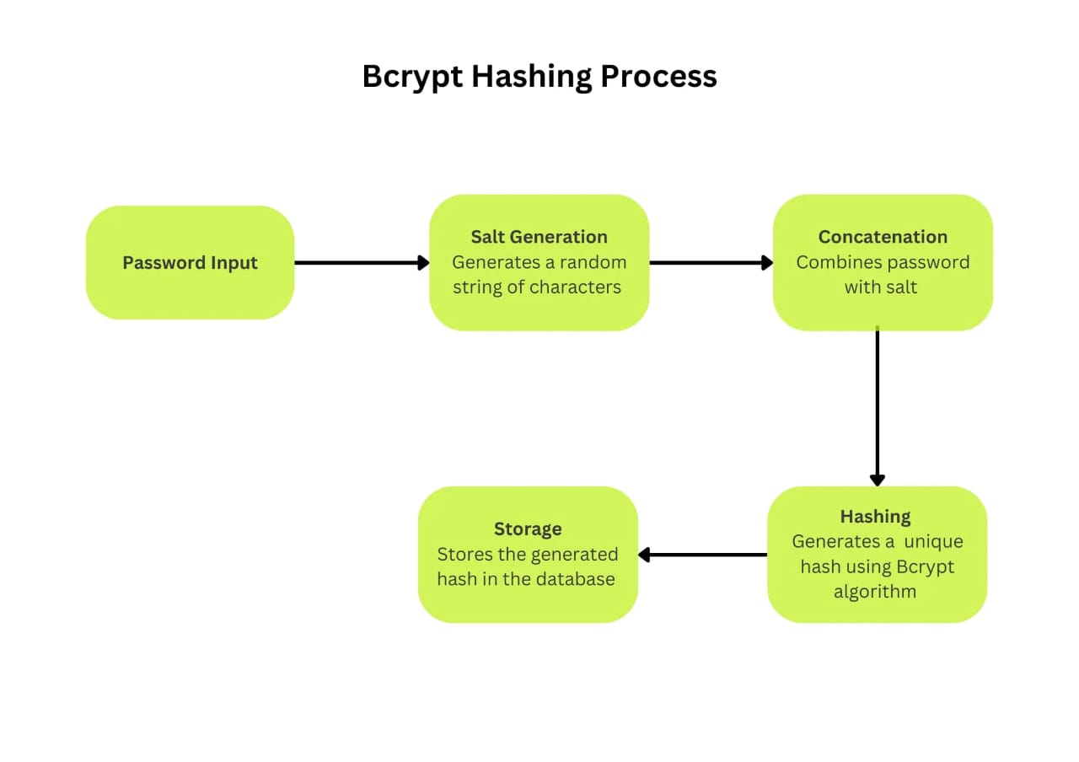
Fig.3: Steps for Bcrypt Password Hashing [15]
The above flow chart describes about securing the password using Bcrypt Password hashing

Sample Pseudo code:
FUNCTION hash_password(password)
salt ← GENERATE_RANDOM_SALT () //
Generate a unique salt
cost_factor ← 12 // Define the computational cost (higher = more secure)
hashed_password ← BCRYPT_HASH (password, salt, cost_factor) // Hash the password
RETURN hashed_password
END FUNCTION

Advantages of algorithms:
These algorithms give the input validation to the website by parametrized queries and bcrypt password hashing. Parametrized queries give the security to the databases and website by separating the code from user input. The user details not placed directly into the SQL queries where it uses placeholders which are ‘?’ and ‘%s’ which stores the user values and the values are passed separately.
This prevents SQL injection because the user values are entering as data, not code. Bcrypt password hashing gives more security by generating salt of the particular raw password, where it converts the plain text into hashed text.

Use of algorithms:
These algorithms are used while making project where the user provided values are stored in the placeholders (? Or %s) in the SQL statement where the user details are treated as data but not code and also the queries are executed securely. The password hashing helps to give more security to the values and the user values are safe by hashed password, where no can find this salt value, which was known by the user itself.
This algorithm gives more security and it prevent the database and website from hackers and SQL injection attacks.
The other algorithms also provide security but the main disadvantage is input validation. This input validation issues can find in other algorithms.

- RESULTS

Here is the sample result

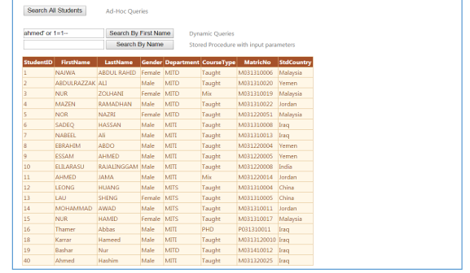
Fig.4: Bypass Sql injection attack [14]
Methods or protection mechanisms used to prevent bypass injection attacks are stored procedures parameterized at the programming level that ensure the security of a web application or website against SQLIA. As we see in Figure 4 that explain the parametrized queries with the input parameter.
It can protect the website from the injection attack that caused by using dynamic queries, by using stored procedure to avoid this attack. That is illustrated by using the parameterized stored procedure with an input parameter to avoid a particular attack.

- CONCLUSION
SQL injection remains one of the most critical security threats to databases, allowing attackers to manipulate queries and gain unauthorized access to sensitive data. Implementing a robust SQL injection prevention system is essential to safeguard databases from such vulnerabilities.

Best preventive measures include using pre-processed data and well-structured queries, validation and cleanup, and bcrypt password encryption. Regular security audits, penetration testing, and monitoring tools further enhance protection by detecting and mitigating potential threats in real time.

By adopting a multi-layered security approach, organizations can significantly reduce the risk of SQL injection attacks, ensuring data integrity, confidentiality, and system availability. Continuous updates and adherence to best security practices are crucial in maintaining a secure database environment.

- REFERENCES
- Halfond, W. G., Viegas, J., & Orso, A. (2006). "A Classification of SQL Injection Attacks and Countermeasures." Proceedings of the IEEE International Symposium on Secure Software
- Understanding SQL Injection (26.06.2016) http://www.cisco.com/c/en/us/about/security-center/sql-injection.html.
- T. Atefeh, M. Massrum, M. Zaman Engineering (ISSSE).
- Clarke, J., & Shepherd, C. (2012). SQL Injection Attacks and Defense. Syngress Publishing.
- Stuttard, D., & Pinto, M. (2011). The Web Application Hacker’s Handbook: Finding and Exploiting Security Flaws (2nd ed.). Wiley.
- SQL Injection – OWASP (19.06.2016) https://www.owasp.org/index.php/SQL_Injection. (in Russian).
- Top ten most critical Web Application Security Risks, OWASP-Open Web Application Security Project (19.06.2014) https://www.owasp.org/index.php/Category:OWASP_Top_Ten_Project (in Russian).
- Halfond, G. William, J. Viegas, A. Orso. "A classification of SQL injection attacks and countermeasures." Proceedings of the IEEE International Symposium on Secure Software Engineering. Vol. 1. IEEE, 2006, pp. 13-20.
- L-K. Shar, H-B Kuan. "Predicting SQL injection and cross site scripting vulnerabilities through mining input sanitization patterns." Information and Software Technology, 2013, рр.1767-1780.
- Website Attacks – SQL Injection and The Threat) http://nulzsec.com/2014/10/08/website-attacks-sql injection-and-the-threat-they-present
- Li Qian, Zhengyuan Zhu, lun Hu, Shuying Liu “Research of SQL Injection Attack and PreventionTechnology 2015” International Conference on Estimation, Detection and Information Fusion (ICEDIF 2015), pp. 303-306.
- Sadeghian, Mazdak Zamani, Azizah Abd Manaf. "A taxonomy of SQL injection detection and prevention techniques. International Conference on. IEEE Informatics and Creative Multimedia pp. 234 – 245.
- Ding Chen et al 2021 J. Phys.: Conf. Ser. 1757 012055.”sql injection attack detection and prevention techniques”
- Hasanien D. Rjeib, Basheer Al-Sadawi “Multi mechanism approach for preventing sql injection attacks in stored procedures on research gate
- On Google Website: https://metana.io/blog/bcrypt-and-jwt-web-app-security/

