**AI IN HR: ENHANCING HUMAN DECISION-MAKING OR REPLACING IT?**

**KAVIYA J, DR.N.PADMAVATHY**

1. MBA student, School of Arts, Humanities and Management, Jeppiaar University, Chennai, India.
2. Associate Professor, School of Arts Humanities and Management, Jeppiaar University, Chennai, India

**ABSTRACT**

The integration of Artificial Intelligence (AI) in Human Resources (HR) has sparked a critical debate: is AI enhancing human decision-making or replacing it entirely? AI-powered tools are increasingly being used for recruitment, employee engagement, performance analysis, and predictive workforce planning, offering efficiency, objectivity, and data-driven insights. However, concerns persist about the potential loss of human judgment, ethical biases in algorithms, and the depersonalization of HR processes.

Proponents argue that AI augments HR professionals by automating repetitive tasks, reducing unconscious bias, and providing actionable analytics. For instance, AI-driven resume screening and chatbot interviews streamline hiring, while sentiment analysis tools gauge employee morale. These advancements allow HR teams to focus on strategic decision-making and employee development, fostering a more dynamic workplace.

Critics, however, warn that over-reliance on AI may erode essential human skills such as empathy, intuition, and contextual understanding. Algorithmic bias, stemming from flawed training data, can perpetuate discrimination, and opaque decision-making processes may reduce transparency. Additionally, employees may resist AI-driven evaluations, fearing a lack of fairness or personal connection in workplace assessments.

The optimal approach may lie in a hybrid model where AI supports, rather than supplants, human judgment. By combining AI’s analytical strengths with human emotional intelligence, HR can achieve more balanced and inclusive outcomes. Ethical AI governance, continuous auditing, and human oversight are crucial to ensuring that technology complements, rather than controls, workforce management.

Ultimately, the future of AI in HR depends on striking the right balance between automation and human touch. While AI can enhance efficiency and objectivity, the irreplaceable value of human interaction in leadership, conflict resolution, and cultural development must remain central. The challenge for organizations is to harness AI’s potential while preserving the core human elements that define successful workplaces.

**Keywords:** Artificial Intelligence, Human Resources, Decision-Making, Automation, Ethics.

**INTRODUCTION**

The integration of Artificial Intelligence (AI) into Human Resources (HR) is transforming the way organizations manage talent, from recruitment to employee engagement. AI-powered tools can analyze vast amounts of data, predict workforce trends, and automate repetitive tasks, allowing HR professionals to focus on strategic decision-making. However, as AI becomes more sophisticated, a critical question arises: Is AI enhancing human decision-making in HR, or is it gradually replacing human roles altogether? This debate has significant implications for the future of work, ethics, and organizational culture.

Proponents argue that AI enhances HR by reducing biases, improving efficiency, and providing data-driven insights. For instance, AI can screen resumes objectively, identify skill gaps, and even predict employee turnover, enabling HR teams to make more informed decisions. By handling administrative tasks like scheduling interviews or processing payroll, AI frees up HR professionals to focus on employee development, workplace culture, and other high-value activities. In this view, AI acts as a collaborative tool that augments human capabilities rather than eliminating jobs.

On the other hand, skeptics warn that over-reliance on AI could lead to job displacement, reduced human judgment, and ethical concerns. Algorithms, while efficient, may inadvertently perpetuate biases present in historical data, leading to unfair hiring practices. Additionally, the lack of emotional intelligence in AI raises questions about its ability to handle sensitive issues like employee grievances or workplace conflicts. If organizations prioritize automation over human interaction, they risk losing the personal touch that is crucial for employee satisfaction and retention.

Ultimately, the role of AI in HR will depend on how organizations balance technology with human expertise. While AI can optimize processes and provide valuable insights, the human element remains essential for empathy, ethical decision-making, and fostering a positive workplace culture. The future of HR may not be about choosing between humans and machines but finding the right synergy where AI supports—rather than supplants—human judgment. The challenge lies in implementing AI responsibly to enhance HR functions while preserving the irreplaceable value of human connection.

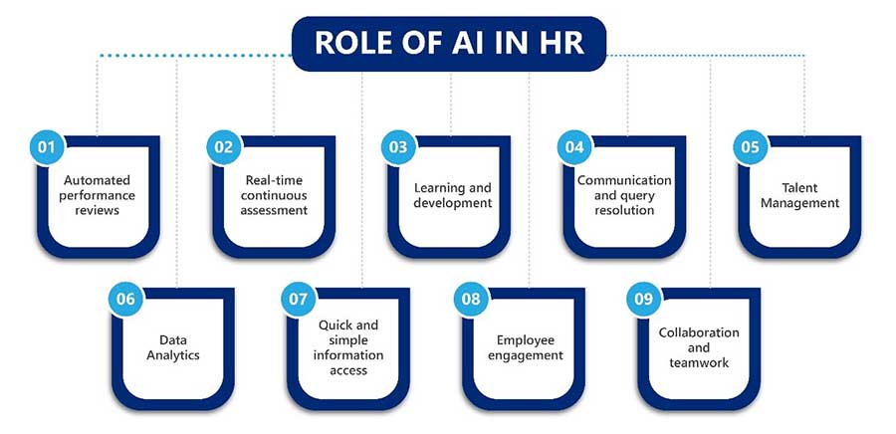

**THE ROLE OF AI IN HR**

Artificial Intelligence (AI) is transforming Human Resources (HR) by streamlining processes, improving decision-making, and fostering diversity. Below is an in-depth look at how AI is reshaping HR functions.

**1. Automating Repetitive Tasks**

HR professionals spend significant time on administrative tasks. AI-driven automation enhances efficiency by handling routine processes, allowing HR teams to focus on strategic initiatives.

**Key Applications:**

**a) Resume Screening & Candidate Matching**

* Natural Language Processing (NLP) scans resumes, extracting relevant skills, experience, and qualifications.
* AI-powered Applicant Tracking Systems (ATS) rank candidates based on job description alignment.
* **Example:** Tools like HireVue and Pymetrics use AI to shortlist top candidates efficiently.

**b) AI Chatbots for Candidate Engagement**

* Chatbots (e.g., Mya, Olivia by Paradox) handle FAQs, interview scheduling, and status updates.
* 24/7 Availability: Candidates receive instant responses, improving engagement.
* Automated Interview Scheduling: AI coordinates calendars to set up interviews without back-and-forth emails.

**c) Onboarding Automation**

* AI-driven platforms (e.g., BambooHR, Workday) automate paperwork, training assignments, and policy acknowledgments.
* Personalized Onboarding: AI tailors onboarding content based on role and department.

**Benefits:**

✔ Time Savings: Reduces manual workload by up to 75%.

✔ Improved Candidate Experience: Faster responses and smoother processes.

✔ HR Focus Shift: Professionals can prioritize culture, retention, and leadership development.

**2. Enhancing Decision-Making with Data-Driven Insights**

AI processes vast amounts of HR data to provide actionable insights, improving hiring and retention strategies.

**Key Applications:**

**a) Predictive Analytics for Hiring & Retention**

* Turnover Prediction: AI analyzes patterns (e.g., employee surveys, performance data) to predict attrition risks.
* High-Potential Employee Identification: Machine Learning (ML) models assess performance trajectories to spot future leaders.
* Example: IBM Watson Talent Insights helps HR teams predict workforce trends.

**b) AI-Powered Recruitment Strategies**

* Historical Data Analysis: AI identifies the best sourcing channels (e.g., LinkedIn vs. job boards) for quality hires.
* Interview Insights: AI assesses video interviews for tone, word choice, and facial expressions (e.g., HireVue’s AI assessments).

**c) Performance & Workforce Planning**

* Skill Gap Analysis: AI detects workforce deficiencies and recommends training programs.
* Optimal Team Structuring: AI suggests ideal team compositions based on productivity data.

**Challenges & Considerations:**

**⚠ Human Oversight Needed:** AI recommendations must be reviewed by HR to avoid over-reliance on algorithms.

**⚠ Data Privacy Concerns:** Compliance with GDPR and other regulations is critical when using employee data.

**3. Reducing Bias and Promoting Diversity**

Unconscious bias in hiring and promotions has long been a challenge. AI can help—but must be carefully managed.

**Key Applications:**

**a) Blind Recruitment**

* AI removes names, gender, age, and universities from resumes to prevent bias.
* Example: Textio helps write gender-neutral job descriptions.

**b) Bias Detection & Correction**

* Algorithmic Audits: AI tools (e.g., Pymetrics, GapJumpers) check for discriminatory hiring patterns.
* Diverse Candidate Sourcing: AI expands talent pools by identifying underrepresented groups.

**c) Structured Interviews & Assessments**

* AI standardizes interview questions and scoring to ensure fairness.
* Example: Unilever uses AI-driven games and video interviews to assess candidates objectively.

**Potential Risks & Mitigations:**

⚠ AI Bias from Historical Data: If past hiring was biased, AI may replicate those patterns.

✔ Solution: Regularly audit AI models and train them on diverse datasets.

**CHALLENGES AND ETHICAL CONSIDERATIONS**

**1. Over-Reliance on AI**

While AI enhances efficiency in recruitment, performance management, and employee engagement, excessive dependence on AI-driven decisions can undermine human judgment and lead to unintended consequences.

**Key Concerns:**

* **Lack of Contextual Understanding:** AI systems may struggle to interpret nuanced factors such as cultural fit, emotional intelligence, or unconventional career paths. For example, a candidate with non-traditional experience might be filtered out by an AI resume screener despite being highly qualified.
* **Bias in Decision-Making:** If AI models are trained on historical data containing biases (e.g., favoring certain demographics), they may perpetuate discrimination, even unintentionally.
* **Black-Box Problem:** Many AI algorithms, particularly deep learning models, operate as "black boxes," making it difficult for HR professionals to explain why a candidate was rejected or an employee was flagged for performance issues. This lack of transparency can lead to legal and ethical challenges.
* **Reduced Human Oversight:** Over-automation may lead to HR professionals deferring to AI without critical evaluation, potentially overlooking exceptional candidates or misinterpreting employee feedback.

**Mitigation Strategies:**

* **Hybrid Decision-Making:** Combine AI insights with human judgment, especially in final hiring or promotion decisions.
* **Explainable AI (XAI):** Use interpretable AI models that provide clear reasoning for decisions.
* **Continuous Auditing:** Regularly assess AI systems for bias and accuracy.

**2. Privacy and Data Security**

AI in HR relies on vast amounts of sensitive data, including employee performance records, biometric data (e.g., from facial recognition in interviews), and even social media activity. This raises significant privacy and security concerns.

**Key Concerns:**

* **Consent and Transparency:** Employees and candidates may not fully understand how their data is being used. For example, AI-powered emotion recognition tools in interviews might analyze facial expressions without explicit consent.
* **Data Misuse:** HR data could be repurposed for unrelated analytics, such as predicting employee attrition, without employee awareness.
* **Cybersecurity Risks:** HR databases are prime targets for cyberattacks, exposing personal details (e.g., salary, addresses, health records) to breaches.
* **Compliance with Regulations:** AI systems must adhere to GDPR, CCPA, and other privacy laws, requiring strict data governance.

**Mitigation Strategies:**

* **Clear Data Policies:** Disclose how AI collects and uses data, ensuring informed consent.
* **Anonymization Techniques:** Use aggregated or anonymized data where possible to protect individual identities.
* **Robust Encryption & Access Controls:** Implement strong cybersecurity measures to prevent unauthorized access.

**3. Job Displacement Fears**

The automation of HR tasks (e.g., resume screening, payroll, chatbots for employee queries) has led to concerns about AI replacing HR jobs. However, the reality is more nuanced.

**Key Concerns:**

* Automation of Routine Tasks: AI can handle repetitive tasks like scheduling interviews or processing leave requests, reducing the need for administrative HR roles.
* Shift in HR Roles: While some entry-level HR jobs may decline, new roles focusing on AI oversight, ethics, and strategic HR management will emerge.
* Employee Distrust: Workers may fear AI-driven performance evaluations or layoff predictions, leading to lower morale**.**

**Mitigation Strategies:**

* Reskilling & Upskilling HR Teams: Train HR professionals in AI management, data analytics, and ethical oversight.
* Transparent AI Integration: Communicate how AI will be used to support, not replace, human roles.
* Focus on Strategic HR: Redirect HR efforts toward employee development, culture-building, and conflict resolution—areas where human judgment is irreplaceable.

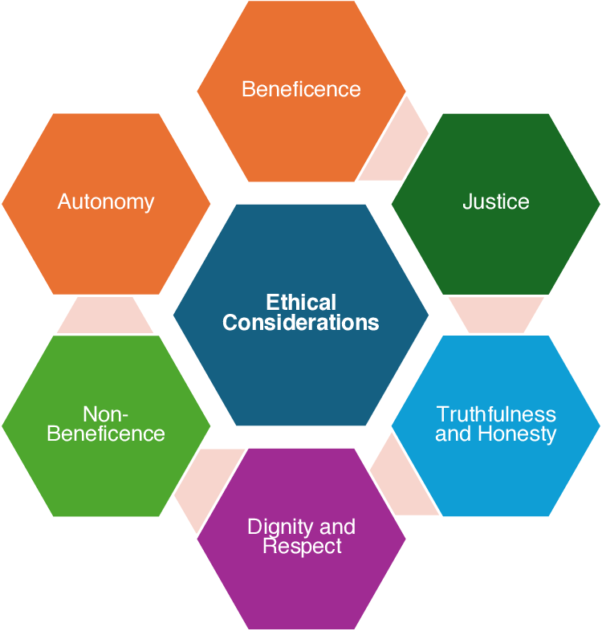

**STRIKING THE RIGHT BALANCE: INTEGRATING AI WITH HUMAN EXPERTISE**

Artificial Intelligence (AI) has revolutionized industries by enhancing efficiency, automating tasks, and providing data-driven insights. However, to maximize its benefits while mitigating risks, organizations must strike the right balance between AI automation and human oversight. The optimal approach involves collaboration, continuous monitoring, and strong ethical frameworks.

**1. Collaboration Between AI and Human Expertise**

AI excels at processing vast amounts of data, identifying patterns, and automating repetitive tasks. However, human judgment remains essential for contextual understanding, ethical considerations, and complex decision-making.

**Key Strategies for Effective Collaboration:**

* **AI for Data Analysis & Automation:**
* Use AI to analyze large datasets, detect trends, and generate predictive insights.
* Automate routine tasks (e.g., customer service chatbots, inventory management) to free up human workers for higher-value work.
* **Human Oversight for Critical Decisions:**
* Ensure that final decisions (e.g., hiring, medical diagnoses, legal judgments) involve human review to account for nuance and ethics.
* Implement human-in-the-loop (HITL) systems where AI provides recommendations, but humans validate outcomes.
* **Cross-Disciplinary Teams:**
* Foster collaboration between data scientists, domain experts, and ethicists to ensure AI aligns with business and societal needs.

**2. Continuous Monitoring & Bias Mitigation**

AI systems can inadvertently perpetuate biases if trained on flawed or unrepresentative data. Continuous auditing and improvement are necessary to maintain fairness and accuracy.

**Best Practices for Monitoring AI Systems:**

* **Regular Audits:**
* Conduct periodic reviews of AI models to detect biases (e.g., racial, gender, or socioeconomic biases in hiring algorithms).
* Use fairness metrics (e.g., demographic parity, equal opportunity) to assess performance across different groups.
* **Diverse & Representative Data:**
* Train AI models on inclusive datasets to minimize skewed outcomes.
* Continuously update training data to reflect real-world changes.
* **Explainability & Transparency:**
* Implement Explainable AI (XAI) techniques to make AI decisions interpretable.
* Provide clear documentation on how AI models operate to build trust among users and stakeholders.

**3. Ethical Frameworks for Responsible AI**

To ensure AI is used responsibly, organizations must establish guidelines that prioritize transparency, accountability, and fairness.

**Core Principles of Ethical AI:**

* **Transparency:**
* Disclose when AI is being used (e.g., in customer interactions, hiring processes).
* Allow users to understand and challenge AI-driven decisions.
* **Accountability:**
* Define clear responsibility for AI outcomes (e.g., who is liable if an AI system makes an erroneous medical diagnosis?).
* Establish governance committees to oversee AI deployment.
* **Fairness & Non-Discrimination:**
* Proactively test AI for biases and correct them before deployment.
* Ensure AI benefits are distributed equitably across different demographics.
* **Privacy & Security:**
* Comply with data protection regulations (e.g., GDPR, CCPA).
* Implement robust cybersecurity measures to prevent misuse of AI systems.

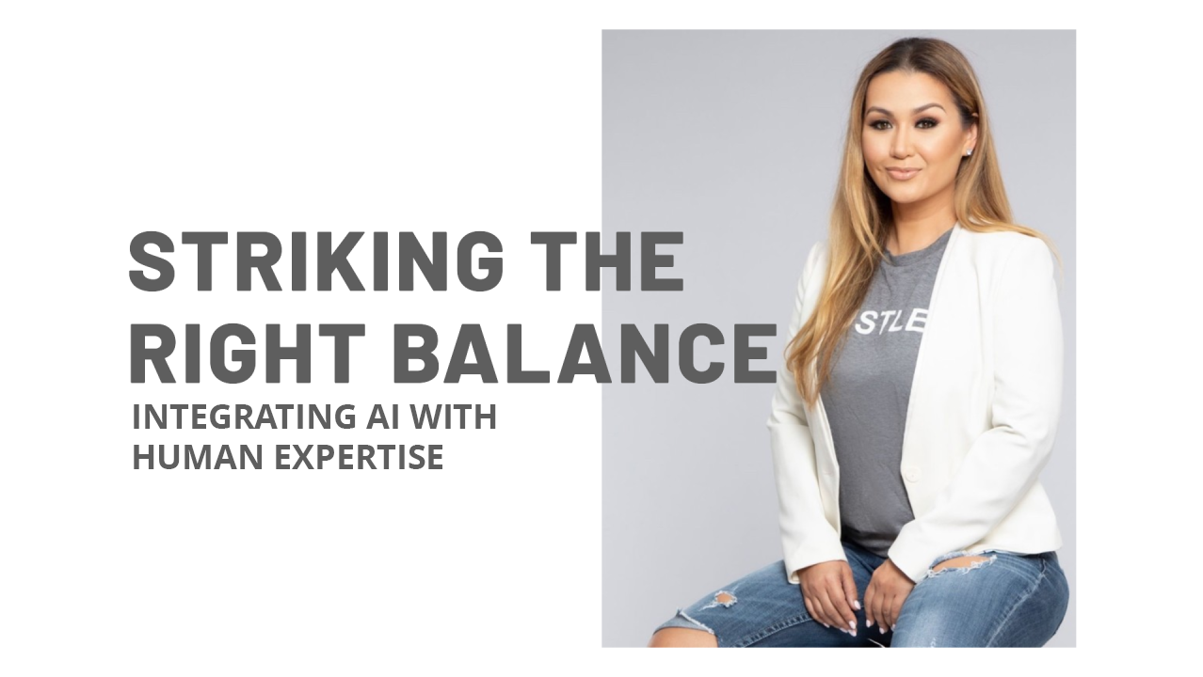

**CONCLUSION**

The integration of AI in HR marks a transformative shift in how organizations manage talent, streamline processes, and enhance employee experiences. Rather than replacing human roles, AI serves as a powerful tool that automates repetitive tasks, reduces biases, and provides actionable insights. This allows HR professionals to dedicate more time to strategic initiatives, such as talent development, employee engagement, and organizational culture—areas where human empathy and intuition are irreplaceable. The true potential of AI lies in its ability to complement human expertise, creating a more efficient and equitable workplace.

As AI continues to evolve, its role in HR will expand beyond administrative efficiency to predictive analytics and personalized employee experiences. By leveraging AI-driven data, HR teams can make more informed decisions, from recruitment to retention, ensuring that policies and practices align with both business goals and employee needs.

However, the success of AI in HR depends on ethical implementation, transparency, and continuous human oversight to prevent misuse and maintain trust. The goal is not to eliminate the human element but to enhance it with intelligent, data-backed support.

The future of HR lies in a balanced collaboration between technology and human judgment. While AI can identify trends and recommend actions, it is up to HR professionals to interpret these insights with emotional intelligence and contextual understanding.

This synergy fosters a workplace where fairness, innovation, and productivity thrive. Organizations that embrace this partnership will be better positioned to attract top talent, improve employee satisfaction, and drive long-term success in an increasingly competitive landscape.

Ultimately, AI in HR represents progress—not as a replacement for human skills but as an enabler of greater efficiency and strategic impact. By automating routine tasks and uncovering data-driven opportunities, AI empowers HR teams to focus on what truly matters: building meaningful workplace relationships and nurturing a culture of growth. The path forward is clear—a harmonious blend of technological advancement and human insight will define the next era of HR, ensuring that businesses remain agile, inclusive, and forward-thinking.

**REFERENCE**

[1] McKinsey & Company. (2020). Leveraging Data Analytics in Recruitment.

[2] Harvard Business Review. (2018). Data-Driven Recruitment: How Analytics Can Improve Hiring.

[3] Society for Human Resource Management (SHRM). (2019). The Role of Data Analytics in Recruitment.

[4] Forbes. (2019). How Data Analytics Can Transform the Recruitment Process.

[5] HR Technologist. (2019). The Benefits of Data Analytics in Recruitment.

[6] World Economic Forum. (2020). The Future of Jobs Report 2020: AI and Automation in HR.

[7] Gartner. (2021). AI Trends in Human Resources: From Hype to Reality.

[8] Deloitte. (2022). Global Human Capital Trends: The Rise of the Social Enterprise.

[9] MIT Sloan Management Review. (2021). Ethical AI in Hiring: Challenges and Solutions.

[10] PwC. (2020). Workforce of the Future: The AI Revolution in HR.