GATEWAY-DRIVEN SMART METER USING STM32 AND A5D2X WITH MQTT-BASED CLOUD INTERFACE

Mr Jawahar R^{[1]}, Ms.Varsha JJ^{[2]} and Dr.A.B.Arockia Christoper^{[3]}

^{[1]} PG Student, Department of MCA, RTC, Coimbatore, India, Email id: jawaharr16@gmail.com
^{[2]}Assisstant Professor,Department of MCA, RTC, Coimbatore,India, Email id:varsha.mca@rathinam.com
^{[3]}Professor and Head,Department of MCA, RTC, Coimbatore,India, Email id:abachristo123@gmail.com

Abstract: This paper leverages the Internet of Things (IoT) to modernize energy monitoring through a smart metering system. The STM32F446RE microcontroller is used for acquiring real-time voltage and current data from sensors such as the ZMPT101B and ACS712. These values are transmitted to the RuggedBoard A5D2X via USART for local display on a 16x2 I2C LCD and onward communication to the cloud using MQTT protocol. The A5D2X acts as a gateway, enabling reliable remote access, real-time monitoring, and data logging through Ethernet connectivity. This system provides a scalable and efficient solution for smart grid applications. Future enhancements include mobile/web dashboards, integration with billing systems, AI-powered consumption analytics, and load control via relays.
Keywords: Smart Meter, IoT, STM32F446RE, RuggedBoard A5D2X, Real-Time Monitoring, MQTT, Energy Management, Embedded Systems, Cloud Connectivity

I. INTRODUCTION
In today’s rapidly evolving energy sector, intelligent monitoring and automation are vital for enhancing efficiency, reliability, and control. The rise of Internet of Things (IoT) technologies has revolutionized smart metering by enabling real-time data acquisition, cloud-based monitoring, and automated energy management. By integrating embedded systems with cloud connectivity, IoT-based energy solutions reduce manual intervention, support data-driven insights, and optimize power consumption in both industrial and residential settings.
This paper presents a Smart Energy Metering System based on the STM32F446RE microcontroller and RuggedBoard A5D2X. The STM32F446RE captures real-time voltage and current values using sensors like the ZMPT101B and ACS712. These measurements are transmitted via USART to the A5D2X, which acts as a robust IoT gateway. The data is displayed locally on a 16x2 I2C LCD for on-site monitoring and simultaneously pushed to the cloud using MQTT over Ethernet, ensuring fast and secure connectivity. This hybrid architecture allows continuous monitoring even in limited connectivity areas and provides real-time insights remotely through cloud dashboards. Python 3.5.5 on the A5D2X facilitates sensor interfacing, serial communication, and MQTT cloud integration using lightweight libraries. This layered system design ensures modularity, reliability, and scalability, making it suitable for smart grid implementations, predictive energy analytics, and IoT-based utility monitoring. The project demonstrates how real-time data visualization, remote control, and gateway communication can work together to build a reliable and future-proof smart energy infrastructure.
II. LITERATURE SURVEY
The Internet of Things (IoT) has revolutionized modern energy monitoring and industrial automation by enabling real-time data acquisition, remote control, and predictive energy management. Embedded systems, when integrated with cloud connectivity and intelligent sensors, play a vital role in automating energy infrastructure, improving operational efficiency, and reducing human dependency. In the context of Industry 4.0, interconnected devices gather, process, and transmit data to optimize decision-making in energy usage and management systems.
In the proposed Smart Metering System, the STM32F446RE microcontroller acts as the edge device responsible for acquiring real-time voltage and current data from sensors like ZMPT101B and ACS712. These values are communicated to the RuggedBoard A5D2X, a robust embedded Linux platform powered by the Microchip SAMA5D2 processor, which serves as a gateway for local visualization and cloud-based control. The A5D2X transmits this data to the cloud via MQTT over Ethernet, enabling remote monitoring and analysis in real-time.
Several studies highlight the importance of embedded systems in the evolution of industrial IoT. Lee et al. (2015) discussed the transition from traditional automation to cyber-physical systems (CPS), emphasizing cloud integration and data-driven control. Kumar et al. (2019) explored the rise of smart factories enabled by MQTT and Ethernet-based IoT devices. Gupta et al. (2021) demonstrated how predictive maintenance through real-time sensor monitoring significantly reduces system downtime and energy losses.
The use of embedded Linux, as highlighted by Mohan et al. (2018), adds flexibility and scalability to industrial systems, particularly when paired with open-source build systems like Yocto. For hardware-software interfacing, libraries such as MRAA and UPM, discussed by Patel & Sharma (2020), simplify the integration of sensors, relays, and communication modules in embedded platforms like the A5D2X. This layered architecture—STM32 for sensing and preprocessing, and A5D2X for gateway communication—represents a modular, future-ready solution tailored for modern industrial and smart grid environments.
Low-power embedded boards and Linux-based environments are well-suited for IoT-enabled energy monitoring and industrial automation. In this project, the combination of the STM32F446RE microcontroller and the RuggedBoard A5D2X demonstrates how intelligent, networked devices can streamline energy workflows, reduce system downtime, and enable efficient, real-time monitoring. By integrating voltage and current sensors with embedded systems and leveraging MQTT-based cloud communication, the solution supports continuous data acquisition, local display, and remote access. The synergy of sensor networks, embedded computing, and cloud platforms highlights a scalable and efficient approach to smart energy infrastructure—contributing to the broader goals of automation and optimization in Industry 4.0.
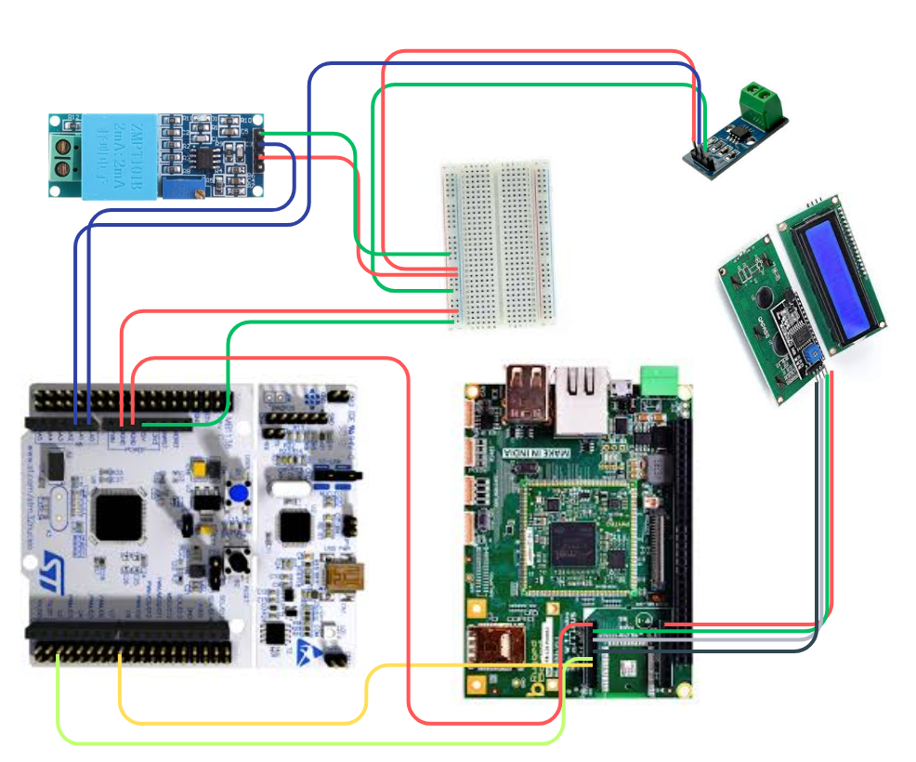

Figure 2.1 Industry Automation

Low-power embedded boards and Linux-based environments are well-suited for IoT-enabled energy monitoring and industrial automation. In this project, the combination of the STM32F446RE microcontroller and the RuggedBoard A5D2X demonstrates how intelligent, networked devices can streamline energy workflows, reduce system downtime, and enable efficient, real-time monitoring. By integrating voltage and current sensors with embedded systems and leveraging MQTT-based cloud communication, the solution supports continuous data acquisition, local display, and remote access. The synergy of sensor networks, embedded computing, and cloud platforms highlights a scalable and efficient approach to smart energy infrastructure—contributing to the broader goals of automation and optimization in Industry 4.0.

III. DATA COLLECTION
In the proposed Smart Meter with Gateway Communication system, accurate and efficient data collection is essential to enable precise energy monitoring, ensure reliable decision-making, and improve overall system performance. The STM32F446RE microcontroller serves as the primary data acquisition unit, collecting real-time voltage and current values using sensors such as the ZMPT101B for voltage and the ACS712 for current. This data is transmitted to the RuggedBoard A5D2X via USART communication for further processing and cloud transmission.
The system supports various communication protocols including GPIO, I2C (for LCD interfacing via PCF8574), and UART, allowing seamless integration of additional sensors or actuators such as push buttons, relay modules, and motor drivers. Polling techniques are used for periodic data sampling, while interrupt-based methods can be utilized for time-critical tasks to enhance efficiency and responsiveness.
To ensure reliability, preprocessing is performed to clean the raw sensor data. This includes applying low-pass filters to eliminate high-frequency electrical noise, and using moving average techniques to smooth out fluctuations in energy readings. Outlier detection mechanisms help discard abnormal spikes or drops in data, which may occur due to sensor glitches or electrical interference. For robustness, missing values can be handled through interpolation or assigning predefined default values during sensor anomalies.
Data normalization techniques, such as min-max scaling and z-score standardization, prepare the data for cloud transmission or local analysis. Encoding is applied where necessary—for example, converting relay or motor status into human-readable formats (ON/OFF). Aggregated metrics, such as average voltage or power consumption over specific intervals, help reduce noise and provide meaningful trends for monitoring. The RuggedBoard A5D2X, running embedded Linux, transmits preprocessed data to the cloud using the MQTT protocol over a reliable Ethernet connection. This enables real-time remote monitoring through platforms like ThingsBoard, AWS IoT, or Google Cloud IoT. Additionally, local storage using lightweight databases such as SQLite supports edge computing for faster analysis and logging, ensuring data integrity even during network disruptions.
IV. PROPOSED METHOD
The proposed Smart Meter with Gateway Communication system integrates sensors, embedded microcontrollers, real-time communication protocols, and cloud platforms to enable automated energy monitoring, remote data access, and predictive analytics. The architecture is based on the STM32F446RE for sensing and preprocessing, while the RuggedBoard A5D2X functions as the edge gateway for cloud connectivity and local display.

a. Utilization of RuggedBoard A5D2X
The RuggedBoard A5D2X acts as the central processing and communication gateway in the system. Operating on an embedded Linux environment, it handles data received from the STM32F446RE via UART and enables seamless communication between local hardware and cloud servers. Its support for multiple protocols such as UART, I2C, Ethernet, and GPIO makes it highly flexible for industrial-grade automation. Additionally, its onboard computing power supports local preprocessing, LCD display handling, and MQTT-based data publishing.

b. Ethernet Connectivity
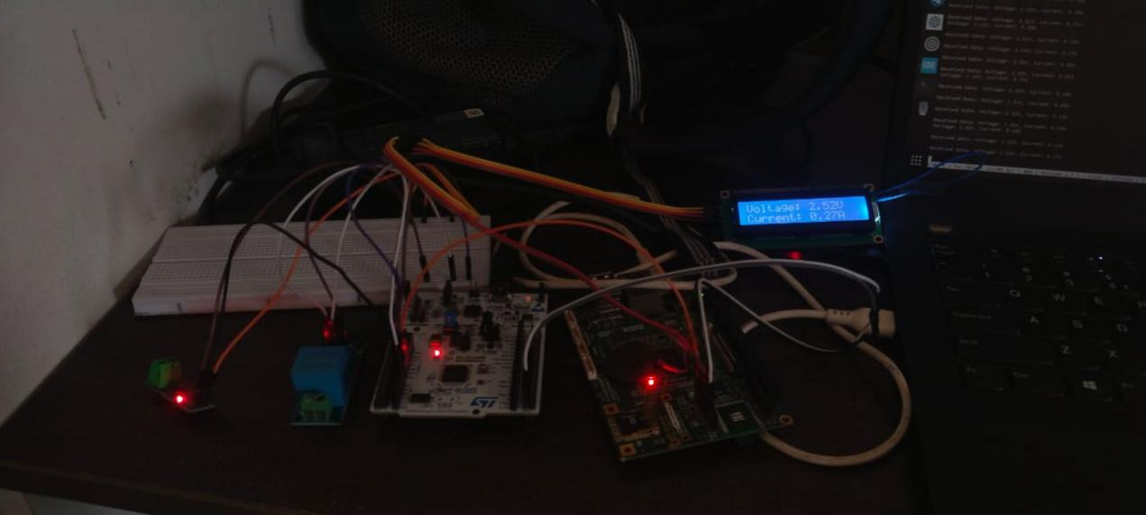
To ensure stable and high-speed data transmission, the RuggedBoard employs Ethernet connectivity for cloud communication. Unlike Wi-Fi, Ethernet minimizes interference and latency, offering a more reliable communication channel in industrial environments. MQTT protocol over Ethernet is used for publishing real-time voltage and current data to platforms like ThingsBoard or AWS IoT. SSL/TLS encryption ensures secure and tamper-proof communication, a critical factor in industrial automation systems.

Figure 4.1. iot_industrial_monitoring_setup

c. USART Communication
The system uses USART communication between the STM32F446RE microcontroller and the RuggedBoard A5D2X to transmit real-time voltage and current data. The STM32 handles sensor interfacing and preprocessing, then sends the processed values via UART to the RuggedBoard. This data exchange ensures reliable and low-latency communication across devices. By replacing relays with serial data flow, the system focuses on monitoring and reporting rather than controlling electrical loads, aligning with its goal of energy usage tracking and remote visualization.

d. Voltage and Current Sensors
The system uses a ZMPT101B voltage sensor and ACS712 current sensor to collect real-time electrical parameters. These sensors are interfaced with the STM32F446RE microcontroller, which processes and transmits the measured data to the RuggedBoard. The accurate acquisition of voltage and current allows the system to compute power usage and detect anomalies like overloads or power drops, essential for effective energy management.

e. 16x2 LCD with I2C Interface
A 16x2 LCD connected via the PCF8574 I2C expander to the RuggedBoard displays real-time readings locally. This ensures that users can view voltage, current, and relay status even in case of temporary internet outages. The LCD enhances usability by providing immediate on-site feedback, especially useful in field environments where a graphical user interface may not be available.

V. RESULTS AND DISCUSSION
Using the STM32F446RE for sensing and the RuggedBoard A5D2X as the gateway, the IoT-based smart metering system was successfully implemented. The setup enabled real-time energy data monitoring, reliable local display, and seamless cloud communication via Ethernet. The following significant outcomes were observed:

- Real-Time Sensor Data Acquisition
Voltage and current levels were accurately measured using the ZMPT101B and ACS712 sensors. The STM32F446RE acquired these values and transmitted them to the RuggedBoard A5D2X via UART. Real-time readings were displayed on the 16x2 I2C LCD, enabling effective on-site monitoring. MQTT over Ethernet was used to publish this data to cloud platforms like ThingsBoard, allowing remote access and analytics.
2. Gateway Communication and Local Monitoring
The RuggedBoard A5D2X effectively handled UART data from the STM32 and displayed it locally on the LCD using I2C. This ensured visibility of critical data even during temporary network interruptions. Python 3.5.5 was used to develop scripts for serial communication, display updates, and MQTT publishing.
3. Reliable Ethernet-Based Cloud Connectivity
Ethernet connectivity ensured a low-latency and interference-free link between the gateway and the cloud. The use of MQTT enabled fast, secure, and lightweight communication, with consistent performance and minimal delay.
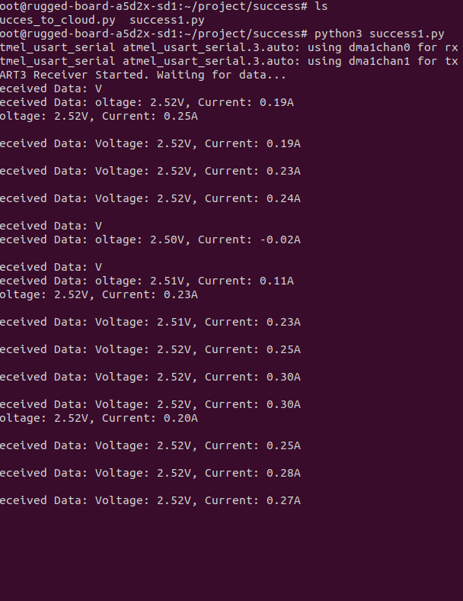

Figure 5.1. serial data output voltage current

4. System Scalability and Responsiveness
The system exhibited quick data refresh rates and stable cloud communication. It can be easily expanded to include additional sensors or integrated into a broader smart grid environment. Offline logging with SQLite also provided resilience against temporary connectivity issues.
5. Advantages of Ethernet over Wireless Communication
Ethernet was chosen over Wi-Fi due to its reliable and stable performance in industrial settings. It provided a low-latency and interference-free channel, crucial for accurate and uninterrupted data transmission to the cloud.

6. Accuracy and Reliability of Sensor Data
Voltage and current measurements were consistent and reliable. The use of moving average filters helped eliminate sudden spikes and noise. While occasional anomalies were observed due to external interference, they highlighted the potential benefit of integrating AI-based correction or redundant sensing in future iterations.
7. System Responsiveness and Edge Computation
Although the current setup mainly performed cloud-based processing, edge computing using the RuggedBoard A5D2X allowed faster display updates and reduced reliance on network availability. This responsiveness could be further enhanced with onboard decision-making capabilities.
8. Scalability and Future Enhancements
The architecture is modular and allows the integration of additional sensors like gas or vibration detectors. Future improvements could include:
- AI-driven analytics for predictive maintenance
- Mobile/web dashboards for visualization
- Integration with billing platforms
- Hybrid edge-cloud models for optimized performance
9. Challenges and Limitations
- Initial setup complexity: Required familiarity with UART, I2C, and MQTT protocols
- Hardware scalability: May need higher-performance boards for larger deployments
- Network dependency: While Ethernet is reliable, temporary disconnections could disrupt cloud updates without offline fallback mechanisms like caching or edge-based control

VI. CONCLUSION
This paper successfully demonstrates a real-time IoT-based smart energy monitoring system using STM32F446RE and RuggedBoard A5D2X. The integration of voltage and current sensors, UART-based data transmission, LCD display, and Ethernet-enabled MQTT cloud communication results in a scalable and efficient energy management solution. It enhances operational visibility, enables remote access to energy data, and supports offline monitoring through local display and database logging. By leveraging embedded systems and reliable communication protocols, the system reduces manual effort and improves accuracy in energy tracking. Future improvements may include mobile applications, AI-powered analytics, billing system integration, and expanded sensor networks for broader applications in smart grids and industrial energy management.

REFERENCES

- Belkacem Kada, Ahmed Alzubairi, Abdullah Tameem, "Industrial communication networks and the future of industrial automation," 2019 Industrial & Systems Engineering Conference (ISEC).
- Bilal Babayigit, Mohammed Abubaker, "Industrial Internet of Things: A review of improvements over traditional SCADA systems for industrial automation," Volume 18, Issue 1, March 2024.
- Hao Ran Chi, Chung Kit Wu, "A survey of network automation for Industrial Internet-of-Things toward Industry 5.0," Volume 19, Issue 2, February 2023.
- Heiko Koziolek, Andreas Burger, Jens Doppelhamer, "Self-commissioning industrial IoT systems in process automation: A reference architecture," 2018 IEEE International Conference on Software Architecture (ICSA).
- Ifiok E Etim, Jaswinder Lota, "Power control in cognitive radios, Internet-of-Things (IoT) for factories and industrial automation," IECON 2016 - 42nd Annual Conference of the IEEE Industrial Electronics Society.
- Ioan Ungurean, Nicoleta-Cristina Gaitan, Vasile Gheorghita Gaitan, "An IoT architecture for things from industrial environment," 2014 10th International Conference on Communications (COMM).
- M. Rudra Kumar, B. Rupa Devi, K. Rangaswamy, M. Sangeetha, Korupalli V Rajesh Kumar, "IoT-edge computing for efficient and effective information process on industrial automation," 2023 International Conference on Networking and Communications (ICNWC).
- Martin Wollschlaeger, Thilo Sauter, "The future of industrial communication: Automation networks in the era of the Internet of Things and Industry 4.0," IEEE Industrial Electronics Magazine.
- Omid Givehchi, Henning Trsek, Juergen Jasperneite, "Cloud computing for industrial automation systems — A comprehensive overview," 2013 IEEE 18th Conference on Emerging Technologies & Factory Automation (ETFA).
- Prof. Niranjan M, Madhukar N, Ashwini A, Muddsar J, Saish M, "IoT-based industrial automation," IOSR Journal of Computer Engineering (IOSR-JCE).
- Renjith V. Ravi, S. B. Goyal, Bogdan Constantin Neagu, Maria Simona Raboaca, "A low-cost industrial automation system using IoT and cloud computing," 2022 International Conference and Exposition on Electrical and Power Engineering (EPE).
- Tomas Lennvall, Mikael Gidlund, Johan Åkerberg, "Challenges when bringing IoT into industrial automation," 2017 IEEE AFRICON.
- Edge Intelligence for Smart Meters
Zhang, X., Liu, Y., & Wu, T. (2022). Edge intelligence-enabled smart meters for real-time energy management. IEEE Internet of Things Journal.
[14] Secure MQTT in Industrial Environments
Singh, R., & Jaiswal, A. (2023). Security enhancements for MQTT in IIoT applications. Journal of Network and Computer Applications.
[15] Modern Energy Metering Using
STM32 and Cloud
Al-Mashaqbeh, I. A., & Abu-Samaha, A. (2023). Smart metering using STM32 with cloud storage integration. International Journal of Embedded Systems and Applications.
[16] ThingsBoard in IoT Architectures
Kim, H., & Jung, J. (2024). IoT frameworks for industrial monitoring: A comparative study of ThingsBoard, AWS IoT, and Azure IoT Hub. Sensors Journal.
[17] AI for Smart Grid Management
Sharma, P., & Raj, M. (2022). AI-assisted predictive maintenance and consumption forecasting in smart grids. Energy Reports.
[18] Low-Power Embedded IoT Gateways
Hassan, M. A., & Noor, M. (2023). Design and optimization of low-power embedded IoT gateways for energy metering. IEEE Access.

