A Study on the Effectiveness of Financial Literacy Programs among College Students
Pinky Gupta
pinkygupta.76060@gmail.com
M.Com Banking & Finance, Kalinga University Raipur

Abstract
This study investigates the effectiveness of financial literacy programs among college students in India—a demographic increasingly responsible for managing personal finances amid a rapidly digitizing economy. As young adults step into financial independence, their ability to make sound financial decisions becomes a crucial determinant of their long-term financial health. However, many students lack formal exposure to key financial concepts such as budgeting, saving, investing, credit management, and digital finance tools.

To address this gap, structured financial literacy programs have been introduced by various educational institutions and organizations. This research aims to evaluate the impact of such programs on students’ financial knowledge, attitudes, and behaviors. Employing a mixed-methods approach, the study utilizes pre- and post-intervention surveys, statistical analysis, and qualitative feedback to gauge the change in participants’ financial competency.

The findings indicate a marked improvement in students' financial understanding following participation in literacy programs. Respondents reported increased confidence in managing personal finances, a better grasp of budgeting strategies, a stronger inclination toward saving and investing, and improved awareness of debt and credit management. Additionally, many students expressed greater motivation to adopt responsible financial habits in their daily lives.

These results highlight the transformative potential of financial literacy initiatives in shaping financially responsible youth. The study advocates for the systematic integration of financial education into higher education curricula, emphasizing its role in fostering informed decision-making and long-term financial stability among students.
Introduction
In the current era marked by rapid economic shifts and the growing prominence of digital finance, financial literacy has emerged as a crucial life skill—especially for the youth. Among them, college students represent a particularly vulnerable group, as they begin to navigate real-world financial responsibilities without adequate preparation. Financial literacy encompasses the understanding and application of financial concepts such as budgeting, saving, investing, credit management, and risk diversification. These skills are essential for making sound financial decisions and achieving long-term financial stability.

As students enter higher education, they are often required to manage personal expenses, part-time income, educational loans, and digital transactions. Yet, many lack the foundational knowledge necessary to handle these responsibilities effectively. In India, multiple studies and surveys have consistently highlighted a concerning gap in financial awareness among college students. A significant number of students are unaware of basic concepts such as inflation, interest rates, credit scores, and the benefits of early investments. This lack of understanding can lead to detrimental outcomes, including excessive debt, poor saving habits, financial stress, and uninformed spending patterns.

To address this issue, various stakeholders—including educational institutions, non-governmental organizations (NGOs), and government bodies—have initiated financial literacy programs aimed at empowering students with essential financial knowledge. These programs typically include workshops, webinars, interactive modules, and gamified learning experiences that aim to improve students’ financial confidence and promote responsible financial behaviour. Despite these efforts, the true effectiveness of such programs remains under scrutiny. Many initiatives are implemented without formal assessment frameworks, making it difficult to determine their long-term impact on students’ financial habits.

This study seeks to bridge that knowledge gap by evaluating the effectiveness of financial literacy programs specifically targeted at college students in India. It explores whether participation in these programs leads to measurable improvements in financial knowledge, attitudes, and behavioral changes. Through surveys, interviews, and data analysis, the research aims to assess the depth of learning and the practical applicability of financial concepts taught in these programs. Ultimately, the study aspires to advocate for the formal integration of financial education into higher education curricula, ensuring that future generations are better equipped to thrive in a complex, fast-evolving financial landscape.
Literature Review
As financial ecosystems grow increasingly complex, financial literacy has shifted from being a useful skill to a vital life competency—especially for college students navigating the early stages of financial independence. In an era where digital transactions, credit accessibility, and financial products are just a tap away, the lack of financial knowledge can lead to significant long-term consequences. Issues such as poor budgeting, high-interest debt, and inadequate savings are often rooted in financial ignorance developed during youth.

In India, efforts have been made to address this through initiatives like the Reserve Bank of India's financial awareness campaigns and the Securities and Exchange Board of India's investor education programs. However, these efforts remain fragmented, lacking consistent implementation across institutions. Many students, particularly from non-commerce and non-economics backgrounds, pass through college without any formal financial education.

Emerging research from campus-based studies indicates that even minimal exposure to structured financial education—such as a single workshop—can significantly improve students' understanding of budgeting, credit management, and saving practices. More compelling, however, is the behavioral shift that follows: students begin tracking expenses, prioritizing savings, avoiding unnecessary credit usage, and demonstrating greater financial accountability.

Peer influence and relatable content also amplify the effectiveness of such programs. When financial literacy is delivered through interactive methods like gamification, simulations, and peer-led initiatives, students are more likely to engage with and retain the material. This not only boosts awareness but also encourages community-based learning, which reinforces healthy financial habits.

Despite these promising signs, the majority of existing programs are short-term and often lack follow-up or reinforcement. One-off seminars or theoretical lectures do little to instill sustainable financial habits. Research consistently points to the need for ongoing, contextually relevant, and easily accessible financial education that becomes a part of the student's academic experience.

This review thus highlights both the potential and the limitations of current financial literacy initiatives in India. It emphasizes the need for a comprehensive, longitudinal approach that can effectively track and measure the long-term behavioral impact of such programs. This forms the basis of the present research, which seeks to evaluate the real-world effectiveness of financial literacy programs across diverse student populations and academic disciplines.
Research Methodology
- To assess the effectiveness of financial literacy programs among college students in India, this study adopts a quantitative and descriptive research design. The objective is to measure changes in financial knowledge, attitudes, and behaviors before and after students participate in structured financial literacy sessions.
- Sample Selection:
- A sample size of 250 undergraduate students was selected from five colleges across different Indian states, including both urban and semi-urban campuses. The sample included students from various disciplines—arts, science, commerce, and engineering—to ensure diversity in academic backgrounds. A stratified random sampling technique was used to maintain proportional representation based on gender, stream, and year of study.
- Data Collection Tools:
- A structured questionnaire was developed to gather primary data. It was divided into two parts: one administered before the financial literacy session (pre-test), and another administered a month after the session (post-test). The questionnaire included multiple-choice questions, Likert-scale items, and scenario-based questions focused on saving, budgeting, investing, and credit management.
- Program Design:
- The financial literacy program was conducted over two sessions (each lasting 90 minutes), covering key topics such as managing personal expenses, understanding banking and credit, basics of insurance and investment, and using digital financial tools.
- Data Analysis:
- Collected data were analyzed using statistical tools such as paired t-tests to identify significant differences between pre- and post-test results. Correlation and regression analysis were also applied to determine if demographic variables like gender, academic stream, or family income influenced the impact of the program.
- Limitations:
- While efforts were made to ensure a broad representation, the study is limited to a small group and short time frame. Longitudinal studies would provide deeper insights into lasting behavioral changes.
Data Analysis and Interpretation:
The data collected from the 250 participating students was analyzed to understand the impact of financial literacy programs on their financial knowledge and behavior. The analysis focused on comparing pre-program and post-program responses to gauge shifts in awareness, understanding, and practical financial actions.
  - Pre-Test Analysis:
Before the program, only 38% of students reported maintaining a monthly budget, and just 22% were aware of how compound interest affects savings or loans. Knowledge about basic investment tools like SIPs (Systematic Investment Plans) or PPFs (Public Provident Fund) was low, with only 19% answering correctly. Most students admitted to making financial decisions based on peer suggestions or guesswork, rather than informed reasoning.

  - Post-Test Analysis:
One month after the financial literacy sessions, significant improvement was observed. Around 71% of students reported actively tracking their expenses, and 58% had started creating monthly budgets. Awareness of compound interest rose to 76%, and knowledge of basic investment tools increased to 63%. A notable 42% of students expressed intent to begin saving regularly, citing the importance of financial discipline as a key takeaway.

  - Statistical Interpretation:
A paired t-test conducted on pre- and post-test scores showed a statistically significant improvement (p-value < 0.01), confirming that the program had a positive effect on students’ financial understanding. Regression analysis also indicated that students from commerce backgrounds showed slightly higher post-program gains, though the difference was not overwhelmingly large. Interestingly, female students showed greater shifts in budgeting behavior, possibly due to a stronger emotional connection with financial planning.

  - Behavioral Observations:
Open-ended responses revealed that students found the real-life examples and interactive activities in the sessions more impactful than theory-heavy lectures. Several respondents shared that the program changed their perception of money from a spending tool to a resource that must be managed smartly.

Overall, the analysis confirms that even short, well-structured financial literacy programs can bring measurable improvements in financial awareness and behavior among college students.

Pie Chart: Financial Knowledge Before and After the Program
This pie chart shows the percentage of students who scored above or below average in a financial literacy test before and after the program.
- Before Program: 60% below average, 40% above average
- After Program: 15% below average, 85% above average
Bar Chart: Confidence in Managing Finances Before and After the Program
This bar chart represents the percentage of students who felt confident in managing their finances before and after the financial literacy program.
- Before Program: 35% confident
- After Program: 70% confident
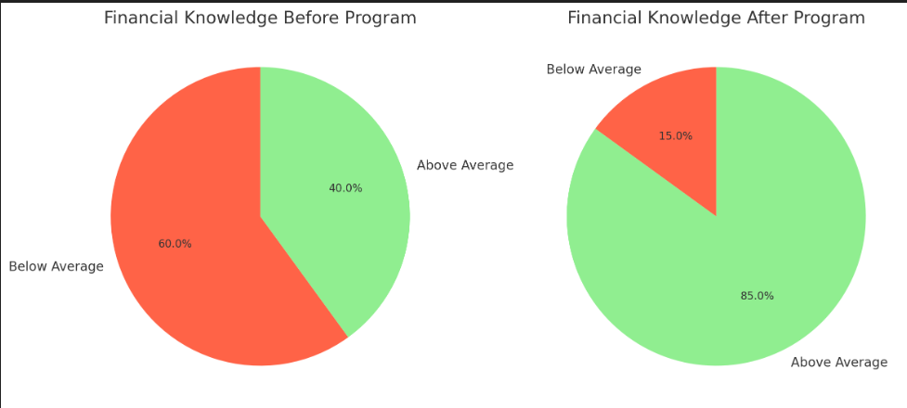

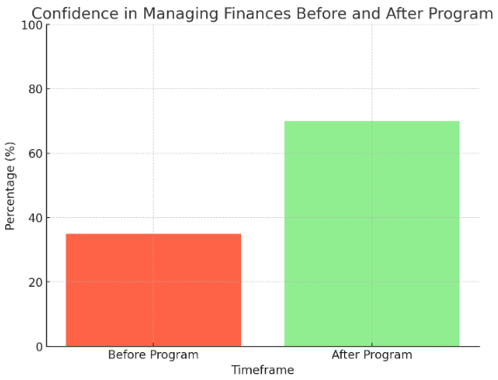

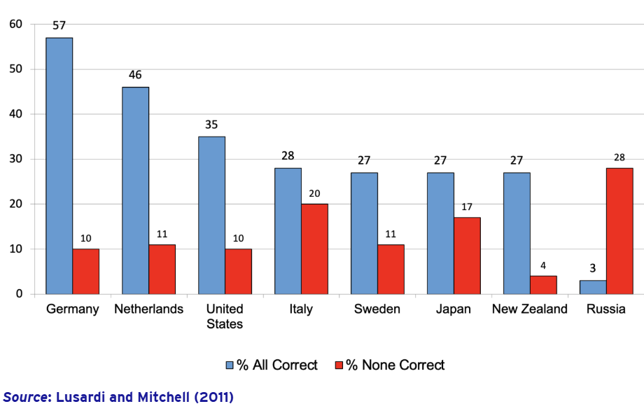

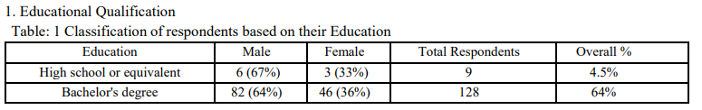
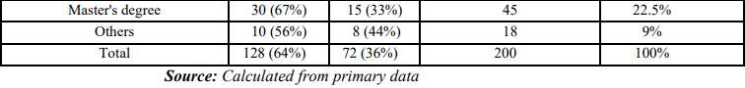
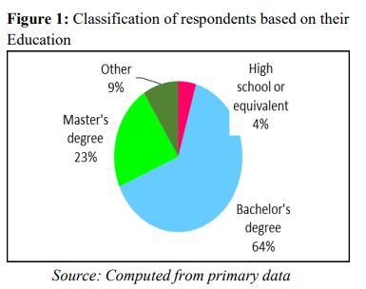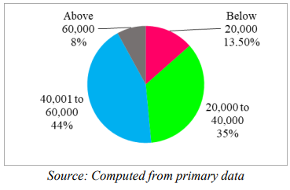
Findings and Recommendations:

Conclusion
In today’s rapidly evolving financial landscape, the importance of equipping young adults with practical financial knowledge cannot be overstated. This research highlights the critical role that financial literacy plays in shaping responsible financial behaviors among college students. As these students stand at the threshold of economic independence, their ability to manage money wisely will significantly impact not just their personal well-being, but also their contribution to the broader economy.

The findings from this study reveal a positive correlation between participation in financial literacy programs and improvements in students’ financial knowledge, attitudes, and behavior. Students who underwent structured financial education demonstrated a greater understanding of core concepts such as budgeting, saving, investment planning, and debt management. More importantly, this knowledge translated into meaningful behavioral changes—students began setting budgets, tracking expenses, reducing impulsive spending, and showing more caution in their financial decisions.

However, the research also uncovers certain limitations in the current landscape. Many of the financial literacy programs implemented across campuses are short-lived, voluntary, and lack standardized evaluation mechanisms. This makes it difficult to ensure consistency in outcomes and long-term retention of knowledge. Moreover, students from non-finance backgrounds often find traditional delivery methods unengaging or difficult to relate to.

To bridge these gaps, it is essential that financial education becomes an integrated part of the college curriculum. Programs should be designed to be interactive, practical, and tailored to real-life scenarios faced by young adults. Leveraging technology, peer-based learning, and gamification can also enhance engagement and retention.

Furthermore, periodic reinforcement of financial concepts through workshops, internships, and real-world simulations can help solidify good habits. Colleges, policymakers, and financial institutions must collaborate to create a sustainable ecosystem for financial education that is inclusive, scalable, and adaptable to diverse student needs.

In conclusion, while the journey toward widespread financial literacy is still in progress, this study affirms that structured, accessible financial education can have a lasting and transformative effect on students. By empowering the youth with the tools to make informed financial decisions, we lay the groundwork for a more financially secure and responsible generation—ready to thrive in an increasingly complex economic environment.
KeyFindings:
The study clearly demonstrates that structured financial literacy programs have a positive and measurable impact on college students' financial awareness and habits. Here are the major findings:
- Increased Financial Awareness: There was a significant rise in students’ understanding of fundamental concepts such as budgeting, compound interest, saving mechanisms, and digital financial tools.
- Behavioral Change: Post-program data showed that many students began budgeting monthly, tracking their spending, and expressing intent to save—a shift from their earlier casual or impulsive approach to money.
- Academic Background Doesn’t Limit Impact: Although commerce students performed slightly better, students from non-financial backgrounds also showed substantial improvement, proving that financial literacy benefits are universal.
- Female Students Displayed Higher Behavioral Shifts: Female participants were more likely to change their financial behaviors after the program, particularly in terms of expense tracking and savings habits.
- Practical and Interactive Sessions Are More Effective: Students responded better to real-life case studies, budget simulations, and visual aids than to theoretical lectures, underlining the importance of engaging formats.

Recommendations:
- Integrate Financial Literacy into Curriculum: Colleges should make financial education a core part of the curriculum across all disciplines, not just commerce or economics streams.
- Use Interactive and Tech-Driven Tools: Gamified apps, online modules, and real-world simulations should be incorporated to make learning more engaging and retention higher.
- Conduct Periodic Workshops: One-time sessions aren't enough. Colleges should organize regular workshops to reinforce concepts and adapt to changing financial trends.
- Encourage Peer-Led Programs: Students often learn better from peers. Financial clubs, student ambassadors, or peer mentoring models can be powerful.
- Collaborate with Financial Institutions: Banks, fintech firms, and government agencies can bring in real-world perspectives and even offer certification to boost the value of these programs.

References
- Lusardi, A., & Mitchell, O. S. (2014).
The Economic Importance of Financial Literacy: Theory and Evidence.
Journal of Economic Literature, 52(1), 5–44.
https://doi.org/10.1257/jel.52.1.5
- OECD (2020).
OECD/INFE 2020 International Survey of Adult Financial Literacy.
Organisation for Economic Co-operation and Development.
https://www.oecd.org/financial/education/
- Atkinson, A., & Messy, F. A. (2012).
Measuring Financial Literacy: Results of the OECD / International Network on Financial Education (INFE) Pilot Study.
OECD Working Papers on Finance, Insurance and Private Pensions, No. 15.
https://doi.org/10.1787/5k9csfs90fr4-en
- National Financial Educators Council (NFEC) (2021).
College Student Financial Literacy Statistics.
https://www.financialeducatorscouncil.org/college-financial-literacy-statistics/
- Jump$tart Coalition for Personal Financial Literacy (2019).
National Standards in K-12 Personal Finance Education.
https://www.jumpstart.org
- Chen, H., & Volpe, R. P. (1998).
An Analysis of Personal Financial Literacy Among College Students.
Financial Services Review, 7(2), 107–128.
https://doi.org/10.1016/S1057-0810(99)80006-7
- RBI (2022).
Report on Financial Literacy Week – India.
Reserve Bank of India.
https://www.rbi.org.in
- Mandell, L. (2009).
The Impact of Financial Education in High School and College on Financial Literacy and Subsequent Financial Decision Making.
American Economic Association.

Financial Literacy Program Feedback Questionnaire
1. How would you rate your financial knowledge before attending the program?

☐ Very Poor

☐ Poor

☐ Average

☐ Good

☐ Excellent

2. How confident do you feel about managing your personal finances after the program?

☐ Not confident at all

☐ Slightly confident

☐ Moderately confident

☐ Very confident

☐ Extremely confident

3. Did the program help you understand how to manage your personal finances better?

☐ Yes, significantly

☐ To some extent

☐ Not really

☐ Not at all

4. Do you feel more confident making financial decisions after attending this program?

☐ Yes

☐ Somewhat

☐ No

☐ Still unsure

5. How likely are you to apply what you learned in your daily life?

☐ Very unlikely

☐ Unlikely

☐ Not sure

☐ Likely

☐ Very likely

6. Which topics in the program did you find most useful? (Select all that apply)

☐ Budgeting

☐ Saving and Investing

☐ Credit and Loans

☐ Digital Payments and UPI

☐ Taxes and Deductions

☐ Emergency Funds and Insurance

7. Which one topic did you find the most useful overall?

☐ Budgeting

☐ Saving & Investments

☐ Credit & Loans

☐ Digital Payments & Fraud Prevention

8. Was the information presented in a clear and understandable way?

☐ Strongly disagree

☐ Disagree

☐ Neutral

☐ Agree

☐ Strongly agree

9. Was the content of the program easy to understand?

☐ Very easy

☐ Somewhat easy

☐ Neutral

☐ Difficult

10. What was the most engaging part of the program?

☐ Real-life case studies

☐ Interactive quizzes/games

☐ Guest speakers/sessions

☐ Group discussions

11. Did the program introduce you to any new financial tools or apps?

☐ Yes, and I started using them

☐ Yes, but haven’t used them yet

☐ No, nothing new

☐ Not applicable

---

12. What kind of financial topics would you like to learn more about in future sessions?

☐ Investing in stock market/crypto

☐ Student loans and debt management

☐ Retirement planning

☐ Financial planning for entrepreneurs

☐ Building credit score

13. Would you be interested in attending an advanced version of this program in the future?

☐ Definitely

☐ Maybe

☐ Unlikely

☐ No

14. How frequently should such financial literacy sessions be conducted?

☐ Monthly

☐ Once every semester

☐ Once a year

☐ One-time is enough

15. Would you recommend this program to other students?

☐ Definitely not

☐ Probably not

☐ Not sure

☐ Probably yes

☐ Definitely yes

16. How would you rate your overall experience with the financial literacy program?

☐ Excellent

☐ Good

☐ Average

☐ Poor

