**AN ANALYSIS OF CUSTOMER SATISFACTION WITH CHRISTY FRIEDGRAM INDUSTRY IN TIRUCHENGODE**

Vijiyapraba M

PG Scholar, Department of MBA, Vivekanandha Institute of Information & Management Studies, Namakkal, Tamil Nadu, India.

vijiyapraba380@gmail.com

**ABSTRACT:** *In current article, we investigate consumer satisfaction in short food supply chains. Particularly, we examine that customer satisfaction is impacted by various elements of marketing mix in short food supply chains. Survey that serves as foundation for our empirical investigation employs method termed multi-criteria satisfaction analysis. According to our research, manufacturers, and sales processes are most essential elements of the marketing mix. They additionally possess exceptional customer satisfaction indicators giving short food supply chains a competitive edge. Short food supply chains are at serious risk from factors including pricing, location, advertising, and shopping atmosphere. Customers take product's outstanding quality for granted, as demonstrated by its high satisfaction rating and low significance rating. Results indicate that largest consideration should be placed on production and sales processes.*

**Keywords: *Customer Satisfaction, Christy Friedgram Industry, Tiruchengode Town, Consumer Perception, Product Quality, Customer Feedback***

1. **INTRODUCTION:**

In marketing, "customer satisfaction," or "CSAT," is frequently employed term. It serves as a gauge for extent that business fulfils or exceeds expectations of its customers with its products and services. Customer happiness is described as "the number of customers, or percentage of total customers, whose reported experience with a firm, its products, or its services (ratings) exceeds specified satisfaction goals." Considering customers are essential to a product or service's continued relevance, it is to company's best advantage in ensuring customer satisfaction and cultivates customer loyalty. As part of its continuous “Common Language in Marketing Project, Marketing Accountability Standards Board (MASB) supports” definitions, goals, and measurements of marketing metrics. In a survey of more than 200 senior marketing managers, 71% of them indicated their perception of customer satisfaction metrics has been extremely beneficial in operating and tracking their companies. Customer satisfaction is considered a critical performance metric in the business sector and is frequently included in balanced

scorecards. In a market where companies compete for customers, customer satisfaction has become recognized as a crucial differentiator and has grown in importance as part of company strategy.

**II. OBJECTIVES:**

1. To assess consumer satisfaction with Christy Friedgram goods in Tiruchengode town.
2. To Identify the primary elements impacting client preference for Christy Friedgram Industries.
3. To Evaluate the quality, packaging, price, and availability of Christy Friedgram items.
4. To understand consumer expectations and views of the brand.
5. To Make ideas for boosting consumer satisfaction and brand loyalty.

**III. NEED OF STUDY:**

1. This study examines consumer satisfaction with Christy Food Products in Tiruchengode town.
2. To Gather consumer feedback on product pricing, quality, coverage, services, and availability.
3. The study examines respondents' preferences and expectations.
4. The study is useful for understanding how customers are motivated to purchase a product.

**IV. CUSTOMER SATISFACTION:**

* 1. **Customer satisfaction definition:**

Customer satisfaction is the extent to which a business's products or services meet or exceed the expectations of its customers. Since it demonstrates degree of customer satisfaction with brand overall, it is an essential indicator of long-term performance, repeat business, and customer loyalty.

**4.2 What Customer Satisfaction Means:**

Customer satisfaction refers to the extent to satisfied a customer is with a product, service, or overall brand experience. Upon using product or service, it demonstrates customer feels and perceives it. Customers who are satisfied with a brand are more inclined to remain loyal to it, purchase more from it, and refer others to it. Numerous elements, including product quality, pricing, packaging, availability, service effectiveness, and the company's capacity to meet or surpass expectations, all have an impact on customer satisfaction. Sustaining business development and establishing a strong brand image in today's cutthroat market depends on maintaining high customer happiness.

**4.3 Customer Satisfaction Explanation:**

A key performance measure that demonstrates whether company's goods or services satisfy the requirements of its consumers is customer satisfaction. Customers' fundamental demands must be met, but they must also be exceeded by consistently high-quality, dependable, and cost-effective services. High customer satisfaction ratings show that the business is doing a good job of providing a satisfying experience for its customers. Customer satisfaction in the context of the Christy Friedgram Industry refers to how customers feel about the food items' availability, quality, flavour, packaging, and cost. A satisfied customer is more inclined to remain loyal, bringing in new business

and promoting the brand. Companies that prioritize customer satisfaction stand a higher chance of retaining clients, lowering complaints, winning over new clients, and expanding their market share. Therefore, enhancing corporate tactics and achieving long-term success requires an awareness of consumer pleasure.

**The following are the top six factors that make customer happiness crucial:**

1. Helps retain existing customers.
2. Encourages positive word-of-mouth.
3. Boosts sales and revenue.
4. Builds strong brand reputation.
5. Provides useful customer feedback.
6. Gives a competitive market advantage.

**The fundamentals of excellent customer service**:

Providing exceptional customer service requires building strong relationships with your clients. If you express gratitude to your customers while establishing friendly, accommodating, and happy environment, they will leave with a positive impression. A satisfied customer is more inclined to make larger purchases and return more often.

* To guarantee that you offer the greatest customer service possible:
* Recognize what your clients think constitutes quality customer service.
* Determine what your consumers want from you
* Pay attention to both positive and negative comments
* Make sure that customer service is taken into account in every facet of your company.
* Always seek methods to raise the Caliber of client service you provide.

**V. RESEARCH METHODOLOGY:**

Research methodology is a method to systematically address research challenges. It serves as a research project's action plan and provides a thorough explanation of the data collection and analysis process. One way to think about research methodology is as the science that studies how scientific research is conducted. It can encompass a broad variety of research, from straightforward description and analysis to the development of complex experiments. A well-defined goal serves as the foundation for the project's design. as determining brand awareness is the primary goal of this study. The most appropriate approach for completing the project was determined to be the descriptive research design, which includes surveys and various fact-finding inquiries. Descriptive characteristics are assumed in this investigation. Primary data gathering served as the foundation for the investigation. Newspapers, journals, magazines, and websites had been sources of secondary

data. Sample size includes a variety of customer categories, including professionals, students, and employees, who may become Honda Two-Wheeler users.

**5.1 Research Design:** A research design is framework or methodology that directs and facilitates collection and analysis of data. Based on empirical research, current research is descriptive and analytical. The data has been collected from both primary and secondary sources. A pre-made questionnaire has been employed for collecting data, that is mostly obtained from respondents. Examples of secondary sources include books, journals, magazines, newspapers, numerous reports, websites, etc.

**5.2 Descriptive Research:** A descriptive research design just explains a certain aspect, such as the demographics of the product's users. Determining how frequently something occurs is usually the focus of descriptive research. Usually, an initial hypothesis serves as the basis for this investigation. A descriptive research design has been utilized for this investigation. It describes the existing state of events. Surveys and fact-finding investigations of various types are included in descriptive research.

**VI. DATA TYPES USED**

**6.1 Primary Data:** Primary data are those that are newly gathered and, as a result, are true to their original essence. To gather primary data, a structured questionnaire was employed. To get information directly from the respondents, questionnaires were given to them.

**6.2 Secondary Data:** This refers to information that has previously been gathered from sources such as books, journals, magazines, websites, and newspapers. Books and websites are examples of secondary data that I have used.

**VII.DATA COLLECTION TOOLS**:

**Questionnaire**: There are four different kinds of questionnaire designs. In this case, we used the structured, undisguised questionnaire, where each respondent is given identical questions in the same order and with the same phrases. Both primary and secondary data are gathered for this survey to fulfil its goals.

**Sampling Techniques:** Research design is the simplest framework or approach for research that governs collection and analysis of data. I used a descriptive research approach to gather and analyse data from consumer surveys. Simple random sampling was the sampling strategy used in this investigation. Method of methodically selecting objects from a population frame is known as simple random sampling. It is sometimes referred to as grab or opportunity sampling. Despite being very hard to handle carefully, it is the approach most frequently used in many real-world scenarios.

**Sampling Design:** The purpose of sampling design is to precisely specify a set of objectives, or what is known as the universe to be explored. Simple random sampling is the method of sampling that is employed.

**Sample Size:** Sample of 130 respondents had been selected for investigation. The number of elements chosen from the universe to make up a sample is referred to as the sample size, and it shouldn't be either too big or too little. It must be at its best.

**Sample Area:** The Christmas Fried Food Industry Surroundings

**Tools For Analysis:** Collected data had been organized and examined with following statistical methods. Basic analysis of percentages This technique, known as simple percentage analysis, is used to analyses two or more data series and to explain their connection or distribution. To determine the proportion of the respondent's response, a percentage analysis test is conducted. This tool identifies different percentages in the study and presents them using bar diagrams to help the user better comprehend the analysis.

No. of respondents

Simple percentage **=** ……………………………… X 100

Total No. of respondents

**VIII. DATA ANALYSIS AND INTERPRETATION**

**Level Of Satisfaction In Buying Christy Products**

| **Satisfaction Level** | **No. of Respondents** | **Percentage (%)** |
| --- | --- | --- |
| Highly Satisfied | 40 | 30.8% |
| Satisfied | 55 | 42.3% |
| Neutral | 20 | 15.4% |
| Dissatisfied | 10 | 7.7% |
| Highly Dissatisfied | 5 | 3.8% |
| **Total** | **130** | **100%** |

**Level Of Satisfaction In Buying Christy Products**

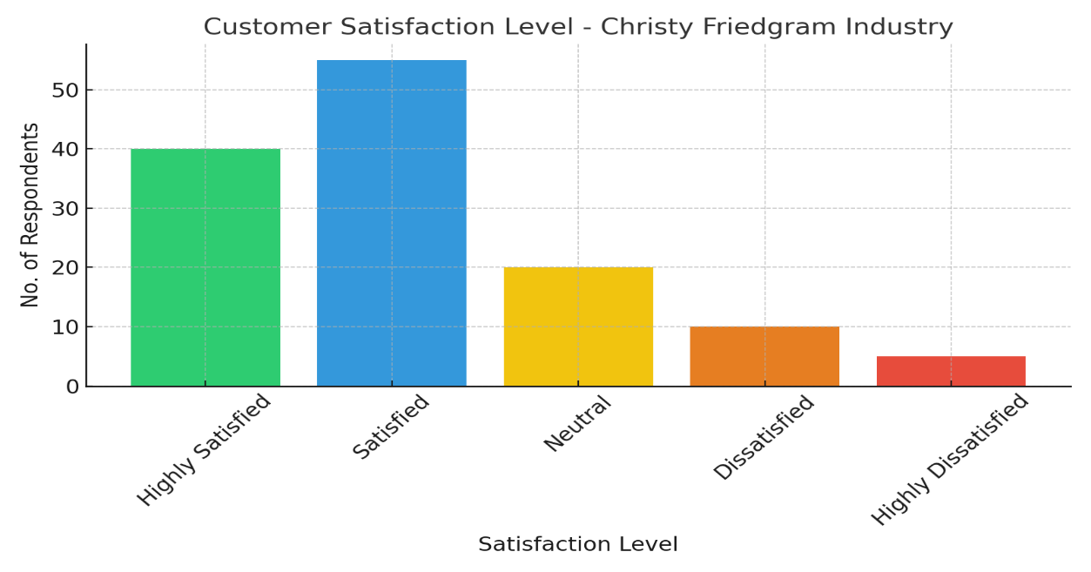

**Interpretation:**

The analysis shows that **73.1%** of respondents are either **Highly Satisfied** or **Satisfied** with Christy Friedgram Industry, indicating a strong positive perception among customers. Only **11.5%** reported dissatisfaction, while **15.4%** remained neutral. This suggests the company's products are generally well-received in Tiruchengode Town.

**Satisfaction with Price Affordability**

| **Price Satisfaction Level** | **No. of Respondents** | **Percentage (%)** |
| --- | --- | --- |
| Highly Satisfied | 35 | 26.9% |
| Satisfied | 60 | 46.2% |
| Neutral | 18 | 13.8% |
| Dissatisfied | 12 | 9.2% |
| Highly Dissatisfied | 5 | 3.8% |
| **Total** | **130** | **100%** |

**Satisfaction with Price Affordability**

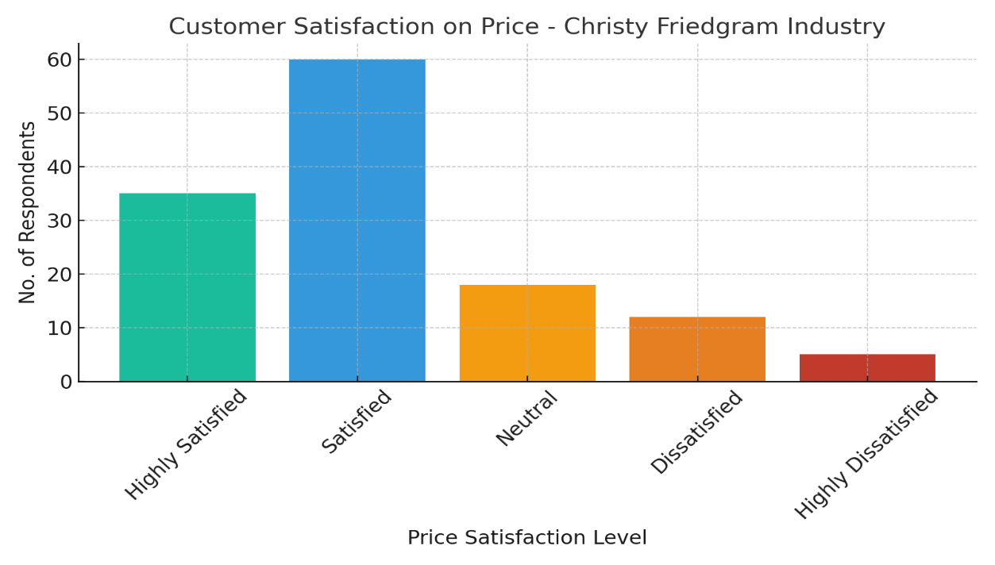

**Interpretation:**

A total of **73.1%** of respondents are **Highly Satisfied** or **Satisfied** with the pricing of Christy Friedgram products, showing strong approval. Only **13%** expressed dissatisfaction, while **13.8%** remained neutral—indicating the pricing is generally seen as affordable and fair.

**IX. FINDINGS:**

1. Majority of customers are aware of Christy Friedgram Industry through local promotions.
2. Most consumers are satisfied with the product's quality and hygiene.
3. Timely delivery of products is appreciated by bulk buyers and institutions.
4. Affordable pricing is a major factor in customer retention.
5. Packaging is considered adequate but not highly appealing to younger consumers.
6. Some customers expressed dissatisfaction with the limited variety of products.
7. Customer service support is minimal and lacks proper follow-up.

**X. SUGGESTIONS:**

1. Enhance marketing efforts through digital and social media platforms.
2. Introduce more product varieties to cater to diverse customer needs.
3. Improve packaging design for better shelf appeal and attraction.
4. Strengthen customer service with proper feedback and complaint resolution system.
5. Offer loyalty programs or discounts to retain long-term customers.
6. Ensure regular product innovation to stay competitive in the market.
7. Conduct periodic customer satisfaction surveys to assess service improvements.

**XI. CONCLUSION:**

The perceived performance of the product and the expectations of the consumer determine customer happiness. Many businesses now strive for complete client happiness because they understand that high levels of satisfaction result in high levels of loyalty. Customer happiness is a goal and a marketing strategy for any business. A key component is quality, which is the sum of a product or service's attributes that have the potential to meet the customer's explicit or implicit needs. Therefore, the secret to creating value and satisfying customers is comprehensive excellence. Christy Food Products is responsible for a corporation that prioritizes quality. They must first take part in developing policies and plans that will assist the business achieve success via complete quality excellence. Second, they need to provide both manufacturing and marketing excellence. Every marketing activity, including advertising, market research, sales training, and customer service, needs to be carried out to exacting standards.

**REFERENCES**

1. Chunawalla, S.A., "Foundation of Advertising Theory and Practice", Himalayan Publishing House, Fifth Edition, 2000.
2. Kothari C.R., “Research Methodology”, New Age International Publishers, Sixth Edition, 2003.
3. Philip Kotler, "Marketing Management", Prentice Hall of India, Eleventh Edition, 2005.
4. Ranaweera, C., & Prabhu, J. (2003). On the relative importance of customer satisfaction and trust as determinants of customer retention and positive word of mouth. Journal of Targeting, Measurement and Analysis for Marketing, 12 (1), 82.
5. Oh, H. (1999). Service quality, customer satisfaction, and customer value: A holistic perspective. International Journal of Hospitality management, 18, 67-82.