

**EFFECTIVENESS OF DANGEROUS GOODS PACKAGING IN AIR TRANSPORTATION, TS India Logistics Solution**

**AN PROJECT REPORT SUBMITTED TO**

**VEL’S INSTITUTE OF SCIENCE, TECHNOLOGY AND ADVANCED STUDIES**

**(VISTAS)**

**(Estd. U/s 3 of the UGC Act, 1956)**

***In partial fulfilment of the requirement***

***for the award of the degree of***

***MASTER OF BUSINESS ADMINISTRATION - SHIPPING AND LOGISTICS MANAGEMENT***

***Submitted by***

**PRINCE CHRISTUDAS**

**Reg.No: (23325129)**

**Under the guidance of**

**Dr. D. ANITHA KUMARI**

**(Programme Coordinator-MBA)**

MBA Shipping and Logistics Management

**SCHOOL OF MANAGEMENT STUDIES**

**VISTAS**

**P.V. VAITHIYALINGAM ROAD,**

**OLD PALLAVARAM CHENNAI-600 117.**

**(2023 - 2025)**



**SCHOOL OF MANAGEMENT STUDIES**

**DEPARTMENT OF MANAGEMENT STUDIES**

**BONAFIDE CERTIFICATE**

This is to certify that Project report on **“EFFECTIVENESS OF DANGEROUS GOODS PACKAGING IN AIR TRANSPORTATION, TS India Logistics Solution”** is a bonafide record of work carried out by **PRINCE CHRISTUDAS (23325129), Department of Management Studies, SCHOOL OF MANAGEMENT STUDIES, VISTAS** submitted in partial fulfilment of the requirements for the award of the degree of **Master of Business Administration - Shipping and Logistics Management** for the fourth semester during 2023 - 2025 under our guidance.

|  |  |  |
| --- | --- | --- |
| **DR.D.ANITHA KUMARI** |  | **MS.P.C. SARANYA** |
| **Programme Coordinator**  **MBA SLM** |  | **(Assistant Professor-MBA)** |
| **DR P G THIRUMAGAL** |  | **DR.JAYASREE KRISHNAN** |
| **HOD – M.B.A** |  | **DIRECTOR - MBA** |

**INTERNAL EXAMINER EXTERNAL EXAMINER**

**PROJECT COMPLETION CERTIFICATE**

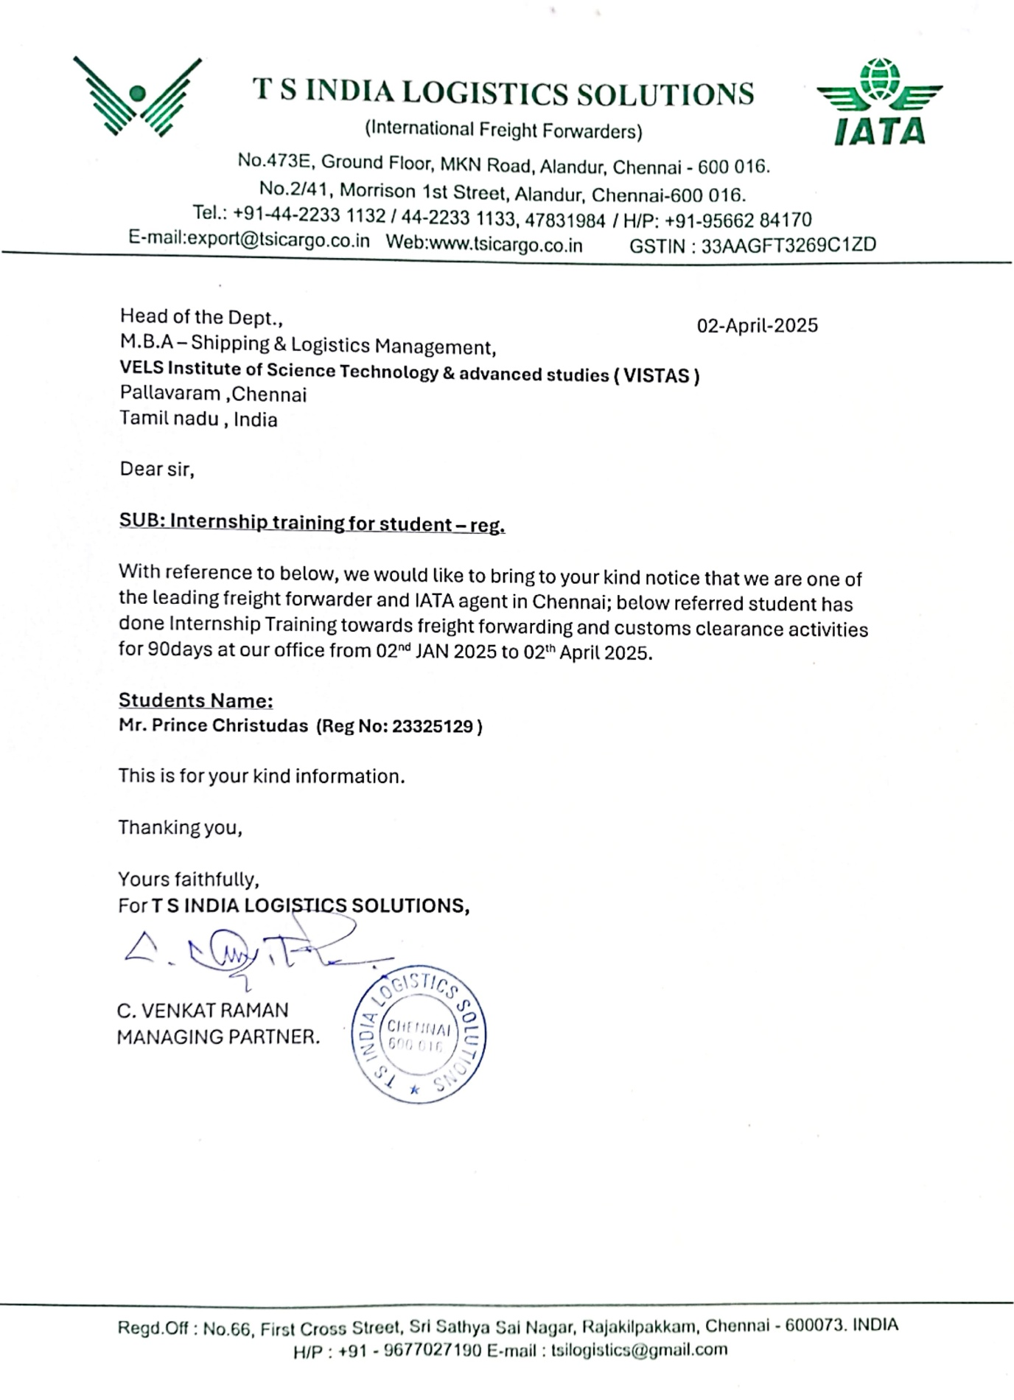

**DECLARATION**

I **PRINCE CHRISTUDAS**, **(23325129)** a student of MBA Shipping and Logistics Management, **Department of Management Studies**, **SCHOOL OF MANAGEMENT STUDIES, VISTAS** here by, declare that the Internship work titled **“EFFECTIVENESS OF DANGEROUS GOODS PACKAGING IN AIR TRANSPORTATION, TS India Logistics Solution”,** submitted to the **VISTAS** in partial fulfilment of the requirement for the award of the degree of **MASTER OF BUSINESS ADMINISTRATION - SHIPPING AND LOGISTICS MANAGEMENT** is a record of bonafide research carried out by me under the guidance of **DR.D.ANITHA KUMARI,** **Programme Coordinator, SCHOOL OF MANAGEMENT STUDIES, VISTAS** and no part of it has been submitted for any other degree or diploma.

**Place: Chennai (PRINCE CHRISTUDAS)**

**Date:**

**ACKNOWLEDGEMENT**

I am very much grateful to our Chancellor **Dr. Ishari K Ganesh,** **Dr. A. Jothi Murugan**, Pro Chancellor – Planning & Development, **Dr. Arthi K Ganesh**, Pro Chancellor – Admin and **Dr. Preethaa Ganesh**, Vice President, Vels Group of Institutions for giving us an opportunity to study and encouraged us in all our efforts throughout the program.

I would like to express my deep gratitude to our Vice Chancellor **Dr.S.Sriman Narayanan,** Pro Chancellor **Dr. M. Bhaskaran,** our Registrar **Dr. P.Saravanan** and **Dr. A. Udayakumar**, Controller of Examinations for all their endeavor in educating us in this esteemed organization.

I wish to express my gratefulness to **Dr.Jayasree Krishnan**, Director, and **Dr. P G Thirumagal**, Head of the Department , **Dr.D.Anitha Kumari,** Programme Coordinator MBA Shipping and Logistics Management for the encouragement and guidance. I wish to express my humble thanks to my guide **Dr.D.Anitha Kumari,** Programme Coordinator MBA Shipping and Logistics Management, VISTAS, for her guidance in the Project and to all faculty members and who mentored and made us learn about managing ourselves and business organizations I am indebted to my company/Organization **Mr. C. Venkatraman, Managing Partner, TS India Logistics Solution, Alandur, Chennai.**

I also express my heartfelt thanks to My Parents, Family members and all my friends for their precious advice, continuous encouragement and support and for all the help they have conducted to me which facilitated to the completion of this work.

**INDEX**

|  |  |  |
| --- | --- | --- |
| **CHAPTER NO.** | **TITLE** | **PAGE NO:** |
| I | INTRODUCTION | 2 |
| 1.1 INDUSTRY PROFILE | 11 |
| 1.2 COMPANY PROFILE | 25 |
| 1.3 NEED/IMPORTANCE OF STUDY | 33 |
| 1.4 STATEMENT OF THE PROBLEM | 37 |
| 1.5 OBJECTIVES | 39 |
| 1.6 SCOPE OF THE STUDY | 40 |
| II | REVIEW OF LITERATURE | 42 |
| III | RESEARCH METHODOLOGY | 46 |
| 3.1 RESEARCH DESIGN | 46 |
| 3.2 SAMPLE SIZE | 48 |
| 3.3 SAMPLING TECHNIQUE | 49 |
| 3.4 QUESTIONNAIRE DESIGN | 50 |
| 3.5 METHODS OF DATA COLLECTION | 51 |
| 3.6 LIMITATION OF STUDY | 52 |
| IV | DATA ANALYSIS & INTERPRETATION | 55 |
| V | FINDINGS AND SUGGESTIONS | 76 |
| CONCLUSION | 80 |
|  |  |  |
|  | BIBLIOGRAPHY | 81 |
|  | APPENDIX | 82 |

**CHAPTER I**

**INTRODUCTION**

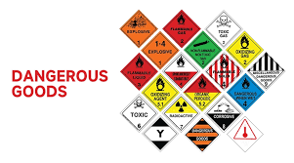This report deals about Effectiveness of Dangerous Goods Packaging in Due to its ability to link markets globally and facilitate the quick flow of commodities, air transportation is essential for international trade and logistics. Dangerous goods (DG) are one of the most difficult items to convey by air. These are compounds or materials that present hazards to property, health, safety, or the environment while in transit because of their hazardous qualities. Chemicals, explosives, radioactive materials, flammable liquids, gasses, and biological agents are examples of dangerous commodities. Due to their nature, specific rules and protocols are required to guarantee their incident-free and safe transportation.

Source: https://img.seabaycargo.com/article/202304/Dangerous%20Goods.webp

Dangerous goods are materials or substances that present a major threat to health, safety, property, or the environment when not handled, stored, or transported correctly. These goods are strictly regulated to ensure that their risks are properly identified and managed, minimizing the hazards associated with their movement and storage. Dangerous goods can include chemicals, gases, explosives, flammable liquids, toxic substances, radioactive materials, and other items that may cause harm.

The transportation of dangerous goods is governed by numerous national and international regulations to maintain public safety. On a global scale, organizations like the United Nations (UN), the International Maritime Organization (IMO), the International Civil Aviation Organization (ICAO), and national authorities such as the U.S. Department of Transportation (DOT) or the European Union’s ADR, play key roles in establishing safety standards for the transportation and handling of dangerous goods.

This study focuses on the vital aspect of packaging dangerous goods in air transport, analyzing the current standards, methods, and practices that ensure safe and efficient handling. Packaging is not just about containing the goods; it must also comply with strict regulations designed to reduce the risks of handling, storage, and transportation. Proper packaging is crucial to prevent spills, leaks, or dangerous reactions that could jeopardize the aircraft, crew, or passengers.

The significance of correct packaging cannot be overemphasized. Failures in packaging or non-compliance with international regulations can result in catastrophic accidents, including fires, explosions, or contamination. Mishandling of dangerous goods has historically caused major financial losses, environmental harm, and loss of life. As air travel becomes more integral to global supply chains, the need for a comprehensive and effective approach to packaging dangerous goods has grown.

Source: https://i0.wp.com/chem-tran.com/wp-content/uploads/2019/09/img_splash-pic.png?w=570&ssl=1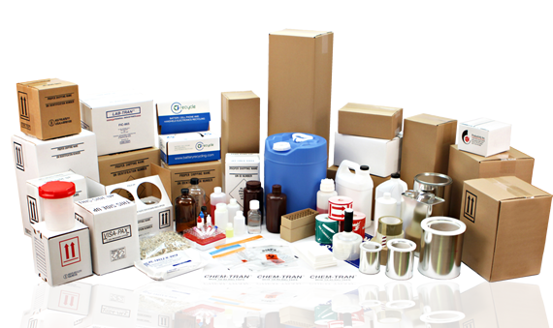

Packaging plays a vital role in logistics, serving several functions that ensure the smooth and efficient movement of goods through the supply chain. The most obvious purpose of packaging is to protect products from damage during transit, handling, and storage. Proper packaging safeguards items against physical harm such as scratches, dents, or breakage, and protects them from environmental factors like moisture, temperature fluctuations, and contamination. Without adequate protection, products may be rendered unsellable or unsafe, leading to financial losses and customer dissatisfaction.

In addition to protection, packaging is crucial for efficient handling and storage. Standardized and well-designed packaging allows for better stacking, optimizing warehouse space, and enabling easier transportation. When goods are packaged effectively, they take up less space, reducing storage costs and maximizing container capacity. This can also translate into lower transportation expenses, as fewer shipments may be required to move the same volume of goods. Moreover, efficient packaging reduces the risk of product damage, which further minimizes the need for replacements or returns.

Packaging also serves as a key marketing tool, providing an opportunity for branding and differentiation. Attractive packaging can influence consumer perceptions, encourage purchases, and enhance brand identity. Beyond aesthetics, packaging ensures compliance with regulatory requirements, especially for hazardous materials, perishable goods, or products that need specific handling instructions. It includes necessary labeling, safety information, and sometimes tracking systems, all of which contribute to safe and legal distribution.

With increasing environmental concerns, sustainable packaging has become a priority for many businesses. Using recyclable or biodegradable materials not only supports sustainability but can also improve a company’s reputation and appeal to environmentally-conscious consumers. Additionally, packaging often includes technologies such as barcodes, QR codes, and RFID tags, which improve inventory tracking and security, preventing theft and ensuring efficient management. Thus, packaging is a multifaceted tool that is essential for effective and secure logistics operations.

With the expansion of global trade and the increasing diversity of materials transported by air, the complexities of dangerous goods transportation have grown. From pharmaceuticals to hazardous waste, these goods come in various forms, each presenting unique risks. As air cargo volumes rise, the logistics of transporting these materials must become more sophisticated and safety-focused. This evolving environment calls for continuous improvements in systems, processes, and technologies involved in dangerous goods packaging to avoid disastrous accidents.

The specialized nature of dangerous goods packaging requires expert knowledge and skills. Packaging must be designed to prevent the accidental release of hazardous materials and ensure compliance with regulations governing air transport. The materials used must withstand air transport's physical conditions—such as temperature shifts, pressure changes, and vibrations—while ensuring secure containment throughout the journey. Additionally, packaging must meet safety standards and facilitate proper labeling, documentation, and marking to adhere to regulatory requirements.

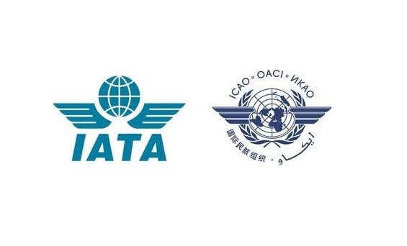The global nature of air transport presents a challenge in standardizing practices and regulations across countries. While international standards, such as those set by ICAO and IATA, exist, differences in national regulations can lead to inconsistencies in packaging practices, potentially causing confusion and errors. As air transport hubs are spread worldwide, the need for universal compliance and standardized procedures is more critical than ever.

Source: https://eturbonews.com/wp-content/uploads/2020/08/0a1-92.jpg

The rising use of new and potentially more hazardous materials, like lithium batteries, adds another layer of complexity. Lithium-ion batteries, commonly used in electronic devices, pose significant fire risks if improperly packed or handled. This has spurred innovations in packaging, focusing on improving safety and operational efficiency. Modern solutions include fire-resistant containers, shock-absorbent materials, and advanced monitoring systems to better track conditions during transport.

As regulations evolve and companies adjust to new standards, packaging remains a crucial element of a comprehensive risk management strategy. Effective training for employees, from packaging specialists to cargo handlers, is essential to ensure everyone involved in the process understands the risks and adheres to best practices.

This research will examine the key challenges related to dangerous goods packaging in air transport, assessing current methods, materials, and regulations. The study will identify trends, gaps, and areas for improvement, with special attention given to emerging technologies like automation, sensors, and predictive analytics, which can enhance safety and efficiency in transporting hazardous materials by air.

By exploring dangerous goods packaging, this study aims to offer valuable insights to professionals, policymakers, and stakeholders in aviation and logistics. The ultimate goal is to reinforce safety, compliance, and risk mitigation while laying the groundwork for advancements in air transportation practices. Through a deeper understanding of the complexities of dangerous goods packaging, this research seeks to contribute to safer and more effective air transport systems for hazardous materials.

Dangerous goods are materials or substances that, if mishandled or inadequately packaged, can lead to serious harm to people, infrastructure, aircraft, and the environment. These include, but are not limited to, flammable liquids, corrosives, explosives, gases, radioactive substances, and biologically hazardous materials. Given their hazardous nature, these goods are subjected to comprehensive regulatory oversight, with international bodies like the International Civil Aviation Organization (ICAO), the International Air Transport Association (IATA), and other national authorities outlining precise guidelines to ensure their secure transit.

One of the fundamental components ensuring the safety of dangerous goods during air transport is packaging. Unlike general cargo, packaging for dangerous goods must do more than simply contain or protect items from physical damage. It must act as a primary safety barrier between the hazardous material and the external environment. This packaging must be robust, resilient to pressure variations, capable of withstanding impact, and impermeable to leaks or spills. Each type of dangerous good has specific packaging requirements, depending on its classification, chemical behavior, and interaction with environmental conditions commonly encountered during flight.

The design and selection of appropriate packaging materials is a science in itself, requiring a thorough understanding of the properties of hazardous substances. Factors such as chemical compatibility, resistance to corrosion, absorption capability, and temperature tolerance must be taken into consideration when selecting packaging solutions. For instance, the packaging of radioactive materials involves the use of shielding containers with specialized markings and labels, while flammable liquids require leak-proof, pressure-resistant containers that minimize the risk of ignition.

Moreover, dangerous goods packaging is more than a physical enclosure—it is part of a holistic safety protocol that includes labeling, documentation, handling instructions, and employee training. International air transport regulations mandate the use of standardized symbols, warning labels, and color codes on DG packaging, which communicate vital information at a glance to all stakeholders in the supply chain. Proper documentation, such as the Shipper’s Declaration for Dangerous Goods, ensures legal compliance and assists in emergency response planning in case of an incident.

One of the modern challenges in the field is the emergence of new high-risk materials, such as lithium-ion batteries. These batteries, ubiquitous in electronics and increasingly used in electric vehicles, have been implicated in several air cargo incidents due to their propensity to overheat and ignite under stress or when damaged. As a result, innovations in packaging design have become more urgent than ever. Fire-retardant containers, thermal insulation liners, pressure-release valves, and shock-resistant casings are now being developed and deployed to mitigate these risks.

The role of technology in advancing dangerous goods packaging has also gained prominence. Smart packaging systems now incorporate sensors that monitor temperature, humidity, impact, and even chemical leaks in real-time. These sensors can transmit alerts if conditions fall outside safe parameters, allowing for immediate action. Additionally, the integration of Internet of Things (IoT) technologies and predictive analytics tools has made it possible to assess and forecast risk levels throughout the shipment’s journey, enhancing operational preparedness and minimizing the likelihood of accidents.

However, despite these advancements, inconsistencies in global compliance remain a significant hurdle. While ICAO and IATA provide unified frameworks for dangerous goods transport, discrepancies in the interpretation and implementation of these regulations at the national level often result in gaps in enforcement and varying levels of safety assurance. This lack of standardization complicates the logistics of international shipments and increases the risk of packaging-related failures due to miscommunication or non-compliance with the specific legal requirements of different jurisdictions.

Furthermore, human factors cannot be overlooked. The effectiveness of packaging is heavily influenced by the knowledge and skills of personnel involved in packaging, labeling, and handling dangerous goods. Inadequate training, oversight, or misinterpretation of protocols can compromise the integrity of even the most sophisticated packaging systems. Therefore, investing in continuous professional development, simulation-based training, and certification programs is essential to uphold safety standards across the industry.

In examining the broader implications, the economic, environmental, and reputational stakes of dangerous goods packaging failures are immense. Accidents can disrupt flight schedules, cause cargo damage, harm personnel, and lead to environmental contamination. Moreover, the financial costs associated with such incidents—ranging from legal liabilities to brand damage—are substantial. Therefore, beyond regulatory compliance, companies are increasingly adopting risk management strategies that prioritize packaging innovation and safety culture as competitive differentiators.

This research will delve deeper into these themes, evaluating the current landscape of dangerous goods packaging practices in air transport. Through qualitative and quantitative analysis, it will assess regulatory frameworks, case studies of packaging failures and successes, and the adoption of emerging technologies. It aims to highlight both achievements and areas requiring urgent attention, with a view to enhancing safety, efficiency, and sustainability in air cargo operations.

Ultimately, the packaging of dangerous goods is not merely a technical or logistical issue—it is a critical enabler of trust in the global air transport system. By ensuring that hazardous materials are transported safely and responsibly, we protect not only the integrity of the supply chain but also the lives of those who operate within and depend on it. This study, therefore, aspires to contribute meaningfully to ongoing efforts to create safer skies and a more resilient air logistics network.

**1.1 INDUSTRY PROFILE**

The air transportation industry is a crucial part of the global logistics and supply chain network, responsible for handling a wide range of goods. Dangerous goods (DG), however, are materials that can pose serious risks during transportation due to their chemical, physical, or biological properties. These risks include fires, explosions, toxic leaks, radiation exposure, and environmental harm. Because air transport is inherently high-risk, ensuring the safe and compliant packaging of dangerous goods is essential for protecting passengers, crew, cargo, and the environment.

The transport of dangerous goods is governed by strict regulations across various modes of transportation, including air, sea, rail, and road. While regulations may differ by country and transportation method, international guidelines are established to ensure consistency and safety.

**Air Transport:**

The ICAO's Technical Instructions for the Safe Transport of Dangerous Goods by Air set the standards for the safe air transport of hazardous materials. These guidelines cover packaging, labeling, and the necessary documentation to ensure the safe handling of dangerous goods during air travel.

**Sea Transport:**

The International Maritime Dangerous Goods (IMDG) Code governs the transportation of dangerous goods by sea. It provides guidelines for the packaging, labeling, and stowing of dangerous goods aboard ships, ensuring that the risk of accidents is minimized during maritime transport.

**Road and Rail Transport:**

The European Agreement Concerning the International Carriage of Dangerous Goods by Road (ADR) and the Rail Transport Dangerous Goods Regulations (RID) regulate the movement of dangerous goods by land. These regulations are aligned with UN standards and focus on driver training, vehicle specifications, and emergency response procedures to ensure the safe transport of hazardous materials.

The dangerous goods packaging and transportation sector spans several industries, such as aviation, logistics, pharmaceuticals, chemicals, manufacturing, and military supplies. The collaboration among these industries creates a complex network where safety, compliance, and efficiency must be carefully regulated and monitored.

* **Key Industry Players**

The packaging and transport of dangerous goods involves several stakeholders, each playing a crucial role in ensuring safe air transport. These include:

* **Airlines and Cargo Carriers:** Commercial airlines and freight carriers like **FedEx, UPS,** and **DHL** are responsible for safely transporting dangerous goods. They follow strict regulations on packaging, handling, and transport to ensure safety.

Source: https://sareld.wpenginepowered.com/wp-content/uploads/2016/11/Marketing-and-Public-Relation-Strategies-of-Fedex-UPS-and-DHL-1024x262.png

* **Freight Forwarders and Logistics Providers:** These companies coordinate the transportation and handling of dangerous goods, ensuring regulatory compliance and managing the required documentation and labeling.

**Classification of Dangerous Goods**

Dangerous goods are grouped into different categories depending on their particular hazards. The UN classification system divides them into nine classes, each with unique properties and safety considerations. Below is an overview of the key categories:

**Class 1: Explosives**



Source: https://www.casa.gov.au/sites/default/files/2022-01/dangerous-goods-class-1-explosives.png

This class covers materials capable of exploding or reacting violently under specific conditions. Examples include dynamite, fireworks, and blasting agents. These are further divided into divisions based on the type of hazard they present, such as mass explosion or projectile risks.

**Class 2: Gases**



Source: https://www.casa.gov.au/sites/default/files/2022-01/dangerous-goods-class-2-gases.png

Gases are categorized into three divisions: flammable, non-flammable, and toxic. Examples include compressed gases like propane, ammonia, and oxygen. They pose significant fire, explosion, or toxicity risks if released.

1. **Division 2.1**

flammable gases such as:

* butane
* propane

1. **Division 2.2**

non-flammable, non-toxic gases such as:

* oxygen
* liquid nitrogen
* compressed air

1. **Division 2.3**

toxic gases such as:

* chlorine
* hydrogen sulphide.

**Class 3: Flammable Liquids**



Source: https://www.casa.gov.au/sites/default/files/2022-01/dangerous-goods-class-3-flammable-liquids.png

Liquids with a flashpoint below 60°C (140°F) fall into this category, including fuels, solvents, and oils. These substances are highly flammable and can ignite easily, leading to fires or explosions in enclosed areas.

**Class 4: Flammable Solids,**

(Spontaneously Combustible Materials, and Materials that are Dangerous When Wet)



Source: https://www.casa.gov.au/sites/default/files/2022-01/dangerous-goods-class-4-flammable-solids.png

This class includes solids that can spontaneously combust or release flammable gases upon contact with water. Examples include matches, phosphorus, and sodium.

1. **Division 4.1**

flammable solids such as:

* hexamine solid fuel tablets for camping stoves
* self-reactive substances
* desensitised explosives

1. **Division 4.2**

substances that can spontaneously combust under normal air transport conditions include:

* camphor
* sulphur
* matches

1. **Division 4.3**

substances that emit flammable gases when they come into contact with water include:

* sodium
* zinc particles
* activated carbon.

**Class 5: Oxidizing Substances and Organic Peroxides**



Source: https://www.casa.gov.au/sites/default/files/2022-01/dangerous-goods-class-5-oxidising-substances-organic-peroxides.png

Oxidizing substances can promote or enhance the combustion of other materials, while organic peroxides are highly reactive. Examples include hydrogen peroxide, chlorine, and ammonium nitrate.

1. **Division 5.1**

oxidising substances that may not be necessarily combustible, but they may readily yield oxygen and cause other materials to combust, such as:

* hydrogen peroxide
* ammonium nitrate
* potassium chlorate
* sodium nitrate

1. **Division 5.2**

organic peroxides are thermally unstable and can emit heat and give off harmful or flammable vapours. They can also be liable to explosive decomposition and react dangerously with other substances. Examples are:

* acetyl acetone peroxide
* benzoyl peroxide
* peracetic acid.

**Class 6: Toxic and Infectious Substances**



Source: https://www.casa.gov.au/sites/default/files/2022-01/dangerous-goods-class-6-toxic-infectious-substances.png

This class includes materials that are toxic or infectious, such as cyanides, poisons, and medical waste with infectious agents, all of which pose significant risks to health or the environment.

1. **Division 6.1**

toxic substances that can cause death, injury or to harm human health if swallowed, inhaled or by skin contact, such as:

* chloroform
* arsenics
* cyanides
* cytotoxic waste
* barium compounds
* pesticides

1. **Division 6.2**

infectious substances that contain or are expected to contain pathogens that can cause disease in humans or animals, including:

* medical or clinical waste
* patient specimens
* genetically modified organisms
* infectious substances
* infected animals.

**Class 7: Radioactive Materials.**



Source: https://www.casa.gov.au/sites/default/files/2022-01/dangerous-goods-class-7-radioactive-materials.png

Radioactive materials emit ionizing radiation, which can lead to serious health issues like cancer or radiation burns. Examples include uranium, radioactive ores, isotypes, radium, cesium, x-ray equipment, medical equipment or parts.

**Class 8: Corrosive Substances**



Source: https://www.casa.gov.au/sites/default/files/2022-01/dangerous-goods-class-8-corrosives.png

Corrosive materials can damage living tissue or materials they contact. This class includes acids like sulfuric acid and alkalis such as sodium hydroxide, which are commonly used in various industries.

**Class 9: Miscellaneous Dangerous Goods**



Source: https://www.casa.gov.au/sites/default/files/2022-01/dangerous-goods-class-9-miscellaneous.png

This category includes substances that pose various risks but do not fit into the other categories. Examples include dry ice, asbestos, and lithium batteries, each regulated according to their specific hazards.

**Handling labels**

Along with hazard labels, trained personnel must apply handling labels when necessary. These four handling labels should be used in conjunction with the corresponding hazard labels as required.

**Cargo Aircraft Only:**

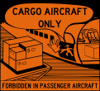

Source: https://www.casa.gov.au/sites/default/files/2023-03/cargo-aircraft-only.png

Used to indicate that the load cannot be transported on a passenger aircraft, and must be carried on a cargo aircraft.

**Cryogenics:**



Source: https://www.casa.gov.au/sites/default/files/2023-03/contains-crogenic-liquid.png

Applied to containers holding liquefied gases, such as those in Class 2, to indicate the presence of cryogenic liquids.

**This Way Up:**



Source: https://www.casa.gov.au/sites/default/files/2023-03/This-way-up.png

Used for ensuring the correct orientation of the load during transport. This label can be used for non-dangerous goods as well.

**Magnetized Material:**



Source: https://www.casa.gov.au/sites/default/files/2023-03/magnetized-materials.png

Indicates that the load is magnetized and should be kept away from aircraft compass detector units during loading and unloading.

* **Regulatory Bodies and Standards Organizations:**
* **International Civil Aviation Organization** **(ICAO):**

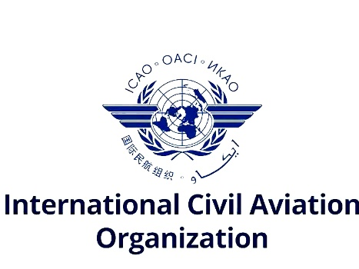

Source: https://www.indiastrategic.in/wp-content/uploads/2024/08/ICAO_Logo-300x225.jpg

ICAO sets global standards for safely transporting dangerous goods by air, including regulations in the Technical Instructions for the Safe Transport of Dangerous Goods by Air.

* **International Air Transport Association (IATA):**



Source: https://unitingaviation.com/wp-content/uploads/2017/05/iata-cmyk-300x186.png

IATA collaborates with ICAO and provides guidelines and training through its Dangerous Goods Regulations (DGR) manual.

* **National Authorities:**

Countries may have national bodies, such as the FAA in the U.S., that enforce regulations like the Code of Federal Regulations (CFR) Part 175.

* **Packaging Suppliers and Manufacturers:** These suppliers produce packaging solutions designed to prevent leakage, explosions, or fires, ensuring the safe transport of hazardous goods.
* **Training and Certification Organizations:** Organizations like IATA, ICAO, and other industry bodies offer training and certification programs to ensure professionals are equipped with the knowledge to manage dangerous goods safely.
* **Key Aspects of Dangerous Goods Packaging**

Proper packaging is the first line of defense in mitigating risks during air transportation. Key aspects of dangerous goods packaging include:

* **Materials:** Packaging materials must be robust enough to endure air transport conditions. Common materials include steel drums, fiberboard boxes, plastic containers, and fire-resistant packaging, selected based on the specific hazards of the goods being transported.
* **Marking, Labeling, and Documentation:** Packages must be clearly labeled with appropriate symbols and warnings indicating the hazards they present. Proper documentation, such as the Dangerous Goods Declaration (DGD), is required for regulatory compliance.
* **Segregation and Compatibility:** Packaging must ensure that incompatible materials are kept separate to prevent dangerous reactions. For instance, flammable materials should be stored apart from oxidizing agents.
* **Hazardous Material Classification:** Packaging design is based on the classification of the dangerous goods, considering their chemical composition, reactivity, toxicity, or other properties like flammability or radioactivity.
* **Leakage Prevention:** Packaging must prevent leakage under both normal and emergency conditions, using secure seals and absorbent materials to manage potential spills.
* **Size and Weight Considerations:** Packaging must comply with weight restrictions set by air carriers. Larger or heavier packages may require special handling.
* **Regulations Governing Dangerous Goods Packaging**

The regulatory framework for dangerous goods packaging is comprehensive, involving various international and national bodies. Key regulations include:

* **ICAO Technical Instructions:** These guidelines set out how dangerous goods should be classified, packaged, and documented for air transport, including packaging testing and performance standards.
* **IATA Dangerous Goods Regulations (DGR):** IATA’s DGR manual builds on ICAO’s guidelines, offering detailed instructions for classification, packaging, labeling, and documentation.
* **UN Recommendations on the Transport of Dangerous Goods:** The UN provides a global framework for classifying and labeling dangerous goods, which forms the foundation of international transport standards.
* **Local Regulatory Bodies:** Each country enforces its own regulations, which may align with or exceed ICAO and IATA standards. For example, the U.S. FAA enforces guidelines under the 49 CFR Part 175.
* **Emerging Trends and Challenges in Dangerous Goods Packaging**

As the air transport industry evolves, several trends and challenges are shaping the future of dangerous goods packaging:

* **Technological Innovations:** New technologies, like smart sensors, fire-resistant materials, and automated monitoring systems, are being incorporated into packaging to improve safety, efficiency, and tracking. Temperature-controlled containers and impact-detection devices are becoming more common.
* **Lithium Batteries and E-Commerce Growth:** The rise of e-commerce and the increased use of lithium-ion batteries in consumer electronics and electric vehicles present new challenges. Lithium batteries require specific packaging standards to prevent overheating and combustion, prompting the development of fire-resistant containers and enhanced labeling.
* **Regulatory Harmonization:** While international standards from ICAO and IATA are widely recognized, differences in national regulations remain a challenge. Efforts to harmonize regulations across borders continue, but non-compliance and confusion are still common issues.
* **Sustainability Concerns:** The push for eco-friendly packaging is influencing the dangerous goods packaging industry. While sustainable solutions, like recyclable and biodegradable materials, are becoming more popular, they still need to meet stringent safety and regulatory standards.

**1.2 COMPANY PROFILE**



TS India Logistics Solution is a global freight forwarding company established in 2010, with the goal of delivering reliable, cost-efficient services for export and import shipments from any location around the world. The company offers customized freight packages at competitive prices, designed to meet the specific service requirements of each shipment.

Recognized as one of the leading organizations in the logistics industry, TS India possesses the necessary resources to manage all aspects of global logistics for its clients, providing an extensive range of value-added services. Whether handling commercial cargo, personal effects, or household items, TS India ensures it offers the most optimal shipping solutions for each client. The company provides services at all levels, including Ex-Works or FOB to Door-to-Door (DDU or DDP), based on the terms of sale with the buyer or supplier.

TS India prides itself on delivering cost-effective, timely, and top-notch logistics solutions. Through its well-trained and motivated team of experts, the company guarantees its clients experience sustained growth and overall success. No matter whether you are exporting or importing goods, you can trust that TS India will handle your freight in a professional manner, ensuring it reaches its destination securely and on time, every time.

Thanks to exclusive partnerships and a collaborative approach, TS India is able to offer dedicated, confirmed space during all seasons, ensuring reliable service year-round. Additionally, the company provides transport and warehousing facilities, helping to meet all of its customers' logistics needs effectively.

TS India Logistics Solution possesses extensive expertise and experience in providing freight forwarding solutions. They have built a well-coordinated and resourceful global network of agents, allowing them to efficiently manage shipments worldwide. The company arranges shipments across all modes of transport, ensuring flexibility and efficiency for their clients. They handle both import and export operations through all major sea and air ports in India. TS India’s comprehensive freight forwarding services cover destinations around the globe, offering a wide-reaching network to meet the diverse needs of their customers.

TSILS will source and manage the most suitable freight package at the best possible price. Their goal is to provide fair pricing, efficient services, and quick responses. With a well-established global network and the expertise of professionals, they offer a range of logistical services to customers, including:

* **AIR FREIGHT**

The transportation of goods via airplanes. It is the fastest mode of international shipping, ideal for time-sensitive shipments. However, it is generally more expensive than sea freight.

* **SEA FREIGHT**

Shipping goods via cargo ships across oceans. It is cost-effective for bulk shipments but takes longer compared to air freight. Common methods include Full Container Load (FCL) and Less than Container Load (LCL).

* **CUSTOMS CLEARANCE**

The process of getting goods approved by customs authorities when importing or exporting. This includes documentation, duties, and taxes to ensure compliance with international trade regulations.

* **TRANSPORTATION**

The movement of goods from one location to another using various modes like trucks, trains, ships, or aircraft. It can be part of domestic or international logistics.

* **WAREHOUSING**

The storage of goods in a facility before distribution. Warehouses can be used for inventory management, order fulfillment, and value-added services like packaging and labeling.

* **DOOR-TO-DOOR SERVICES**

A complete logistics solution where goods are picked up from the sender’s location and delivered directly to the recipient’s address. This service reduces handling and ensures faster deliveries.

* **INSURANCE**

Coverage that protects goods from damage, theft, or loss during transit. It provides financial security for businesses and individuals involved in shipping.

* **DOMESTIC CARGO**

The transportation of goods within a single country, using trucks, trains, or domestic flights. It involves local regulations and is usually quicker than international shipping.

* **POST-SHIPMENT FOLLOW-UP**

The tracking and monitoring of shipments after dispatch to ensure they reach their destination on time. It also includes handling claims, documentation, and customer service support for any issues.

**VISSION, MISSION, ORGANIZATIONAL CHART**

TS India Logistics Solutions is a forward-thinking logistics provider committed to becoming the top choice in the region, delivering services that prioritize speed, safety, and dependability. Our goal is to be the leading logistics partner by consistently surpassing customer expectations.

Focused on customer satisfaction, we offer customized logistics solutions tailored to the specific needs of each client. We are dedicated to ongoing improvement, continually enhancing our processes through a comprehensive Quality Management System to ensure exceptional service.

At TS India Logistics Solutions, we also place great importance on the well-being and career development of our employees. We foster a work environment that prioritizes safety, job satisfaction, and overall well-being, which not only contributes to superior service delivery but also creates a motivated and dedicated team to serve our clients.

Whether it involves road, air, or sea freight, we are committed to delivering each logistics solution with precision, reliability, and a keen attention to detail. Our dedication to excellence drives everything we do, reinforcing our reputation as a trusted logistics partner.

* **VISION:**

Aim to become the preferred logistics service provider in the region by providing the fastest, safest, and trustworthy services to our customer.

* **MISSION:**
* To provide tailor made solutions to our valued customer.
* Continuous improvement of our service through Quality Management System.
* Career focused and safe working condition for all our personnel, under better environment
* **ORGANIZATIONAL CHART**

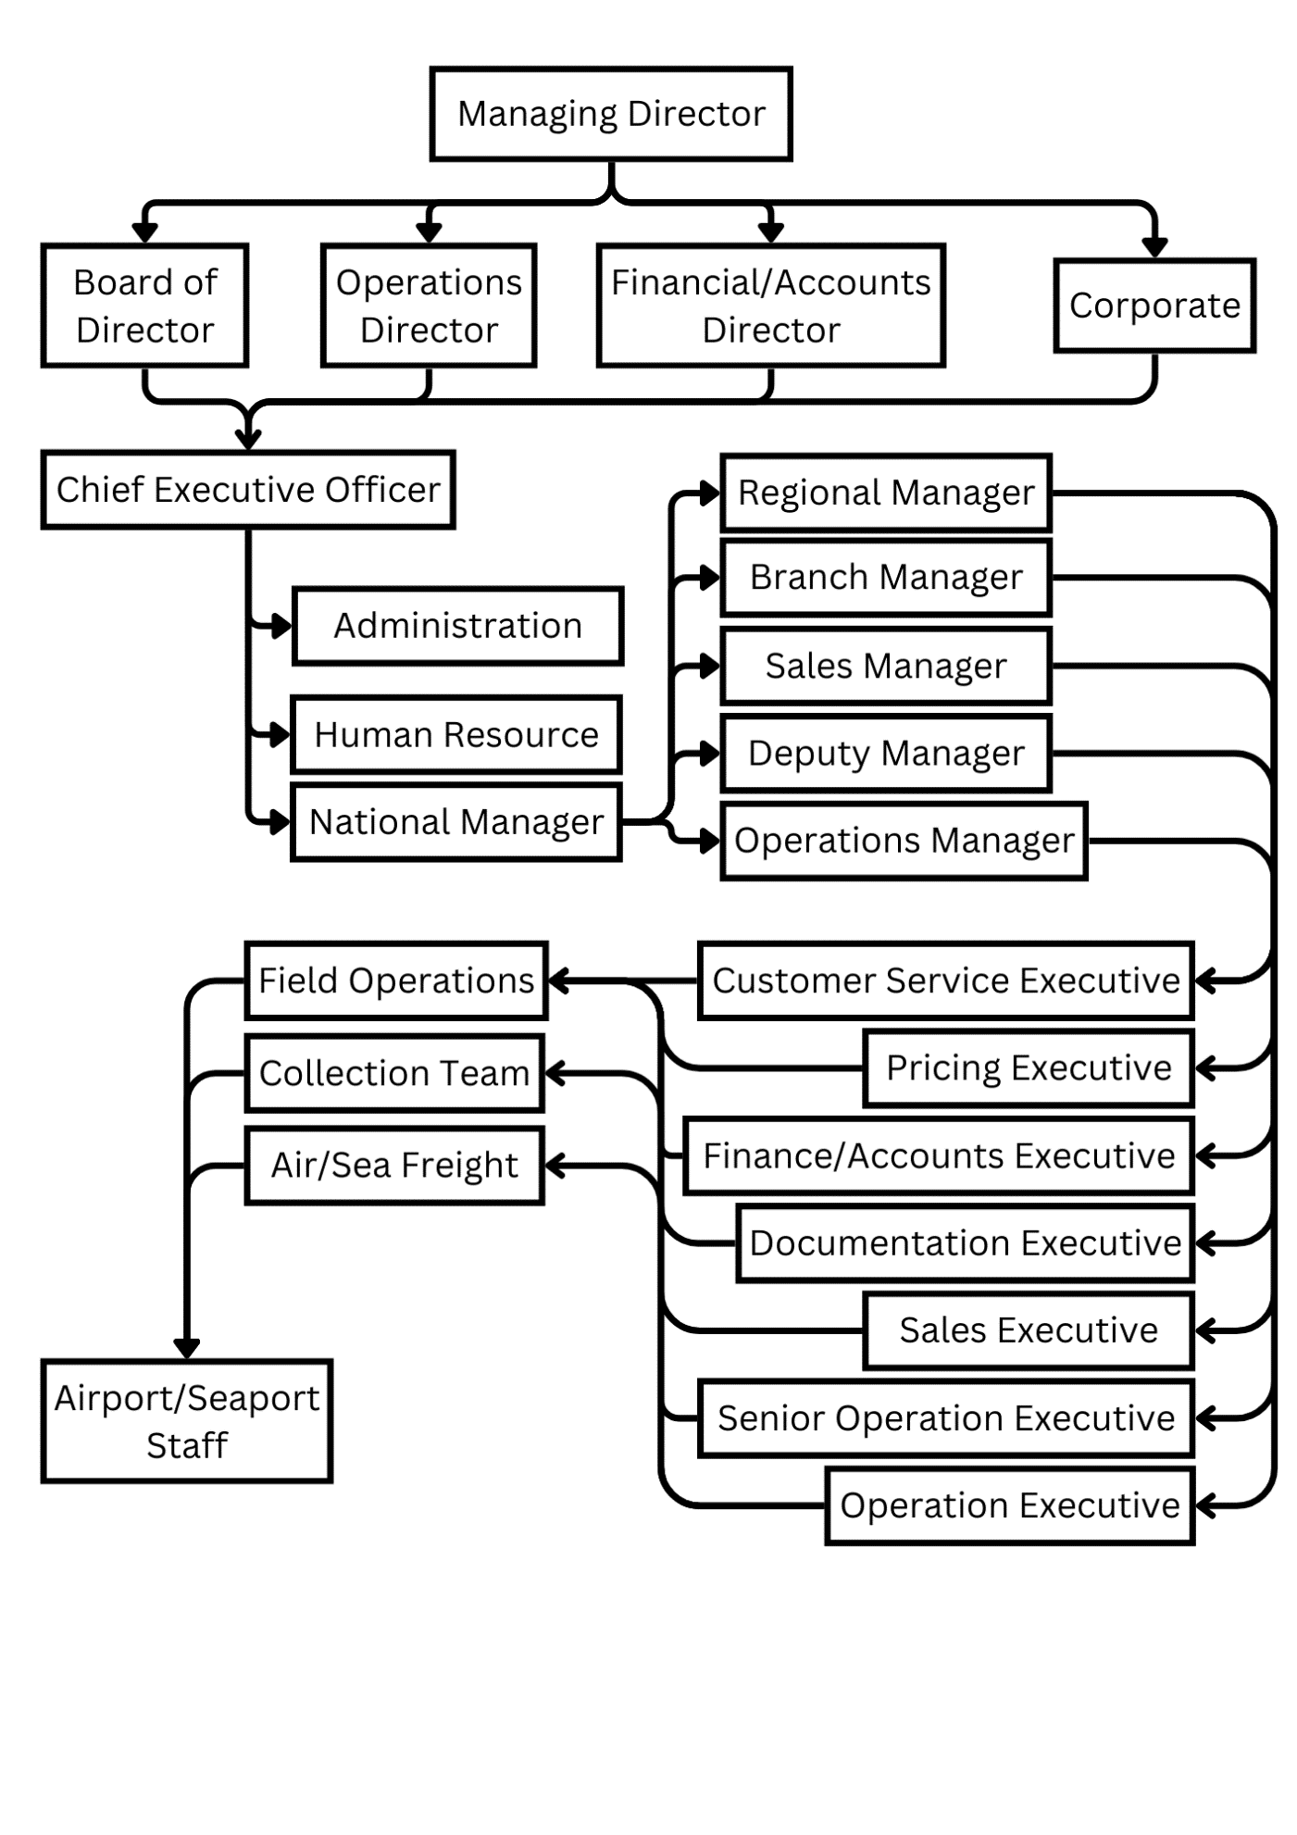

**PRODUCTS AND SERVICES**

* **AIR FREIGHT**

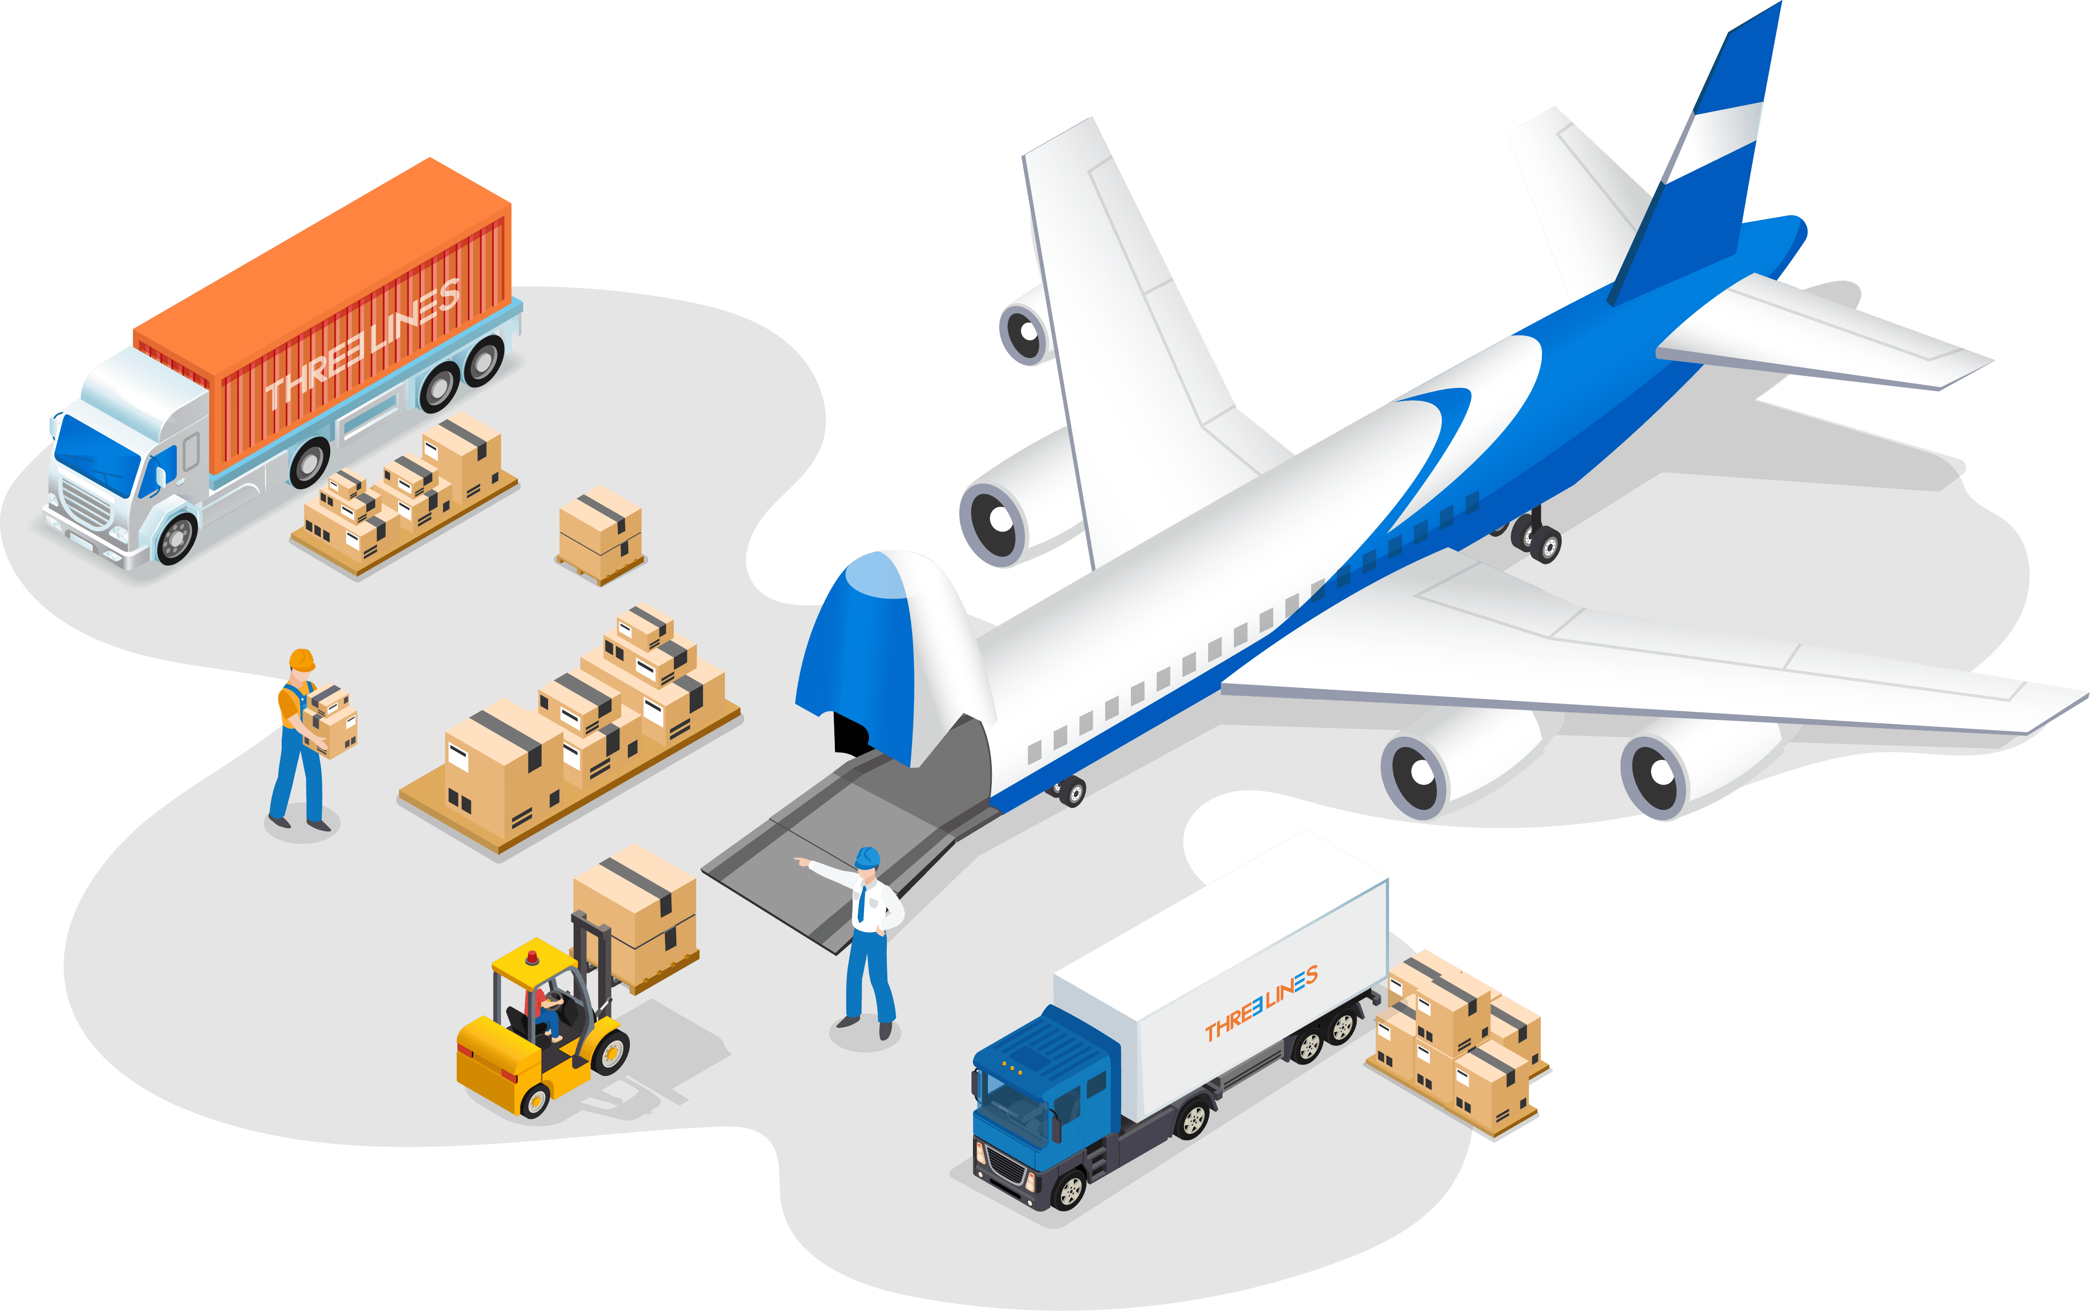

https://threelineshipping.com/wp-content/uploads/2022/09/air-freight-1-1024x643.png

**EXPORT** – TSILS is an IATA-accredited cargo agent and a member of one of the fastest-growing worldwide networks. The company is fully equipped to handle a wide range of cargo, including textiles, auto parts, engineering goods, perishables, leather products, pharmaceuticals, temperature-controlled cargo, live animals, dangerous goods (DG), and ODC cargo.

**IMPORT** – TSILS has the capability to serve customers globally, thanks to its extensive worldwide network. They offer competitive rates along with excellent service, arranging consolidation of import consignments from all continents to any airport in India. The team is highly experienced in preparing advance manifests and providing customers with arrival status updates.

* 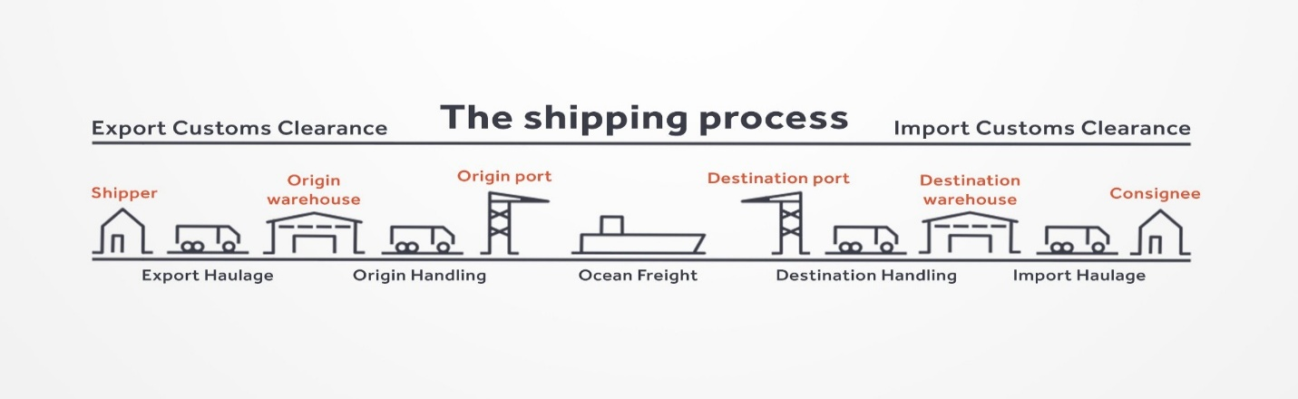**SEA FREIGHT**

Source: https://transporteca.co.uk/wp-content/uploads/2017/03/ShippingProcess-8-1024x366.jpg

Their well-trained and highly experienced team provides services for both LCL and FCL shipments, offering options for direct boxes and transshipment services based on customer requirements. The team is fully qualified to deliver accurate information and solutions promptly for any queries customers may have.

They manage shipments through major ports such as Chennai, Cochin, Kolkata, Mundra, Nhavasheva, Tuticorin, and Vizag, as well as other ICD locations including Ahmedabad, Bengaluru, Garhi Harasaru, Indore, New Delhi, and Pune. Additionally, they handle dry port shipments with the support of all major shipping lines and have service contracts with them.

The company also manages shipments for clients such as M/s. Grasim Bhiwani India, M/s. Banswara Textiles, and M/s. Reliance Industries, along with handling familiar cargo including auto parts, machinery, medical items, leather products, foodstuffs, and fabrics.

* **CUSTOM BROKERAGE (CB)**

They provide efficient and expedited customs clearance and delivery services for both import and export shipments. Additionally, they arrange for bonding, storage, and ex-bonding of cargo.

* **MARINE INSURANCE**

They provide Marine Insurance for both export and import shipments through leading insurance companies in India. With these value-added services, they offer a complete range of solutions under one roof for their customers.

* **TRANSPORTATION**

TSILS handles all types of transportation activities across India, offering vehicles of various sizes to meet customer requirements, along with arrangements for pickup and delivery. With a strong supply chain solution in place, they are able to design transportation systems that provide competitive rates and cost-effective solutions for consolidating cargo pickups.

* **WAREHOUSING**

They offer general transit warehousing and 3PL warehousing services, which include processes such as cargo staging, segregation by SKU, inbound scanning, data entry, stock management, and replenishment planning.

They implement thorough quality control measures to ensure the correct SKU and quantity are maintained. Each TSILS-linked warehouse is equipped with a high-quality packing team skilled in using the latest packing technologies, ensuring safe cargo handling. They offer various packing solutions, including palletization, wooden packing, ODC packing, lashing, GOH containers, drum packing, tire packing, onsite packing, blanket wrap, and more.

* **DANGEROUS GOODS CARGO**

Their specialized DG team handles shipments with the utmost care, ensuring priority approval from airlines based on proper documentation.

**1.3 NEED /IMPORTANCE OF STUDY**

**Definition of Dangerous Goods:**

Dangerous goods, often referred to as hazardous materials (hazmat), are substances or items that pose a risk to health, safety, property, or the environment. These materials can take various forms, including solids, liquids, and gases, and can cause harm due to their chemical, physical, or biological properties. The United Nations (UN) has created a globally recognized classification system for dangerous goods, dividing them into nine classes:

The rapid growth of global air cargo operations, coupled with the increasing volume and variety of dangerous goods (DG) being transported, has amplified the importance of ensuring safe and secure packaging methods. Dangerous goods pose inherent risks due to their chemical, physical, or biological properties, which, if not properly managed, can lead to catastrophic consequences such as in-flight fires, chemical spills, explosions, and even loss of life. With the aviation industry facing mounting pressure to maintain high safety standards while facilitating faster delivery, the effectiveness of dangerous goods packaging has become a critical concern.

Despite the existence of strict international regulations set by organizations such as ICAO and IATA, incidents involving the mishandling or improper packaging of hazardous materials continue to occur. These incidents highlight the persistent gaps in compliance, awareness, and technological application across different regions and industry sectors. The need for a more unified, robust, and innovative approach to packaging is pressing—especially with the rise of new and complex materials like lithium-ion batteries that present evolving safety challenges.

Moreover, the effectiveness of DG packaging is not only a matter of regulatory compliance but also of operational efficiency, environmental responsibility, and financial risk mitigation. Improper packaging can lead to product loss, flight delays, cargo damage, reputational harm, and expensive legal consequences. For logistics providers, airlines, and shippers alike, improving packaging effectiveness is a proactive step toward reducing these risks while strengthening supply chain reliability.

This study is also essential in light of emerging technologies such as smart sensors, fire-retardant packaging, and real-time tracking systems, which are beginning to transform how dangerous goods are monitored and handled. However, there is still a lack of comprehensive research evaluating how effectively these innovations are being integrated and what barriers exist to their widespread adoption.

Additionally, the globalization of trade and the variation in national regulatory frameworks create inconsistencies in the enforcement of safety standards. These differences can lead to confusion, inefficiencies, and potential safety breaches. Thus, it becomes crucial to investigate current practices, assess compliance challenges, and identify areas for harmonization and improvement.

By examining the effectiveness of dangerous goods packaging in air transport, this study aims to bridge the knowledge gap, offer data-driven insights, and contribute to the development of safer, more reliable packaging practices. The findings can guide policy-makers, industry professionals, and academic researchers in fostering a culture of safety, innovation, and continuous improvement in the transportation of hazardous materials by air.

**Prevalence and Importance:**

Air transport plays a critical role in the safe and efficient movement of dangerous goods worldwide. The volume of dangerous goods transported by air has grown significantly due to the globalized economy and advancements in air cargo capabilities. According to the International Civil Aviation Organization (ICAO), over 50 million tons of dangerous goods are transported by air annually. This includes essential items such as:

**Pharmaceuticals**: Many life-saving medicines, vaccines, and biologics require air transport for urgent delivery across borders, especially in the case of pandemics or medical emergencies.

**Chemicals**: Various industrial chemicals needed for manufacturing, research, and development are often transported by air due to time-sensitive production cycles.

**Electronics**: Critical components, especially those requiring special handling (e.g., lithium batteries), are shipped by air to meet fast-paced technological demand.

**Emergency Response**: Air transport of dangerous goods includes medical supplies, firefighting materials, and other crucial resources needed during natural disasters or emergency situations.

The swift delivery provided by air transport ensures the timely arrival of hazardous materials that are essential to industries, healthcare, and emergency responders. The reliability of air cargo also enables critical parts and materials to be delivered to assembly lines or factories across the globe.

**Global Scope:**

The air transport of dangerous goods is a truly global endeavor, with hazardous materials crossing international borders on a daily basis. The movement of goods via air is essential for international trade, with numerous regulations and safety protocols in place to prevent accidents and environmental damage. Key factors that contribute to the global scope of this transportation include:

**International Trade**: Dangerous goods are an integral part of global commerce. Whether it's chemicals for manufacturing, pharmaceuticals for healthcare, or electronics for technology companies, many industries rely on the rapid and secure transport of hazardous materials. Air transport enables these goods to reach markets and customers quickly, reducing delays and enhancing global supply chains.

**Cross-Border Transportation**: With the rise of international trade agreements and the interconnectedness of markets, the air transport of dangerous goods has become even more essential. International conventions, such as the International Air Transport Association (IATA) Dangerous Goods Regulations (DGR), ensure a standardized approach to the safe handling, packaging, and documentation of hazardous materials.

**Safety and Regulation**: Global organizations like the United Nations (UN), ICAO, and IATA regulate the air transport of dangerous goods to ensure safety. These organizations create and enforce protocols for packaging, labeling, and transporting hazardous materials to minimize the risks posed during transit. Given the complex nature of air transport, the regulatory framework ensures that these goods are transported safely while minimizing their risk to the public and the environment.

**1.4 STATEMENT OF THE PROBLEM**

The increasing globalization of trade and the growing reliance on air transportation have led to a significant rise in the volume of dangerous goods (DG) being moved by air. These materials—including flammable liquids, toxic substances, corrosive chemicals, radioactive items, and lithium batteries—pose serious threats to the safety of people, property, and the environment if not handled, packaged, and transported correctly. Although international bodies such as the International Civil Aviation Organization (ICAO) and the International Air Transport Association (IATA) have laid down detailed regulations for the air transport of dangerous goods, incidents related to improper packaging and handling continue to occur. This raises major concerns regarding the adequacy and effectiveness of current packaging practices in preventing accidents and ensuring the safety of air cargo operations.

Packaging plays a critical role in mitigating the risks associated with the transport of hazardous materials. It serves not only as a containment solution but also as a protective barrier against leaks, physical damage, environmental exposure, and pressure changes encountered during flight. However, in practice, packaging failures are often reported due to poor material quality, improper design, lack of compliance with regulations, or human error during the packaging process. These failures can result in leakage, fire, or contamination onboard aircraft, putting crew, passengers, and cargo at severe risk.

A particularly challenging issue is the transportation of modern, high-risk goods like lithium-ion batteries, which are widely used in consumer electronics. These batteries are known to overheat or catch fire if not packaged correctly, and incidents involving them have increased in recent years. Despite growing awareness and revised regulations, the number of related accidents suggests that the packaging standards for such materials are either insufficiently implemented or not well understood across the industry.

Moreover, discrepancies between national regulations and inconsistent levels of enforcement create confusion and non-compliance in the global air cargo sector. While ICAO and IATA provide a unified framework, variations in interpretation and implementation at the national level often result in packaging that meets the requirements in one country but fails in another. This lack of harmonization weakens the overall safety structure of dangerous goods transportation.

Additionally, there is limited integration of new technologies—such as smart packaging, fire-resistant materials, and real-time monitoring systems—despite their potential to significantly enhance safety. Coupled with gaps in employee training, awareness, and accountability, this highlights the need for urgent review and improvement of current practices.

Given these concerns, this study seeks to investigate the effectiveness of existing dangerous goods packaging practices in air transportation. It aims to assess how well current packaging methods align with safety standards, address modern risks, and identify areas for innovation and improvement. Without such research, the risk of preventable accidents remains high, endangering lives, property, and the reputation of the global logistics industry.

**1.5 OBJECTIVES OF THE STUDY**

* To analyze the effectiveness of current packaging material used for Dangerous Good in Air Freight.
* To study the impact of packaging weight and dimensions on air cargo’s efficiency and cost.
* To analyze hoe labeling and documentation affect the safe handling of packaged dangerous goods.
* To study the effectiveness of Multi-layered packaging in ensuring safety.
* To access the risk associated with improper packaging and it’s potential consequences.
* To analyze the compliance of existing packaging solutions with international regulations (IATA, ICAO, and UN standards).
* To explore new materials and technologies in dangerous goods packaging, assessing their impact on safety and operational efficiency.
* To identify gaps in the current packaging systems that might contribute to incidents or pose risks during transportation.

**1.6 SCOPE OF THE STUDY**

This study will focus on the packaging methods used for dangerous goods in air transportation, specifically looking at the following aspects:

* **Regulatory Compliance:** Evaluating how well packaging adheres to international regulations such as IATA (International Air Transport Association) Dangerous Goods Regulations (DGR) and ICAO (International Civil Aviation Organization) Technical Instructions.
* **Types of Dangerous Goods:** Assessing packaging for various categories of dangerous goods (e.g., flammable materials, toxic substances, explosives, etc.).
* **Safety Effectiveness:** Analyzing the effectiveness of current packaging in preventing leaks, spills, fires, and other potential hazards during air transport.
* **Material Innovation:** Reviewing the role of new packaging materials and technologies in improving safety and efficiency.
* **Accident Case Studies:** Investigating past air transport accidents caused by improper packaging or handling of dangerous goods.
* **Operational Challenges:** Identifying operational challenges faced by airlines and logistics companies in implementing dangerous goods packaging standards.

**CHAPTER II**

**REVIEW OF LITERATURE**

1. **Carriage of Dangerous Goods by Air**

**By, Springer Nature**

**Abstract:**

The transportation of hazardous materials by air is governed by Annex 18 of the Chicago Convention, which was created in response to a global demand for a standardized set of regulations to ensure the safe movement of dangerous goods through air travel. This framework was developed by the Air Navigation Commission and reflects the need for internationally recognized safety measures. In order to align with global standards for transporting hazardous goods by various other transport methods, the guidelines set out in Annex 18 are based on the recommendations from the United Nations Committee of Experts on the Transport of Dangerous Goods and the International Atomic Energy Agency's regulations for safely moving radioactive materials.

In fact, dangerous goods make up over half of the cargo transported worldwide across all transportation modes, encompassing explosives, corrosive substances, flammable materials, toxic chemicals, and radioactive materials. Despite the inherent risks associated with these goods, they are vital to numerous sectors, including industry, commerce, medicine, and scientific research. Given the advantages of air transport, a significant portion of this dangerous cargo is moved by aircraft to meet global demands.

1. **Safety in the Transport of Dangerous Goods and Special Loads by Air**

**By, Walewska Patrycja**

**Abstract:**

This paper aims to explore the international legal framework governing the transport of air cargo. The primary research question focuses on how well the existing regulations are implemented in real-world practice. The article is structured around three key areas of investigation. The first part provides an overview of the international legal provisions regarding air freight transport. The second section delves into the classification of dangerous goods, as well as the specific documentation required for their transportation by air. The third part examines the procedures for safely handling hazardous materials and special goods during air transport. The findings of this study are based on an extensive review of the relevant literature and the author’s personal experience in the field.

1. **Package performance testing of dangerous goods in high-altitude shipments**

**By, S. Paul Singh**

**Abstract:**

This paper examines how high-altitude shipments affect the integrity of packaging used for transporting dangerous goods. High-altitude shipments occur when cargo is moved through mountain regions or when it is carried in non-pressurized or partially-pressurized holds of cargo planes. These transportation methods expose packages to significant changes in air pressure compared to those shipped at or near sea level. Testing packaging under these conditions is crucial because such pressure fluctuations could compromise the integrity of the package. Existing shipping tests, typically conducted in controlled laboratory environments, do not take into account the combined effects of pressure changes and vibrations. The study reveals that current testing methods for combination packages—used for dangerous and hazardous goods—based on existing standards from the UN, ICAO, and US DOT are insufficient and may lead to significant leaks. The paper emphasizes the need for testing that simulates both vibration and pressure variations to better ensure package safety.

1. **A New Test Method and Pictorial Markings for Packages Containing Liquid Dangerous Goods in High Altitude Shipments**

**By, J. Test. Eval.**

**Abstract:**

Over the past decade, there have been several serious accidents resulting from package failures during high-altitude shipments by aircraft. Dangerous goods require packaging that is more durable to prevent life-threatening incidents if the contents are exposed to environmental factors. High-altitude shipments occur when cargo is transported through mountainous regions or when packages are carried in non-pressurized or partially-pressurized holds of aircraft. These transport methods cause significant pressure reductions compared to those experienced by packages transported at or near sea level. Testing packages under these extreme conditions is essential to ensure their integrity is not compromised. Current shipping tests conducted in laboratories do not consider the combined effects of pressure changes and vibrations. This paper introduces a new testing method designed to simulate the conditions of high-altitude shipments by exposing the package to both low pressure and vibration simultaneously. Additionally, it proposes the use of pictorial markings on packages to clearly indicate whether they meet the requirements for both air and ground transportation.

**CHAPTER III**

**RESEARCH METHODOLOGY**

The research methodology outlines the approach taken to investigate the effectiveness of dangerous goods packaging in air transportation. This section elaborates on the research design, data collection methods, sampling techniques, data analysis strategies, limitations, and ethical considerations. The primary aim of this study is to derive insights into how well current packaging methods ensure safety and regulatory compliance while identifying gaps and potential improvements.

**3.1 RESEARCH DESIGN**

The research design of this study is primarily descriptive in nature, combined with elements of exploratory analysis. Descriptive research is employed to accurately portray the existing situation related to dangerous goods (DG) packaging in air transportation, while exploratory elements are included to identify potential gaps, emerging trends, and opportunities for improvement. This design allows the researcher to observe, record, and analyze packaging practices, regulatory compliance, and risk management strategies in real-world air cargo logistics settings.

The focus on a descriptive design is justified by the nature of the research problem. Dangerous goods packaging is governed by complex international regulations, and the packaging standards vary based on the type of material being shipped. A descriptive approach enables the collection of data about current industry practices, levels of awareness among cargo handlers and logistics professionals, and the effectiveness of existing protocols. Moreover, this research design aids in identifying discrepancies between theoretical regulations and practical implementation.

The study investigates whether organizations strictly follow ICAO and IATA Dangerous Goods Regulations (DGR), and how effective these practices are in reducing incidents during air transport. In addition, the research design allows for analysis of multiple variables, such as the type of packaging used, training received by staff, use of technology, and reported accidents or near misses due to packaging failure.

The combination of descriptive and exploratory elements ensures that the study is not only grounded in factual accuracy but also flexible enough to explore unexpected findings or emerging issues. By utilizing this design, the study aims to provide a detailed understanding of the current packaging landscape while laying the groundwork for informed recommendations to enhance safety and efficiency in the transport of dangerous goods by air.

**3.2 SAMPLE SIZE**

The sample size for this research has been determined to be 50 respondents, carefully selected from professionals and personnel actively involved in the air transportation of dangerous goods. This group includes packaging supervisors, air cargo safety officers, logistics managers, freight forwarders, and handlers with direct experience in the preparation, handling, and transport of hazardous materials by air. The chosen number is considered appropriate for the scope of this academic research, balancing depth of insight with feasibility in terms of time, access, and analysis.

In qualitative and descriptive studies like this, the goal is not necessarily to generalize findings across the entire industry but to gather rich, detailed information from those with relevant and practical experience. A sample size of 50 is large enough to capture diverse perspectives and practices while remaining manageable for the researcher to conduct data analysis efficiently. The responses will provide both quantitative data—such as percentages of compliance with packaging protocols—and qualitative insights, including observations about challenges and recommendations for improvement.

This sample size ensures adequate representation from different segments of the logistics chain, including those working in freight companies, air cargo terminals, and logistics support services. Respondents will be selected from both private and public sector enterprises, and where possible, from companies that operate in different regions to add variety to the data.

It is important to note that while the sample size is relatively limited, every effort will be made to ensure the selection captures a balanced and informed cross-section of the air cargo industry. The quality of data collected from an informed sample is often more impactful than sheer volume, especially in studies dealing with regulatory compliance, operational safety, and specialized logistics functions such as dangerous goods handling and packaging.

**3.3 SAMPLING TECHNIQUE**

For this study on the effectiveness of dangerous goods packaging in air transportation, the chosen sampling technique is purposive sampling, a type of non-probability sampling method. Purposive sampling is particularly effective for studies that require the collection of information from individuals with specific knowledge, experience, or involvement in the subject matter—in this case, professionals who are directly engaged with the packaging, handling, or transportation of hazardous materials via air cargo.

The rationale for using purposive sampling lies in the specialized nature of the topic. Not all individuals in the logistics or aviation industry are involved in dangerous goods operations, and only a targeted group would possess the technical expertise and understanding needed to provide relevant insights. Therefore, selecting respondents based on their roles, qualifications, and exposure to air cargo operations involving dangerous goods ensures that the data collected is highly relevant and credible.

Respondents will be chosen from organizations that handle or oversee dangerous goods shipments, including airlines, freight forwarders, ground handling agents, logistics companies, and regulatory bodies. Particular attention will be given to selecting individuals in positions such as cargo safety officers, packaging compliance officers, DG-certified staff, and warehouse managers. Their expertise will contribute valuable real-world perspectives on the challenges, compliance issues, safety procedures, and innovations in packaging for hazardous materials.

Unlike random sampling, purposive sampling does not aim for statistical generalization. Instead, it focuses on gaining deep, context-specific insights from a knowledgeable subset of the population. This technique allows the researcher to strategically include voices from those with hands-on experience, making the findings richer and more actionable.

By applying this method, the study ensures that the information collected directly reflects the practical realities of dangerous goods packaging in air transportation, forming a solid foundation for analysis, recommendations, and potential improvements in current practices.

**3.4 QUESTIONNAIRE DESIGN**

The design of the questionnaire plays a crucial role in ensuring that relevant, accurate, and comprehensive data is collected for this study on dangerous goods packaging in air transportation. The questionnaire is structured to gather both quantitative and qualitative data, providing a well-rounded understanding of the current practices, challenges, and safety concerns in the packaging and transport of hazardous materials by air.

The questionnaire is designed with clear, concise, and structured questions to minimize ambiguity and improve response accuracy. It consists of three main sections:

**Demographic Information:** This section collects background data about the respondents, such as their professional role, years of experience in air cargo logistics, and familiarity with dangerous goods regulations. The purpose is to assess the level of expertise among respondents and ensure that only those with relevant experience are providing insights.

**Current Practices and Compliance:** This section aims to evaluate the respondents' knowledge of dangerous goods packaging protocols and the extent to which their organizations adhere to international safety regulations such as ICAO’s Technical Instructions for the Safe Transport of Dangerous Goods and the IATA Dangerous Goods Regulations (DGR). Questions in this section explore the types of packaging materials used, packaging procedures, staff training, and internal audits for compliance.

**Challenges and Improvement Suggestions:** The final section focuses on understanding the challenges and barriers respondents face in ensuring safe and effective packaging. It asks about the difficulties in meeting regulations, the role of technology in packaging safety, and suggestions for improving current practices. Open-ended questions are included here to gather qualitative insights on potential innovations and improvements.

**3.5 METHODS OF DATA COLLECTION**

The data collection process for this study on dangerous goods packaging in air transportation involves multiple methods to ensure comprehensive and reliable results. The research adopts a mixed-methods approach, combining primary data collection through surveys (questionnaires) and secondary data from existing literature and reports. The combination of these methods allows the study to both validate current industry practices and explore new insights from first-hand experiences.

1. **PRIMARY DATA COLLECTION:**

**Questionnaires:** As mentioned in the previous section, a structured questionnaire will be distributed to a carefully selected sample of 50 respondents who are directly involved in dangerous goods packaging and transportation. These respondents include cargo handlers, packaging specialists, logistics managers, and safety officers working in the air cargo industry. The questionnaire will be administered electronically via email or through a web-based survey platform, ensuring convenience and ease of response.

The questionnaire design allows for both quantitative data (e.g., frequency of compliance with regulations) and qualitative data (e.g., challenges faced in packaging). The combination of closed and open-ended questions will provide a well-rounded view of industry practices, challenges, and areas for improvement.

1. **SECONDARY DATA COLLECTION:**

In addition to the primary data collected through the questionnaire, secondary data will be gathered from a range of reliable sources. These include industry reports, safety regulations (such as ICAO and IATA DGR), academic papers, and case studies related to dangerous goods transportation. Secondary data will provide a theoretical foundation and context for interpreting the primary data collected. By reviewing existing literature, the study will also be able to identify trends, gaps, and existing research on the effectiveness of dangerous goods packaging.

**3.6 LIMITATION OF STUDY**

While this research provides valuable insights into the effectiveness of dangerous goods packaging in air transportation, several limitations must be acknowledged. These limitations, though inherent to any research study, may affect the scope, generalizability, and depth of the findings. Understanding these constraints is essential for interpreting the results within the context of the study’s objectives.

**Sample Size and Scope:** One of the primary limitations of this study is the relatively small sample size of 50 respondents. Although this sample is sufficient for gathering qualitative insights from professionals with direct experience, it may not fully represent the entire global air cargo industry. The findings, therefore, may not be entirely generalizable across all regions, especially considering the diverse regulations and operational practices that may exist in different countries or regions. A larger sample size would allow for broader conclusions, but practical constraints, including time and resources, limit the number of respondents in this study.

**Geographical Limitations:** The study primarily focuses on air cargo operations within specific regions, which may not fully account for the nuances and challenges faced by international logistics companies or those in countries with less stringent enforcement of dangerous goods regulations. As air cargo operations are highly localized and subject to varying national regulations, the results of this study may not universally apply to all regions or international standards.

**Response Bias:** Since the study relies on self-reported data through questionnaires, there is a risk of response bias. Respondents may provide answers that reflect ideal practices or regulations rather than actual practices, potentially skewing the data. Additionally, individuals with more experience or expertise may be overrepresented, leading to a potential bias in the analysis of challenges and improvements.

**Time Constraints**: Given the time constraints associated with academic research, the study will not be able to conduct in-depth interviews or focus group discussions, which could provide richer, more nuanced data. The reliance on questionnaires limits the depth of personal insights compared to more extensive qualitative methods.

**CHAPTER IV**

**DATA ANALYSIS & INTERPRETATION**

1. **Frequency of Handling Dangerous Goods Shipments**

**TABLE 1:**

|  |  |  |
| --- | --- | --- |
| **PARTICULARS** | **FREQUENCY** | **PERCENTAGE** |
| DAILY | 8 | 34.8% |
| WEEKLY | 10 | 43.5% |
| MONTHLY | 2 | 8.7% |
| RARELY | 3 | 13% |
| **TOTAL** | **23** | **100%** |

**CHART 1:**

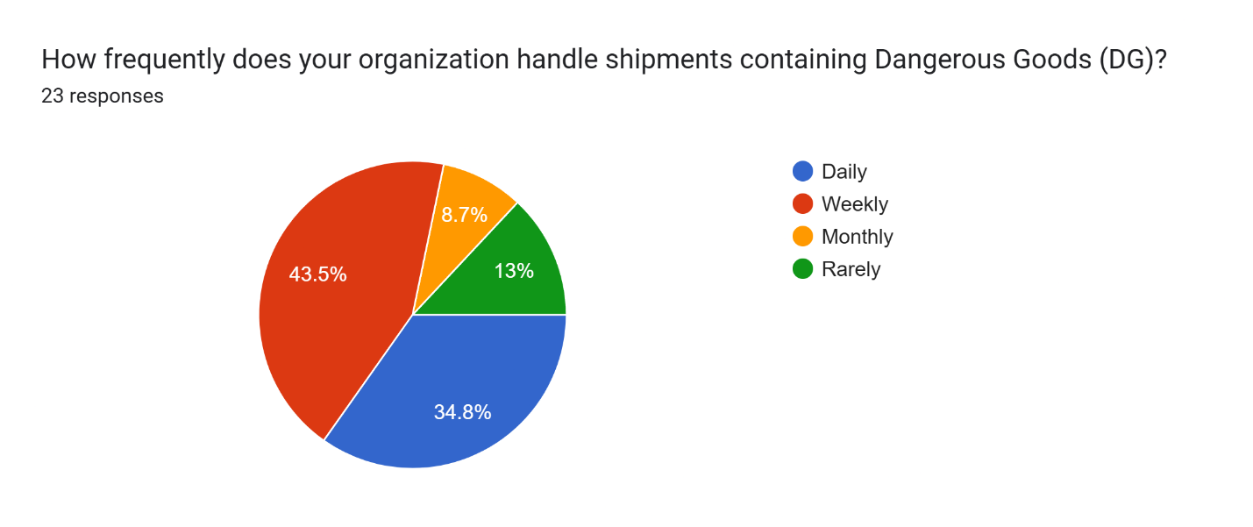

Most respondents 43.5% handle dangerous goods on a weekly basis, while 34.8% deal with them daily. A smaller portion reported handling DG monthly (8.7%) or rarely (13%).

**Interpretation:**

Dangerous goods are clearly a routine part of operations for many, with over three-quarters managing such shipments on a regular basis. This frequency demands a high level of consistency in safety protocols, proper packaging, and updated training. Organizations involved in daily or weekly handling are likely to be more aligned with international standards like IATA DGR. However, those with infrequent exposure may face challenges in maintaining compliance without regular practice or refresher programs.

1. **DG Packaging Compliance Issues**

**TABLE 2:**

|  |  |  |
| --- | --- | --- |
| **PARTICULARS** | **FREQUENCY** | **PERCENTAGE** |
| FREQUENTLY (EVERY WEEK) | 5 | 21.7% |
| OCCASIONALLY (1–2 TIMES A MONTH) | 13 | 56.5% |
| VERY FREQUENTLY (ALMOST DAILY) | 2 | 8.7% |
| NEVER | 3 | 13% |
| **TOTAL** | **23** | **100%** |

**CHART 2:**

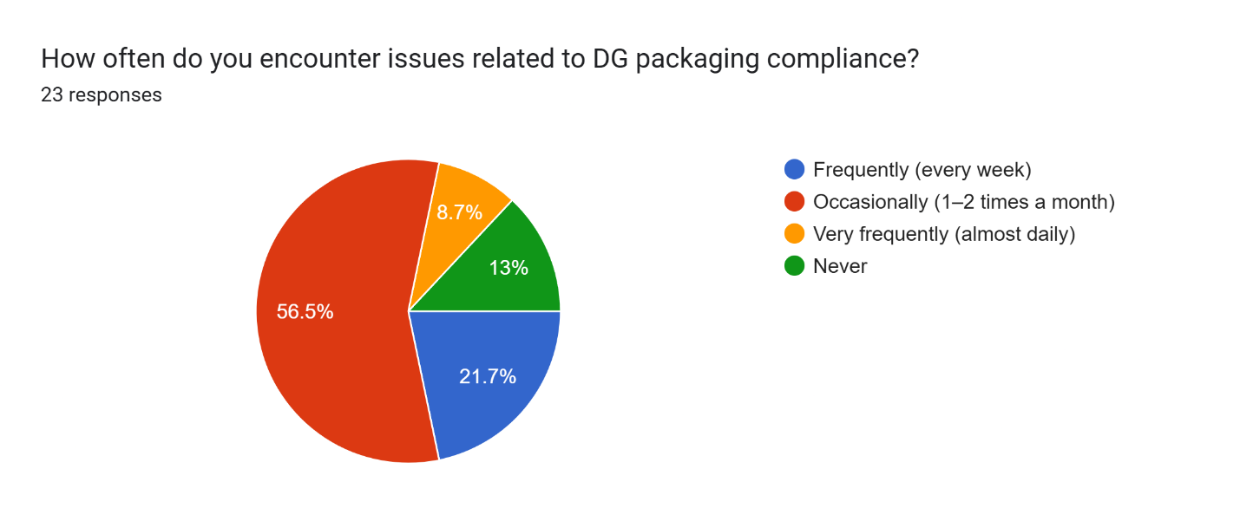

The majority 56.5% encounter packaging compliance issues occasionally, around 1–2 times a month. 21.7% face such problems frequently on a weekly basis, and 8.7% deal with them almost daily. Interestingly, 13% reported never facing any issues.

**Interpretation:**

While a small number claim zero issues, most respondents do encounter compliance challenges to some degree. This points to ongoing gaps in training, awareness, or packaging processes. The fact that nearly a third face issues frequently or very frequently raises concerns about the overall consistency in adhering to DG packaging regulations. These findings highlight the importance of continuous audits, staff upskilling, and possibly investing in smarter packaging solutions to minimize non-compliance and associated risks.

1. **Most Common DG Packaging Issue**

**TABLE 3:**

|  |  |  |
| --- | --- | --- |
| **PARTICULARS** | **FREQUENCY** | **PERCENTAGE** |
| DAMAGED PACKAGING | 4 | 17.4% |
| INCOMPLETE/MISSING LABELS | 16 | 69.6% |
| NON-COMPLIANCE WITH ICAO/IATA RULES | 3 | 13% |
| WRONG PACKAGING TYPE | 0 | 0 |
| **TOTAL** | **23** | **100%** |

**CHART 3:**

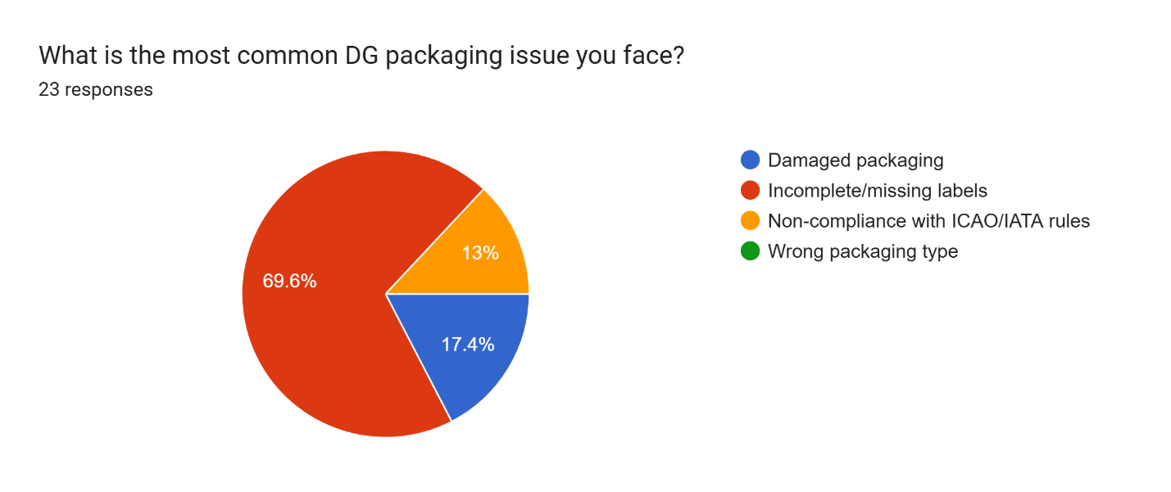

A significant 69.6% of respondents said that incomplete or missing labels are the most common issue with dangerous goods (DG) packaging. Another 17.4% pointed to damaged packaging, while 13% cited non-compliance with ICAO/IATA regulations. Interestingly, no one reported using the wrong type of packaging.

**Interpretation:**

Labeling issues clearly top the list, highlighting a widespread need for better training and more thorough checks during the labeling and documentation process. Since proper labeling is critical for identifying, handling, and responding to DG shipments, this is a serious concern. On the bright side, it's good to see that incorrect packaging types aren’t a problem. Still, the reports of damage and regulatory non-compliance suggest there’s room to improve quality control and ensure stricter adherence to IATA Dangerous Goods Regulations (DGR).

1. **Time Required to Resolve DG Packaging Issues**

**TABLE 4:**

|  |  |  |
| --- | --- | --- |
| **PARTICULARS** | **FREQUENCY** | **PERCENTAGE** |
| LESS THAN 1 DAY | 7 | 30.4% |
| 1 – 2 DAYS | 10 | 43.5% |
| 3 – 5 DAYS | 6 | 26.1% |
| MORE THAN 5 DAYS | 0 | 0 |
| **TOTAL** | **23** | **100%** |

**CHART 4:**

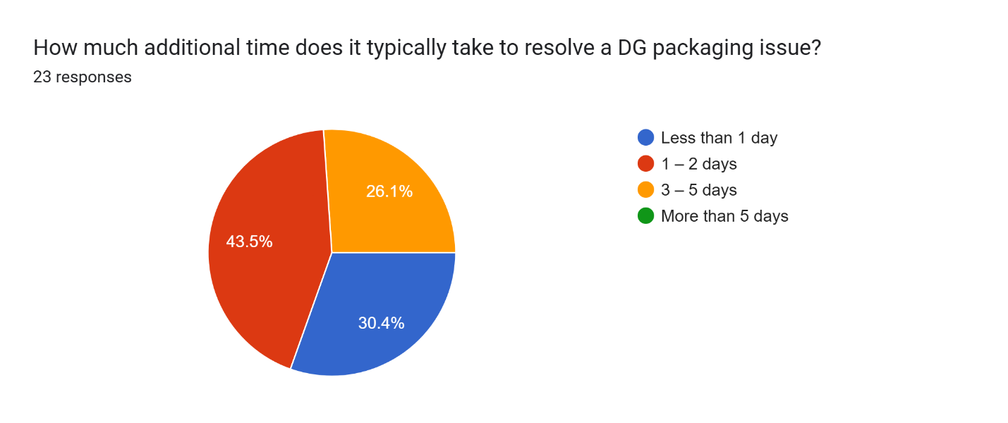

Nearly half of the respondents (45.5%) said it usually takes 1 to 2 days to resolve a DG packaging issue. About 30.4% are able to fix problems in under a day, while 26.1% said it takes them between 3 to 5 days. Notably, no one reported delays beyond five days.

**Interpretation:**

Most DG packaging issues get sorted out fairly quickly—typically within two days. That’s a good sign that many companies have systems in place to respond efficiently when problems come up. However, the fact that over a quarter of respondents need up to five days points to some possible bottlenecks—whether that's due to limited resources, packaging supply issues, or administrative slowdowns. In the fast-paced world of air transport, even a few days of delay can ripple through the supply chain. Tightening up compliance processes and focusing on prevention could help shorten turnaround times even more.

1. **Average Cost Incurred Due to DG Packaging Issues**

**TABLE 5:**

|  |  |  |
| --- | --- | --- |
| **PARTICULARS** | **FREQUENCY** | **PERCENTAGE** |
| LESS THAN ₹1,000 | 1 | 4.3% |
| ₹1,000 – ₹5,000 | 9 | 39.1% |
| ₹5,000 – ₹10,000 | 10 | 43.5% |
| MORE THAN ₹10,000 | 3 | 13% |
| **TOTAL** | **23** | **100%** |

**CHART 5:**

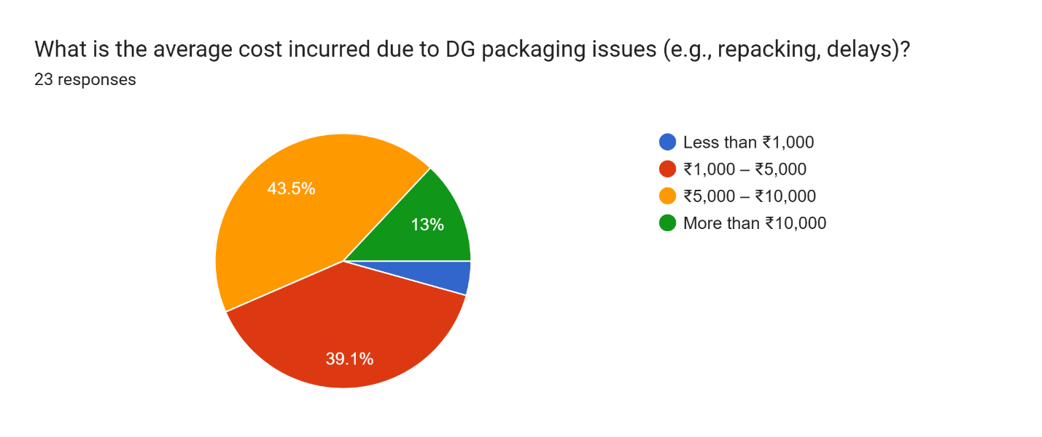

The biggest chunk of respondents—43.5%—said they typically spend between ₹5,000 and ₹10,000 to resolve a single DG packaging issue. Another 39.1% reported costs between ₹1,000 and ₹5,000, while 13% said each incident cost them more than ₹10,000. Only a small group (4.3%) managed to keep costs below ₹1,000.

**Interpretation:**

DG packaging problems aren't just about compliance—they hit the wallet too. Most companies end up spending anywhere from ₹1,000 to ₹10,000 per issue, and a notable 13% are dealing with even higher costs. These expenses can stack up quickly when you factor in things like repacking, delays, fines, and potential product damage. It’s a clear sign that investing upfront—in better materials, proper training, and consistent processes—can save serious money in the long run by preventing these issues altogether.

1. **Effectiveness of Packaging Materials in Preventing Leaks or Spills**

**TABLE 6:**

|  |  |  |
| --- | --- | --- |
| **PARTICULARS** | **FREQUENCY** | **PERCENTAGE** |
| VERY INEFFECTIVE | 2 | 8.7% |
| SOMEWHAT EFFECTIVE | 11 | 47.8% |
| EFFECTIVE | 7 | 30.4% |
| VERY EFFECTIVE | 3 | 13% |
| **TOTAL** | **23** | **100%** |

**CHART 6:**

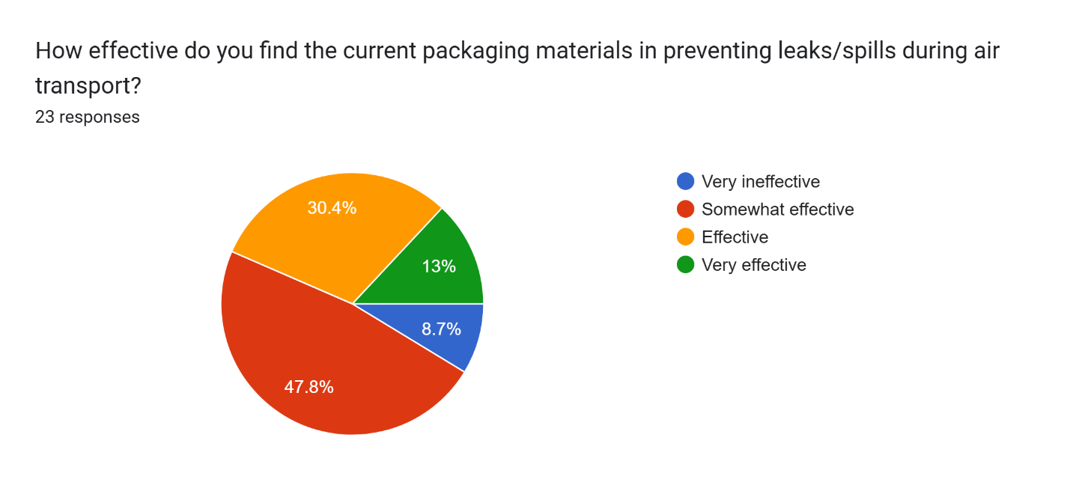

Almost half of the respondents (47.8%) felt that current packaging materials are only somewhat effective at preventing leaks or spills. About 30.4% rated them as effective, and just 13% said they’re very effective. On the flip side, 8.7% believed the materials are very ineffective.

**Interpretation:**

The feedback paints a mixed picture. While the materials seem to do an okay job overall, many users aren’t fully confident in their reliability—especially when it comes to high-stakes situations like air transport. The fact that nearly half find them only “somewhat effective,” and a few consider them outright ineffective, is concerning. Leaks or spills in DG shipments can lead to serious safety risks and costly consequences. This points to a clear need for better packaging solutions—whether through upgraded materials, stricter quality checks, or improved compliance with IATA DGR standards to boost safety and reliability.

1. **Frequency of Pre-Shipment Packaging Inspections**

**TABLE 7:**

|  |  |  |
| --- | --- | --- |
| **PARTICULARS** | **FREQUENCY** | **PERCENTAGE** |
| EVERY SHIPMENT | 17 | 73.9% |
| WEEKLY | 6 | 26.1% |
| MONTHLY | 0 | 0 |
| RARELY | 0 | 0 |
| **TOTAL** | **23** | **100%** |

**CHART 7:**

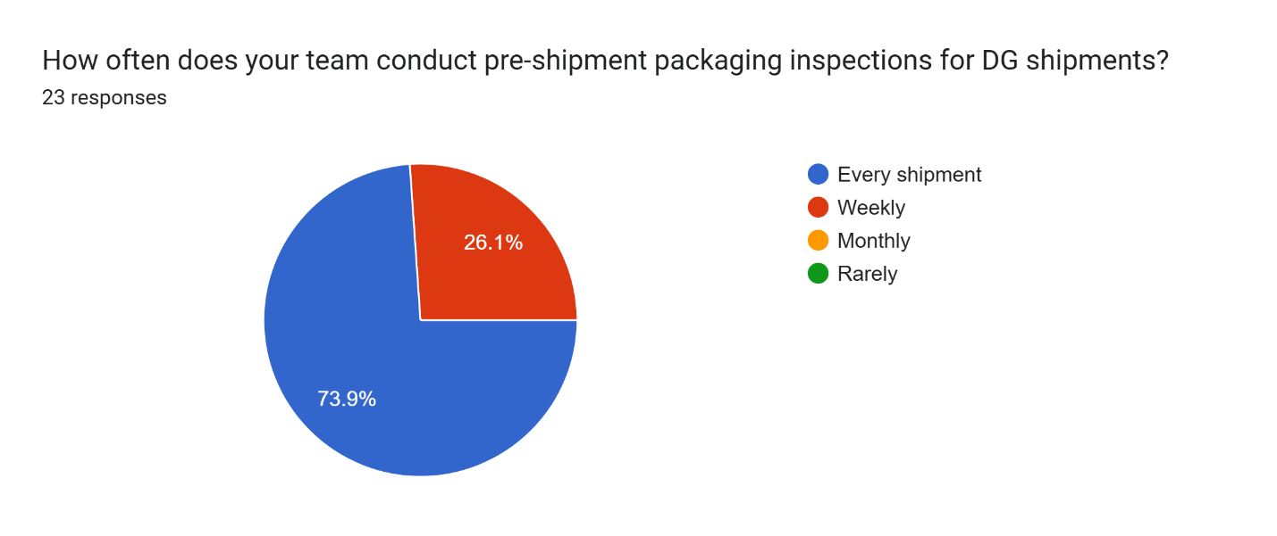

A solid 73.9% of respondents said they inspect DG packaging before every shipment. The remaining 26.1% conduct these checks on a weekly basis. Notably, no one reported doing inspections monthly or only occasionally.

**Interpretation:**

This is a great sign—it shows that most organizations are taking DG packaging seriously by performing routine inspections before every shipment. That level of diligence reflects a strong focus on safety, compliance, and minimizing risk. Weekly checks are still a good effort, but they might not catch issues in time, especially for operations handling large volumes. The complete absence of monthly or rare inspections reinforces the idea that those involved in air transport of dangerous goods understand the critical importance of thorough packaging checks.

1. **Percentage of DG Shipments Requiring Repacking**

**TABLE 8:**

|  |  |  |
| --- | --- | --- |
| **PARTICULARS** | **FREQUENCY** | **PERCENTAGE** |
| 0 – 10% | 8 | 34.8% |
| 11 – 25% |  | 47.8% |
| 26 – 50% |  | 17.4% |
| MORE THAN 50% |  | 0 |
| **TOTAL** | **23** | **100%** |

**CHART 8:**

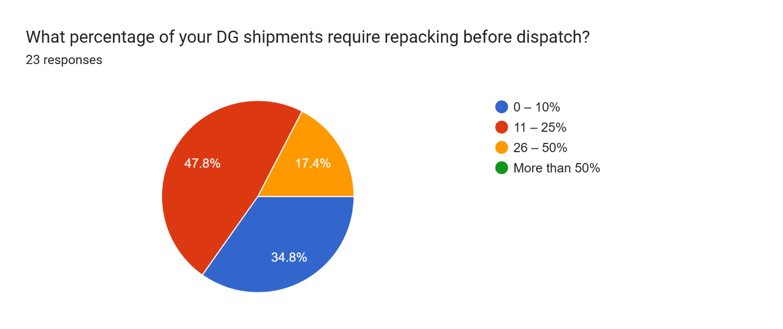

Nearly half of the respondents (47.8%) said that 11–25% of their dangerous goods (DG) shipments need to be repacked before dispatch. Another 34.8% reported needing to repack only 0–10% of shipments. Meanwhile, 17.4% said that 26–50% of their shipments require repacking. No one reported needing to repack more than half of their DG shipments.

**Interpretation:**

Repacking is clearly a recurring part of DG shipping operations, especially for up to a quarter of shipments. It’s promising that over a third of respondents keep repacking needs to a minimum, but the fact that almost half are repacking up to 25% of shipments points to potential issues—like initial packaging errors, outdated compliance practices, or damage during handling. The good news is that no one is facing extreme repacking volumes, which shows the situation is manageable. Still, there’s room to improve. Better packaging practices, updated training, and closer attention to compliance could help more teams reduce repacking rates—saving both time and money.

1. **Use of Third-Party Experts or Certified Packers for DG Packaging**

**TABLE 9:**

|  |  |  |
| --- | --- | --- |
| **PARTICULARS** | **FREQUENCY** | **PERCENTAGE** |
| ALWAYS | 4 | 17.4% |
| SOMETIMES | 9 | 39.1% |
| RARELY | 9 | 39.1% |
| NEVER | 1 | 4.3% |
| **TOTAL** | **23** | **100%** |

**CHART 9:**

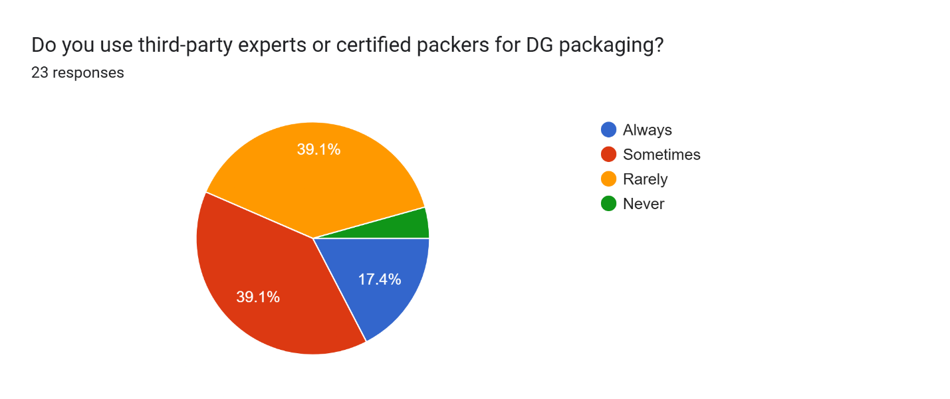

About 39.1% of respondents said they sometimes rely on third-party experts or certified packers for DG packaging, while another 39.1% use them rarely. 17.4% reported using them all the time, and 4.3% never use such services.

**Interpretation:**

For most organizations, turning to third-party experts or certified packers is more of an occasional or rare choice. This suggests that while companies recognize the benefits of external expertise, they often prefer to handle packaging internally—possibly due to cost, availability, or having trained in-house staff. The 17.4% who always use certified packers likely do so for high-risk shipments or because of strict internal policies focused on safety. The small group who never use third-party services might face risks of non-compliance or mistakes if their internal teams aren't properly certified or trained. This could be an area for improvement, where forming partnerships with certified packers could help boost safety and ensure better compliance across the board.

1. **Frequency of Staff Training in DG Handling and Packaging Regulations**

**TABLE 10:**

|  |  |  |
| --- | --- | --- |
| **PARTICULARS** | **FREQUENCY** | **PERCENTAGE** |
| ANNUALLY | 9 | 39.1% |
| EVERY 6 MONTHS | 11 | 47.8% |
| EVERY 2 YEARS | 1 | 4.3% |
| NOT REGULARLY | 2 | 8.7% |
| **TOTAL** | **23** | **100%** |

**CHART 10:**

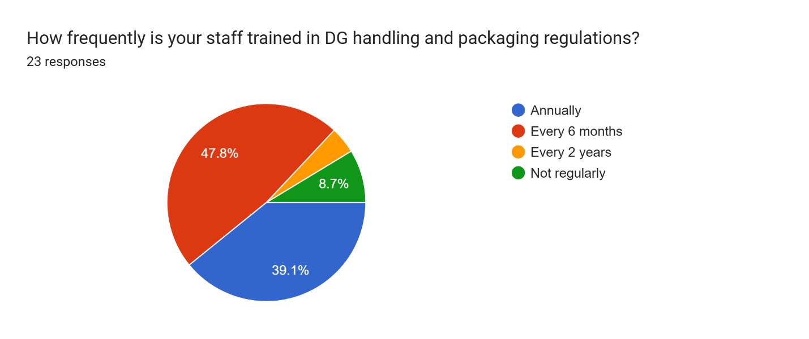

The majority of respondents—47.8%—train their staff every six months, while 39.1% conduct training annually. Only 4.3% update training every two years, and 8.7% admitted that their staff doesn’t receive regular training.

**Interpretation:**

Training is clearly a priority for most organizations involved in handling dangerous goods, with nearly 90% offering refresher courses at least once a year. This is a positive indicator of their commitment to safety and staying up-to-date with regulatory changes, especially given the constantly evolving nature of DG packaging standards under IATA DGR and ICAO regulations. However, the small percentage of organizations that either train infrequently or only every two years could be leaving themselves vulnerable to compliance gaps or operational risks. Given the complexities and potential dangers of air transport for hazardous materials, more frequent training—ideally every six months or even quarterly for high-risk sectors—could significantly improve accuracy in handling and reduce costly incidents.

1. **Biggest Challenge in Maintaining Packaging Compliance**

**TABLE 11:**

|  |  |  |
| --- | --- | --- |
| **PARTICULARS** | **FREQUENCY** | **PERCENTAGE** |
| LACK OF AWARENESS | 4 | 17.4% |
| HIGH PACKAGING COSTS | 4 | 17.4% |
| FREQUENT CHANGES IN REGULATIONS | 10 | 43.5% |
| HUMAN ERROR | 5 | 21.7% |
| **TOTAL** | **23** | **100%** |

**CHART 11:**

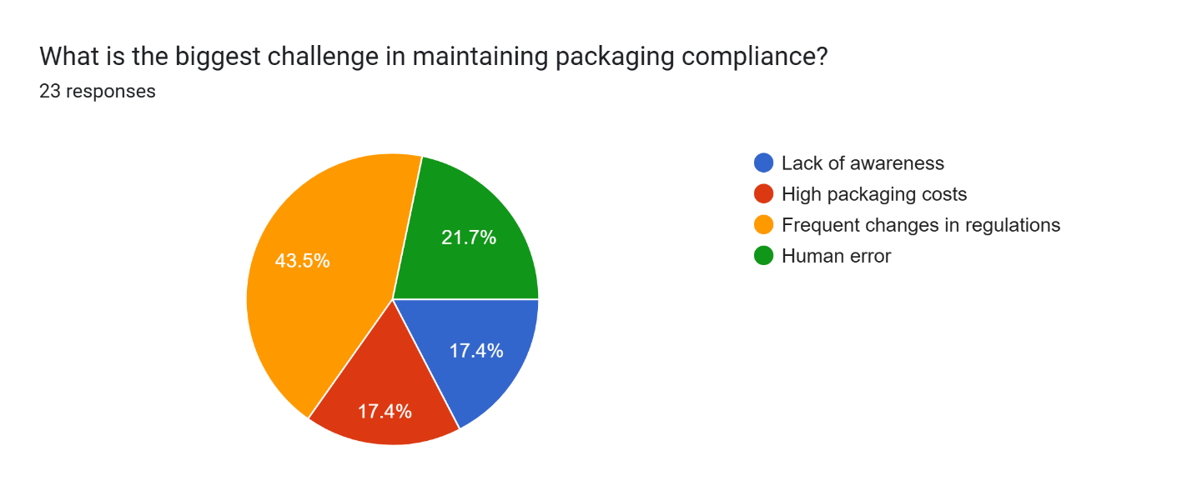The biggest challenge, according to 43.5% of respondents, is keeping up with frequent changes in regulations. Another 21.7% pointed to human error, while 17.4% each cited lack of awareness and high packaging costs.

**Interpretation:**

The main concern—frequent regulatory changes—reflects the difficulty many organizations face in staying updated with ever-evolving international standards, like those from IATA DGR and ICAO. This constant change means that training, documentation, and operational procedures need to be continuously revised, making compliance feel like a moving target.

While human error isn’t the top issue, it still poses a significant risk. With the high stakes involved in DG packaging, even small mistakes can lead to serious consequences, highlighting the need for thorough training, strong quality control systems, and perhaps even automation in certain areas.

Interestingly, awareness and cost are secondary concerns, though still important. The relatively low focus on cost might suggest that most organizations are willing to invest in safety. However, for smaller companies or those with tighter margins, cost could still be a hidden challenge.

This data points to a growing need for standardized digital compliance tools, automated alerts for regulatory updates, and enhanced staff training to address both evolving regulations and human error.

1. **Most Common Packaging Material Used for DG Shipments**

**TABLE 12:**

|  |  |  |
| --- | --- | --- |
| **PARTICULARS** | **FREQUENCY** | **PERCENTAGE** |
| FIBERBOARD BOXES | 11 | 47.8% |
| STEEL DRUMS | 6 | 26.1% |
| PLASTIC CONTAINERS | 5 | 21.7% |
| COMPOSITE PACKAGING | 1 | 4.3% |
| **TOTAL** | **23** | **100%** |

**CHART 12:**

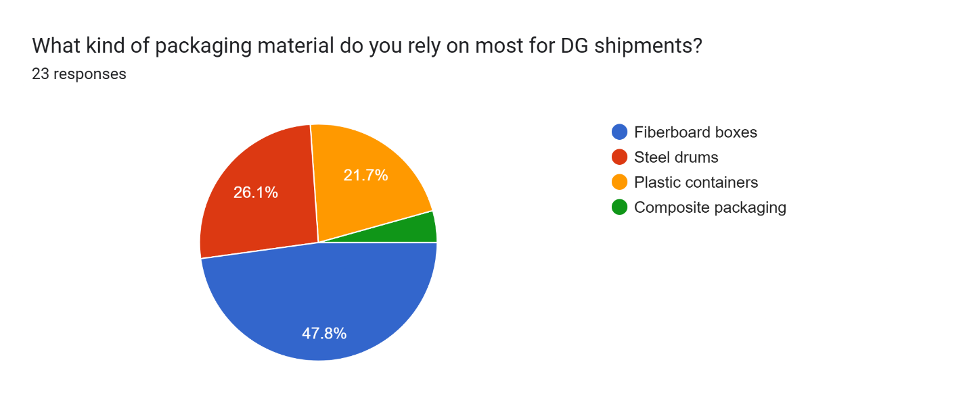

The most common packaging material used by respondents is fiberboard boxes, with 47.8% of companies using them for their dangerous goods shipments. Steel drums come in second at 26.1%, followed by plastic containers at 21.7%, and a smaller group (4.3%) using composite packaging.

**Interpretation:**

Fiberboard boxes dominate, which aligns well with UN-certified packaging standards. These boxes are lightweight, cost-effective, and compliant, making them a popular choice for smaller hazard classes and inner packagings. Their popularity could also be due to the ease of labeling and marking required for regulatory compliance, making them a practical option for many types of dangerous goods.

Steel drums and plastic containers are used when more durable containment is needed, particularly for bulk liquids or highly reactive substances. These materials offer better resistance to pressure, corrosion, or impact—key factors for safely transporting certain types of dangerous goods.

Composite packaging, though offering the benefits of dual-layer protection, is less common. This might be due to higher costs, complexity, or because it’s not needed for most shipments in the sample.

Overall, while most companies are following industry standards, there's an opportunity to explore more advanced or smart packaging solutions, especially for shipments requiring enhanced safety or environmental resistance. As more materials like lithium batteries are shipped, we may see a shift toward fire-resistant and tech-enabled packaging in the future.

1. **Confidence in Packaging Methods Meeting IATA/ICAO Standards**

**TABLE 13:**

|  |  |  |
| --- | --- | --- |
| **PARTICULARS** | **FREQUENCY** | **PERCENTAGE** |
| VERY CONFIDENT | 11 | 47.8% |
| SOMEWHAT CONFIDENT | 9 | 39.1% |
| UNSURE | 3 | 13% |
| NOT CONFIDENT | 0 | 0 |
| **TOTAL** | **23** | **100%** |

**CHART 13:**

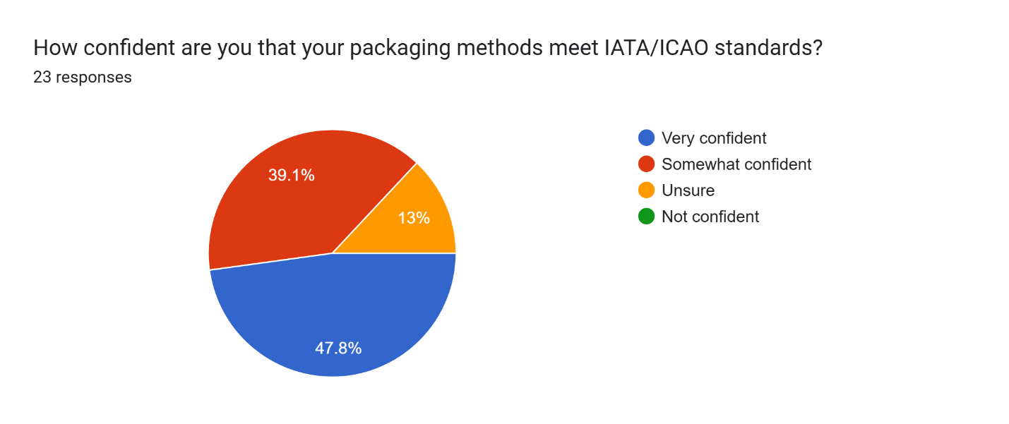

A strong 47.8% of respondents are very confident that their packaging methods meet IATA/ICAO standards, while 39.1% are somewhat confident. 13% are unsure, but no one reported feeling unconfident about their packaging compliance.

**Interpretation:**

This is a positive indicator of regulatory compliance, with over 85% of respondents expressing at least some level of confidence in their ability to meet the stringent standards set by IATA and ICAO. Given the complex and ever-changing nature of dangerous goods transportation, this is encouraging.

However, the 13% who are unsure may point to gaps in knowledge, a reliance on outdated procedures, or a lack of regular audits. To address this uncertainty, organizations could benefit from more frequent self-assessments, third-party audits, or investing in updated training to boost confidence in their compliance.

Overall, while most respondents feel they're on track with meeting the necessary standards, it's essential to maintain ongoing efforts to stay up to date with regulatory changes to ensure safety and avoid potential penalties.

1. **Frequency of Concerns Raised by Customs or Airline Authorities About DG Packaging**

**TABLE 14:**

|  |  |  |
| --- | --- | --- |
| **PARTICULARS** | **FREQUENCY** | **PERCENTAGE** |
| NEVER | 5 | 21.7% |
| OCCASIONALLY | 15 | 65.2% |
| FREQUENTLY | 3 | 13% |
| VERY FREQUENTLY | 0 | 0 |
| **TOTAL** | **23** | **100%** |

**CHART 14:**

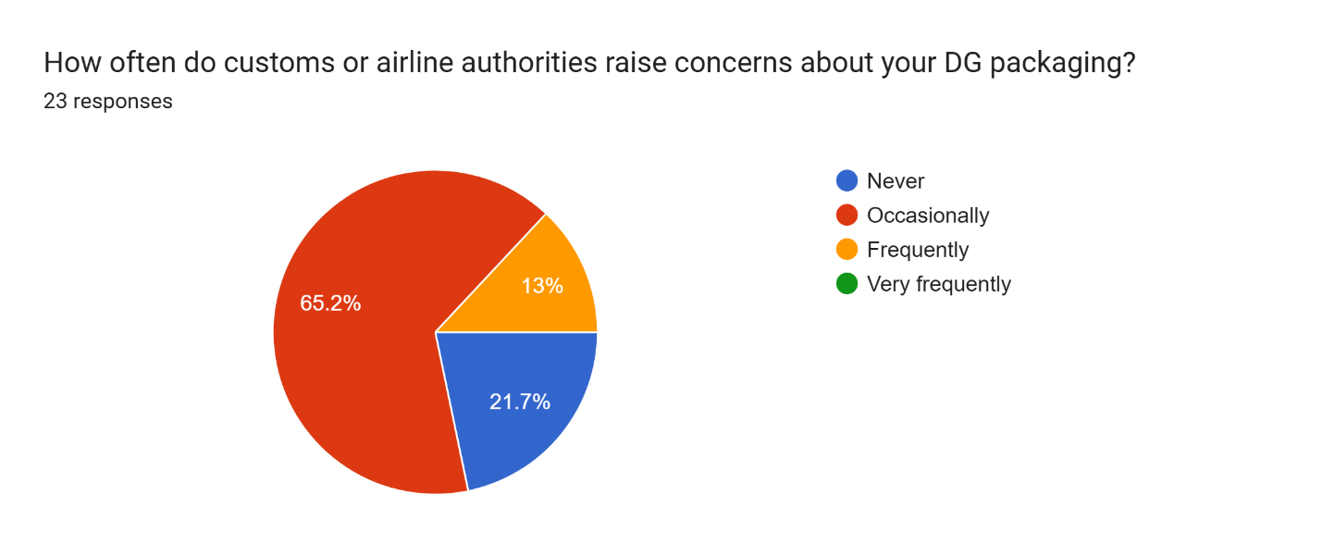

A majority of respondents (65.2%) report that customs or airline authorities raise concerns about their DG packaging occasionally. 21.7% said they never face concerns, while 13% deal with concerns frequently. No one reported concerns being raised very frequently.

**Interpretation:**

The fact that most respondents experience occasional issues with packaging compliance suggests that while they’re likely following regulations, there’s still room for improvement. The 13% who face concerns frequently could be dealing with more significant issues around consistency, adherence to guidelines, or evolving regulations. These could stem from fluctuating packaging practices, gaps in staff training, or misunderstandings of new or updated rules.

The 21.7% who never face concerns might be operating with high confidence in their packaging methods, or they may have developed a strong working relationship with authorities, possibly making their shipments less scrutinized. However, this could also signal a lack of audits or checks, which could be risky over time.

This data underscores the importance of proactive self-regulation, continuous training, and closer collaboration with airlines or customs to ensure full alignment with global standards. Even occasional compliance concerns can lead to delays, fines, or reputational damage, so it’s crucial to stay vigilant.

1. **Percentage of DG Shipments Delayed Due to Packaging-Related Documentation Errors**

**TABLE 15:**

|  |  |  |
| --- | --- | --- |
| **PARTICULARS** | **FREQUENCY** | **PERCENTAGE** |
| 0 – 10% | 9 | 39.1% |
| 11 – 25% | 12 | 52.2% |
| 26 – 50% | 2 | 8.7% |
| MORE THAN 50% | 0 | 0 |
| **TOTAL** | **23** | **100%** |

**CHART 15:**

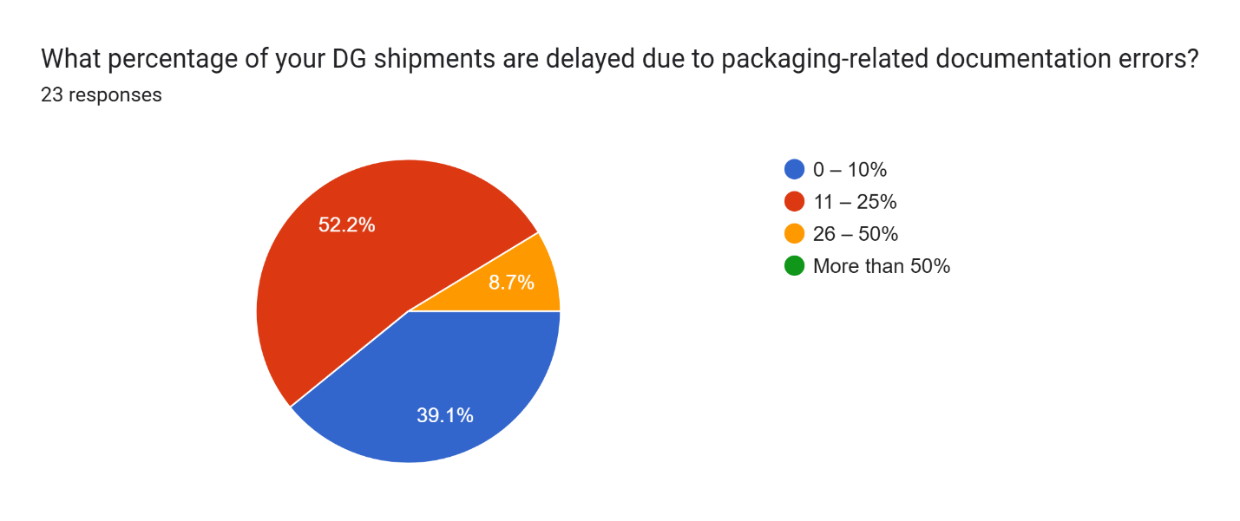

Over half of respondents (52.2%) report that 11–25% of their DG shipments are delayed due to packaging-related documentation errors. 39.1% face delays in only 0–10% of shipments, while 8.7% experience delays in 26–50% of shipments. No one reported delays affecting more than 50% of their shipments.

**Interpretation:**

Packaging-related documentation errors are a significant issue for many organizations, but not an overwhelming one. The majority experience delays in up to 25% of shipments. These errors are often due to incorrect or incomplete paperwork, mislabeling, or failing to meet regulatory requirements—all of which can cause delays at various points in the logistics process.

While 39.1% of respondents face delays in a relatively small portion of their shipments, the 52.2% who report delays in 11–25% represent an area where improvements could be made. These errors may point to issues with the documentation review process, insufficient training, or miscommunications between departments.

The 8.7% who experience delays in 26–50% of their shipments face a more serious concern. This group might need to implement stronger checks, more thorough training, or more reliable systems for ensuring documentation accuracy.

Reducing these documentation errors could lead to significant improvements in efficiency and minimize disruptions in the supply chain. Streamlining documentation processes and leveraging digital tools for compliance checks could help reduce the frequency of delays caused by packaging errors.

1. **Penalties or Fines Due to Improper DG Packaging**

**TABLE 16:**

|  |  |  |
| --- | --- | --- |
| **PARTICULARS** | **FREQUENCY** | **PERCENTAGE** |
| NO | 1 | 4.3% |
| LESS THAN ₹10,000 | 10 | 43.5% |
| ₹1,00,000 – ₹2,50,000 | 8 | 34.8% |
| MORE THAN ₹2,50,000 | 4 | 17.4% |
| **TOTAL** | **23** | **100%** |

**CHART 16:**

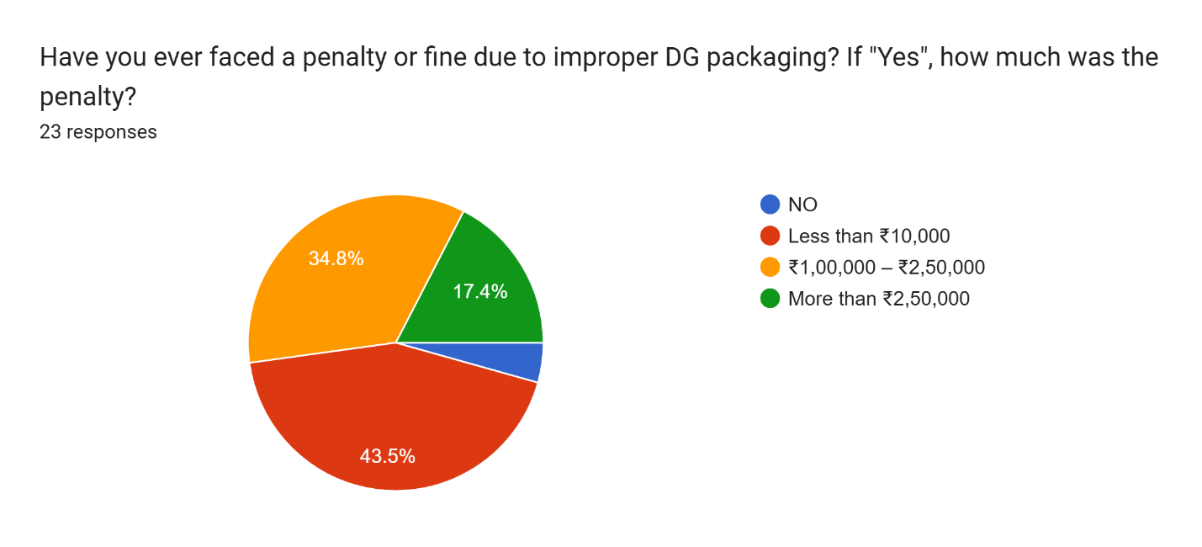

About 43.5% of respondents reported that they haven’t faced any penalties or fines due to improper DG packaging. Among those who did incur penalties, 43.5% faced fines of less than ₹10,000, 34.8% had fines ranging from ₹1,00,000 to ₹2,50,000, and 17.4% received fines exceeding ₹2,50,000.

**Interpretation:**

It’s encouraging that nearly half of the organizations (43.5%) have avoided penalties, suggesting that many are likely compliant with packaging standards or have solid risk mitigation processes in place. However, the other 43.5% who did face fines indicate that non-compliance is still a common issue, even among well-established organizations. The fines, especially those in the ₹1,00,000 to ₹2,50,000 range, can have a significant financial impact, highlighting that there may be recurring issues with packaging processes or a lack of strict adherence to regulations.

The 17.4% who faced fines above ₹2,50,000 signal a more serious compliance failure. These larger fines could be the result of major packaging errors or significant violations of IATA/ICAO standards, often involving safety or environmental risks. Such breaches can not only disrupt operations but also damage a company’s reputation.

The fact that a significant portion of respondents still faces penalties underscores the importance of continuous vigilance in packaging procedures. Keeping both staff and third-party handlers up-to-date on the latest regulations and compliance requirements is essential. This could also point to the need for investing in regular training, audits, and compliance checks to minimize the risk of costly mistakes.

1. **Primary Source of Packaging Compliance Guidance**

**TABLE 17:**

|  |  |  |
| --- | --- | --- |
| **PARTICULARS** | **FREQUENCY** | **PERCENTAGE** |
| IN-HOUSE SOP/MANUAL | 4 | 17.4% |
| IATA DGR BOOK | 17 | 73.9% |
| EXTERNAL DG CONSULTANTS | 1 | 4.3% |
| AIRLINE/CARGO AGENT GUIDANCE | 1 | 4.3% |
| **TOTAL** | **23** | **100%** |

**CHART 17:**

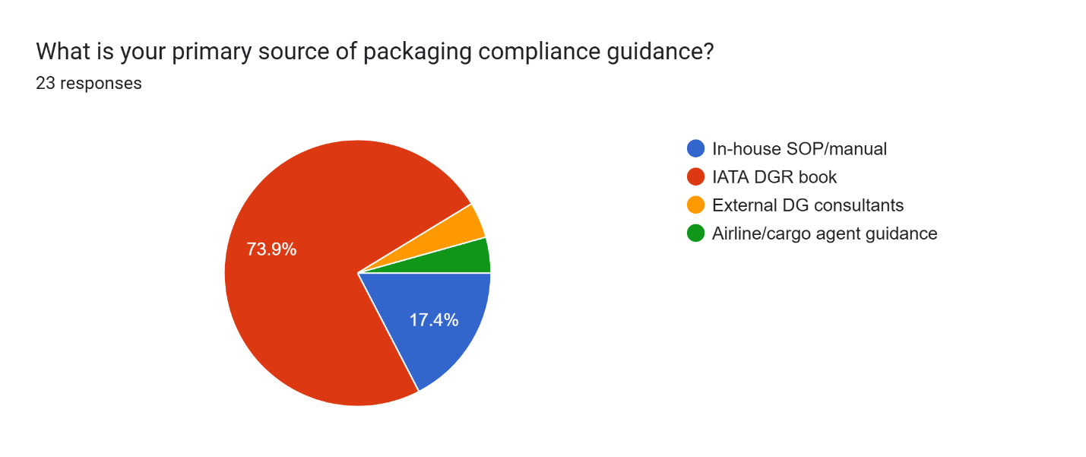The majority of respondents (73.9%) rely on the IATA Dangerous Goods Regulations (DGR) book as their primary source of packaging compliance guidance. 17.4% follow their in-house Standard Operating Procedures (SOPs), 4.3% consult external DG consultants, and another 4.3% rely on guidance from airlines or cargo agents.

**Interpretation:**

The heavy reliance on the IATA DGR book (73.9%) highlights its essential role in helping organizations stay compliant with global packaging and transportation standards for dangerous goods. The DGR book offers detailed and comprehensive guidelines on packaging, labeling, marking, and documentation, making it a vital tool for any company involved in shipping hazardous materials.

The 17.4% of respondents who use in-house SOPs suggest that some companies have developed their own internal guidelines to address specific needs or local regulations. While this can offer flexibility, it also means these organizations may be handling compliance on a more localized level, which could lead to inconsistencies when managing international shipments.

The 4.3% who turn to external DG consultants or airline/cargo agents likely do so for additional expertise or specialized knowledge. External consultants bring deep insights into ever-changing regulations and can provide customized training or audits. The small percentage of respondents using this method suggests that most organizations feel confident managing compliance in-house or using standardized resources like the DGR book.

This data underscores the importance of a solid compliance framework, whether it’s based on trusted industry standards like the IATA DGR or internal procedures. The fact that so many rely on the DGR book reinforces its critical role in maintaining safety and compliance in dangerous goods transportation.

1. **Need for Innovation or Regulation to Improve DG Packaging**

**TABLE 18:**

|  |  |  |
| --- | --- | --- |
| **PARTICULARS** | **FREQUENCY** | **PERCENTAGE** |
| STRICTER REGULATIONS | 4 | 17.4% |
| BETTER MATERIALS/INNOVATION | 3 | 13% |
| IMPROVED TRAINING | 10 | 43.5% |
| INCREASED INSPECTIONS | 1 | 4.3% |
| ALL THE ABOVE! | 5 | 21.7% |
| **TOTAL** | **23** | **100%** |

**CHART 18:**

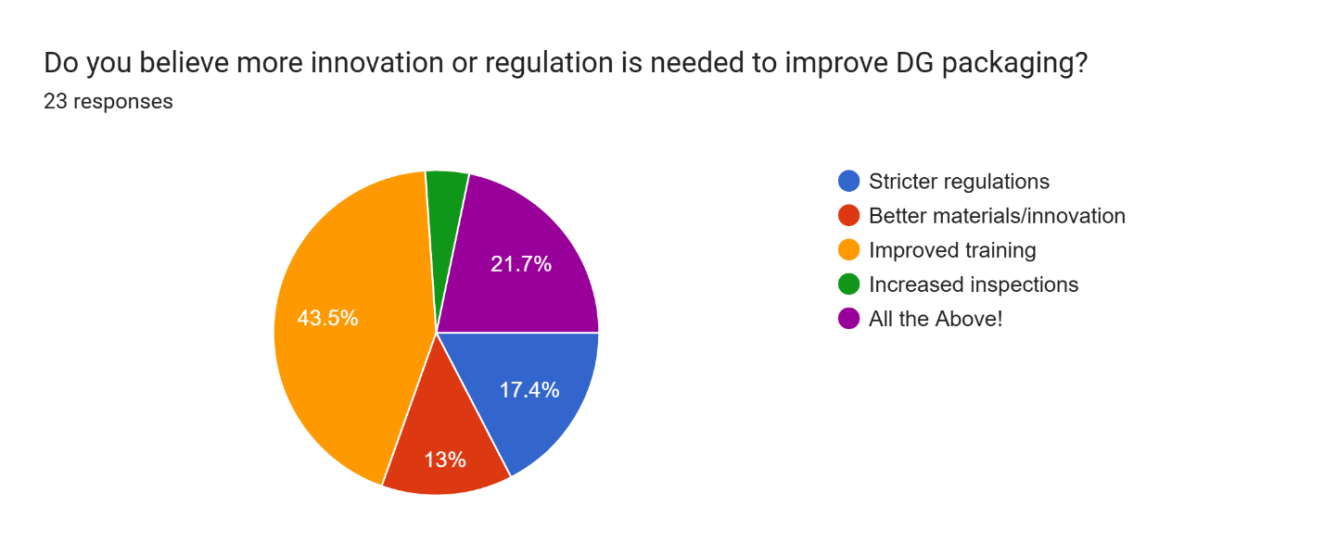

When it comes to improving DG packaging, 43.5% of respondents believe the key factor is better training. 21.7% feel that a combination of stricter regulations, better materials, innovation, improved training, and more inspections is needed. 17.4% advocate for stricter regulations, 13% think better materials and innovation are the solution, and 4.3% suggest more frequent inspections.

**Interpretation:**

The strong focus on improved training (43.5%) highlights the recognition that human error and lack of awareness are significant contributors to DG packaging issues. Proper training on regulatory requirements, safe handling, and packaging techniques is essential to minimizing mistakes and improving compliance. Regular updates and training on changes in regulations could go a long way in reducing errors and increasing safety.

The 21.7% who selected "All of the Above" suggest a more comprehensive approach. This viewpoint stresses that while training is crucial, there’s also a need for innovation in packaging materials, stricter regulations, and more frequent inspections to address the complex challenges involved in the transport of dangerous goods.

Stricter regulations (17.4%) and improved materials/innovation (13%) were also mentioned as important. These responses point to the need for continuous updates in both legal frameworks and packaging technologies to keep pace with the evolving nature of hazardous materials. Interestingly, fewer respondents (4.3%) felt that increased inspections were the most critical factor, indicating that while inspections are important, they aren’t seen as the top priority compared to measures like training and innovation.

Overall, the results suggest that respondents understand the multifaceted nature of the challenge and see a combination of improved training, updated regulations, technological advancements, and inspections as essential to ensuring safe and compliant DG packaging practices.

**CHAPTER V**

**FINDINGS AND SUGGESTIONS**

**FINDINGS**

Based on the data collected and analyzed in the previous chapter, several key findings emerge regarding the current state of dangerous goods (DG) packaging in air transportation:

**Frequent Handling of DG Shipments**

* Over 78% of respondents handle DG on a weekly or daily basis.
* This indicates DG is a routine operational element, necessitating consistent adherence to safety and regulatory protocols.

**Prevalence of Packaging Compliance Issues**

* Around 87% face packaging issues to varying degrees.
* Labeling errors (69.6%) are the most commonly reported problem, overshadowing issues like damage or non-compliance.

**Efficiency in Resolving Packaging Issues**

* Most issues are resolved within 1–2 days (75.9% of respondents).
* However, 26.1% of respondents require 3–5 days, showing that delays are still significant.

**Cost Implications**

* 82.6% incur between ₹1,000 and ₹10,000 per packaging issue, while 13% report higher costs exceeding ₹10,000.
* This highlights that non-compliance isn't just a safety concern but a financial burden as well.

**Effectiveness of Packaging Materials**

* Nearly half (47.8%) of respondents believe packaging is only "somewhat effective."
* Only 13% find their packaging "very effective," indicating room for improvement in material quality and design.

**Inspection Practices**

* 73.9% conduct inspections before every shipment—this is a positive sign of procedural integrity.
* Weekly inspections are still practiced by some, which may not be sufficient for high-frequency handlers.

**Need for Repacking**

* 47.8% repack 11–25% of their shipments, often due to labeling, damage, or compliance gaps.
* Indicates inefficiencies in the initial packaging process.

**Reliance on Third Parties**

* Only 17.4% always use certified packers, while the rest use them occasionally or rarely.
* Shows a dependency on in-house teams, possibly limiting access to specialized expertise.

**Staff Training Frequency**

* While most organizations train staff every 6–12 months, 8.7% provide no regular training.
* This gap can lead to lapses in safety and compliance.

**Challenges in Maintaining Compliance**

* The top challenge (43.5%) is staying updated with frequent regulation changes.
* Human error, lack of awareness, and cost are other contributing factors.

**Confidence in Packaging Compliance**

* 86.9% of respondents are at least somewhat confident in meeting IATA/ICAO standards.
* 13% are unsure, showing a lack of self-assessment or clarity on current standards.

**Delays and Documentation Errors**

* Over half (52.2%) report delays in 11–25% of shipments due to packaging-related documentation errors.
* Reflects a need to tighten administrative and documentation procedures.

**Penalties Due to Non-Compliance**

* 43.5% have faced fines, with some paying over ₹2,50,000.
* This financial liability highlights the critical need for preventive measures.

**Sources of Regulatory Guidance**

* 73.9% rely on the IATA DGR book, while others use internal SOPs or external consultants.
* Shows a preference for standardization, though over-reliance may lead to missed local nuances.

**Call for Improvements**

* 43.5% suggest better training as the top solution, followed by innovation, material improvements, and more inspections.

**SOLUTIONS AND RECOMMENDATIONS**

**Strengthen Training Programs**

* Implement quarterly training cycles, especially for high-risk materials like lithium batteries.
* Utilize simulation-based learning and certification courses offered by IATA/ICAO.
* Include refresher courses focusing on labeling accuracy, documentation, and regulation updates.

**Adopt Smart Packaging Technologies**

* Introduce sensor-enabled packaging to detect temperature, leakage, or pressure changes.
* Use fire-resistant and shock-absorbent materials, especially for items like batteries or reactive chemicals.

**Standardize and Digitize Documentation**

* Implement digital documentation platforms to reduce human error.
* Use software to auto-generate IATA DGD forms, labels, and checklists.

**Engage Certified Third-Party Packers**

* Encourage partnerships with certified DG packaging firms for high-risk or non-routine shipments.
* Outsourcing could mitigate human error and boost compliance rates.

**Conduct Regular Internal Audits and Compliance Reviews**

* Monthly or quarterly audits to assess packaging, labeling, and documentation.
* Introduce compliance scorecards for departments to encourage accountability.

**Upgrade Packaging Materials**

* Replace low-quality fiberboard where necessary with durable composite materials.
* Ensure packaging meets UN certification standards and is suited to high-altitude conditions.

**Integrate Automated Regulatory Update Systems**

* Use tools that send automated alerts on DGR/ICAO updates, enabling faster adaptation.
* Keep SOPs and manuals in sync with the latest international and national regulations.

**Improve Pre-shipment Inspection Protocols**

* Mandatory inspections before every shipment should be institutionalized.
* Use checklists and digital tools (e.g., tablets or handheld scanners) to standardize inspections.

**Promote Industry Collaboration**

* Form industry clusters for knowledge sharing and joint training sessions.
* Engage in forums and regulatory update webinars hosted by IATA, ICAO, and DG specialists.

**Emphasize a Safety Culture**

* Foster a workplace culture where compliance is a shared responsibility, not just a managerial directive.
* Reward teams for zero-incident months, innovation in packaging, or audit compliance.

**CONCLUSION**

This study concludes that while there is general awareness and a conscious effort to comply with regulations for dangerous goods packaging in air transportation, notable shortcomings persist particularly in areas such as labeling accuracy, staff training, and the prompt handling of packaging-related issues. Incomplete or incorrect labeling emerged as the most common challenge, often leading to delays and increased operational costs. Although many of the packaging materials in use are considered moderately effective, there is a growing need for more dependable solutions, especially for high-risk goods like lithium batteries. The uneven adoption of new technologies and inconsistencies in adhering to international standards further complicate the packaging process. To enhance overall effectiveness, the industry must adopt a comprehensive strategy that includes better training programs, stricter enforcement of global standards, and proactive investment in advanced packaging technologies. Ultimately, the secure and efficient handling of hazardous materials is not only a regulatory requirement but also a vital responsibility that safeguards people and maintains the integrity of global supply chains.

**BIBLIOGRAPHY**

1. International Civil Aviation Organization (ICAO). (2020). Technical Instructions for the Safe Transport of Dangerous Goods by Air. 2021-2022 Edition. ICAO.
2. International Air Transport Association (IATA). (2020). Dangerous Goods Regulations (DGR). 62nd Edition. IATA.
3. United Nations. (2019). Recommendations on the Transport of Dangerous Goods: Model Regulations. 21st Edition. United Nations Economic and Social Council.
4. Seabay Cargo. (2023). Dangerous Goods in Air Transport.
5. Chem-Tran. (2019). Hazardous Materials and Dangerous Goods Transportation.
6. Eturbonews. (2020). Air Cargo Safety and Dangerous Goods Handling in the Aviation Industry.
7. U.S. Department of Transportation. (2020). Hazardous Materials Regulations (HMR). Title 49 of the Code of Federal Regulations (CFR), Parts 171-180.
8. Taylor, J. (2021). Logistics and Supply Chain Management in Dangerous Goods Transportation. Journal of Logistics and Transport Safety, 28(4), 345-362.
9. Mishra, A. & Verma, R. (2020). Packaging Solutions for Dangerous Goods: A Global Review. International Journal of Packaging Technology, 35(2), 112-126.
10. Yung, W. & Shaw, J. (2018). The Role of Packaging in Reducing Air Cargo Risks for Dangerous Goods. Safety in Air Transport Journal, 15(3), 202-215.

**APPENDIX**

**A. Questionnaire for Data Collection**

1. How frequently does your organization handle shipments containing Dangerous Goods (DG)?
2. Daily
3. Weekly
4. Monthly
5. Rarely
6. What is the most common class of DG handled by your organization?
7. Class 1: Explosives
8. Class 2: Gases
9. Class 3: Flammable Liquids
10. Class 4: Flammable Solids
11. Class 5: Oxidizing Substances and Organic Peroxides
12. Class 6: Toxic and Infectious Substances
13. Class 7: Radioactive Material
14. Class 8: Corrosives
15. Class 9: Miscellaneous Dangerous Goods
16. How often do you encounter issues related to DG packaging compliance?
17. Frequently (every week)
18. Occasionally (1–2 times a month)
19. Very frequently (almost daily)
20. Never
21. What is the most common DG packaging issue you face?
22. Damaged packaging
23. Incomplete/missing labels
24. Non-compliance with ICAO/IATA rules
25. Wrong packaging type
26. How much additional time does it typically take to resolve a DG packaging issue?
27. Less than 1 day
28. 1 – 2 days
29. 3 – 5 days
30. More than 5 days
31. What is the average cost incurred due to DG packaging issues (e.g., repacking, delays)?
32. Less than ₹1,000
33. ₹1,000 – ₹5,000
34. ₹5,000 – ₹10,000
35. More than ₹10,000
36. How effective do you find the current packaging materials in preventing leaks/spills during air transport?
37. Very ineffective
38. Somewhat effective
39. Effective
40. Very effective
41. How often does your team conduct pre-shipment packaging inspections for DG shipments?
42. Every shipment
43. Weekly
44. Monthly
45. Rarely
46. What percentage of your DG shipments require repacking before dispatch?
47. 0 – 10%
48. 11 – 25%
49. 26 – 50%
50. More than 50%
51. Do you use third-party experts or certified packers for DG packaging?
52. Always
53. Sometimes
54. Rarely
55. Never
56. How frequently is your staff trained in DG handling and packaging regulations?
57. Annually
58. Every 6 months
59. Every 2 years
60. Not regularly
61. What is the biggest challenge in maintaining packaging compliance?
62. Lack of awareness
63. High packaging costs
64. Frequent changes in regulations
65. Human error
66. What kind of packaging material do you rely on most for DG shipments?
67. Fiberboard boxes
68. Steel drums
69. Plastic containers
70. Composite packaging
71. How confident are you that your packaging methods meet IATA/ICAO standards?
72. Very confident
73. Somewhat confident
74. Unsure
75. Not confident
76. How often do customs or airline authorities raise concerns about your DG packaging?
77. Never
78. Occasionally
79. Frequently
80. Very frequently
81. What percentage of your DG shipments are delayed due to packaging-related documentation errors?
82. 0 – 10%
83. 11 – 25%
84. 26 – 50%
85. More than 50%
86. Have you ever faced a penalty or fine due to improper DG packaging? If "Yes", how much was the penalty?
87. NO
88. Less than ₹10,000
89. ₹1,00,000 – ₹2,50,000
90. More than ₹2,50,000
91. What is your primary source of packaging compliance guidance?
92. In-house SOP/manual
93. IATA DGR book
94. External DG consultants
95. Airline/cargo agent guidance
96. Do you believe more innovation or regulation is needed to improve DG packaging?
97. Stricter regulations
98. Better materials/innovation
99. Improved training
100. Increased inspections
101. All the Above!

**B. Data Tables and Charts**

1. How frequently does your organization handle shipments containing Dangerous Goods (DG)?

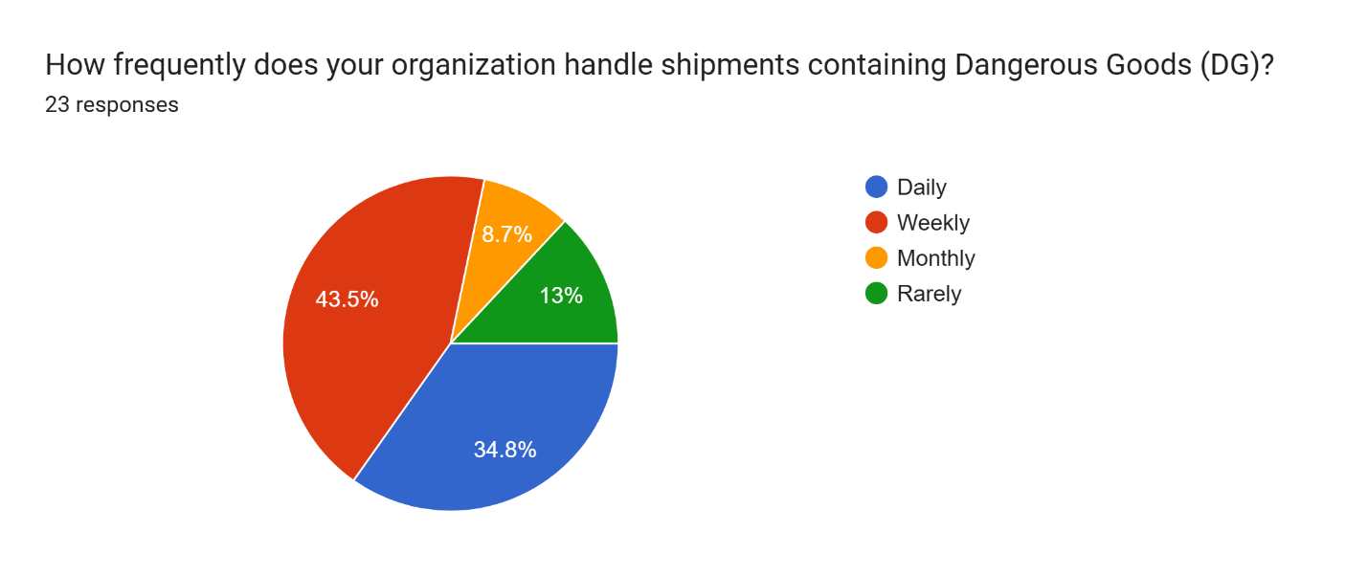

1. What is the most common class of DG handled by your organization?

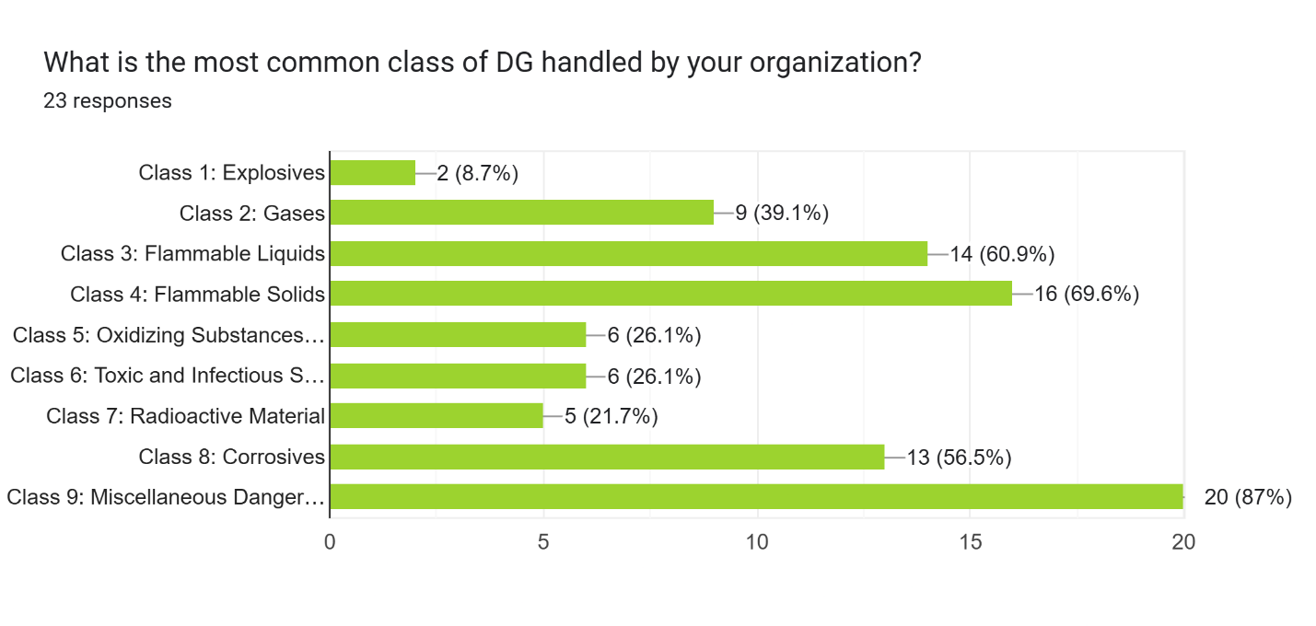

1. How often do you encounter issues related to DG packaging compliance?

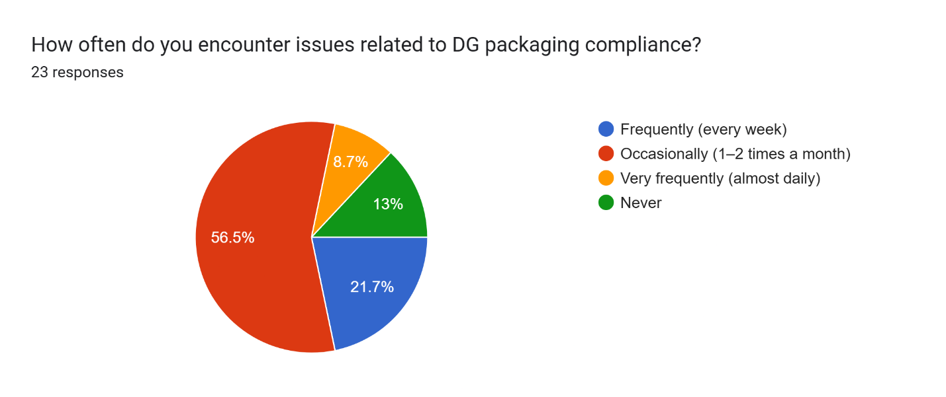

1. What is the most common DG packaging issue you face?

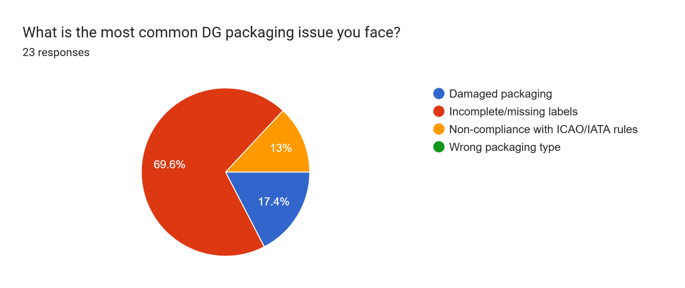

1. How much additional time does it typically take to resolve a DG packaging issue?

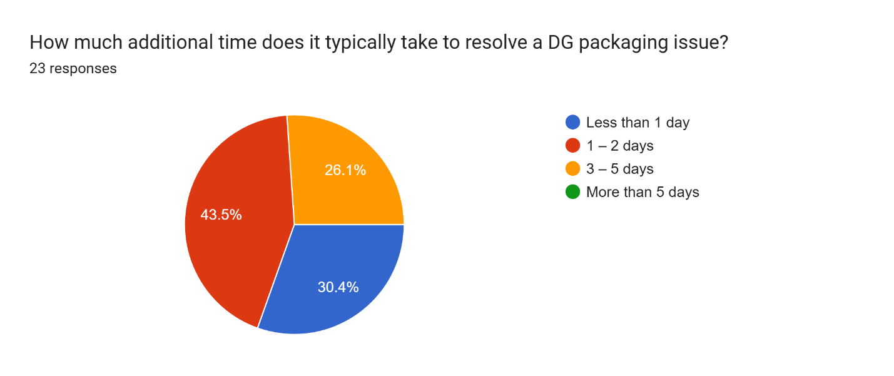

1. What is the average cost incurred due to DG packaging issues (e.g., repacking, delays)?

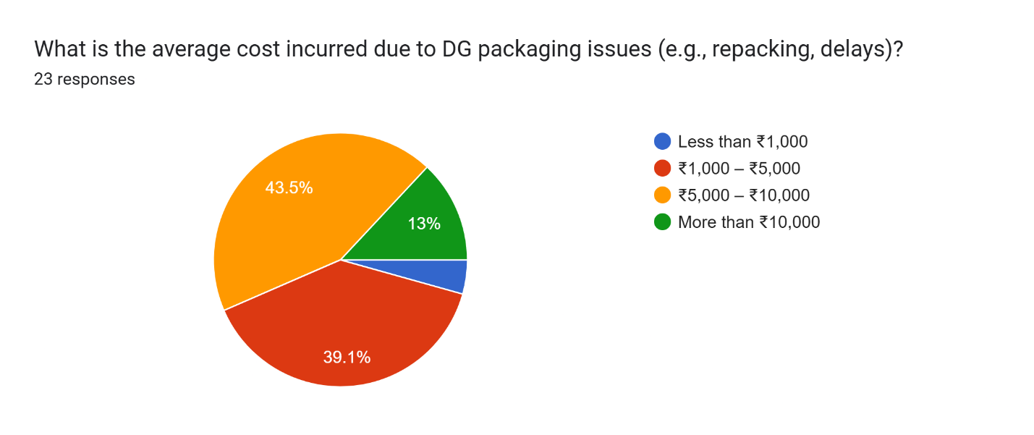

1. How effective do you find the current packaging materials in preventing leaks/spills during air transport?

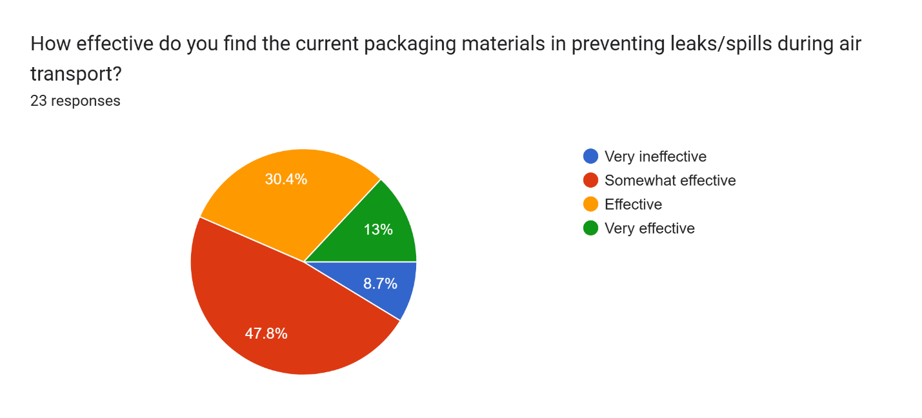

1. How often does your team conduct pre-shipment packaging inspections for DG shipments?

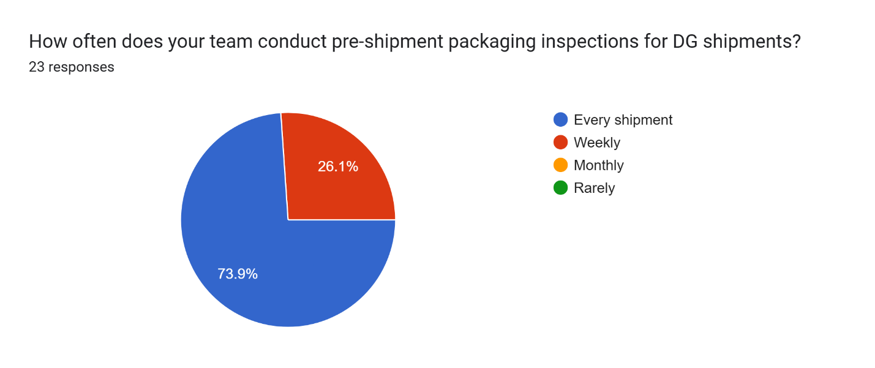

1. What percentage of your DG shipments require repacking before dispatch?

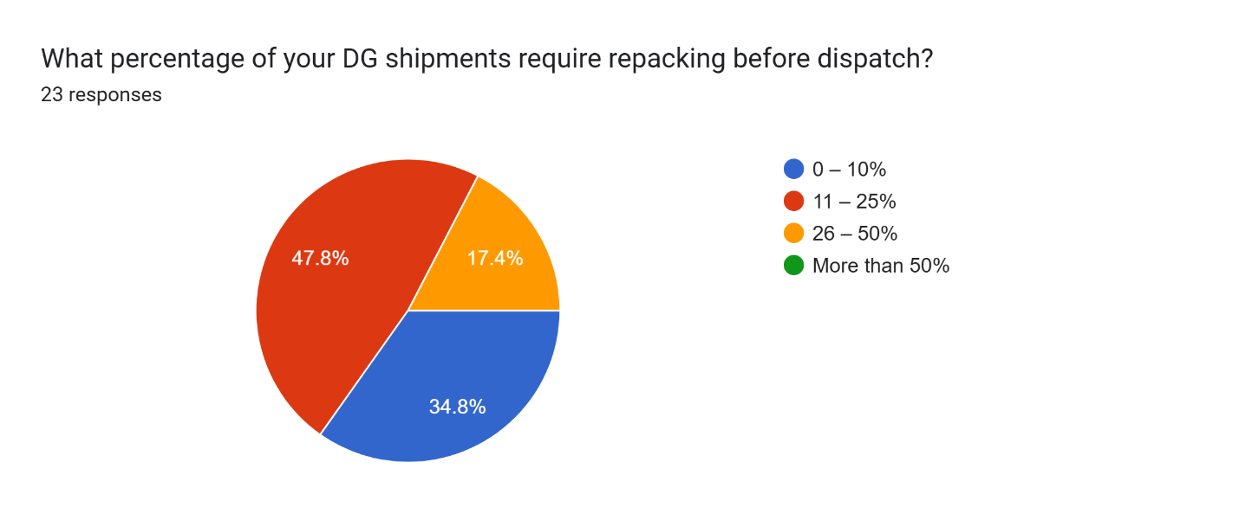

1. Do you use third-party experts or certified packers for DG packaging?

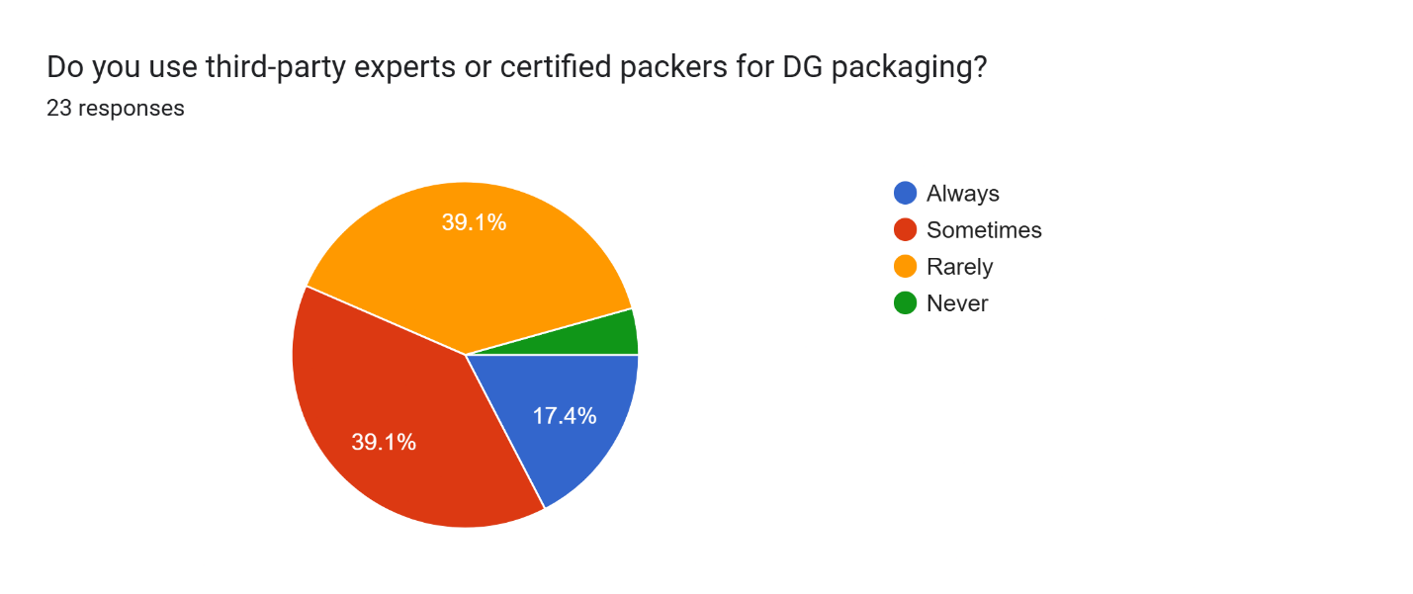

1. How frequently is your staff trained in DG handling and packaging regulations?

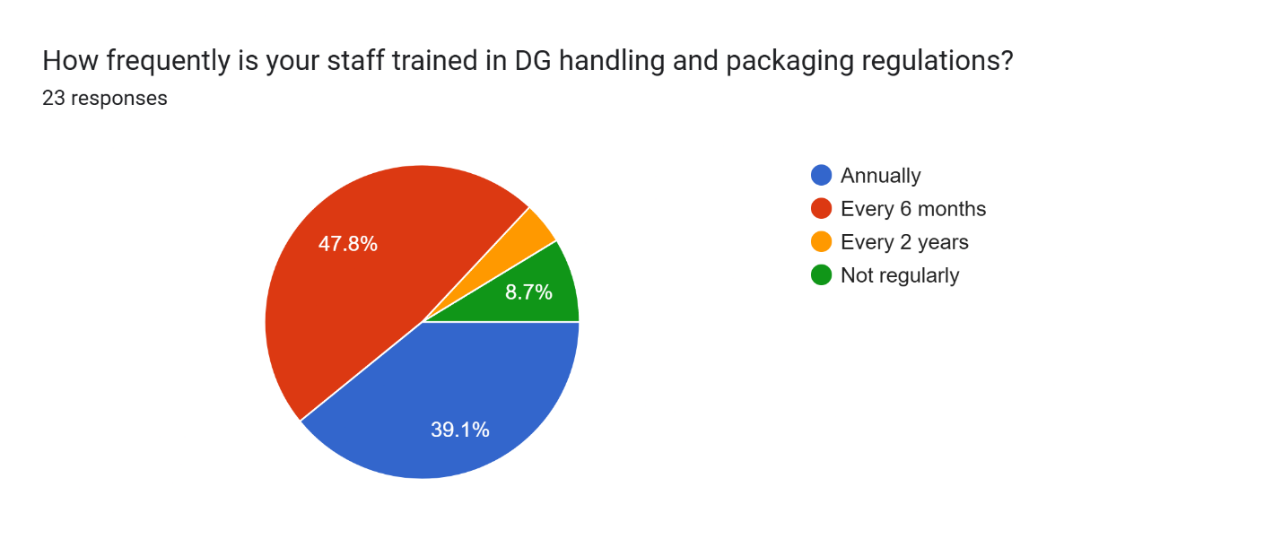

1. What is the biggest challenge in maintaining packaging compliance?

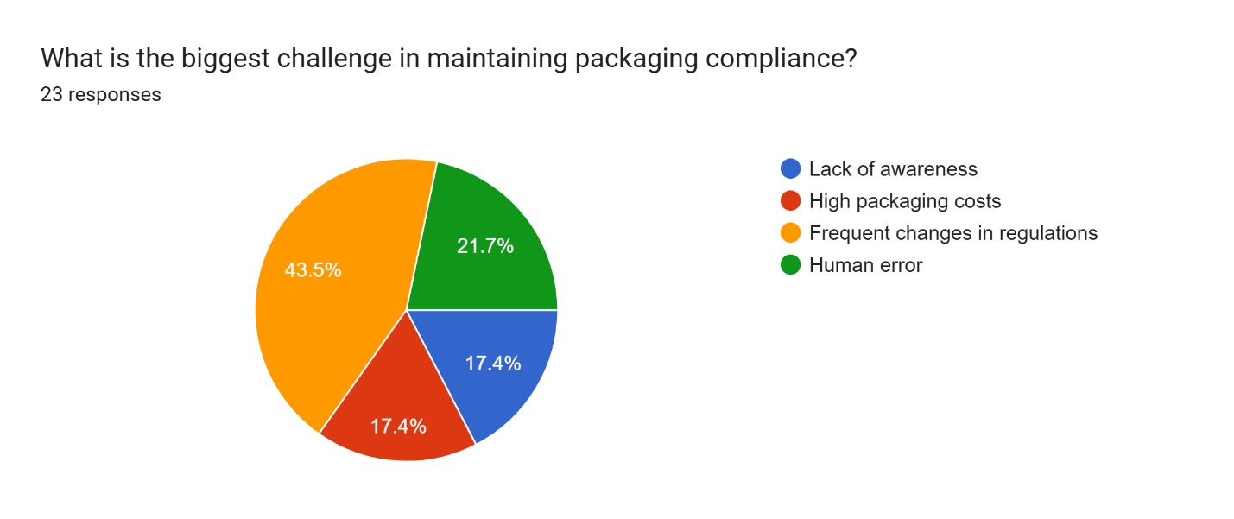

1. What kind of packaging material do you rely on most for DG shipments?

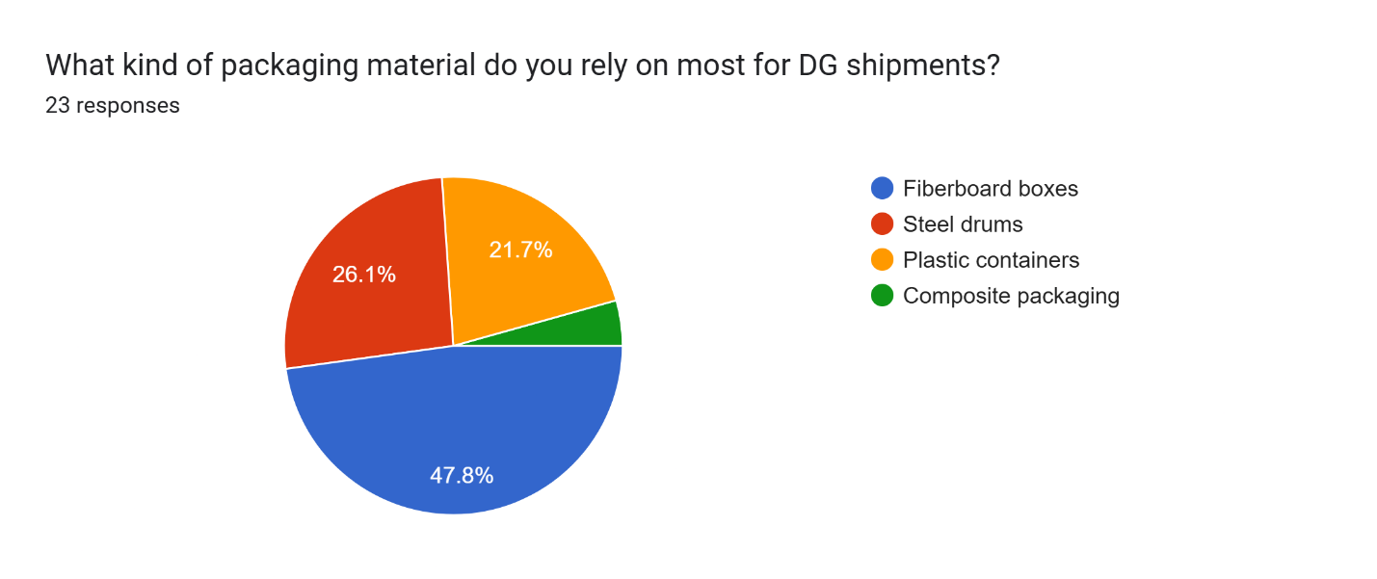

1. How confident are you that your packaging methods meet IATA/ICAO standards?

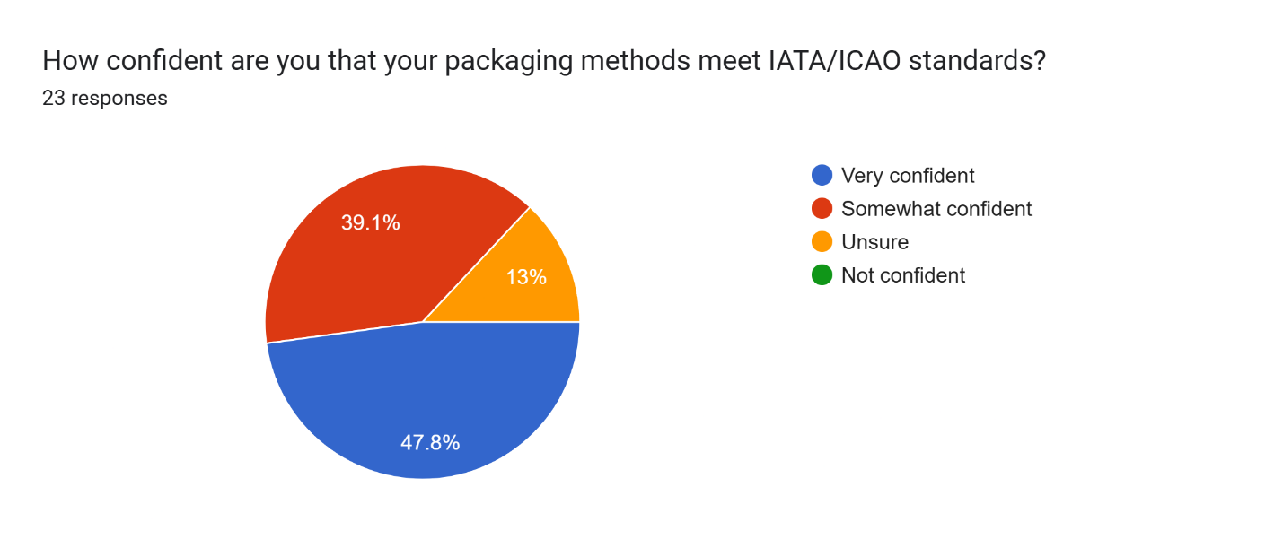

1. How often do customs or airline authorities raise concerns about your DG packaging?

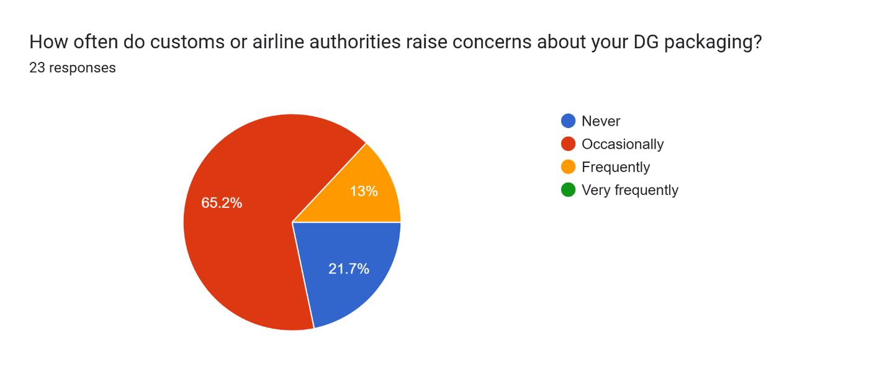

1. What percentage of your DG shipments are delayed due to packaging-related documentation errors?

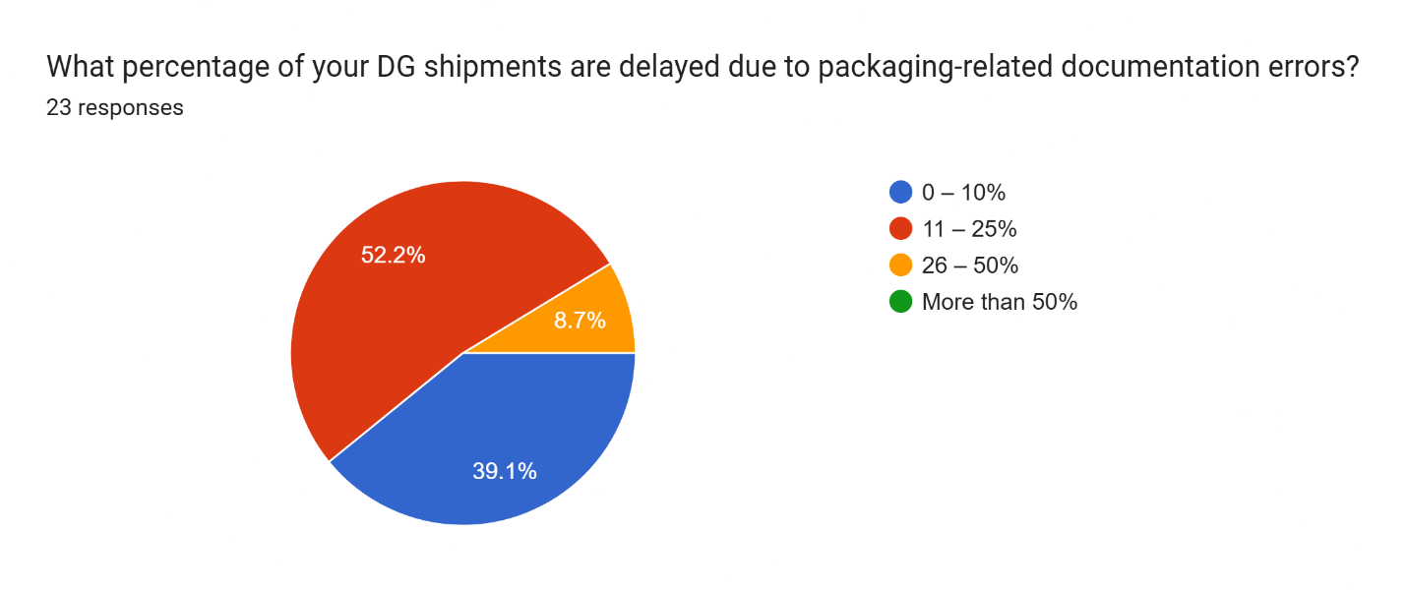

1. Have you ever faced a penalty or fine due to improper DG packaging? If "Yes", how much was the penalty?

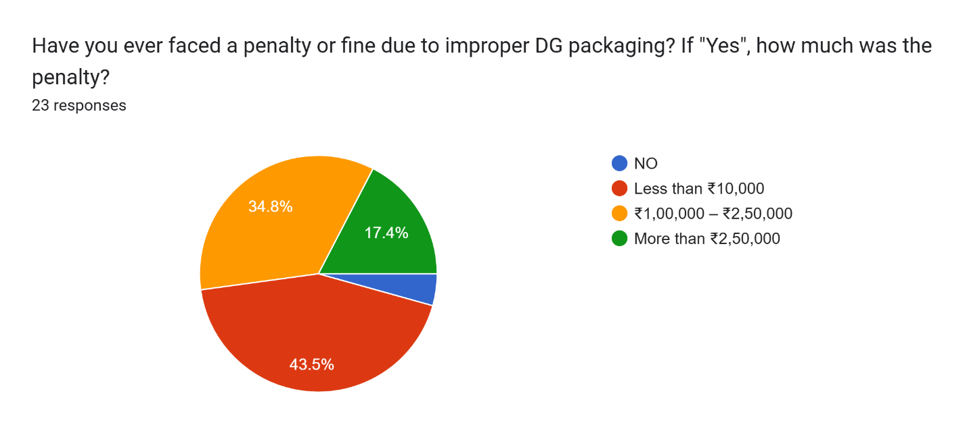

1. What is your primary source of packaging compliance guidance?

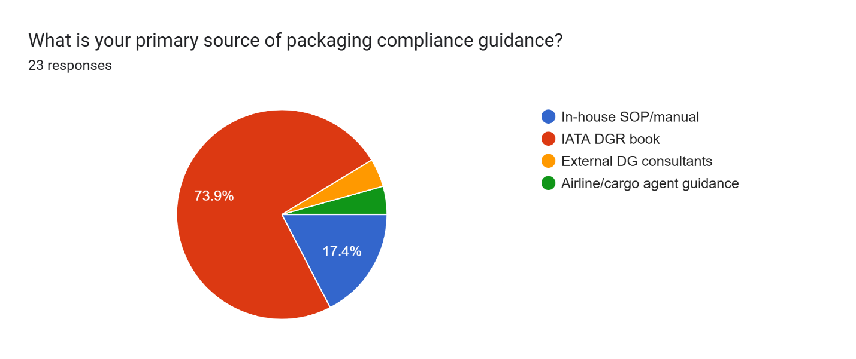

1. Do you believe more innovation or regulation is needed to improve DG packaging?

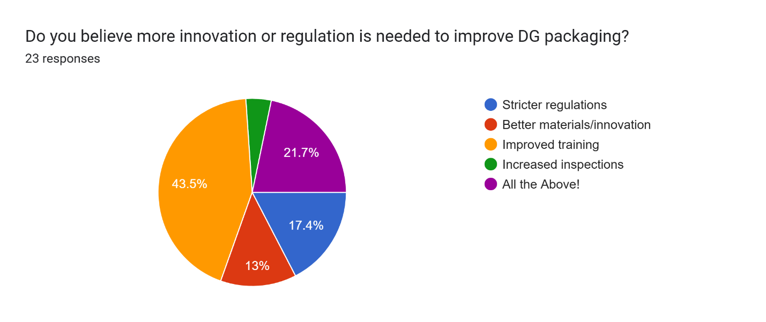

**C. Additional References**

* International Civil Aviation Organization (ICAO). (2020). Technical Instructions for the Safe Transport of Dangerous Goods by Air. 2021-2022 Edition. ICAO.
* International Air Transport Association (IATA). (2020). Dangerous Goods Regulations (DGR). 62nd Edition. IATA.
* U.S. Department of Transportation (DOT). (2020). Hazardous Materials Regulations (HMR). Title 49 of the Code of Federal Regulations (CFR), Parts 171-180.
* Seabay Cargo. (2023). Dangerous Goods in Air Transport.

**D. Glossary of Terms**

**Dangerous Goods (DG):** Substances or materials that pose a risk to health, safety, property, or the environment when not handled, stored, or transported properly.

**UN-certified Packaging:** Packaging that meets the United Nations regulations for the transport of dangerous goods.

**IATA DGR:** Dangerous Goods Regulations developed by the International Air Transport Association, governing the safe air transport of hazardous materials.

**ICAO Technical Instructions:** A set of guidelines issued by the International Civil Aviation Organization to ensure the safe transport of dangerous goods by air.