**DESIGN AND IMPLEMENTATION OF HARMONICS COMPENSATION SYSTEM USING SAPF AND BAND PASS FILTERING TECHNIQUES**

**VEMULAKONDA NIHARIKA¹, DR.S.RATHINAVEL²**

1Student, Electronics and Instrumentation, Bharathiar University, Coimbatore, Tamil Nadu, India

2Assistant Professor, Electronics and Instrumentation, Bharathiar University, Coimbatore, Tamil Nadu, India

**ABSTRACT**

Power quality and system efficiency are impacted by harmonics distortions introduced by nonlinear loads including switching devices, rectifiers, and inverters in contemporary power systems. In order to identify and remove particular harmonic components, This thesis use bandpass filtering techniques in combination with a shunt active power filter to simulate and develop a harmonic compensation system. In order to simulate a distorted waveform, the input signal is formed of a fundamental component at 150Hz with injected third, fifth and seventh harmonics. These harmonic components were separated using a bandpass filter- based technique created **in MATLAB. The pure sinusoidal waveform was then recovered by subtracting these harmonics components from the original signal. Furthermore, a compensator enable signal was generated based on a harmonics distortion threshold using binary control logic. Total Harmonic Distortion (THD) was used as a criterion to assess the system’s performance. The success of the suggested strategy was validated by the findings, which revealed a considerable decrease in THD from 37.19% prior to filtering to 0.96%. This study presents a straightforward yet effective harmonic compensation technique that may be incorporated into real-time power quality control and monitoring systems.**

**Keywords:**Harmonics, Shunt Active Power Filter (SAPF), MATLAB Simulation, Band-Pass Filter(BPF), Total Harmonics Distortion(THD).

1. **INTRODUCTION**

In modern power system, nonlinear loads such as computers, inverters, LED lighting and variable speed drives are widely used. These machine uses non-sinusoidal current, which creates the production of harmonics within the system. Harmonics induces severe power quality problems like voltage distortion, equipment overheating, and higher power losses [1],[2].shunt active power filters( SAPFs) have gained prominence as effective solutions for dynamic harmonic compensation, offering advantages over passive filters by injecting compensating currents in real time [1],[2],[7]. To further improve filtering precision, SAPFs can be integrated with band-pass filters(BPFs), which isolate specific harmonic components, thereby enhancing the overall compensation process.

Various control strategies such as instantaneous power theory (p-q) [1], Synchronous Reference Frame theory (SRF) [2], and intelligent methods like Particle Swarm Optimization (PSO) and fuzzy logic controllers have been proposed to optimize SAPF performance[4],[15]. In distorted supply conditions, tools like Phase Locked Loop (PLL) circuits and dq0 transformations aid in accurate harmonic detection and synchronization [1],[6],[10]. Moreover, the use of multilevel inverters and advanced modulation methods has been explored to enhance output waveform quality and reduce switching losses [9],[12].

This paper presents a MATLAB – based simulation of a hybrid harmonic compensation system that integrates SAPF and BPF techniques. The system targets and extracts the 3rd, 5th, and 7th harmonics from a distorted current waveform (with a fundamental of 150Hz), generates corresponding reference signals, and compensates the harmonics to achieve a nearly sinusoidal output. A binary control logic monitors Total Harmonics Distortion (THD) and activates compensation when a defined threshold is exceeded. The results demonstrate a marked reduction in THD, confirming the system’s potential for real- time power quality improvement in smart grid applications[1-15].

1. **METHODOLOGY**

This research adopts a structured simulation- based approach for harmonic compensation using MATLAB. The methodology involves generating a distorted input signal, isolating harmonics components, applying compensation logic , and evaluating performance using Total Harmonic Distortion(THD). The stepwise process is outlined as follows:

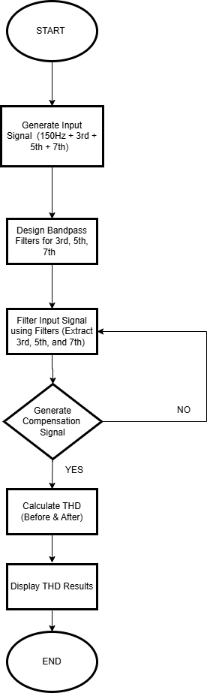

Fig 1. Flowchart

1. Signal generation with harmonic components: A synthetic current signal is generated comprising a 150Hz fundamental component combined with 3rd,5th, and 7th order harmonics. This input replicates typical waveform distortions caused by nonlinear loads in practical systems.
2. Design of Band-PassFilters: Band-Pass Filters are designed and tuned to extract specific harmonic frequencies namely the 3rd, 5th, and 7th harmonics while preserving the integrity of the fundamental waveform.
3. Harmonics extraction via Filtering: The distorted input signal is passed through the BPFs to isolate the harmonic components. This process helps separate the undesired frequencies from the original waveform, facilitating targeted compensation.
4. Generation of compensation signal: A compensation logic block is implemented to monitor the system’s harmonic content. If harmonics levels exceed a predefined threshold, a compensation signal is generated to initiate corrective actions simulating the behavior of a shunt active power filter(SAPF).
5. THD evaluation: Using FFT analysis, the THD is computed both before and after compensation to assess the system’s effectiveness. This ensures that the performance improvement is quantitatively validated.
6. Result visualization: The simulation concludes by displaying the comparative THD results, demonstrating the compensation effect and validating the proposed system’s performance.
   1. **BLOCK DIAGRAM:**

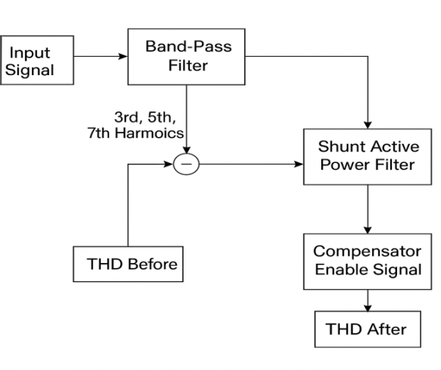

Fig 2. System overview

**2.2 MATHEMATICAL FORMULAS**

**1. Input Signal with Harmonics**

To simulate a distorted waveform composed of the fundamental and injected harmonics:

$$v(t)=V1sin(2πf1t)+V3sin(2πf3t+ϕ3)+V5sin(2πf5t+ϕ5)+V7sin(2πf7t+ϕ7)$$

Where,

• = 150Hz (Fundamental)

• =3 $f1$ =450 Hz

• =5 $f1$ =750 Hz

• =7 $f$ 1=1050 Hz

• : Amplitude of the nth harmonic

• ​: Phase angle of the nth harmonic

**2. Band-Pass Filter Transfer Function**

To isolate each harmonic, a band-pass filter can be defined

$$H(s)=\frac{sω_{c}/Q}{s^{2}+\frac{ω_{c}}{Q}S+{ω_{C}}^{2}}$$

Where:

* $ωc=2πfc$: Center frequency
* Q: Quality factor, controls bandwidth

Each filter is tuned to one harmonic (3rd, 5th, 7th) and isolates its amplitude.

**3. Harmonic Subtraction (Compensation)**

Recovered or compensated signal:

$$υ_{pure}(t)=υ(t)-[υ_{3}(t)+υ_{5}(t)+υ_{7}(t)]$$

Where $υ_{n}(t)$ is the extracted nth harmonic via the corresponding BPF.

**4. THD Calculation**

Total Harmonic Distortion is calculated as:

$$THD=\frac{\sqrt{{v_{3}}^{2}+{v_{5}}^{2}+{v_{7}}^{2}+.....}}{v_{1}}×100\%$$

Where:

* $v_{1}$ ​: RMS of the fundamental
* $v_{n}$ ​: RMS of the nth harmonic

Your THD improvement result:

Before=37.19% ⇒ After=0.96%

**5. Harmonic Threshold Logic (Enable Signal)**

Binary logic for enabling compensation based on threshold:

$$Enable=\left\{\begin{matrix}1, if THD > Threshold \\ 0, if THD ≤ Threshold\end{matrix}\right.$$

1. **RESULTS AND DISCUSSION**

**Input Signal :** The plot represents the X-axis as time(s) and Y-axis as amplitude. The signal contains a 150 Hz fundamental with added 3rd, 5th, and 7th harmonics. Visible distortion indicates nonlinear effects from loads like rectifiers. It reflects real-world power system issues due to harmonic contamination is shown in Fig 3.1.

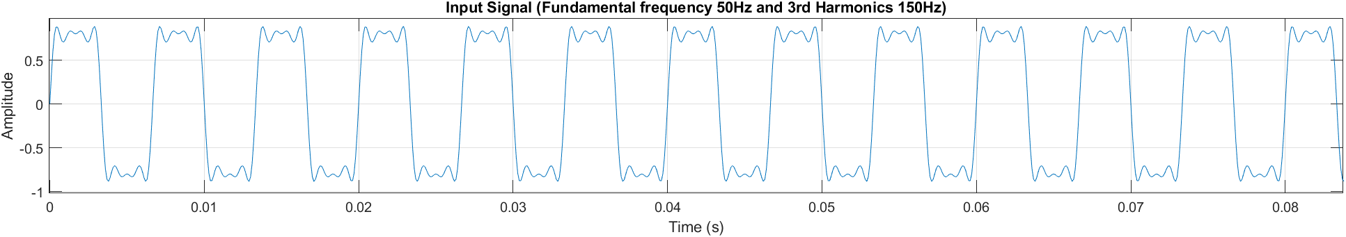

Fig 3.1 Input signal

Filtered Signal : The plot represents the X-axis as time(s) and Y-axis as filtered output. The effectiveness of the Band-Pass Filter (BPF) technique used to remove unwanted harmonics. By applying targeted filtering for the 3rd,5th, 7th harmonics, a nearly pure sinusoidal waveform is recovered. This confirms that the filtering method correctly isolates and subtracts harmonic content while preserving the fundamental 150 Hz component is shown in Fig 3.

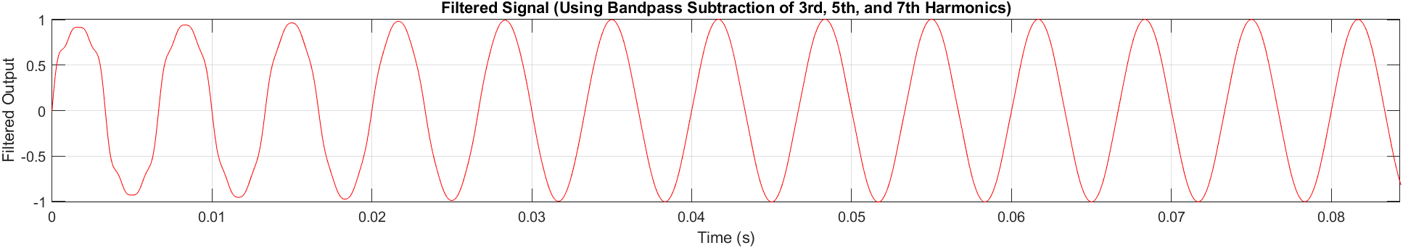

Fig 3.2 filtered signal

**Compensator Enable Signal:** The plot represents the X-axis as time(s) and Y-axis as ON/OFF. The bottom plot shows a binary ON/OFF signal used to control compensation. It switches based on real-time detection of harmonic content in the input. Frequent toggling ensures compensation activates only when needed, improving efficiency is shown in Fig 3.3.



Fig 3.3 compensated enable signal

**RESULTS**

The MATLAB simulation results of the proposed Shunt Active Power Filter with bandpass filtering. The top subplot illustrates the distorted input current waveform, which includes the 150 Hz fundamental frequency and dominant harmonics. The initial Total Harmonic Distortion (THD) was calculated to be **37.19%**. The middle subplot shows the output waveform after filtering. Using bandpass subtraction of the 3rd, 5th, 7th harmonics, the compensated signal is restored to a nearly pure sinusoidal waveform. The THD of the filtered signal was significantly reduced to **0.96%**.The bottom subplot displays the binary enable signal used to activate the compensator. The switching occurs based on real-time THD monitoring, ensuring the system operates only when necessary.

1. **CONCLUSION**

This paper presented a Shunt Active Power Filter integrated with bandpass filtering for effective harmonic compensation in power systems. The proposed method successfully identified and removed dominant harmonic components specifically the 3rd, 5th, 7th using selective filtering and instantaneous power theory.

Simulation results demonstrated a significant reduction in Total Harmonic Distortion (THD) from **37.19%** to **0.96%**, confirming the system’s effectiveness in restoring waveform quality. Additionally, the use of a binary enable logic ensured that the compensator operated efficiently by responding only when distortion exceeded acceptable limits. The proposed approach proves to be a viable solution for real-time power quality enhancement in smart grid and nonlinear load environments, aligning with IEEE 519 harmonic standards.

**ACKNOWLEDGEMENTS**

No potential conflict of interest was reported by the authors.

**REFERENCES**

1. Muhammad Ossama Mahmoud, WaelMamdouh, Hamdy Khalil “Source current harmonic mitigation of distorted voltage source by using shunt active power filter” in IJECE access,Vol. 10, No. 4, August 2020, pp. 3967~3977 ISSN: 2088-8708, DOI:<http://doi.org/10.11591/ijece.v10i4.pp3967-3977>
2. Mukesh Kumar, Shiv Kumar Tripathi “Shunt Active Power Filter Control with Synchronous Reference Frame to Harmonic Reduction” in IJIRSET access , Volume 9, Issue 6, June 2020,eISSN: 2319-8753 p-ISSN: 2320-6710,<https://www.ijirset.com/upload/2020/june/153_Shunt_NC.PDF>
3. K. Kalyan, M. S. Rao and S. Gawre, "Improvement of Power Quality Using Series Active Power Filter(SAPF)," 2020 IEEE International Students' Conference on Electrical,Electronics and Computer Science (SCEECS), Bhopal, India, 2020, pp. 1-5, doi: 10.1109/SCEECS48394.2020.151.
4. Minh Ly Duc , Dong Phan Tan, “Single Phase Harmonic Mitigation Using Particle Swarm Optimization in Shunt Adaptive Power Filter” in access IJETMS Issue: 5 Volume No.7 September - October – 2023 DOI:10.46647/ijetms.2023.v07i05.028 ISSN: 2581-4621.
5. K. Frifita, M. Boussak, A. Naamane and N. M'Sirdi, "Performance tolerant control of shunt active power filter under unbalanced nonlinear load," 2015 16th International Conference on Sciences and Techniques of Automatic Control and Computer Engineering (STA), Monastir, Tunisia, 2015, pp. 279-284, doi: 10.1109/STA.2015.7505130.
6. I. I. Abdalla, K. S. R. Rao and N. Perumal, "Harmonics mitigation and power factor correction with a modern three-phase four-leg shunt active power filter," 2010 IEEE International Conference on Power and Energy, Kuala Lumpur, Malaysia, 2010, pp. 156-161, doi: 10.1109/PECON.2010.5697574.
7. V. Mahajan, P. Agarwal and H. O. Gupta, "Simulation of shunt active power filter using instantaneous power theory," 2012 IEEE Fifth Power India Conference, Murthal, India, 2012, pp. 1-5, doi: 10.1109/PowerI.2012.6479562.
8. K. N. M. Hasan and M. F. Romlie, "Comparative study on combined series active and shunt passive power filter using two different control methods," 2007 International Conference on Intelligent and Advanced Systems, Kuala Lumpur, Malaysia, 2007, pp. 928-933, doi: 10.1109/ICIAS.2007.4658522.
9. M. Hinduja, M. K. Rathi, S. T. Jaya Christa and N. R. Prabha, "PI control of multi level inverter based shunt active power filter for harmonic mitigation in three phase systems," 2015 International Conference on Circuits, Power and Computing Technologies [ICCPCT-2015], Nagercoil, India, 2015, pp. 1-8, doi: 10.1109/ICCPCT.2015.7159419.
10. S. Agrawal, Y. K. Nagar and D. K. Palwalia, "Analysis and implementation of shunt active power filter based on synchronizing enhanced PLL," 2017 International Conference on Information, Communication, Instrumentation and Control (ICICIC), Indore, India, 2017,doi: 10.1109/ICOMICON.2017.8279152.
11. Murat Kale, EnginÖzdemir, ”Harmonic and reactive power compensation with shunt active power filter under non-ideal mains voltage”, Electric Power Systems Research, Volume 74, Issue 3, 2005, Pages 363-370, ISSN 0378-7796, <https://doi.org/10.1016/j.epsr.2004.10.014>.
12. M. Aourir, A. Abouloifa, C. Aouadi, F. El Otmani, I. Lachkar, K. Noussi, H. Katir, “Hybrid Control of Flying Capacitor Converter Based Shunt Active Power Filter for Photovoltaic Systems Interconnection” , IFAC-PapersOnLine, Volume 55, Issue 12, 2022, Pages 49-54, ISSN 2405-8963, <https://doi.org/10.1016/j.ifacol.2022.07.287>.
13. KhairulAnuarMohdNor, Noramalina Abdullah, “Power quality improvement of three-phase electrical systems using active-passive hybrid harmonic filter”, Results in Engineering, Volume 22, 2024, 102242, ISSN 2590-1230, <https://doi.org/10.1016/j.rineng.2024.102242>.
14. FarzaneSoleimani Rudi, Mohammad NaserHashemnia, “Compensation of active filter using p-q theory in photovoltaic systems”, Memories - Materials, Devices, Circuits and Systems, Volume 9, 2025,100122, ISSN 2773-0646, [https://doi.org/10.1016/j.memori. 2025.100122](https://doi.org/10.1016/j.memori.%202025.100122).
15. Chaturvedi, Khushbu&Goswami, Garima&Goswami, Pankaj Kumar. (2018). “A Review On Power Quality Control For Non Linear Loads”. International Journal of Innovative Research and Growth.7. 10.26671/IJIRG.2018.3.7.102.