SYSTEM OF FRACTIONAL NONLINEAR BOUNDARY VALUE PROBLEM
INVOLVING RIEMANN-LIOUVILLE DERIVATIVE
J.A.Nanaware¹, K.A.Shanediwan², M.S.Panchal³
^{1,2} Department of PG Studies and Research in Mathematics, Shrikrishna Mahavidyalaya, Gunjoti, Dist. Dharashiv-413606(M.S.), India, ¹jag₋skmg91@rediffmail.com, ²shanediwankalim@gmail.com,
³ SNBP School and Junior College, Kokane Chowk, Rahatani, Pune-27 (M.S.), India, mayatakle@gmail.com
ABSTRACT
In this paper, Green’s function is defined to study an existence and uniqueness of solution for system of fractional nonlinear boundary value problems. Banach contraction principle is also applied to study the problem.
Keywords: Riemann-Liouville fractional derivative, Green’s function, Existence and uniqueness of solution, Banach contraction principle.
- INTRODUCTION:
The theory of fractional differential equations attracted many researchers during last two decades due to wide range of applications in applied sciences, economics, engineering and technology etc. For more details reader may refer [7, 9, 12]. The existence, uniqueness and stability results were studied in [6, 13] using Green function, fixed point theorems, monotone iterative techniques and Lie group symmetry etc. Boundary value problems for various types of fractional value problems have been studied by many authors [1]-[5] and [10]-[16]. The existence and uniqueness of solutions for a class of fractional nonlinear boundary value problems under mild assumptions was studied by Bachar et. al.[2] using Banach contraction principle.
In 2017, Zou et al.[16] studied uniqueness result for the solution of the following nonlinear boundary value problem
D^{α}v(x) + f(x,v(x)) = 0, 2 < α ≤ 3, x ∈ (0,1),
v(0) = v⁰(0) = v(1) = 0.
Recently, Bachar et al. [2] obtained existence and uniqueness results for a class of fractional nonlinear boundary value problems under mild assumptions.
Many physical phenomena are modeled as system of fractional differential equations with various types of conditions that depends upon physical situations. The existence and uniqueness of solutions of system of fractional differential equations with different conditions were studied by researchers [8]. Very few studies on the existence and uniqueness results for system of nonlinear fractional differential equations is rare in the literature. Therefore, investigating this interesting research topic makes our results novel and worthy.
Motivated by aforementioned work, we generalize the results obtained in [2] for the solution of system of following fractional nonlinear boundary value problem:
D^{α}v_{i}(s) + f_{i}(s,v₁(s),v₂(s)) = 0, (1.1)
v_{i}(0) = v_{i}⁰(0) = v_{i}(1) = 0, i = 1,2,
where D^{α} is the Riemann-Liouville fractional derivative of order α and f_{i} ∈ (0,1)× 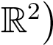 satisfies the following assumptions:
(A₂) There exists q ∈ C((0,1),[0,∞)) such that
|f_{i}(s,v₁,v₂) −f_{i}(s,w₁,w₂)| ≤ q_{i}(s)|v_{i} −w_{i}|, ∀ s ∈ (0,1), v_{i}(s),w_{i}(s) ∈ R,
and 0 < M_{q,α} < ∞, where 0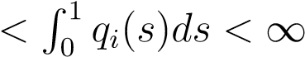 and
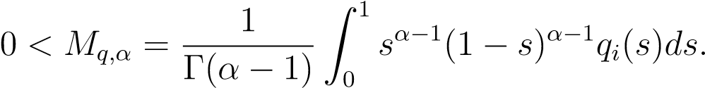
Define the following:
- h_{i}(s) = s^{α−1}(1 −s), s ∈ [0,1], α ∈ [2,3].
- G_{αi}(s,t) be the Green’s function of the operator v_{i} → −D^{α}v_{i} with boundary conditions
v_{i}(0) = v_{i}⁰(0) = v_{i}(1).
be nonempty
and
M_{i} = infE (1.2)
- For a ∈ R, a⁺ = max(a,0).
- C([0,1]) = {v ∈ C([0,1]): there is σ >0 such that |v(s)| ≤ σh_{i}(s),s ∈ [0,1]}.
The paper is organized as follows:
In Section 2, we recall some basic definitions from fractional calculus and give some useful preliminary results. In section 3, we prove the existence and uniqueness results for solution of system of fractional nonlinear boundary value problem using Green function.

PRELIMINARIES
In this section, we recall some definitions and results which are used to obtain main results.
Definition 2.1 [9] Euler-Gamma function denoted by Γ(α) is defined as
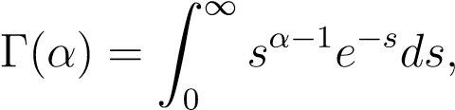 where s^{α−1} = e^{(α−1)log(s)} and α ∈ C.
Definition 2.2 [9] Riemann-Liouville fractional integral of order α >0 of function f is defined as
Definition 2.3 [9] Riemann-Liouville fractional derivative of order α >0 of f is defined as
where n = [α] + 1 , and [α] is the integer part of α.
Lemma 2.1 [14] If y(s) ∈ C(0,1) ∩ L(0,1), then the unique solution of the problem
⁽D^{α}v_{i}(s) + y(s) = 0, 0 < s <1, u_{i}(0) = u⁰_{i}(0) = u_{i}(1) = 0
is given by
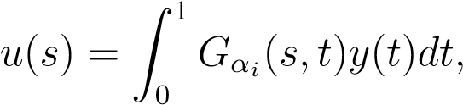
where G_{αi}(s,t) is the Green function
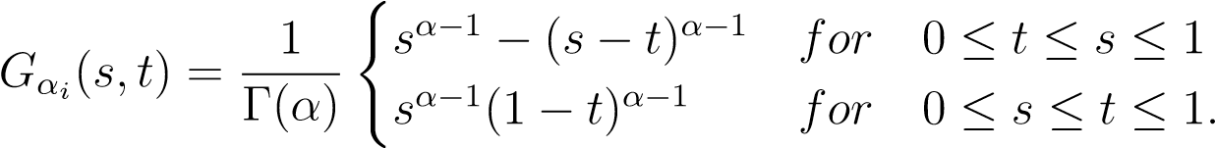
Lemma 2.2 [2] The Green function G_{αi}(s,t) has the following properties:
- G_{αi}(s,t) is nonnegative continuous function on [0,1] × [0,1]
- For all s,t ∈ [0,1], we have
H_{αi}(s,t) ≤ G_{αi}(s,t) ≤ (α −1)H_{αi}(s,t), (2.1)
where .

MAIN RESULTS
In this section, we obtain the existence and uniqueness results for the solution of system of fractional nonlinear boundary value problem using Green function. Also, we obtain sequence of iterations that converges to a solution of system of fractional nonlinear boundary value problem.
Lemma 3.1 Let q_{i} ∈ C((0,1),[0,∞)) and assume that 0 < M_{q,α} <∞. Then M_{q,α+1} ≤ M_{i} ≤ M_{q,α}, where M_{i} is the constant defined by (1.2).
Proof. Let
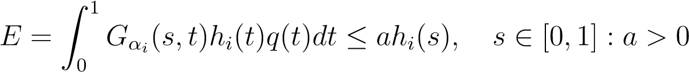,
where h_{i}(s) = s^{α−1}(1 −s), s ∈ [0,1].
By inequality (2.1), we obtain
≤ M_{q,α}h_{i}(s), where 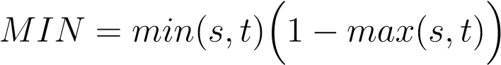.
It follows that E≠ φ and M_{i} ≤ M_{q,α}, where M_{i} = infE.
On the other hand, using inequality (2.1) and
min(s,t)(1 −max(s,t)) ≥ st(1 −s)(1 −t) for t ∈ [0,1], we deduce that for any a ∈ E,
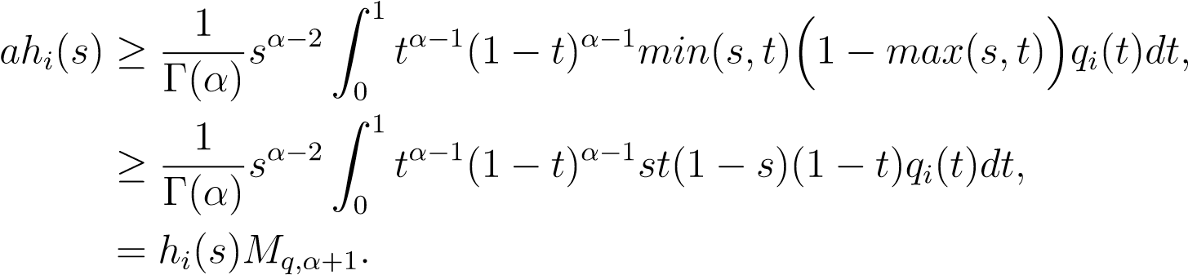
Hence for each a ∈ E, a ≥ M_{q,α+1}. Therefore M_{i} ≥ M_{q,α+1}. Thus the result.
Remark 3.1 From Lemma 3.1, it is obvious that if M_{q,α} <1, then M_{i} = infE <1.
Note that the inequality M_{q,α} <1 can be verified for a large class of functions q, including the singular cases.
Lemma 3.2 If α ∈ (2,3) and let φ be a function such that s → (1 −s)^{α−1}φ(s) ∈ C((0,1)) ∩ L¹((0,1)).
Then the unique continuous solution of the problem
D^{α}v_{i}(s) = −φ(s), s ∈ (0,1) (3.1)
v_{i}(0) = v_{i}⁰(0) = v_{i}(1) = 0
is given by
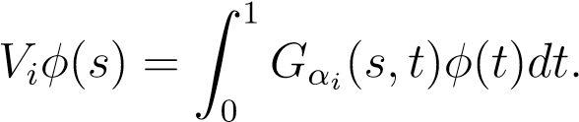
Proof. Let φ be a function such that s → (1−s)^{α−1}φ(s) ∈ C((0,1))∩L¹((0,1)). Since by Lemma 2.2, G_{αi}(s,t) belongs to C([0,1] × [0,1]) with 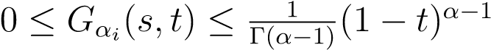,
By the dominated convergence theorem it follows that V_{i}φ ∈ C([0,1]) and V_{i}φ(0) = V_{i}φ(1) = 0. Therefore I^{3−α}(V_{i}|φ|) is bounded on [0,1]. By Fubini’s theorem, we obtain
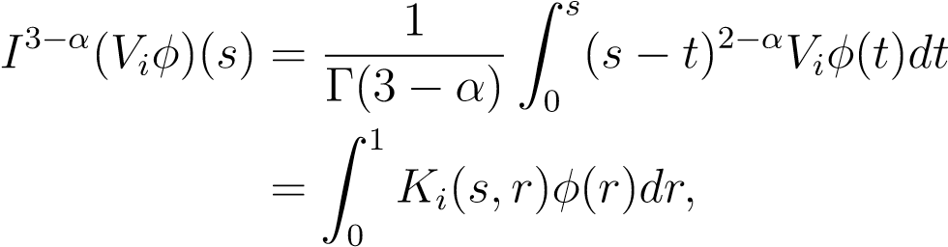
where
Thus .
Hence, for s ∈ (0,1), we have
This implies that
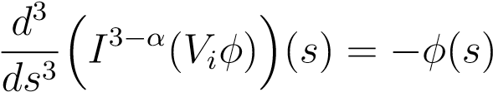.
Now, since for each y ∈ (0,1),
By the dominated convergent theorem, we obtain (V_{i}φ)⁰(0) = 0.
To prove the uniqueness, let v_{i},w_{i} ∈ C([0,1]) be two solutions of problem (3.1) and set θ_{i} = v_{i} −w_{i}. Then θ_{i} ∈ C([0,1]), and we have
D^{α}θ_{i}(s) = 0, s ∈ (0,1)
θ_{i}(0) = θ_{i}⁰(0) = θ_{i}(1) = 0.
By [[9], Corollary 2.1] there exist c₁,c₂,c₃ ∈ R such that
θi(s) = c₁s^{α−1} + c₂s^{α−2} + c₃s^{α−3}.
Applying the boundary conditions, we obtain c₃ = c₂ = c₁ = 0, that is v_{i} = w_{i}. This proves the uniqueness of solutions of the problem (3.1).
Remark 3.2 The conclusion of Lemma 3.1 remains true for α = 3.
Theorem 3.1 Assume that (A₁) and (A₂) hold. If M <1, then problem (1.1) has a unique solution v_{i} ∈ C([0,1]). In addition, for any v₀ ∈ C([0,1]), the iterative sequence
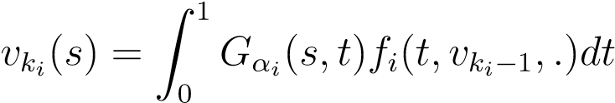
converging to v_{i} with respect to the h−norm, and we have
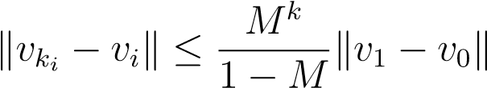 (3.2)
Proof. Define the operator T by
. (3.3)
We claim that T is a contraction operator from 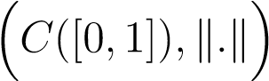 into itself.
Let 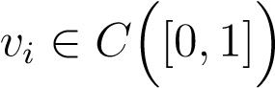, and let σ >0 be such that |v_{i}(s)| ≤ σh_{i}(s) for all s ∈ [0,1]. By Lemma 2.2 (ii), and
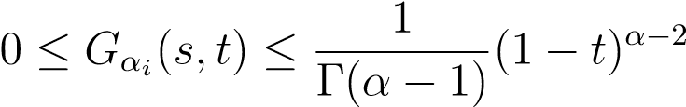,
it follows from (A₂) that
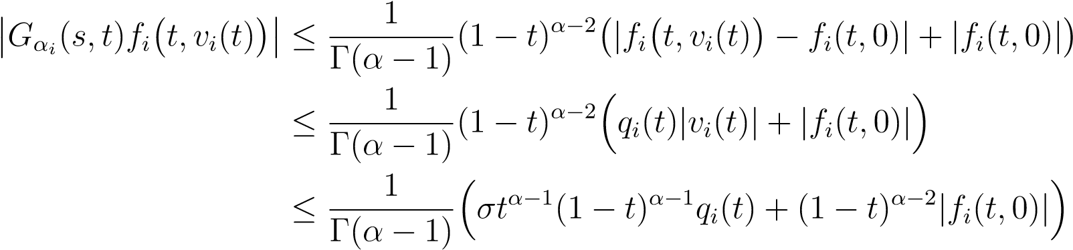
Since G_{αi}(s,t) is continuous on [0,1] × [0,1], by (A₁)-(A₂) and the dominated convergence theorem we deduce that Tv_{i} ∈ C([0,1]).
Furthermore, from Lemma 2.2 (ii), we have
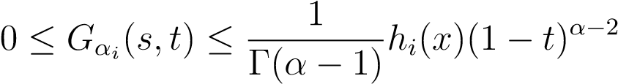, (3.4)
Hence by using inequality (3.4) and similar arguments as before we obtain
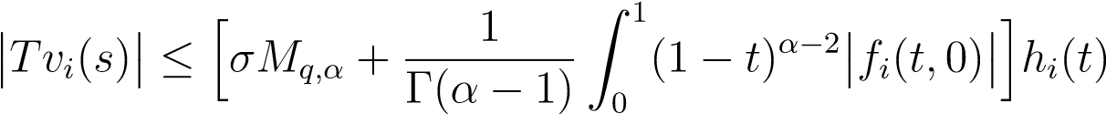
and thus T(C([0,1])) ⊂ C([0,1]).
Next, for any v_{i},w_{i} ∈ C([0,1]), using (A₂), we obtain for s ∈ [0,1],
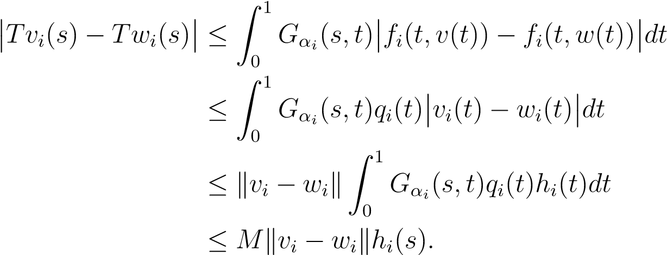
Hence kTv_{i} −Tw_{i}k ≤ Mkv_{i} −w_{i}kh_{i}(s). Since M <1, T becomes a contraction operator in C([0,1]). So there exists a unique v_{i} ∈ C([0,1]) satisfying
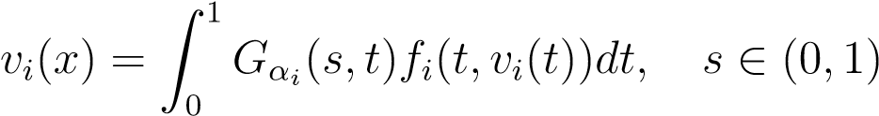.
It remains to prove that v_{i} is a solution of problem (1.1). It is clear that
s → (1 −s)^{α−1}f_{i}(s,v_{i}(s)) ∈ C((0,1)).
Next, by using (A₂) and v_{i} ∈ C([0,1]) we obtain
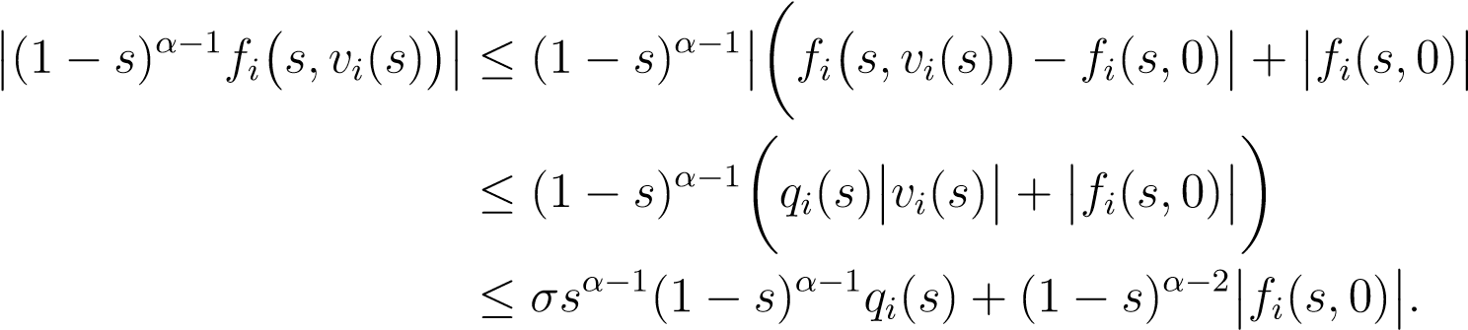
Therefore by (A₁) and (A₂), it follows that
Hence from Lemma 3.1, we derive that v_{i} is a solution of problem (1.1).
Finally, it is known that for any v_{i} ∈ C([0,1]), the iterative sequence
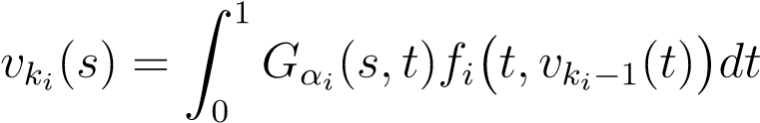
converges to v_{i}, and we have
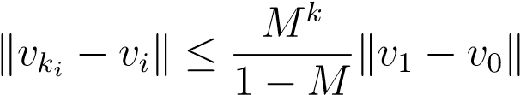.
This proves the theorem.

4. CONCLUSION
The existence and uniqueness of solution for system of fractional nonlinear boundary value problem (1.1) is obtained using Green function. It is also proved that the obtained sequence of iterations of solutions v_{ki}(s) converges to v_{i}.
REFERENCES
- Atangana A., Akgul A. Analysis of new trends of fractional differential equations. In : Fractional Order Analysis, Wiley, USA(2020), 91-111.
- Bachar I., Maagli H.,Eltayeb H. Existence and uniqueness of solutions for a calss of fractional nonlinear boundary value problems under mild assumptions, Advances in difference Equations, Vol (2021) 2021:22.
- Bai Z. On On positive solutions of a nonlocal fractional boundary value problem. Nonlinear Anal. 72(2), (2010) 916-924.
- Bai Z., Zhang S. Sun S., Yin,C. Mnotone iterative method for fractional differential equations. Electron. J. Differ. Equ. 2016, 6(2016).
- Cui Y. Uniqueness of solution for boundary value problems for fractional differential equations. Appl.Math.Lett.51, (2016) 48-54.
- Chatibi Y., Kinani E.H.E., Ouhadan A., Lie Symmetry analysis of conformable differential equaitons. AIMS Math. 4, (2019) 1133-1144.
- Diethelm K. The analysis of Fractional Differential Equations. Lecture Notes in Mathematics, Vol.2004. Springer, Berlin (2010).
- Dhaigude D.B., Nanware J.A., Nikam V.R. Monotone technique for system of caputo fractional differential equations with periodic boundary conditions. Dynamics of Continuous, Discrete and Impulsive System Series A : Mathematical Analysis 19, (2012) 575-584.
- Kilbas A.A., Srivastava H.M., Trujillo J.J. Theory and Applications of Fractional Differential Equations. North-Holland Mathematrics Studies, Vol.204. Elsevier, Amsterdam (2006).
- Liang S., Zhang J. Positive solutions for boundary value problems of nonlinear fractional differential equation. Nonlinear Anal.71(11), (2009) 5545-5550.
- Nanware J.A., Jadhav N.B., Dhaigude D.B. Existence of uniqueness of solutions of nonlinear implicit fractional differential equation. Dynamics of Continuous, Discrete and Impulsive System Series A : Mathematical Analysis 27, (2020) 275-282.

- Podlubny I. Fractional differential equations Academic Press. 198, San Diego,(1999).
- Starrett J. Solving differential equations by symmetry groups. Mar. Math. Mon. 114, (2007) 778-792.
- Zhang X., Liu L., Wu Y. Multiple positive solutions of a singular fractional differetial equation with negatively perturbed term. Math. Comput, Model. 55(34), (2012) 1263-1274.
- Zhang X., Liu L., Wu Y. The uniqueness of positive solution for a fraztional order model of turbulent flow in porous medium. Appl.Math.Lett.37, (2014) 26-33.
- Zou Y., He G. On the uniqueness of solutions for a class of fractional differential equations. Appl. Math. Lett. 74, (2017) 68-73.

