**SMARTCART: RFID-ENABLED AUTONOMOUS SHOPPING SYSTEM WITH CLOUD INTEGRATION**

**R.SRIANANDHAN¹, DR.S.RATHINAVEL²**

1Student, Electronics and Instrumentation, Bharathiar University, Coimbatore, Tamil Nadu, India

2Assistant Professor, Electronics and Instrumentation, Bharathiar University, Coimbatore, Tamil Nadu, India

**ABSTRACT**

The ESP8266-Based intelligent Shopping Cart is an retail Smart automation system designed to streamline the shopping experience through automated billing, IoT-enabled inventory management, and motorized human tracking. This project employs two microcontrollers: an Arduino Uno for autonomous human tracking using ultrasonic and PIR sensors, and an ESP8266 for handling RFID-based billing, cloud connectivity, and real-time transaction updates. The RFID system enables seamless product identification, displaying item details and total billing amounts on an I2C LCD screen. A buzzer and push button are integrated for user interaction and error alerts. The ESP8266’s cloud connectivity allows for real-time inventory updates and digital payment processing, enhancing retail efficiency. Meanwhile, the Arduino Uno-driven motorized tracking system ensures that the cart autonomously follows the user, reducing manual effort. By combining IoT, RFID, and autonomous navigation, this smart shopping cart minimizes checkout delays, optimizes inventory tracking, and improves the overall shopping experience for both customers and retailers.The intelligent shopping cart successfully integrated automated billing, real-time cloud updates, and a human-following system using RFID, Wi-Fi, PIR, and ultrasonic sensors. RFID ensured accurate item tracking, while cloud connectivity supported efficient inventory management.

**KEYWORDS:** ESP8266 & Arduino Uno, RFID-Based Billing, IoT-Enabled Inventory Management, Autonomous Navigation, Retail Automation

1. **INTRODUCTION**

Today, life automation is fast emerging as an enabler with efficiency in labour reduction and time saving. This project has integrated automated billing and a human-following robot to provide a better shopping experience. This automated billing system, based on ESP8266, RFID technology, an I2C LCD display , push buttons, and a buzzer, enables scanning of RFID-tagged products , displaying the finalized total bill on an LCD screen, providing audio alerts, and confirming purchases using a push button , which bypasses manual scanning and reduces waiting time. At the same time, the human-following robot, depending on Arduino Uno with an ultrasonic sensor unit HC-SR04, PIR sensor, servo motor, and gear motors, detects human movement and maintains an adjustable distance, enabling it to comfortably follow the shopper, providing assistance to him or her hands-free while shopping. It shuts down the entire dull aspect of traditional retail shopping since it combines comfort, minimal waiting, and accuracy**.** The intelligent shopping cart successfully integrated automated billing, real-time cloud updates, and a human-following system using RFID, Wi-Fi, PIR, and ultrasonic sensors. RFID ensured accurate item tracking, while cloud connectivity supported efficient inventory management.

That system is aimed to reduce labour, improve inventory handling, and enhance the shopping experience. Should there be a wrong entry of the product, this situation will be rectified by simply rescanning [1]. RFID tags allow automatic identification of items in a smart shopping cart, thereby preventing the need to scan items manually and reducing wait time at the checkout [2]. Each smart cart possesses an RFID reader, an LCD display, an Arduino Mega 2560 board, a Wi-Fi module, and a power supply. Customers scan RFID-tagged products, and the card updates the bill in real-time via IBM Cloudant, a cloud database [3]. Customers may remove unwanted items from the cart using a push button. At checkout, scanning the QR code on the cart generates an e-bill, indicating that payments can be made online through Paytm, UPI, and PhonePe. At checkout, payment is processed through contactless methods, such that the digital system integrates image recognition, radar-based self-following technology, and multi-sensor fusion. For an intelligent shopping experience. Key features include an improved SIFT algorithm for product identification and a cloud platform for real-time data processing [4, 5].

1. **METHODOLOGY**

This study of methodology for creating an intelligent shopping cart with RFID, cloud connectivity, and autonomous navigation follows a methodical approach to enhance shopping experiences through automation.

**The methodology consists of the following steps**:

* System initialization: An ESP8266 microcontroller and Arduino Uno are both turned on. The sensors, RFID reader, LCD display, and motor driver all establish initialization and communication and are designed to manage inventory in real time.
* Scanning RFID products: the product tag is picked up by the RFID reader when a customer adds an item to their card. After identifying the product, the system retrieves its name, price, and stock information from the cloud database. The I2C LCD panel displays the product details. A buzzer alerts the customer when a scan is successful.
* Automated billing and transaction processing: The total amount is increased by the cost of the scanned item. When item is withdrawn, the system detects it and deducts the price from the overall bill. Customers can click the finalize button to confirm their purchase. Cloud updates and the display of the entire amount.
* Motorized human tracking and Autonomous navigation: That ardunio uno processes inputs from PIR and Ultrasonic sensors. The cart follows the customers autonomously using gear motors and using gear motor driver. More infrared sensors can enhance tracking accuracy and object avoidance.
* Cloud connectivity and intelligent alerts: The ESP8266 microcontroller is used to updates cloud based inventory data. Customers can view their billing information on a smartphone through related app.
* The cloudount and completion procedure: At the ending process shopping session, the customers fills out the bill. Cloud-based technologies can be used to manage payments. The system is reset for the next shopping session

.

* 1. **Block diagram:**

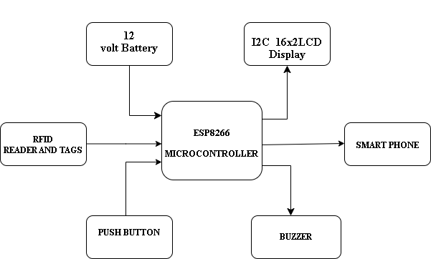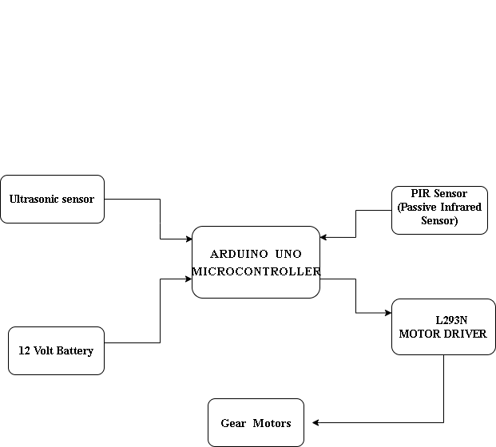

**Figure 1: Overview of hardware setup**

* 1. **HARDWARE CONFIGURATION:**

**ESP8266 Microcontroller**

ESP8266 is a powerful, low-cost WiFi microcontroller ideal for IoT applications like smart shopping carts. It features a 32-bit Tensilica L106 RISC processor with an 80 MHz clock (upgradable to 160 MHz), built-in 2.4 GHz WiFi (IEEE 802.11 b/g/n), and supports dual mode (AP+STA). With 11 GPIO pins, it supports interrupts, PWM, I2C, SPI, and UART. It offers 80 KB RAM, 1–4 MB flash and secure TCP/IP, UDP, HTTP, and MQTT communication with WPA/WPA2 encryption. Programmable via Arduino IDE, Lua, or MicroPython, it’s powered by 3.3V (level shifting needed for 5V devices).

**Ardunio uno microcontroller**

The Arduino Uno, an open-source microcontroller based on the ATmega328P, features six analog inputs, 14 digital I/O pins, a power jack, and a USB port., it's widely used in robotics, IoT, and automation projects involving sensors, motors, and modules. The Arduino IDE enables programming for tasks like distance measurement (Ultrasonic sensor) and motion detection (PIR sensor), which control a self-following trolley via the L298N motor driver. Compiled code is uploaded via USB, after which the Arduino runs the program to operate the system.

**I2C LCD Display**

I2C LCD display reduces pin usage by communicating over the I2C protocol using two wires (SDA and SCL), unlike standard LCDs that require multiple connections. Common in embedded systems, it displays real-time data, messages, and is available in sizes like 16x2 and 20x4. In this project, it shows product details, prices, and the total amount to the user and sharing this total amount in cloud connectivity.

**Ultrasonic Sensor**

An ultrasonic sensor measures distance using high-frequency sound waves (40 kHz). It includes a transmitter and receiver to detect the time delay of reflected pulses, calculating distance with the formula: Distance = (Speed of Sound × Time) / 2. The HC-SR04, operating at 5V DC with a 2–400 cm range, is widely used in obstacle detection, human-following robots, and security applications due to its accuracy and reliability.

**PIR Sensor**

The PIR (Passive Infrared) sensor detected the motion by measuring change using infrared (IR) radiation with in field of viewed. It uses a Fresnel lens to focus IR light onto a pyroelectric sensor, which responds to the movement of warm objects like humans or animals. In this project, the PIR sensor is used solely for detecting movement. Due to its low power usage, reliability, and 3–7 meter detection range, it is ideal for motion-based applications such as human-following robots and automated systems.

**Servo motor**

A PWM signal is used by servo motors, which are accurate actuators, to regulate position. With three primary connections—signal (control), GND, and VCC (5V–12V, depending on the servo type)—it normally spins between 0° and 180°. The servo motor in this project is utilized to adjust the human-following car's angle in order to control its direction changes based on the sensor data, a PWM signal from the microcontroller modifies the servo's position to provide smooth turns. For steady operation, high-torque servos sometimes need an extra voltage regulator.

**Gear Motor**

An gear motor are integrate an electric motor with an gearbox to enhance torque and lower speed, making it ideal for controlled and powerful motion. Common in robotics and automation, DC gear motors an preferred for small projects. Depending on specifications, they operate at 3V–24V. PWM control via motor drivers like L298N or L293D adjusts speed and voltage efficiently. In this project, gear motor are used to control the forward and backward movement of a human-following car. Based on sensor input detecting human presence or obstacles, the gear motors adjust direction accordingly.

**Motor driver LP298N**

L298N motor driver, built on a dual H-bridge circuit, controls the direction and speed of DC and stepper motors using PWM signals. Key pins include VCC (7V–35V motor power), GND, and 5V (logic power, optional if using the on board regulator). Direction is controlled via IN1–IN4 pins; for example, IN1 HIGH and IN2 LOW drive the motor forward. Speed is managed through ENA and ENB using PWM to adjust the duty cycle. In this project, the L298N is used to drive the gear motors, enabling forward and backward movement based on sensor input.

**Push button**

Often employed for input control in electronic circuits, a pushbutton is a basic switch that, when pressed, can create or break an electrical connection. It typically has 2 or 4 pins, with internal pairing in 4-pin types. In this project, the pushbutton is used to share the total bill to the website. One pin is connected to a digital input on the microcontroller (e.g., D2 on ESP8266) and the other to GND. A 10kΩ pull-up resistor (or the microcontroller's internal pull-up) ensures the pin reads HIGH when idle and LOW when pressed. The pushbutton operates at 3.3V or 5V logic levels, and proper voltage handling ensures stable and accurate triggering. When pressed, it sends a signal that initiates the transmission

**Buzzer**

Buzzers are commonly used in electronic circuits to provide audible alerts. They come in two types: active, which sound when powered, and passive, which require a PWM signal. Typically, buzzers have two pins: VCC (3.3V–5V for small buzzers) and GND. In microcontroller systems like Arduino or ESP8266, the GND connects to ground, while VCC is powered directly or through a digital pin. High-voltage buzzers may need transistor control to protect low-power microcontrollers. In this project, the buzzer is used to produce sound when items are scanned via RFID—a short beep for successful scans and longer tones for item removal. This enhances user experience by providing clear audio feedback during the shopping process.

* 1. **Software configuration**

**Ardunio IDE**

The Arduino IDE is an cross-platform, user-friendly software used to write, build, and upload C/C++ code to microcontrollers like Arduino Uno and ESP8266. It features a built-in editor, debugging console, and USB connectivity via AVRdude. Supporting a wide range of boards and expandable with third-party libraries, it’s ideal for sensor, display, and wireless projects. In this project, the IDE is used to program the Arduino Uno for autonomous navigation and the ESP8266 for RFID scanning and cloud data transmission, creating a seamless smart shopping experience.

**Cloud connectivity website for iot application kazhugu**

In this cloud, connectivity is enabled using the Kazhugu Cloud API to display the total bill amount online. The ESP8266 connects to Wi-Fi and sends the current bill value to the cloud in real-time using a unique sensor code (KwYME50G6B24299) and registered email (user@gmail.com).The data is transmitted via a secure HTTP POST request to https://api.kazhugu.cloud/api/v1/iot/update_sensor_reading, allowing users to view the billing information from any device connected to the internet. This makes the system more accessible, transparent, and easy to monitor remotely.

* The ESP8266 connects to a Wi-Fi network.
* The total bill amount is updated in real-time when items are scanned or removed.
* After each update, an HTTP POST request is sent to the Kazhugu Cloud API.
* The data is stored and displayed via a dedicated web dashboard.
  1. **FLOW CHART**

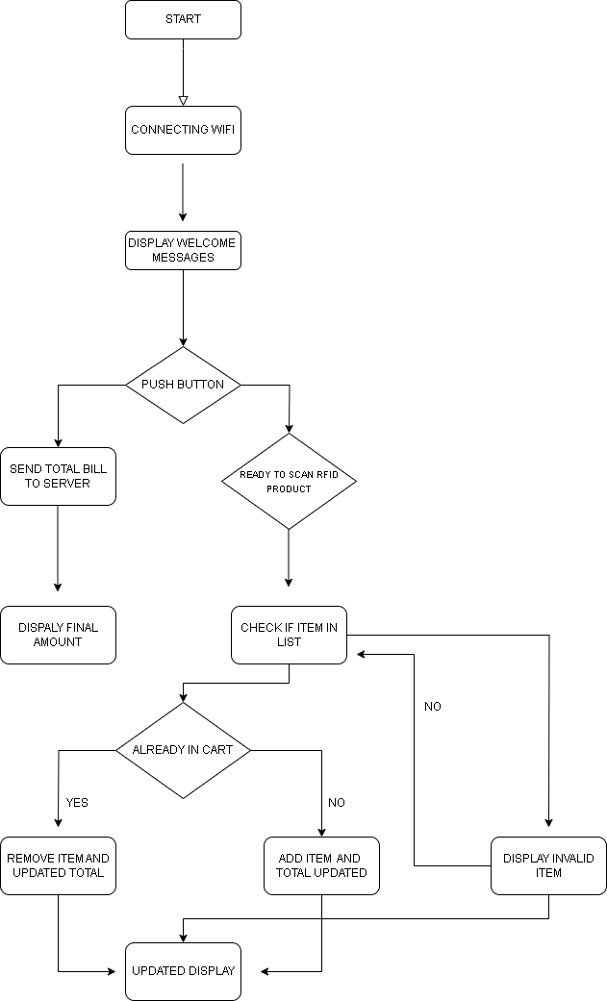

**FIGURE 2 :Flow chart**

1. **IMPLEMENTATION**

**ESP8266** – **Handing RFID-based billing and cloud connectivity**

The ESP8266 microcontroller handles cloud connectivity and RFID-based automated billing. It connects to the cloud via Wi-Fi for real-time transaction updates and is powered by a 12V battery regulated to 5V. Products are scanned using an RFID reader, connected to the ESP8266 (VCC to 3.3V, GND to GND, TX to RX, RX to TX). Billing details are shown on an I2C 16x2 LCD, connected via SDA (D2) and SCL (D1) pins. A buzzer connected to D3 provides alerts, while two push buttons enhance control—one on D4 for confirming purchases and another on D5 for removing items from the bill.

**Arduino Uno** – **Controls the autonomous navigation system for human following**

The Ultrasonic Sensor (HC-SR04) connects to the Arduino Uno via VCC to 5V, GND to GND, Trigger to D7, and Echo to D8. The PIR sensor is connected with VCC to 5V, GND to GND, and Data to D6. Two gear motors are driven by an L298N motor driver, with Motor 1 (left) on OUT1/OUT2 and Motor 2 (right) on OUT3/OUT4. Motor direction is controlled via IN1–IN4 connected to D9–D12, while speed control is handled by ENA (D3) and ENB (D5), both PWM pins.

1. **RESULTS AND DISCUSSION**
   1. **Result**

The intelligent shopping cart successfully integrated automated billing, real-time cloud updates, and a human-following system using RFID, Wi-Fi, PIR, and ultrasonic sensors. RFID ensured accurate item tracking, while cloud connectivity supported efficient inventory management. Autonomous navigation enhanced user convenience, especially for the elderly and differently abled. Features like LCD displays, buzzer alerts, and automatic cart clearance streamlined the shopping process by eliminating barcode scanning and reducing checkout time. The project made shopping smarter and faster, with future potential for voice control, AI suggestions, and digital payments to further enhance the experience.

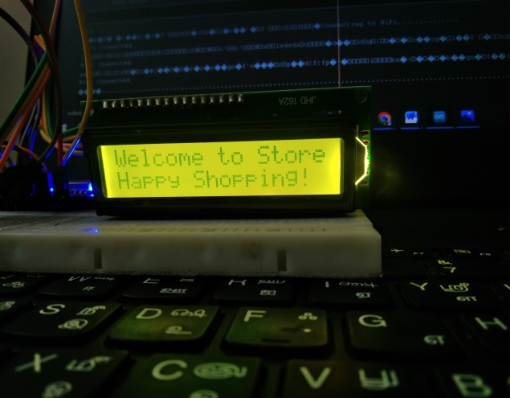 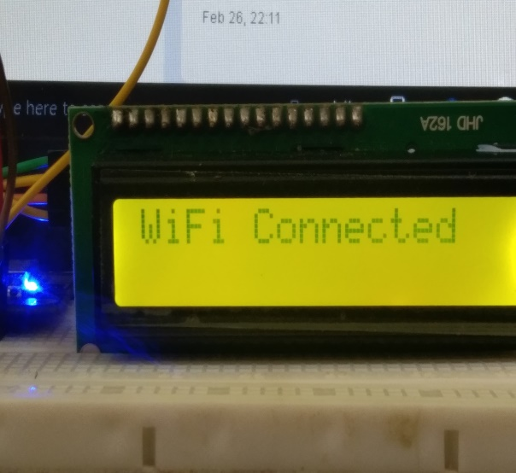

**FIGURE 3: WELCOME MESSAGES TO CONNECTING WIFI**

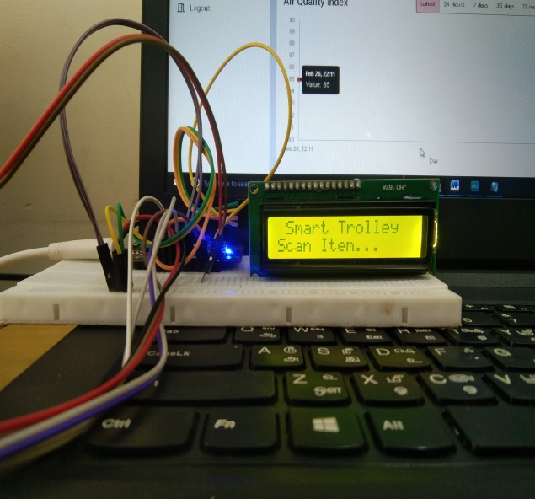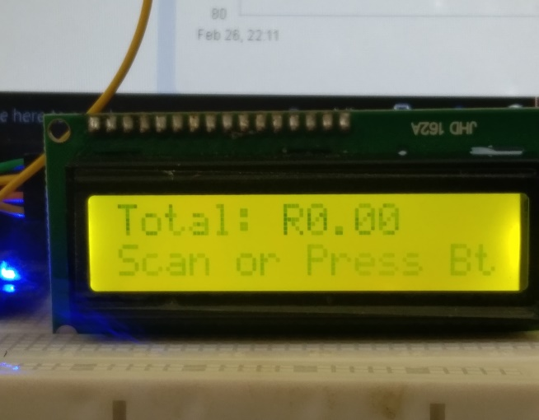

**FIGURE 4: READY TO SCAN THE PRODUCTS**

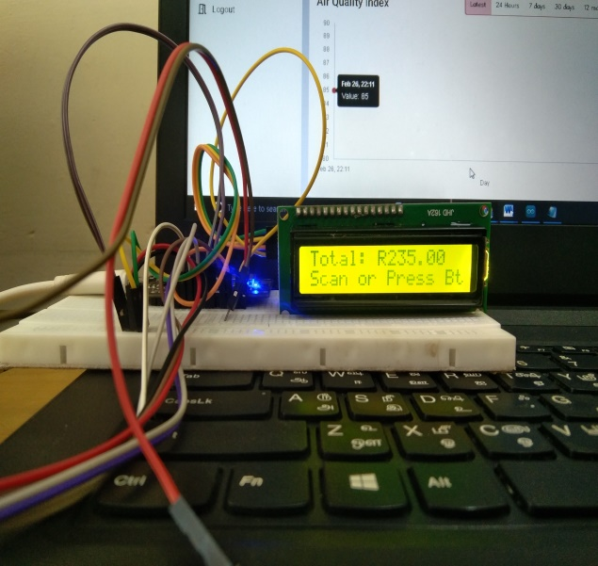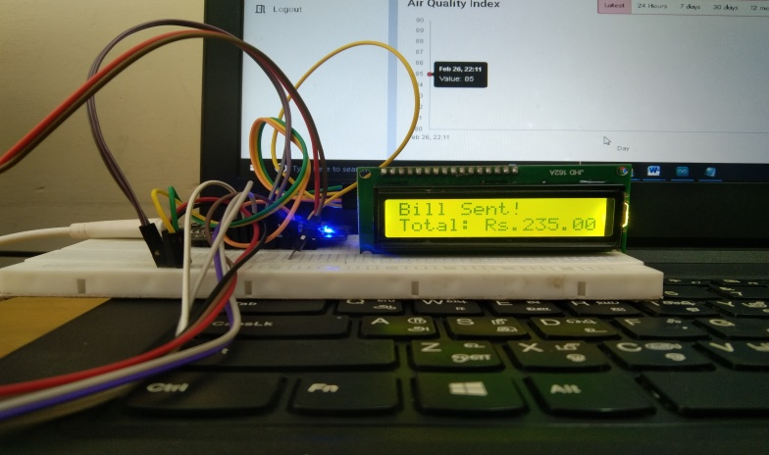

**FIGURE 5: TOTAL BILL AND SENDING WEB SERVER**

When clients first utilize the clever Intelligent Shopping System, a welcome message is displayed on the I2C_16x2 LCD display. The LCD displays billing and shopping-related messages, creating an intuitive user experience. The text is clearly and correctly centered on the LCD. It greets users and improves the clever Smart Shopping system's interactive experience. ESP8266 module is trying to establish a Wi-Fi connection. This means your cloud update or mobile integration feature is initializing properly. I2C 16x2 LCD screen showing the message **"WiFi Connected"**, indicating that the ESP8266 microcontroller has successfully connected to the configured Wi-Fi network.

The system is ready and waiting for an item to be scanned via RFID. This confirms that your RFID reader is active and the code has reached the item-scanning loop. Items have been scanned, and the total bill has been calculated. the bill has successfully been sent to the cloud or finalized for display. this shows both your item pricing logic and cloud update function are working. The system dynamically updates the 16x2 LCD panel and determines the overall cost of the scanned products. This makes it easier for customers to monitor their entire purchase while they buy. The screen appears total cost following an item scan. The user is prompted to continue shopping with the "Scan more..." notification. As products are scanned, the total price is updated instantly. After viewing the new bill, users can either continue scanning or check out.

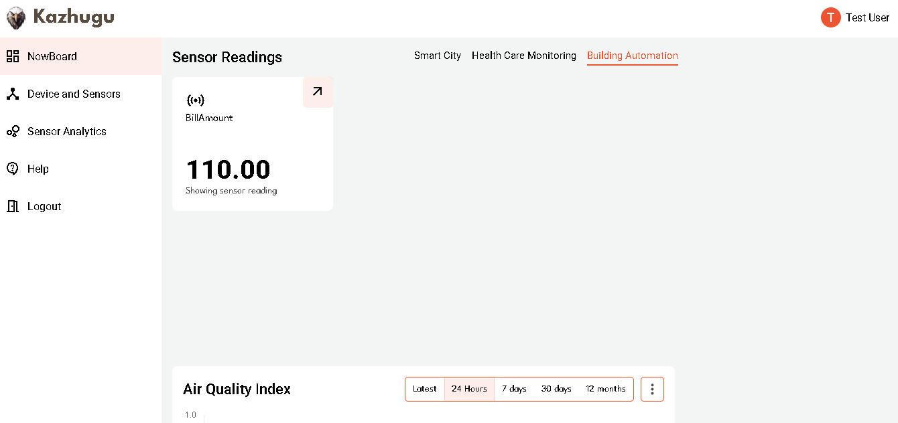

**FIGURE 6: SHOWING TOTAL AMOUNT IN WEBSITE**

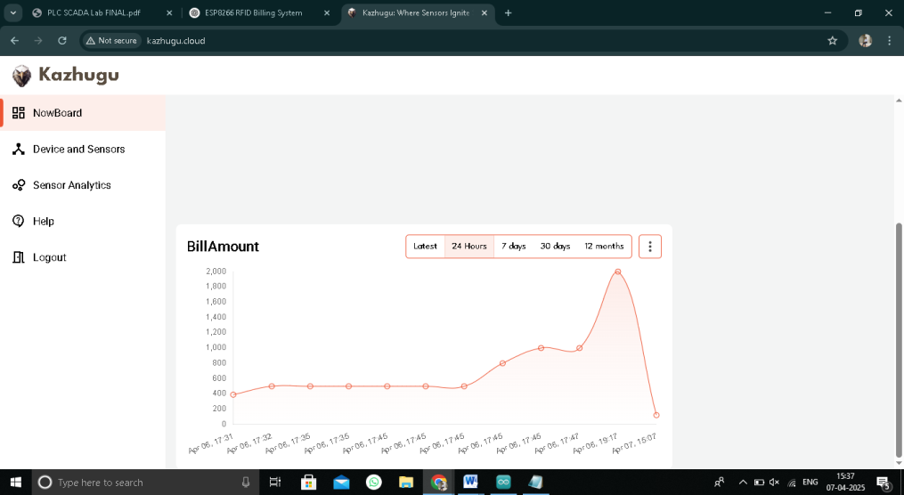

**FIGURE 7: DAILY PURCHASE RATIO**

.**REFERENCE:**

[1] L. Yao, T. Li, R. Tong, K. Wang and L. Zhang, "Radar Self-Following Shopping Cart Based on Multi-Sensor Fusion," in IEEE Access, vol. 11, pp. 77055-77072, 2023, doi: 10.1109/ACCESS.2023.3297889.

[2] T. K. Das, A. K. Tripathy and K. Srinivasan, "A Smart Trolley for Smart Shopping," 2020 International Conference on System, Computation, Automation and Networking (ICSCAN), Pondicherry, India, 2020, pp. 1-5, doi: 10.1109/ICSCAN49426.2020.9262350.

[3] Y. Berdaliyev and A. P. James, "RFID-Cloud smart cart system," 2016 International Conference on Advances in Computing, Communications and Informatics (ICACCI), Jaipur, India, 2016, pp. 2346-2352, doi: 10.1109/ICACCI.2016.7732405.

[4] A. Kumar, A. Gupta, S. Balamurugan, S. Balaji and R. Marimuthu, "Smart Shopping Cart," 2017 International conference on Microelectronic Devices, Circuits and Systems (ICMDCS), Vellore, India, 2017, pp. 1-4, doi: 10.1109/ICMDCS.2017.8211723.

[5] T. Arciuolo and A. -s. Abuzneid, "Simultaneously Shop, Bag, and Checkout (2SBC-Cart): A Smart Cart for Expedited Supermarket Shopping," 2019 International Conference on Computational Science and Computational Intelligence (CSCI), Las Vegas, NV, USA, 2019, pp. 1162-1167, doi: 10.1109/CSCI49370.2019.00219.

[6] Y. -C. Wang and C. -C. Yang, "3S-cart: A Lightweight, Interactive Sensor-Based Cart for Smart Shopping in Supermarkets," in IEEE Sensors Journal, vol. 16, no. 17, pp. 6774-6781, Sept.1, 2016, doi: 10.1109/JSEN.2016.2586101.

[7] P. Lopez-Iturri et al., "Implementation of Wireless Sensor Network Architecture for Interactive Shopping Carts to Enable Context-Aware Commercial Areas," in IEEE Sensors Journal, vol. 16, no. 13, pp. 5416-5425, July1, 2016, doi: 10.1109/JSEN.2016.2561319.

[8] Shopping Cart Using Radio Frequency Identification," in IEEE Access, vol. 8, pp. 68426-68438, 2020, doi: 10.1109/ACCESS.2020.2986681.

[9] H. -S. Kim, J. Ko and S. Bahk, "Smarter Markets for Smarter Life: Applications, Challenges, and Deployment Experiences," in IEEE Communications Magazine, vol. 55, no. 5, pp. 34-41, May 2017, doi: 10.1109/MCOM.2017.1600260.

[10] R. Li, T. Song, N. Capurso, J. Yu and X. Cheng, "IoT Applications on Secure Smart Shopping," 2016 International Conference on Identification, Information and Knowledge in the Internet of Things (IIKI), Beijing, China, 2016, pp. 238-243, doi: 10.1109/IIKI.2016.25.

[11]P. K. Khairnar and D. H. Gawali, "Innovative shopping cart for smart cities," 2017 2nd IEEE International Conference on Recent Trends in Electronics, Information & Communication Technology (RTEICT), Bangalore, India, 2017, pp. 1067-1071, doi: 10.1109/RTEICT.2017.8256762

[12] S. R. Subudhi and R. N. Ponnalagu, "An Intelligent Shopping Cart with Automatic Product Detection and Secure Payment System," 2019 IEEE 16th India Council International Conference (INDICON), Rajkot, India, 2019, pp. 1-4, doi: 10.1109/INDICON47234.2019.9030331.

[13] P. Chandrasekar and T. Sangeetha, "Smart shopping cart with automatic billing system through RFID and ZigBee," International Conference on Information Communication and Embedded Systems (ICICES2014), Chennai, India, 2014, pp. 1-4, doi: 10.1109/ICICES.2014.7033996.

[14] D. Sinha, K. Cottur, K. B. H., G. C. and B. N. K., "Automated Billing System using RFID and Cloud," 2019 Innovations in Power and Advanced Computing Technologies (i-PACT), Vellore, India, 2019, pp. 1-6, doi: 10.1109/i-PACT44901.2019.8960144.

[15] RachanaDoshi, A. S., SonaliAher, S., & BR, C. (2017). RFID based smart trolley for automatic billing system. Global Journal of Advanced Engineering Technologies, *5*(4-2016).

[16] Jayshree, G., Gholap, R., & Yadav, P. (2014). RFID based automatic billing trolley. International Journal of Emerging Technology and Advanced Engineering, 4(3), 136-139.