**A STUDY ON CHALLENGES IN TALENT ACQUISITION WITH REFERENCE TO CAREERNET TECHNOLOGIES**

**Name : Nivetha D ,** Student, Master of Business Administration, M. Kumarasamy College of Engineering, Karur, Tamil Nadu, India.

**Guide Name: Mrs.A.Santhiya ,** Assistant Professor Master of Business Administration, M. Kumarasamy College of Engineering, Karur, Tamil Nadu, India.

**ABSTRACT**This study explores the challenges faced in talent acquisition at Careernet Technologies, a prominent recruitment and staffing solutions firm. It investigates issues such as skill gap alignment, candidate sourcing, employer branding, and the effectiveness of recruitment strategies in a competitive talent market. By analyzing internal recruitment processes and external market dynamics, the research aims to identify bottlenecks and recommend strategic improvements. Insights were gathered through interviews, surveys, and performance metrics, offering a comprehensive understanding of the hurdles faced in hiring top talent. The findings aim to enhance recruitment efficiency and support organizational growth.

**Keywords:**Talent Acquisition, Recruitment Challenges, Skill Gap, Employer Branding, Candidate Sourcing, Careernet Technologies, Hiring Strategies, Human Resources

**1. INTRODUCTION**

This study examines the key challenges in talent acquisition at Careernet Technologies. It focuses on understanding difficulties in sourcing qualified candidates, aligning skills with job roles, and enhancing employer branding. The research aims to provide actionable insights to improve recruitment efficiency and support the company’s strategic hiring goals**.**

**2. OBJECTIVES OF THE STUDY**

To provide top-tier talent acquisition services that meet the diverse needs of organizations across industries.

To support organizations in building diverse, inclusive workforces that foster innovation and growth.

To streamline recruitment processes through innovative strategies, technology, and data-driven approaches.

To build strong, lasting partnerships with clients by consistently delivering value and exceeding expectations.

To offer career transition and outplacement services, helping individuals grow professionally and find meaningful opportunities.

**NEED FOR THE STUDY**

The study is essential as to identifying the key difficulties Careernet Technologies faces in attracting and retaining top talent in a competitive job market.

It helps analyze the effectiveness of existing talent acquisition methods as to exploring potential improvements for better hiring outcomes.

The study will provide insights as to how market trends, skill shortages, and evolving job roles impact Careernet’s recruitment approach.

**SCOPE OF THE STUDY**

The study will focus on identifying the key obstacles Careernet Technologies faces in recruiting, sourcing, and retaining skilled talent.

It will assess the effectiveness of Careernet’s recruitment methods, including digital hiring, leadership hiring, and RPO (Recruitment Process Outsourcing).

It will provide strategic insights and solutions to enhance Careernet’s talent acquisition efficiency, employer branding, and overall hiring effectiveness.

**LIMITATIONS OF THE STUDY**

Limited Scope to One Organization – The study focuses only on Careernet Technologies, which may not fully represent the challenges faced by the entire talent acquisition industry.

Data Availability Constraints – The accuracy of the findings depends on the availability and accessibility of Careernet’s internal recruitment data, which may be restricted.

Changing Market Trends – The recruitment landscape is constantly evolving, and the study may not fully capture emerging trends or future industry shifts.

**3. REVIEW OF LITERATURE**

**Karthik, R., & Selvakumar, P. (2024). "Post-Pandemic Hiring: Challenges and Strategies in Consultancies."** This study explored the impact of the COVID-19 pandemic on talent acquisition strategies within HR consultancies. The researchers analyzed how firms adapted to remote hiring, virtual onboarding, and increased reliance on AI-driven recruitment tools.

**Chen, R. (2023). "Virtual Recruitment Events: Navigating the New Normal."** With in-person hiring events becoming less frequent, this study examined the effectiveness of virtual career fairs and digital recruitment events.

**Martinez, L. (2022). "Employer Branding in a Digital Age: Attracting Top Talent."** Martinez highlighted the increasing importance of employer branding in talent acquisition. With growing digital competition, HR consultancies faced the challenge of positioning their clients as employers of choice.

**Anderson, P. (2021). "The Role of Artificial Intelligence in Modern Recruitment."** Anderson’s study explored the growing role of artificial intelligence (AI) in recruitment processes within HR consultancies. The research examined AI-driven tools such as applicant tracking systems (ATS), automated resume screening, and AI-powered chatbots designed to streamline hiring.

**Patel, S. (2020). "Diversity and Inclusion Challenges in Talent Acquisition."** Patel’s study examined the persistent challenges of achieving diversity and inclusion (D&I) in talent acquisition, particularly within HR consultancies.

**4. RESEARCH METHODOLOGY**

**4.1 RESEARCH DESIGN**

A research design is the framework that guides a research study, outlining the methods used to collect and analyze data to address research questions or test hypotheses. This study employs a descriptive research design to examine the challenges in talent acquisition at Careernet Technologies. The research focuses on identifying key obstacles in the recruitment process, such as skill gaps, high candidate drop-off rates, sourcing difficulties, competition for top talent, and lengthy hiring cycles.

**5. METHOD OF DATA COLLECTION**

The data collection process within Careernet Technologies it involves primary data collection methods to ensure a comprehensive understanding of the challenges in talent acquisition. Primary data will be gathered through surveys, interviews, and focus group discussions (FGDs) with HR professionals, recruiters, and hiring managers. Surveys will contain both quantitative (Likert scale, multiple-choice) and qualitative (open-ended) questions to capture insights into recruitment challenges such as skill gaps, sourcing difficulties, and candidate drop-off rates. In-depth interviews with key stakeholders will provide deeper insights into specific recruitment bottlenecks and their impact. Additionally, FGDs will be conducted among recruiters to encourage discussions on shared challenges and potential solutions.

**5.1 POPULATION**

The total population of the study is 200.

**5.2 SAMPLING UNIT**

The sampling unit for this study consists of employees directly involved in the talent acquisition process at Careernet Technologies. This includes HR professionals, recruiters, hiring managers, and department heads, as they possess firsthand experience in identifying, sourcing, and selecting candidates. These individuals are chosen because they actively face challenges such as skill shortages, candidate drop-offs, and competitive hiring pressures. The sample will be drawn from employees working across different departments within the organization to ensure a diverse range of perspectives.

**5.3 SAMPLE SIZE**

The sample size for this study will be 110.

**5.4 SAMPLING METHOD**

The study employs a purposive sampling method to ensure that data is collected from employees directly involved in the talent acquisition process at Careernet Technologies. The sampling process involves selecting 110 employees, including HR professionals, recruiters, hiring managers, and department heads, who have firsthand experience with recruitment challenges. Data has been collected through a survey, which will be circulated via Google Forms to employees within the organization.

**TOOLS FOR DATA ANALYTICS**

Correlation analysis Correlation shows a strong relationship between flexible work schedules and employee productivity, indicating that flexibility leads to better performance and work-life balance.

**PROPOSED MODEL**

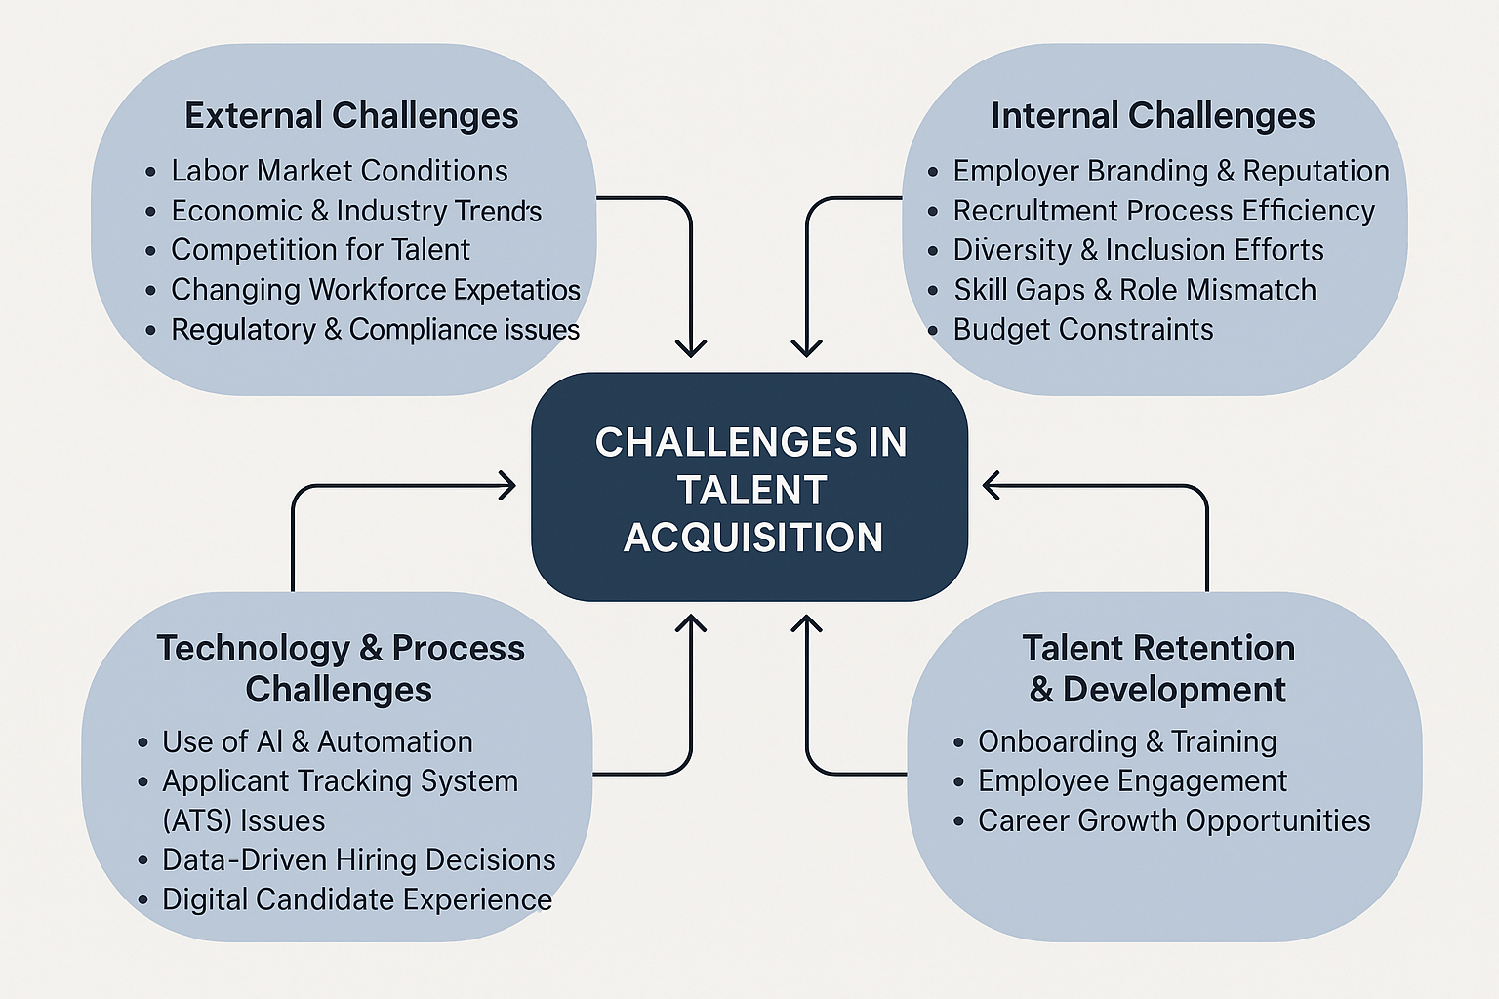

**SCALING METHOD**

The process of arriving at a set of statements to measure attitude, opinion, or perception is known as scaling. In this paper, the impact of service quality on customer loyalty is analyzed using a questionnaire based on a five-point Likert scale.

**Correlations**

|  |  | Understands hiring needs | Support in acquiring talent |
| --- | --- | --- | --- |
| Understands hiring needs | Pearson Correlation | 1.000 | .118 |
| Sig. (2-tailed) |  | .221 |
| N | 110 | 110 |
| Support in acquiring talent | Pearson Correlation | .118 | 1.000 |
| Sig. (2-tailed) | .221 |  |
| N | 110 | 110 |

**Inference**

The Pearson correlation coefficient (.118) indicates a weak positive relationship between understanding hiring needs and supporting talent acquisition. However, the significance value (.221) exceeds the 0.05 threshold, suggesting that this relationship is not statistically significant at the 95% confidence level.

|  |  | Clear job descriptions | Responsiveness and support |
| --- | --- | --- | --- |
| Clear job descriptions | Pearson Correlation | 1.000 | .172 |
| Sig. (2-tailed) |  | .073 |
| N | 110 | 110 |
| Responsiveness and support | Pearson Correlation | .172 | 1.000 |
| Sig. (2-tailed) | .073 |  |
| N | 110 | 110 |

**Inference**

The Pearson correlation coefficient (.172) shows a weak positive correlation between having clear job descriptions and the responsiveness/support received. Although the relationship is slightly stronger, the significance level (.073) still exceeds 0.05, implying that the correlation is not statistically significant at the standard 95% confidence level.

**6. RESULT**

The Pearson correlation analysis revealed a weak positive relationship between understanding hiring needs and support in acquiring talent (r = .118, p = .221). Similarly, a weak positive correlation was observed between clear job descriptions and responsiveness/support (r = .172, p = .073). However, neither of these relationships was statistically significant at the 0.05 level, indicating that the observed correlations may be due to chance and do not demonstrate a meaningful linear association within the sampled data.

**7. CONCLUSION**

The study concludes that while there are weak positive correlations between understanding hiring needs and support in talent acquisition, as well as between clear job descriptions and responsiveness, these relationships are not statistically significant. This suggests that other factors may play a more influential role in effective talent acquisition at Careernet Technologies. Further investigation into additional variables and broader organizational practices may provide deeper insights for enhancing recruitment strategies.

**8. SUGGESTIONS**

Based on the findings, it is recommended that Careernet Technologies enhance communication between hiring teams and recruiters to ensure better alignment in understanding hiring needs. Improving the clarity of job descriptions through targeted training for hiring managers can also help attract more qualified candidates and streamline the recruitment process. Additionally, strengthening internal support systems for the talent acquisition team can lead to more efficient workflows and timely hiring. Implementing regular feedback loops between recruiters and hiring managers can help identify ongoing challenges and adapt strategies accordingly. Finally, future efforts should explore other influential factors such as employer branding, candidate experience, and the use of recruitment technologies, which may have a more significant impact on successful talent acquisition.

**9. REFERENCES**

1. Karthik, R., & Selvakumar, P. (2024). *Post-Pandemic Hiring: Challenges and Strategies in Consultancies*. [https://eajournals.org/gjhrm/wp-content/uploads/sites/34/2024/03/Human-resource-management.pdf?](https://eajournals.org/gjhrm/wp-content/uploads/sites/34/2024/03/Human-resource-management.pdf?utm_source=chatgpt.com)
2. Chen, R. (2023). *Virtual Recruitment Events: Navigating the New Normal*. [https://primecandidate.ai/articles/the-future-of-recruitment-events-navigating-virtual-career-fairs-and-networking?](https://primecandidate.ai/articles/the-future-of-recruitment-events-navigating-virtual-career-fairs-and-networking?utm_source=chatgpt.com)
3. Martinez, L. (2022). *Employer Branding in a Digital Age: Attracting Top Talent*. [https://www.martinez-agency.com/blog/the-power-of-branding-in-recruitment-attract-engage-and-retain-top-talent?](https://www.martinez-agency.com/blog/the-power-of-branding-in-recruitment-attract-engage-and-retain-top-talent?utm_source=chatgpt.com)
4. Anderson, P. (2021). *The Role of Artificial Intelligence in Modern Recruitment*. [https://www.eqstaffingsolutions.com/the-role-of-artificial-intelligence-in-modern-recruitment/?](https://www.eqstaffingsolutions.com/the-role-of-artificial-intelligence-in-modern-recruitment/?utm_source=chatgpt.com)
5. Patel, S. (2020). *Diversity and Inclusion Challenges in Talent Acquisition*. [https://link.springer.com/chapter/10.1007/978-3-030-60060-0_12?](https://link.springer.com/chapter/10.1007/978-3-030-60060-0_12?utm_source=chatgpt.com)