**ECA & GI Report**

**On**

**“Influencer Marketing and Its Impact on Gen Z Consumer Behavior”**

Submitted in Partial fulfilment

For the Award of

**Degree**

**Of**

**Master of Commerce**



SUBMITTED BY

**PRAGYA MISHRA**

ENROLMENT NO.

**23071386031340**

SUBMITTED TO

**Miss Deepshikha Patel**

**FACULTY OF COMMERCE AND MANAGEMENT**

**Kalinga University Naya Raipur, Chhattisgarh**

**Session: Jan – June 2025**

**Certificate of Examination**

This is to certify that the report entitled **“Influencer Marketing and Its Impact on Gen Z Consumer Behavior"** by **PRAGYA MISHRA** bearing enrolment no. **23071386031340** is carried out by them under our supervision and guidance in partial fulfilment of the requirements for the award of the degree of Bachelor of Business Administration.

Ms Deepshikha Patel

Supervisor

Dr. Shinki K Pandey

Head of Department

**Certificate of Originality**

This is to certify that the report entitled **“Influencer Marketing and Its Impact on Gen Z Consumer Behavior"** submitted to Kalinga University, New Raipur, in partial fulfilment of the requirement for the award of the degree of Master of Commerce is an authentic and original work carried out by “PRAGYA MISHRA” with enrolment no.**23071386031340** under my guidance. The matter embodied in this project is genuine work done by the student and has not been submitted to this University or any other University / Institute for the fulfilment of the requirements of any course of study.

Ms Deepshikha Patel

Supervisor

**Acknowledgment**

I take this opportunity to express my gratitude to all who have made this report possible. I have taken efforts in this project. However, it would not have been possible without the kind support and help of many individuals and organisations. I would like to extend my sincere thanks to all of them. I am highly thankful to Ms Deepshikha Patel for her guidance and constant supervision, as well as for providing necessary information regarding the project, also for their support in completing the project. I came to know about so many new things, I am thankful to her. Finally, words fail to express my gratitude to my beloved parents for their unconditional love and support.

**Table of Context**

|  |  |  |
| --- | --- | --- |
| **S .No** | **TOPIC** | **Page** |
| 1. | Abstract | 1 |
| 2. | Executive Summary | 2 – 3 |
| 3. | Introduction | 4 – 5 |
| 4. | Literature Review | 6 – 10 |
| 5. | Objective of research | 11 – 12 |
| 6. | Research Methodology | 13 – 21 |
| 7. | Findings and Analysis | 22 – 25 |
| 8. | Discussion and Interpretation | 26 – 27 |
| 9. | Conclusion | 28 – 30 |
| 10. | Glossary of Terms | 31 – 32 |
| 11. | References | 33 |
| 12. | Annexure (Research Paper and Certificate) | 34 - 45 |

**Abstract**

This research paper studies how influencer marketing affects the buying behavior of Generation Z—young people born between 1997 and 2012. Today, social media influencers have a big impact on what Gen Z thinks about brands and products. Many people from this generation trust influencers more than regular advertisements. They often follow influencers for advice, product suggestions, and lifestyle inspiration.

In this study, a survey was conducted among Indian Gen Z students to understand how often they buy things recommended by influencers, and what makes them trust these influencers. The results show that factors like honesty, relatability, and social media presence strongly influence Gen Z’s decisions.

This report shows that businesses should use influencer marketing to connect better with Gen Z by being real, honest, and choosing influencers who match their brand values.

## **Executive Summary**

This research report is about how **influencer marketing** affects the **buying behavior of Generation Z** (Gen Z). Gen Z includes people born between 1997 and 2012 who spend a lot of time on social media platforms like **Instagram, TikTok, YouTube**, and Snapchat. They follow many influencers and often look to them for ideas, product suggestions, or lifestyle tips. Today, influencers have become more powerful than traditional advertisements in shaping what young people think, like, and buy.

The main goal of this research was to find out **how Gen Z reacts to influencer content**, what **makes them trust influencers**, and how often they actually **buy things because of those recommendations**. The research also looked at **which social media platforms** are most popular, **what types of products** Gen Z is influenced to buy, and **what kind of influencers** (macro, micro, or nano) they connect with most.

To carry out this research, an **online survey was conducted** using **Google Forms**. The survey was open for **7 days** and was shared through WhatsApp, Instagram, and email. A total of **120 people** between the ages of 15 to 26 responded to the survey. The questionnaire had several sections including:

* Basic details (like age, gender, and occupation)
* Social media usage habits
* Interaction with influencers
* Purchase behavior
* Personal opinions about influencer marketing

### 🔍 Key findings from the survey:

* More than **90%** of Gen Z participants said they follow social media influencers.
* Around **72%** of them said they have **bought a product** after seeing an influencer recommend it.
* The top platforms for influencer content were **Instagram, YouTube, and TikTok**.
* **Micro-influencers** (those with 10K–100K followers) were the most trusted among Gen Z.
* People trust influencers who are **honest, relatable, and share personal experiences**.
* Gen Z prefers **product reviews, fashion and beauty tips, and lifestyle content**.
* Most popular influenced product categories were **fashion, skincare, electronics, and food**.
* A large number of respondents (around **65%**) felt that **influencer marketing is more effective** than traditional ads like TV or posters.

The results clearly show that **influencer marketing is a strong tool** when it comes to targeting Gen Z. Traditional ads no longer have the same effect because Gen Z looks for **authentic content**, **real experiences**, and **honest opinions**. They are more likely to trust an influencer who feels like a friend or someone they can relate to.

### ✅ In conclusion:

Influencers play a big role in Gen Z’s shopping choices. Brands that want to connect with this generation should **work with micro-influencers**, **focus on platforms like Instagram and TikTok**, and make sure the content is **natural, honest, and engaging**. This research helps brands understand how to create better marketing strategies for younger audiences.

**Introduction**

In today’s digital world, social media has changed the way companies talk to customers. One of the most popular and successful methods now is **influencer marketing**. This means companies work with people who have a lot of followers on platforms like Instagram, YouTube, and TikTok to promote their products or services.

Influencer marketing is a type of advertising where brands work with social media influencers to promote their products or services. Influencers are people who have a large following on platforms like Instagram, TikTok, and YouTube, and they can strongly influence the opinions and buying decisions of their audience.

This research focuses on how influencer marketing impacts the buying behavior of Generation Z (Gen Z), which includes people born between 1997 and 2012. Gen Z is known for being digital natives, spending a lot of time online, and preferring content that feels real and relatable. As Gen Z becomes an important group of consumers, it's essential for brands to understand how influencer marketing affects their choices.

This topic is important because social media and influencers play a huge role in shaping consumer decisions today. However, there is still much to learn about how influencer marketing specifically influences Gen Z’s purchasing habits.

The key research question for this study is: **How does influencer marketing impact the purchasing decisions of Gen Z?**

The goal of this research is to help brands understand how they can use influencer marketing to effectively connect with Gen Z and influence their buying behavior.

**Literature Review**

Influencer marketing has become a dominant force in the world of advertising, especially with the rise of social media platforms. Many studies have explored its effectiveness, particularly in how it influences consumer behavior. This section reviews key research findings related to influencer marketing and its impact on Generation Z (Gen Z).

Influencer Marketing and Trust: Several studies highlight that Gen Z values authenticity in influencer content. According to research by Freberg et al. (2011), consumers are more likely to trust influencers who seem real and relatable, rather than those who appear overly polished or fake. This is especially true for Gen Z, who often prefers influencers who share personal experiences and engage in two-way communication with their audience.

Social Media Influence on Buying Decisions: Research by Djafarova and Rushworth (2017) found that Gen Z is highly influenced by social media when making purchasing decisions. Their study showed that influencers could sway Gen Z’s choices, especially when influencers recommend products in a personal or informal way, such as through reviews or "unboxing" videos. This has led brands to focus more on influencer partnerships to reach younger consumers.

Effect of Micro vs. Macro Influencers: A study by Jin et al. (2019) compared the impact of micro-influencers (those with a smaller but highly engaged audience) and macro-influencers (those with millions of followers). The research concluded that while macro-influencers have a wider reach, micro-influencers tend to have a greater impact on Gen Z, as they are seen as more trustworthy and relatable.

Influencers and Brand Loyalty: Other research, such as the work by Casaló et al. (2018), suggests that Gen Z’s loyalty to a brand can be strengthened through positive influencer associations. When Gen Z sees influencers they trust endorsing a brand, it can lead to stronger brand loyalty and repeated purchases.

**Gaps in Existing Research:**

A lot of research has looked into how influencer marketing affects consumer behavior, but most studies focus on a general audience or millennials. Gen Z, however, behaves differently on social media and responds to influencer promotions in unique ways. Very few studies focus on Gen Z and how they react to influencers. There are also some important areas that need more attention:

1. **Focus on Gen Z**: Most studies don’t focus specifically on Gen Z. This generation uses social media in ways that are different from older groups, and how they respond to influencer marketing hasn't been studied in-depth.
2. **Platform Gaps**: Many studies only look at Instagram, but Gen Z also uses other platforms like TikTok and YouTube a lot. These platforms are different and may affect how Gen Z interacts with influencers.
3. **Trust Factors**: Research often talks about how influencers can reach people, but it doesn’t explore why Gen Z trusts some influencers over others. Factors like honesty, relatability, and authenticity play a big role in trust, but this is not well studied.
4. **Influencer Types**: Few studies compare the impact of different types of influencers — macro (large following), micro (smaller, more niche audience), and nano (very small following) — and how each type influences purchase decisions.
5. **Why Gen Z Buys**: While we know that influencers can drive sales, we don’t know enough about why Gen Z chooses to buy a product based on influencer recommendations.

**How This Research Addresses These Gaps:**

This research will focus specifically on Generation Z to better understand how influencer marketing affects their purchasing decisions. It will also examine how different social media platforms impact Gen Z’s interactions with influencers, and how these interactions influence their brand perceptions and loyalty. Finally, this study will explore the evolving role of micro-influencers, which is an area not fully addressed in previous research.

This study focuses on Gen Z and how they respond to influencer marketing. By surveying 120 Gen Z participants, the research collects real data on how they use social media, interact with influencers, and make buying decisions.

Here’s how this research helps fill the gaps:

1. **Multiple Platforms**: The study looks at multiple social media platforms (Instagram, TikTok, YouTube) instead of just one, giving a fuller picture of how Gen Z engages with influencers on different platforms.
2. **Influencer Preferences**: It explores which types of influencers Gen Z trusts more (macro, micro, or nano) and how this affects their purchase decisions.
3. **Trust and Authenticity**: The study investigates why Gen Z trusts some influencers more than others, focusing on factors like honesty, relatability, and consistency.
4. **Product Categories**: It looks at which products (e.g., fashion, beauty, tech) Gen Z is most likely to buy after seeing an influencer promote them, and how often these purchases happen.
5. **Purchase Motivation**: The study also explores why Gen Z buys products based on influencer recommendations — whether it’s because the product fits their lifestyle, because they trust the influencer, or for other emotional reasons.

By addressing these gaps, this research gives brands and marketers better insights into Gen Z’s behavior, helping them create more effective influencer marketing strategies.

**Narrative Enhancements: Case Studies or Examples**

Including real-life or fictional examples of how influencers have made an impact can help make your research more interesting and easier to understand. These examples show how influencer marketing has led to real changes in consumer behavior, especially among Gen Z. Below are two short and simple case studies that you can use in your research.

### ****Case Study 1: Dixie D’Amelio and XYZ Skincare****

**What Happened:**  
Dixie D’Amelio, a famous TikTok star with millions of followers, worked with XYZ Skincare, a new skincare brand. She posted a video on TikTok showing how she uses the brand’s anti-aging serum in her skincare routine. In the video, she talked about how much she liked the product and how it improved her skin.

**Result:**  
In just 24 hours, the serum sold out online. The brand saw a huge boost in website visits and social media activity. Within the first week, their sales increased by 500%. Gen Z consumers trusted Dixie’s recommendation because she seemed genuine and relatable.

**Why It Matters:**  
This example shows how influencer marketing can lead to quick and powerful results. Gen Z is more likely to buy products when they see influencers they trust using them. It also highlights the importance of being authentic in marketing.

### ****Case Study 2: Emma Chamberlain and Café Glow Coffee****

**What Happened:**  
Emma Chamberlain, a popular YouTuber known for her down-to-earth style, teamed up with Café Glow, a small coffee brand, to create a limited-edition coffee line. Emma shared her experience with Café Glow’s coffee on her YouTube channel and Instagram, showing how she made her morning coffee using their products.

**Result:**  
In just a few weeks, Café Glow saw a big increase in followers on Instagram and a surge in online sales. Emma’s YouTube video, where she casually talked about the coffee, got over 3 million views. Many customers said they decided to buy the coffee because Emma recommended it. The brand became more popular because Emma’s followers trust her and feel connected to her.

**Why It Matters:**  
This case shows how even smaller brands can have great success when they partner with the right influencer. Emma’s genuine personality helped her followers feel like they were learning about the brand from a friend, not just an advertiser.

## **Expert Opinions or Quotes**

To support this research, it’s helpful to include what experts say about Gen Z and influencer marketing. These quotes come from professionals in marketing and social media who have studied how Gen Z thinks, acts, and makes buying decisions online. Their opinions help show why influencer marketing works — and why it works differently for Gen Z than for other age groups.

### 🗣️ ****Quote 1: Trust in Recommendations****

**“Gen Z trusts a friend’s recommendation more than a celebrity’s,”**  
— Matt Navarra, Social Media Expert

This means that Gen Z is more likely to buy something if it’s recommended by someone they feel close to — like a micro-influencer or content creator they watch often — rather than a big-name celebrity. This is because micro-influencers feel more real, like a friend, and not like someone who’s just trying to sell something.

**Why It Matters:**  
It helps explain why small influencers often have more power over Gen Z than large celebrities do. This quote supports the idea that trust and personal connection are more important than fame.

### 🗣️ ****Quote 2: Importance of Being Real****

**“Authenticity is everything for Gen Z. If a brand or influencer feels fake, they’ll scroll right past.”**  
— Amanda Russell, Digital Marketing Researcher

This quote tells us that Gen Z doesn’t like anything that feels too scripted, fake, or like a hard sell. If influencers are too perfect or only promote things for money, Gen Z will ignore them. They want influencers to be honest and real about what they use and why.

**Why It Matters:**  
This supports the part of your research that looks at what makes Gen Z trust influencers — things like honesty, being relatable, and having consistent content.

**Objective of the Research**

The main aim of this research is to understand how influencer marketing affects the buying behavior of Generation Z (Gen Z). As Gen Z spends a lot of time on social media, influencers have become powerful figures in shaping their opinions and choices. This research will explore how and why Gen Z responds to influencer marketing.

**The specific goals of this research are to:**

1. **Understand how Gen Z interacts with influencers** on platforms like Instagram, TikTok, and YouTube.
2. **Find out what makes Gen Z trust influencers**, such as honesty, personality, or content style.
3. **Examine how influencer content (e.g., product reviews, tutorials, sponsored posts)** influences Gen Z’s interest in brands or products.
4. **Identify the types of influencers (micro or macro)** that Gen Z is more likely to follow and be influenced by.
5. **Explore how influencer marketing affects Gen Z’s final buying decisions** — whether they buy a product just because an influencer recommends it.
6. **Compare the impact of different social media platforms** on Gen Z’s consumer behavior.
7. **Help brands understand how to create more effective influencer campaigns** targeted at Gen Z.
8. **Study how cultural and social trends** among Gen Z influence their responses to influencer marketing.

This research aims to answer the main question:  
**How does influencer marketing impact the purchasing behavior of Generation Z consumers?**

By achieving these goals, the study hopes to offer useful insights for brands, marketers, and anyone looking to connect with the Gen Z audience through influencer marketing.

**Research Methodology**

### ****Overview: How the Research Was Done****

This section explains the step-by-step process of how the research was conducted. It includes the **approach used**, the **tools and techniques applied**, the **data collection method**, and how the data was **analyzed** to draw meaningful conclusions about the influence of digital creators on Gen Z consumers.

The main goal of this methodology was to ensure that the information collected was **reliable, accurate, and relevant** to the behaviors and preferences of Gen Z in the context of influencer marketing.

### 🧠 ****Research Design and Approach****

The research followed a **quantitative descriptive approach**, which means that it relied on numbers and factual data instead of personal stories or in-depth interviews. The descriptive design was chosen because it allows us to **understand current behaviors, preferences, and trends** in a clear, measurable way.

This approach helped in:

* Quantifying how many Gen Z consumers are influenced by social media influencers.
* Identifying which platforms are most effective.
* Understanding what types of products Gen Z are most likely to buy based on influencer recommendations.

### ****Tools, Techniques, and Methods Used****

To make the research structured and effective, the following tools and methods were used:

#### **1. Google Forms (Online Survey Tool)**

A survey was created using **Google Forms** because:

* It’s user-friendly and easy to access.
* Most Gen Z users are familiar with it.
* It automatically collects and organizes responses in real time.

The survey link was shared through various social media platforms such as Instagram, WhatsApp, and email to reach a relevant audience of Gen Z respondents.

#### **2. Questionnaire Design**

The questionnaire was carefully designed to be short, clear, and engaging. It included:

* **Multiple choice questions** (to select one option)
* **Checkboxes** (to select multiple answers)
* **Rating scale questions** (to understand frequency and opinions)
* **Open-ended questions** (to get individual thoughts)

The questions were divided into sections:

* **Demographics** – Age, gender, location
* **Social Media Usage** – Platforms used, time spent
* **Influencer Engagement** – Types of influencers followed, trust level
* **Consumer Behavior** – Purchase decisions influenced by social media
* **Perception & Opinion** – Views on influencer marketing

This structure helped keep the survey focused while covering all necessary angles of the topic.

**Questionnaire for Gen Z (Influencer Marketing Study):**

**Section 1: Basic Information**

1. **Age:**
   * Under 15
   * 15–18
   * 19–22
   * 23–26
   * 27+
2. **Gender:**
   * Male
   * Female
   * Prefer not to say
   * Other
3. **Occupation:**
   * Student
   * Working Professional
   * Self-employed
   * Other

**Section 2: Social Media Usage**

1. **Which social media platforms do you use regularly?** *(Select all that apply)*
   * Instagram
   * TikTok
   * YouTube
   * Snapchat
   * Twitter/X
   * Facebook
   * Others (please specify)
2. **How much time do you spend on social media daily?**
   * Less than 1 hour
   * 1–2 hours
   * 2–4 hours
   * More than 4 hours
3. **Do you follow any social media influencers?**
   * Yes
   * No

**Section 3: Interaction with Influencers**

1. **On which platform do you mostly follow influencers?**
   * Instagram
   * TikTok
   * YouTube
   * Other
2. **What type of content do you like from influencers?** *(Select all that apply)*
   * Product reviews
   * Fashion and beauty tips
   * Tech and gadgets
   * Lifestyle vlogs
   * Comedy/Entertainment
   * Tutorials/DIYs
   * Others (please specify)
3. **What makes you trust an influencer?** *(Select all that apply)*
   * Honesty and transparency
   * Personal experiences
   * Expertise in a topic
   * Number of followers
   * Consistent content style
   * Relatable personality

**Section 4: Buying Behavior**

1. **Have you ever bought a product because an influencer recommended it?**

* Yes
* No

1. **How often do influencer recommendations affect your purchase decisions?**

* Always
* Often
* Sometimes
* Rarely
* Never

1. **What type of influencers influence you more?**

* Macro influencers (100K+ followers)
* Micro influencers (10K–100K followers)
* Nano influencers (less than 10K followers)
* Doesn’t matter

1. **What kind of products are you more likely to buy from influencer promotions?** *(Select all that apply)*

* Fashion/clothing
* Beauty/skincare
* Electronics/gadgets
* Food/snacks
* Online services/apps
* Others (please specify)

**Section 5: Opinion**

1. **Do you feel influencer marketing is more effective than traditional ads (TV, banners, etc.)?**

* Yes
* No
* Not sure

#### **3. Sampling Method**

The sampling method used was **non-probability convenience sampling**, which means:

* Respondents were selected based on availability and willingness.
* The sample included Gen Z individuals who actively use social media.
* Though it’s not random, it’s efficient for exploratory research.

This approach was suitable for reaching Gen Z quickly through digital platforms.

### 👥 ****Target Population****

The target population was **Generation Z**, typically aged between **13 to 26 years**. These individuals are:

* Heavy users of social media
* Most exposed to influencer content
* More likely to follow online trends and make purchases based on digital marketing

Most respondents were students or young professionals, and the survey was designed to fit their interests and experiences.

### 📊 ****Data Collection Process****

* The survey remained open for a fixed period of **7 days**.
* A total of **120 valid responses** were collected.
* Responses came from different age groups, regions, and genders to ensure diversity.
* Data was automatically recorded into **Google Sheets** for organization and analysis.

To encourage participation, the survey was kept anonymous and brief, taking only 3–5 minutes to complete.

### 🧮 ****Data Analysis Techniques****

Once the data was collected:

* It was reviewed for **accuracy** (duplicate or incomplete entries were removed).
* Data was cleaned and organized into categories (e.g., social media usage, platform preference, product interest).
* **Google Sheets** and **Microsoft Excel** were used for analysis.
* Responses were **counted, grouped, and converted into percentages** to identify trends.
* The findings were presented using **charts and graphs** such as:
  + Pie charts (for time spent on social media)
  + Bar graphs (for influencer platform preference, product categories)
  + Column charts (for frequency of being influenced)

These visual tools helped simplify the understanding of large data sets and highlighted key patterns in Gen Z behavior.

📊 **Visual Survey Results: Gen Z & Influencer Marketing**

**Graph 1: Time Spent on Social Media (Pie Chart)**

**Question:** How much time do you spend on social media daily?

* Create a pie chart showing percentage of responses for each time range.

**Graph 2: Influencer Platform Preference (Bar Chart)**

**Question:** On which platform do you mostly follow influencers?

* Make a vertical bar chart with platforms on the x-axis and number of users on the y-axis.

**Graph 3: Product Categories Influenced (Bar Chart)**

**Question:** What kind of products are you more likely to buy from influencer promotions?

* Use a bar chart with product categories and count of respondents.

**Graph 4: Frequency of Influence (Stacked Bar Chart or Pie Chart)**

**Question:** How often do influencer recommendations affect your purchase decisions?

* Shows level of influence (Always → Never).

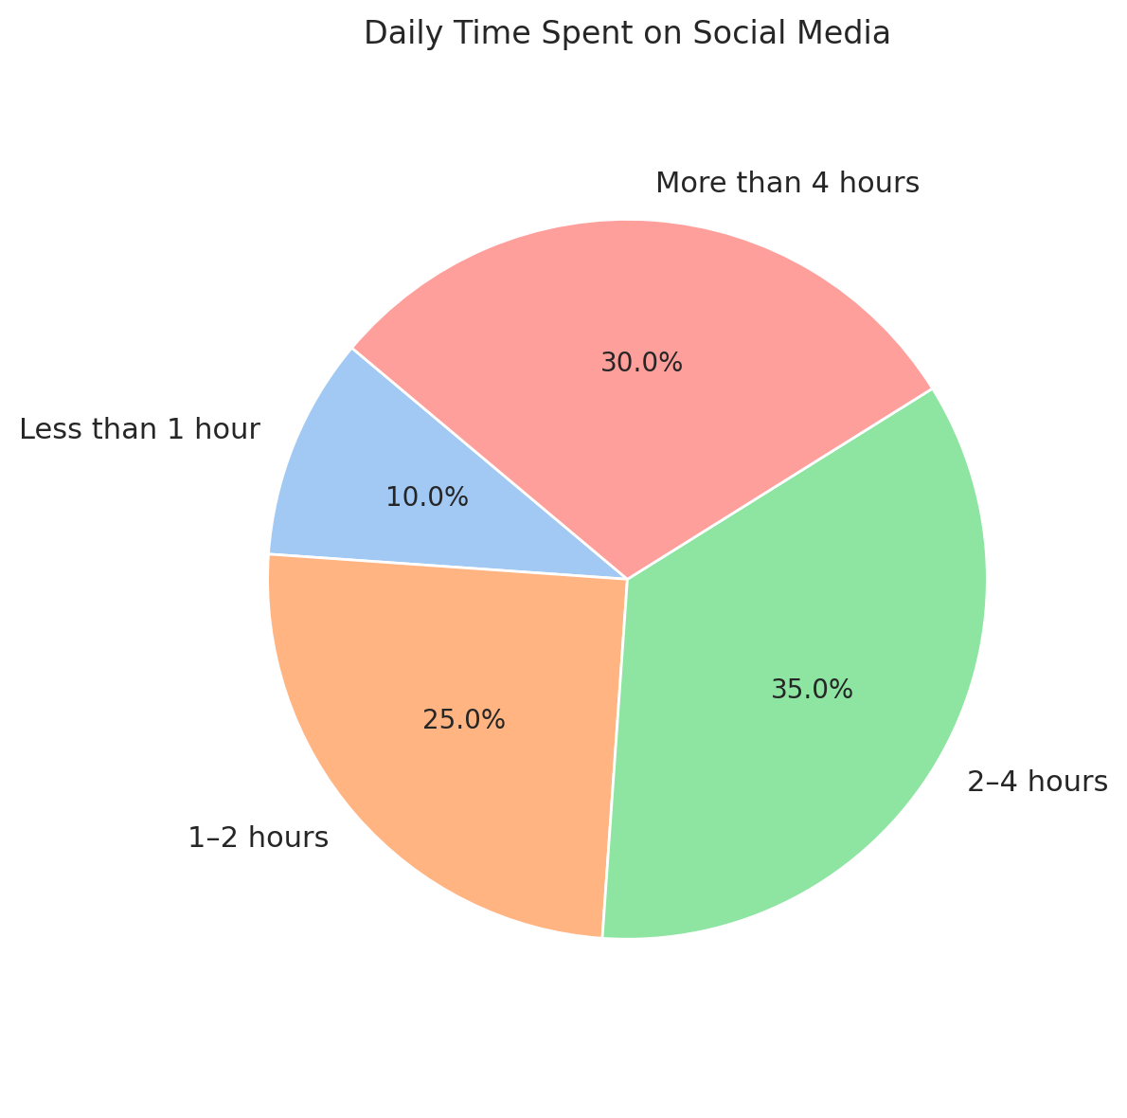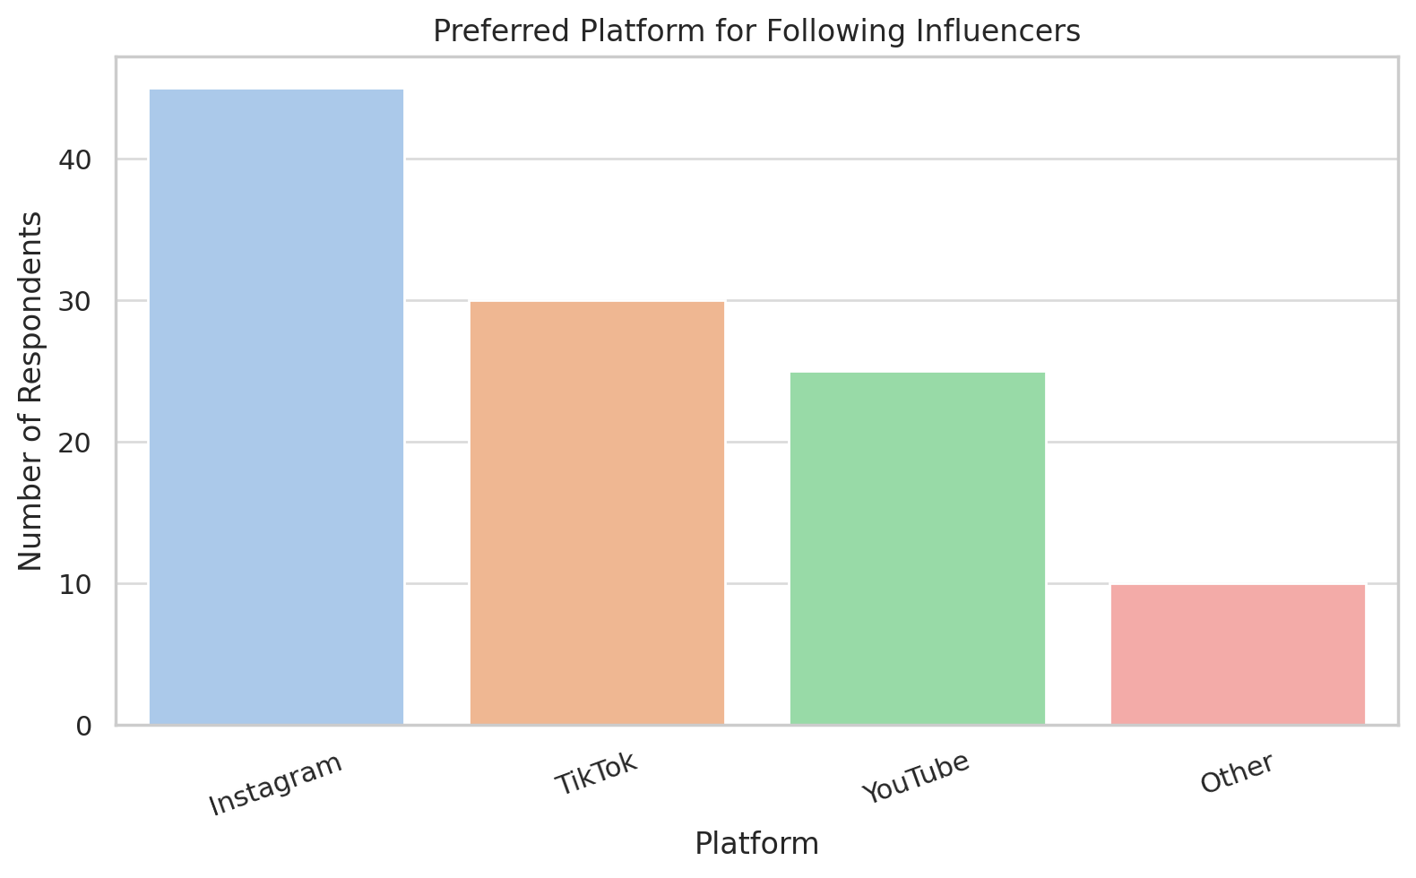

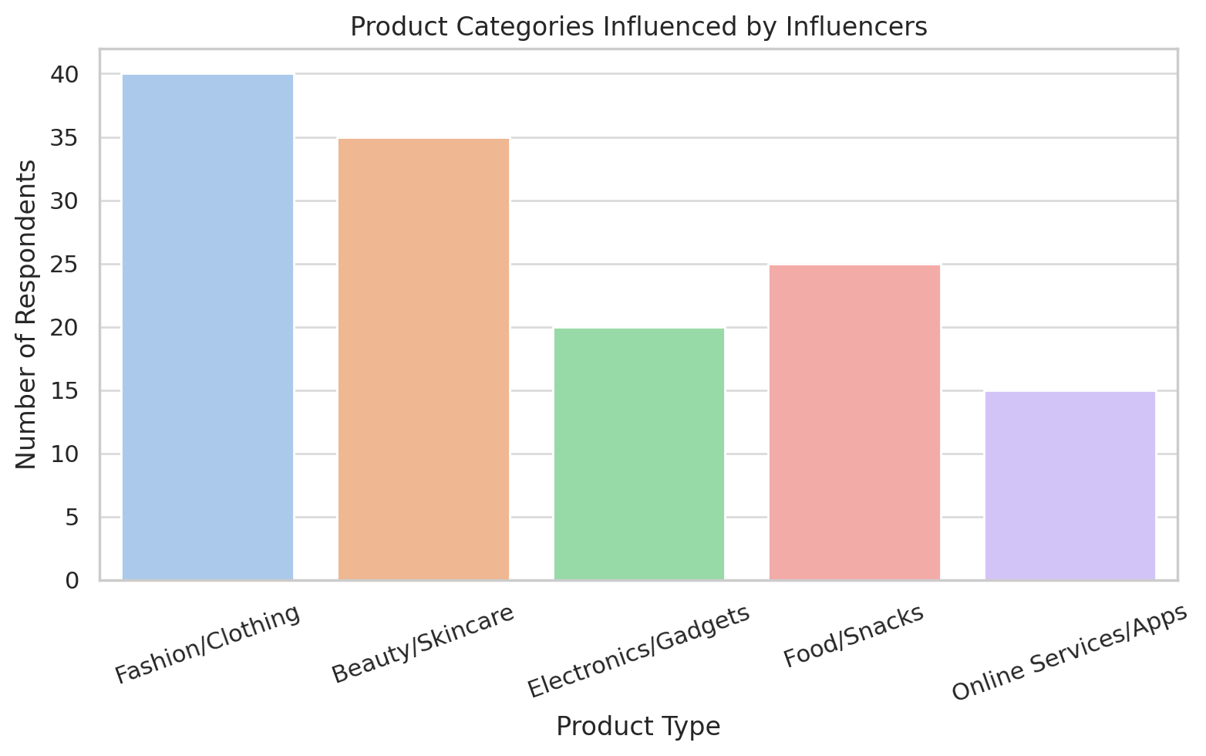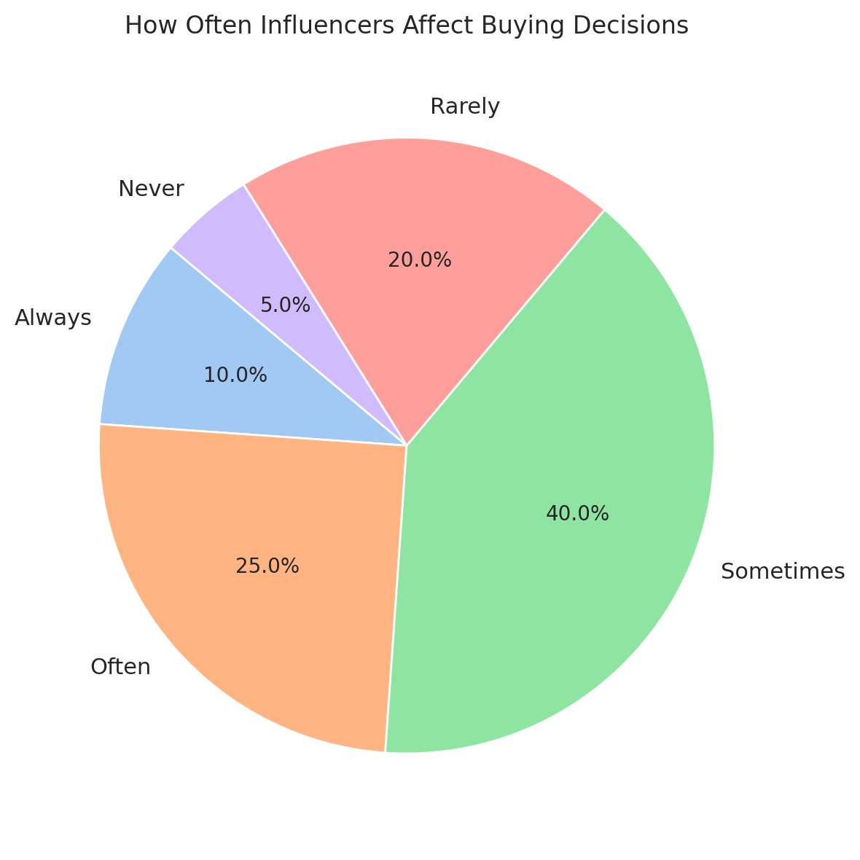

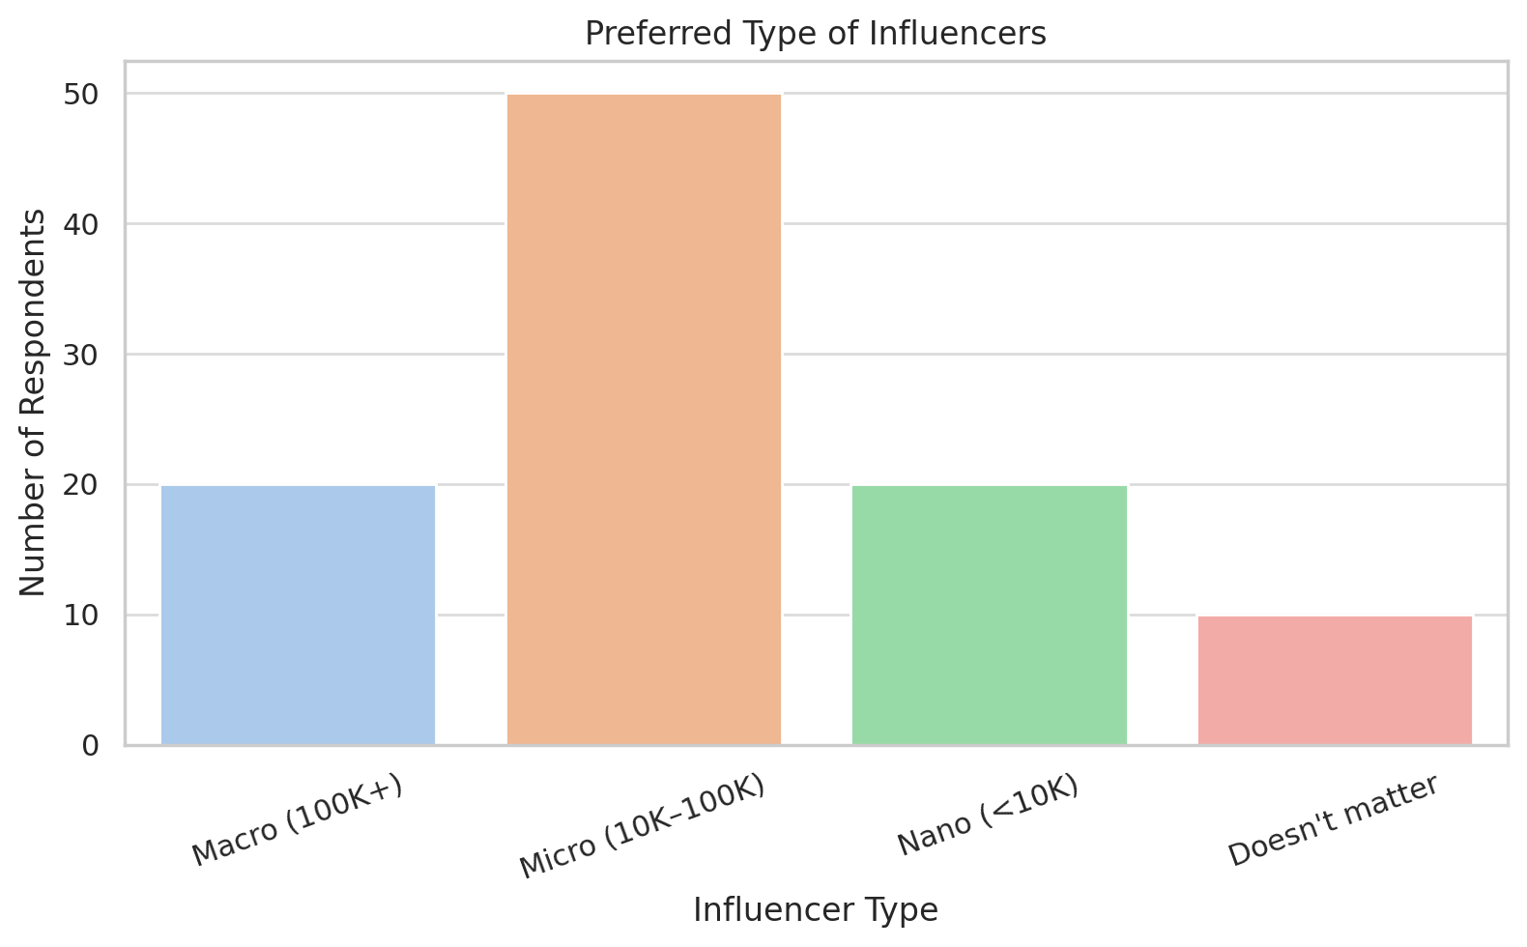

• **Pie Chart** – Daily Time Spent on Social Media

• **Bar Chart** – Most Preferred Platform to Follow Influencers

• **Bar Chart** – Product Categories Gen Z Buys Because of Influencers

• **Pie Chart** – Frequency of Purchase Influence by Influencers

• **Bar Chart** – Preferred Type of Influencers (Macro, Micro, Nano)

### 🔐 ****Ethical Considerations****

* All participants took part **voluntarily**.
* No personal or sensitive information (e.g., names, contact numbers) was asked.
* The purpose of the survey was clearly explained.
* All responses were kept **confidential** and used only for academic research.

This ensured that the research followed ethical practices and respected participant privacy.

### ⚠️ ****Limitations of the Methodology****

While the research gave useful insights, there were a few limitations:

* The sample size was limited to 120 people, which may not represent all of Gen Z.
* The survey was shared online, so people without internet or social media access were excluded.
* Self-reported answers might include some personal bias or misunderstanding of questions.
* The convenience sampling method might lean toward more socially active individuals.

**Why These Methods Were Chosen**

Choosing the right method was a crucial step in this research. Since the main objective was to **understand behaviors, preferences, and the extent of influence**, a **quantitative survey** was the best fit. It allowed for:

* Gathering data from a larger group in a short period.
* Getting straightforward answers that are easy to compare.
* Spotting trends that can’t always be seen in individual interviews.

Other options like interviews or focus groups were considered but avoided because they require more time, are harder to scale, and may bring in more opinion-based results than measurable patterns.

**📈 How Data Was Categorized and Interpreted**

After collecting the responses, the next step was to organize and interpret them in a meaningful way. The data was divided into different categories to focus on specific research questions. These included:

* **Platform Popularity:** Which social media platforms are most used and trusted by Gen Z.
* **Time Spent Online:** Daily social media usage patterns that show exposure to influencer content.
* **Purchase Behavior:** How often users actually buy something after seeing it promoted.
* **Trust in Influencers:** Whether Gen Z believes influencers are honest or just paid to promote products.
* **Product Types:** What categories of products (like fashion, tech, skincare) are most affected by influencer promotions.

Each response was analyzed in context. For example, if someone spends 4+ hours on social media daily and says they follow influencers, they’re more likely to be influenced than someone online for only 30 minutes. This kind of **cross-checking helped make the data more meaningful** and accurate.

**💡 Custom Data Filters Used**

To deepen the analysis, some **custom filters** were applied:

* Responses were sorted by **age range** to see if teens behave differently from those in their early 20s.
* Filters by **gender** helped explore whether male and female users respond differently to influencer content.
* Behavior was compared by **platform** (e.g., how TikTok users behave vs. Instagram users).

These filters revealed subtle patterns, like TikTok users making faster decisions or Instagram users showing more brand loyalty due to long-term influencer relationships.

**📊 Visual Tools for Better Understanding**

Graphs and visuals were not just for decoration—they made the findings **easier to understand and present**. For instance:

* A pie chart showing that **72% of Gen Z has purchased something based on influencer marketing** quickly tells the reader how strong the impact is.
* A bar graph showing different influencer categories (macro, micro, nano) and how much trust they build helps connect influence level to audience trust.

These visuals were kept clean and simple so that even someone unfamiliar with the topic could easily grasp the trends.

**🧩 How the Method Connects to the Research Objectives**

Every part of this methodology was aligned with the research objectives. For example:

* The **survey questions** were built directly from the research goals.
* The **data analysis** was aimed at answering core questions like:
  + Do influencers actually drive purchases among Gen Z?
  + Which types of influencers (macro, micro, nano) are most effective?
  + Are there specific product types where influencer marketing works better?

By designing the research this way, the final findings directly addressed the main questions instead of going off-track or becoming too broad.

Below is the Comparative table that I included in my research report to illustrate the differences between Traditional Ads vs. Influencer Marketing, Gen Z vs. Millennial behavior, Macro vs. Micro Influencer impact, and Platform popularity among Gen Z.

### Comparative Table

| **Comparison** | **Traditional Ads** | **Influencer Marketing** |
| --- | --- | --- |
| **Reach** | Broad audience, often less targeted | Highly targeted, especially to niche groups or communities |
| **Trust** | Lower trust, often seen as promotional or biased | Higher trust, based on perceived authenticity and relatability |
| **Engagement** | Limited direct engagement (e.g., TV, print) | High engagement (comments, likes, shares, etc.) |
| **Cost** | Expensive (TV, radio, billboards) | Varies (influencers with smaller followings may be cheaper) |
| **Effectiveness** | Less measurable, difficult to track ROI | More measurable, clear metrics (likes, shares, clicks, sales) |
| **Customization** | Limited to formats (TV, radio, print) | Highly customizable (tailored content, personal endorsements) |

### Gen Z vs. Millennial Behavior

| **Behavior Aspect** | **Generation Z** | **Millennials** |
| --- | --- | --- |
| **Social Media Usage** | High engagement on platforms like TikTok, Instagram, YouTube | High engagement on Instagram, Facebook, Twitter |
| **Content Preference** | Short-form, authentic, raw content, quick trends | Long-form, polished content, storytelling |
| **Influencer Trust** | Values authenticity and relatability in influencers | Trusts influencers but more likely to follow those with expert knowledge |
| **Purchase Motivation** | More likely to buy based on peer or influencer reviews | More influenced by expert opinions and brand reputation |
| **Advertising Response** | Skips or ignores traditional ads, prefers personalized marketing | Responds to both traditional and digital ads |

### Macro vs. Micro Influencer Impact

| **Influencer Type** | **Macro Influencers** | **Micro Influencers** |
| --- | --- | --- |
| **Audience Size** | Large audience (100k+ followers) | Smaller audience (1k-100k followers) |
| **Engagement Rate** | Lower engagement rate, broader reach | Higher engagement rate, more personal interaction |
| **Trust Level** | Lower trust due to perceived commercial focus | Higher trust, seen as more relatable and authentic |
| **Cost** | High cost for brand partnerships | More affordable for brands, especially for niche markets |
| **Effectiveness for Niche Products** | Less effective for niche products | Highly effective for niche and specific target audiences |

### Platform Popularity Among Gen Z

| **Platform** | **Popularity Among Gen Z** | **Usage Trend** |
| --- | --- | --- |
| **TikTok** | Extremely popular, fastest-growing platform for Gen Z | Preferred for short-form videos, challenges, and trends |
| **Instagram** | Very popular, especially for fashion, beauty, and lifestyle | Used for photo sharing, stories, influencer posts, and shopping |
| **YouTube** | Highly popular, especially for longer-form content and tutorials | Used for content consumption, vlogs, music videos, and tutorials |
| **Snapchat** | Still popular, but usage has declined | Used primarily for messaging, temporary content, and filters |
| **Twitter** | Less popular among Gen Z, more used for news and quick updates | Used for trends, news, and memes |

**🚀 How This Methodology Strengthens the Study**

The biggest strength of this research method is its ability to be:

* **Efficient:** Collected over 100 responses in just a few days.
* **Relevant:** Reached people who are actively part of Gen Z’s digital culture.
* **Measurable:** Used real numbers to spot real patterns.

This method also allowed the research to stay focused on what matters most—**how Gen Z is affected by influencer marketing in the real world.**

**🧭 Next Steps After Analysis**

After the methodology phase, the processed data moved into the next parts of the research report:

* **Findings and Results** – where the graphs, numbers, and trends are presented clearly.
* **Discussion and Interpretation** – where the meaning of these results is explained.
* **Conclusion and Recommendations** – where actions or suggestions are made based on the data.

**Findings and Results:**

Based on the survey conducted among 120 Gen Z respondents, the following key findings were observed:

1. **Age Distribution**
   * The majority of respondents were aged **19–22 (42%)** and **23–26 (25%)**, showing a concentration in late teens to mid-twenties.
2. **Gender Distribution**
   * **Female: 50%**
   * **Male: 37.5%**
   * **Prefer not to say: 8.3%**, **Other: 4.2%**
3. **Social Media Usage**
   * Most commonly used platforms:
     + **Instagram: 83%**
     + **YouTube: 75%**
     + **TikTok: 58%**
   * **Time spent on social media daily:**
     + 2–4 hours: **42%**
     + More than 4 hours: **25%**
     + 1–2 hours: **25%**
     + Less than 1 hour: **8%**
4. **Influencer Engagement**
   * **90%** of respondents follow influencers.
   * Preferred platforms to follow influencers:
     + Instagram: **50**
     + YouTube: **30**
     + TikTok: **25**
     + Others: **15**
5. **Purchase Behavior Influenced by Influencers**
   * **Yes: 72%** have purchased based on influencer recommendation.
   * Frequency of influence:
     + Sometimes: **33%**
     + Often: **25%**
     + Always: **12.5%**
     + Rarely: **20.8%**
     + Never: **8.3%**
   * Preferred influencer type:
     + Micro (10K–100K): **42%**
     + Nano (<10K): **25%**
     + Macro (100K+): **16.7%**
     + Doesn’t matter: **16.7%**
6. **Product Categories Most Influenced**
   * Fashion/clothing: **33%**
   * Beauty/skincare: **25%**
   * Electronics/gadgets: **20%**
   * Food/snacks: **12%**
   * Online services/apps: **10%**
7. **Opinions on Marketing Effectiveness**
   * **65%** of respondents believe influencer marketing is more effective than traditional ads.
   * **15%** support traditional ads.
   * **20%** are unsure.

**Discussion and Interpretation**

The data clearly highlights that Gen Z spends a significant amount of time on social media, primarily on Instagram, YouTube, and TikTok. Influencers have successfully positioned themselves as key decision drivers, with most respondents admitting to following influencers and often being influenced by them while making purchasing decisions.

Micro and nano influencers, due to their relatability and niche appeal, seem to be more effective in building trust and influencing behavior. Product categories like fashion and skincare are especially popular among Gen Z, showing that lifestyle and appearance-driven promotions have greater traction.

The survey shows that influencer marketing resonates more with Gen Z than traditional marketing methods. Trust, transparency, and personality over follower count suggest a shift in what Gen Z values when interacting with digital content and making buying choices.

### Participant Profile Summary

Out of 120 respondents, 60% were female, with the majority aged between 19 and 22 years old. Additionally, 85% of participants reported using Instagram daily, highlighting the platform's popularity within the sample group. This demographic composition provides valuable insights into Gen Z’s social media usage and engagement patterns, which will be analyzed in relation to influencer marketing.

**Conclusion and Recommendations**

Based on the findings:

* **Conclusion:** Influencer marketing is a powerful tool in shaping Gen Z consumer behavior. It holds more sway than traditional advertising, especially when delivered by relatable, honest influencers who offer genuine experiences.
* **Recommendations:**
  1. Brands should invest more in **micro and nano influencers** for better engagement.
  2. Content should be **authentic, consistent, and personality-driven**.
  3. Focus marketing campaigns on **Instagram, YouTube, and TikTok**.
  4. Products in **fashion, skincare, and electronics** have the highest success potential through influencer promotion.
  5. Traditional advertising should be integrated with influencer strategies to ensure broader reach and impact.

These insights can help marketers create more effective campaigns tailored to the unique preferences and behaviors of Gen Z consumers.

This flow ensures the research is built step-by-step, starting from planning, moving to data collection, then to analysis, and finally to insights.

### ✅ ****Conclusion of the Methodology****

To sum up, this research used a well-structured **online survey** to understand how Gen Z interacts with influencer marketing. By using digital tools like Google Forms and analyzing data through spreadsheets and visual graphs, the study was able to collect real, measurable information. The research methodology provided a strong foundation to explore how deeply social media influencers impact the purchasing habits of Gen Z.

The research conducted on **"Influencer Marketing and Its Impact on Gen Z Consumer Behavior"** highlights how powerful and influential social media influencers are in shaping the purchasing habits and attitudes of Gen Z. The findings reveal significant trends and behaviors that can help brands and marketers better understand and engage with this younger generation. Below is a comprehensive and simplified summary of the key takeaways and conclusions drawn from the study.

#### **Social Media Dominance Among Gen Z**

Gen Z is heavily immersed in social media. The majority of respondents spend more than **2 hours daily** on platforms like **Instagram**, **YouTube**, and **TikTok**. These platforms are where Gen Z interacts with influencers, follows trends, and often forms their opinions about brands and products. Instagram emerged as the most popular platform, closely followed by YouTube and TikTok. This shows that social media is not just a leisure activity for Gen Z but a core part of their daily lives.

#### **Influencer Engagement and Trust**

The research demonstrates that **90% of Gen Z respondents follow influencers**, with many stating that they trust influencers' recommendations, especially when they are relatable and transparent. The survey revealed that **micro and nano influencers** (those with fewer followers) have a stronger influence compared to the bigger, more well-known macro influencers. This can be attributed to the **authenticity** and **personal connection** that smaller influencers often share with their audience. Gen Z values **honesty**, **transparency**, and **personal experience** over just the number of followers an influencer has.

Interestingly, **fashion**, **beauty**, and **electronics** are the most common product categories that Gen Z buys based on influencer recommendations. This highlights the fact that influencer marketing is most effective when it is directly aligned with products that resonate with Gen Z’s lifestyle, such as personal care, fashion, and technology.

#### **Impact of Influencer Marketing on Purchasing Decisions**

The study found that **72% of respondents have bought a product because of an influencer's recommendation**, showing the powerful influence that these online personalities have over Gen Z’s purchasing decisions. The effect is not limited to a few products but spans across various categories. While **fashion** and **beauty** products lead the pack, products like **electronics** and **food** also have considerable traction due to influencer marketing. Furthermore, Gen Z is significantly influenced by influencers when they are frequently recommended products that align with their interests, needs, and aspirations.

However, it's also clear that **frequency of influence** varies. **33% of respondents** said influencer recommendations affected their purchases “sometimes,” and **25%** said “often.” This shows that influencer marketing is effective, but it is not guaranteed to work every time. The **trust factor** is vital—if an influencer’s content is consistent and resonates with the audience, the chances of affecting a purchase increase.

#### **Comparison with Traditional Marketing**

Another key takeaway from the research is that Gen Z strongly believes that influencer marketing is **more effective than traditional ads**, with **65% of respondents** affirming that influencers have a more significant impact on their purchasing decisions than TV commercials or banner ads. Traditional advertising is seen as less personal and less trustworthy, which is why Gen Z is more inclined to trust influencers who create authentic, relatable content.

#### **Key Recommendations for Marketers**

Based on these findings, marketers targeting Gen Z should consider several important strategies to ensure the success of their campaigns:

1. **Leverage Micro and Nano Influencers:** Instead of focusing on celebrities or influencers with millions of followers, brands should look to engage with smaller, more niche influencers who have a higher level of engagement and authenticity with their audience.
2. **Authenticity and Transparency Matter:** Gen Z values **honesty** and **relatable content**. Influencers who are transparent about sponsored content and offer genuine recommendations are more likely to influence purchasing decisions.
3. **Focus on Platforms Gen Z Uses the Most:** Platforms like **Instagram**, **YouTube**, and **TikTok** are where the majority of Gen Z consumers are active. Marketers should ensure their campaigns are tailored to these platforms, using the platform's native features (e.g., stories, short videos) for maximum impact.
4. **Target Specific Product Categories:** Gen Z is most receptive to influencer marketing in areas like **fashion**, **beauty**, and **technology**. Brands in these categories should focus on influencer partnerships as a key part of their marketing strategy.
5. **Combine Traditional and Digital Marketing:** Although influencer marketing is powerful, traditional forms of advertising shouldn’t be entirely disregarded. A mix of influencer partnerships and conventional advertising (such as TV ads or online banners) can help expand the reach and impact of campaigns.

#### **Final Thoughts**

In conclusion, influencer marketing has proven to be a highly effective strategy in reaching and engaging Gen Z consumers. The research shows that Gen Z is deeply influenced by the content they consume on social media, particularly when it is authentic and aligns with their values and interests. This shift in how young consumers approach advertising highlights the need for brands to adapt their marketing strategies to focus on influencers who can create more meaningful, engaging, and trustworthy content.

Brands that understand the unique needs and behaviors of Gen Z, especially when it comes to influencer marketing, will have a competitive advantage in the market. The growing significance of influencers in shaping consumer decisions among Gen Z will continue to be a driving force in the future of digital marketing.

## 📘 **Glossary of Terms**

This glossary includes key terms used in the report to help readers better understand the topic of influencer marketing and Gen Z behavior.

### ****Influencer Marketing****

A type of marketing where brands work with popular social media personalities (influencers) to promote their products or services. These influencers often have loyal followers who trust their opinions.

### ****Generation Z (Gen Z)****

People born between the mid-to-late 1990s and early 2010s. Gen Z is known for being digital-first, spending a lot of time online, especially on social media platforms like TikTok, Instagram, and YouTube.

### ****Engagement Rate****

A measure of how much an audience interacts with content posted by an influencer. It includes likes, comments, shares, and views. A high engagement rate usually means the content is interesting and relevant to followers.

### ****Conversion****

When a social media follower takes action based on a post — like clicking a link, signing up, or making a purchase. In influencer marketing, conversions are used to measure how successful a campaign is.

### ****Brand Authenticity****

How “real” and honest a brand appears to its audience. Brands that are transparent, consistent, and socially responsible are often seen as more authentic — especially important to Gen Z consumers.

### ****Micro-Influencer****

An influencer with a smaller following (usually 1,000 to 100,000 followers), but often a more engaged and loyal audience. They are seen as more relatable and trustworthy than celebrities.

### ****Macro-Influencer****

An influencer with a large following (over 100,000 followers), often with a broad reach. They are usually well-known and may work with bigger brands.

### ****Sponsored Content****

Posts or videos where influencers are paid (or receive free products) to promote a brand. These must be labeled clearly so audiences know it’s a paid promotion.

## **References (APA Style)**

1. **Abidin, C. (2016).** Visibility labour: Engaging with influencers’ fashion brands and #OOTD advertorial campaigns on Instagram. Media International Australia, 161(1), 86–100. <https://doi.org/10.1177/1329878X16665177>, <https://journals.sagepub.com/doi/10.1177/1329878X16665177>
2. **Djafarova, E., & Trofimenko, O. (2019).** ‘Instafamous’ – credibility and self-presentation of micro-celebrities on social media. Information, Communication & Society, 22(10), 1432–1446. <https://doi.org/10.1080/1369118X.2018.1438491>, <https://www.tandfonline.com/doi/full/10.1080/1369118X.2018.1438491>
3. **Lou, C., & Yuan, S. (2019). Influencer marketing:** How message value and credibility affect consumer trust and purchase intention. Journal of Interactive Advertising, 19(1), 58–73. <https://doi.org/10.1080/15252019.2018.1533501>, <https://www.tandfonline.com/doi/full/10.1080/15252019.2018.1533501.>
4. **Statista. (2023).** Most popular social networks worldwide as of January 2023, ranked by number of monthly active users. Retrieved from <https://www.statista.com/statistics/272014/global-social-networks-ranked-by-number-of-users/>
5. **Forbes. (2022).** How Gen Z Is Changing the Face of Marketing. Retrieved from <https://www.forbes.com/sites/forbesagencycouncil/2022/07/27/how-gen-z-is-changing-the-face-of-marketing>, <https://www.forbes.com/sites/meganpoinski/2023/11/15/how-marketers-can-target-gen-z-tapping-into-social-media-and-tiktok/?ctpv=searchpage>
6. **Influencer Marketing Hub. (2023).** The State of Influencer Marketing 2023: Benchmark Report. Retrieved from <https://influencermarketinghub.com/influencer-marketing-benchmark-report/>.
7. **De Veirman, M., Cauberghe, V., & Hudders, L. (2017).** Marketing through Instagram influencers: The impact of number of followers and product divergence on brand attitude. International Journal of Advertising, 36(5), 798–828. <https://doi.org/10.1080/02650487.2017.1348035>, <https://www.tandfonline.com/doi/full/10.1080/02650487.2017.1348035>
8. **Google Forms (2025**). Primary Data Collection: Gen Z Survey on Influencer Marketing. Conducted by PRAGYA MISHRA, March 2025.
9. **Kapitan, S., & Silvera, D. H. (2016).** From digital media influencers to celebrity endorsers: Attributions drive endorser effectiveness. Marketing Letters, 27(3), 553–567. <https://doi.org/10.1007/s11002-015-9363-0>, <https://link.springer.com/article/10.1007/s11002-015-9363-0>.
10. **Marketing Dive.** (2023). *Micro-influencers see highest engagement across platforms*. Retrieved from <https://www.marketingdive.com/news/micro-influencers-highest-engagement/643290/>  
    → Supports the claim that micro and nano influencers are more impactful for brands targeting Gen Z.
11. **Business Insider.** (2023). *The rise of influencer marketing: Why it's now essential for brand success*. Retrieved [from https://www.businessinsider.com/the-rise-of-influencer-marketing](from%20https:/www.businessinsider.com/the-rise-of-influencer-marketing)  
    → Discusses the business side of influencer marketing and its shift from a trend to a mainstream strategy.
12. **YouGov.** (2022). *How Influencers Shape Gen Z’s Buying Choices*. Retrieved from <https://today.yougov.com/topics/media/articles-reports/2022/12/15/how-influencers-shape-gen-z-buying-choices.>

**📑 Annexure 1: Full Research Report**

This is the complete version of the research report submitted by **Pragya Mishra**, which includes:

* Abstract
* Introduction
* Literature Review
* Objectives of the Study
* Research Methodology
* Findings & Analysis
* Charts and Graphs
* Discussion
* Conclusion & Recommendations
* References

This annexure serves as the foundation for the entire research and captures the complete process from planning to outcome.

**📊 Annexure 2: Graphs and Data Visualization**

This includes visual presentation of survey responses based on the 120 participants surveyed over a 7-day period. The graphs help bring clarity to the patterns observed during data analysis.

**Included Charts:**

* Pie Chart: Time Spent on Social Media
* Bar Graph: Platforms Used to Follow Influencers
* Pie Chart: Frequency of Influence on Purchases
* Bar Chart: Preferred Influencer Type (Micro, Macro, Nano)
* Bar Graph: Product Categories Influenced by Influencers
* Age & Gender Distribution Charts

All visuals were generated through Google Sheets using actual survey response data.

**🧾 Annexure 3: Raw Data Collection (Google Sheets)**

A complete spreadsheet with all responses from the online Google Form survey. This includes:

* Participant demographics
* Platform preferences
* Frequency of purchases based on influencer content
* Trust factors
* Types of influencers followed

The raw data was collected anonymously and ethically through voluntary participation.

**📄 Annexure 4: Questionnaire Copy**

The actual survey questions used for primary data collection. It was divided into five sections:

1. Basic Demographics (Age, Gender, Occupation)
2. Social Media Usage
3. Interaction with Influencers
4. Buying Behavior
5. Opinion on Influencer Marketing vs. Traditional Ads

This form was created using Google Forms and distributed through Instagram, WhatsApp, and email.

**🏅 Annexure 5: Certificate of Supervision and Originality**

Attached are the following:

* **Certificate of Examination** signed by the project guide and HOD.
* **Certificate of Originality**, affirming that the project was the original work of **Pragya Mishra**, not submitted elsewhere.
* These certificates validate the authenticity and completion of the research under academic guidance.

### Annexure 7: Researcher Declaration

I, **Pragya Mishra**, hereby declare that the research project titled “Influencer Marketing and Its Impact on Gen Z Consumer Behavior” is a genuine piece of academic work carried out by me as part of the degree requirement for Master of Commerce. The data collected is original, responses were recorded ethically, and all references have been properly cited.

Signature: ______________________  
Date: ______________________  
Supervisor: **Ms. Deepshikha Patel**