**RASPBERRY PI AND OPEN CV BASED SIGN LANGUAGE RECOGNITION SYSTEM FOR MUTE COMMUNITY**

1K. Trisha,2 K. Tejas Abhilash Varma,3 K. Ramu,4 K. Swamy Sekhar,5 L. Sampath,6Dr N.N.S.V. Rama Raju,7 Dr B. Siva Prasad

1,2,3,4,5 B.Tech student Department of ECE, NSRIT, Vizag, AP, India

6Professor, Department of ECE, NSRIT, Vizag, AP, India

7Professor, Head of Department of ECE, NSRIT, Vizag, AP, India

# ABSTRACT

Motion sign based language becomes important roles for mute community for data transmission. Mute people facing very difficult situation to convey information to normal people. We find the solution for dumb community to make their communication simple and smart using microprocessor. We proposed a latest sign language system for dumb people; it helps in emergency situation to convey their required information to normal people easily. This proposed system converts their sign signal to voice. In this proposed method we implemented using Raspberry Pi microprocessor to fast conversion of data. In this technique two major roles that sign based data conversion and voice generation system using microprocessor. For the implementation of this enhanced sign conversion system. we used Open CV camera as sign conversion and RPI module for processing and 3.5mm Audio jack for voice enable. This proposed system will be useful to all mute community, physically unable persons as well as older people to share their information in any situation.

**Keywords:** Raspberry Pi, sign language, speech conversion, mute community, microprocessor, openCV, camera, voice generation, data transmission, communication, accessibility, assistive technology, physically disabled, elderly, emergency situations.

# 1 INTRODUCTION

Human communication predominantly relies on speech and hearing. However, individuals with speech or hearing impairments face significant challenges in interacting with others. For this community, sign language serves as a vital mode of communication, involving a combination of hand gestures, movements, and facial expressions to convey thoughts effectively. While this language is widely understood within the deaf and mute community, it remains largely inaccessible to those outside it, often requiring the assistance of a human interpreter to facilitate communication. However, the presence of an interpreter cannot always be guaranteed. This limitation presents a communication barrier, particularly for elderly, mute, or visually impaired individuals, who often experience further isolation due to their dependency on others for basic interactions. There is thus a growing need for technologically-assisted solutions that bridge this communication gap in a seamless, natural, and real-time manner. Previous systems for sign language translation have used glove-based sensors and MEMS accelerometers to detect hand movements. These systems typically involve hardware such as ADC converters, microcontrollers, accelerometers, and speakers, integrated with platforms like Arduino. Although functional, these systems are often characterized by limited accuracy, high power consumption, and complex hardware integration. To overcome these limitations, this paper proposes a novel, camera-based gesture recognition system using the Raspberry Pi 3 Model B+ and OpenCV. The proposed system uses a USB camera to capture real-time hand gestures without the need for wearable sensors. These gestures are processed using image processing techniques to identify and classify the sign, which is then translated into audible speech using a text-to-speech engine. Additionally, predefined visual or textual alerts can be sent via email to notify caretakers in specific use cases involving visually impaired users. The Raspberry Pi-based system offers a low-cost, energy-efficient, and non-invasive solution that is both scalable and portable. By leveraging open-source software and embedded computing, the proposed model provides an accessible tool to enhance communication for the speech and hearing-impaired community, with potential applications in healthcare, education, and assistive robotics.

# LITERATURE SURVEY

In all around the globe about 9.1 billion individuals are hard of hearing and idiotic. In their day by day life they face a lot of issues on their correspondence. It is perceived that in excess of a half of our mind is committed to the understanding of what we see, making the sight the most prevailing sense.[1]

In this paper, motion acknowledgment that assumes a key job. Proposed paper incorporates a brilliant glove that interprets the Braille letter set, which is utilized generally by the proficient hard of hearing visually impaired populace, into text and the other way around, and imparts the message by means of SMS to a distant contact. While it's simple for the Deaf to impart among themselves utilizing hand signs, the overall population regularly finds it hard to follow these motions.[2]

Mediators who have aced the methods associated with Sign Language are continuously required in such cases. The speak module, a minimal, open source, programming discourse synthesizer for Raspberry pi is used which changes over the predefined text to discourse. The produced codes even relate to activities like turning on the fan, lights and so forth. [3]

A vibration sensor is associated as a wrist band to the client at whatever point the doorbell rings, the sensor vibrates, which tells the client. The essential point of this paper is to present an issue that will proficiently interpret language signals to each text and reasonableness voice. Regularly daze individuals have an issue in recognizing their current area. So to support them, the Raspberry Pi is associated to the glove has a GPS module which recognizes the scope what’s more, longitude. The location comparing to those qualities are discovered utilizing the decoder’s module of python. Once again the Speak module changes over this location into discourse or then again sound yield.[4]

Signal acknowledgment is classed into a couple of principle classifications: vision based for the most part and locator based. conceived a gadget for the hard of hearing visually impaired clients that can utilize the glove to convey messages to other clients, utilizing the Malossi letters in order. The characters (and phrases) along these lines made, will be sent to the android application and shown or heard through discourse.[5]

In the past, many techniques have been used to convert the hand gesture to text. However, they were limited in terms of their functionalities. Many techniques required gloves with sensors which not only made the application more complex but also expensive. In the other version, the system was limited to a particular background without any noise or disturbance. There were some projects which were heavily dependent on heavy GPUs making it difficult for common man to use the system. Additionally, there were some systems for detections which required the object to be of a particular skin colour.[6]

About nine billion people at intervals the planet unit of measurement dumb. The communication between a dumb and hearing person poses to be an important disadvantage compared to communication between blind and ancient visual people. This creates an extremely little house for them with communication being associate degree elementary aspect of human life.[7]

The blind people can speak freely by implies that of ancient language whereas the dumb have their own manual-visual language referred to as language. Language is also a non-verbal form of intercourse that's found among deaf communities at intervals the planet. The languages haven't got a typical origin and thence hard to interpret. A Dumb communication interpreter is also a tool that interprets the hand gestures to sensibility speech. A gesture in associate degree extremely language is also a certain movement of the hands with a particular kind created out of them. Facial expressions collectively count toward the gesture, at constant time.[8]

# PROPOSED SYSTEM

The proposed sign conversion system is integrated of both hardware and software. This system used open cv based finger gesture sign, audio speakers and Raspberry Pi 4 model microprocessor, regulated power supply section for sign conversion system using python programming.

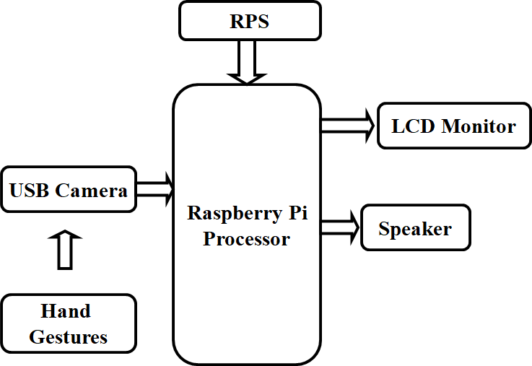

Fig.3.1: Architectural Block diagram of Proposed System.

The system is designed around the Raspberry Pi 3 Model B+, chosen for its compact size, processing capability, and built-in connectivity features. A USB camera captures live video feed of hand gestures. The images are processed using OpenCV, where background subtraction, thresholding, and contour detection are applied to isolate and recognize gestures. Recognized gestures are mapped to predefined text messages and converted into audio using a text-to-speech engine. The output is displayed on an LCD screen and played through speakers. The entire process is executed in real-time, providing immediate feedback to the user.

1. **COMPONENTS AND CONNECTIONS**

The hardware setup includes the Raspberry Pi 3 Model B+, a USB webcam, an HDMI or LCD display, and an audio speaker. Power is supplied via a 5V/2.5A micro USB adapter. The Raspberry Pi handles all image processing and control functions. The camera is connected through a USB port, and the display is connected via HDMI. Audio output is delivered through the 3.5mm jack or USB audio adapter. This simple yet effective setup ensures portability, ease of use, and low energy consumption.

**RASPBERRY PI :** The Raspberry Pi 3 Model B+ serves as the core of the system. It is a compact, affordable single-board computer capable of handling image processing tasks required for real-time gesture recognition. Its built-in HDMI, USB, and GPIO interfaces allow easy integration with peripherals such as displays, cameras, and audio devices.

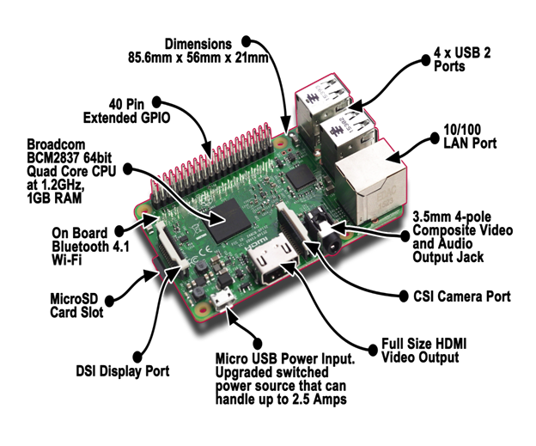

Fig.4.1: Raspberry Pi

**USB CAMERA**: A USB camera is used to capture live video input of hand gestures. The video feed serves as the primary input for the system. Its plug-and-play compatibility with the Raspberry Pi allows straightforward setup and reliable performance.

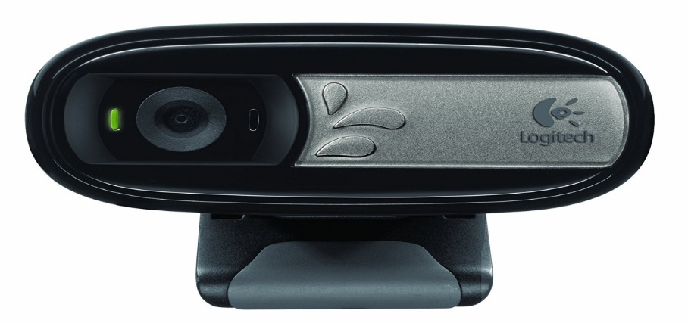

Fig.4.2: USB Camera

**OpenCV**, an open-source computer vision library, is used for processing the camera feed. It enables gesture recognition through techniques like grayscale conversion, Gaussian blur, thresholding, and contour detection. These steps help in isolating hand shapes and identifying specific gestures.

The recognized gestures are then translated into speech using a text-to-speech engine, such as pyttsx3 or espeak. These libraries convert the corresponding text into audio output, allowing the system to vocalize the message.

**DISPLAY:** An LCD or HDMI display is used to show the interpreted text output, offering visual confirmation of the recognized gesture. This ensures feedback for both the user and the person interacting with them.

**AUDIO SPEAKERS:** The audio speaker outputs the generated speech, making the system usable in real-time communication. It connects via the 3.5mm audio jack or USB port of the Raspberry Pi and delivers clear audio output of the recognized gesture.

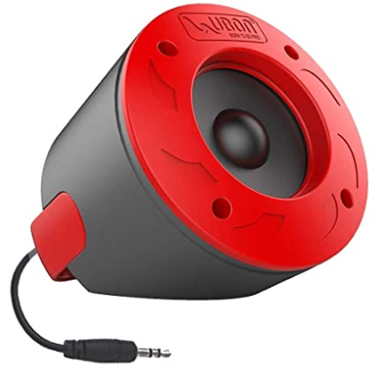

Fig.4.3: Audio Speakers

**POWER SUPPLY:** Power is supplied to the entire setup through a 5V/2.5A micro USB adapter. This provides sufficient current to support the Raspberry Pi and all connected peripherals without compromising performance or causing voltage drops.

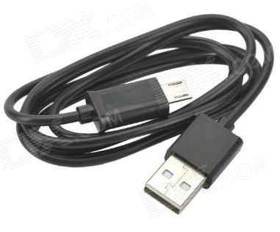

Fig.4.4: Power Supply

Software Implementation: The software is developed using Python and relies heavily on the OpenCV library for image processing. Captured frames are pre-processed using grayscale conversion, Gaussian blurring, and binary thresholding. Contours are detected to identify hand shapes and movements, which are matched against a predefined set of gestures. Once a gesture is recognized, it is mapped to a corresponding message and passed to a text-to-speech engine like pyttsx3 or espeak for audio output. The recognized text is also displayed on the screen for visual feedback.

# WORKING:

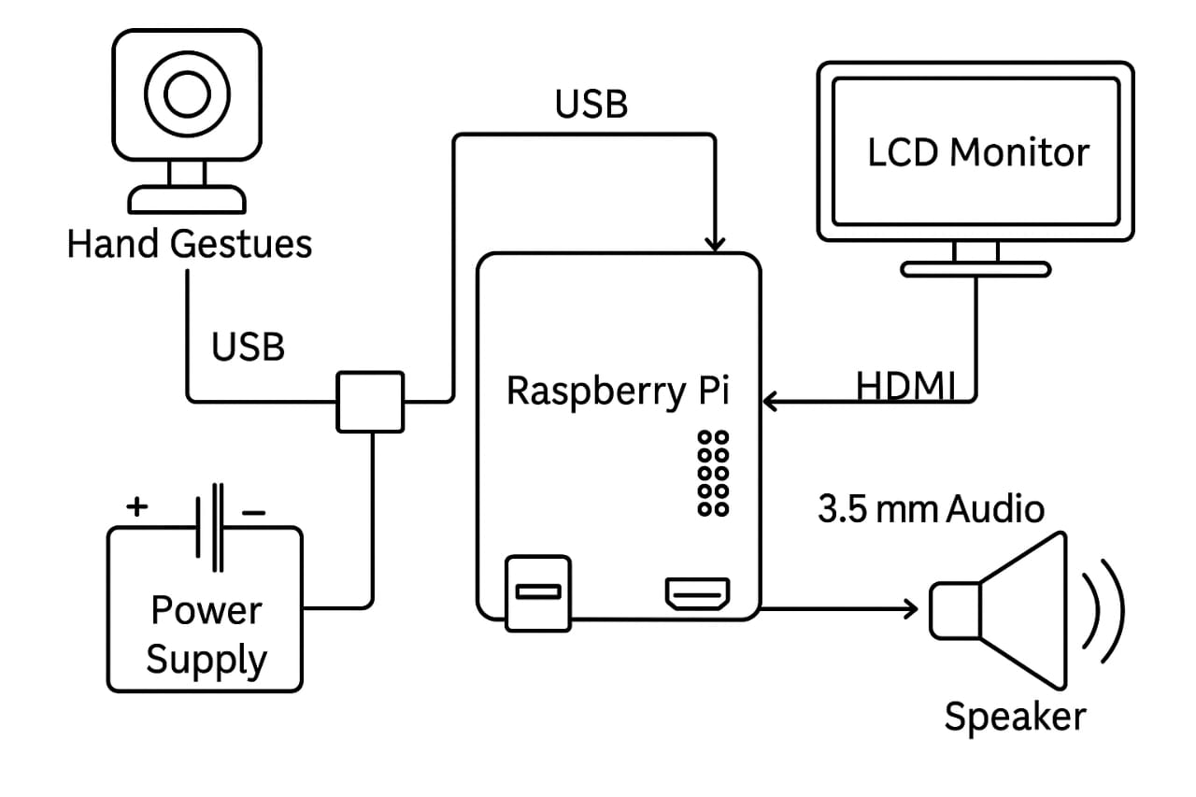

Fig.5.1: Circuit Diagram

1. The implementation of the Sign Language Recognition System begins with setting up the Raspberry Pi. First, the Raspberry Pi OS is installed, and necessary peripherals such as a monitor, keyboard, mouse, and camera are connected.
2. Python and the OpenCV library are then installed to enable image processing capabilities. Once the setup is complete, a USB webcam or Pi camera module is connected and tested to ensure it can capture live video feed correctly.
3. The next step involves capturing and preprocessing the images. The system continuously captures video frames from the camera, and each frame is converted to grayscale or HSV format. Filters like Gaussian blur are applied to reduce noise and improve the accuracy of gesture detection.
4. Following preprocessing, the hand region is detected using methods such as color segmentation or contour detection. This allows the system to isolate the hand from the background, making it easier to analyze the gesture.
5. The detected hand shape is then compared with a set of predefined gestures stored in the system, using basic conditional checks or simple pattern-matching techniques to recognize the correct letter, number, or word.
6. Once a gesture is recognized, the corresponding output is displayed on the screen as text. Optionally, a text-to-speech module can be added to convert this text into spoken words, allowing the system to communicate the recognized gesture audibly.
7. Finally, the system is tested under different conditions, and adjustments are made to improve gesture accuracy and overall performance.
   1. **Image Acquisition:** The USB camera is interfaced with Raspberry Pi and continuously captures frames. Each frame is analysed for detecting hand regions using colour thresholding, background subtraction, or machine learning models like Haar cascades or Media Pipe.
   2. **Pre-processing:** Captured images are processed using:

* Grayscale conversion
* Gaussian blur
* Thresholding
* Contour detection to isolate the hand gesture from background noise
  1. **Gesture Recognition:** Recognized gestures are compared to a predefined set of gestures (e.g., letters B, C, Y, etc.) using either contour matching, feature comparison, or a trained classifier (like KNN or CNN for higher accuracy).
  2. **Output Generation:** Based on recognized gestures, the system triggers corresponding messages which are:
* Displayed on the LCD screen using OS, system or GUI.
* Converted to speech using the TTS engine and played through the speaker.
  1. **Sample Gesture Mapping**

|  |  |  |
| --- | --- | --- |
| **Gesture** | **Message Displayed** | **Voice Output** |
| B | I need water | "I need water" |
| Y | I need food | "I need food" |
| C | I need medicine | "I need medicine" |

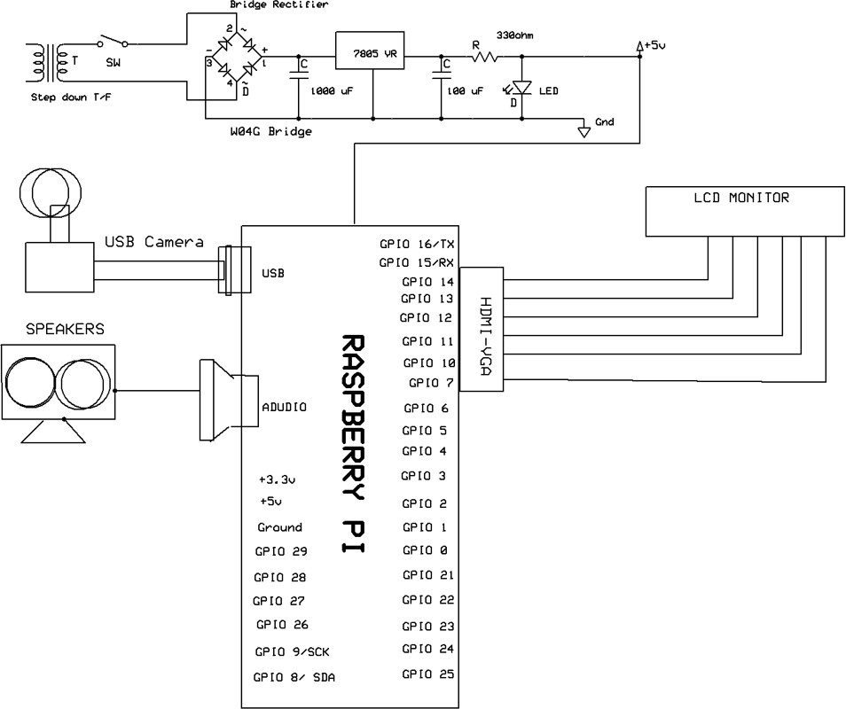

Fig.5.2. Schematic diagram

# RESULTS AND DISCUSSION

Figure 6.1 shows the two pictures where in one of the picture where we find the sign language of the letter ‘W’ and in the command window we can notice there is a need of the sign language so the ‘W’ represents the “HELP FOR WASHROOM”.

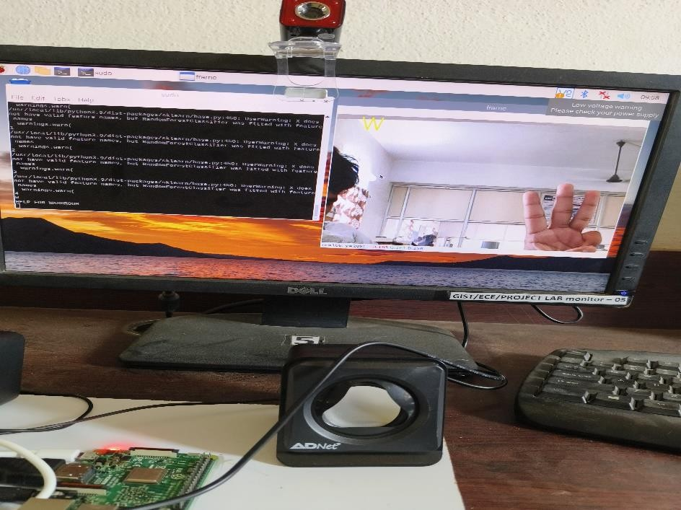

Fig.6.1: Presents the sign language letter ‘W’.

The prototype was tested under various lighting conditions and background setups. It successfully recognized a set of predefined static gestures with an accuracy of around 90% in well-lit environments. The system responded in real-time with minimal delay. Limitations were observed in scenarios with poor lighting or complex backgrounds. Compared to sensor-based systems, the camera-based approach proved to be more natural and user-friendly. The system demonstrated strong potential for use in schools, hospitals, and public service counters.

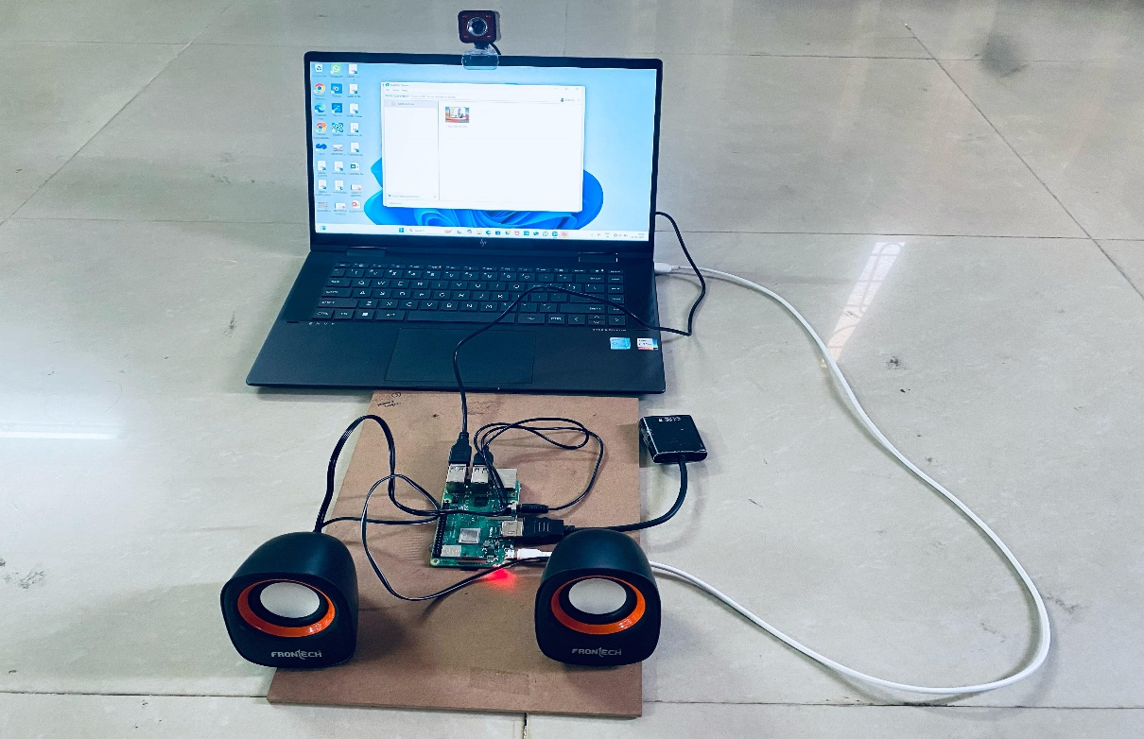

Fig.6.2: Schematic diagram

1. **RESULTS AND DISCUSSION:**

The prototype was tested under various lighting conditions and background setups. It successfully recognized a set of predefined static gestures with an accuracy of around 90% in well-lit environments. The system responded in real-time with minimal delay. Limitations were observed in scenarios with poor lighting or complex backgrounds. Compared to sensor-based systems, the camera-based approach proved to be more natural and user-friendly. The system demonstrated strong potential for use in schools, hospitals, and public service counters. In addition to basic functionality testing, the system was also evaluated for usability and consistency. The gesture recognition speed averaged around 0.8 seconds per gesture, making the system sufficiently fast for real-time use. Users with no prior technical knowledge were able to operate the system intuitively, confirming its user-friendliness. The audio output was found to be clear and sufficiently loud under normal indoor conditions, and the display provided an effective visual feedback mechanism. During stress testing with continuous gestures, the system maintained stable performance without overheating or crashing, showcasing the reliability of the Raspberry Pi for prolonged usage. While the current system recognizes only a limited set of gestures, the modular design makes it

easy to add more gestures in future updates. Testing across different hand shapes and skin tones showed that the system maintained recognition accuracy, though further training with diverse datasets would improve robustness. These results confirm the practical viability of using Raspberry Pi and OpenCV as a base for developing affordable, offline, and real-time assistive communication tools.

# CONCLUSION

The implementation of a Raspberry Pi and OpenCV-based sign language recognition system represents a meaningful advancement in bridging the communication gap between the mute community and the broader public. By harnessing the power of computer vision and machine learning, the system effectively detects and interprets hand gestures, converting them into both textual and speech outputs. This enables real-time, cost-effective, and portable communication support for individuals with speech impairments. The use of Raspberry Pi makes the system lightweight, energy-efficient, and affordable, while OpenCV ensures fast and accurate image processing for gesture recognition. Though the current prototype is limited to a set of static gestures, it has successfully demonstrated reliable performance under standard conditions. Areas such as gesture diversity, lighting adaptability, and response speed present opportunities for future enhancement. In the next phase, this system can be further developed by integrating deep learning models for dynamic gesture recognition, multilingual voice output, and enhanced user interfaces for a more inclusive experience. The overall system—comprising gesture detection, text generation, and speech synthesis—was successfully implemented. All input and output modules were integrated with the Raspberry Pi microprocessor, and the results were found to be accurate and consistent. The output gestures were clearly displayed on an LCD screen and voiced through audio speakers, making communication natural and intuitive. In conclusion, this project not only demonstrates the feasibility of gesture-to-speech translation using embedded systems, but also highlights the growing role of assistive technologies in empowering the differently-abled community and fostering a more inclusive society.

1. **FUTURE SCOPE**

The Sign Language Recognition System using Raspberry Pi and OpenCV has significant potential for further development and practical implementation. In the future, the system can be expanded to recognize dynamic gestures, enabling the interpretation of complete words and sentences instead of just static signs. Adding a voice output feature through text-to-speech conversion would allow the translated signs to be spoken aloud, enhancing communication with individuals who do not read text. The system can also be upgraded to support multiple sign languages and regional spoken languages, making it more versatile and accessible across different communities. A mobile application can be developed to provide users with a more portable and convenient interface. Additionally, cloud integration can enable data storage, remote updates, and system personalization based on user preferences. Improving the user interface and exploring integration with wearable devices like smart glasses or wristbands can further increase usability and make the system more seamless in daily life. These enhancements would help transform the prototype into a reliable and widely usable communication tool for the mute and hearing-impaired community.

**10. REFERENCES**

1. Wolf, C. G. Will individuals use motion orders? IBM Examination Report, (RC 11867), April 7, 1986.
2. Sanna K., Juha K., Jani M. furthermore, Johan M (2006), Perception of Hand Gestures for Pervasive Computing Conditions, in the Proceedings of the working meeting on cutting edge visual interfaces, ACM, Italy, p. 480-483.
3. WII Nintendo, 2006, http://www.wii.com, Available at http://www.wii.com [Last got to April 21, 2009]. 9. W. K. Edwards and R. E. Grinter, "At home with universal figuring: seven difficulties," introduced at Ubicomp, Atlanta, USA, 2001.
4. Malik, S. furthermore, Laszlo, J. (2004). Visual Touchpad: A Twohanded Gestural Input Device. In Proceedings of the ACM Global Conference on Multimodal Interfaces. p. 289
5. Rithesh M Nanda1, Harshini H K1, Praveen Kuruvadi1, Ankit B V1, C Gururaj2,"wireless Gesture Controlled Framework", 1Student, Dept. of Telecommunication, BMS College of Engineering, Bangalore, India 2Assistant Professor, Dept. o Telecommunication, BMS College of Engineering, Bangalore, India.
6. Jia, P. furthermore, Huosheng H. Hu. (2007), "Head signal acknowledgment for sans hands control of a keen wheelchair", Industrial Robot: An International Journal, Emerald
7. Juha K., Panu K., Jani M., Sanna K., Giuseppe S., Luca J. furthermore, Sergio D. M. Accelerometer-based signal control for a structure condition, Springer, Finland, 2005.
8. Pooja Dongare1,Omkar Kandal Gaonkar2, Rohan Kanse3, Sarvesh Kukyan4,"Innovative Tool For Deaf, Dumb Furthermore, Blind People", B.E Students K.C. School Of Engineering and Management Studies and Research, Kopri, Thane(E)- 400 603, India.
9. Solanki Krunal M, “Indian Sign Languages using Flex Senser Glove,” International Journal of Engineering Trends and Technology (IJETT) - Volume4 Issue6- June 2013 ISSN: 2231