IOT ENABLED AGRICULTURE ROBOT FOR AUTOMATED FARMING AND NUTRIENT MONITORING

1P. Gnaneswar rao, 2P. Jaya Srujana, 3S. Hari Sai Kishore, 4P. Akash Varma, 5 V. Omkar Sai, 6K.V.E Sarojini, 7Dr B.Siva Prasa

1,2,3,4,5 B. Tech student Department of ECE, NSRIT, Vizag, AP,India

6Assistant Professor, Department of ECE, NSRIT, Vizag, AP, India

7Professor, Head of Department of ECE, NSRIT, Vizag, AP, India

**INTRODUCTION:** The developments of a multifunctional Agricultural Robot which will be capable of automating critical operations in agriculture including tilling, sowing seeds and irrigation of the farmland will be covered through this research paper. At the heart of the system is a microcontroller-an Arduino, which governs all actions of the robot. The robot would start the operation using a high-torque DC geared motor to till the soil efficiently so that it may be set as optimum before planting. Then, it would drop the seeds at uniform intervals and at the right time, switching on a computer-controlled sprinkler to cater for moisture needs for the germination of seedlings.The robot will have various sensors as a component of the smart feature of these robots. A Soil Moisture Sensor would evaluate the moisture content of the soil, and optimize watering intervals. The DHT11 Sensor senses the room temperature and humidity, assisting in monitoring the environment. The NPK sensor is for soil nutrient composition as it helps assess soil fertility and plan the appropriate strategy for fertilizing.Based on this, the IoT module allows remote operation of the robot by farmers by controlling the working of the robot from their mobile application or web platform. It will have a positive impact by reducing physical labor dramatically.

This Agricultural Robot made feasible integration of embedded systems, IoT, and sensor technologies for smart and cost-effective yet efficient service to small and medium scale farms. The real idea behind this is to empower farmers with intelligent automation tools that take profit out of improved productivity and reduced manual labor.

**KEYWORDS:** Arduino, Agricultural Robot, IoT Automation, Smart Farming, DC Geared Motor, Seed Dispensing, Soil Tilling, Water Sprinkler, Soil Moisture Sensor, DHT11 Sensor, NPK Sensor, Remote Monitoring, Embedded Systems, Real-Time Data, Mobile-Controlled Robot, Precision Agriculture.

1. **LITERATURE SURVEY**

The mechanization and precision agriculture technologies have indeed greatly altered the ancient practices of farming by providing solutions to problems associated with human effort, water availability, and sustainable cropping. It is further made clear that advances have been made in such research to lay the foundation for autonomous agricultural systems such as Agribot. Nandurkar et al. [1] considered precision agriculture based on WSNs for monitoring environmental parameters with soil moisture, temperature, and humidity. They showed that these parameters, being monitored in real time, could lead to effective irrigation and fertilization management practices, thereby improving crop yields while reducing water usage. Using WSNs and a GPRS module, Gutierrez et al. [2] developed a remote-controlled irrigation system. They found that their irrigation system allowed automatic adjustment of the irrigation schedule based upon actual field conditions, increasing irrigation efficiency while reducing water wastage.

Mirabella and Brischetto [8] implemented a hybrid wired/wireless design for greenhouse control where they maximized their monitoring effectiveness through the integrated data collection from many sensors that enable a better understanding of climate control in accommodated farming environments. IoT is one of the smart-farming technologies that Patel and Patel [9] work on, establishing irrigation automation and monitoring soil parameters. Real-time soil data acquisition was designed to optimize water use and demonstrate the grandeur of IoT in enhancing precision agriculture. The Applications of Wildlife Sensor Networks in Real-Time Monitoring of Agricultural Fields were studied by Sontakke and Salunke [11]. It was shown that systems based on sensors have become more practical for effective decision-making concerning crop health and physical conditions of the field. The contributions made by these research works illustrate an increasing emphasis on automation and data-centric agriculture. The integration of the Internet of Things, wireless sensor networks, and embedded systems has allowed projects like IoT-enabled agricultural robot to integrate real-time sensing, autonomous operation, and sustainable power sources to optimize the contemporary agricultural industry.

1. **INTRODUCTION**

**2.1 Background and Motivation**

So, agriculture has stayed true to India being an economy that lives up to the livelihood of more than half of the population through direct and allied work: However, this sector plays a prominent role and faces the following challenges: increased input costs; served by skilled manpower, and water availability. Such challenges endanger even the survival of agriculture in India and demand technological solutions for increased productivity and efficiency of resource use.

Automation and robotics, advances previously found in manufacturing, health care, and defense, are now making their incursion into agricultural environments. Agricultural robotics encompasses application of intelligent and autonomous systems within farm environments and then mechanized operations across variant agricultural domains-crop production, forestry, aquaculture, and so on. Such technologies, however, seem to promise a possible transformation from labor-dependent agriculture to minimize precision in performing tasks but having optimal yield in terms of quality.

Automation in agriculture has advanced with its application to certain key agricultural field operations such as ploughing, planting seeds, spraying pesticides, removing weeds, and harvesting. The greatest number of these currently available systems seems to target predominantly single-task operations, which, in fact, is a major limitation to their development. Development, therefore, is required in terms multifunctionality with robots that can be designed with capabilities for wide-ranging agricultural task applications without extensive human intervention. This remains a pertinent concern for academia and engineering.

Traditionally, farming has always depended heavily on labor for performing most of its physically intensive and repetitive work involving the mobilization of machinery, weeding, or harvesting. All these have serious drawbacks in operational efficiency and expose workers to health hazards, especially during periods of agrochemical applications. On the other hand, mechanized implements like tractors to a lesser extent aggravate problems such as soil compaction through their weight which affect soil aeration and fertility adversely and, at the same time, limit proper operation in uneven or sensitive grounds.

Intelligent agricultural robots and autonomous systems are definitely a more sustainable and flexible alternative. Such systems are created for implementing complex agricultural tasks with really good accuracy, with a minimal footprint on ecology, and real-time reactivity, thus being one of the best ways to address the changing needs of modern agriculture.

**2.2 Objectives**

The key aim of IoT Enabled Agriculture Robot is trying to modernize conventional agricultural methods through the mechanization or perfection of core field operations such as ploughing, seeding, and irrigating. By augmenting the other benefits brought by fewer dependency conditions on manual labor, IoT-enabled agricultural robot also enhances efficiency, consistency, and scalability in farming processes significantly. By precision agriculture-based methodologies, the system facilitates crop yield and resource utilization through accurate seed placement and predefined irrigation techniques, making it less wasteful for inputs and more sustainable environmentally.

Another significant aspect of IoT-enabled agricultural robot is connecting the IoT function for remote control and monitoring, which will allow farmers to work and monitor field activities using smart devices. This guarantees the real-time adaptability, execution flexibility, and hence added convenience, especially for remote or hard-to-reach areas of the farm. The modular, scalable robot, designed to perform agricultural activities with varying attachments, allows for such alteration. It also enhances crop-specific and terrain-specific operations.

It will therefore have solar power systems and will minimize fossil fuel dependency to leave a cleaner and greener agriculture footprint. Therefore, combined with GPS and sensor-based technologies, it will be able to produce precise field data maps and collect data that will help farmers and researchers make informed and accurate data-driven decisions. Such data will be useful in precision farming since it will show much information about the state of soil health, crop conditions, and operational performance.

By automating such labor-intensive activities, IoT-enabled agricultural robot thus addresses some of the rather larger problems in agriculture, allowing farmers the time and opportunity to think on a higher level about the whole farm operation. It can definitely reduce some of the very common environmental concerns associated with conventional farming practices, such as overusage of water, overconsumption of fuels, and runoff of chemicals from agricultural sources.

1. **METHODOLOGY**

The following is how the IoT-enabled agricultural robot was developed: a systematic combination of hardware design, embedded system programming, and IoT- based communication which resulted in a multifunction autonomous robot. The architecture of the system was founded on a central control unit that acted as the entire control unit called the Arduino Uno microcontroller. Locomotion and field operations such as ploughing were done by DC motors geared with an L293D motor driver and an Arduino for control. A gear-based mechanism was used for accurate seed dispensing, along with an automated irrigation system using a water pump and sprinkler.

The robot was installed with a DHT11 temperature humidity sensor for environmental and soil data collection; soil moisture sensor for irrigation control; and npk sensor that collected and monitored nutrient levels. A rechargeable battery with solar panels formed the power supply, which ensured energy efficiency and continuous operation in the field without frequent manual intervention.

Furthermore, the software development was based on Embedded C programming with the Arduino IDE control logic programmed for autonomous task execution so that any situation could have been programmed into it. The programmed logic responded to the sensor input to trigger specific actions such as ploughing through dispensing seeds at set intervals of time, activating the water pump when the moisture drops below the set level, could also be programmed to onboard a collection of environmental data logged in the system for soil health monitoring and enhancing decision-making for future applications such as automated fertilization.

For advanced usability and remote management, an IoT communication module was integrated, such as the ESP8266, which allowed the robot to go online and interact with a web- based interface. This has enabled the user to start or stop the robot remotely, to view, in real time, sensor data as well as provide alerts to the user regarding environmental parameters. The mobile interface was designed in a simple and easy understanding way with an overview dashboard to provide users with conditions from the field and system status. All these have moved precision agriculture towards achieving efficiency in operation and gradual inclination towards lower dependence for manual labor.

1. **IMPLEMENTATION**

The realization of IoT-enabled agricultural robots is an amalgamation of multidisciplinary approaches. This process includes embedded systems, electronics, mechanical design, and wireless communication technology. This process began with an assembly of the main hardware; Arduino Uno was used as the main microcontroller due to programmability, low cost, and compatibility with various peripherals. For locomotion, the geared type of DC motor was interfaced with the Arduino Uno through the L293D IC motor driver, ensuring accurate and stable locomotion capable of withstanding soil tilling and navigating through various conditions of the field. The robot's mechanical design had to ensure structural integrity while holding these components for optimum balance and movement configuration.

The seed dispensing system was designed using a geared motor that functioned in synchronization with the robot's movement to ensure steady and timely placement of seeds across the cultivated area. The irrigation system was fitted with a water pump, operated with a relay module, which became operational upon receiving real-time data from a soil moisture sensor for need-dependent irrigation aiming at water conservation. Environmental data collection was further augmented with a DHT11 sensor recording ambient temperature and humidity, and an NPK sensor that monitored the levels of vital soil nutrients. The input from these sensors play a pivotal role in enabling the adjustment to dynamic field scenarios for executing precision agriculture.

Powering the robot was through a renewable energy system which consisted of solar panels connected to a charge controller and a rechargeable battery. Continuous operation was guaranteed which does not rely on any external power systems; thus, making it more sustainable and flexible into the unmeasured sources. The embedded C program was used to develop microcontroller programming in the Arduino IDE. The software logic was engineered to automate major sequential agricultural operations depending on sensor feedback, and to allow for autonomous operations in true ploughing, seeding, and irrigation.

To grant the remote operation and the monitoring, an IoT communication module such as ESP8266 has been incorporated into the system. Thus, enabling the robot to interface with the cloud-connected mobile application, monitoring real-time field conditions and system performance. A manual override was also possible through that platform, enabling users to view live sensor data and monitor operation status. The application interface was designed with the user being in mind to assist the real-time management of farming activities.

The complete implementation of this system proved to have drastic effects on decreasing labor, improving field-level decision-making, and providing an alternative for data-driven sustainable agriculture.

**5. SYSTEM DESIGN AND ARCHITECTURE**

**5.1 Block Diagram**

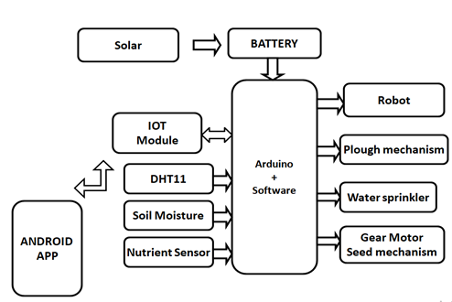

**Figure 5.1** – Block Diagram of IoT-Enabled Smart Agricultural Robot

The system architecture of the IoT-enabled agricultural robot is depicted in the block diagram, where modules such as DHT11, IoT, soil moisture, and NPK sensors are controlled by a solar-powered Arduino. The Arduino controls water spraying, seed dispensing, plowing, and robot movement based on sensor data, all of which can be remotely monitored through an Android app.

**5.2 Circuit Diagram**

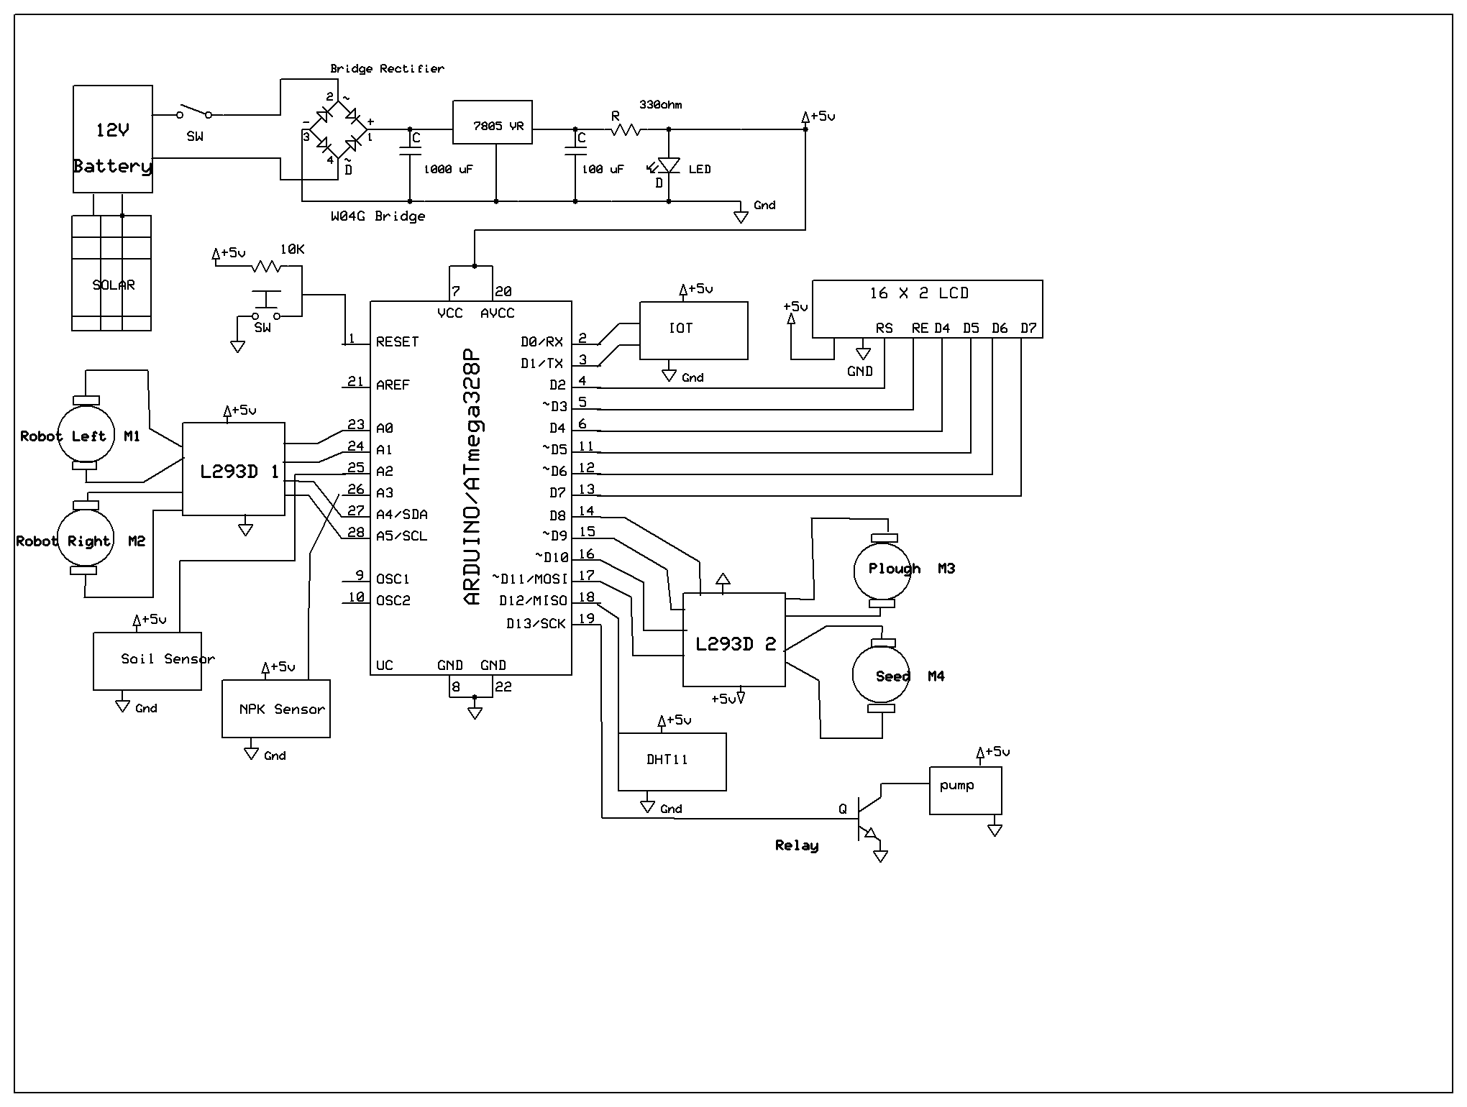

**Figure 5.2** – Circuit Diagram of the IoT-Enabled Smart Agricultural Robot

The agricultural robot's electronic implementation is described in detail in the circuit diagram. It has a circuit for a power supply that connects to an Arduino ATmega328P microcontroller via a 12V battery and solar input. The robot's wheels and agricultural equipment, including the plough and seed dispenser, are controlled by two L293D motor drivers. Real-time environmental feedback is provided by integrated sensors, such as DHT11, NPK, and soil moisture. Local and remote data visualization is made possible by an LCD display and an Internet of Things module, and the irrigation pump is managed by a relay using sensor data.

**6.WORKING**

The IoT-enabled agricultural robot has been developed to perform basic farming activities on its own, like soil ploughing, seed sowing, irrigation, and environment monitoring. The all mechanical operations are done under the supervision of the Arduino Uno type microcontroller, which coordinates sensor inputs and gives action commands according to the appropriate control logic.

Then during the first stage of initializing the robot, the ploughing unit is driven by a DC geared motor for soil preparation and that disrupts the topsoil to aerate it and provide the seeds with a good environment for germination. As it moves through a field, a gear-driven seed dispenser also located on the machine drops seeds into freshly ploughed soil according to the distance and height synchronization with the robot. Thus, the system guarantees an equal distance and depth for the seeds, which will ensure an even crop growth.

After sowing, the next stage is irrigation. A soil moisture sensor continuously senses the amount of moisture in the soil. When it goes below the threshold level, a relay module connected to the Arduino turns on a pump mounted in the robot, which feeds into a sprinkler system. Early water planning helps save water while ensuring development during the early life of a plant. Jointly conducting those activities, environmental and soil nutrient data are recorded. The sensor DHT11 measures the ambient temperature and humidity while the NPK sensor measures the macronutrients in the soil. This data are immediately processed and sent to the user interface far away through IoT module like the ESP8266. Connectivity will enable the users to monitor and control the operational parameter remotely through a dedicated mobile application.

This robot usually depends on a solar-charged battery system to which it is attached for improving energy autonomy in off-grid agricultural environments and merely a provision of sustainability. Integrating all these subsystems will help it go through an entire farming cycle with little human intervention required. Such robots will thus be employed as practical and efficient precision farming robots that can be remotely supervised and modified in its function, resulting in both increased productivity and sustainable resource management.

1. **APPLICATIONS AND FUTURE SCOPE**

**7.1 Applications:**

Multiple applications of the IoT agricultural robot support precision and sustainable farming. Such tasks include requiring ploughing and seeding operations wherein crops would be planted in such a manner that they are distributed evenly and spaced in rows without manual intervention. A smart irrigation system with IoT whereby water is applied according to the real-time soil moisture level greatly increases water-use efficiency and prevents over-irrigation.

Environmental monitoring is another function, with sensors such as DHT11 and NPK sensor delivering extremely useful information concerning temperature, humidity, and soil nutrients. This information is processed in real-time, and thus stored in the cloud for remote access, historical analysis, and decision-making on the crop plan and yield optimization.

This system supports precision input application where sensors assist in control of the use of the inputs-seeds, water, and nutrients, thereby minimizing wastage and environmental damage. An onboard LCD displays real-time data from the field, while Internet Connectivity enabled by the IoT module allows remote control and monitoring of its operations via a user-friendly mobile interface.

This robotic platform may also be used in research and educational endeavors as it has datacollection capabilities and modular design. It is a scalable, energy-efficient, cost-effective solution, with applications in small and medium-sized farms that will bridge the gap between conventional and smart agriculture.

**7.2 Future Scope:**

The present agricultural robotics implementation acts as a platform to boost automation in precision farming, while there is tremendous scope for enhancement and scalability. Future developments may include several computer vision and image processing algorithms that would allow the robot to autonomously identify obstacles in its path, navigate around them, identify rows of plants, and carry out precision operations such as targeted weeding and seeding.

With systems integration of AI and machine-learning frameworks, the robot can be adaptive, adjusting to varying soil textures, moisture contents, and crop types. Thus, allowing the real-time fine-tuning of agricultural strategies, enhancing efficiency and yield.

Going further, the introduction of high-resolution environmental sensors may enable real-time detection of micronutrient deficiencies, pest presence, or crop stress symptoms. The system architecture is modular and can thus be further extended to support operations from smallholders to megafarms.

Cloud connectivity will provide a robust backbone for high-level data analytics and predictive modeling and long-term agricultural planning. The aforementioned will increase robot autonomy and intelligent behavior along with instituting data-led sustainable farming practices.

1. **CONCLUSION**

Developmental robots which are useful for the agriculture field in carrying out automated ploughing, seed spreading, and watering sowing, in designing the whole system with Arduino and IoT technology-made system, possess progress in agricultural automation. The improvement is very helpful in increasing the efficiency of conventional methods for farm work whilst having its tasks completed accurately and on time. In addition to this, the system is made even more effective because of the use of IoT in it as it enables remote control and monitoring, providing more convenience and accessibility, especially on wide or isolated agricultural lands.

With the help of an Arduino microcontroller, all elements function mango motors, sensors, and other associated items into one machine so that the robot can complete more than just one activity within a full cycle or operation task without human supervision. Another feature is its lightweight construction, which helps reduce the effect of soil compaction caused by heavy agricultural machines. This will further lead to improved soil and plant health.

Sustainable agriculture becomes an option using this system by optimizing the use of very precious resources like water and seed and, finally, reducing unnecessary waste and operational cost. This system is an example of low-cost and energy-efficient, easy to scale, smart farming technologies suited for small to medium farms. This stands as a base towards horizon advancements in precision agriculture in innovation bridging between conventional and modern agricultural practices.

1. **REFERENCES:**
2. S. R. Nandurkar, V. R. Thool, and R. C. Thool, “Design and Development of Precision Agriculture System Using Wireless Sensor Network,” Proc. IEEE Int. Conf. on Automation, Control, Energy and Systems (ACES), 2014.
3. J. Gutiérrez, J. F. Villa-Medina, A. Nieto-Garibay, and M. A. Porta-Gándara, “Automated Irrigation System Using a Wireless Sensor Network and GPRS Module,” IEEE Trans. Instrum. Meas., vol. 63, no. 1, pp. 166–176, 2014.
4. V. Vidya Devi and G. Meena Kumari, “Real-Time Automation and Monitoring System for Modernized Agriculture,” Int. J. Rev. Res. Appl. Sci. Eng. (IJRRASE), vol. 3, no. 1, pp. 7–12, 2013.
5. Y. Kim, R. Evans, and W. Iversen, “Remote Sensing and Control of an Irrigation System Using a Distributed Wireless Sensor Network,” IEEE Trans. Instrum. Meas., vol. 57, no. 7, pp. 1379–1387, Jul. 2008.
6. Q. Wang, A. Terzis, and A. Szalay, “A Novel Soil Measuring Wireless Sensor Network,” IEEE Trans. Instrum. Meas., vol. 60, no. 1, pp. 412–415, Jan. 2011.
7. S. Yoo, J. Kim, T. Kim, S. Ahn, J. Sung, and D. Kim, “A2S: Automated Agriculture System Based on WSN,” in Proc. IEEE Int. Symp. Consumer Electronics (ISCE), Irving, TX, USA, 2007.
8. T. Arampatzis, J. Lygeros, and S. Manesis, “A Survey of Applications of Wireless Sensors and Wireless Sensor Networks,” in Proc. IEEE Int. Symp. Intelligent Control & 13th Mediterranean Conf. Control and Automation, Limassol, Cyprus, 2005, pp. 719–724.
9. O. Mirabella and M. Brischetto, “A Hybrid Wired/Wireless Networking Infrastructure for Greenhouse Management,” IEEE Trans. Instrum. Meas., vol. 60, no. 2, pp. 398–407, Feb. 2011.
10. R. N. Patel and D. P. Patel, “IoT Based Smart Farming System for Agriculture Automation,” in Proc. 2nd IEEE Int. Conf. Trends in Electronics and Informatics (ICOEI), 2018, pp. 339–344.
11. L. Sharma and V. Sharma, “An IoT Based Smart Irrigation System Using Soil Moisture Sensor and Temperature Sensor,” Int. J. Sci. Eng. Res., vol. 9, no. 5, May 2018.
12. S. R. Sontakke and C. V. Salunke, “Agriculture Field Monitoring System Using Wireless Sensor Network to Improve Crop Production,” Int. J. Sci. Res. Comput. Sci. Eng. Inf. Technol., vol. 2, no. 6, 2017.
13. A. Jawarkar, A. G. Khatri, A. Lanjewar, and P. K. Laturkar, “Microcontroller Based Controlled Irrigation System for Plantation,” in Proc. IEEE Int. Conf. Control, Automation, Communication and Energy Conservation (INCACEC), 2009, pp. 1–5.
14. G. Nisha and V. S. Jebarani, “Design of Wireless Sensor Network for Automatic Monitoring and Controlling of Greenhouse Environment,” Int. J. Eng. Res. Gen. Sci., vol. 2, no. 6, 2014.
15. P. Prathibha, A. Anusha, and J. U. Sri, “Irrigation System Using a Wireless Sensor Network and GPRS Module,” Int. J. Adv. Res. Comput. Commun. Eng., vol. 3, no. 5, May 2014.
16. M. Jain, V. Jain, and S. Jain, “Precision Farming: An Approach Towards Environmental Sustainability with Special Reference to India,” J. Environ. Res. Dev., vol. 7, no. 4A, Apr.–Jun. 2013.
17. P. Prathibha, A. Anusha, and J. Usha Sri, “Irrigation System Using a Wireless Sensor Network and GPRS Module,” International Journal of Advanced Research in Computer and Communication Engineering, Vol. 3, Issue 5, May 2014.
18. M. Jain, V. Jain, S. Jain, "Precision Farming: An Approach Towards Environmental Sustainability with Special Reference to India," Journal of Environmental Research and Development, Vol. 7, No. 4A, April-June 2013.