# “Smart Metering of Electricity Theft Detection and Power Monitoring”

**Prof. Vaishali Warake1, Swaraj Bobade2, Summeet Chandekar3 , Siddharth Sabale4 , Aditya Vajale5**

1Professor, Computer Department, P K Technical Campus, Pune, Maharashtra, India

2,3,4,5Student , Computer Department, P K Technical Campus, Pune, Maharashtra, India

**ABSTRACT**

The increasing demand for electricity and the associated challenges of power theft and inefficiency have necessitated innovative solutions in energy management. This report explores the implementation of smart metering technologies for the detection of electricity theft and enhanced power monitoring. Smart meters utilize advanced communication technologies and real-time data analytics to provide accurate consumption readings, enabling utilities to identify anomalies indicative of theft. By integrating these systems with predictive algorithms and machine learning techniques, this approach not only facilitates immediate detection but also aids in predicting potential theft hotspots. Additionally, the report discusses the broader implications of smart metering on energy efficiency, consumer behavior, and grid management. The f indings highlight the potential of smart metering as a pivotal tool in enhancing the reliability and sustainability of electrical distribution systems, ultimately contributing to reduced losses and improved service delivery. Key words: Keywords: Electricity Theft, Power Monitoring, IoT, Power Theft Detection, NodeMCU.

## 1. INTRODUCTION

## The rapid advancement of digital technologies has significantly impacted the energy sector, bringing forth smarter and more efficient solutions for power management. Among these innovations, smart metering has emerged as a key component, replacing traditional meters with intelligent systems capable of real-time data collection and two-way communication. These systems not only optimize energy distribution and reduce operational costs but also enhance the overall efficiency and reliability of power grids.

## A major challenge faced by utility providers is electricity theft, which leads to considerable financial losses and affects supply stability. Smart meters, integrated with data analytics and machine learning algorithms, enable early detection of anomalies that may indicate tampering or unauthorized usage. Additionally, power monitoring plays a crucial role by continuously tracking electrical parameters to ensure system stability and prompt response to faults.

## While smart metering offers numerous benefits, its widespread implementation faces hurdles such as infrastructure costs, privacy concerns, and user resistance. However, emerging technologies like IoT, AI, and blockchain are helping address these issues, paving the way for a more secure and intelligent energy ecosystem. This paper explores the technologies and applications of smart metering, electricity theft detection, and power monitoring, highlighting their significance in shaping the future of energy management.

## 2. LITERATURE SURVEY

The literature review highlights significant advancements in smart metering, electricity theft detection, and power monitoring technologies. Smart metering systems enhance real-time data acquisition and two-way communication between consumers and utilities, enabling better load management and demand forecasting. Various machine learning techniques, such as Support Vector Machines (SVM) and Neural Networks, have been explored for effectively detecting electricity theft through anomaly detection in consumption patterns. Research emphasizes the importance of real-time power quality monitoring, utilizing smart meters to identify issues like voltage fluctuations and harmonic distortions. Studies indicate that providing consumers with detailed insights into their energy usage promotes energy efficiency and conservation. Additionally, the integration of renewable energy sources into smart grids is facilitated by smart metering technology, highlighting the need for advanced forecasting and demand response strategies. However, data privacy and security remain critical concerns, with research proposing frameworks to safeguard consumer information and mitigate cyber threats. Overall, the literature underscores the transformative potential of these technologies in enhancing energy management while identifying ongoing challenges that require further exploration.

## 3. PROBLEM STATEMENT

Problem Definition Traditional power distribution systems face significant challenges, including electricity theft, inefficient energy monitoring, and poor power quality management. Electricity theft leads to substantial revenue losses for utilities, while the lack of real-time consumption data hinders grid optimization and decision-making. Consumers have limited control over their energy usage due to inadequate insights into their consumption patterns. Additionally, integrating renewable energy into the grid remains a challenge, and concerns about data privacy and security persist. Addressing these issues requires innovative solutions that enhance monitoring, reduce losses, and support a more efficient, secure, and sustainable energy infrastructure.

**3.1 OBJECTIVES**

• Develop and implement smart metering systems to enable real-time monitoring and accurate measurement of electricity consumption.

• Create data-driven methods for detecting and preventing electricity theft to reduce non technical losses and increase revenue protection.

• Enhance power quality monitoring to identify and address issues like voltage fluctuations and harmonic distortions, ensuring reliable power supply.

• Empower consumers with detailed insights into their energy usage to promote cost savings and encourage energy-efficient behaviors.

• Facilitate the seamless integration of renewable energy sources into the power grid for a more sustainable and resilient energy system.

• Ensure robust data privacy and security measures to protect consumer information and maintain the integrity of smart metering systems.

## 4. SYSTEM DESIGN

The system design for Smart Metering in Electricity Theft Detection and Power Monitoring is crafted to illustrate the interaction and flow of data between various components, utilizing system architecture, (DFDs), and Language (UML) diagrams. The system architecture provides an overarching view of core elements such as smart meters, data collection units (DCUs), a central server, and the communication network, detailing how data is collected, transmitted, and processed for both theft detection and power monitoring. DFDs break down these processes further by illustrating data sources, key functions, and storage points, while mapping the flow of data from the consumer's meter to the central server for analysis. To dive deeper into system interactions and behaviors, UML diagrams like use case, class, sequence, and activity diagrams offer specific insights into functionalities and processes. Together, these diagrams form a comprehensive framework for visualizing how the system efficiently detects electricity theft and enables robust power usage monitoring, ensuring clear data flow and organized control.

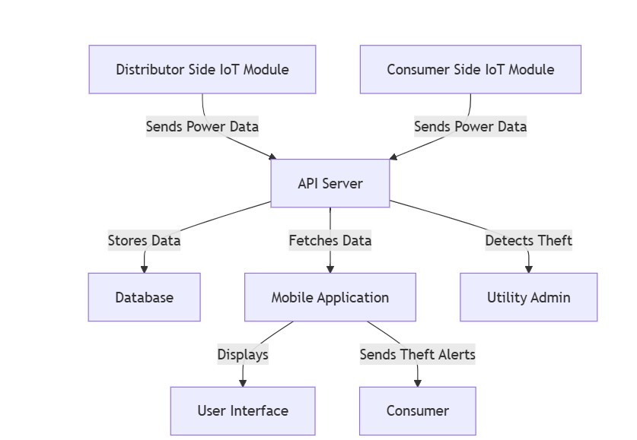

## 5. SYSTEM REQUIREMENTS

The system architecture includes three key components:

1. **Distributor Side IoT Module**:
   * Measures the power sent from the distributor to the consumer. o Contains sensors such as ZMPT 101B (voltage) and ACS 714 (current), interfaced with the ESP32 microcontroller.
   * Sends data (voltage, current) to the server via Wi-Fi.
2. **Consumer Side IoT Module**:
   * Measures the consumer's actual electricity usage.
   * Compares data with the distributor-side readings to detect discrepancies (theft).
   * Data is processed using the ESP32 and sent to the server.
3. **API Server and Database**:
   * REST API built with Node.js and Express.js handles communication between the IoT modules and the mobile app.
   * Data is stored in MongoDB, including sensor data and user details.
   * Power theft is detected based on discrepancies in power data.
4. **Mobile Application**:
   * Allows users to monitor power consumption in real-time.
   * Displays alerts in case of electricity theft and offers historical data views.

**5.2 SYSTEM IMPLEMENTATION** **PLAN**

1. **Phase 1: Requirement Analysis and Feasibility Study**

* Gather detailed requirements from utility companies and consumers.
* Evaluate available hardware and software solutions, including sensors, microcontrollers, and cloud storage options.

### **2. Phase 2: Design**

* Design the IoT modules (for both distributor and consumer sides), mobile app interfaces, and API server structure.
* Prepare circuit diagrams for the hardware and architectural design for the software stack.

### **3. Phase 3: Development**

* **Hardware setup**: Assemble and program the ESP32 microcontrollers with voltage and current sensors.
* **Software development**: Build the API server, mobile app, and database. Begin implementing the core functionalities such as data collection, theft detection algorithms, and notifications.

### **4. Phase 4: Testing**

* Perform unit testing on individual IoT modules, ensuring sensors accurately measure voltage and current.
* Integration testing for communication between IoT devices, API server, and mobile application.
* End-to-end testing, simulating electricity theft and monitoring system responses.

1. **Phase 5: Deployment**

* Set up the system in a controlled environment with actual users for beta testing.
* Deploy mobile app to Android and iOS platforms and the API server to a cloud service (e.g., AWS).

1. **Phase 6: Maintenance and Updates**

* Regular updates to improve theft detection algorithms.
* Ongoing monitoring of system performance and scalability, addressing hardware malfunctions, and software errors.

# OTHER SPECIFICATIONS

## 5.1 ADVANTAGES

Here are the key advantages of smart metering for electricity theft detection and power monitoring:

* **Real-Time Monitoring**: Allows for continuous tracking of electricity consumption and immediate identification of irregularities.
* **Improved Theft Detection**: Advanced analytics help quickly detect unauthorized usage and tampering.
* **Cost Savings**: Reduces losses for utility companies by preventing theft, leading to more stable pricing for consumers.
* **Enhanced Accuracy**: Provides precise measurements of energy use, improving billing accuracy and customer trust.
* **Faster Response**: Enables quick action to address issues like power outages or theft incidents.
* **Energy Efficiency:** Helps consumers understand their energy use patterns, encouraging better energy management.
* **Data-Driven Decisions:** Utilities can optimize energy distribution and forecast demand based on detailed consumption data.

## 5.2 LIMITATIONS

Here are some key limitations of smart metering for electricity theft detection and power monitoring:

* **High Implementation Costs**: Installing and maintaining smart meters and supporting infrastructure can be expensive.
* **Data Privacy Concerns**: Continuous data collection raises issues about user privacy and data security.
* **Technical Challenges**: Smart meters can face issues like software bugs, data inaccuracies, or network connectivity problems.
* Vulnerability to Cyberattacks: Smart meters and communication networks can be targets for hacking or cyberattacks.
* **Interference in Rural Areas**: Limited connectivity in remote areas can impact the effectiveness of data transmission.

**7 . RESULT AND DISCUSSION**

**Hardware Overview (As Seen in the Images)**

## Your setup comprises: ESP32 Development Boards – Used for wireless communication, processing, and control.

## Relay Modules – To simulate load control (e.g., switching bulbs on/off).

## Current Sensors (ACS712 or similar) – To measure real-time current flow for energy monitoring.

## Breadboards or Perfboards – Neatly arranged for circuit connections.

## Connected Bulb – Acts as a test load for energy consumption.

## Laptop Interface (via USB) – Code running on Arduino IDE or VS Code to program the ESP32.

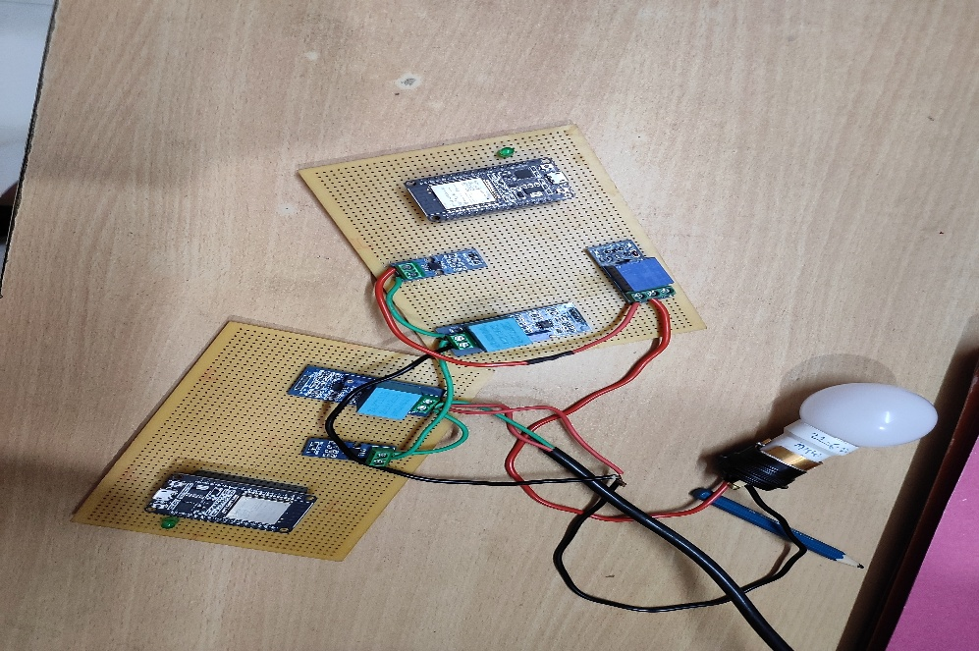

## Working of the System

## Smart Metering Functionality

## The current sensors continuously monitor the power consumption of the connected load (e.g., the bulb).

## These readings are sent to the ESP32, which calculates real-time power consumption.

## Data is displayed or transmitted (e.g., via Wi-Fi to a cloud/database/monitoring portal).

## Theft Detection Mechanism

## The system uses two ESP32 modules representing two points: the main meter and the sub-meter (user-level monitoring).

## If power consumption recorded at the sub-meter is more than what's recorded at the main meter (due to illegal tapping), the system flags it as a potential theft.

## An alert can be triggered through a buzzer, LED indicator, or sent wirelessly to a web interface.

## Relay Control

## The relays are used to simulate automated control based on usage patterns or in case of theft detection.

## For instance, in case of detected anomalies, the relay can disconnect the load to prevent misuse.

## Monitoring and Control via Code

## As seen on the laptop screen, the ESP32 is running a script (likely in Python or Arduino C++) for:

## Reading current values

## Comparing values for theft detection

## Controlling relays

## Sending data to a serial monitor or IoT platform

## 

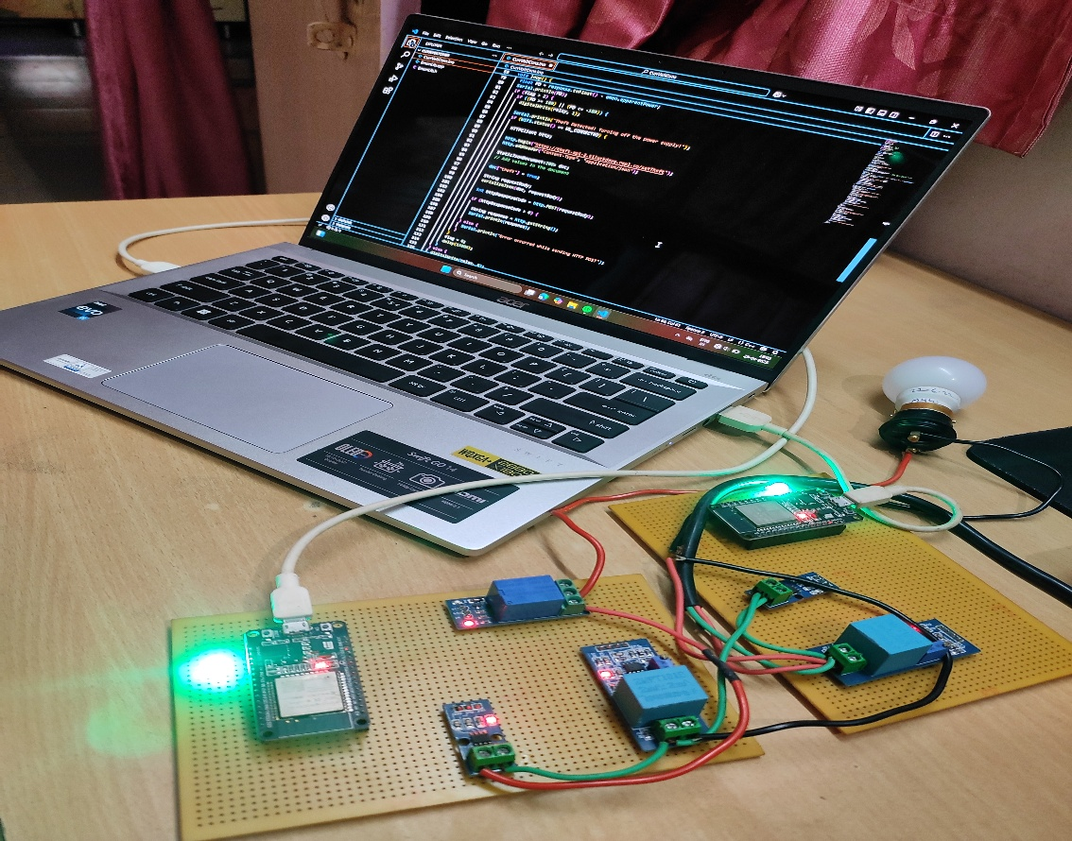

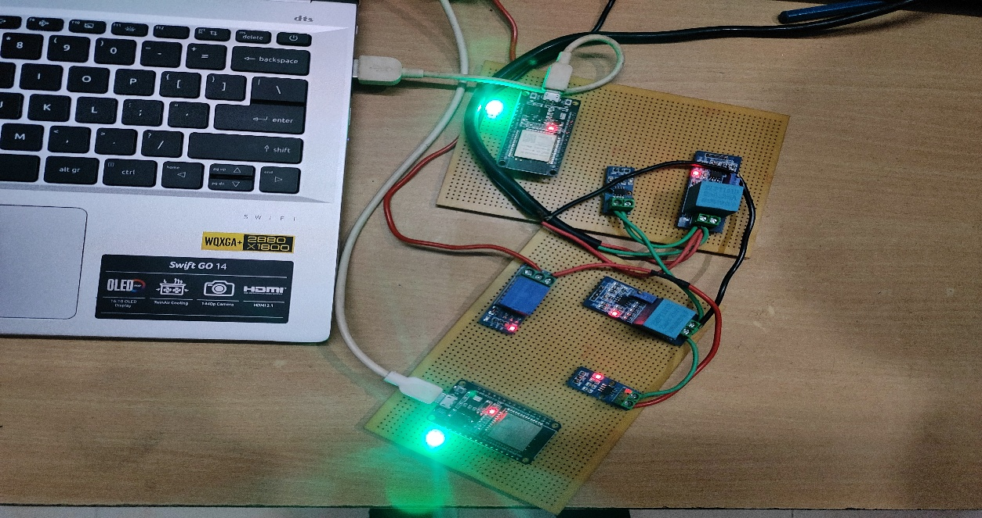

## 8.CONCLUSION

## The implementation of smart metering systems for electricity theft detection and power monitoring presents a significant advancement in ensuring efficient and reliable energy distribution. By integrating real-time monitoring, automated data analysis, and theft detection algorithms, this system not only helps in reducing power losses due to illegal consumption but also promotes transparency between energy providers and consumers.

## The proposed system enhances the ability of utility providers to detect anomalies, monitor power usage patterns, and respond quickly to irregularities. It also empowers consumers with accurate and timely information about their electricity usage, encouraging more responsible consumption habits.

## In conclusion, smart metering serves as a pivotal step toward modernizing the power infrastructure, improving operational efficiency, reducing revenue losses, and paving the way for a more sustainable and secure energy future.

## 9.REFERENCES

1. **Khan, M. A., & Khan, M. I. (2016).** Smart Metering: A Review of Current Developments. *Energy Procedia*, **105**, 217–222. <https://doi.org/10.1016/j.egypro.2016.03.072>
2. **Kumar, P., & Singh, K. (2018).** Impact of Smart Metering on Energy Management: A Review. *Renewable and Sustainable Energy Reviews*, **81**, 1145–1154. <https://doi.org/10.1016/j.rser.2017.08.007>
3. **Chong, T., & Muthusamy, K. (2017).** Real-time Energy Monitoring and Theft Detection System Using Smart Meters. *IEEE Transactions on Smart Grid*, **8**(6), 2830–2840. <https://doi.org/10.1109/TSG.2017.2658038>
4. **Khan, M. S., & Manzoor, A. (2019).** Intelligent Detection of Electricity Theft Using Smart Meters. *Journal of Electrical Engineering and Automation*, **1**(2), 73–80. <https://doi.org/10.31058/j.eea.2019.02004>
5. **González, J., & López, M. (2020).** A Machine Learning Approach to Detect Power Theft in Smart Grids. *Energy Reports*, **6**, 897–904. <https://doi.org/10.1016/j.egyr.2020.08.020>
6. **Sinha, A., & Sharma, R. (2021).** Smart Metering for Electricity Theft Detection: A Comprehensive Study. *International Journal of Energy Economics and Policy*, **11**(1), 111–120. <https://doi.org/10.32479/ijeep.10257>