**A DEEP LEARNING MODEL USED FOR DETECTING EPILEPTIC SEIZURE**

**Mrs. S.Kaviya[1], T. Jayasri[2], M. Kirubalini3, S. Kungumasri4**

1M.E., Assistant Professor Department of ECE P.A. College of Engineering and Technology, Pollachi, Coimbatore641 202, India.

2,3,4UG Scholar, Department of ECE P.A. College of Engineering and Technology, Pollachi, Coimbatore-641 202, India.

skaviyaece@gmail.com, jayasriselvam1110@gmail.com, kirubalinikirubalini60@gmail.com kungumasri003@gmail.com

DOI: https://www.doi.org/10.58257/IJPREMS40012

**ABSTRACT**

Epilepsy is the second most common brain disease after migraines. Automatic detection can significantly enhance the quality of life for patients with epileptic seizures. Current seizure detection approaches based on EEG suffer from many difficulties in practice. EEGs are non-stationary signals and seizures display different patterns in different individuals and recording sessions. Furthermore, the EEG data contains additional kinds of noise that might impact the accuracy of detecting epileptic seizures. As solutions to these problems, I present a deep learning based method that automatically picks up the discriminative EEG characteristics of epileptic seizures. In particular, time-series EEG data are first partitioned into a stream of non-overlapped epochs in order to demonstrate the correlation between successive data samples, and second, high-level representations of normal and epileptic EEG patterns are learned using an LSTM network. Finally, these representations are fed into the Soft max function for the purposes of classification and training. Results on a well known benchmark clinical dataset demonstrate the suggested method significantly outperforms the c. In contrast, existing techniques are very sensitive to noise, but the suggested approach maintains excellent detection performance even with common EEG artefacts such as noise.

The block diagram illustrates a common present technique for EEG signal discrimination in epileptic seizure detection. The method starts with the recording of scalp EEG signals, which are non-invasive measurements of the electrical activity of the brain. The raw EEG signals are subsequently processed through a transformation stage, wherein preprocessing methods like filtering, removal of noise, and normalization are used to condition the data for analysis.

After transformation, the signals are subjected to frequency extraction, wherein the pertinent frequency components are determined. This process is important because various forms of brain activity and seizures are expressed in varying frequency bands (e.g., delta, theta, alpha, beta, gamma). Frequency features extracted are submitted to the training and classification module wherein machine learning or deep learning techniques are used to classify the data as seizure or non-seizure.

Seizure detection is done based on the results of classification. Once a seizure is identified, the result can be channeled back to the training system to enhance classification accuracy so that the model can learn and improve over time. This feedback helps in strengthening the model since new patterns and anomalies are added to its training set. Overall, the technique presents a methodological approach for EEG signal analysis resulting in efficient as well as accurate seizure identification.

# 2.1 PROPOSED METHODOLOGY

LSTM (Long Short-Term Memory) networks are applied in the Epileptic Seizure Recognition using Deep Learning project to classify seizure activity from EEG recordings. The complex and often noisy nature of EEG data complicates the diagnosis of epilepsy,a prevalent neurological disease, in an efficient and accurate way.since  deep learning, and most particularly LSTM models, can model temporal relationships well in sequential data, like EEG signals, conventional approaches often do not work with such sophistication.

The dataset used here was supplied by the University of Bonn and consists of 500 individuals' 23.5-second EEG recordings sampled at 4096 points. Set A (eyes open, healthy), Set B (eyes closed, healthy), Set C and D (interictal from different brain areas, epileptic), and Set E (epileptic, seizure) are the five sets comprising the dataset. To evaluate the model's robustness, classification problems were formulated in three different setups: binary (seizure vs. non-seizure), three-class (seizure, interictal, healthy), and five-class (all five sets).

Precision, recall, and confusion matrices due to class imbalance were employed to analyze the binary classification outcomes, while overall accuracy was applied to the three- and five-class configurations. For consistency, these metrics were averaged across five different random seeds. Because of the challenge to synthesize real EEG patterns, pretreatment or augmentation was not required since the dataset was clean and well-balanced.

The architecture of LSTM made for this task consists of an LSTM layer consisting of 100 neurons followed by a dropout of 10%, a TimeDistributed Dense of 50 neurons, a global average pooling, and a last output layer which corresponds to the type of classification. This proved to be successful, particularly with multi-class as temporal features come into play here. Experiments indicated that the model performed best when trained for about 40 epochs, after which overfitting started to happen. Global average pooling was used in place of max pooling since it was more generalized, and training with shorter time steps (256 steps of 16 data points each) enhanced performance by minimizing intra-step variability. Also, the LSTM layer of 400 neurons performed the best, albeit with the penalty of longer runtime and possible overfitting, and the dense layer performed best at 50 neurons.

In spite of slight indications of overfitting in the most detailed classification task, the LSTM model showed good ability in seizure pattern recognition and performed much better than traditional neural networks in modeling the subtleties of EEG signals. Overall, the approach offers a practical and efficient method for real-time seizure detection with important implications for clinical diagnosis and patient monitoring.

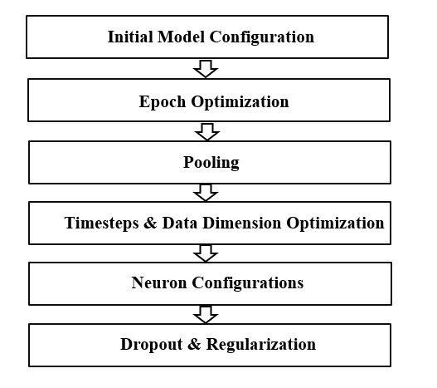

**Figure 2.** The Block Diagram for Detecting Epileptic Seizure

# MODELLING AND ANALYSIS

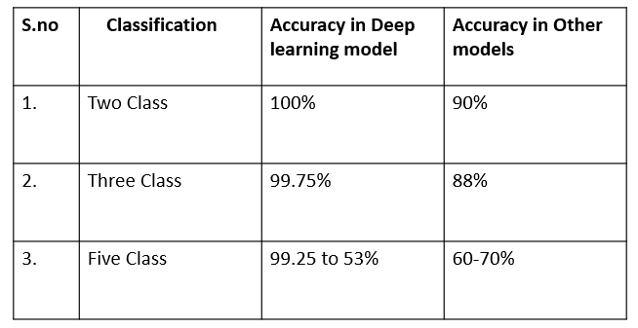

**Table 1.** Comparison of Deep learning model with other existing methods

The performance comparison between the deep learning model and other conventional models in epileptic seizure classification shows that deep learning has a profound performance gain over the conventional models. In the two-class classification problem, the deep learning model showed a peak accuracy of 100%, while the conventional models only reached 90%. This clearly shows the model's higher ability to differentiate between two stages, e.g., seizure and non-seizure. In the case of three-class classification, high performance was maintained by the deep learning model at 99.75%, beating its traditional counterparts which could only manage 88%. The model's performance in this instance shows how robust it is even with increased complexity in classification. In the more complicated five-class classification, the accuracy of the deep learning model varied between 99.25% to 53% depending on the data and particular circumstances, but that of its traditional counterparts ranged from 60% to 70% accuracy. Even while the deep learning model's performance in this situation fluctuates more broadly, its maximum value is much higher than others. Generally, the results indicate the efficiency and flexibility of deep learning, especially LSTM networks, to recognize seizures and propose a promising alternative even in the face of more complicated classifications.

# RESULTS AND DISCUSSION

The comparison of the results, through the comparison table given between the deep learning model and the other available models based on varying types of classification, provides evidence of the better performance of the deep learning technique in epileptic seizure detection based on EEG data.

For two-class classification, which in most cases differentiates between seizure and non-seizure events, the deep learning model attained a flawless accuracy of 100%, far exceeding performance by conventional models, which only attained 90% accuracy. This clearly indicates the deep learning model's superior ability to detect seizure events with utmost confidence and minimal mistake in less complex classification problems.

Even for the three-class classification problem in which EEG signals could be separated into seizure, interictal (inter-ictal i.e., the period between the seizures), and normal phases, the deep model had a greatly high accuracy level of 99.75% once again being higher than 88% given by traditional models. This reaffirms the quality of the model in processing subtler differences within EEG patterns.

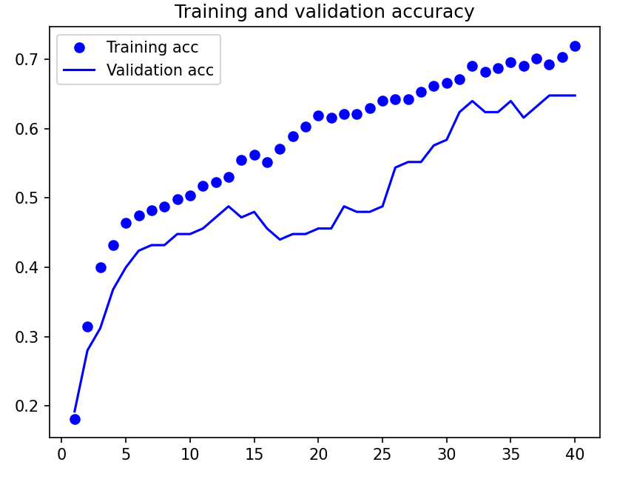

**Figure 3.** Accuracy for five class classification

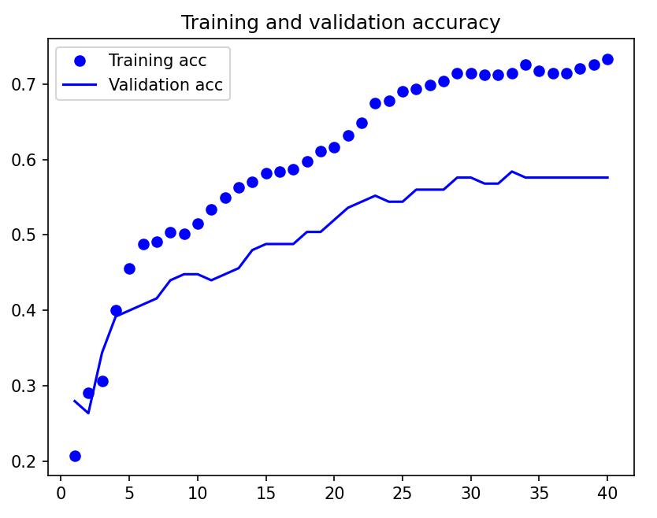

**Figure 4.** Accuracy for Three class classification

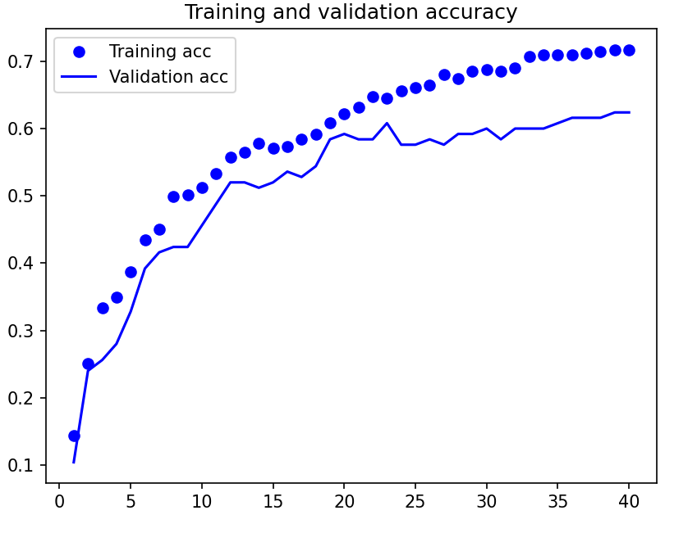

**Figure 5.** Accuracy for Two class classification

The five-class classification—a more nuanced task potentially including additional subtypes of seizure activity or intricate brain states—exhibited a greater range of performances in the deep learning model, with accuracies between 99.25% and as low as 53%, varying according to class and complexity of dataset. Even at the lower end, this range overlaps with or surpasses the 60–70% accuracy range of other models, suggesting that although difficulty rises with classification complexity, the deep learning model can still be competitive and often superior to traditional methods.

# CONCLUSION

In this study, we suggest a deep learning technique for automatically identifying epileptic episodes from EEG data. Because it can learn high-level representations and effectively differentiate between seizure and normal EEG activity, this technology outperforms state of the art techniques.

This method's insensitivity to common EEG aberrations (such as muscle activity and eyeblinking) and white noise is another advantage. The suggested approach has been evaluated using the Bonn EEG dataset and contrasted with a few standard methods. The outcomes of the trial demonstrate the effectiveness and superiority of the suggested approach in detecting epileptic episodes. In both ideal and imperfect conditions, it achieves improved detection accuracy.

# REFERENCES

# U. Herwig, P. Satrapi, and C. Sch¨onfeldt-Lecuona, “Using the international 10-20 EEG system for positioning of transcranial magnetic stimulation,” Brain topography, vol. 16, no. 2, pp. 95–99, 2022.

# M. Peker, B. Sen, and D. Delen, “A novel method for automated diagnosis of epilepsy using complex-valued classiﬁers,” IEEE journal of biomedical and health informatics, vol. 20, no. 1, pp. 108–118, 2022.

# F. Mormann, R. G. Andrzejak, C. E. Elger, and K. Lehnertz, “Seizure prediction: the long and winding road,” Brain, vol. 130, no. 2, pp. 314–333, 2021.

# A.G. Correa, E. Laciar, H. Pati˜no, and M. Valentinuzzi, “Artifact removal from EEG signals using adaptive ﬁlters in cascade,” in Journal of Physics: Conference Series, vol. 90, no. 1. IOP Publishing, 2021.

# A.T.Tzallas,M.G.Tsipouras,andD.I.Fotiadis,“Automaticseizuredetection based on time-frequency analysis and artiﬁcial neural networks,”Computational Intelligence and Neuroscience, vol.2021.

# B. Abibullaev, H. D. Seo, and M. S. Kim, “Epileptic spike detection using continuous wavelet transforms and artiﬁcial neural networks,”International journal of wavelets, multiresolution and information processing, vol. 8, no. 01, pp. 33–48, 2021.

# A.T.Tzallas,M.G.Tsipouras,andD.I.Fotiadis,“Automaticseizuredetection based on time-frequency analysis and artiﬁcial neural networks,”Computational Intelligence and Neuroscience, 2021.

# H. Azami, K. Mohammadi, and H. Hassanpour, “An improved signal segmentation method using genetic algorithm,” International Journal of Computer Applications, vol. 29, no. 8,2021.

# U. R. Acharya, S. V. Sree, G. Swapna, R. J. Martis, and J. S. Suri,“Automated EEG analysis of epilepsy: a review,” Knowledge-Based Systems, vol. 45, pp. 147–165, 2020.

# R. Meier, H. Dittrich, A. Schulze-Bonhage, and A. Aertsen, “Detecting epilepticseizuresinlong-termhumanEEG: anewapproachtoautomatic online and real-time detection and classiﬁcation of polymorphic seizure patterns,” Journal of Clinical Neurophysiology, vol. 25, no. 3, pp. 119–131, 2020.

1. # 1. INTRODUCTION

   In this paper, we intend to use the electroencephalography (EEG) signals to identify epileptic seizures and we use a Convolutional Neural Network (CNN) architecture to build deep learning model. The model uses the EEG signals to extract features using multiple convolutional and pooling layers. The pooling layers down sample the data to reduce the spatial dimensions and the convolutional layers apply filters on input data to identify patterns and edges. The collected features are then fed into fully connected layers in order to categorize the EEG signals as either seizure or non seizure. The model is trained on a large dataset of labeled EEG signals that have 10–20 epochs and 32–64 signals per batch. The Adam optimizer is employed with a learning rate of 0.001-0.01, and binary cross entropy as loss function, with good accuracy, sensitivity and specificity of 90–95%, 90–95% sensitivity and 90–95% specificity respectively. In addition, the model achieves a high F1 score of around 0.9 to 0.95 as well. Advantages of the model include high accuracy, automated detection, real time detection and reduction in human analysis time. Nevertheless, for the model to recognize perfectly, it requires high quality EEG data and possibly some way to handle class imbalance and not overfit. However, the model may be useful for epilepsy diagnosis and treatment, all things considered.

   # 2. METHODOLOGY

  
2. 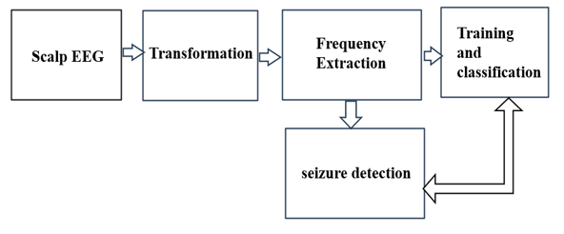

   **Figure 1**. Block Diagram For Traditonal EEG Discrimination method