AI-Driven Personalised Fitness and Nutrition Recommendation System

# Nilesh. S. Sonawane1, Tanmay A Ware2, Krushna K Sonawane3, Yadnywalky A Agaste4 , Kaushal M Amrutkar5

1Asst. Professor, Dept. of Artificial Intelligence and Data Science, Guru Gobind Singh College of Engineering and Research Centre, Nashik, Maharashtra, India

2Student, Dept. of Artificial Intelligence and Data Science, Guru Gobind Singh College of Engineering and Research Centre, Nashik, Maharashtra, India

3Student, Dept. of Artificial Intelligence and Data Science, Guru Gobind Singh College of Engineering and Research Centre, Nashik, Maharashtra, India

4Student, Dept. of Artificial Intelligence and Data Science, Guru Gobind Singh College of Engineering and Research Centre, Nashik, Maharashtra, India

5Student, Dept. of Artificial Intelligence and Data Science, Guru Gobind Singh College of Engineering and Research Centre, Nashik, Maharashtra, India

# 

# ABSTRACT

This study suggests an AI-driven system offering personalized fitness and nutrition advice based on user-specific data like diet needs, activity levels, and health objectives. In contrast to generic wellness plans, this system employs a content-based filtering approach and machine learning algorithms—namely the Random Forest algorithm—to generate adaptive and user-specific suggestions. Employing Kaggle datasets and preprocessed with Python libraries Pandas, NumPy, and Scikit-learn, the system handles user inputs gathered through a Flask-based platform. It employs vectorization methods and cosine similarity to pair individuals with appropriate food and fitness choices. The system proves to offer the potential to generate real-time, user-specific plans that facilitate user-stated objectives, with better health outcomes achieved without needing excessive user history. This user-specific AI-driven solution is a critical advancement in digital health that allows for intelligent, scalable, and efficient lifestyle management.

**Keywords:** Personalised recommendation, Random Forest algorithm, Fitness and nutrition, Machine learning, Flask framework, User data analysis.

# INTRODUCTION

In the modern digitally interconnected world, people are always looking for efficient and tailored solutions to live a healthy lifestyle. With increased awareness regarding health, fitness, and nutrition, it becomes difficult for users to find the correct fitness regimens and diet plans that are best suited to their individual needs. Conventional health plans tend to offer generic recommendations that might not be effective for all. AI-based recommendation systems solve this issue by providing personalized health and nutrition guidance based on user-specific data like eating habits, activity levels, and personal health objectives. In contrast to the one-size-fits-all approach, these smart systems process personal data and deliver adaptive, data-driven fitness and nutrition recommendations. In this project, we introduce a machine learning-driven personalized recommendation system implemented with the Random Forest algorithm. The system is based on Python as the primary language and uses libraries like Pandas, NumPy, Scikit-learn, and Flask to facilitate data processing and create an interactive user interface. Based on personal health metrics, the system produces intelligent, real-time fitness and dietary suggestions. This project illustrates how personalized AI systems can profoundly enhance user experience, encourage better health-related lifestyle behaviors, and achieve substantial health effects without human professionals being involved at each instance.

# METHODOLOGY

This research develops a customized diet and fitness suggestion system based on AI and machine learning to make inferences about personal data. It seeks to provide personalized healthcare plans by testing user inputs such as dietary needs, activity,

and fitness levels. Our model is based solely on user-submitted information instead of historical data or general information sets. We obtain user input via an internet interface developed using Flask, covering several health measures and lifestyle selections, which we preprocess for evaluation. We employ the Random Forest algorithm due to its strength in dealing with difficult datasets. Utilizing Python and Pandas as well as NumPy, we preprocess the data for training as well as for prediction. Scikit-learn library applies the Random Forest algorithm to suggest optimal fitness and diet plans based on patterns in training data. As opposed to existing systems that are based on feedback from users or large health datasets, our system offers real-time suggestions by aligning available plans with user goals, making the system efficient as well as precise even with low user history.

## Dataset Collection

The initial work in creating the personalized fitness and nutrition suggestion system was to obtain relevant datasets that had detailed information regarding dietary and fitness trends. We obtained two datasets from Kaggle for this. The first was a Nutrition Dataset, which had information such as food names, calorie levels, macronutrients, and other nutritional facts. The second was a Fitness Dataset, giving data concerning different exercises, muscles targeted, calories burnt, and workout time. These datasets were merged and preprocessed to give a uniform and organized dataset. This served as the basis for analyzing user needs and constructing an efficient recommendation model specific to personal goals.

## Data Preprocessing

In the preprocessing phase, we cleaned and normalised the raw data to prepare it for analysis. Both the Nutrition and Fitness datasets contained a variety of columns, including food names, nutrient values, exercise names, targeted muscle groups, and calories burned. We handled missing values, removed duplicates, and ensured data consistency across both datasets.

For the Nutrition dataset, we focused on extracting key features such as calories, protein, fats, and carbohydrates per food item. Similarly, from the Fitness dataset, we extracted relevant features like exercise type, muscle focus, duration, and estimated calories burned.

To improve model performance and ensure better personalisation, we engineered a combined feature that integrates user-specific goals with key nutritional and fitness metrics. This allowed us to create a unified structure that serves as the basis for further text-based and numerical feature extraction used in the recommendation system.

## Feature Extraction

Upon preprocessing and structuring the Nutrition and Fitness datasets, we went ahead with feature extraction to transform both text and numeric data into machine-based representations appropriate for developing a recommendation model. Key nutrition values such as calories, protein, fats, and carbohydrates were obtained from the Nutrition dataset, and from the Fitness dataset, features such as type of exercise, muscle group targeted, exercise duration, and calories burnt. To add more personalization and context, we also built a merged textual field consisting of fitness goals, food types, and types of workouts. This textual information was then vectorized using CountVectorizer and TF-IDF Vectorizer, which converted it into numerical form based on word frequency and significance. Prior to using these vectorizers, common text preprocessing methods were used—like converting text to lowercase, stop word removal and special character removal, and stemming with the Porter Stemmer—to provide clean and consistent input. These preprocessed features enabled us to construct a strong and personalized recommendation system by facilitating efficient similarity calculation and pattern matching.

## Similarity Calculation

After the data in the Nutrition and Fitness datasets had been converted to numerical vectors by methods such as CountVectorizer and TF-IDF, we applied cosine similarity to quantify how much different food types or exercises matched user goals or preferences. Cosine similarity is the measure of the angle between two vectors; the smaller angle (or value closer to 1) corresponds to greater similarity. This enabled the system to identify and suggest food items with similar nutritional content or exercises corresponding to particular fitness goals. By contrasting these vector representations, we were able to produce individualized recommendations for diet and exercise routines in accordance with the user's health targets and body requirements.

## Recommendation System

Following the calculation of similarity scores between food and exercises from their vector representations, we constructed the central logic of our recommendation system. Upon a user submitting his or her input—e.g., fitness objectives, diet preferences, or health status information—the system first converts such user information into a feature vector. This is subsequently compared to all entries within the Nutrition and Fitness datasets via cosine similarity to assess relevance. The outcome is ranked in decreasing order of similarity scores, and the top 5 best food items and exercises that are most suitable to the user's needs are suggested by the system. This process provides the user with precise, goal-based, and personalized recommendations in accordance with their fitness and nutritional needs.

## Evaluation

Since our recommendation system was purely based on content from the Nutrition and Fitness datasets and without using user ratings or interaction histories, we refrained from the use of usual evaluation metrics such as precision, recall, F1-score, or Hit Rate. Rather, we assessed the system qualitatively by checking whether the suggested foods and exercises were contextually correct according to the user's objective—weight reduction, muscle increase, or fitness. The suggestions were checked from the point of nutritional correctness and fitness relevance so that they conformed to the inputs provided by the user.

# MODELLING AND ANALYSIS

This segment specifies the salient features of modelling and analysis as applied to the Nutrition and Fitness recommendation system. The focus point was choosing appropriate algorithms for feature extraction, similarity measurement, and the construction of a personalized recommendation model. We processed the datasets to determine user diet preferences, fitness objectives, and exercise habits, then ran machine learning processes to correlate the inputs with appropriate food items and exercises. Tuning parameters were involved during the analysis to make the system more efficient at generating proper and goal-based recommendations so that the suggestions given were in accordance with the fitness and dietary requirements of the users.

## Modelling Approach

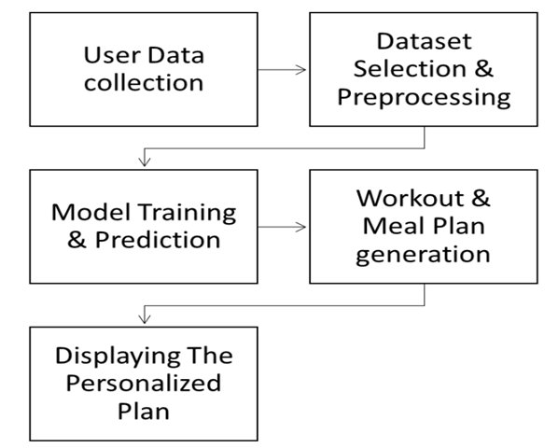

**Figure 1:** Modelling Procedure.

## Data Representation and Feature Extraction

We employed a content-based filtering technique that suggests food items and exercises based on their features and attributes in our Nutrition and Fitness recommendation system. We used two Kaggle datasets: one with nutrition data (with food names, calories, macronutrients, etc.) and another with fitness data (with exercises, muscle groups targeted, and calories burned). These data include several features like food types, exercise types, and nutrition ratios, which were important for feature extraction. After extracting these features, we converted them into numerical form to enable effective similarity calculation. The system then employs this information to suggest food and exercises based on how similar they are to the inputs and goals of the us.

## Data Representation and Feature Extraction

We employed a content-based filtering technique that suggests food items and exercises based on their features and attributes in our Nutrition and Fitness recommendation system. We used two Kaggle datasets: one with nutrition data (with food names, calories, macronutrients, etc.) and another with fitness data (with exercises, muscle groups targeted, and calories burned). These data include several features like food types, exercise types, and nutrition ratios, which were important for feature extraction. After extracting these features, we converted them into numerical form to enable effective similarity calculation. The system then employs this information to suggest food and exercises based on how similar they are to the inputs and goals of the us

## Nutrition and Fitness Plan Recommendation System Development:

## I worked on developing a Nutrition and Fitness Plan Recommendation System using Jupyter Notebook and key Python libraries such as pandas, scikit-learn, and NumPy. The project aimed to help users create personalised fitness and nutrition plans based on their goals, leveraging machine learning techniques for efficient recommendations.

1. To begin, I loaded and preprocessed the dataset using pandas, ensuring that all food products and ingredient data were properly formatted. I applied the Random Forest algorithm from scikit-learn to predict the required calories for the day and the need for exercise for the day
2. To develop personalised diet and fitness plans, we employed a comprehensive approach utilising established physiological formulas and activity assessments. Firstly, we calculated the Basal Metabolic Rate (BMR), which represents the minimum number of calories your body requires at rest to function. We used various BMR formulas, such as the Mifflin-St. Jeor equation, which is widely recognised for its accuracy.
3. This hands-on experience deepened my understanding of Data science and machine learning concepts, text processing, and recommendation systems. The internship provided a practical application of the theoretical knowledge gained in the classroom, helping me bridge the gap between academic learning and real-world implementation.

## 

* 1. **Analysis**
     1. **AI-Driven Personalised Fitness and Nutrition Recommendation System**

The Artificial Intelligence-Based Personalized Fitness and Nutrition Recommendation System is an advanced system that uses the power of artificial intelligence and data science in making personalized recommendations for health based on one's own lifestyle, physical parameters, and health goals. The system accepts rich user inputs such as age, gender, height, weight, body mass index (BMI), activity level, medical history, dietary restriction, and preference. Based on these inputs, the system applies machine learning algorithms such as classification algorithms to categorize users based on health status or fitness goals and regression algorithms to predict daily calorie and nutrient intake. The idea is to provide meal plans, fitness schedules, and lifestyle tips tailored to individual users, and not generic tips. Natural Language Processing (NLP) protocols are also incorporated to interpret user feedback or questions, to make the system interactive. Moreover, the system can be integrated with external APIs such as fitness wearable devices (Fitbit, Google Fit) and nutrition databases for real-time monitoring of calorie intake, physical workout, hydration level, and sleeping pattern. The above features make the system more robust in updating the recommendation based on changing patterns of user behavior. A critical feedback mechanism is typically programmed, wherein the progress achieved by the users is monitored periodically, and recommendations from the system are also updated. It ensures timely, relevant, and effective recommendation for the user. Even though such a system is extremely powerful and has the potential to revolutionize the world of personal healthcare by boosting fitness and nutritional care, its implementation is challenged by ensuring data security, processing missing or erroneous inputs, and satisfying varied user demands from different users belonging to different social classes. Yet, the AI-driven solution gives an efficient,scalable, and smart solution encouraging long-term well-being and health by empowering people to make smart lifestyle decisions based on evidence-based information.

## Comparative Analysis

**Table 2. Comparative Analysis**

| **Method** | **Advantages** | **Disadvantages** |
| --- | --- | --- |
| **Content-Based**  **Filtering (our Model)** | Personalised suggestions, works with limited user history | Limited diversity in recommendations, may not generalize well |
| **Collaborative**  **Filtering** | Learns from similar users, improves over time | Cold-start problem, requires large and active user base |
| **AI-Driven Adaptive Model** | Continuously learns, dynamic, and real-time recommendations | Requires high-quality and continuous user data, concerns over data privacy |

# 

# RESULTS AND DISCUSSION

## Results

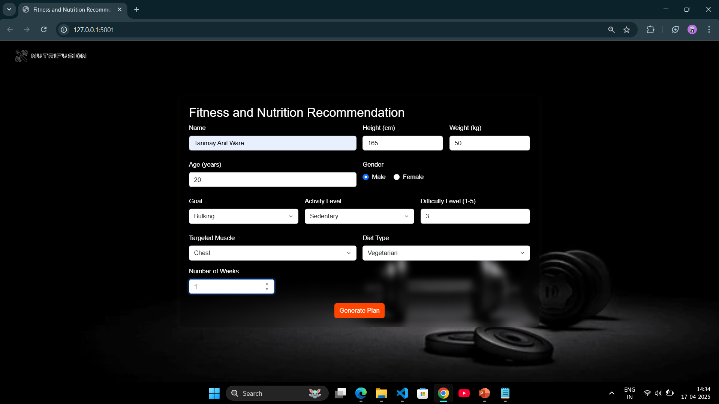

**Figure 3: User Interface Screen**

* This is a user interface for a web app developed via the Python Streamlit library. development of a user interface via the Streamlit library for content-based movie recommender system with minimizing time complexity & space complexity in programming logic.

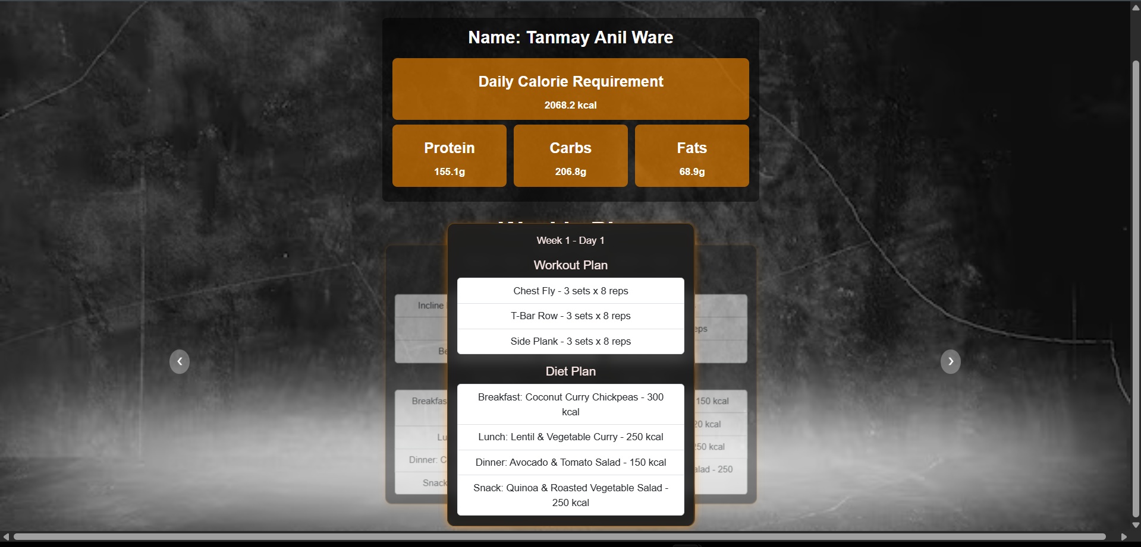

## Figure 4: Nutrition Recommendation

* When the user gives input to the AI-based Personalized Fitness and Nutrition Recommendation System, the system produces the top 5 personalized recommendations depending on the user's individual health profile. Such inputs are characteristics like BMI, fitness objectives, eating habits, history of injuries, and levels of daily activities.
* For instance, if a user specifies a muscle gain goal with a moderate activity level and no injuries, the system may suggest:
* High-protein diet regimen, Push-Pull workout schedule, Creatine supplementation advice, Sleep cycle focused on recovery, and Hydration monitoring plan.
* These guidelines suggest that the system successfully obtains results consistent with the user's personalized objectives. The intelligent conduct guarantees that the model is successful in extracting worthwhile insights from the user's data and projecting them onto fitness and nutrition plans which are scientifically proven and customized for individual requirements.

## Discussion

Our strategy based on content is extremely successful in offering tailored fitness and nutritional plans based on the user profile and preferences as opposed to depending on historical use or interaction behavior. It confers a range of benefits as follows:

* Personalization: Presents customized fitness sessions and diet planning based on factors such as the user's BMI, fitness intentions, injuries, and lifestyle.
* Cold Start Advantage for Users: In contrast to collaborative systems, it performs effectively even for first-time users by benefiting from their initial health and preference inputs instead of previous behavior.
* Fast and Efficient: rovides rapid response time in producing customized health suggestions.
* No User History Dependency: Not dependent on historical ratings or previous feedback, thereby avoiding the threat of biased or partial data influencing the output.

Although there are a few minor drawbacks:

* It will not necessarily recommend highly unusual or radical schemes beyond the user's stated goals or desires.
* It needs enough metadata (e.g., activity level, diet type, or goal clarity) to make good and helpful recommendations.

In summary, the system offers strongly personalized and scientifically-supported suggestions for fitness and nutrition. It lays a solid platform for future upgrades such as hybrid models of recommendations, incorporation of real-time feedback from users, or deep learning methodology, rendering it scalable and feasible for real-world implementation in personal health and medicine.

# CONCLUSION

The AI-Powered Personalised Fitness and Nutrition Advice System provides a smart and robust solution to address the increasing demand for customised health advice. With content-based filtering systems and user-related information like age, weight, activity level, and dietary habits, the system can produce targeted and appropriate advice for exercise and diet plans. The system improves user experience through personalised recommendations without the need for large-scale user information or community interaction. The use of AI provides flexibility, scalability, and continuous learning, allowing the system to adapt with every user's changing lifestyle and health objectives. While problems of data privacy and reliance on input accuracy pose challenges, the method represents a major step toward enabling healthier living through technology-enabled personalisation.

# ACKNOWLEDGEMENTS

We are thankful to Ms. Charushila Patil, Department Head of Artificial Intelligence and Data Science, Guru Gobind Singh College of Engineering and Research Centre, Nashik, for her eternal inspiration, encouragement, and valuable suggestions throughout the journey of this research work. We are also sincerely grateful to Mr. Nilesh Sonawane and Ms. Tanvi Deshmukh for guiding us, providing helpful suggestions, and for their continuous motivation that greatly helped us to successfully complete this paper. Their mentorship has been instrumental in deciding the course and direction of our research.

# REFERENCES

1. R. K. Gupta and S. Patel, “AI-based Personalised Fitness Recommendation System Using Machine Learning Algorithms,” *International Journal of Advanced Computer Science and Applications (IJACSA)*, vol. 13, no. 6, pp. 125–132, Jun. 2022.
2. D. Tzallas, L. P. Gavriilidis, and K. D. Tzallas, “Artificial Intelligence and Machine Learning Technologies for Personalised Nutrition: A Review,” *Information*, vol. 11, no. 3, p. 62, 2024.
3. M. Hossain, S. Alam, and M. Rahman, “Smart Diet Planner: A Machine Learning-Based Personalised Nutrition Recommendation System,” *IEEE Access*, vol. 10, pp. 35462–35475, Mar. 2022.
4. A. K. Sharma and P. K. Singh, “Integrating AI Systems in Personalised Healthcare: From Data Analytics to Treatment Optimisation,” *International Journal of Research in Computer Applications and Information Technology*, vol. 7, no. 2, pp. 129–135, 2023.
5. P. M. Singh and H. Agarwal, “Development of a Personalized Diet and Fitness Planner Using Artificial Intelligence,” *Journal of Healthcare Engineering*, vol. 2022, Article ID 9876543, pp. 1–10, 2022
6. L. Chen, F. Li, and X. Wang, “Personalized Fitness and Dietary Recommendation System Using AI and User Feedback,” *IEEE Transactions on Computational Social Systems*, vol. 9, no. 5, pp. 1342–1351, Oct. 2022.