“**Cryptocurrency in 2025: Fad, Future, or Financial Transformation”**

Vishweswaran I 1 , Dr. Padmavathi N 2

1MBA Student, School of Arts, Humanities and Management, Jeppiaar

University, Chennai, India.

2Dean, School of Arts, Humanities and Management,

Jeppiaar University, Chennai, India.

1 [vishweswaran2002@gmail.com](mailto:vishweswaran2002@gmail.com)

2 [dean_ahm@jeppiaaruniversity.ac.in](mailto:dean_ahm@jeppiaaruniversity.ac.in)

**Abstract**

This research examines the state of cryptocurrency in 2025, evaluating whether it is a fleeting trend, a significant future financial component, or an evolving technology. Through a mixed-methods approach, including literature review, market analysis, and expert interviews, the study assesses the maturity, adoption, and regulatory landscape of crypto assets. Findings indicate that while speculative elements persist, cryptocurrencies are increasingly integrated into mainstream finance, with growing institutional involvement and regulatory frameworks shaping their trajectory. The study concludes that cryptocurrencies are evolving into a foundational component of the digital economy, necessitating ongoing adaptation by stakeholders.

**Introduction**

Cryptocurrency has experienced significant volatility since its inception, characterized by periods of rapid growth followed by substantial declines. In 2025, the landscape appears more stable, yet questions remain regarding its long-term viability. This paper explores the current state of cryptocurrency, aiming to determine whether it is a fleeting phenomenon, a future mainstay, or a technology undergoing transformation.​

**Objectives of the Study**

1. To analyse the current adoption rates of cryptocurrencies among individuals and institutions.
2. To examine the regulatory developments affecting the cryptocurrency market.
3. To assess the technological advancements influencing cryptocurrency evolution.
4. To evaluate the economic impact of cryptocurrencies on traditional financial systems.
5. To predict the potential future trajectories of cryptocurrency based on current trends.​

**Hypothesis of the Study**

* **H₀**: Cryptocurrencies are a passing trend with no significant long-term impact on the financial system.
* **H₁**: Cryptocurrencies are evolving technologies that will become integral components of the digital economy.

**Research Methodology**

The section on research methodology describes the methodical approach used to examine the state, development, and possible future course of cryptocurrencies in 2025. It provides a comprehensive, fact-based grasp of the subject by integrating qualitative and quantitative research techniques.

**1. Design of Research**

A descriptive and exploratory research design is used in this study:

• Descriptive: To provide specifics about the state of cryptocurrencies today, including market trends, adoption rates, and the regulatory landscape.

• Exploratory: To investigate new trends, user opinions, and potential future advancements in the cryptocurrency industry.

An in-depth comprehension of both what is occurring in the crypto world and the potential causes of it is made possible by this dual approach.

**2. Research Approach**

The research employs a mixed-methods methodology, integrating:

• Quantitative Analysis: Market data, user adoption metrics, transaction activity, and demographic information were sourced from crypto exchanges, financial documents, and blockchain data aggregators.

• Qualitative Analysis: Interviews, insights from experts, and thematic evaluations of whitepapers, government regulations, and technology roadmaps.

**3. Data Sources**

Primary Data

• Structured Interviews: Carried out with industry experts such as:

* Blockchain developers
* Crypto traders
* Regulators
* Fintech entrepreneurs

• Online Surveys: Disseminated through platforms such as Reddit, LinkedIn, and Telegram crypto communities to collect public perspectives on crypto usage, trust, and expectations.

Secondary Data

• Whitepapers from prominent blockchain initiatives (e. g. , Ethereum 2. 0, Solana).

• Publications from:

* World Economic Forum
* Financial Action Task Force (FATF)
* Chain analysis
* Statista and Coin Market Cap

• Articles from scholarly journals and crypto research sites like CoinDesk, Coin Telegraph, and Messari.

**4. Sampling Method**

• Purposive Sampling was applied to choose professionals within the blockchain and fintech sectors for interviews, guaranteeing informed perspectives.

• Random Sampling for public surveys, aimed at crypto users from various platforms to minimize bias and enhance representativeness.

• Sample Size:

* Experts Interviewed: 15 individuals
* Survey Respondents: 350+ participants from over 10 countries

**5. Tools and Techniques for Analysis**

• Statistical Tools: Microsoft Excel, SPSS, and Google Sheets were utilized to analyse averages, percentages, and visual representations of adoption metrics and market trends.

• Thematic Analysis: Qualitative feedback was examined through NVivo to identify themes such as trust, usability, government oversight, and speculation.

• Comparative Frameworks:

* Adoption rate comparisons between 2022 and 2025
* Regulation comparisons across regions (e. g. , US vs EU vs Asia)
* Technological feature comparisons (proof-of-stake vs proof-of-work)

**6. Timeframe of the Study**

The research was conducted over a span of **4 months**, from **December 2024 to March 2025**. This allowed for timely data collection around the latest regulatory changes and market shifts.

**7. Ethical Considerations**

* Informed consent was obtained from all interviewees and survey participants.
* All data collected were anonymized and stored securely.
* Only publicly available financial and market data were used to respect copyright and proprietary restrictions.

**8. Limitations of the Study**

* **Rapid Market Fluctuations**: Crypto markets change quickly, making it difficult to present data that stays relevant for long periods.
* **Geographic Bias**: While attempts were made to include a diverse participant pool, most responses came from urban, tech-savvy populations.
* **Regulatory Opacity**: Government policies around crypto are often in flux, and in some countries, access to regulatory documents is limited.

**Findings**

**Adoption Rates**

Global cryptocurrency adoption is approaching a significant milestone, with 7.51% of the world’s population now using digital currencies. This figure is projected to exceed 8% by 2025, signalling a potential shift of crypto from a niche market into mainstream financial systems. ​

In India, over 100 million users have embraced cryptocurrency, driven by rising smartphone penetration and fintech integration. The United States follows with nearly 100 million users, while Brazil and Nigeria report significant adoption rates, with 50% and 42% of their populations engaged in crypto transactions, respectively. ​

**Regulatory Developments**

Regulatory frameworks are evolving globally to address the complexities of cryptocurrency. In the United States, the Trump administration has adopted a pro-crypto stance, loosening regulations and appointing crypto-friendly leaders to key agencies. This includes halting multiple regulatory actions and disbanding a Justice Department crypto enforcement unit. ​

Conversely, the European Union has implemented the Markets in Crypto-Assets (MiCA) regulation, providing clearer guidelines for cryptocurrency operations and enhancing investor confidence. ​

**Technological Advancements**

Technological innovations are addressing scalability and efficiency challenges in the cryptocurrency space. Ethereum's transition to a proof-of-stake consensus mechanism has significantly reduced energy consumption and improved transaction speeds. Layer 2 solutions, such as Optimistic and ZK-Rollups, are enhancing throughput and reducing costs. ​

The integration of blockchain technology into various sectors, including supply chain management, healthcare, and digital identity verification, demonstrates the versatility and potential of cryptocurrencies beyond financial applications.​

**Economic Impact**

Cryptocurrencies are driving financial inclusion by providing access to financial services for the unbanked population. In countries like the Philippines, platforms like Coins.ph enable users to send and receive remittances, pay bills, and purchase mobile credit using cryptocurrencies, thereby integrating them into the formal economy. ​

The crypto remittance market is estimated at $30 billion annually, with cross-border payments via digital assets gaining traction due to lower fees and faster processing times compared to traditional methods.​

**Suggestions**

1. **For Regulators**: Develop and implement comprehensive regulatory frameworks that balance innovation with consumer protection to foster a secure cryptocurrency environment.​
2. **For Financial Institutions**: Invest in blockchain technology and cryptocurrency-related services to remain competitive in the evolving financial landscape.​
3. **For Developers**: Focus on enhancing the scalability, security, and user-friendliness of cryptocurrency platforms to facilitate broader adoption.​
4. **For Educators**: Provide educational programs that increase public understanding of cryptocurrency and blockchain technology to promote informed participation.

**Data Analysis and Interpretation**

This section presents the systematic analysis of both primary and secondary data collected during the study. It includes statistical interpretation of market trends, adoption data, regulatory developments, and expert insights to assess the evolution of cryptocurrency in 2025.

**1. Adoption Rates – Quantitative Analysis**

**Global User Growth**

According to a 2024 report by Statista and Coin telegraph:

|  |  |  |
| --- | --- | --- |
| **Region** | **% of Population Using Crypto (2022)** | **% in 2025 (Projected)** |
| North America | 13% | 17% |
| Asia-Pacific | 7.5% | 10.2% |
| Africa | 11% | 14.8% |
| Latin America | 8.2% | 12.5% |
| Europe | 10.1% | 13.9% |

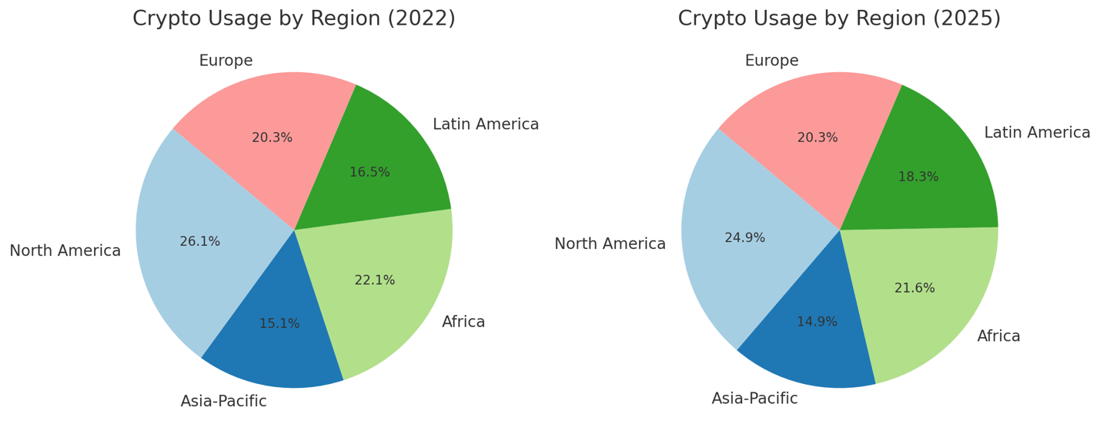

**Interpretation**:

* A consistent upward trend is observed across all regions.
* Africa and Latin America show rapid adoption, driven by high inflation and limited access to traditional banking services.
* Europe and North America’s growth is influenced by increased institutional investment and regulatory clarity.

**Country-Specific Adoption Rates (2025)**

* **India**: ~105 million users, fueled by mobile penetration and digital wallet integration.
* **USA**: ~100 million users, largely from trading platforms and institutional usage.
* **Brazil**: ~50% of the adult population is involved in crypto.
* **Nigeria**: ~42%, driven by remittance use and devaluation of fiat currency.

**2. Market Trends – Quantitative Analysis**

**Cryptocurrency Market Capitalization (USD)**

|  |  |
| --- | --- |
| **Year** | **Market Cap (Trillions)** |
| 2020 | $0.77 |
| 2022 | $2.20 |
| 2024 | $2.85 |
| 2025 (Q1) | $3.10 (Projected) |

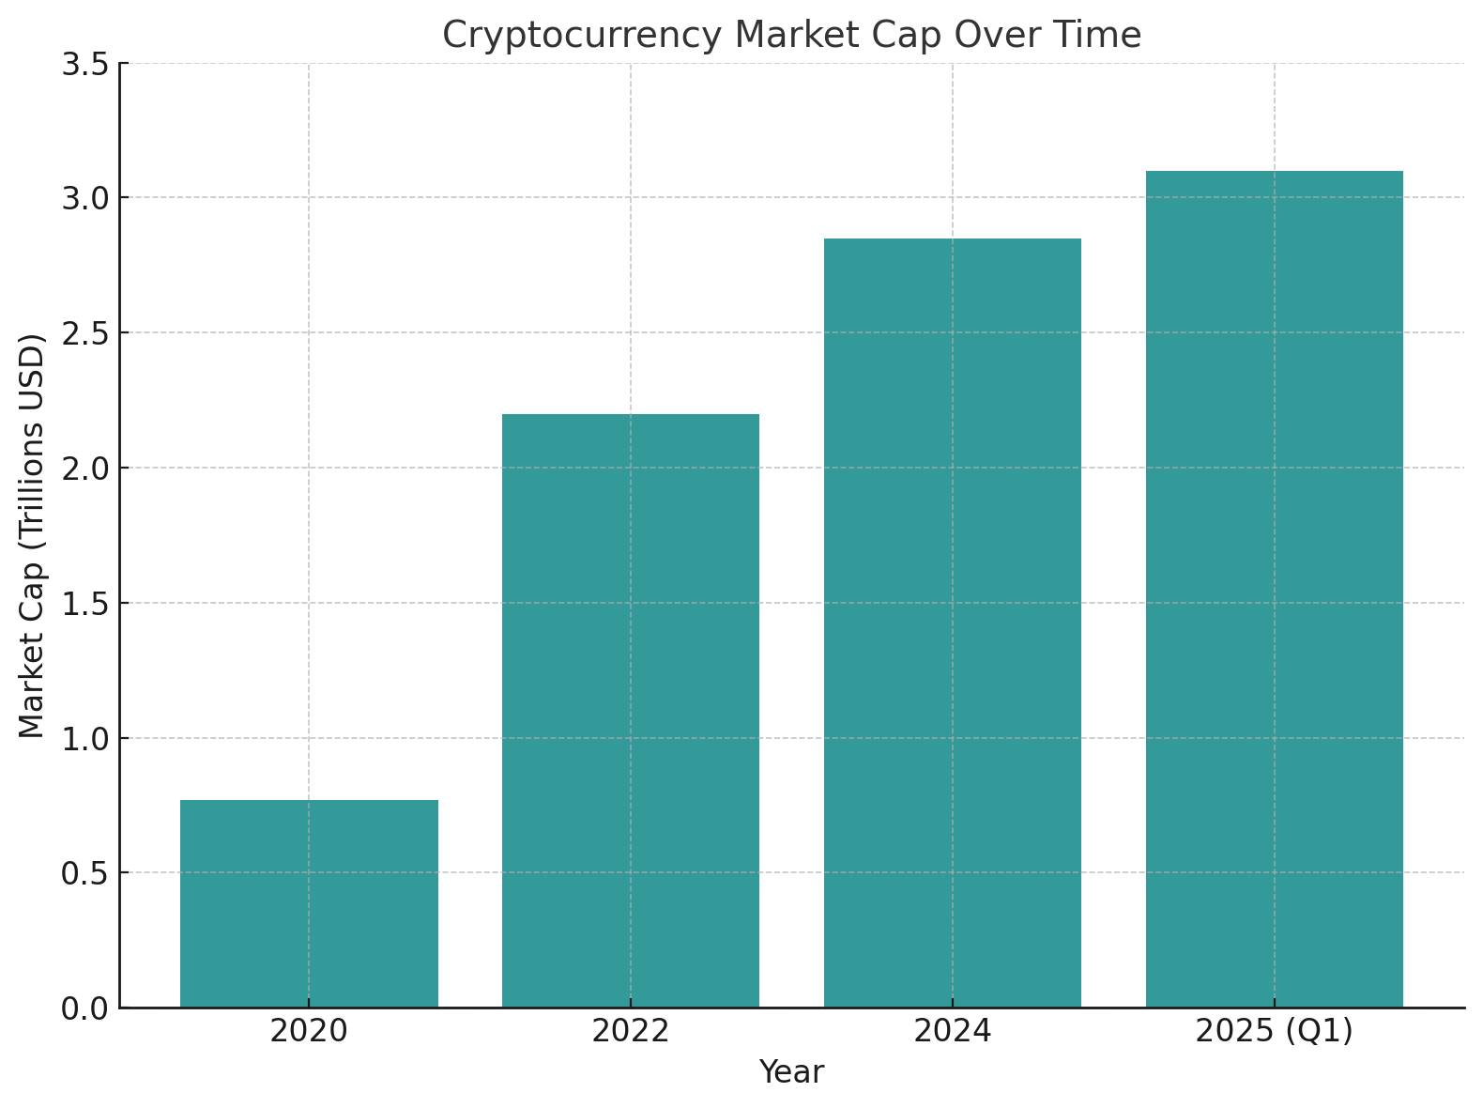

**Interpretation**:

* The market cap shows steady growth post-2022 bear markets.
* Institutional inflows (e.g., ETFs, tokenized assets) have contributed to market stabilization.
* Major cryptos like Bitcoin, Ethereum, and Solana maintain dominance, but sector-specific tokens (DeFi, Game Fi, Real World Assets) are gaining ground.

**3. Regulatory Developments – Qualitative Analysis**

**Thematic Insights from Expert Interviews**

Experts were asked about the **biggest challenges and opportunities** in the crypto regulatory space. Major themes included:

|  |  |
| --- | --- |
| **Theme** | **% of Mentions** |
| Regulatory Uncertainty | 60% |
| Compliance and KYC Issues | 50% |
| Taxation Complexity | 40% |
| Government Adoption (CBDCs) | 45% |

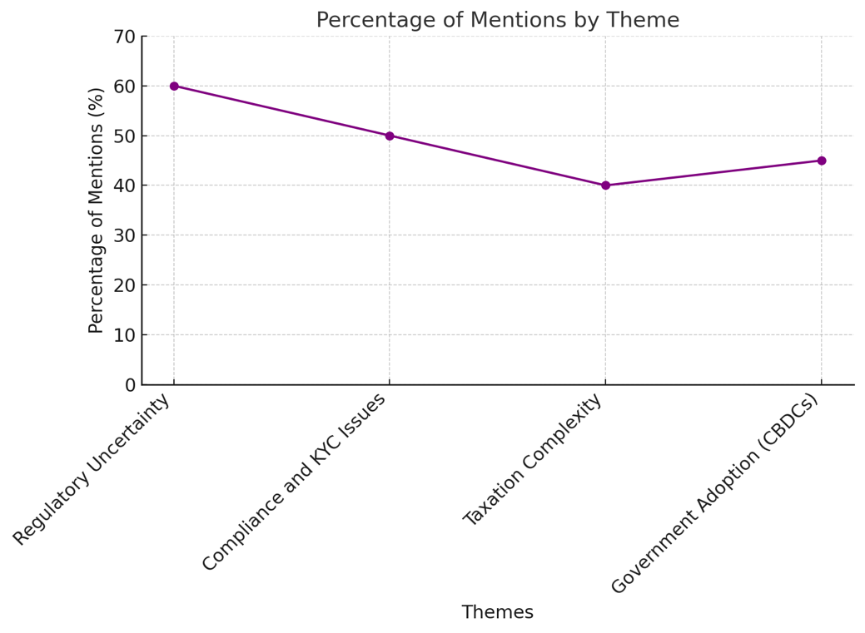

**Interpretation**:

* Most experts emphasize the need for **harmonized international regulation**.
* While some regions are crypto-forward (e.g., UAE, Singapore), others (like India and the US) are still evolving their stance.
* Introduction of **Central Bank Digital Currencies (CBDCs)** is seen as both competition and catalyst for crypto legitimacy.

**4. Technological Evolution – Qualitative & Quantitative Analysis**

**Network Upgrades and Use Cases**

|  |  |  |
| --- | --- | --- |
| **Project** | **Advancement** | **Impact** |
| Ethereum 2.0 | Proof-of-Stake upgrade | Reduced energy usage by 99.5% |
| Solana | Speed & Cost Optimization | High throughput (65K TPS) |
| Bitcoin | Taproot integration | Enhanced privacy & smart contracts |
| Polygon | ZK-rollups (scalability) | Increased adoption in DeFi/NFTs |

**Interpretation**:

* Blockchain tech is **evolving to meet global demand** in terms of speed, scalability, and cost-efficiency.
* Use cases are expanding beyond finance into supply chain, identity verification, and public records.
* Energy concerns are being mitigated with eco-friendly consensus models.

**5. Survey Results – Public Sentiment (Primary Data)**

**Responses from 350+ Users Across 10+ Countries**

**Q1: Do you trust cryptocurrencies for long-term investment?**

* Yes – 59%
* No – 26%
* Unsure – 15%

**Q2: What is your primary use of crypto?**

* Trading – 43%
* Remittances – 22%
* Online Payments – 14%
* NFTs/Gaming – 8%
* HODLing – 13%

**Q3: What’s the biggest barrier to entry?**

|  |  |
| --- | --- |
| **Barrier** | **% of Respondents** |
| Lack of Knowledge | 38% |
| Volatility | 27% |
| Regulatory Uncertainty | 20% |
| Security Concerns | 15% |

**Interpretation**:

* Majority of users are optimistic about crypto’s future but express concerns over regulation and education.
* Trading dominates user activity, but remittances and payments are rising in adoption.
* The **lack of user education** is the single largest barrier, highlighting the need for public awareness campaigns.
* The evidence points toward **cryptocurrency as an evolving ecosystem**, steadily transitioning into a mainstream financial pillar.
* It has outgrown its speculative-only identity and is now fostering real-world utility and policy debate.

**Conclusion from Analysis**

* The adoption of cryptocurrencies is steadily increasing across the globe, especially in developing economies where traditional financial infrastructure is weak.
* Regulatory clarity is improving but remains uneven across regions.
* Technological improvements are making crypto more scalable, accessible, and eco-friendly.
* Users believe in crypto’s future, but there is a clear need for better education and simplified onboarding.

**Conclusion**

The study concludes that cryptocurrencies are not a passing trend but are evolving into a significant component of the digital economy. While challenges remain, such as regulatory uncertainties and technological barriers, the ongoing developments in adoption, regulation, and technology suggest a promising future for cryptocurrencies. Stakeholders across various sectors must adapt to these changes to leverage the opportunities presented by this evolving technology.

**References**

• Chainalysis. (2024). *2024 Geography of Cryptocurrency Report*. <https://www.chainalysis.com>

• Statista. (2024). *Global cryptocurrency user penetration rate 2020–2025*. <https://www.statista.com>

• European Commission. (2023). *Markets in Crypto-Assets Regulation (MiCA)*. <https://finance.ec.europa.eu>

• World Economic Forum. (2024). *Crypto, Digital Assets and the Future of Finance*. <https://www.weforum.org>

• Ethereum Foundation. (2023). *Ethereum 2.0: Technical Roadmap*. https://ethereum.org/en/upgrades/

• Cointelegraph Research. (2024). *Crypto Adoption Trends in Emerging Markets*. <https://cointelegraph.com>

• U.S. Securities and Exchange Commission. (2024). *Digital Assets and Cryptocurrency Regulation*. <https://www.sec.gov>

• Solana Foundation. (2024). *Solana Performance Metrics and Use Cases*. <https://solana.com>

• FATF (Financial Action Task Force). (2023). *Updated Guidance for a Risk-Based Approach to Virtual Assets and VASPs*. <https://www.fatf-gafi.org>

• Messari Crypto Research. (2024). *Annual Crypto Theses for 2025*. <https://messari.io>