**Health Monitoring System - MediWatch AI**

**Vanshaj Gaur1, Rishita Maheshwari2,**

**Priyanshi3, Ms. Alka Rani4**

Poornima Institute of Engineering and Technology, Jaipur

[2021pietadvanshaj055@poornima.org](mailto:2021pietadvanshaj055@poornima.org) , [2021pietadrishita042@poornima.org](mailto:2021pietadrishita042@poornima.org) , [2021pietadpriyanshi063@poornima.org](mailto:2021pietadpriyanshi063@poornima.org) , [alka.rani@poornima.org](mailto:alka.rani@poornima.org)

*Abstract - With the rapid pace of life these days, real-time monitoring of health is essential to ensure preventive healthcare and prompt medical attention. MediWatch AI fills this requirement by offering a complete health monitoring system that continuously monitors vital signs including heart rate, oxygen saturation, body temperature, and movement. Targeted at critically ill patients or patients in geographically remote areas, MediWatch AI utilizes smart wearable technology in conjunction with artificial intelligence to recognize abnormalities, deliver real-time notification to caregivers, and save information for long-term health analysis. The system architecture, the functioning of machine learning algorithms in predictive health, and the significance of real-time analysis of data are examined in this paper. Moreover, it elaborates on practical applications, existing challenges, and potential possibilities in AI-enabled healthcare monitoring.*

*Keywords: Health Monitoring, Wearable Devices, Vital Signs, MediWatch AI, Smart Healthcare, IoT, AI in Healthcare, Anomaly Detection, Real-time Alerts, Predictive Analysis, Remote Patient Monitoring, Machine Learning, Deep Learning, Smart Bracelet.*

1. Introduction

We are in an era where health issues are burgeoning at lightning speed, and timely medical intervention can be a matter of life and death. As chronic disease rates rise, populations age, and health systems come under mounting strain, never has there been a greater need for constant, real-time monitoring of health. That's where smart systems like MediWatch AI enter the picture. MediWatch AI is a sophisticated health monitoring system that utilizes wearable tech and artificial intelligence to monitor vital signs and identify health anomalies. Monitoring health is not new—however, similar to many technologies, it has undergone a complete metamorphosis. What initially was basic manual observation has developed into smart, automatic systems able to make decisions in real time. Due to improvements in machine learning, IoT, and data analytics, health monitoring has never been more accurate, proactive, and accessible. This paper examines the fundamentals of real-time health monitoring, MediWatch AI architecture and components, the application of AI in the care of patients, existing limitations, practical applications, and the future outlook of AI-driven healthcare solutions

2. SYSTEM ARCHITECTURE AND COMPONENTS

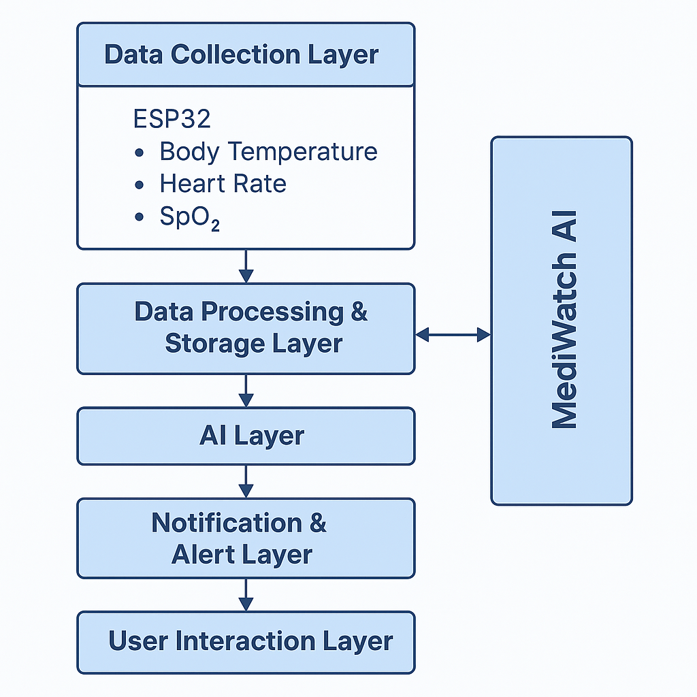

MediWatch AI follows a modular, layered architecture leveraging cloud computing to perform real-time processing and storage, AI/ML for cognitive diagnostics, a mobile-first frontend to provide accessibility for users, and embedded hardware for real-time acquisition of physiological data. The individual subsystems both function standalone and in interaction with each other through clearly defined APIs and channels for data transfer to ensure scalability, maintainability, and performance efficiency.

This chapter describes the hardware components, software stack, layered architecture, access control mechanisms, and the overall security model of the system.

*1. Hardware Components*

The IoT subsystem is tasked with the collection of real-time patient vitals. The hardware components are as follows:

* ESP32 Microcontroller: Bluetooth and Wi-Fi enabled; acts as the master controller for data collection from sensors and wireless transmission.
* MAX30102 Sensor: Uses photoplethysmography (PPG) to measure heart rate and blood oxygen saturation (SpO₂).
* DS18B20 Sensor: A digital one-wire sensor used to monitor body temperature with high accuracy.
* Power Supply: Battery-powered or USB-powered circuit enabling portability and uninterrupted monitoring.

*2. Software Technologies*

The MediWatch AI software stack includes contemporary, scalable technologies tuned for real-time healthcare use cases:

1. Frontend (Mobile):

* Tools: Firebase SDK, Expo, React Native
* Visualization: Real-time health trends using Victory Charts

1. Backend APIs:

* Frameworks: Django REST Framework, Python
* Authentication: JWT, Firebase Admin SDK

1. *Database & Storage:*

* Primary Storage: Firebase Firestore (NoSQL)
* Media Storage: Firebase Storage
* Authentication: Firebase Auth

1. *AI Inference Pipeline:*

* Tools: TensorFlow, ResNet-50, Flask API, Docker

1. *NLP Pipeline:*

* Libraries: spaCy, Hugging Face Transformers
* Chatbot: Gemini H1 API for conversational interface

1. *Cloud Services:*

* Realtime Processing: Firebase Realtime DB
* Notifications: Firebase Cloud Messaging (FCM), Render.com for backend hosting

*3. System Architecture*

3.1. Data Collection Layer

* ESP32 reads body temperature, heart rate, and SpO₂.
* Sensor data is pushed to Firebase every 5 seconds over Wi-Fi.

3.2. Data Processing & Storage Layer

* User-specific health data is stored securely in Firestore.
* X-ray scans and prescription images are stored by Firebase Storage.
* Django backend provides data access, authentication, and role validation through JWT.

3.3. AI Layer

* X-ray images are processed through a ResNet-50 model through a Flask API.
* Textual information (such as medical reports) is abstracted by a spaCy + BERT pipeline.
* Gemini H1 chatbot offers real-time AI support for patient inquiries.

3.4. Notification and Alert Layer

* Firebase Cloud Functions constantly track health metrics.
* Urgent alerts and updates are notified to users through FCM.

3.5. User Interaction Layer

* React Native app displays real-time information to users.
* Dashboards are dynamically rendered depending on user roles and permissions.

*4. Role-Based Access Model (RBAC)*

MediWatch AI provides data privacy and access control using RBAC. Every role has specific access rights:

1.Patient:

* Upload health records
* View personal vitals and AI summaries
* Receive health alerts

2. Doctor:

* Access assigned patient data
* Interpret AI-generated diagnostics
* Respond to real-time alerts

3. Admin:

* Monitor system logs
* Manage user roles and permissions
* Configure application settings

*5. Security Architecture*

To protect user data confidentiality and system integrity, MediWatch AI utilizes:

* JWT-based user authentication
* Firebase Security Rules for fine-grained read/write access
* Encrypted fields for storing sensitive patient data
* Automatic session expiration and refresh mechanisms
* Secure API headers to prevent unauthorized access

3. TECHNIQUES USED

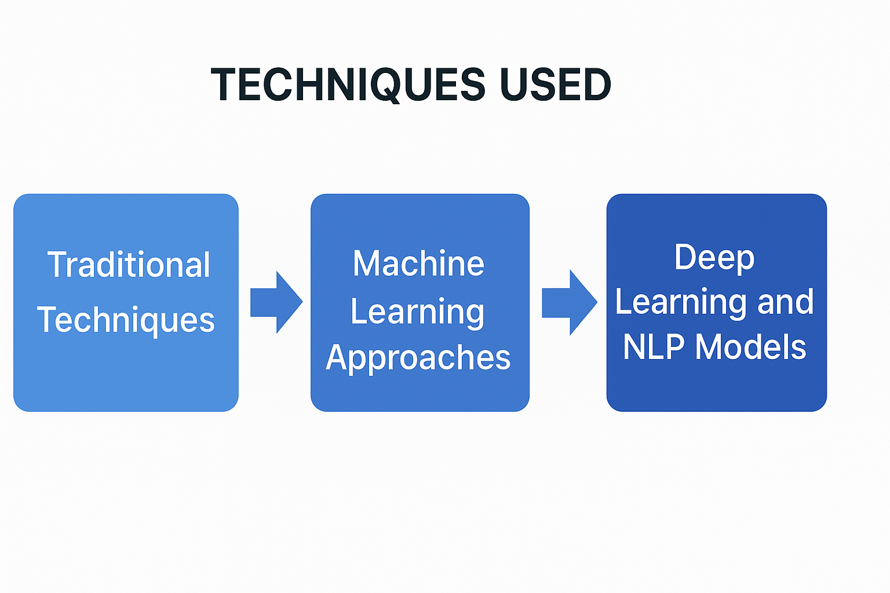

*3.1 Traditional Techniques*

MediWatch AI uses a mixture of conventional NLP techniques, machine learning approaches, and the latest deep learning methods to facilitate intelligent summarization and medical chatbot conversations. The progression in summarization strategies—from rule-based to transformer-based language models—has enabled the system to provide both extractive and abstractive information from intricate medical text and reports.

*3.2 Conventional Techniques*

Prior to AI integration, text summarization was largely based on rule-based and statistical methods. MediWatch AI assessed these methods during the initial prototyping stage:

3.2.1. *TF-IDF (Term Frequency-Inverse Document Frequency)*

* Determines important terms within a document through frequency and novelty.
* Applied for extracting sentences with high-scoring terms for elementary relevance-based summarization.

*3.2.2. Bayesian Models and Clustering*

* Used for clustering similar sentences and topics.
* Provides topic segmentation but is shallow in semantics, so less suitable for complex medical content.

*3.2.3. TextRank / LexRank*

* Graph ranking algorithms, adapted from PageRank.
* Sentences are ranked according to similarity graphs, choosing the most central sentences for extractive summarization.
* Good for brief patient descriptions and rapid diagnosis notes.

*3.3 Machine Learning Approaches*

* MediWatch AI experimented with supervised learning techniques using paired datasets (original reports and their summaries).
* Sentence position, term weight, and POS tag-based feature engineering.
* Classification models (e.g., SVMs, Naive Bayes) that are trained to determine if a sentence must be part of a summary.
* Although more flexible than rule-based systems, they needed much labeled training data.

*3.4 Deep Learning and NLP Models*

The current design of MediWatch AI uses state-of-the-art deep learning methods for abstractive summarization and chatbot replies.

*A. Recurrent Neural Networks (RNNs) & LSTMs*

* Initial experiments employed LSTMs for sequence-to-sequence learning.
* Assisted in the capture of temporal relationships in structured medical histories.

*B. Transformer-Based Models*

* BERT + spaCy Pipeline is utilized for contextual awareness and sentence-level feature learning.
* Hugging Face Transformers (BERT, T5, and BART) offer state-of-the-art abstractive summarization.
* These models produce coherent, patient-optimized summaries of complex medical reports for better readability and comprehension.

*C. Chatbot Integration*

* Gemini H1 API drives natural interaction between patients and physicians.
* The chatbot employs context embeddings from transformer models to give sensible answers to health-related questions.

4. APPLICATIONS

Text summarization and smart AI solutions such as MediWatch AI are transforming the way industries—particularly healthcare—process and respond to data. The following are some practical application examples that match your project objectives:

*4.1 Healthcare & Medical Industry (MediWatch AI Application)*

* Medical data summarization assists physicians in critically interpreting patient vitals, diagnoses, and history in a timely manner.
* Practical Tools: MediWatch AI summarizes patient vitals, X-rays, prescriptions, and physician-patient conversations through NLP and deep learning.
* Why it Matters: Facilitates quicker diagnosis, informed decision-making, and life-saving warnings, particularly in ICUs or remote monitoring.

*4.2 News and Public Health Reporting*

* Public agencies or health journalists can condense outbreak reports or policy updates.
* Platforms: Google Health News, WHO dashboards.
* Impact: Keeps health workers and the public informed about pandemics or health advisories effectively.

*4.3 Research & Clinical Trials*

* Condensing medical research and clinical trial reports for health professionals and researchers.
* AI Tools: Semantic Scholar, MediWatch AI (through NLP summarization).
* Impact: Saves time on literature reviews and assists in the identification of important insights from lengthy reports.

*4.4 Legal and Ethical Reports in Healthcare*

* Patient consent forms, medical regulations, and case law need to be summarized for clarity.
* Usage: Summarizing legal clauses, patient consent, and medical liabilities.
* Impact: Assists legal compliance, ethics, and patient understanding.

*4.5 Support Systems & Hospital Staff Communication*

* Hospitals create tons of logs, patient notes, and handover summaries.
* Use Cases: Condensing prior visit notes for return visits.
* Creating fast summaries of physician prescriptions or treatment schedules.
* Impact: Improves doctor coordination, less burnout, and better quality care.

*4.6 Public Sentiment & Feedback Monitoring*

* NLP can be used by hospitals or health tech platforms to condense patient feedback and web reviews.
* Tools: Lexalytics, MonkeyLearn, or custom MediWatch AI integrations.
* Impact: Identify patient satisfaction trends, automate quality control, and enhance services.

5. CHALLENGES

Whereas MediWatch AI introduces innovation in patient care through summarization, some challenges need to be overcome to make it reliable, safe, and ethically deployable:

*A. Lack of Coherence*

* Problem: Summaries generated by AI can be grammatically correct but logically incorrect, resulting in misinterpretation of patient data or diagnostics.
* Consequence: Inconsistent summaries can lead to clinical mistakes or inappropriate treatment decisions in high-stakes settings such as ICUs.

*B. Factual Inaccuracies ("Hallucinations")*

* Issue: AI generative can produce information that never existed in the source, referred to as "hallucinations."
* Risk in Healthcare: Falsely reporting a symptom or changing a medication name can be deadly.

*C. Bias and Ethics*

* Challenge: AI can miss or underrepresent minority populations when developed from biased medical information.
* Ethical Concern: This can lead to discriminatory patterns of diagnoses, underrepresented symptoms, or unequal access to insights on care.

*D. Evaluation Metrics*

* Problem: Standard evaluation measures such as ROUGE or BLEU score do not measure accuracy or clinical significance.
* Need: More domain-specific metrics and human-in-the-loop checks to confirm outputs in life-critical applications.

*Path Forward*

To transcend these, MediWatch AI needs:

* Improved clinical curation of data
* Incorporation of physicians' feedback loops
* Application of domain-specific benchmarks for real-world validation
* Robust regulatory compliance (HIPAA, etc.)

6. METHODOLOGY

MediWatch AI combines machine learning, computer vision, and natural language processing to provide an effective, real-time health monitoring and summarization platform for ICU patients. The system is scalable, modular, and always running—processing live clinical data, analyzing patient actions, and producing actionable recommendations.

*6.1 Data Acquisition*

* Sources: The system acquires real-time data through ICU cameras, wearable devices, and electronic health records.
* Input Types: Visual (facial expressions and movements), physiological (vital signs), and metadata (age, condition, medical history).
* Goal: To create a personalized health baseline for every patient to facilitate context-aware interpretation.

*6.2 Preprocessing and Feature Extraction*

Process: Medical videos/images are preprocessed with:

* Grayscale conversion
* Resizing
* Noise reduction
* Normalization
* Feature Extraction: Identifies essential health cues such as abnormal postures, labored breathing, or facial distress by using body keypoints and emotion recognition.

*6.3 Behaviour Classification and Interpretation*

Techniques: Leverages CNNs and pose estimation models to predict patient behaviors such as:

* Pain expression
* Restlessness
* Drowsiness
* Discomfort or distress
* Interpretation: Cross-references predicted behaviors against past health trends for real-time decision-making.

*6.4 Recommendation Engine*

Outputs: Outputs real-time recommendations such as:

* Alerting doctors/nurses
* Administering medications
* Modifying care routines
* Personalization: Merges live predictions of behavior with stored patient history for accurate care guidance.

*6.5 AI Interaction Layer*

* Interface: Utilizes LangChain to facilitate doctor-patient-nurse interaction through voice or text.
* Functionality: Translates queries, retrieves video-based inferences, and provides care recommendations with conversational ease.

*6.6 System Architecture*

Design: Utilizes a microservices-based architecture to compartmentalize:

* Vision analysis
* Recommendation logic
* User interface
* Advantages: Facilitates simple scaling, effortless maintenance, and effective real-time data processing through APIs.

7. CONCLUSION

MediWatch AI is a revolutionary system that integrates visual surveillance with intelligent recommendation systems and AI agents specially crafted for real-time ICU patient treatment. The system draws conclusions of behavior from real-time visual inputs and fuses them with tailored medical histories to provide correct and context-specific health suggestions—connecting patients, healthcare professionals, and automated assistance systems.

The use of large language model-driven agents facilitates natural and relevant interactions, streamlining sophisticated functions like patient surveillance, behavioral interpretation, and coordination of health services. MediWatch AI is architecturally scalable, opening the way to a completely autonomous smart critical care assistant.

Future developments will enhance performance with more sophisticated patient emotion recognition, gesture-based emergency notifications, and more extensive IoT integration (e.g., smart beds, biometric wearables). This work lays the groundwork for intelligent, responsive, and empathetic AI-powered healthcare ecosystems.

8. REFERENCES

1. *He, K., Zhang, X., Ren, S., & Sun, J. (2016). Deep Residual Learning for Image Recognition. In Proceedings of the IEEE Conference on Computer Vision and Pattern Recognition (CVPR), pp. 770–778.*
2. *Redmon, J., & Farhadi, A. (2018). YOLOv3: An Incremental Improvement. arXiv preprint arXiv:1804.02767.*
3. *Zhang, Y., Gong, Y., Zhang, Z., & Xiao, J. (2021). Vision-based Animal Behaviour Recognition: A Review. Computers and Electronics in Agriculture, 189, 106367*
4. *Burke, R. (2002). Hybrid Recommender Systems: Survey and Experiments. User Modelling and User-Adapted Interaction, 12(4), 331–370.*
5. *Ricci, F., Rokach, L., & Shapira, B. (2011). Introduction to Recommender Systems Handbook. Springer.*
6. *Vaswani, A., Shazeer, N., Parmar, N., Uszkoreit, J., Jones, L., Gomez, A. N., Kaiser, Ł., & Polosukhin, I. (2017). Attention is All You Need. In Advances in Neural Information Processing Systems (NeurIPS).*
7. *Lin, C.-Y. (2004). ROUGE: A Package for Automatic Evaluation of Summaries. In Text Summarization Branches Out: Proceedings of the ACL-04 Workshop.*