**CHATBOT APPLICATION USING MACHINE LEARNING**

G. Prathiba

*KV SubbaReddy Engineering College, Kurnool, A.P, India*

Bushra Thasin , C. Hindu, B. Kavyanjali, K. Nohita

*KV SubbaReddy Engineering College, Kurnool, A.P, India*

# 

***Abstract***: The advancement of artificial intelligence and machine learning has led to significant innovations in human-computer interaction, with chatbots emerging as one of the most impactful applications. This project focuses on developing a chatbot application using machine learning techniques to simulate intelligent human-like conversations. The system is designed to understand user queries, process natural language input, and provide relevant and context-aware responses. It incorporates Natural Language Processing (NLP) to interpret the user's intent and machine learning algorithms to improve its responses over time through continuous learning from interactions. The chatbot can be customized for various domains, including education, healthcare, customer service, and e-commerce. By automating repetitive tasks and providing instant support, the chatbot enhances user experience, reduces human workload, and demonstrates the practical utility of machine learning in real-world applications. The system is trained on diverse datasets to handle different types of queries and is evaluated for accuracy, efficiency, and user satisfaction.

**I. INTRODUCTION**

Chatbot Application using Machine Learning is simple web application which aims to provide the information regarding college. The information can be in the form of teachers or student’s GPA or the various activities in the college. It can be an upgraded form of our college’s webkiosk. After some improvements and some additions this project can be fully embedded into the working site of the college.

The chatbot created here is a web based application which used Natural Language Processing Libraries and Artificial Intelligence Markup Language to have conversations with humans. “Eliza” and “Cleverbot” are some of the web applications which have been created in the past. Like “Eliza”, the responses of this chatbot are programmed up to some extent. This is because of the fact that it is a simple bot which answers the queries regarding the college. Since the curriculum of the college keeps on changing, there has to be database which can be edited and upgraded from time to time.

So far, what I have achieved is a sample program which processes the response of the users by using simple parsing and substituting them into premade templates. It also uses hardcoded phrases so that the conversation is continued.

In the future, NLP can be implemented to understand what a user is saying and give the solutions to his problems. Natural Language Processing is a field of computer science sub- branch artificial intelligence which is concerned with interactions between computer and humans. Some the field inside NLP are Natural Language Understanding(NLU) and Natural Language Generation(NLG). College Enquiry ChatBot is a web application which uses artificial intelligence concepts to have conversations with humans. Some of the similar web applications built in the past are “Eliza”, “Cleverbot” etc. This report will revolve around the concept of NLP and AIML along with the work committed to build Eliza. Further, we will also see the various problems and complications that arise while developing these applications and how these can be managed to make them better.

The sample application is developed using Python Kernel and XML’s Artificial Intelligence Markup Language(AIML) along with a database file which stores the name, e-mail, and password to tell the GPA of a student. It is accessed using MYSQL. The front end of the project is designed using HTML, CSS and Javascript.

The inspiration to build this project came from the working our college’s webkiosk. It is possible that the chatbot can be connected to the college database using the webkiosk’s API but it included the implementation of JSON.

The construction of the project is similar to Eliza. Since it was first of its kind and an open source, it provided an idea of how these programs work. It worked on an algorithm based on substitution. Another creation named Cleverbot was much efficient than Eliza, but since it is not an open source and its algorithm is also very complex, it is not much of an importance here. However, if its algorithm is studied, it would create an application which would be very complex and help to broaden the scope of ChatBot.

## **II. LITERATURE SURVEY**

The development of chatbot systems has evolved significantly over the past few decades, beginning with rule- based approaches and advancing to machine learning and deep learning techniques. This section reviews the foundational work and the state-of-the-art technologies used in chatbot development.

#### **ELIZA (1966)**

One of the earliest chatbots, ELIZA, was developed by Joseph Weizenbaum at MIT. It used a pattern-matching and substitution methodology to simulate conversation, particularly mimicking a psychotherapist. Though it lacked true understanding, ELIZA laid the foundation for rule-based conversational systems.

#### **ALICE (1995)**

The Artificial Linguistic Internet Computer Entity (ALICE), created by Richard Wallace, utilized AIML (Artificial Intelligence Markup Language) to build conversation patterns. ALICE improved upon ELIZA by introducing more flexible templates, yet it remained limited by its reliance on static rules and lacked contextual awareness.

##### **Cleverbot (1997)**

Developed by Rollo Carpenter, Cleverbot marked a transition toward learning from real user interactions. It used a large dataset of previous conversations to provide more human-like responses. Unlike ALICE, Cleverbot improved over time as it accumulated user data, although it did not utilize deep learning techniques.

##### **Chatbots Using Machine Learning (Post-2010)**

With the rise of machine learning, chatbots have become more dynamic and capable of understanding complex queries. Techniques such as Natural Language Processing (NLP), Intent Classification, and Entity Recognitionare widely used to interpret user input. Algorithms like Naive Bayes, Support Vector Machines (SVM), and Decision Treeshave been applied for intent recognition.

##### **Deep Learning in Chatbots**

The introduction of Recurrent Neural Networks (RNNs) and Long Short-Term Memory (LSTM)networks enabled chatbots to maintain context across multiple turns of conversation. These models can generate responses based on sequence learning, greatly enhancing the user experience. More recently, transformer-based models like BERT, GPT, and T5have set new benchmarks for language understanding and generation.

##### **Current Technologies and Tools**

Modern chatbot development leverages frameworks such as:

* **Rasa** (open-source, ML-based)
* **Dialogflow** (by Google, supports NLP and ML)

##### Microsoft Bot Framework

* **OpenAI GPT Models** (e.g., ChatGPT) These platforms allow integration with messaging services, voice assistants, and websites.

**III.EXISTING SYSTEM**

In earlier days, students and their parents were required to **physically visit educational institutions** to obtain essential information such as course offerings, fee structures, admission procedures, and eligibility criteria. This traditional method of inquiry was often **cumbersome, time-consuming, and inconvenient**, especially for those residing far from the institution. The entire process demanded considerable **manual effort**, not only from the students but also from college administrative staff who were responsible for handling repetitive queries and providing detailed explanations.

With limited technological support, **manual record-keeping** and verbal communication were the primary modes of information dissemination. Collecting and distributing details such as admission requirements, course duration, subject modules, and fee structures involved **multiple steps and personnel**, increasing operational overheads. As a result, educational institutions had to allocate dedicated resources to manage these tasks, leading to increased workload and reduced efficiency.

Moreover, in the absence of digital platforms or intelligent systems, the range of queries that could be handled was **restricted to predefined FAQs.** These systems were incapable of interpreting or responding to personalized or complex questions. Users often found it frustrating when they couldn’t obtain specific answers, and there was **no mechanism to guide them further**. The lack of adaptability and automation in the system meant **that response times were slow,** often causing delays in decision-making for prospective students.

### **Disadvantages of Existing System**

* **Time-Consuming Process**: Students and parents are required to visit the campus physically to obtain information, which consumes valuable time and effort.
* **Delayed Responses**: Due to manual handling of inquiries, response times are often slow, resulting in frustration and longer waiting periods for prospective students.
* **Limited Query Handling**: Traditional systems can only respond to a **fixed set of predefined questions.** They are not designed to handle custom or detailed queries.
* **Lack of Intelligence and Personalization**: The system cannot understand specific problems or contexts and **cannot perform tasks tailored to the user's individual needs**, limiting its usefulness and efficiency.

**IV. PROPOSED SYSTEM**

The primary objective of the proposed application is to develop a **chatbot-based enquiry system** that enables students to communicate directly with educational institutions in a smart and efficient manner. By incorporating **Artificial Intelligence (AI)** and **Natural Language Processing (NLP)** techniques, the chatbot is designed to understand and respond to user queries in a human-like fashion. The system comprises two main components: the **interface layer**, which handles user interaction, and the **core processing unit**, which utilizes NLP for parsing, tokenizing, stemming, and filtering the input to derive accurate responses.

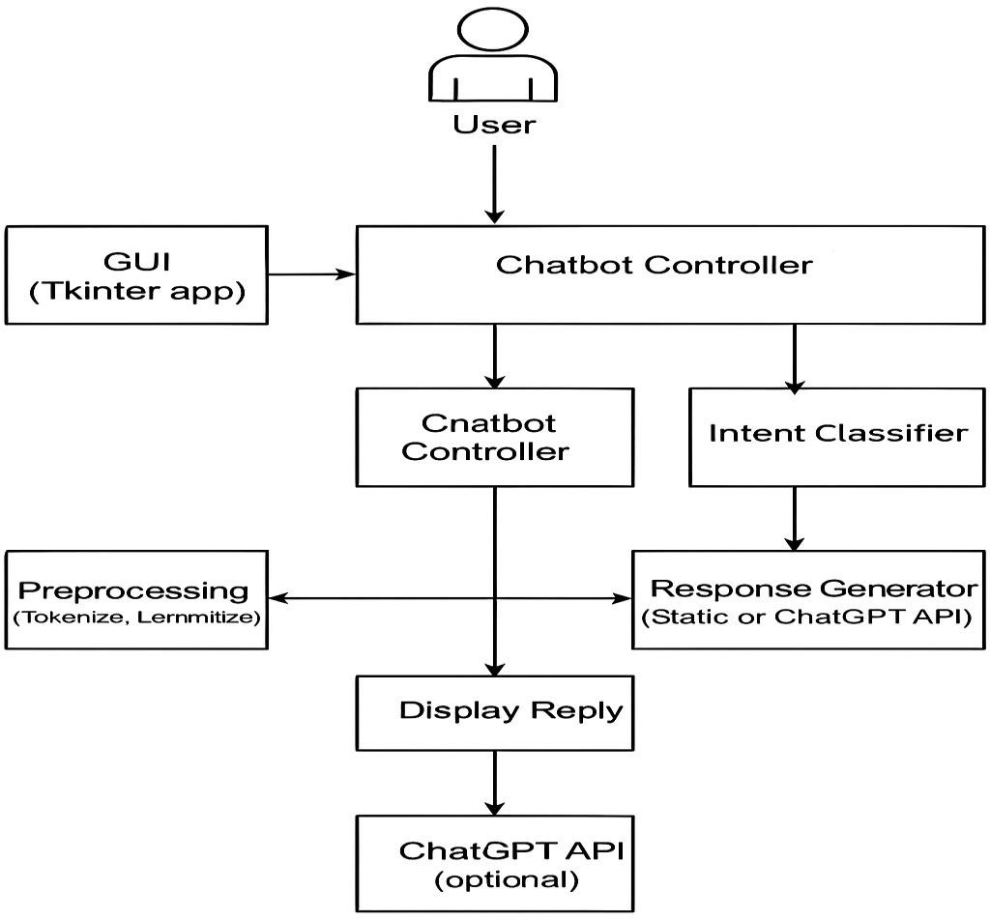Python is selected as the development language due to its wide adoption, ease of use, and robust support for AI and NLP libraries. The system leverages **Artificial Neural Networks (ANNs)** for enhancing the intelligence of the chatbot, allowing it to learn from interactions and improve over time. The backend is integrated with a database using Python, enabling the system to retrieve and store information dynamically and efficiently.

### **Advantages of Proposed System**

* **Faster Processing**: The chatbot significantly reduces the time required to process queries compared to manual or traditional systems. With automated AI-based responses, users receive information almost instantly.
* **Reduced Response Time**: Unlike the existing system, which relies on human intervention, the chatbot responds within seconds, enhancing user experience and satisfaction.
* **Intelligent Query Handling**: Instead of offering fixed or predefined options, the chatbot interprets and answers free-form queries using natural language processing. This makes the interaction more flexible and user-friendly.
* **24/7 Availability**: One of the most important advantages is the chatbot's round-the-clock availability. Students can make inquiries at any time, without being restricted to office hours or staff availability.
* **Reduced Workload on Staff**: The automated system handles repetitive queries, reducing the burden on administrative staff and allowing them to focus on more critical tasks.
* **Scalability**: The system can handle multiple users simultaneously, making it suitable for colleges with high enquiry volumes, especially during admission seasons.
* **Improved Accessibility**: Being a web-based chatbot, it can be accessed from any device with internet connectivity, allowing students from remote areas to get necessary information easily.

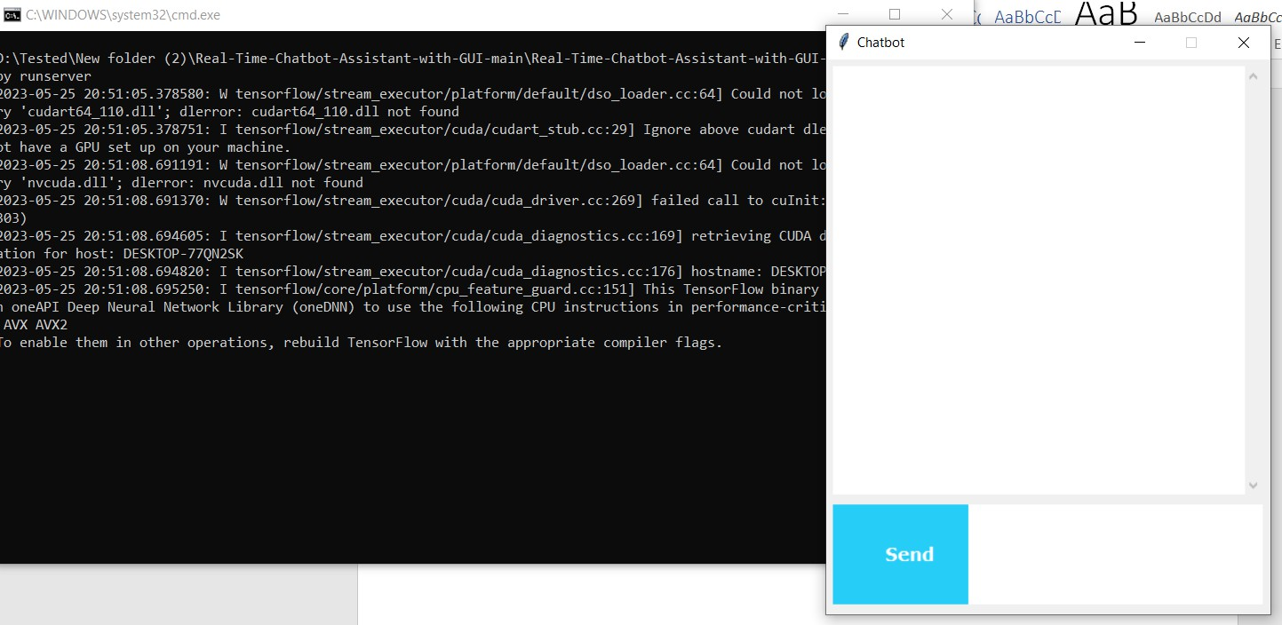**V. RESULTS**

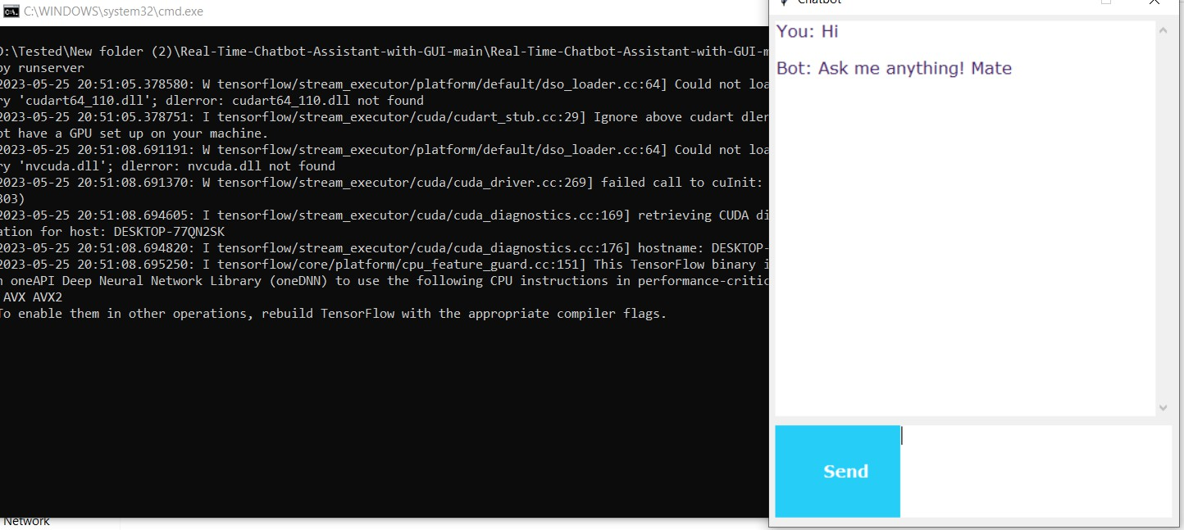

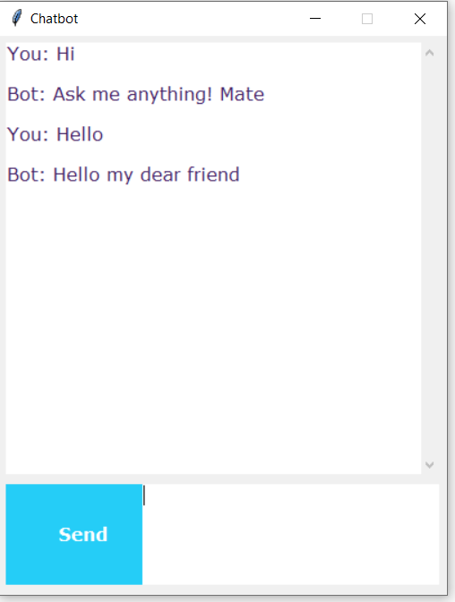

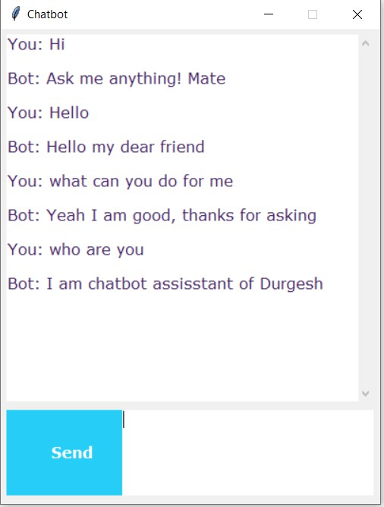**VI. CONCLUSION**

What we can conclude from the above situation and usage is that greater the database and more the models and use cases, the better is the reaction produced for the client. In any case, the issues are many. For adjusting more uses, the scope changes from the investigation of AI to language examine.

We additionally need to recollect that we are taking a shot at a cell phone. The NLP is very broad and maybe utilizing them on a server and isolating this application into customer and server side application can fathom the speed issue as when we do that the speed of the program won’t be restricted to the equipment.

We live in a time of intelligent technology. Our watches let us know the time, however they likewise remind us to work out. Our telephones prescribe the best places to eat, and our PCs foresee our inclinations, helping us to do our everyday work all the more productively.

**All things are considered, these advanced collaborators show just a modest bit of Artificial Intelligence (AI).**

**Future Enhancements:**

The 21st century has seen the advancement in technology and its impact on the people. In many ways, the technology innovation has helped to make the lives of the people easier.

It is widely known that information is carried out from one person to another. When someone does not know about something, he asks the other person. That way the information is carried on. Keeping this fact in mind when the computers came into existence, some of the scholars and scientists came up with the idea of making them answer the problems of the people. By creating this portal, the users could get their problems answered.

Google started with a simple web application which answered the queries of the people but that was something different from one on one talk. So it introduced the concept of Google Assistant through which every user could talk. Not only the user can talk but it is equipped with top notch features today.

You might have heard the statement “Something that works perfectly doesn’t mean it can’t be upgraded”. Keeping this thought in mind, this project can also be upgraded to a much higher extent according to the need.

* One of the major additions that can be done is the introduction of Voice API in the near future. The users will give the queries through their voice and the system will give text and voice output both.

**VIII. REFERENCES**

1.Weizenbaum, Joseph. "ELIZA - A Computer Program for the Study of Natural Language Communication between Man and Machine," Communications of the Association for Computing Machinery 9 (1966).

2.Suchman, Lucy A. Plans and Situated Actions: The problem of human-machine communication (Cambridge University Press, 1987).

3.Sagar Pawar, Omkar Rane, Ojas Wankhede and Pradnya Mehta. “A Web Based College Enquiry Chatbot with Results”, (IJIRSET, April 2018).

4.Pratike Salve, Vishruta Patil, Vyankatesh Gaikwad and Prof. Girish Wadhwa: “College Enquiry Chatbot”. (IJRTCC March 2017).

5.Tarun Lalwani, Shashank Bhalotia, Ashish Pal, Shreya Bisen, Prof. Vasundhra Rathod: “Implementation of a ChatBot system using AI and NLP”.