**HOSPITAL INFORMATION MANAGEMENT SYSTEM**

D. Vidya Sree

*KV SubbaReddy Engineering College, Kurnool, A.P, India*

Shaik Haseena, B. Lakshmi, A. Swetcha, K. Amulya

*KV SubbaReddy Engineering College, Kurnool, A.P, India*

# 

***Abstract***: India Meteorological Department has implemented state level medium range rainfall forecast system applying multi model ensemble technique, making use of model outputs of state-of-the-art global models from the five leading global NWP centers. The pre-assigned grid point weights on the basis of anomaly correlation coefficients (CC) between the observed values and forecast values are determined for each constituent model utilizing two season datasets and the multi model ensemble forecasts are generated at the same resolution on a real-time basis. The ensemble forecast fields are then used to prepare forecasts for each state, taking the average value of all grid points falling in a particular district. In this paper, we describe the development strategy of the technique and performance skill of the system during 15 years of rain fall at different states in india. The study demonstrates the potential of the system for predicting future rainfall forecasts for upcoming years and scale over Indian region. District wise performance of the ensemble rainfall forecast reveals that the technique, in general, is capable of providing reasonably good forecast skill over most states of the country, particularly over the states where the monsoon systems are more dominant.

**I. INTRODUCTION**

The project Hospital Management system includes registration of patients, storing their details into the system, and also computerized billing in the pharmacy, and labs. The software has the facility to give a unique id for every patient and stores the details of every patient and the staff automatically. It includes a search facility to know the current status of each room. User can search availability of a doctor and the details of a patient using the id.

The Hospital Management System can be entered using a username and password. It is accessible either by an administrator or receptionist. Only they can add data into the database. The data can be retrieved easily. The interface is very user-friendly. The data are well protected for personal use and makes the data processing very fast.

Hospital Management System is powerful, flexible, and easy to use and is designed and developed to deliver real conceivable benefits to hospitals.

Hospital Management System is designed for multi-specialty hospitals, to cover a wide range of hospital administration and management processes. It is an integrated end-to-end Hospital Management System that provides relevant information across the hospital to support effective decision making for patient care, hospital administration and critical financial accounting, in a seamless flow.

Hospital Management System is a software product suite designed to improve the quality and management of hospital management in the areas of clinical process analysis and activity-based costing. Hospital Management System enables you to develop your organization and improve its effectiveness and quality of work. Managing the key processes efficiently is critical to the success of the hospital helps you manage your processes

## **II. LITERATURE SURVEY**

The project Hospital Management system includes registration of patients, storing their details into the system, and also computerized billing in the pharmacy, and labs. The software has the facility to give a unique id for every patient and stores the details of every patient and the staff automatically. It includes a search facility to know the current status of each room. User can search availability of a doctor and the details of a patient using the id.

The Hospital Management System can be entered using a username and password. It is accessible either by an administrator or receptionist. Only they can add data into the database. The data can be retrieved easily. The interface is very user-friendly. The data are well protected for personal use and makes the data processing very fast.

Hospital Management System is powerful, flexible, and easy to use and is designed and developed to deliver real conceivable benefits to hospitals.

Hospital Management System is designed for multispecialty hospitals, to cover a wide range of hospital administration and management processes. It is an integrated end-to-end Hospital Management System that provides relevant information across the hospital to support effective decision making for patient care, hospital administration and critical financial accounting, in a seamless flow.

Hospital Management System is a software product suite designed to improve the quality and management of hospital management in the areas of clinical process analysis and activity-based costing. Hospital Management System enables you to develop your organization and improve its effectiveness and quality of work. Managing the key processes efficiently is critical to the success of the hospital helps you manage your processes

Intangible handling:

Bdtask HMS Software work as intangible handling for admins and owner. Because they can operate this medical software from anywhere and check anytime any data they wanted to see.

Ensure the best Medicare:

Medicare means proper medical care of a patient. In this HMS software user can provide the best service to the patient from admission to discharge without any kinds of difficulty.

Dynamic management:

Our Clinic Management software can accelerate all of your activities & reporting. It can manage all the important document in a certain place with a dynamic management system.

Centralized controlling:

Bdtask hospital management system operates all works under a chain of command. It starts from the admin and ends to the bottom. One operational place helps to maintain all very easily and smoothly.

Accumulative services:

Our HMS Software manages issues like medical, financial, administrative, and overall service and so on. Which covers the whole services a hospital offers generally.

Maximization of profit:

An organized management system software ascertain not only effective management but also minimize the operational cost and maximize profit. Grab the best HMS software to make the business profitable for the future.

Are you thinking! How Hospital Software add a extra value to your medical? Ok, Let's read the following information and our product features to take a wise decision about getting hospital automation system.

What is hospital Management System?

HMS software or Hospital management system is the digital outcome of traditional hospital or clinic management. Basically, the regular hospital activities like IPD, OPD, Billing, Test, Bed management, Account, HR management, etc. what a hospital do manually now all of them are managed very efficiently by the medical software. It also brings reports as per your requirements. Like you can see daily, weekly, monthly, half-yearly and yearly reports of sales, revenue, patients, lab test, bed management, etc very easily. Just a few clicks, all you need to see the reports. Another thing is that an admin can observe everyone through the software. And internal messaging platform helps employees to communicate with each other as well. All in all clinic management software helps you to be with trends and it also gives you the chance to run your business administration digitally and very efficiently.

How does a hospital management system take care of every operational aspect of a multi-sectoral hospital?

Automation, Security and Storage: There have many reasons, why a hospital needs an entire hospital automation system. Because this kind of system mainly aims at taking care of functional aspects of entire hospital so that Medicare Center can concentrate on enhanced patient care. It conjointly aims at providing reliable automation of the prevailing systems. The system also provides glorious security at each level of user-system interaction and conjointly provides strong & reliable storage and backup facilities.

Helps To Do All Alternative Vital Tasks: To be the desirable and best hospital is not mean a large area you might have & a huge amount of profit you might gain. But the nice administration and management skills of all the staffers, nurses and doctors to realize results, Managing and maintaining up-to-date information on patient care, medications and alternative technological methodology of providing service etc. are the basic components of measurement for quality score to be the best. And if you have got an automatic system that may pay attention to relieve you to try and do alternative vital tasks.

Remains Hospital Error Free: As a human being, Is it possible for medical officer & employee to be an erroneous staff? But every single mistake of misplacing of data creates a self-annihilation. Therefore, all medical professionals and hospital directors want to avoid errors. Having put in an automatic management software eliminates the possibility that is vulnerable to errors. It stores all the data regarding the hospital well guaranteeing that your hospital remains error free if you follow processes.

Track Every Single Information’s: Tracking every details is the foremost exciting but soothing step of a hospital management software. A Hospital Management system tracks the entire journey of each patient from appointment booking to medical emergencies. It virtually carries the burden of hospital employees to travel through multiple files to know patient’s records. It will reserve data including doctors, nurses and each hospital permanent and temporary workers those are working in your hospital according to locums you assigned on your hospital application and portal.

Ensure The Best Patient Care: Rather than storing and showing knowledge, associate intelligent hospital management software can share insights to optimize utilization of hospital workers, occupancy rates, clinical activities and every aspect associated with hospitals. It'll solve errors by its own and inform users of their important tasks. The goal is to develop a sophisticated hospital working circle which will manage a patient’s journey to the hospital and worker records while not generating a long-written account. When you have patient care as your saying, you would like to own the most effective management system that may pay attention to your hospital and follow your hospital’s processes.

Rescue From data Violation: Data violation is one of the most alarming and detrimental things for a business. Hospitals that record information manually usually misplace files and medical records of patients resulting unwanted confusions and heartburns. An HMS can manage all the access points via authentication for every user if he/she need to utilize the information. It'll additionally verify that user is able to access information on their shift timings guaranteeing that out-of-turn information access is prohibited. So, getting rescue from data violation this system will act as a gatekeeper.

Implements Dotty Care And Bed Issues: Accurate information that's accessible at a time is essential to make sure that clinical selections are implementing dotty care and bed issues when elaborate data. It'll facilitate Pharmacists to produce medicines that are prescribed by the doctor, And Nurses to be conscious about the time that patient must have medications. Moreover, each Doctor at clinic and Patient receive notifications once a check-up is due.

Ensure The Financial Growth: A hospital needs a endless stream of revenue and funding not to ensure solely sustainable growth however additionally improve their infrastructure and care processes. Developing an on-demand custom Hospital Management system not only save time and value but also generate reports to boost potency. The most important is that we get all necessary data are on the market with a mouse click. It'll facilitate scientific hospital management and respond to best financial growth.

**III.EXISTING SYSTEM**

In the current scenario, many healthcare institutions, particularly those operating in resource-constrained environments, continue to depend heavily on traditional **paper-based systems** or outdated and **fragmented software solutions** for managing day-to-day hospital operations. These legacy systems are not only inefficient but also lack the scalability and flexibility required to support modern healthcare needs. Most of these systems operate in isolation, without any meaningful integration between departments such as admissions, billing, laboratory, pharmacy, and medical records. As a result, data is stored in **silos**, making it difficult for healthcare professionals to access real-time, consolidated information about patients, resources, and workflows.

The absence of **automation** in crucial operational areas such as patient registration, appointment scheduling, discharge planning, and billing often leads to a high degree of **manual intervention**, increasing the risk of human error, delays, and data duplication. Additionally, these manual processes are time-consuming and labor-intensive, placing a significant burden on hospital staff and reducing overall productivity. The lack of standardized digital practices also makes it challenging to maintain comprehensive and accurate patient histories, which can adversely impact clinical decisions and patient outcomes.

From a security standpoint, traditional systems typically offer **minimal or no role-based access control**, and often rely on generic login credentials or manual record-keeping to manage access. This creates serious **data security and privacy vulnerabilities**, including unauthorized access to sensitive patient information, lack of accountability, and poor audit trails. In today’s data-sensitive healthcare environment, such gaps can lead to non-compliance with data protection regulations and a loss of patient trust.

Furthermore, the **limited accessibility** of records in such systems—often confined to physical files or local machines—hinders real-time collaboration among healthcare providers. Doctors, nurses, and administrative staff are unable to quickly retrieve or update information from remote locations or different departments, leading to communication breakdowns and fragmented care delivery.

Another major disadvantage is seen in the **inefficient billing systems** that are often prone to miscalculations and delays. Without automated tracking of services rendered, medications dispensed, or procedures performed, there is a greater chance of billing errors, which may either result in patient dissatisfaction due to overcharging or lead to **financial losses** for the institution due to underbilling or missed charges. These inefficiencies also make it difficult for hospital administrators to generate timely financial reports, track revenue streams, or plan budgets effectively.

### **Disadvantages of Existing System**

* **Lack of Integration**: The absence of a unified system leads to disconnected workflows between departments, creating inefficiencies and reducing the quality of care.
* **Manual Processes**: Patient management functions are performed manually, increasing the chances of errors, delays, and inconsistencies.
* **Security Risks**: Limited or no authentication and authorization mechanisms make systems vulnerable to breaches, risking the confidentiality of sensitive health data.
* **Limited Accessibility**: Data is often confined to physical files or standalone systems, which restricts timely access and collaborative decision-making.
* **Inefficient Billing**: The lack of automation in billing can cause inaccurate invoicing, delayed payments, and potential revenue losses.

**IV. PROPOSED SYSTEM**

The proposed system is designed as a **comprehensive, web-based hospital management application** aimed at overcoming the numerous limitations of traditional paper-based and fragmented digital systems. This solution offers a centralized platform that seamlessly integrates various hospital functions into a cohesive digital ecosystem. The primary objective is to streamline hospital workflows, eliminate redundant processes, and enhance both clinical and administrative efficiency. By utilizing modern web technologies, the proposed system ensures high availability, real-time accessibility, and scalability, which are critical in today’s fast-paced healthcare environment.

At the core of this system lies an **integrated approach**, where all modules—ranging from patient registration, appointment booking, outpatient and inpatient management, pharmacy, diagnostics, inventory, human resources, and billing—operate within a unified interface. This interconnectivity ensures that data flows smoothly across departments, reducing information gaps and supporting timely, data-driven decision-making. Additionally, the system incorporates **robust security protocols**, including multi-level authentication and role-based access control, to protect sensitive patient and operational data from unauthorized access or breaches.

Moreover, the proposed system emphasizes **automation** to replace manual and repetitive tasks. From automated appointment reminders to instant bill generation and discharge summaries, automation reduces staff workload, minimizes human error, and speeds up service delivery. The web-based deployment also allows for **remote access**, meaning healthcare professionals and administrators can manage operations or retrieve patient records from any location, enhancing collaboration and response time.

### **Advantages of the Proposed System**

* **Integrated Solution**: One of the major strengths of the proposed system is its fully integrated architecture. All hospital operations—such as patient admission, scheduling, clinical services, diagnostics, pharmacy, inventory management, billing, and administrative tasks—are managed through a single platform. This eliminates departmental silos and facilitates seamless communication and coordination between various units of the hospital.
* **Automation**: The system automates a wide range of routine tasks, including patient intake, appointment scheduling, medical record updates, and billing processes. This not only reduces the burden on hospital staff but also significantly lowers the possibility of human errors, resulting in improved accuracy and faster turnaround times.
* **Enhanced Security**: With increasing concerns about patient data confidentiality, the system incorporates strong authentication mechanisms and role-based access controls. Only authorized users can access specific modules and data based on their roles, ensuring that sensitive medical and personal information remains protected against unauthorized access or data breaches.
* **Improved Accessibility**: Being web-based, the application can be accessed from any device with internet connectivity. This greatly benefits doctors, nurses, and administrative staff by allowing them to retrieve and update patient information, view reports, and manage tasks remotely or on-the-go, fostering better communication and timely interventions.
* **Streamlined Billing**: The system supports automated billing by linking clinical services and prescriptions directly with the billing module. Invoices are generated based on predefined rules, service charges, and consumables used, thereby reducing discrepancies, speeding up the payment cycle, and enhancing financial accountability.
* **Real-Time Reporting and Analytics**: The system can generate a variety of real-time reports and dashboards related to patient flow, bed occupancy, revenue, and resource utilization. These insights support better planning, performance monitoring, and strategic decision-making.
* **Scalability and Customization**: The modular design of the system ensures that it can be easily scaled to accommodate new departments, facilities, or functionalities. It can also be customized to align with the unique operational workflows of different hospitals.
* **Compliance and Audit Trails**: All actions performed within the system are logged, ensuring traceability and accountability. This is particularly useful for regulatory compliance, audits, and internal quality control.

**V. RESULTS**

**Input Design:**

The input design is the link between the information system and the user. It comprises the developing specification and procedures for data preparation and those steps are necessary to put transaction data in to a usable form for processing can be achieved by inspecting the computer to read data from a written or printed document or it can occur by having people keying the data directly into the system. The design of input focuses on controlling the amount of input required, controlling the errors, avoiding delay, avoiding extra steps and keeping the process simple. The input is designed in such a way so that it provides security and ease of use with retaining the privacy. Input Design considered the following things:

* What data should be given as input?
* How the data should be arranged or coded?
* The dialog to guide the operating personnel in providing input.
* Methods for preparing input validations and steps to follow when error occur.

## **Output Design:**

A quality output is one, which meets the requirements of the end user and presents the information clearly. In any system results of processing are communicated to the users and to other system through outputs. In output design it is determined how the information is to be displaced for immediate need and also the hard copy output. It is the most important and direct source information to the user. Efficient and intelligent output design improves the system’s relationship to help user decision-making.

1. Designing computer output should proceed in an organized, well thought out manner; the right output must be developed while ensuring that each output element is designed so that people will find the system can use easily and effectively. When analysis design computer output, they should Identify the specific output that is needed to meet the requirements.

* + - 1. Select methods for presenting information.
      2. Create document, report, or other formats that contain information

produced by the system.

The output form of an information system should accomplish one or more of the following objectives.

* Convey information about past activities, current status or projections of the Future.
* Signal important events, opportunities, problems, or warnings.
* Trigger an action.
* Confirm an action. 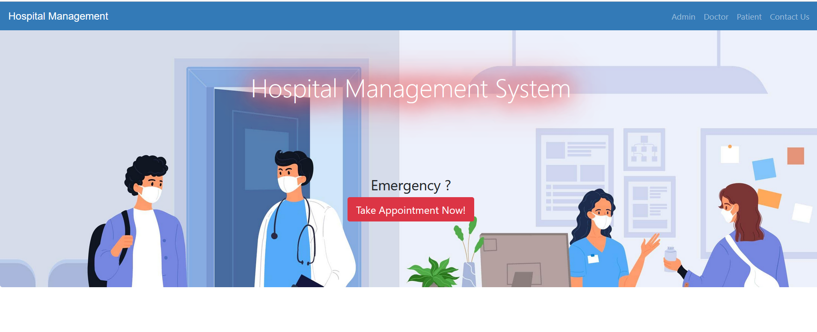

Fig : 1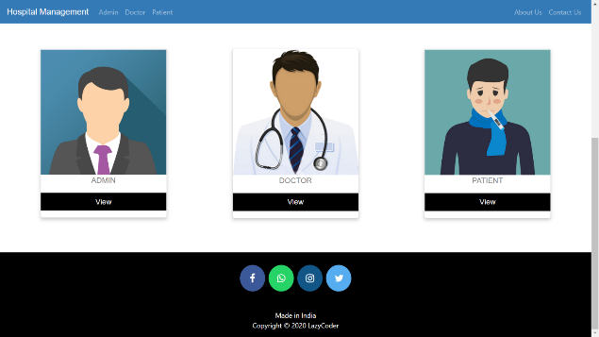

Fig:2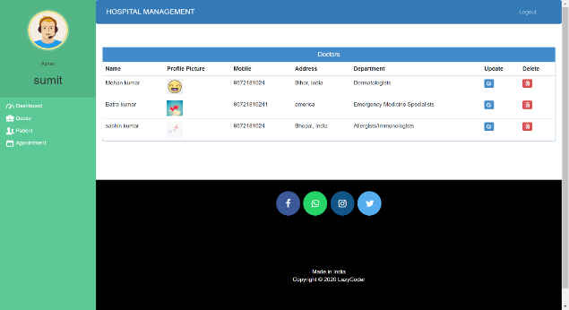

Fig:3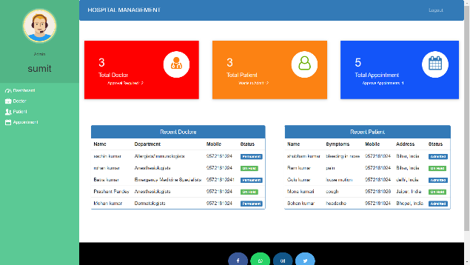

Fig :4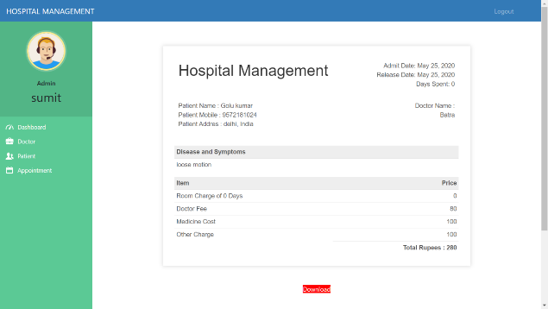

Fig:5

**VI. CONCLUSION**

From the results obtained, it is inferred that the SVM classifier along with the K-means clustering and BoV classifiers is best suited for gesture recognition. A user friendly application that can interpret Indian Sign Language has been developed using the most efficient SVM classifier (for gesture to text conversion) and Google Speech Recognition API (for speech to gesture conversion). Thus, a more reliable sign language interpretation system has been developed.

**8.1 Further Enhancement:**

Communication is a vital activity of human beings to live, as they can express their feel-ing, encourage cooperation and social bond, share their idea, and work together in soci-ety through communication only. People who are not able to hear or speak (hearing-impaired people) uses sign language as a mean of communication. Like spoken language, sign language also emerges and evolves naturally within hearing-impaired persons. It is a visual form of communication and in each country/region, where the hearing-impaired.

**VIII. REFERENCES**

1. Ramesh, R., & Prakash, K. (2016). "Hospital Management System: A Review." International Journal of Computer Applications, 140(7), 36-40.
2. Gupta, P., & Sharma, S. (2018). "A Study on Hospital Management Information System (HMIS) for Efficient Management of Hospital: A Case Study." International Journal of Engineering Technology Science and Research, 5(7), 53-58.
3. Al-Hakim, L. A., & Jin, J. (2019). "Development of a Hospital Management Information System (HMIS): A Review." In Proceedings of the 10th International Conference on Information Management and Engineering (pp. 199-203). ACM.
4. Aggarwal, R., & Singh, A. K. (2020). "A Review on Hospital Management Systems." International Journal of Computer Sciences and Engineering, 8(5), 178-184.
5. Tiwari, R., & Sinha, A. (2021). "Design and Implementation of Hospital Management System." International Journal of Engineering and Advanced Technology, 11(2), 93-98.