|  |  |  |  |
| --- | --- | --- | --- |
| **PRN** | **Name of Student** | **Academic year/ Semester** | **Class/Batch** |
| 23UF18067AI058 | Hrithik Tiwari | AY-2024-25/IV | SE / Batch- C |

|  |  |  |  |  |
| --- | --- | --- | --- | --- |
| **Experiment No. – 3** | | | | |
| **Date of Performance:** | **23/01/2025** | | | |
| **Date of Submission:** | **31/01/2025** | | | |
| Program Execution/  formation/  correction/  ethical practices  (06) | Timely  Submission  (01) | Viva  (03) | Experiment  Total (10) | Sign with Date |
|  |  |  |  |  |

**Experiment No. 3**

**3.1 Aim:** Exploring Files and directories

a. Python program to append data to existing file and then display the entire file

b. Python program to count number of lines, words and characters in a file.

c. Python program to display file available in current directory

**3.2 Course Outcome:** Understand basic concepts in python and explore contents of files, directories and text processing with python.

**3.3 Learning Objectives:** By the end of this experiment, students should be able to:

* To write Python programs that append data to an existing file and read its contents.
* To calculate the number of lines, words, and characters in a file.
* To list all files in the current directory programmatically.

**3.4 Requirement:** Python (Google Colab), Jupyter Notebook

### **3.5 Related Theory:** **File Handling in Python:** Python provides built-in functions to work with files, such as opening, reading, writing, and closing files.

### Modes: 'r' for reading, 'w' for writing, 'a' for appending, etc.

### Context managers (with statement) ensure proper resource management and automatically close files after operations.

### The read(), readline(), and readlines() methods allow reading file content in different ways.

### **OS Module:** The os module provides functions to interact with the operating system, including listing files and directories, checking file existence, and deleting files.

### Functions like os.listdir(), os.path.isfile(), and os.remove() are useful for directory and file manipulation.

### **String Manipulation:** Useful for processing text files and extracting meaningful information. Splitting, joining, and analyzing strings are commonly used when working with file content.

### **Error Handling in File Operations:** It is crucial to handle exceptions like FileNotFoundError and PermissionError when performing file operations to make the program robust.

### **Importance of File Operations:** File handling is essential in real-world applications, such as logging, configuration management, and data persistence.

**3.6 Coding & Results:**

**(a) Python program to append data to an existing file and display the entire file:**

**# Function to append data to a file**

**def append_data_to_file(file_name, data):**

**with open(file_name, 'a') as file:  # Open file in append mode**

**file.write(data + '\n')  # Append data with a newline**

**# Function to display the entire content of the file**

**def display_file_content(file_name):**

**with open(file_name, 'r') as file:  # Open file in read mode**

**content = file.read()  # Read the entire content**

**print(content)**

**# Main program**

**file_name = 'example.txt'  # Specify the file name**

**data_to_append = 'This is the new data being appended to the file.**

**Hrithik Tiwari**

**23UF18067AI058**

**# Append data and display the file content**

**append_data_to_file(file_name, data_to_a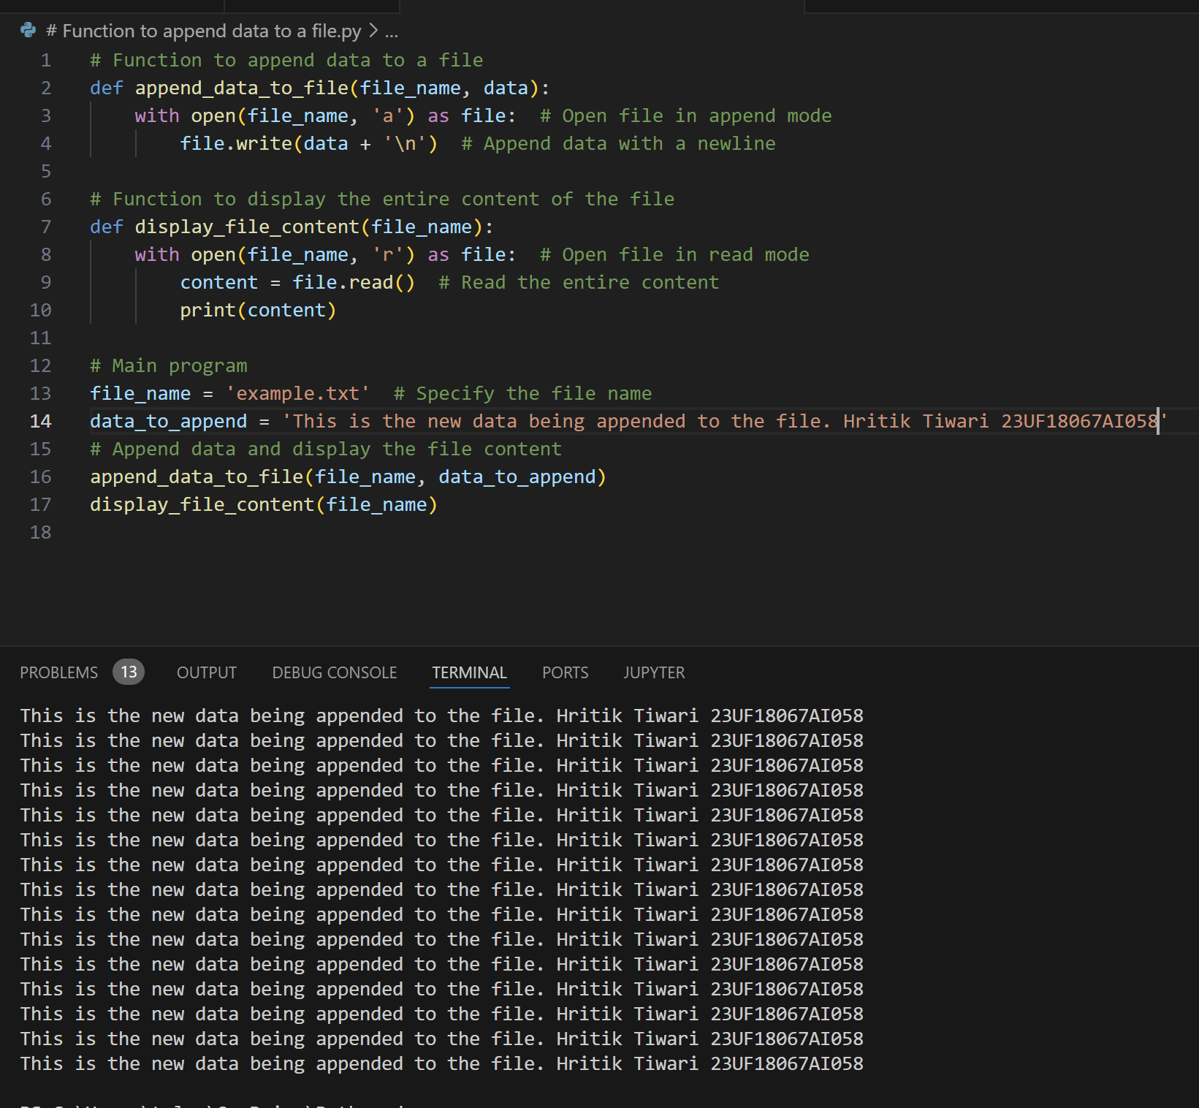ppend)**

**(b) Python program to count the number of lines, words, and characters in a file:**

**def count_file_details(file_name):**

**try:**

**with open(file_name, 'r') as file:**

**lines = file.readlines()  # Read all lines in the file**

**num_lines = len(lines)  # Number of lines**

**num_words = 0  # Word count**

**num_chars = 0**

**for line in lines:**

**words = line.split()  # Split line into words based on whitespace**

**num_words += len(words)  # Add number of words in the line**

**num_chars += len(line)  # Add number of characters in the line**

**return num_lines, num_words, num_chars**

**except FileNotFoundError:**

**print(f"The file {file_name} was not found.")**

**return 0, 0, 0**

**file_name = 'example.txt'  # Specify the file name**

**lines, words, chars = count_file_details(file_name)**

**print(f"Number of lines: {lines}")**

**print(f"Number of words: {words}")**

**print(f"Number of characters: {chars}")**

**print("Name:Hritik Tiwari")**

**print("PRN:23UF18067AI058")**

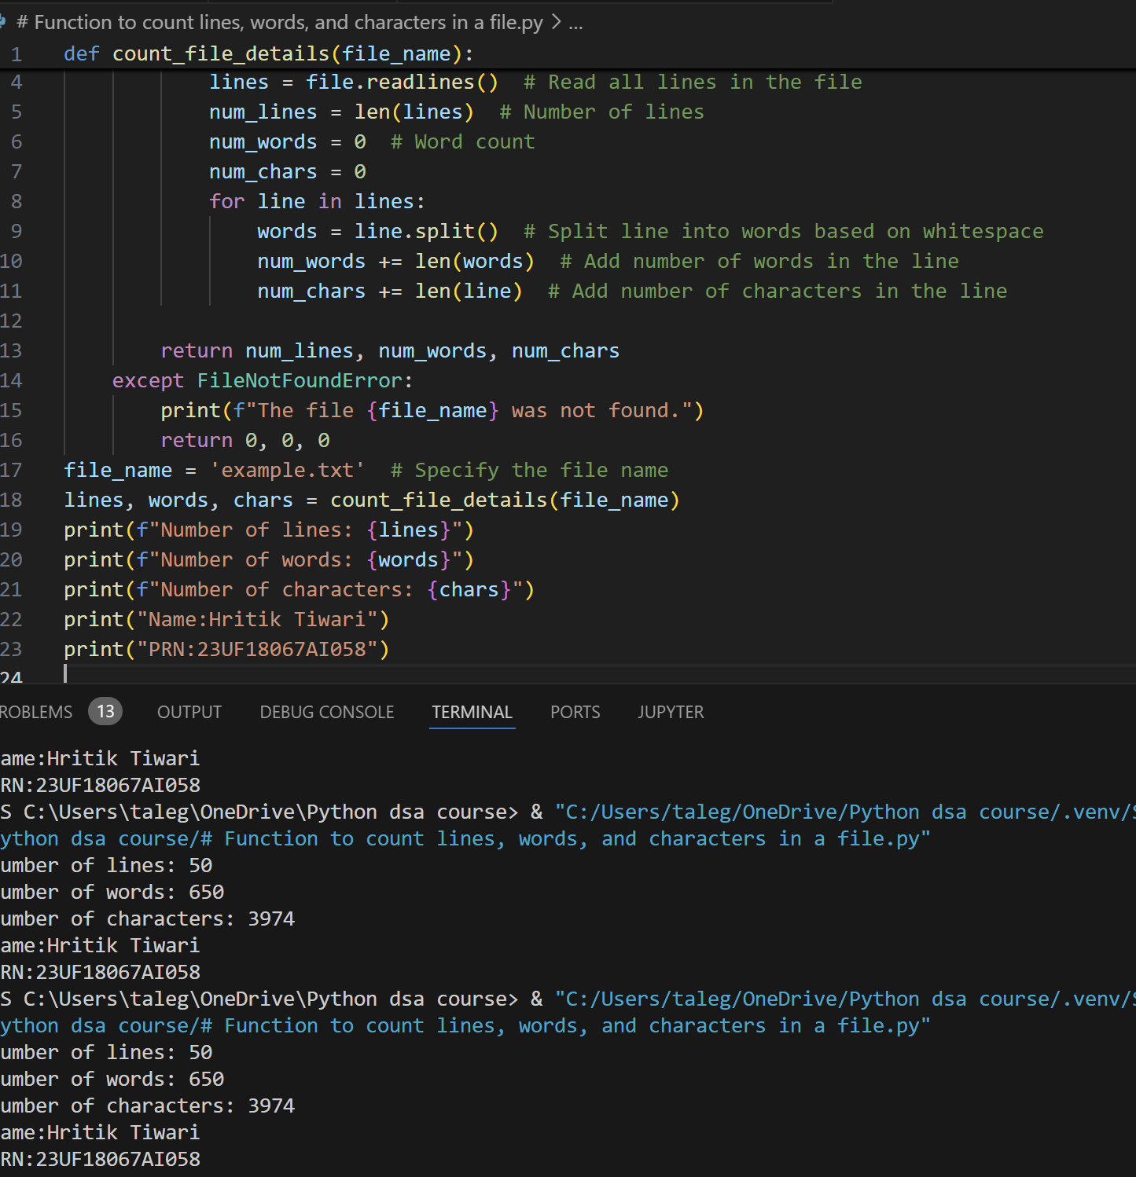

**(c) Python program to display files available in the current directory:**

**# Function to display files in the current directory**

**def list_files_in_directory():**

**# Get a list of all files and directories in the current directory files = os.listdir()**

**# Filter out only the files (exclude directories) files_only = [file for file in files if os.path.isfile(file)] return files_only**

**# Main program files_in_directory = list_files_in_directory()**

**# Display the files print("Files available in the current directory:") for file in files_in_directory: print(file)**

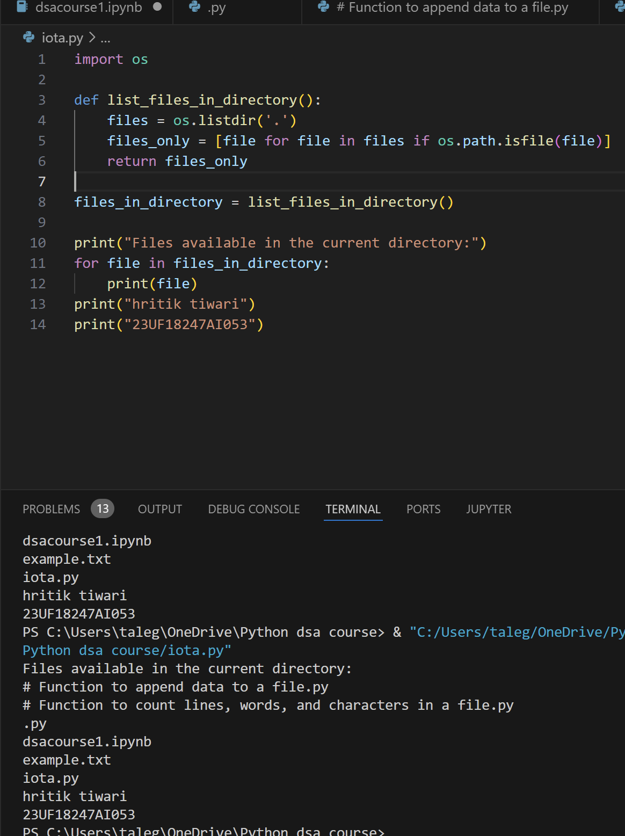

**Conclusion: …………………We executed the experiment successfully………………………………………………………………………………………………………………………………………………………………………………………………………………………………………………………………………………………………………………………………………………………………………………………**

### **MCQ Questions:**

1. Which mode is used to append data to a file?

a) 'w' b) 'r' c) 'a' d) 'x'  
**Answer:**

1. Which Python module is used to interact with the operating system for file and directory operations?

a) sys b) os c) file d) io  
**Answer:**

1. In Python, which method is used to split a string into words?

a) splitlines() b) split() c) partition() d) join()  
**Answer:**

1. Which of the following methods is used to check if a file exists?

a) os.path.exists() b) os.path.isfile() c) os.file() d) os.exists()  
**Answer:**

1. Which of the following statements about file handling is false?

a) 'r' mode is used to read a file.

b) Files must always be manually closed after use.

c) The with statement ensures the file is closed automatically.

d) FileNotFoundError occurs when trying to open a non-existent file in read mode.

**Answer:**