# A STUDY ON THE PERFORMANCE OF HR POLICIES AND ITS IMPLEMENTATION

## 1 Nepolean Bonapart J and 2 DR. R. Kandavel

1. MBA Student, School of Arts, Humanities and Management, Jeppiaar University, Chennai, India.
2. Associate Professor, School of Arts, Humanities and Management, Jeppiaar University, Chennai, India.

nepolean1910@gmail.com

# ABSTRACT

Human resource management is concerned with people element in management. Since every organization is made up of people, acquiring their services, developing their skills/ motivating to high level of performances and ensuring that they continue to maintain their commitments to the organization which are essential to achieve organizational objectives. This project is meant to know the Human Resource Policies in the organization. The HR

Policies are a tool to achieve employee satisfaction and thus highly motivated employees. The main objective of various HR Policies is to increase efficiency by increasing motivation and thus fulfill organizational goals and objectives. The objective is to provide the reader with a framework of the HR Policy Manual and the various objectives that the different policies aim to achieve. The main focus was on the managerial levels of employees.

***Keywords:*** *HR policies, Employee Relationship, Organization.*

# INTRODUCTION

This study is conducted to measure the effect of human resource policies (planning, recruitment & selection, training & development, job analysis & design, motivation, performance appraisal, and employee participation in decision making) on organizational performance, to verify if there is a positive and significant relationship between human resource policies and organizational performance, and to measure the scope of application of human resource policies. These guidelines identify the organizations intention in matters of recruitment, selection, promotion, development, compensation, motivation, and otherwise leading and directing employees in the working organization. HR policies serve as a road map for the manager. HR policies are also defined as that body of principles and rules of conduct which govern the enterprise in its relationship with employees. Such a policy statement provides guidelines for a wide variety of employment relationships in the organization. The purpose and significance of the HR policies hardly need any elaboration. Every organization needs policies to ensure consistency in action and equity in its relation with employees. Policies serve the purpose of achieving organizational goals in an effective manner. HR policies constitute the basis for sound HRM practices. Moreover, policies are the yardstick by which accomplishment of programs can be measured.

# REVIEW OF LITERATURE

* ***Kundu. Sub hash C., Diva Mahan (2009)*** This study is based on the "Human Resources Management Practices in Insurance Companies: The study was made in

Indian and MNC’s and explains the benefits of the organization is generated only by Human Resources. However, the advantage of giving insurance to the Human Resources is one of the employee benefits issued by the Human Resource Management. The findings of the study says that both domestic and international Insurance companies have to improve more on their HR practices like performance appraisal, HR planning and Recruitment.

* ***Hemant Rao (2007)*** In this research study he explained the changes in the role Human Resources. There was an extraordinary change in the role of Human resource department. He found that each individual should work in the organization such that they should treat the employees irrespective to cast, religion, gender etc. The productivity of the company is based on the quality of work done by the employees in the organization.

* **Dessler (2002)** human resources policies and practices needed to contribute to the greater well-being of people, allowing them greater personal and professional fulfilment. In addition to the policies and practices defined by Dessler (2002), began considering the “involvement” policy in the group.

* **Wright et al (2003**) with their study entitled “The impact of HR practices on performance of business units’’; the study evaluates the HR practices and organisation commitment on the operating performance and profitability of business units. The purpose of this study is to examine the relationship between HR practices and firm performance in a way that improves the casual inferences that can be drawn. Questionnaires were used to survey employee attitude. So, business units were sampled within on large corporation. The articles revealed that both organisational commitment and HR practices are significantly related operational measure of performance, as well as operating expenses and pre-tax profits.

* **Mariyam Imna; Zubair Hassan** Human resource policies have impact on the employees in the organization. The main purpose of this research paper is to analyse the factor which influence the employees in the organization. The most human resource policies related to recruitment, training, reward, compensation, performance appraisal, training and development, career development etc. The policies will have impact on the employees who are working in the organization.

# NEED OF THE STUDY

* HR policies are important for employees to work for an Organization.
* It helps to maintain motivation and willing work forces.
* It is an interesting and significant area for conducting research.
* They also ensure compliance with employment legislation and inform employees of their responsibilities and the Company's expectations.

# SCOPE OF THE STUDY

* As most of the company’s overall performance depends on its employee’s performance which depends largely on the HR POLICIES of the organization.
* So, the project has wide scope to help the company to perform well in today’ global competition.
* The core of the project lies in analysing and assessing the organization and to design and HR policy manual for the organization.
* They provide clear communication between the organization and their employees regarding their condition of employment.

# OBJECTIVES OF STUDY

## *PRIMARY OBJECTIVES*

To study the amendments made in the HR Policies of in MSN CONTAINER LINE PVT.

LTD. the time of incorporation.

## *SECONDARY OBJECTIVES*

To Study the amendments in the base policy and prepare a final policy. To Examine a HR Policy manual for the company with special emphasis on the “Managerial Service

Conditions”. To understand the HR policies maintaining the sound relation among

Employees & Employer. To find out the employees’ satisfaction towards satisfied with the implementation of policy in organization.

# RESEARCH METHODOLOGY

* ***Sample Size***

*The sample size of the research study is 133.*

* ***Sources of Data***

The research study used both Primary data and Secondary Data.

## ➢ *Sampling Techniques*

The research study adopted a Simple and Convenience Sampling method and Data Collection was done through questionnaire methods.

## ➢ *Structure of the Questionnaire*

The Quantitative and dichotomous questions and Multiple-choice Questions are asked to the Employees.

# DATA ANALYSIS AND INTERPRETATION

## DESCRIPTIVE ANALYSIS

### 1) Based on the training conducted by the trainer on the areas can be shown any development

|  |  |  |
| --- | --- | --- |
| **PARTICULARS** | **NO. OF**  **RESPONDENTS** | **PERCENTAG**  **E** |
| Agree | 70 | 52.6% |
| Disagree | 13 | 9.8% |
| Neither agree nor disagree | 27 | 20.3% |
| Strongly agree | 5 | 3.8% |
| Strongly disagree | 18 | 13.5% |
| Total | 133 | 100 |



**training**

**areas**

**can**

**be**

**shown**

**any**

**development**

4

%

%

14

20

%

53

%

10

%



Agree



Disagree



Neither

agree

nor

disagree



Strongly

agree



Strongly

disagree

## INTERPRETATION

From the above table it is interpreted that 52.6% of the respondents agreed, 9.8% of the respondents disagreed, 20.3% of the respondents neither agreed nor disagreed, 3.8% of the respondents strongly agreed, 13.5% of the respondents strongly disagreed.

## INFERENCE

Majority (52.6%) of the respondents agree.

### 2) Whether you satisfied with the recruitment team

|  |  |  |
| --- | --- | --- |
| **PARTICULARS** | **NO. OF RESPONDENTS** | **PERCENTAGE** |
| Satisfied | 61 | 45.9% |
| Highly dissatisfied | 4 | 3.0% |
| Neither satisfied or nor dissatisfied | 17 | 12.8% |
| Highly satisfied | 43 | 32.3% |
| Dissatisfied | 8 | 6.0% |
| Total | 133 | 100 |

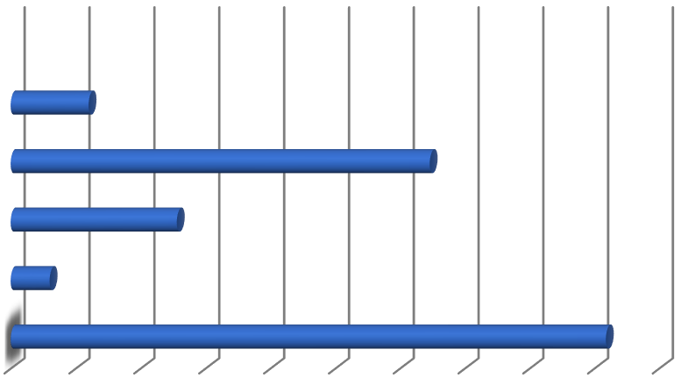

**Series**

**1**



Dissatisfied

Highly

satisfied

Neither

satisfied

or

nor

dissatisfied

Highly

dissatisfied



Satisfied

0.00

%

5.00

%

10.00%15.00%20.00%25.00%30.00%35.00%40.00%45.00%50.00

%

Series

1

### INTERPRETATION

From the above table it is interpreted that 45.9% of the respondents satisfied, 3% of the respondents highly satisfied, 12.8% of the respondents Neither satisfied or nor dissatisfied,

32.3% of the respondents Highly satisfied, 6% of the respondents Dissatisfied.

### INFERENCE

Majority (54.9%) of the respondents satisfied.

#### 3) There is the equal contribution of 12% each from Employer and Employees

|  |  |  |
| --- | --- | --- |
| **PARTICULARS** | **NO. OF**  **RESPONDENTS** | **PERCENTAGE** |
| Agree | 5 | 3.8% |
| Disagree | 20 | 15.0% |
| Neither agree nor disagree | 71 | 53.4% |
| Strongly agree | 5 | 3.8% |
| Strongly disagree | 32 | 24.1% |
| Total | 133 | 100 |



**equal**

**contribution**

**of**

**12**

**%**

**of**

**employer**

**and**

**employees**



60.00

%

40.00

%

20.00

%

0.00

%



equal

contribution

of

12

%

of

employer

and…



equal

contribution

of

12

%

of

employer

and

employees

### INTERPRETATION

From the above table it is interpreted that 3.8% of the respondents are Agree, 15% of the respondents are neither Disagree, 53.4% of the respondents are Neither agree nor disagree, 3.8% of the respondents are Strongly agree, 24.1% of the respondents are Strongly disagree.

### INFERENCE

Majority (53.4%) of the respondents are Neither agree nor disagree.

**4) Are you feel company leave policies are able to meet your needs?**

|  |  |  |
| --- | --- | --- |
| **PARTICULARS** | **NO. OF RESPONDENTS** | **PERCENTAGE** |
| Agree | 61 | 45.9% |
| Disagree | 4 | 3.0% |
| Neither agree nor disagree | 17 | 12.8% |
| Strongly agree | 43 | 32.3% |
| Strongly disagree | 8 | 6.0% |
| Total | 133 | 100 |

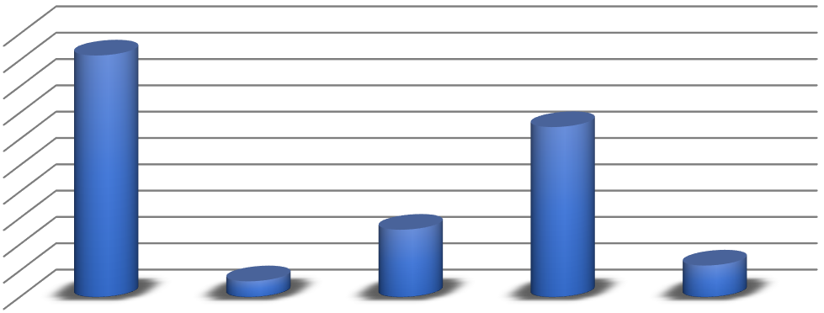

**leave**

**policies**



**are**

**able**

**needs**



**to**

**meet**

**your**



50.00

%

45.00

%

40.00

%

35.00

%

30.00

%

25.00

%

20.00

%

15.00

%

10.00

%

5.00

%

0.00

%



45.90

%



32.30

%



12.80

%



3.00

%



6.00

%



Agree

Disagree



Neither

agree

nor

disagree



Strongly

agree



Strongly

disagree



leave

policies

are

able

to

meet

your

needs

### INTERPRETATION

From the above table it is interpreted that 45.9% of the respondents agreed, 3% of the respondents disagreed, 12.8% of the respondents neither agreed nor disagreed, 32.3% of the respondents strongly agreed, 6% of the respondents strongly disagreed.

***INFERENCE***

Majority (54.9%) of the respondents agree.

# CHI SQUARE ANALYSIS

**AGE OF THE RESPONDENTS Vs**

## BASED ON THE TRAINING CONDUCTED BY THE TRAINER ON THE AREAS CAN BE SHOWN ANY DEVELOPMENT

**H0 (NULL HYPOTHESIS)** = There is no significant relationship between age of the respondents and Based on the training conducted by the trainer on the areas can be shown any development.

**H1 (Alternate Hypothesis)** = There is a significant relationship between age of the respondents and Based on the training conducted by the trainer on the areas can be shown any development**.**

|  |  |  |  |  |  |  |
| --- | --- | --- | --- | --- | --- | --- |
| **AGE * BASED ON THE TRAINING CONDUCTED BY THE TRAINER ON THE AREAS CAN BE SHOWN ANY DEVELOPMENT CROSSTABLE** | | | | | | |
| **AGE** | **AGREE** | **DISAGREE** | **NEITHER**  **AGREE NOR**  **DISAGREE** | **STRONGLY AGREE** | **STRONGLY DISAGREE** | **TOTAL** |
| 20 –30  years | 39.5 | 7.3 | 15.2 | 2.8 | 10.2 | 75.0 |
| 31 –40  years | 21.1 | 3.9 | 8.1 | 1.5 | 5.4 | 40.0 |
| 41 –50  years | 8.9 | 1.7 | 3.5 | .6 | 2.3 | 17.0 |
| 50years and above | 0.5 | 0.1 | 0.2 | .0 | 0.1 | 1.0 |
| TOTAL | 70.0 | 13.0 | 27.0 | 5.0 | 18.0 | 133.0 |

### CHI-SQUARE TESTS

|  |  |  |  |
| --- | --- | --- | --- |
|  | **Value** | **df** | **Asymptotic**  **Significance (2- sided)** |
| Pearson Chi-  Square | 10.090a | 12 | .608 |
| Likelihood Ratio | 10.067 | 12 | .610 |
| N of Valid Cases | 133 |  |  |
| a. 12 cells (60.0%) have expected count less than 5. The minimum expected Count is.04. | | | |

**At 5% level of significance and df (12) the table value is 10.090 calculated value = 0.04**

**Significance value** *(p=0.005)* **< calculated value H0 is accepted.**

## INFERENCE

The results of the “**Pearson Chi-Square**” say that χ *(12) = 10.090, P = 0.04*. This tells us that there is a statistically significant association between the age of the respondents and also Based on the training conducted by the trainer on the areas can be shown any development.

# ONE WAY ANOVA TEST

Hypothesis is set between the age of the respondents and equal contribution of 12% each from Employer and Employees

## NULL HYPOTHESIS

**H0** = There is no statistically significant relationship between age the respondents and equal contribution of 12% each from Employer and Employees

### ALTERNATIVE HYPOTHESIS

**H1** = There is a statistically significant relationship between age of the respondents and equal contribution of 12% each from Employer and Employees

|  |  |  |  |  |  |  |  |  |
| --- | --- | --- | --- | --- | --- | --- | --- | --- |
| **DESCRIPTIVES** | | | | | | | |  |
| **AGE** | | | | | | | |  |
|  | **N** | **M**    **E**  **A**  **N** | **STD.**  **DEV**  **I**  **ATI**  **O N** | **STD.**  **ERR**  **OR** | **95%**  **CONFIDEN**  **C E**  **INTERVAL**  **FOR MEAN** | | **MIN**  **I MU**  **M** | **MA**  **X I**  **M**  **U**  **M** |
|  |  |  |  |  | **LOW**  **E R**  **BOUN**  **D** | **UPPE**  **R**  **BOUN**  **D** |  |  |
| Agree | 73 | 1. 63 | .717 | .084 | 1.4 6 | 1.80 | 1 | 3 |
| Disagre e | 3 | 2. 00 | 1.000 | .577 | -  .48 | 4.48 | 1 | 3 |
| Neither agree  nor disagre e | 19 | 1. 63 | .831 | .191 | 1.2 3 | 2.03 | 1 | 4 |
| Strongl y agree | 35 | 1. 34 | .639 | .108 | 1.1 2 | 1.56 | 1 | 3 |
| Strongl y  disagre e | 3 | 2. 33 | 1.155 | .667 | -  .54 | 5.20 | 1 | 3 |
| Total | 133 | 1. 58 | .741 | .064 | 1.4 5 | 1.71 | 1 | 4 |

|  |  |  |  |  |  |
| --- | --- | --- | --- | --- | --- |
|  |  | **ANOVA** | |  |  |
|  |  | **AGE** | |  |  |
|  | **Sum of**  **Squares** | **df** | **Mean**  **Square** | **F** | **Sig.** |
| Between Groups | 4.434 | 4 | 1.108 | 2.087 | .086 |
| Within Groups | 67.987 | 128 | .531 |  |  |
| Total | 72.421 | 132 |  |  |  |

#### *INTERPRETATION*

This is the table that shows the output of the ANOVA analysis and we have a statistically significant difference between our group means. We can see that the significance level is 0.086, which is more than 0.005. Therefore, there is a statistically significant relationship between the age of the respondents and equal contribution of 12% each from Employer and Employees.

# FINDINGS

* 59.4% of the respondents are 20-30 years,31.6% of the respondents are 31-40 years,7.5% of the respondents are 41- 50 years,1.5% of the respondents are 50 years and above.
* 58.6% of the respondents are Male, 41.4% of the respondents are Female.
* 23.3% of the respondents are finance.
* 23.3% of the respondents are Under Graduate, 50.4 % of the respondents are Post Graduate, 18 % of the respondents are Diploma and 8.3 % of the respondents are others.
* 50.4 % of the respondents are HR, 18 % of the respondents are Production, and 8.3 % of the respondents are sales,9 % of the respondents are others.
* 17.3 %of the respondents are Assistant Executive Finance, 24.8 %of the respondents are HR Managers, 34.6% of the respondents are Production Head,11.3 %of the respondents are Sales Executive, and 12%of the respondents are others.
* 42.9%of the respondents are 10000 to 25000, 36.1% respondents are 25000 to 45000,21.1% of the respondents are 45000 to 60000, and 7.5 % of the respondents are 60000 and above.

# CONCLUSION

The Policy of the organization gives offices to all adjust development of People via preparing inhouse and outside the association, Reorientation, sidelong portability and self-improvement through self-inspiration. The Policy grooms each person to understand his potential altogether features While adding to achieve higher hierarchical and individual objectives. The Policy constructs groups and cultivates collaboration as the essential instrument altogether exercises. The Policy executes even handed, logical and target arrangement of prizes, motivators and control. The Policy perceives worth commitments on schedule and properly, to keep a significant degree of representative inspiration and resolve. The representatives concur on the piece of their exhibition that they know what is normal from them. The representatives see how their work objectives identify with organization objectives. Organization moves the representatives to accomplish their best work each day. The workers are not happy with the correspondence and dynamic measure as it releases the data identified with association. The workers don't get the proper acknowledgment and compensations for their commitments and achievements. The workers feel that they are not paid decently for the commitments they make to organization's prosperity.

# REFERENCE

* ***Absar, M., Nimalathasan, B., and Jillian, M. (2010).*** Impact of HR Practices on Organizational Performance in Bangladesh, International Journal of Business Insights & Transformation, 3 (2), 15-19.
* ***Abu-Doleh, J. (2000).*** Human Resource Planning in Jordan: A Challenge for the Next Millennium, Middle East Business Review, 4(1), 57-68.
* ***Antarello, S.; Filippini, R.; Nosella,*** A. Linking human resources management practices and customer satisfaction on product quality. The International Journal of Human Resources Management, v. 13, n. 18, p. 3906-3924, 2012.
* ***Guest D, Conway N****.* The impact of HR practices, HR effectiveness and a ‘strong HR system’ on organizational outcomes: a stakeholder perspective. The International Journal of Human Resource Management, v. 22, n. 8, p. 1686- 1702, 2011
* ***Katou, A. A.*** Investigating reverse causality between human resource management policies and organizational performance in small firms. Management Research Review, v. 35, n. 2, p. 134-156, 2012.