Hackroid

Author: Jayesh Dive Department of Computer Technology Sou. Venutai Chavan Polytechnic, Pune Email: [Jayeshdive12@gmail.com](mailto:Jayeshdive12@gmail.com)

Author: Sanika Shinde Department of Computer Technology Sou. Venutai Chavan Polytechnic, Pune

Email: [sanushinde289@gmail.com](mailto:sanushinde289@gmail.com)

Author: Mayuri Bhalekar Department of Computer Technology Sou. Venutai Chavan Polytechnic, Pune Email: [mbhalekar105@gmail.com](mailto:mbhalekar105@gmail.com)

Author: Prathmesh Gidde Department of Computer Technology Sou. Venutai Chavan Polytechnic, Pune

Email: [pp.gidde12345@gmail.com](mailto:pp.gidde12345@gmail.com)

P.N.Kale Lecturer and project guide

Department of Computer Technology Sou. Venutai Chavan Polytechnic, Pune Email: [Pranalimane48@gamil.com](mailto:Pranalimane48@gamil.com)

## ABSTRACT

**Making a website based on hacking where beginners can learn and practice how to hack. We have created a website in that we will provide the latest updates of cyber security in 2024, were students can practice and learn about hacking with no cost.**

**We will provide blogs of various hacking methods for free in our website. We also provide leaked courses on our official Telegram channel for educational purposes.**

**We will also provide competition for those students who have knowledge of hacking like recommended web security and system hacking for that competition, and that data we will provide to company, with that data company can hire those students for part-time or fill-time job. We will provide paid books for reference for more content useful information for their carer. Students will get Dark Web data like leaked Database of companies and other useful information for their carer data and audio copies of experienced hackers. In the audio recording we will provide multiple hacking technic and experience of hackers how they work in the company.**

**we will create a private section for experience hackers where they can perform realtime hacking on real website and for that if Ethical hacker get any bug, then they will get paid for that bug from range**

**$S0 to $500. If company like the skills of that particular hacker, then hacker can also get a job from our website. We will Al charge some amount for that private section form that company. We will also tack projects from company and posted on websites for other hackers who comfortable with the amount, technology of website, Domain and sub-domain scope. In private section student will get company's private data like technology Etc.**

# INTRODUCTION

In today's digital era, YouTube serves as a key platform for driving content creation as a viable career options like entertainment, education, and communication. Creators specialized in niche area, produce videos that drives engagement of the audience. Comment left by the audience plays a Pivotal role by offering creators real time feedback, inspiring content ideas, shaping overall content strategies. YouTube's advanced algorithms prioritize videos based on engagement metrics like comments, likes, and shares, which impacts on content visibility and contribute to a creator's success. However, not all comments are positive; negative comments can impact both the content and the creator's success. As a result, successful content creators analyze comments to gain insights, improving their content to strengthen audience connections and boost their favorability with platform algorithms.

Hence, the aim of this project is to present and automate the classification of comments into positive, negative, or neutral sentiments by offering content creators and platform administrators a thorough understanding of audience sentiment.

The framework consists of four interconnected components: sentiment classification, sentiment distribution visualization, temporal sentiment analysis, and automated email summaries. By utilizing the Random Forest algorithm for sentiment classification, the system provides a detailed categorization of comments into three sentiment categories: positive, negative, and neutral.

# SYSTEM ARCHITECTURE

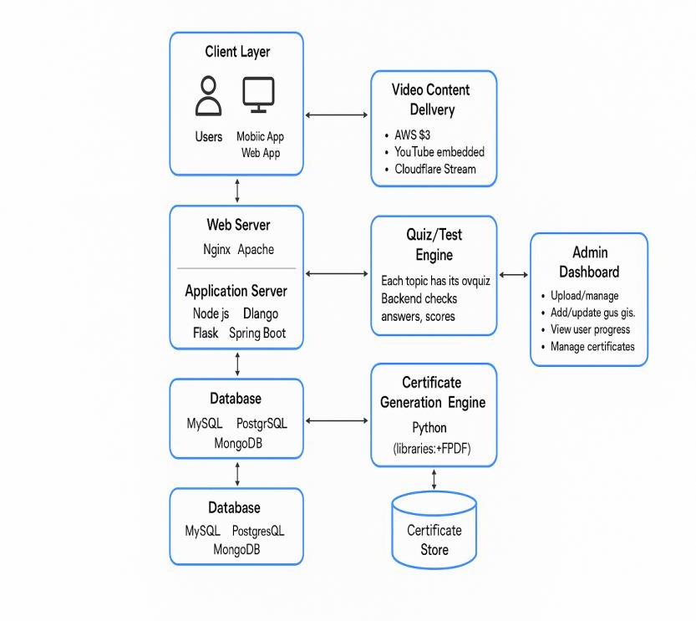The system architecture of our ethical hacking learning platform is designed to ensure scalability, security, and user accessibility. The platform follows a modular client-server model comprising three main layers: the frontend, backend, and database. The frontend, developed using modern JavaScript frameworks such as React.js or Vue.js, provides a user-friendly interface for students, ethical hackers, and companies. The backend, powered by technologies like Node.js or Django, handles business logic, user authentication, and communication with the database. A secure database system, such as PostgreSQL or MongoDB, stores user data, course content, challenge results, and job listings. The architecture includes a sandboxed lab environment using Docker containers to safely host vulnerable applications for hands-on practice. A role-based access control system ensures secure access to advanced features like the private hacker zone, where authorized users can participate in bug bounty simulations and company- assigned.

# PROPOSED METHODOLOGY

The main goal of the project is to create a thorough system for sentiment analysis of YouTube comments. The system automatically categorizes comments into positive, negative, and neutral sentiments by using machine learning, specifically the Random Forest algorithm. Content producers, administrators of video platforms, and data analysts who wish to comprehend viewer engagement and sentiment regarding YouTube videos are among the target users.

Through the automation of YouTube comment classification, this system offers instantaneous insights into how viewers are responding to videos. This can affect the way content is strategically created, giving producers the opportunity to tailor their videos to the preferences of their audience. Administrators of the platform can also use this analysis to enhance engagement metrics and the recommendation system.

Agile development methods are at the core of the system's development, ensuring an iterative and flexible process. The project is divided into short sprints, each focusing on specific aspects such as data collection, comment preprocessing, model development, and sentiment visualization. At the end of each sprint, working software is delivered, enabling rapid feedback cycles and improvements. This approach ensures that the system can quickly adapt to changes, whether they arise from user feedback or evolving platform requirements.

Throughout the development, continuous integration (CI) is employed, where code is regularly merged into a shared repository and tested automatically. This practice ensures that new features and updates do not disrupt existing functionality. Automated testing and validation help maintain the system’s robustness as it grows in complexity. Feedback is gathered from stakeholders, including content creators and platform administrators, to refine features and ensure the system meets real-world needs.

Instead of focusing solely on algorithmic accuracy, the development process emphasizes user experience and scalability. The system is designed to handle large volumes of data, enabling it to analyze comments from multiple videos efficiently. Regular sprint reviews ensure that the system evolves in alignment with the end-users' goals.

The Random Forest algorithm serves as the backbone for sentiment classification. However, the overall success of the project lies in the integration of Agile methodologies, which allow for continuous improvements, frequent testing, and adaptability to the changing landscape of user requirements and platform capabilities.

# IMPLEMENTATION

Free Learning

You’ll provide free blogs and articles that teach people about hacking methods like website hacking, password cracking, phishing, etc.

Practice Labs

You will create a safe space (virtual labs) where users can try hacking techniques without breaking any law.

CTF Competitions

You can run online contests (Capture The Flag) where users solve security problems. The top users can win prizes or be noticed by companies.

Community

Create a group on Telegram or Discord where users can ask questions, get help, and share knowledge.

Job Help

You can connect students with companies. Companies can see how skilled a student is and can hire them if they want.

Pro Section

You’ll create a private area where companies can post bug bounty tasks. Hackers can join and try to find bugs in return for money.

## SCOPE FOR FUTURE WORK

In the platform can grow in many useful ways in future. one improvement could be using artificial intelligence to track each user’s learning progress and suggest topics or labs based on their skills and interests. more advanced and realistic practice labs can be added, such as labs for mobile app hacking, cloud security, internet of things (iot) devices, and wireless network hacking. a mobile app version of the platform can be created so users can access lessons, practice challenges, and community features easily on their phones.

the platform can introduce certification programs where users get certificates after completing certain tasks or courses, which can help them in their career. a global leaderboard system can show the best-performing users from different countries, increasing motivation and recognition. more partnerships with cyber security companies, colleges, and training institutes can be built to offer internships, paid tasks, and full-time job placements directly through the platform.

future versions of the platform can also include live training events, webinars, and interviews with professional ethical hackers and security experts. a bug bounty marketplace can be created where companies post real problems and ethical hackers on the platform can earn money by finding and reporting bugs. more languages can be supported on the website to help learners from different regions. overall, the platform has a lot of potential to become a full learning, practice, and career-building system for anyone interested in cyber security.

We are building a free and ethical cybersecurity learning platform where beginners can explore the world of hacking and advance their skills through hands-on practice. The website will offer daily cybersecurity updates, detailed blogs on ethical hacking techniques, and curated learning resources including free and paid legal courses. Users can join our Telegram community for discussions and support. Our platform features simulated environments and Capture The Flag (CTF) challenges to help students gain real-world experience in

Advanced users can access a private section with authorized bug bounty programs, where they can earn rewards and potentially get hired by companies based on their skills.

## CONCLUSION

In This research project has developed a comprehensive Sentiment Analysis System for YouTube comments, which uses advanced techniques, user-centric features, and a Random Forest algorithm to categorize comments into distinct sentiments. The system provides content creators and stakeholders with a deep understanding of audience feedback dynamics. It offers intuitive visual representations to help users understand prevailing sentiment trends within the comment section.

The temporal analysis component adds a dynamic dimension, offering insights into how sentiments evolve over time in response to contextual factors. An automated email module ensures that stakeholders receive timely summaries of sentiment analysis results, facilitating swift and informed responses to viewer feedback.

The potential for enriching this system is boundless, with opportunities for multilingual support and fine-grained sentiment analysis. The integration of state-of-the-art Natural Language Processing (NLP) techniques and real-time sentiment tracking promises even more immediate and nuanced insights. Ethical considerations, accessibility, and bias mitigation strategies will guide the pursuit of a fair and inclusive sentiment analysis system.

Scalability and performance optimization are paramount as the system adapts to the growing demands of an ever-expanding user base. By embracing these prospects, the sentiment analysis framework not only empowers content creators .

## ACKNOWLEDGMENT

We are grateful to our guide, Mrs. P.N.Kale for their valuable guidance and support at this project. We are very grateful for the availability of software such as Java and MYSQL which made the process of website development easy.

The project was indeed a unique experience, for which we owe this guidance and creative applications that resulted in its realization, thank you.

## REFERENCES

[1]N. Anggraini and M. J. Tursina, "Sentiment Analysis of School Zoning System On Youtube Social Media Using The K-Nearest Neighbor With Levenshtein Distance Algorithm" 2019 7th International Conference on Cyber and IT Service Management (CITSM), Jakarta, Indonesia, pp. 1-4

[2]M. Alkaff, A. Rizky Baskara and Y. Hendro Wicaksono, "Sentiment Analysis of Indonesian Movie Trailer on YouTube Using Delta TFIDF and SVM”, 2020 Fifth International Conference on Informatics and Computing (ICIC), Gorontalo, Indonesia, 2020,

pp. 1-5

[3]K. Goel and K. Batra, "A Deep Learning Classification Approach for Short Messages Sentiment Analysis"2020 International Conference on System, Computation, Automation and Networking (ICSCAN),

Pondicherry, India, pp. 1-3

[4]J. Li and L. Qiu, "A Sentiment Analysis Method of Short Texts in Microblog," 2017 IEEE International Conference on Computational Science and Engineering (CSE) and IEEE International Conference on Embedded and Ubiquitous Computing (EUC), Guangzhou, 2017, pp.776-779, doi:10.1109/CSE EUC.2017.153.

1. 2019 7th International Conference on Cyber and IT Service Management (CITSM), Jakarta, Indonesia, 2019, pp. 1-4, doi: 10.1109/CITSM47753.2019.8965407. N. Anggraini

and M. J. Tursina, "Sentiment Analysis of School

Zoning System On Youtube Social Media Using The

1. The paper "Sentiment Analysis of Indonesian Movie Trailer on YouTube Using Delta TFIDF and SVM" was presented at the Fifth International Conference on Informatics and Computing (ICIC) I2020 in Gorontalo, Indonesia. It was published on page1–5, with a doi: 10.1109/ICIC50835.2020.9288579