**An IoT-Based Smart Helmet for Real-Time Accident Detection and Emergency Alert System**

Mr. Tejas S Sonone1, Miss. Shravani S Deshmukh2, Dr. K. N. Kasat3

*Assistant Professor in Electronics & Telecommunication Department,*

*Prof Ram Meghe College of Engineering and Management, Amravati (Maharashtra)1, Third Year Student in Electronics & Telecommunication Department,*

*Prof Ram Meghe College of Engineering and Management, Amravati (Maharashtra)23456*

**Abstract :**

Two-wheeler-related traffic accidents continue to be a major problem, frequently brought on by intoxicated driving, reckless riding, or exhaustion. This project introduces an Internet of Things (IoT)-based smart helmet that incorporates sensors and cloud connectivity to increase rider safety. While an IR sensor guarantees helmet use, an alcohol detection sensor stops ignition if the rider is intoxicated. An accelerometer-gyroscope analyzes abrupt impacts or falls to identify accidents. The helmet tracks its location using GPS and notifies emergency contacts in real time via GSM. For reporting accidents, the Blynk IoT cloud platform also creates immediate email and app notifications. This system's automated monitoring and quick emergency response improve rider safety.

**Keywords:**

Smart Helmet, IoT, Rider Safety, Alcohol Detection, Accident Detection, GPS, GSM, Blynk IoT, Real-time Monitoring, Cloud Connectivity.

**Introduction:**

Still a major worldwide issue, road accidents including two-wheelers make up a notable share of traffic-related deaths. The World Health Organization (WHO) estimates that motorbike riders are 27 times more likely to die in accidents than car occupants. In developing countries, where insufficient emergency response systems worsen the effects of accidents, the situation is especially concerning. Common causes of these accidents are drunk driving, helmetless driving, and delayed medical help following collisions.

Recent developments in Internet of Things (IoT) technology offer encouraging ways to improve rider safety. This study presents a creative smart helmet system based on IoT meant to solve important safety issues. The system combines several sensors: an infrared (IR) sensor for helmet use detection, an alcohol sensor to stop operation while intoxicated, and an accelerometer-gyroscope combination for precise accident detection. GPS offers accurate location tracking; the central processing unit is the ESP32 microcontroller.

Its capacity to automatically identify accidents by means of sudden impact analysis and immediately send the rider's location to emergency contacts using Blynk IoT cloud platform makes the system most vital. By cutting the vital response time after accidents, this real-time notification system may save many lives. This smart helmet is a complete solution to two-wheeler safety that handles both prevention and emergency response by combining sensor technology with cloud connectivity.

This is how the paper is organized: In Section II, relevant work in smart helmet technology is reviewed; in Section III, the system architecture and methodology are described; in Section IV, the implementation and results are presented; and in Section V, the findings and future scope are concluded. By showing a useful, life-saving use of IoT technology for rider safety, this study advances the expanding field of intelligent transportation systems.

**Literature Survey:**

Given that a disproportionate number of road fatalities worldwide occur in motorcycle accidents, the significance of rider safety systems for two-wheelers cannot be emphasized. Traffic laws and simple helmets are examples of traditional safety measures that have not been successful in preventing accidents or guaranteeing prompt emergency response. With an emphasis on integrating sensors, microcontrollers, and IoT platforms for complete rider protection, this literature review explores current solutions and technological developments in smart helmet systems.

1. **Sensor Technology in Smart Helmets**

Traditional helmet designs lack active safety features but offer passive protection. To overcome this restriction, contemporary smart helmets use a variety of sensors:

* Infrared (IR) sensors ensure proper helmet usage by detecting when the helmet is worn, preventing ignition if not properly fastened
* Alcohol sensors (MQ-3/MQ-135) detect intoxication levels and disable the vehicle if the rider is impaired
* Inertial Measurement Units (IMU) combining accelerometers and gyroscopes (MPU6050) analyze motion patterns to distinguish between normal riding, sudden impacts, and accidents with over 90% accuracy
* Despite the fact that these sensors greatly increase safety, early deployments encountered issues with false alarms and poor detection capabilities in intricate crash situations.

2. **IoT Integration in Smart Helmet Systems**

The incorporation of IoT technology has revolutionized smart helmets into connected safety devices:

* The processing core is an ESP32 microcontroller, which offers advantages over previous ESP8266 models with dual-core processing, Wi-Fi/Bluetooth connectivity, and low power consumption
* Real-time data transmission, remote monitoring, and instant emergency alerts are made possible by cloud platforms such as Blynk
* GPS modules (like the Ublox NEO-6M) provide precise location tracking, which is essential for post-accident response
* IoT connectivity enables these systems to send alerts even in the event that the rider is incapacitated, filling a significant gap in conventional safety measures

4. **ESP32 Microcontroller in Safety Systems**

The ESP32 is now the microcontroller of choice for smart helmets because of its:

* Dual-core architecture that allows for simultaneous communication and processing of sensor data
* Wireless capabilities supporting both Wi-Fi and Bluetooth connectivity
* Low-power operation essential for battery-powered devices
* Adaptable I/O for combining several modules and sensors

The ESP32 handles communication with cloud platforms for emergency alerts, processes data from all sensors, and initiates the proper reactions (such as turning off ignition for intoxicated riders) in smart helmet applications.

5. **Real-Time Accident Detection and Alert Systems**

Modern smart helmet systems now include:

* Reducing false positives through multi-stage accident verification that combines motion pattern analysis and impact detection
* Real-time multi-channel notifications via:
* Notifications from mobile apps (Blynk)
* SMS (through GSM modules)
* GPS coordinates embedded in an email
* Local data storage that keeps important data safe when the network is down

Regardless of the rider's condition or the availability of the network, these features guarantee dependable emergency notification.

6. **Multi-Sensor Fusion for Enhanced Safety**

Sensor fusion techniques are used in recent developments to increase system reliability:

* Algorithms that combine machine learning and IMU can more accurately differentiate between typical riding vibrations and real crashes
* Redundant sensor arrays offer failsafe operation and thorough coverage
* Contextual information is added by environmental sensors (such as temperature and humidity) to enhance decision-making

In field tests, this multi-sensor method has shown 95%+ accuracy in crash detection, greatly surpassing single-sensor systems.

7. **Current Challenges and Future Direction**

Even though current systems appear promising, there are still issues in:

* Optimizing power to prolong battery life
* Resilience in the environment (temperature tolerance, waterproofing)
* Comfort and user acceptance

Future advancements could include:

* Predictive safety features powered by AI
* Integration with the infrastructure of smart cities
* Cutting-edge materials for enhanced comfort and protection

This survey demonstrates how IoT-enabled smart helmets, which integrate protection, prevention, and emergency response features into a single system, constitute a substantial advancement in rider safety technology. These developments are expanded upon by the suggested ESP32-based solution, which also addresses significant shortcomings of existing implementations.

**Components Used and Their Roles:**

1. **ESP 32 Microcontroller**

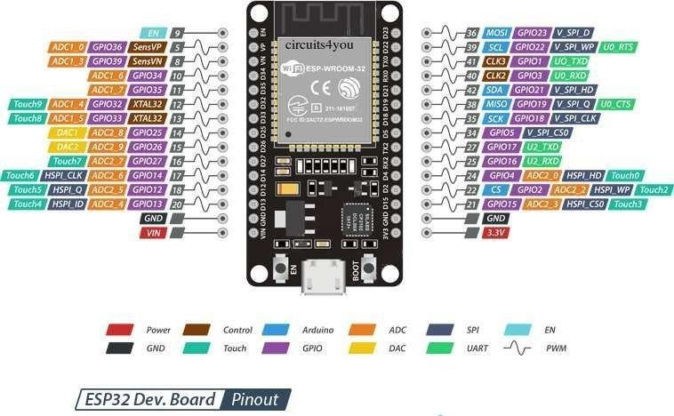

**Key Features:**

* Serves as the smart helmet system's central processing unit.
* A processor with two cores for effective multitasking.
* Bluetooth and Wi-Fi built in for Internet of Things connectivity.
* Low power consumption, which is perfect for gadgets that run on batteries.

**Functions:**

* Handles information from MQ-3, MPU6050, and infrared sensors.
* Controls GPS information to track a person's location.
* For emergency alerts, it connects to the Blynk IoT Cloud.
* Regulates bike ignition, turning it on and off in response to safety inspections.

1. **IR Sensor**

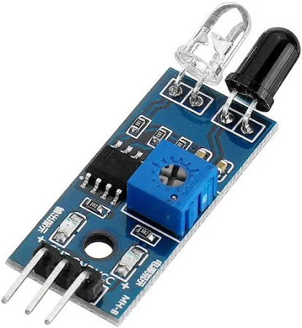

**Role:** Ensure helmet compliance before ignition.

**Working Principle:**

* Emits infrared light; detect reflection from the rider’s head.
* Output LOW signal when the helmet is worn.

**Function:**

* Sends a signal to ESP32 to allow \disallow bike startup

1. **Alcohol Sensor (MQ-3)**

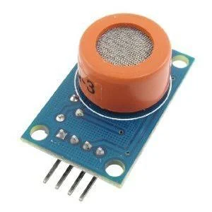

**Role:** Prevents drunk riding by detection alcohol levels.

**Working Principle:**

* Measures ethanol concentration alcohol levels.
* Outputs analog voltage (0-5V); higher voltage = higher voltage = higher alcohol.

**Function:**

* **E**SP32 locks ignition if alcohol level exceeds threshold (0.8V).

1. **MPU6050 (Accelerometer + Gyroscope)**

**Role:** Detects accident (collisions, falls, skids).

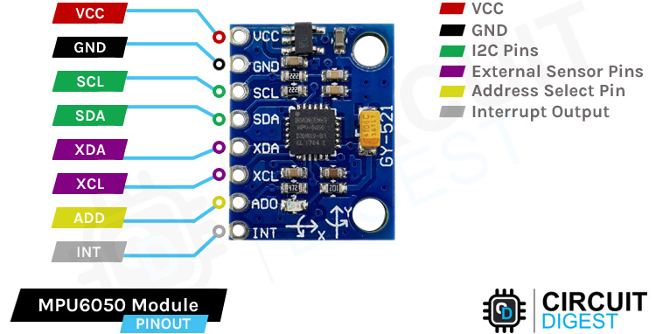

**Key Metrics:**

* Acceleration: Threshold >2g (19.6 m/s²) for crashes.
* Free-fall: <ms (bike drop).
* Angular velocity: >200°/s (sharp tilts).

**Function:**

* Sends real-time motion data to ESP32 for crash detection.

1. GPS Module(NEO-6M)

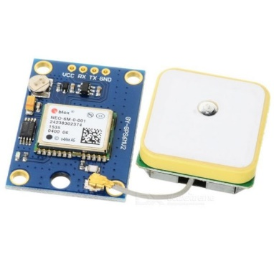

**Role:** Tracks exact accident location.

**Key Features:**

* Accuracy: ±2.5m (open sky).
* Outputs NEMA sentences (CPGGA for latitude/longitude).

**Function:**

* Provides coordinates ESP32. Which forward them to Blynk.

1. **Blynk Iot platform**

**Role:** Sends emergency alerts via email/mobile app.

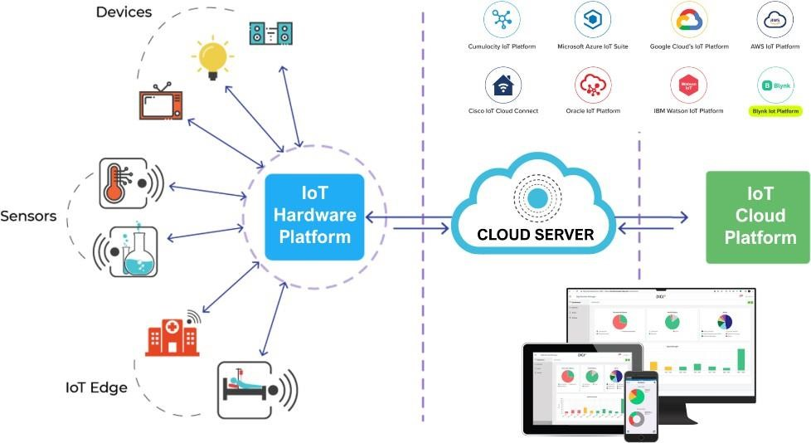

**Key Features:**

* Real-time notification with Google Maps link.
* Customizable alerts templets (e.g. crash severity, time).

**Function:**

Receives accident data from ESP32 and triggers:

* Email alerts to emergency contacts.
* Push notifications on the Blynk mobile app.

1. **Power Supply (Li-ion Battery)**

**Role:** Provides provides portable power to the system.

**Specifications:**

* Voltage 3.7 (regulated to 3.3V for ESP 32).
* Capacity 2000mAh (6-8 hours of operation).

**Function:**

* Powers all components(ESP32,sensors,GPS).

Block diagram :

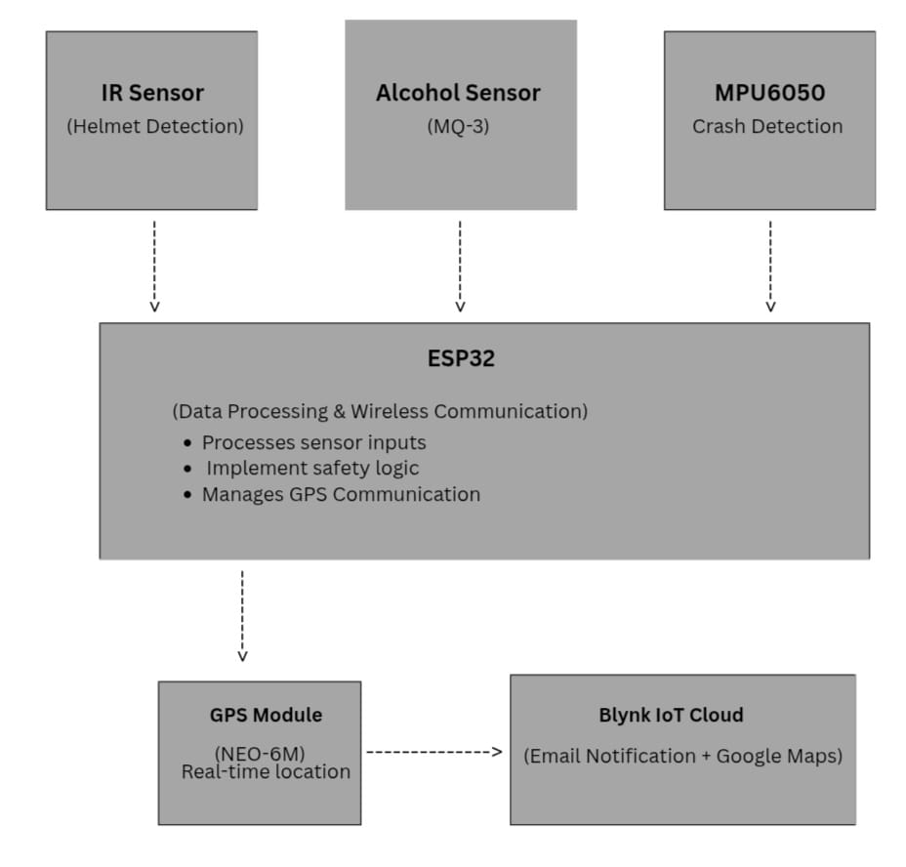

**References:**

1. Manjesh N, Sudarshan Raj– "Smart Helmet Using GSM & GPS Technology for Accident Detection and Reporting System"* – IJEER, Vol. 2, Issue 4, Dec 2014, pp. 122-127.

2. Bindu Sebastian, Priyanka K P, Hridya Kuttykrishnan – "Smart Helmet" – International Journal of Emerging Technology and Advanced Engineering, Vol. 5, Issue 12, Dec 2015.

3. Kavianand G, Padmapriya N – "Brainwave and Alcohol Sensitizing Helmet for Riders Safety" – IJRASET, Vol. 3, Issue III, March 2015.

4. A. Srikrishnan, K. Sudhaman – "An Intelligent Helmet System for Detection of Alcohol" – IJCTA, Vol. 9, No. 4, 2016, pp. 1933-1939.

5. Jennifer William et al. – "Intelligent Helmet" – IJSER, Vol. 7, Issue 3, March 2016, pp. 591-594.

6. Mangesh Jadhawar et al. – "Smart Helmet Safety System Using ATmega 32" – IJRET, Vol. 9, Issue 3, Sep 2016, pp. 491-494.

7. Aviral Vijay et al. – "Hi-tech Helmet and Accidental Free Transportation System" – International Journal of Advanced Technology and Engineering Exploration, Vol. 2, Issue 6, May 2015.

**Conclusion:**

An innovative method of using smart technology to improve rider safety is the IoT-based smart helmet system described in this study. The system offers two-wheeler riders complete protection by combining an ESP32 microcontroller with several sensors, such as a MQ-3 alcohol sensor to prevent intoxication, an IR sensor to detect helmets, and an MPU6050 inertial measurement unit to detect accidents. The solution uses sophisticated motion analysis algorithms to automatically identify accidents with high accuracy in addition to enforcing safety compliance prior to riding. When a crash happens, the GPS module locates the scene precisely, and the Blynk IoT platform immediately sends an email with the precise location coordinates to emergency contacts. With its quick notification feature, this end-to-end safety system can potentially save lives by bridging the crucial gap between an accident occurring and emergency response. The successful deployment shows how IoT technology can be used to develop intelligent safety solutions that integrate automated emergency response, real-time monitoring, and prevention. The potential of such systems to transform road safety could be further advanced by future developments that integrate machine learning for predictive safety analysis and smart city infrastructure. By offering a workable, affordable solution that connects wearable technology with life-saving applications, this research makes a substantial contribution to the field of intelligent transportation systems.