***Adaptive Quiz System for Progressive Learning***

**S. Yuvasri1., A. Siva Ganesh2.,**

1Department of MCA,

2Assistant Professor, Department of MCA,

1,2Mepco Schlenk Engineering College, Sivakasi– 626124

1yuvasri267_mca25@mepcoeng.ac.in, 2sivaganesha@mepcoeng.ac.in

***Abstract***

***This paper tells about the advanced learning system designed to enhance education by providing a personalized learning experience, specifically developed for beginners who want to test and improve their knowledge. It initially evaluates the user's understanding through a common set of multiple-choice questions. This serves as the baseline to analyze their current knowledge level. Based on the assessment, the system identifies the user's weak areas. Using machine learning techniques, the system then tailors the learning process by generating personalized questions, ensuring a dynamic and adaptive approach. Unlike traditional systems that offer static questions to all users, it focuses on individualized improvement, making learning more interactive and efficient.***

**Keywords:** Personalized learning, reinforcement learning, Intelligent Tutor System, Machine Learning, Question Recommendation, Question Generation.

**I. Introduction**

With the rapid evolution of e-learning platforms, personalized learning has become essential for improving student engagement and knowledge retention. Personalized learning is currently crucial for raising student engagement and information retention due to the quick development of e-learning platforms. Conventional quiz-based systems frequently lack flexibility, providing static questions that don't take the learner's skill level or development into consideration. The effectiveness of information acquisition is limited by the one-size-fits-all approach taken by many current methods. Because every student learns differently and has various degrees of prior knowledge, a tailored learning method is essential to meeting each student's needs. By dynamically adapting instructional materials to each learner's unique needs, an intelligent tutoring system (ITS) can close this gap. The platform assesses the learner's strengths and shortcomings through the use of a content-based suggestion system, guaranteeing that the questions produced correspond to their present comprehension level. (ITS) can help close this gap by dynamically adjusting instructional materials to meet the unique requirements of every student. The platform assesses the learner's strengths and shortcomings through the use of a content-based suggestion system, guaranteeing that the questions produced correspond to their present comprehension level. This approach promotes ongoing learning without overburdening the student while simultaneously reinforcing areas of weakness. Furthermore, by providing increasingly difficult questions that correspond with the learner's development over time, adaptive learning strategies promote user engagement. A dynamic, customized question-generation approach guarantees that students obtain pertinent and significant practice, in contrast to typical teaching systems that rely on static question banks. By encouraging a better comprehension of ideas, this interactive and adaptable approach improves the effectiveness and efficiency of the learning process.

**2. Literature Survey**

[1] This paper proposes an intelligent adaptive E-learning system that uses the machine learning to build deep learner profile and reinforcement learning to recommend the personalized learning paths.

[2] This system aims to develop the automated and adaptable system suitable for the individual user learning needs and built on the Moodle platform.

[3] This paper uses the RLLP, the reinforcement learning algorithm that recommends the effective learning paths by considering the knowledge levels and learner’s goals.

[4] This research aims to personalize through adaptive E-learning and ML based recommendation system. It uses the content based filtering, collaborative filtering, hybrid and knowledge based.

[5] The author aims to combine the lazy learning and reinforcement learning, proving significantly faster than using either alone or learning from scratch.

[6] This paper uses a multi-constraint learning path recommendation algorithm based on the knowledge map. It considers the preferences, learning behaviours and time constraints.

[7] The paper proposes the intelligent adaptive E-learning system using machine learning and reinforcement learning. Recommends the learning path using q-learning.

[8] This paper analyzes the Nearest Neighbor Q-Learning (NNQL) algorithm, which applies nearest neighbor regression to estimate the optimal Q-function.

[9] This study aims to enhance the academic performance by aligning learning resources with students' learning styles of a personalized E-Learning approach.

[10] This system uses the multi agent approach and q-learning to recommend personalized learning paths for an adaptive E-learning system.

**2.1. Introduction to Intelligent tutor system**

The growing demand for personalized learning has driven advancements in e-learning platforms. Traditional models with fixed curricula and standardized assessments struggle to accommodate individual learning paces. In static quiz systems, questions don't adapt based on performance, reducing engagement and hindering knowledge retention. To address this, an intelligent tutor system is proposed, utilizing machine learning and reinforcement learning, specifically Q-learning. This system adapts question difficulty and content to match the learner's progress. Q-learning dynamically adjusts the complexity of questions based on user performance, using a Q-table that updates to optimize learning efficiency. By combining content-based recommendations with reinforcement learning, the system provides a tailored learning experience. This adaptive approach keeps learners engaged, offering a balanced level of challenge while focusing on areas of weakness. Performance tracking and feedback further support learners in improving their skills.

**2.2. Existing Systems**

Existing intelligent tutor systems primarily rely on static question banks or predefined question sets to assess and improve a learner’s understanding of a subject. These systems typically follow a rigid structure where users are presented with multiple-choice questions (MCQs) in a sequential manner without adapting to individual learning patterns. Many traditional platforms utilize rule-based algorithms or simple decision trees to assign difficulty levels, offering limited personalization. Some advanced systems incorporate content-based recommendation techniques, where similar questions are suggested based on previously attempted topics. However, these methods do not dynamically adjust to the learner’s progress in real-time. Additionally, most existing platforms lack reinforcement learning techniques, meaning they do not refine question selection based on the user’s historical responses and evolving knowledge. As a result, learners may repeatedly encounter questions that do not align with their actual proficiency, reducing engagement and learning efficiency. While machine learning-based approaches have been explored, they often require extensive labelled datasets and complex training mechanisms, making their implementation challenging in adaptive learning systems.

**2.3 Limitations of existing systems**

As the quiz system is a common application used by many users but many systems just give you the static set of questions which is common for all the users where that system doesn’t work on any personalization for users. And also there is no adaptation in the question difficulty on user’s answer. The system can’t able to analyse the user needs in the education it just simply gives questions from all the topic. That system will not get any user analyses based on the score which is given after the completion of the static quizzes. The other system recommends the courses of the user needs. That system won’t give practice to the user in the form of quiz.

**2.4 Recommendation System**

A recommendation engine plays a critical role in personalizing the learning experience by suggesting questions that align with the learner’s current level of understanding. The system employs a content-based recommendation approach, where recommendations are generated based solely on the user's own performance data rather than relying on interactions or comparisons with other users, as seen in collaborative filtering methods. To facilitate this, the K-Nearest Neighbors (KNN) algorithm is employed—not to compare between users, but to identify questions that are most relevant to the weak topics of a single learner. After an initial assessment quiz, the user’s performance is analyzed and represented as a feature vector. Topics with the lowest performance scores are flagged as weak areas.

**2.4 Q-Learning:**

Q-learning is a model-free reinforcement learning algorithm that enables agents to learn optimal actions in an environment by trial and error. It aims to find the best sequence of actions to maximize long-term rewards. Q-learning works by assigning a "Q-value" to each action in a given state, representing the expected reward from taking that action in that state. The agent then updates these Q-values based on the rewards it receives, gradually learning the most beneficial actions for each situation. In contrast to traditional systems that rely on predefined difficulty progression, Q-learning enables the platform to learn optimal question-selection strategies over time by interacting with the learner and receiving feedback in the form of correct or incorrect answers. the learner is treated as an agent navigating through different levels of question difficulty—categorized as *Easy*, *Medium*, and *Hard*. The learning environment is defined by a set of states, where each state represents the current difficulty level of the question being answered. The actions correspond to transitioning to a higher or lower difficulty level for the next question. The reward is determined by the correctness of the learner’s response: a correct answer yields a positive reward, encouraging the system to increase the difficulty, while an incorrect answer results in a negative reward, prompting the system to reduce difficulty or stay at the current level.

**3. Proposed System**

**3.1 System Architecture**

The architecture of the proposed adaptive learning platform is designed to ensure scalability, modularity, and real-time personalization. The system is composed of four primary layers: the user interface layer, application layer, database layer, and machine learning layer. Each component plays a critical role in delivering a dynamic and customized learning experience to users based on their individual performance.

**3.2 Workflow**

Once authenticated, the user selects a course and answers a set of predefined questions covering multiple subtopics. Based on the performance, the system identifies the weakest subtopic—the one with the lowest score—and highlights it for focused improvement. The user is then given two options: Explanation and Practice Now. The explanation is generated using Google Gemini’s API, providing a clear, AI-generated overview of the weak topic. If the user chooses to practice, they are taken to a personalized quiz where questions related to the weak subtopic are recommended using the K-Nearest Neighbors (KNN) algorithm. To adapt to the user’s progress, Q-learning is employed to adjust question difficulty dynamically. The user starts with an easy question; correct answers increase the difficulty, while incorrect ones maintain or reduce it. This is controlled by a Q-table that updates in real-time based on the user’s performance. If the user consistently performs well, they receive a message like *“You have trained this topic.”* Otherwise, the system encourages further learning. All scores and progress are tracked and displayed on the user’s profile page.

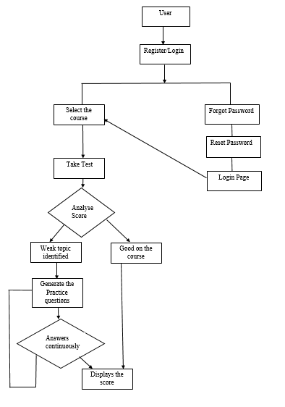

**Fig 3.1 Architectural design**

**4. Implementation Methodology**

**4.1 Technologies Used**

The system is built using a combination of modern web and machine learning technologies to support adaptive and personalized learning. The frontend is developed using React.js, providing a responsive and interactive user interface. The backend is implemented with Flask (Python), which handles API requests, data processing, and integration with machine learning components. A PostgreSQL database is used to manage and store user data, questions, quiz results, and learning progress. For question recommendation, the system employs the K-Nearest Neighbors (KNN) algorithm to find and suggest questions relevant to the user’s weak topics. To adjust difficulty dynamically, Q-learning, a reinforcement learning technique, is used to optimize question difficulty based on user performance. Additionally, the system integrates with the Google Gemini API to generate explanations for weak topics, enhancing conceptual understanding. Together, these technologies create a seamless learning experience tailored to each user.

**5. Results:**

The system effectively identified users’ weak subtopics through an initial static quiz and provided targeted practice using KNN-based question recommendations. The recommended questions aligned well with the identified weak areas, enhancing the relevance of practice sessions. Q-learning dynamically adjusted the difficulty level based on user responses, ensuring an adaptive learning experience. Users who answered correctly progressed to harder questions, while incorrect answers retained or lowered the difficulty, maintaining engagement. Integration with Google Gemini API provided real-time explanations, further supporting concept clarity. Overall, the system improved user performance and promoted a more personalized and efficient learning process.

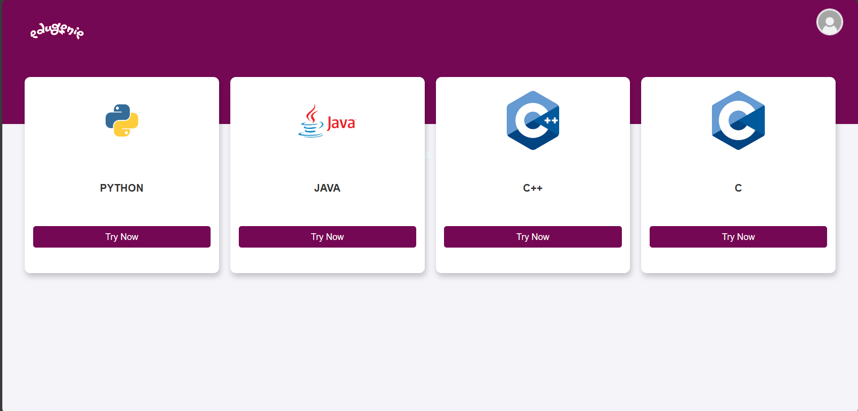

**Fig 5.1 Subjects Selection**

User can select the subject they want to get trained or practiced. After selecting a subject it will redirect to the particular subject’s quiz section.

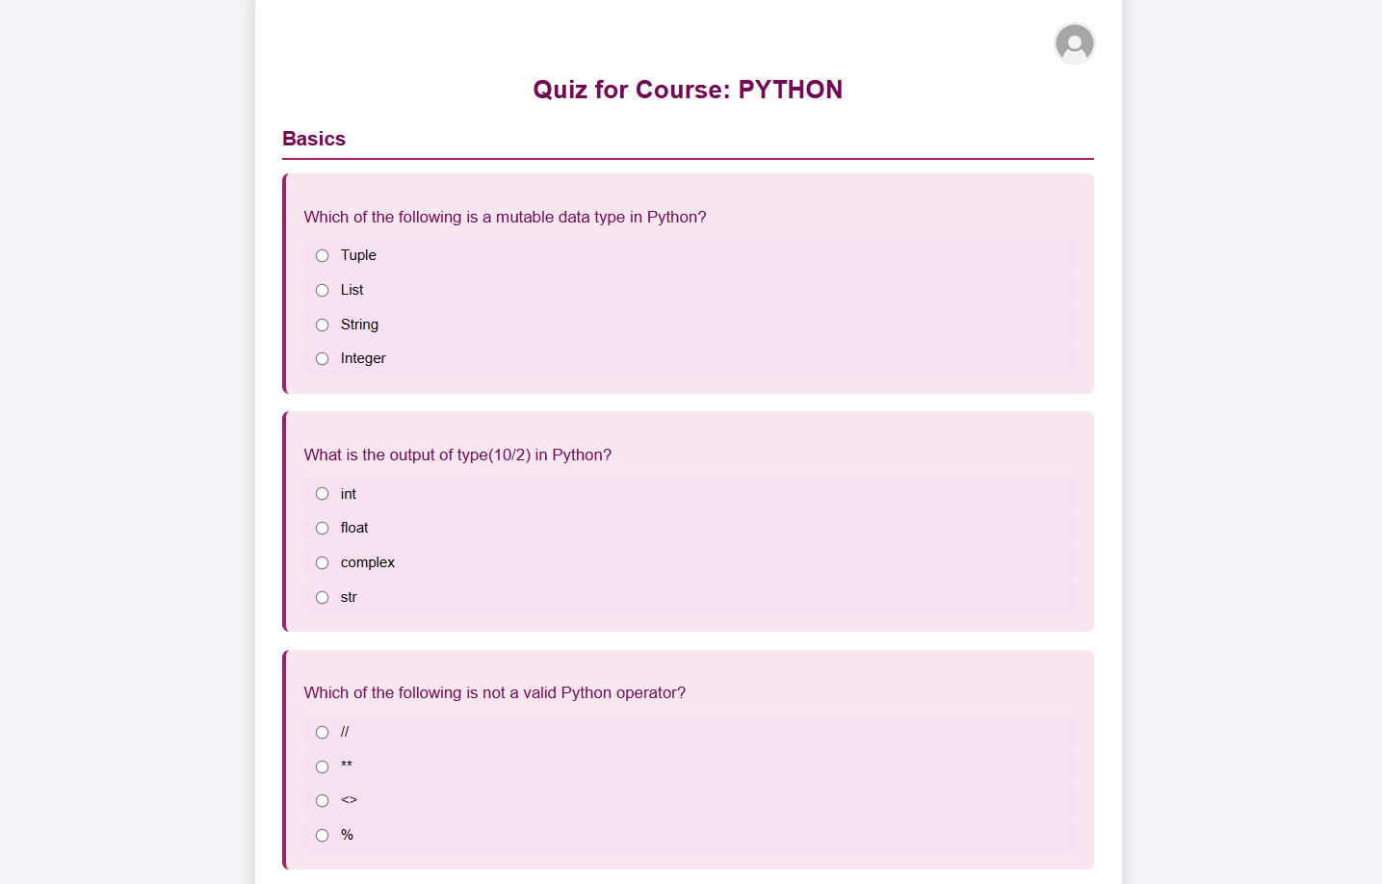

**Fig 5.2 Questions Page**

This is the static set of questions where the user has to attend all the questions to get the weak topic of the particular user

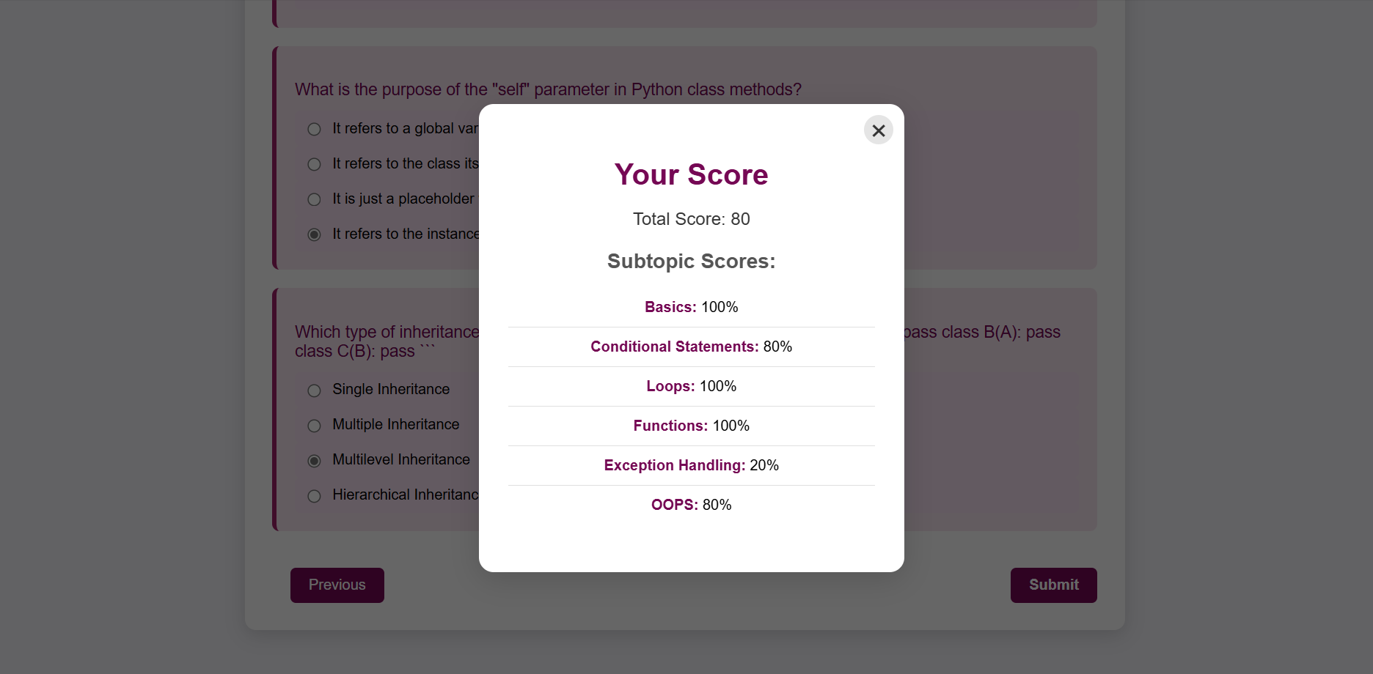

**Fig 5.3 Mark display**

This is a pop up just displays the scores scored in the subtopic wise and total and also displays all subtopics score of the user on the recent attempt and these scores also displayed in the profile page also.

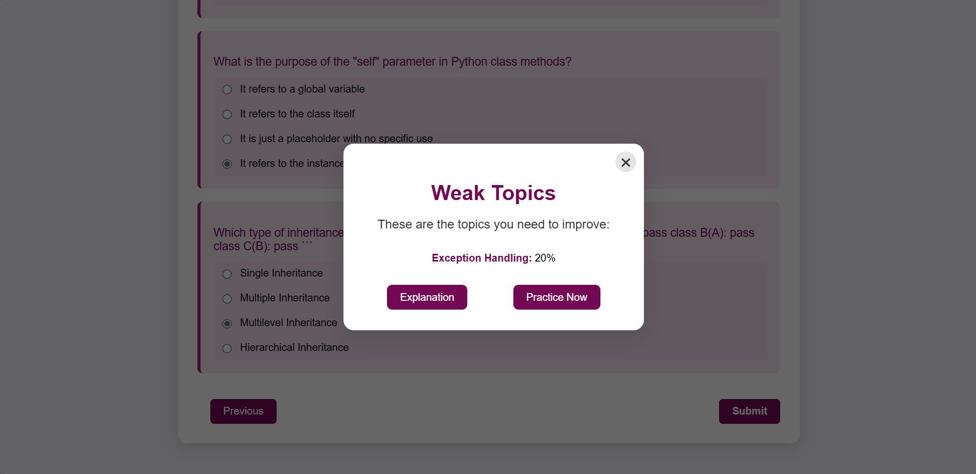

**Fig 5.4 Weak topic**

This page shows the weak topic of the user and also shows two buttons Explanation, which will give the short explanation with example of the weak topic and Practice now which will give the questions to get practiced on that weak topic.

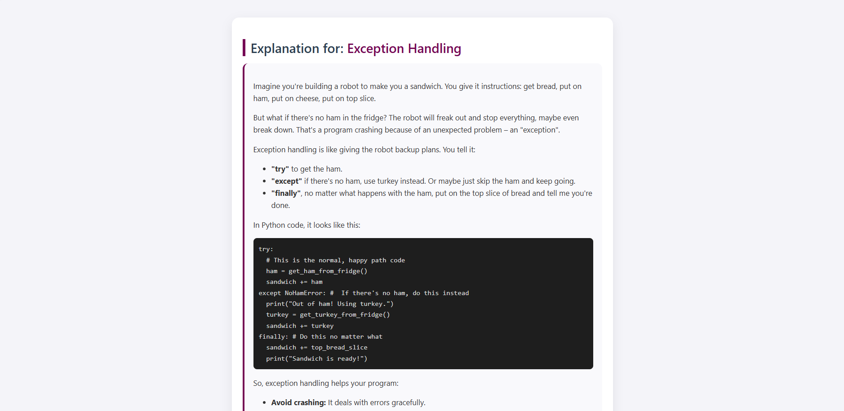

**Fig 5.5 Explanation**

This page will give the explanation of that weak topic this is done by using the Gemini AI with its API key the explanations are get generated dynamically when the weak topic is passed to it is displays the explanation. With this explanation the user can get a glance of the that topic before getting into the practice session.

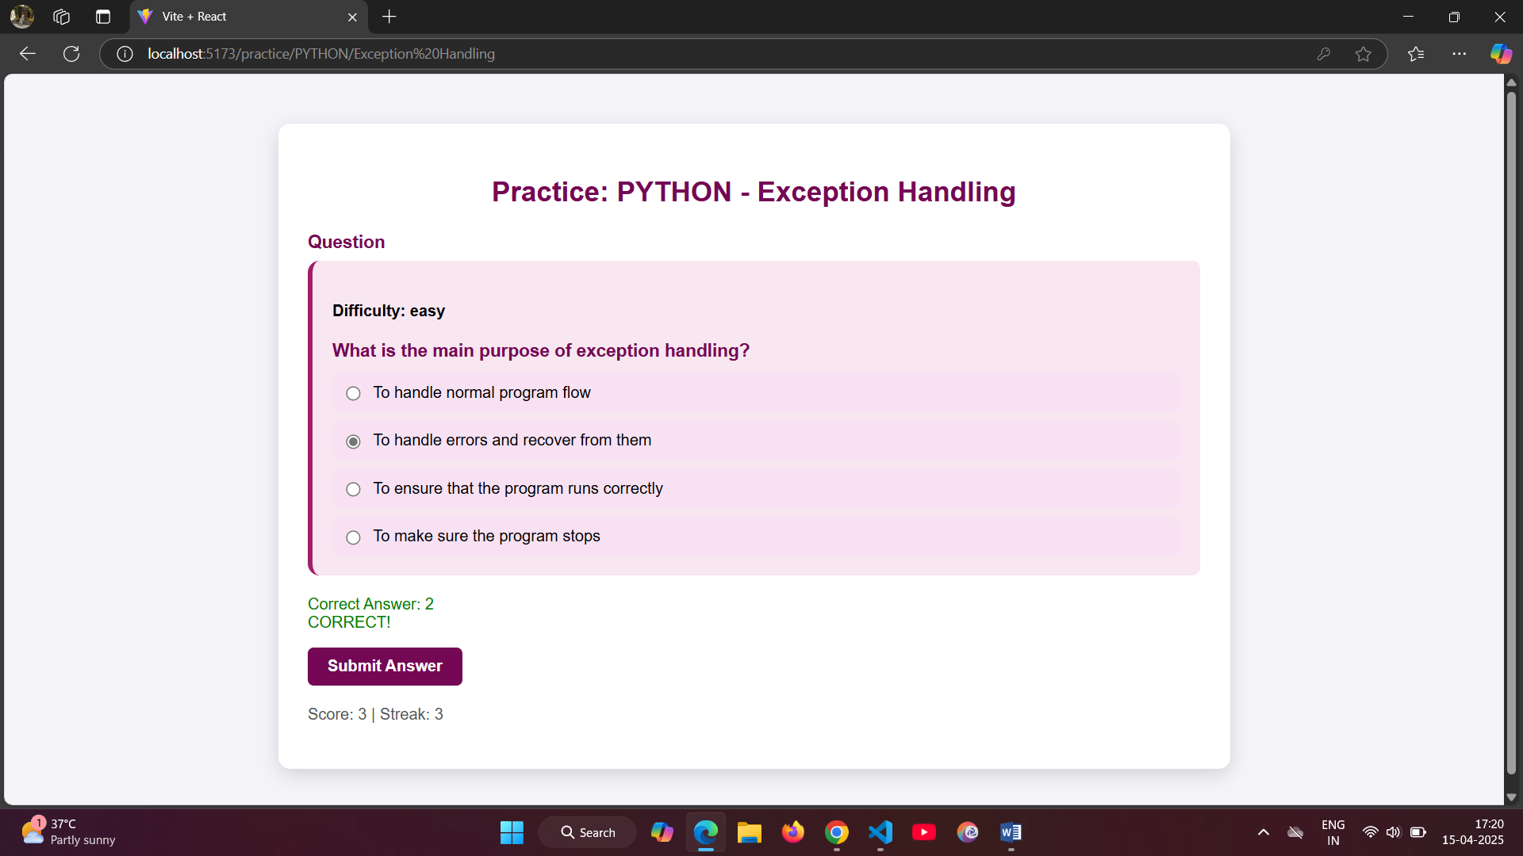

**Fig 5.6 Practice Questions**

When the user selects the practice now it will give the questions based on the content based recommendation system. This uses the KNN algorithm to recommend the questions on the weak topic.

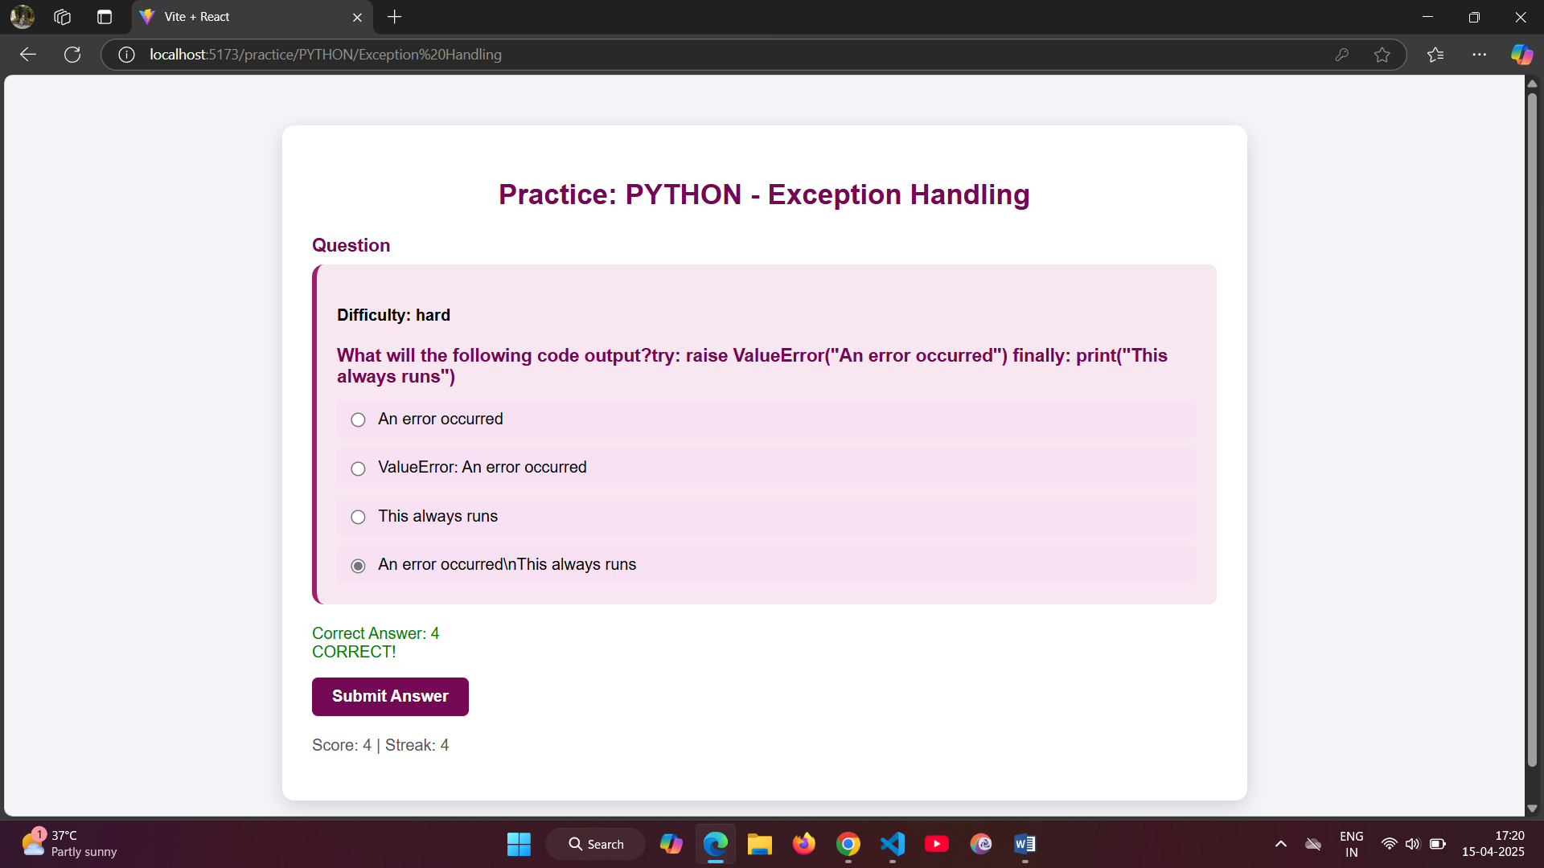

**Fig 5.7 Difficulty changing**

After the user answering the question the difficulty level will get changed according to the user answers if the answer is correct it will change difficulty to medium or hard level if incorrect it will stay in the easy level. The difficulty level will get changed dynamically with the help of the Q-learning algorithm which takes user answers as feedback and stores the value in the Q-table with that Q-table value the algorithm will decide which difficulty level it can recommend to the user increase, decrease or stay in the difficulty level.

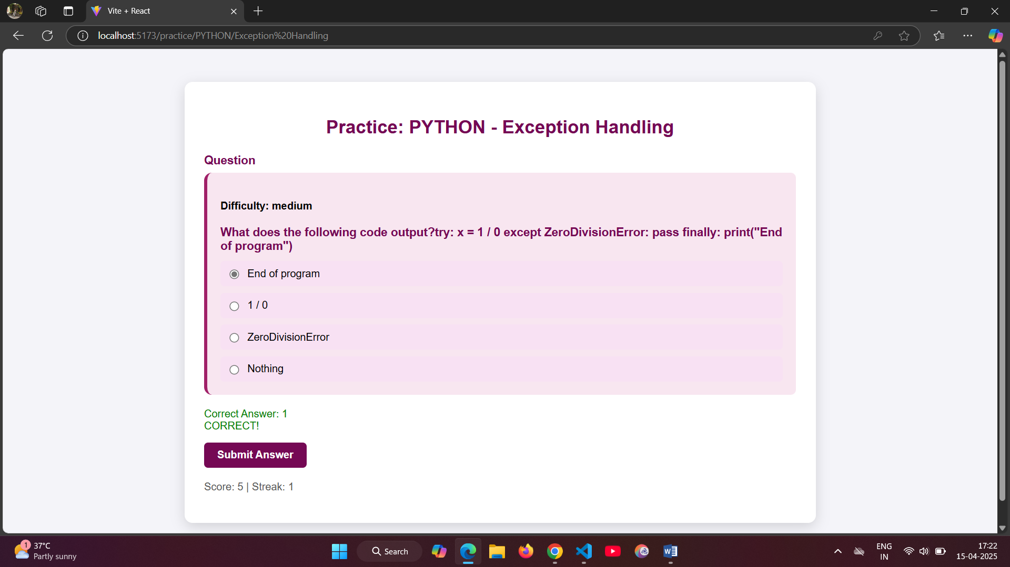

**6. Conclusion:**

This project presents a personalized and adaptive learning system that enhances the user’s educational experience by combining machine learning techniques with intelligent tutoring strategies. By identifying weak topics through performance analysis and delivering targeted content using KNN-based recommendations, the platform ensures learners receive focused practice. The integration of Q-learning allows for dynamic difficulty adjustment, tailoring question levels to each user’s proficiency. Additionally, real-time explanations generated via the Google Gemini API further support conceptual understanding. Overall, the system fosters a more engaging, efficient, and individualized learning journey, demonstrating the potential of machine learning in modern education.

**References:**

[1] Riad Mustapha, Gouraguine Soukaina, Qbadou Mohammed, Aoula Es-Saadia, “Towards an Adaptive e-Learning System Based on Deep Learner Profile, Machine Learning Approach, and Reinforcement Learning” International Journal of Advanced Computer Science and Applications, Vol. 14, No. 5, 2023.

[2] M. Laaziri, S. Khoulji, K. Benmoussa, and K. M. Larbi, "Outlining an Intelligent Tutoring System for a University Cooperation Information System," Engineering, Technology & Applied Science Research, vol. 8.

[3] Ji Li, Simiao Yu, Tiancheng Zhang,” Learning Path Recommendation Based on Reinforcement Learning” Volume 32, Issue 9, September 2024, Pages 1823-1832.

[4] S. S. Khanal, “A Systematic Review: Machine Learning-Based Recommendation Systems for E-Learning”, Education and Information Technologies, July 2020.

[5] Zvezdan Loncarevic, Mihael Simonic, Ales Ude, Andrej Gams, “Combining Reinforcement Learning and Lazy Learning for Faster Few-Shot Transfer Learning”, 2022 IEEE-RAS 21st International Conference on Humanoid Robots (Humanoids).

[6] Zhu H, Tian F, Wu K, et al. A multi-constraint learning path recommendation algorithm based on knowledge map[J]. KnowledgeBased Systems, 2018, 143: 102-114.

[7] M. Boussakssou, B. Hssina, and M. Erittali, "Towards an Adaptive Elearning System Based on Q-Learning Algorithm," Procedia Computer Science, vol. 170, pp. 1198–1203, Jan. 2020, https://doi.org/ 10.1016/j.procs.2020.03.028.

[8] Devavrat Shah and Qiaomin Xie “Q-learning with Nearest Neighbors”, arXiv:1802.03900v2 [cs.LG] 23 Oct 2018.

[9] Nazempour, R.; Darabi, H. Personalized learning in virtual learning environments using students’ behavior analysis. Educ. Sci. 2023, 13, 457. [Google Scholar] [CrossRef].

[10] W. Intayoad, C. Kamyod, and P. Temdee, "Reinforcement Learning for Online Learning Recommendation System," in 2018 Global Wireless Summit (GWS), Chiang Rai, Thailand, Nov. 2018, pp. 167170,https://doi.org/10.1109/GWS.- 2018.8686513.