**IOT-BASED ADVANCED HEALTH SERVICES SYSTEM TO ENHANCE EMERGENCY MEDICAL SERVICES INTEGRATED WITH INTELLIGENT TRAFFIC CONTROL, PATIENT MONITORING AND EFFECTIVE HOSPITAL COMMUNICATION**

**Mr. Abhinav C1, Dr. Azha Periasamy/2**

1Student, Electronics and Instrumentation, Bharathiar University, Coimbatore, Tamil Nadu, India

2 Associate Professor, Electronics and Instrumentation, Bharathiar University, Coimbatore, Tamil Nadu, India

**ABSTRACT**

Urban traffic congestion remains a major obstacle to emergency medical services, often leading to delays in critical care. This project introduces an IoT-enabled smart ambulance system that combines real-time traffic management, hospital communication, and advanced patient monitoring. Using sensors like LM35, MAX30100, and a pulse sensor, the system monitors key health parameters such as temperature, heart rate, blood pressure, and SpO₂. Patient details including name, age, blood group, and blood pressure are entered via a web interface hosted on the ESP8266 microcontroller and transmitted to the hospital, where they are displayed along with sensor readings on the Blynk dashboard. The system also features accident detection using the MPU6050 accelerometer, which triggers buzzer alerts and emergency SMS notifications. Additionally, a push button is used to send SMS alerts to traffic control systems for clearing signals and prioritizing ambulance movement. The system proved successful in real-time data display, cloud integration, and emergency alerting, both on the LCD and the Blynk platform. With its modular, cost-effective, and scalable design, it is suitable even for resource-constrained settings. This IoT-based solution improves pre-hospital care, speeds up emergency response, and enhances coordination between hospitals, ambulances, and traffic management authorities.

Keywords: Emergency Medical Services, Intelligent Traffic Control, Patient Monitoring, Real-time Data, ESP8266 Microcontroller, Cloud Platform.

1. **INTRODUCTION**

In today’s rapidly urbanizing world, providing timely emergency medical care has become increasingly challenging due to rising traffic congestion and a lack of real-time communication between ambulances, hospitals, and traffic control systems. Emergency Medical Services (EMS) are critical in saving lives during urgent situations, yet existing systems often face delays that may lead to overcrowded emergency departments and even preventable fatalities. To address these issues, this project titled “IoT-Based Advanced Health Services System to Enhance Emergency Medical Services Integrated with Intelligent Traffic Control, Patient Monitoring, and Effective Hospital Communication” introduces a smart ambulance solution that leverages IoT to streamline emergency response processes. The system integrates real-time health monitoring, cloud-based data transmission, accident detection, and intelligent traffic clearance to enhance pre-hospital care and minimize delays.

Upon patient admission into the ambulance, a push button is pressed to activate the emergency response system. This triggers the ESP8266 microcontroller to send an SMS alert to traffic management authorities, enabling them to grant green signal priority for the ambulance route. Simultaneously, basic patient details—such as name, age, blood group, and blood pressure—are entered into a web interface hosted on the ESP8266. This information is transmitted to a hospital-side cloud dashboard, where medical personnel can prepare for the patient’s arrival. To monitor vital signs, the system uses the LM35 sensor for body temperature, pulse sensor for heart rate, and MAX30100 for SpO₂ levels. These values are continuously uploaded in real-time via the Blynk IoT platform, where hospital staff can monitor the patient's condition through the Blynk dashboard before the ambulance arrives.

Beyond health monitoring and traffic management, the system includes an accident detection module using the MPU6050 accelerometer sensor. When a sudden impact or abnormal motion is detected, the system triggers a buzzer alert within the ambulance and sends an emergency SMS to the hospital to indicate a possible accident. This feature ensures a secondary layer of preparedness in the event of an ambulance crash. All transmitted data is protected using encryption, and the dual communication channels—HTTP for cloud updates and SMS for alerts—add redundancy and reliability to the system.

This IoT-based solution is built around the cost-effective and scalable ESP8266 microcontroller, making it highly adaptable even in resource-constrained environments. By combining intelligent traffic control, real-time health tracking, and seamless hospital communication, the system significantly improves EMS coordination. It reduces treatment delays, boosts hospital readiness, and ultimately increases survival rates by enabling early medical intervention. This project highlights how IoT and embedded systems can transform traditional ambulances into intelligent life-saving platforms, contributing to a smarter and more responsive urban healthcare infrastructure.

1. **METHODOLOGY**

The methodology for developing the IoT-Based Advanced Health Services System follows a structured approach comprising system design, hardware-software integration, testing, and evaluation. The process begins with defining the architecture, identifying core components such as the ESP8266 microcontroller, health sensors (LM35, Pulse Sensor, MAX30100, MPU6050), and cloud platforms like Blynk. After selecting and assembling components, sensors are integrated and calibrated using suitable libraries to ensure accurate readings. The Arduino IDE is used to develop firmware that enables Wi-Fi connectivity, sensor data acquisition, Blynk dashboard communication, and a web server for patient data entry. The system also incorporates an SMS alert function triggered by accident detection using the MPU6050 sensor. Once integrated, extensive testing is conducted, including sensor accuracy checks, data transmission validation, and simulations under emergency scenarios. Real-time feedback is gathered during controlled deployment to evaluate performance and reliability. Finally, comprehensive documentation is created to summarize design, implementation, and results, ensuring the system is ready for future enhancements and real-world application in improving emergency medical services.

**2.1 HARDWARE COMPONENTS**

**ESP8266 Microcontroller**

The ESP8266 is an inexpensive Wi-Fi enabled microcontroller used in IoT applications for its compact size, integrated TCP/IP stack and reliable performance. The device is ideal for real surveillance systems as it establishes a connection to the internet and allows data to be exchanged wirelessly. In this project, the ESP8266 acts as a core controller, sensor data recording, web server hosting, Blynk-Cloud communication, and SMS-based warning functions. With compatibility with the Arduino IDE and support for several libraries, it can be easily programmed and integrated into a variety of sensors. This makes it a cheap solution for intelligent healthcare systems.

**Arduino UNO**

The Arduino Uno is an open-source microcontroller board based on the ATmega328P, widely used for prototyping electronic projects. In this system, it collects data from sensors like LM35, MAX30100, and the pulse sensor, then communicates with the ESP8266, making it a key component in patient health monitoring.

**LM35 temperature sensor**

The LM35 is a precision analog temperature sensor that directly provides the output voltage directly to temperatures in degrees Celsius. Known for accuracy, cheap cost and user friendly. In this project, the LM35 is used to monitor patient temperature in real time and measurements processed by the Arduino via ESP8266 are transferred to both the LCD-Bord and Blynk fitting boards. Simple calibration and reliable performance make it ideal for continuous health monitoring in medical emergency applications.

**Pulse sensor**

The Pulse Sensor is an optical heart rate sensor that measures the heartbeat by detecting changes in blood volume through light absorption. It is compact, easy to use, and connects directly to a microcontroller like the Arduino. In this project, the pulse sensor continuously monitors the patient’s heart rate, providing real-time BPM (beats per minute) data. This information is sent to the ESP8266 and displayed on both the LCD screen inside the ambulance and the Blynk IoT dashboard for remote monitoring. Its accurate and responsive readings make it a vital component for emergency patient care.

**MAX30100**

The MAX30100 is an integrated impulse oximeter and heart rate sensor that combines two LEDs (red and infrared), photodetectors and signal processing circuits in the compact module. Both SPOS (blood oxygen saturation) and heart rate are measured noninvasively by analyzing light absorbed by the blood at different wavelengths. The MAX30100 is used in this project to continuously monitor the patient's oxygen content and pulse rate. The data is read by the Arduino and transferred to the ESP8266, and is displayed in real time on both the LCD and the Blynk dashboard. This allows for remote surveillance and timely medical intervention.

**MPU6050**

The MPU6050 is a six-axis movement inheritance sensor that combines a three-axis acceleration meter and a three-axis gyroscope into a single module. It is often used to identify movement, direction, and sudden effects. In this project, the MPU6050 is used for accident recognition by monitoring sudden changes in acceleration. When a collision or abnormal movement is determined, the system will cause a summer alarm and send an emergency-M to hospital authorities via ESP8266. This function improves security by ensuring immediate response in the event that the ambulance reaches an emergency.

**16X2 LCD display**

The 16x2 LCD display is a widely used alphanumeric screen that can show 16 characters per line across 2 lines. It is easy to interface with microcontrollers like Arduino and is ideal for displaying real-time data. In this project, the 16x2 LCD displays vital patient information such as body temperature, heart rate, and SpO₂ levels inside the ambulance. This allows paramedics to continuously monitor the patient’s condition without needing external devices or internet connectivity. Its simplicity and reliability make it a practical component for emergency healthcare applications.

**Buzzer**

The buzzer is a simple electronic component that produces an audible alert when activated. In this project, it is used as an alarm system triggered by the MPU6050 accelerometer in case of an accident or sudden impact. When abnormal motion is detected, the buzzer sounds to alert paramedics inside the ambulance. This immediate audible warning ensures quick awareness and response to emergency situations, enhancing overall safety during patient transport.

**Push button**

The push button in this project serves as a manual trigger to initiate the emergency response system. When pressed, it signals the ESP8266 microcontroller to send an SMS alert to traffic authorities, requesting priority signal clearance for the ambulance. This helps reduce delays caused by traffic congestion and ensures faster, uninterrupted transit to the hospital. The push button provides a simple yet effective way to activate critical functions in real-time.

**2.2 SOFTWARE CONFIGURATION**

**Arduino IDE**

The Arduino IDE (Integrated Development Environment) is an open-source platform used to write, compile, and upload code to Arduino-compatible microcontrollers like the Arduino Uno and ESP8266. It supports programming in C/C++ and provides a user-friendly interface with built-in libraries and examples for quick development. In this project, the Arduino IDE is used to develop the firmware that connects sensors, manages Wi-Fi communication, and integrates with the Blynk platform. It also includes functions for web server hosting, sensor data processing, and SMS alert triggers. Its simplicity and versatility make it ideal for rapid prototyping and IoT-based system development.

**Blynk IoT Platform**

The Blynk IoT platform is a powerful tool that makes it easy to create and manage connected devices. This allows real-time data monitoring, remote control and visualization via customizable dashboards that can be accessed via mobile devices or via web apps. This project uses Blynk to display patient health parameters such as temperature, heart rate, SPO2 and personal information from the ESP8266 microcontroller. Hospital employees can see this data live, allowing for better preparation and faster medical responses. Blynk simplifies IoT development through seamless communication with cloud storage, virtual pens and devices in the cloud.

**Web browser Interface**

The Web Browser Interface in this project serves as a simple, user-friendly platform for entering patient information such as name, age, blood group, and blood pressure. Hosted by the ESP8266 microcontroller, the interface is accessible via a local IP address on any device connected to the same network. When the form is submitted, the data is processed and transmitted to the Blynk dashboard, allowing hospital staff to access it in real time. This feature ensures quick and secure entry of patient details without the need for external applications, enhancing communication between ambulance and hospital during emergencies.

**ESP8266 Web server Library**

The ESP8266 Web Server Library is a powerful tool that enables the ESP8266 microcontroller to host a web server, making it ideal for IoT applications like the one in this project. It allows the ESP8266 to serve real-time data, such as patient health information, through a web-based interface, which can be accessed by medical professionals and traffic authorities. By handling HTTP requests, the library facilitates seamless communication between the ambulance and the hospital's cloud system, ensuring that health data is transmitted securely and efficiently. This functionality supports real-time monitoring, patient tracking, and the integration of critical services, thereby enhancing the overall effectiveness of the emergency medical system.

**ArduinoJson Library**

The ArduinoJson Library is a lightweight and efficient tool for handling JSON (JavaScript Object Notation) data in Arduino-based projects. It enables the parsing, creation, and manipulation of JSON data, making it easy to exchange information between

IoT devices and web servers. The library is optimized for memory-constrained devices, offering efficient memory management while maintaining fast data processing. It is commonly used in applications like web APIs, cloud data exchange, and real-time sensor data transmission, making it ideal for projects like your IoT-based smart ambulance system. The library simplifies working with JSON, enabling seamless communication in IoT and embedded systems.

1. **RESULTS AND DISCUSSION**

The IoT-Based Advanced Health Services System was successfully implemented and tested to monitor patient health, transmit data to hospitals, detect accidents, and support emergency response. The LM35, pulse sensor, and MAX30100 accurately measured body temperature, heart rate, and SpO₂, displayed on a 16x2 LCD inside the ambulance for paramedics. Simultaneously, data was transmitted via the ESP8266 to the Blynk IoT platform for real-time monitoring by hospital staff. The web interface allowed efficient input of patient details. The MPU6050 accelerometer detected accidents, triggering alarms and SMS alerts. Additionally, traffic control authorities received SMS alerts for signal clearance, ensuring efficient emergency response.

**Traffic signal clearance alert**

This section shows the system's ability to notify traffic control authorities when sending ambulances, primarily due to overloaded areas. If a print button is installed, the ESP8266 will be sent with an SMS alarm automated with HTTP-API. This message provides the transportation system or emergency vehicle on the road near the control staff, allowing traffic signals to be adjusted manually or automatically green on the ambulance route. This function plays a key role in minimizing delays due to traffic, timely arrivals to hospitals, and potential rescue of living in critical emergencies.

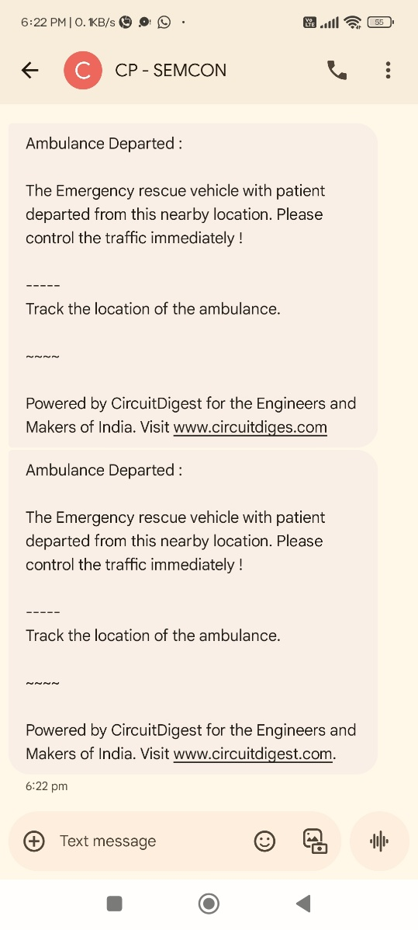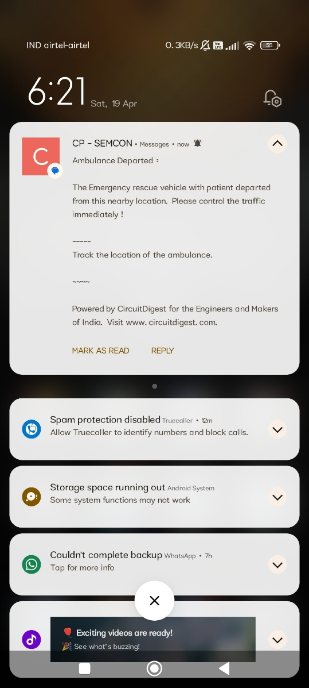

**Figure 1:** SMS received for controlling traffic

**Web Interface for patient data entry**

The system provides a lightweight web interface hosted on the ESP8266, which acts as a local server. Paramedics can connect a device to the same Wi-Fi network and access a web page to enter patient details such as name, age, blood group, and blood pressure. This data is submitted via HTTP POST and processed by the ESP8266, which updates virtual pins on the Blynk IoT platform. These details are instantly reflected on the Blynk dashboard, allowing hospital staff to view patient information in real time. This ensures efficient, seamless communication between ambulance paramedics and hospital authorities during emergencies.

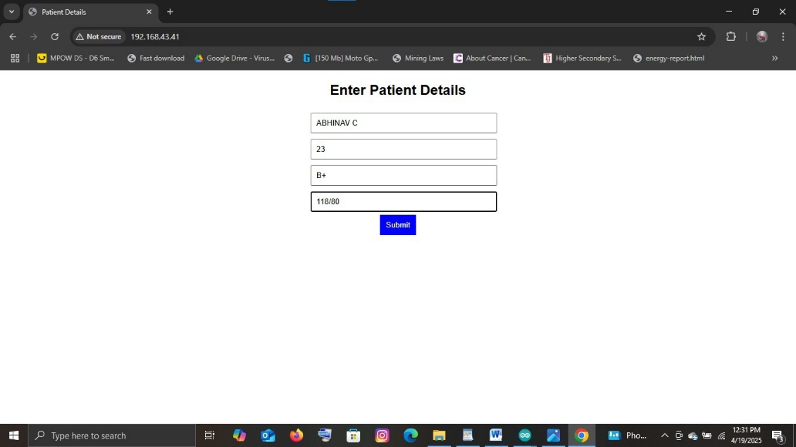

**Figure 2:** Web server Interface for entering patient details

**Sensor Data monitoring**

The system incorporates three biomedical sensors to continuously monitor vital signs such as temperature, heart rate, and SpO₂ during ambulance transit. These sensors interface with an Arduino board, which reads and processes the data. The processed information is then transmitted to the ESP8266 via serial communication. The ESP8266 uploads the sensor values to the Blynk IoT platform using virtual pins assigned to each parameter. Hospital staff can access and monitor these real-time readings through the Blynk mobile or web dashboard for timely medical response.

**1)LM35 temperature sensor**

The LM35 is an analogue temperature sensor that provides an output voltage linearly proportional to the ambient temperature in Celsius. It is connected to an analogue input pin of the Arduino, which reads the voltage and converts it to a temperature value using a simple formula. The data is then sent to the ESP8266 and displayed on the Blynk dashboard through a virtual pin (e.g., V2). The result can be visualized using a value display or a gauge widget showing the patient’s real-time body temperature.

**2)Pulse sensor**

The pulse sensor is an optical heart rate sensor that detects changes in blood volume through light absorption. It is connected to the Arduino’s analogue pin and calculates the patient’s beats per minute (BPM). The Arduino processes the pulse rate and sends it to the ESP8266, which updates the Blynk dashboard via a virtual pin (e.g., V0). The real-time BPM data is shown using a gauge or graph widget, allowing hospital staff to track heart rate trends during transit.

**3)Max30100 sensor**

The MAX30100 is a combined SpO₂ (oxygen saturation) and heart rate sensor that uses red and infrared LEDs to measure the oxygen level in the blood. It communicates with the Arduino via the I²C protocol. The Arduino processes both SpO₂ and pulse data and forwards the values to the ESP8266. The ESP8266 then uploads them to virtual pins on the Blynk platform (e.g., V4 for SpO₂, V0 or V1 for heart rate if not already used by pulse sensor). These values are displayed on the Blynk dashboard using gauge or value widgets.

**Blynk Dashboard**

The Blynk dashboard successfully displayed all the sensor readings in real time during testing. The temperature, heart rate, and SpO₂ values updated continuously, ensuring that hospital authorities could monitor the patient's condition live. Each widget on the Blynk app was linked to its corresponding virtual pin, and changes in patient vitals were reflected instantly with minimal delay. This real-time visibility significantly improves emergency preparedness by allowing medical teams to evaluate the patient’s condition before arrival, ensuring timely medical intervention

**LCD display**

A 16x2 LCD display inside the ambulance shows real-time patient vitals including temperature, heart rate, and SpO₂ levels. It is connected to an Arduino that collects and processes data from sensors. This allows paramedics to monitor the patient’s condition effectively, even without internet, ensuring timely decisions during emergencies.

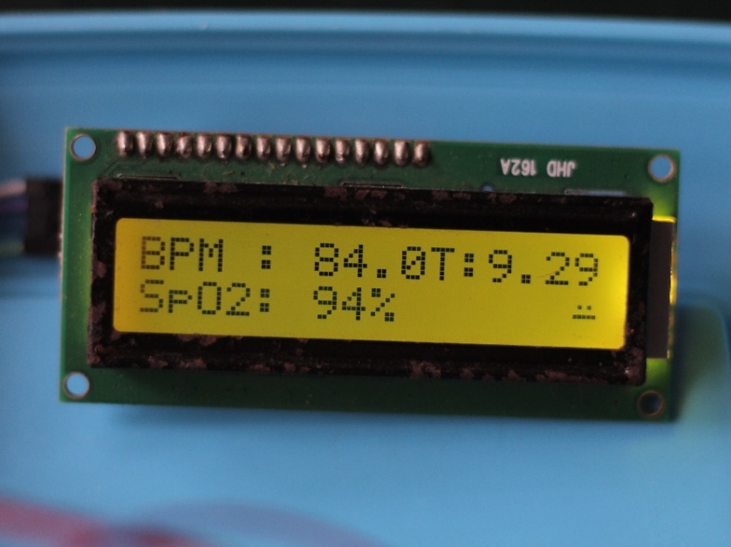

**Figure 3:** LCD displaying the real time output from sensors

**Blynk dashboard visualization**

The Blynk dashboard provides a cloud-based interface for real-time monitoring of patient health data during ambulance transit. Sensor readings such as body temperature, heart rate, and SpO₂ levels are transmitted via the ESP8266 microcontroller to the Blynk platform using virtual pins. These are visualized through gauges, value displays, and labeled widgets, along with patient details like name, age, blood group, and blood pressure. This live dashboard helps hospital staff monitor the patient’s condition remotely, enabling timely preparation, quick medical response, and efficient resource allocation.

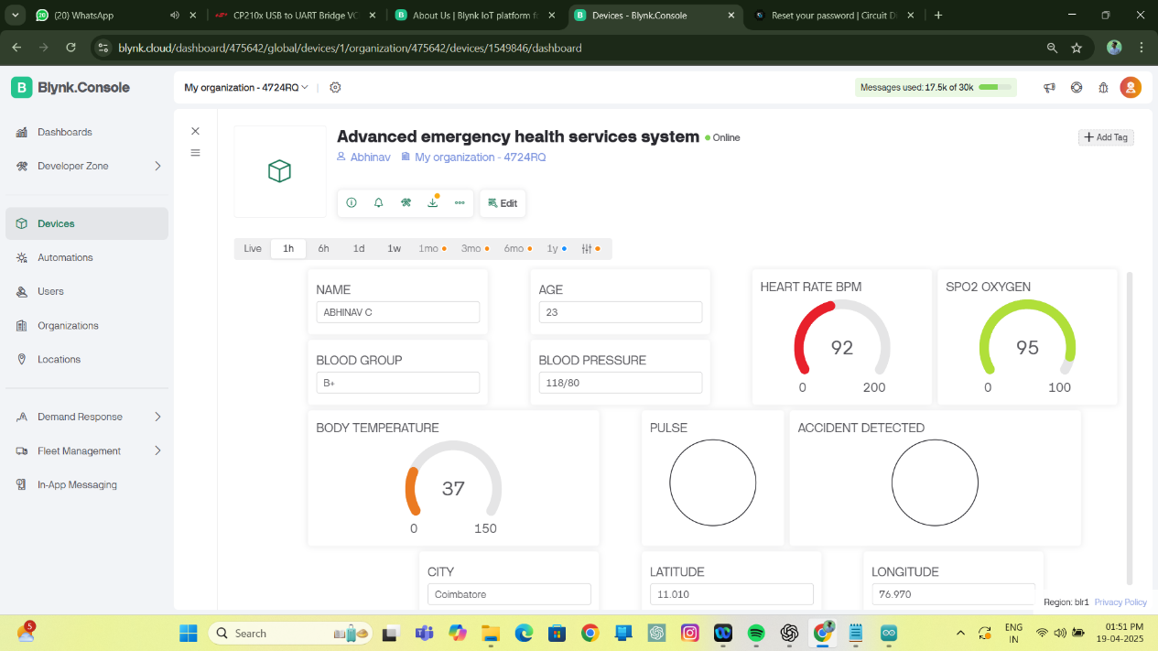

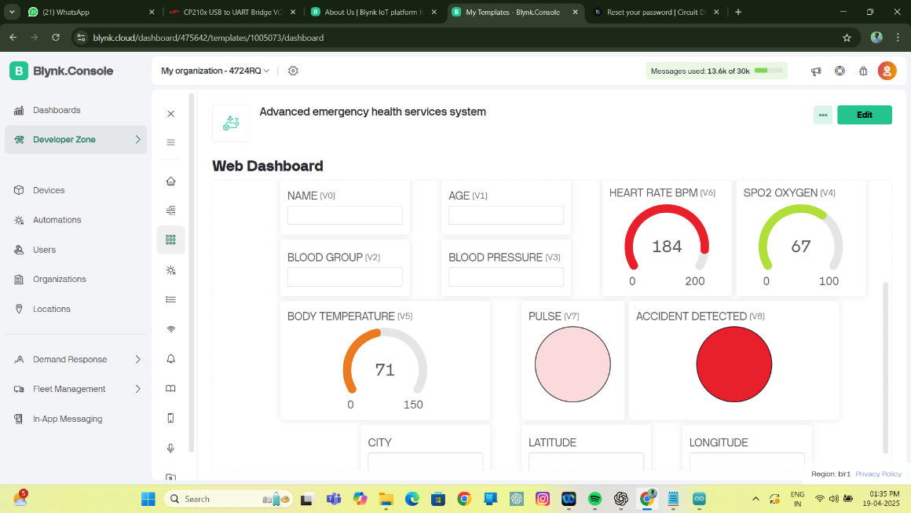

**Figure 4:** Hospital Dashboard displaying the output

**Accident detection and emergency alert system**

The accident detection and emergency alert system uses the MPU6050 accelerometer to monitor the ambulance's motion. When a sudden impact or abnormal acceleration is detected, the Arduino triggers a buzzer and alerts the ESP8266, which sends an emergency SMS via a cloud API. This ensures hospitals are immediately notified, enabling timely backup support and preparation for potential casualties.

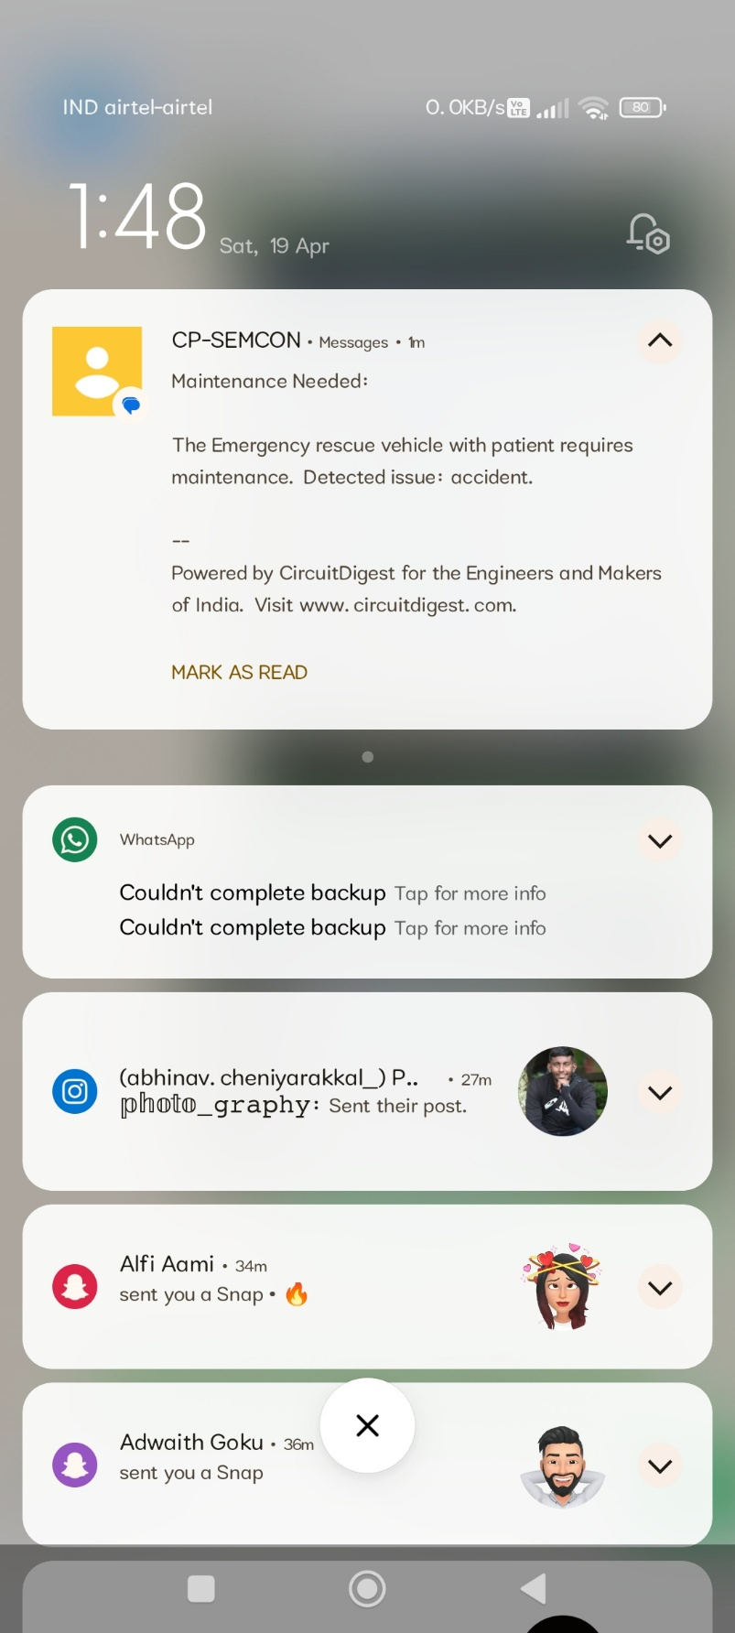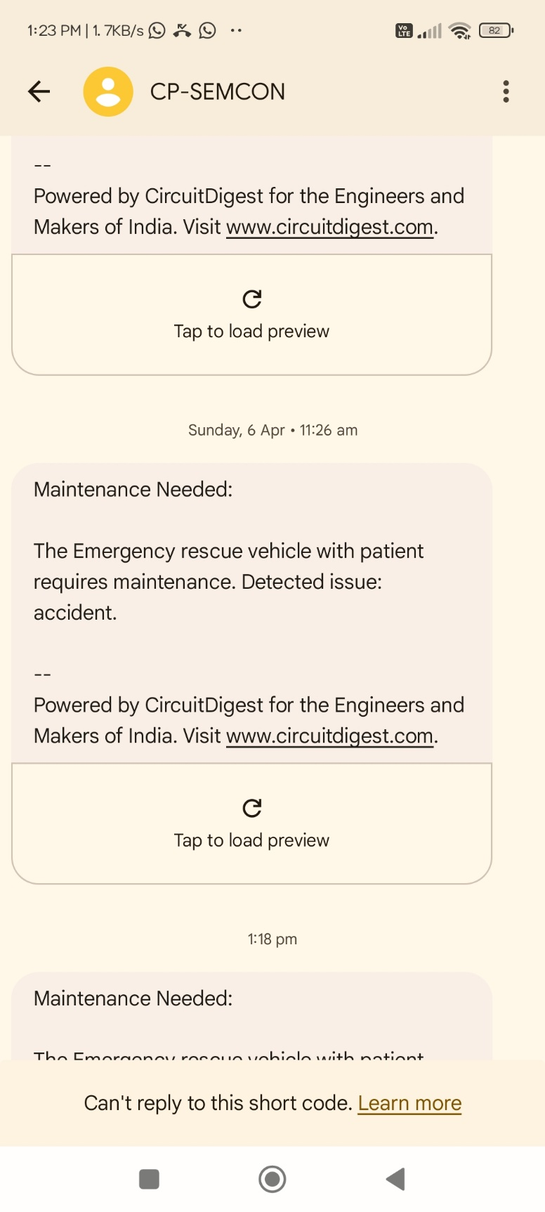

**Figure 5:** Emergency SMS alert received in case of an accident

**System Integration and final assembly**

The system integration and final assembly phase marked the culmination of the hardware and software development process, bringing together all individual modules into a cohesive, working prototype. This involved careful planning to physically assemble and logically coordinate the flow of data between components. The Arduino Uno was assigned the role of collecting real-time health data from biomedical sensors such as the LM35 temperature sensor, Pulse Sensor, and MAX30100 SpO₂ and heart rate sensor. These sensors were precisely connected to the Arduino's analog and I²C pins, with code written to process and structure the data before sending it to the ESP8266 microcontroller through serial communication.



**Figure 6:** Integrated Ambulance System prototype

The ESP8266 microcontroller acted as the central communication hub, responsible for establishing Wi-Fi connectivity, handling web server hosting, and transmitting data to the Blynk IoT platform. It received sensor data from the Arduino, updated the Blynk dashboard in real time, and displayed patient information such as temperature, heart rate, and SpO₂ levels for hospital staff to access remotely. In addition, the ESP8266 hosted a web interface that allowed paramedics to enter the patient’s name, age, blood group, and blood pressure, which were then sent to the hospital’s monitoring system via the cloud. The microcontroller also managed the SMS alert system, sending emergency messages to traffic control and hospital authorities whenever the push button or accident detection mechanism was triggered.

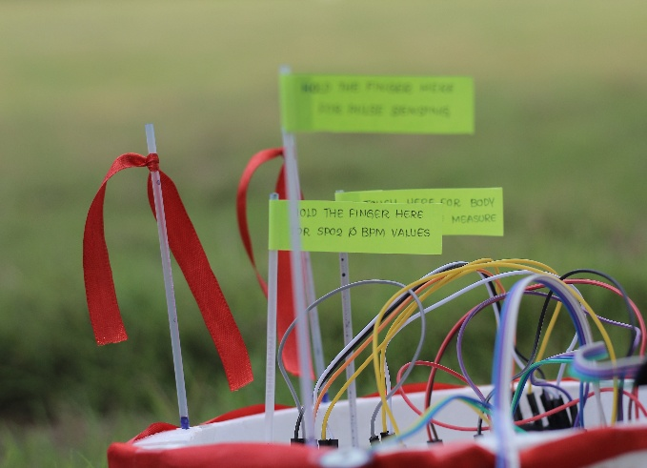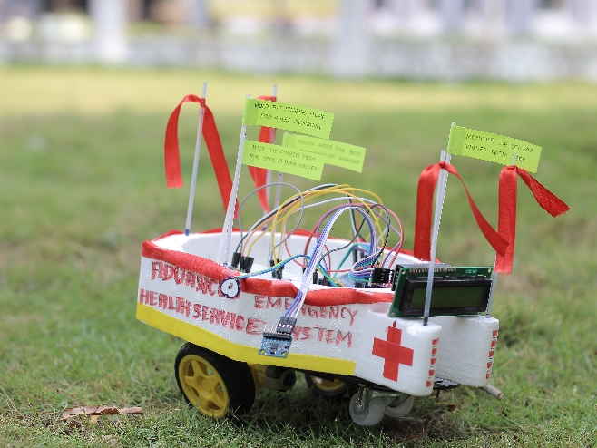

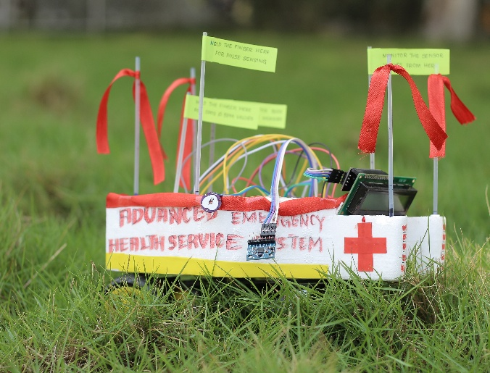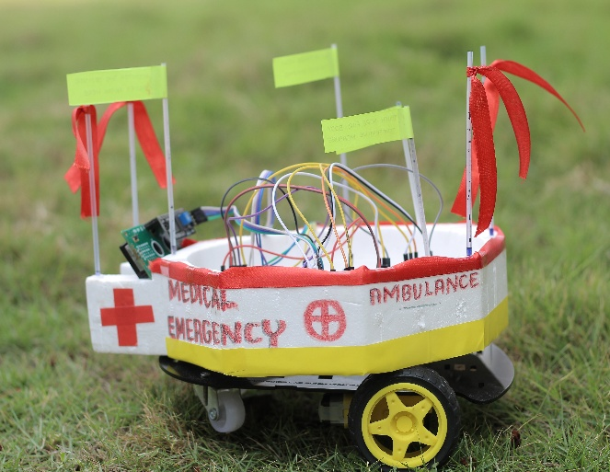

**Figure 7:** Final Implemented System in various angles

The MPU6050 accelerometer was integrated to detect any unusual acceleration or impact that could indicate an accident involving the ambulance. When such motion was detected, the system automatically activated a buzzer alarm to alert the onboard medical team and simultaneously sent an emergency SMS to the hospital. A 16x2 LCD display was mounted inside the ambulance to provide live visualization of the patient’s vitals, enabling paramedics to continuously monitor critical information even without internet connectivity. All hardware components were securely mounted on a breadboard or custom PCB, and powered by a regulated power supply to ensure stability during operation.

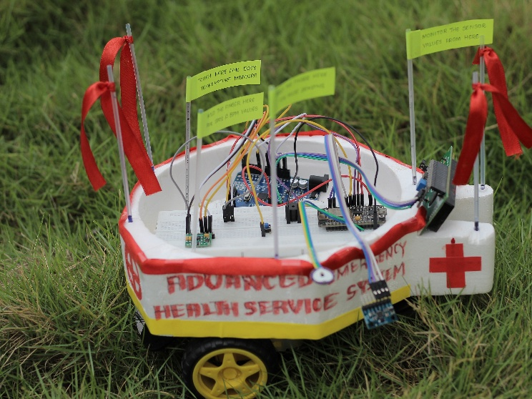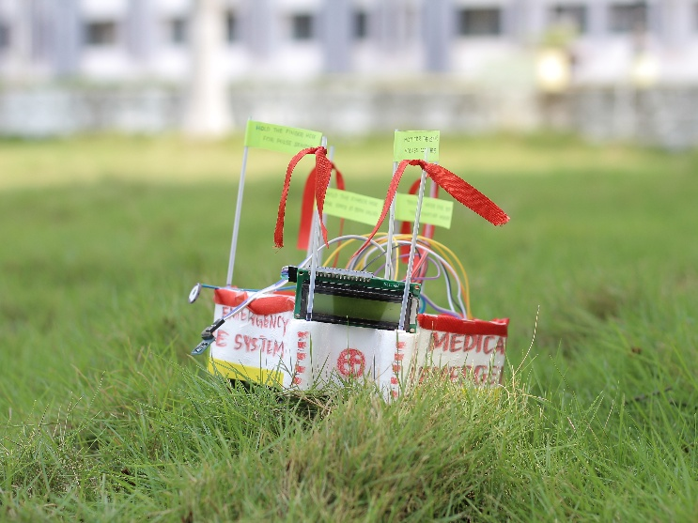

**Figure 8:** Aerial and Front view of the system

Extra attention was given to minimizing electrical noise and interference, ensuring reliable communication between modules and consistent data readings. Once assembled, the complete system was thoroughly tested in a controlled environment simulating emergency scenarios. Testing included verifying sensor accuracy, checking Blynk dashboard updates, validating the reliability of web form submissions, and confirming the functionality of the SMS alert features. The final prototype operated successfully, demonstrating its potential as a real-world solution for improving emergency medical services through seamless integration of IoT, communication, and health monitoring technologies.

1. **CONCLUSION**

The IoT-based Advanced Health Services system developed in this project provides comprehensive and practical solutions to key health emergency services challenges, including patient monitoring, hospital coordination, and intelligent traffic management. Integrates cheap biomedical sensors such as the Arduino LM35, Impulse sensor, MAX30100, and an ESP8266 microcontroller to continuously collect patient columns such as body temperature, heart rate, and SPO values. These measurements are transferred in real time to the Blynk-IoT platform via ESP8266, allowing hospital staff to monitor patient status during ambulance remote movement. A local 16x2-LCD display in the ambulance allows paramedics to instantly access patient data even in areas that are not connected to the Internet. The system also has a web interface hosted on the ESP8266, which captures the occurrence of patient details such as name, age, blood type, and blood pressure reflected in the Blynk dashboard. The accident recognition function using the MPU6050 sensor triggers a warning when it recognizes abnormal movements and sends an emergency SMS to hospital authorities. Additionally, an SMS-based traffic warning mechanism notifies you of traffic control for route releases. The system has been successfully implemented and tested, proved to be inexpensive, reliable and scalable. It demonstrates great possibilities for improving real-time communication, accelerated treatment and use in intelligent health infrastructure.

**ACKNOWLEDGEMENT**

The contentment and elation that accompany the completion of any task would be incomplete without the mention of the people who made it possible, and whose constant guidance and encouragement have strengthened our efforts toward success.

Firstly, I would like to thank my parents who have been given me such courage and destiny to carry out my work without many hurdles throughout the study period. Secondly, I am very much honored to thank my guide, **Dr. AZHA PERIASAMY,** Associate Professor Department of Electronics and Instrumentation, Bharathiar University, Coimbatore, without his support the compendium of the essence of the project would not have been achieved. I am also privileged to thank **Dr. J. VIJAYAKUMAR**, Associate Professor & Head of the Department, Bharathiar University, Coimbatore, who has always been concrete support to get going the project without any obstructions. I also thank **Dr. S. RATHINAVEL**, Assistant Professor and **Dr. K G PADMASINE**, Assistant Professor, Department of Electronics and Instrumentation, Bharathiar University, Coimbatore, encourage me during my research work.

Furthermore, I would like to thank all my family members, friends, scholars, and lab members for being with me alongside to give me the valor and grit to carry out all the immense works that have led me to this position. I wish to extend my sincere thanks to **Dr. R MAHESHWARAN, Mrs. DEVILALITHA**, and **Mrs. SANGEETHA**, department staffs, **Mrs. K KAVITHA BHARATHI,** Research scholar, Department of Electronics and Instrumentation, Bharathiar University, Coimbatore, Tamil Nadu.

1. **REFERENCES**
2. Saha, H. N., Raun, N. F., & Saha, M. (2017, August). Monitoring patient's health with smart ambulance system using Internet of Things (IOTs). In 2017 8th Annual Industrial Automation and Electromechanical Engineering Conference (IEMECON) (pp. 91-95). IEEE.
3. Vistro, D. M., Rehman, A. U., Mehmood, S., Idrees, M., & Munawar, A. (2020). AN IoT based approach for smart ambulance service using thingspeak cloud. Journal of Critical Reviews, 7(9), 1697-1703
4. Poonam, Y. M., & Mulge, Y. (2013). Remote temperature monitoring using LM35 sensor and intimate android user via C2DM service. International Journal of Computer Science and Mobile Computing, 2(6), 32-36.
5. Oyebola, B., & Toluwani, O. (2017). LM35 Based digital room temperature meter: a simple demonstration. Equatorial Journal of Computational and Theoretical Science, 2(1).
6. Deepika, k., vedanth, k., & tejesh, k. (2024). blood oxygen and heart rate monitor with max30100 and arduino. material science, 23(05).
7. Annapurna, B., Manda, A. P., Raj, A. C., Indira, R., Kumari, S. P., & Nagalakshmi, V. (2021). Max 30100/30102 sensor implementation to viral infection detection based on Spo2 and heartbeat pattern. Annals of the Romanian Society for Cell Biology, 25(2), 2053-2061.
8. Mostafa Ahmed Helmy, S., Mahmoud Amar, A., & El-Horabty, E. S. M. (2022). Internet of Things (IoT) based smart device for cardiac patients monitoring using Blynk App. International Journal of Intelligent Computing and Information Sciences, 22(4), 86-99.
9. Irawan, Y., Fernando, Y., & Wahyuni, R. (2019). Detecting Heart Rate Using Pulse Sensor as Alternative Knowing Heart Condition. Journal of Applied Engineering and Technological Science (JAETS), 1(1), 30-42.
10. Azlan, H. H., & Salimin, S. (2023). Vehicle accident detection system using accelerometer. Evolution in Electrical and Electronic Engineering, 4(1), 195-202.
11. Landa-Jimenez, M. A., Gonzalez-Gaspar, P., Montes-Gonzalez, F. M., Morgado-Valle, C., & Beltran-Parrazal, L. (2022). An open-source low-cost wireless sensor system for acquisition of human movement data. Anais da Academia Brasileira de Ciências, 94(1), e20191419.
12. Mesquita, J., Guimarães, D., Pereira, C., Santos, F., & Almeida, L. (2018, September). Assessing the ESP8266 WiFi module for the Internet of Things. In 2018 IEEE 23rd international conference on emerging technologies and factory automation (ETFA) (Vol. 1, pp. 784-791). IEEE.
13. Srivastava, P., Bajaj, M., & Rana, A. S. (2018, February). Overview of ESP8266 Wi-Fi module based smart irrigation system using IOT. In 2018 Fourth International Conference on Advances in Electrical, Electronics, Information, Communication and Bio-Informatics (AEEICB) (pp. 1-5). IEEE.
14. Umapathi, N., Sabbani, S., & Poovarasan, S. (2020, November). Person Location Tracking Using Global Positioning System and ESP8266 with Internet of Things. In International Conference on Futuristic Communication and Network Technologies (pp. 211-217). Singapore: Springer Nature Singapore.
15. Jawad, S., Munsif, H., Azam, A., Ilahi, A. H., & Zafar, S. (2021, December). Internet of things-based vehicle tracking and monitoring system. In 2021 15th International Conference on Open Source Systems and Technologies (ICOSST) (pp. 1-5). IEEE.
16. Karuppusamy, P. (2020). A sensor based IoT monitoring system for electrical devices using Blynk framework. Journal of Electronics and Informatics, 2(3), 182-187.
17. Kodali, R. K., & Soratkal, S. (2016, December). MQTT based home automation system using ESP8266. In 2016 IEEE Region 10 Humanitarian Technology Conference (R10-HTC) (pp. 1-5). IEEE.
18. Kodali, R. K., & Sahu, S. (2017, December). MQTT based vehicle accident detection and alert system. In 2017 3rd International Conference on Applied and Theoretical Computing and Communication Technology (iCATccT) (pp. 186-189). IEEE.
19. Mushahadah, M., Mohd Nizam, O., & Nurul Fatin, Z. (2017). SMS-based content alert: A digital library web-based system using SMS technology. 2017 Jurnal Kejuruteraan, Teknologi dan Sains Sosial, 3 (2).
20. Aziz, D. A. (2018). Webserver based smart monitoring system using ESP8266 node MCU module. International Journal of Scientific & Engineering Research, 9(6), 801-808.
21. Baballe, M. A. (2023). Accident detection system with gps, gsm, and buzzer. TMP Universal Journal of Research and Review Archives, 2(1), 28-36.