**Design and Implementation of a Cost-Effective Intelligent Garbage Classification and Sorting System Using Edge Impulse and ESP32-CAM**

**Mr. Deekshith1, Dr. Azha Periasamy2**

1Student, Electronics and Instrumentation, Bharathiar University, Coimbatore, Tamil Nadu, India

2Associate Professor, Electronics and Instrumentation, Bharathiar University, Coimbatore, Tamil Nadu, India

**ABSTRACT**

This project proposes a low-cost, smart waste segregation system using an ESP32-CAM and Edge Impulse for real-time object classification. Designed for household and small-scale applications, the system identifies and sorts waste into plastic and paper categories. A camera captures images, and a servo motor segregates waste based on the model’s predictions. Initially trained on a publicly available dataset, the model was later retrained using a custom dataset collected with the same ESP32-CAM, enhancing compatibility with the target hardware. Grayscale images were used to reduce processing load, aligning with the limited resources of the ESP32-CAM. The system demonstrated good results in the software environment and proved effective for limited classes. However, hardware implementation revealed increased inference time and reduced accuracy due to the limitations of the ESP32-CAM and grayscale imaging. Adding more classes impacted performance both in training and deployment. While higher-end hardware and larger datasets could improve accuracy, they would raise costs. This project instead emphasizes an affordable and scalable solution for waste segregation, aiming to tackle the broader waste problem through small, distributed contributions.

Keywords: Waste segregation, ESP32-CAM, Edge Impulse, Servo motor, Smart bin, Object classification

1. **INTRODUCTION**

Waste disposal is a highly important part of the green and clean environment. Regardless waste disposal leads to pollution, wastage of natural resources, and health risks. Manual sorting of waste is labor-intensive, susceptible to human error, costly, and labor-intensive. Lack of proper segregation of recyclables and non-recyclables is one of the problems in waste management, which leads to inefficient recycling and more landfill waste. To fill the gaps in these challenges, intelligent waste sorting and classification systems have come to the forefront in recent years. Emerging technologies in edge computing and embedded systems have allowed the creation of intelligent waste management solutions that are efficient without the need for cloud processing.

Intelligent waste sorting plants employ real-time image perception for waste category recognition and automatic segregation with little human intervention and more accuracy. Work in the area of embedded vision and low-power processing has proved that small-sized AI models can be embedded into low-resource hardware and enable autonomous sorting of waste for domestic and business use. The aim of this project is to build a smart waste classification and sorting system using the ESP32-CAM and Edge Impulse. ESP32-CAM is a low-resource microcontroller that has a built-in camera and Wi-Fi connection. It can be used for live image processing.

This strategy differs from traditional cloud-based models as it implements edge computing in order to handle images of garbage directly on the device, mitigating latency and server reliance. The system takes snapshots of waste materials, identifies them, and segregates them automatically with the help of a servo motor system. By integrating embedded computing with AI, this project improves waste segregation effectiveness and stimulates eco-friendly recycling. Although there are many merits to waste categorization by machine, there exist some challenges which need to be tackled. Ambient light conditions influence classification accuracy to some extent; therefore, methods for dataset optimization and preparation should be used. Also, methods of optimized deployment need to facilitate real-time work on low-energy hardware.

The first application of this system is the segregation of plastic and paper, but future developments plan to extend the functionality to more materials, including metal, glass, and organic waste, by broadening the dataset and improving the process of segregation.

1. **METHODOLOGY**

The creation of an intelligent garbage classification and sorting system using Edge Impulse and ESP32-CAM is structured with data acquisition, training of a machine learning model, embedded implementation, and performance testing. A waste image dataset is acquired under different lighting conditions and angles for improved generalization. Preprocessing of images involves resizing, normalization, and augmentation. Lightweight CNN is trained with Edge Impulse, with hyper parameters like epochs, learning rate, and batch size optimized to balance accuracy with efficiency. The trained network is quantized using INT8 profiling for efficient computation on ESP32-CAM. The ESP32-CAM with servo motors and an LDR sensor takes pictures of waste, classifies the images, and activates the sorting mechanism based on classification. System testing continuously analyzes classification accuracy, response time, and sorting performance in actual application conditions. The system's efficacy is confirmed with performance indicators including accuracy rates, inference time, and system dependability. It makes it feasible to have an economical and scalable solution for automating waste collection.

**2.1 HARDWARE COMPONENTS**

**ESP32-CAM**

The ESP32-CAM (AI-Thinker) module is a small development board with an ESP32-S microcontroller and a dual-core Xtensa LX6 processor at 240 MHz. It has 520 KB SRAM, 8 MB PSRAM, onboard Wi-Fi, Bluetooth 4.2, and a microSD interface (up to 4 GB). The module allows AI-enabled applications like image classification, face recognition, and smart surveillance. The OV2640 camera sensor, which has a 2 MP resolution of 1600×1200, offers auto-exposure, auto white balance, and adjustable focus. The ESP32-CAM is flashed using an external FTDI programmer and offers Edge Impulse and TensorFlow Lite for ML inference on the edge.

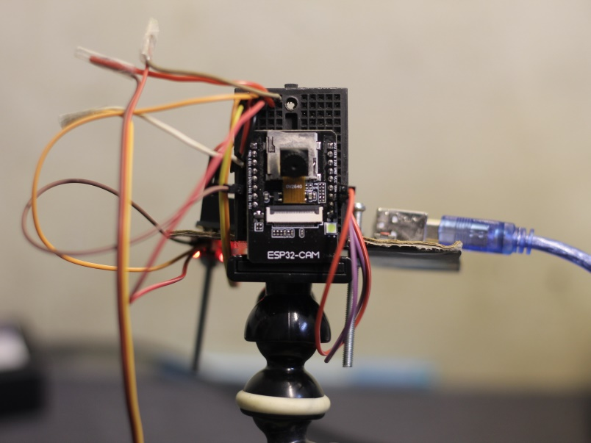

**Figure 1:** ESP32 CAM module on hardware setup

**Servo Motor**

Servo motors supply accurate control of position, acceleration, and speed. Feedback control mechanisms are operated by them, varying position as per input signals. Miniature but high-torque, servo motors find broad usage in robots and automation. Here, they are utilized for driving waste into appropriate compartments depending upon classification outcomes.

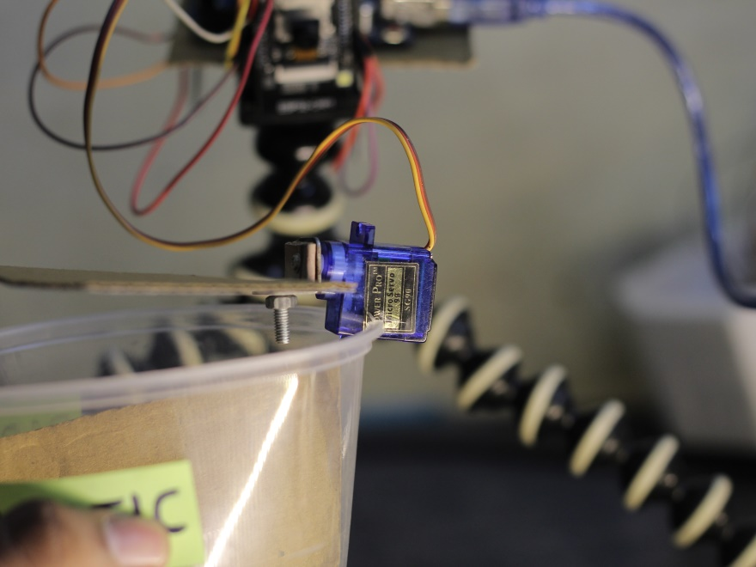

**Figure 2:** Servo motor on hardware setup

**LDR Sensor**

A Light Dependent Resistor (LDR) varies its resistance depending on the amount of light present. It behaves as an insulator when the light is dim and is conductive when bright. LDR sensors are applied for automatic brightness control in image capture, making sure that the classification accuracy is consistent across varying lighting conditions.

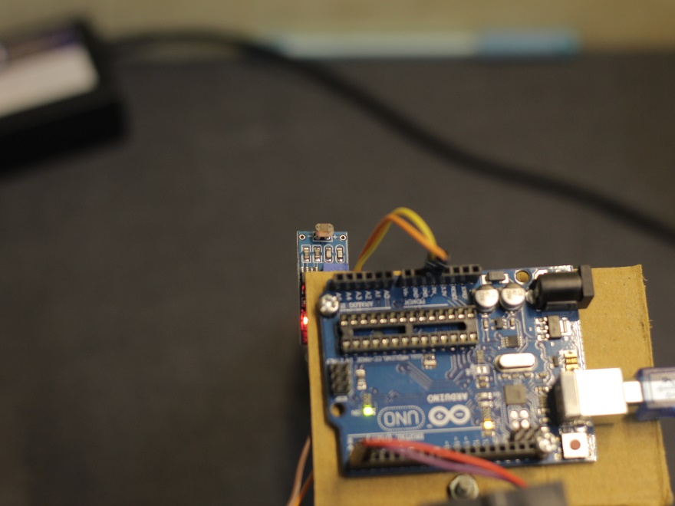

**Figure 3:** LDR sensor on hardware setup

**2.2 SOFTWARE CONFIGURATION**

**Edge Impulse**

Edge Impulse offers a cloud platform for developing AI models for edge devices. It facilitates data acquisition, feature extraction, model training, and deployment.

The process involves:

• Data Collection & Preprocessing: Image data acquisition, labeling, and feature extraction.

• Model Training & Optimization: CNN training, transfer learning, quantization, and hardware acceleration.

• Model Deployment: Exporting models in TensorFlow Lite format for deployment on ESP32-CAM, supporting real-time AI inference.

**Arduino IDE**

Arduino IDE is applied to write, compile, and upload software to ESP32-CAM. It is capable of C/C++ programming, offers a rich library ecosystem, and allows serial monitoring for debugging. It makes it easy to integrate ML models into the embedded system. This approach guarantees a realistic and effective way of AI-based waste classification through edge computing to enhance automation in smart waste management systems.

1. **RESULTS AND DISCUSSION**

The AI-based waste sorting system implemented using the ESP32-CAM demonstrated efficient performance across multiple machine learning models designed for classifying waste materials such as paper, plastic, and metal. Three different models were developed and tested using Edge Impulse, each optimized for varying levels of complexity and dataset characteristics. Model 1, trained on a pre-collected dataset with balanced paper and plastic samples, served as a baseline. However, due to moderate class overlap and differences in image capture conditions, it achieved a moderate F1 score of 73%, with noticeable misclassifications, including 30.5% of paper and 21.8% of plastic predicted as background. Model 2, trained on a custom ESP32-CAM dataset with three classes—metal, paper, and plastic—offered a more practical real-world solution. It achieved an impressive overall F1 score of 91.9%, with plastic being recognized with extremely high precision (98%) and recall (97%), and only minor confusion between metal and paper. Model 3, also trained on the user's ESP32-CAM dataset but limited to paper and plastic classes, delivered perfect classification performance with 100% F1 score, precision, and recall for all classes including background. However, due to the relatively small and imbalanced dataset, there is a possibility of overfitting. All models were quantized to INT8 and optimized using the EON Compiler in RAM-optimized configuration. The system utilized grayscale image processing to reduce memory load and integrated a digital LDR sensor to activate onboard LED lighting under low-light conditions, which improved image consistency and classification reliability. The servo motor precisely directed waste items to their respective bins, enhancing overall automation. Despite the strong performance, inference time remained a limitation across all models, averaging between 1103 ms and 1222 ms, which may impact responsiveness in high-speed sorting scenarios.

**Table 1.** Modal performance comparison

|  |  |  |  |
| --- | --- | --- | --- |
| Metric | Model 1 (Paper vs Plastic) | Model 2 (Metal, Paper, Plastic) | Model 3 (Paper vs Plastic) |
| Dataset Source | Pre-collected (External) | ESP32-CAM (Custom) | ESP32-CAM (Custom) |
| Classes | Paper, Plastic | Metal, Paper, Plastic | Paper, Plastic |
| Overall F1 Score | 73% | 91.9% | 100% |
| Paper F1 Score | 0.73 | 0.76 | 1.0 |
| Plastic F1 Score | 0.74 | 0.98 | 1.0 |
| Metal F1 Score | — | 0.94 | — |
| Inference Time (ms) | 1103 | 1140 | 1222 |
| RAM Usage (KB) | 119.4 | 119.4 | 119.4 |
| Flash Usage (KB) | 90.8 | 90.8 | 90.8 |
| Misclassification to BG | 30.5% (Paper), 21.8% (Plastic) | None | None |
| Class Confusion Observed | Yes (Paper-Plastic) | Slight (Metal-Paper) | None |

The developed smart waste sorting system effectively integrates machine learning, computer vision, and embedded hardware to offer a practical solution for small-scale waste management. At the heart of the system lies the ESP32-CAM, a compact and affordable microcontroller with an integrated camera, responsible for capturing waste item images and running classification models trained using the Edge Impulse platform. To optimize resource usage, image capture was performed in grayscale, significantly reducing memory load on the ESP32-CAM. This trade-off, while improving efficiency, slightly reduced the system's ability to differentiate between similar textures—particularly noticeable in classes with visual similarity, such as paper and metal. An adaptive lighting mechanism, enabled via a digital LDR sensor, was crucial in maintaining consistent image quality. It automatically triggered the onboard LED under low-light conditions, contributing positively to classification accuracy.

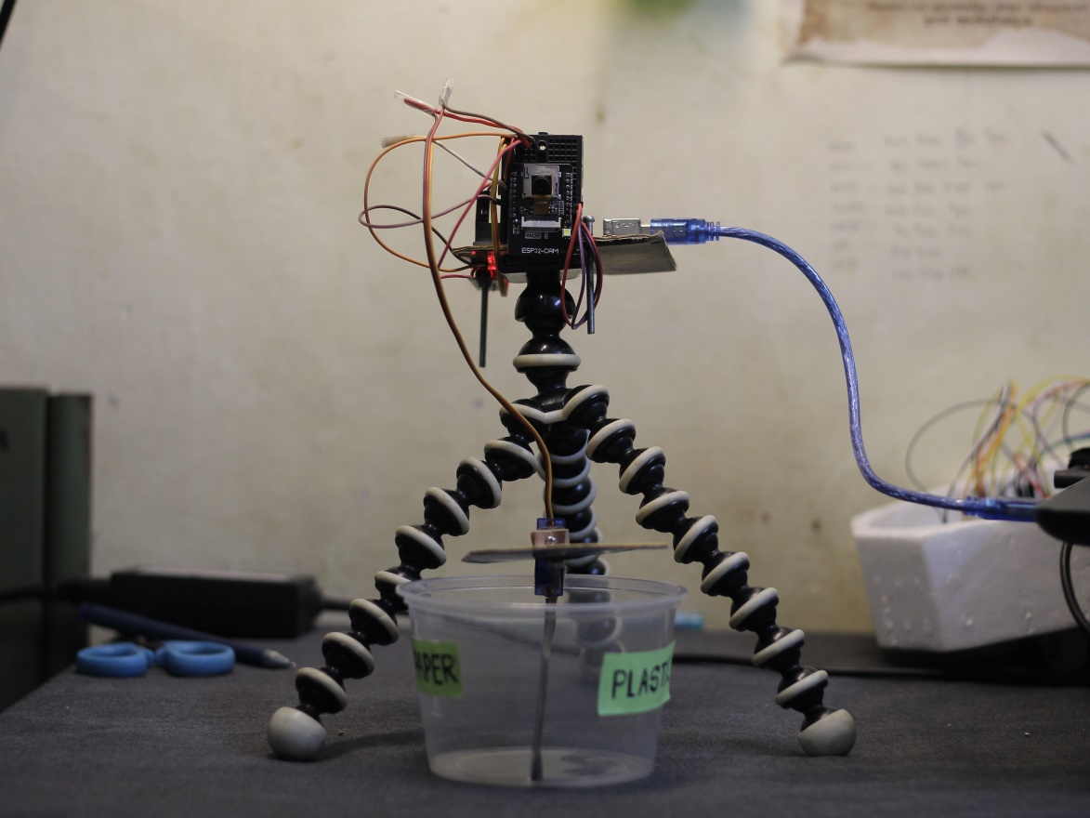

**Figure 4:** Hardware setup at initial condition

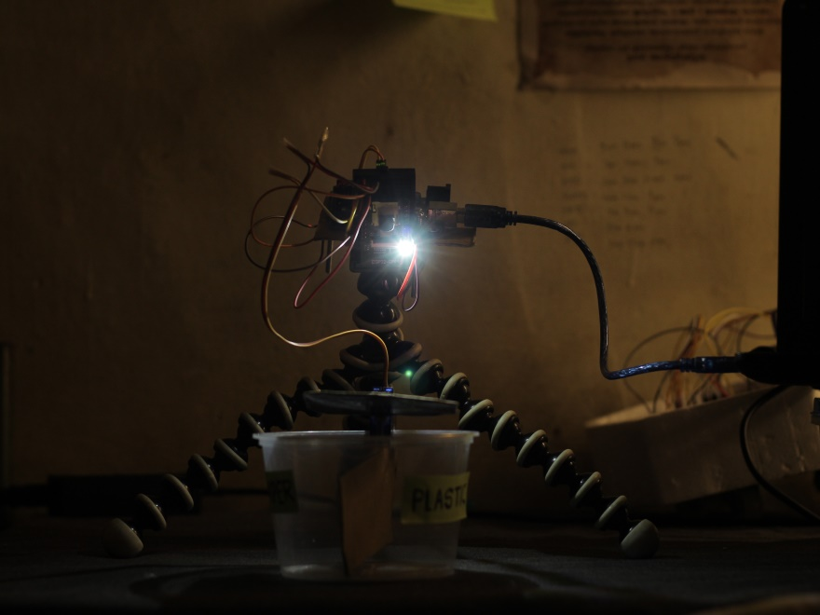

**Figure 5:** Hardware setup in low light condition

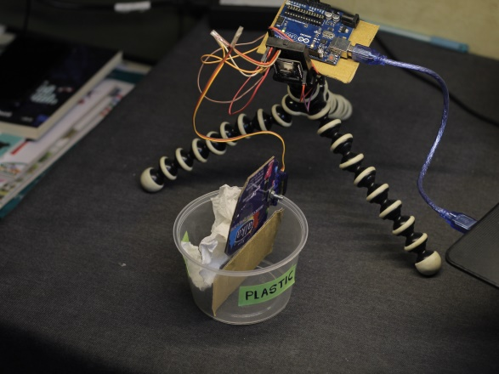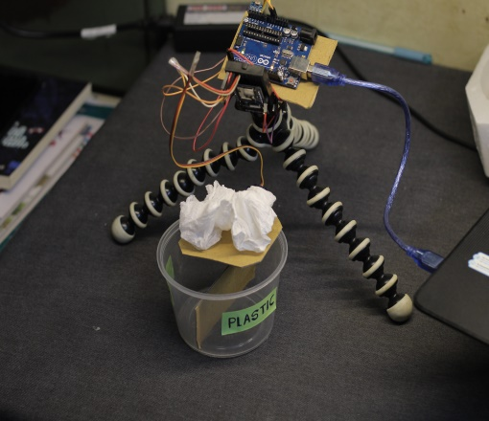

**Figure 6:** Paper material sorting in hardware setup

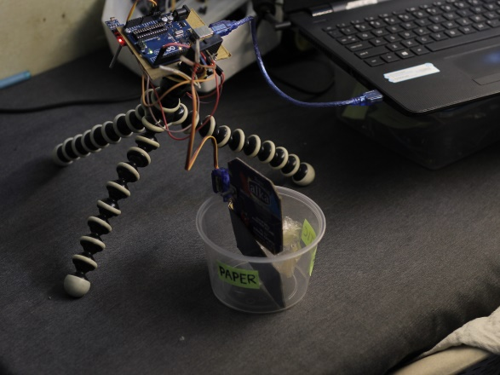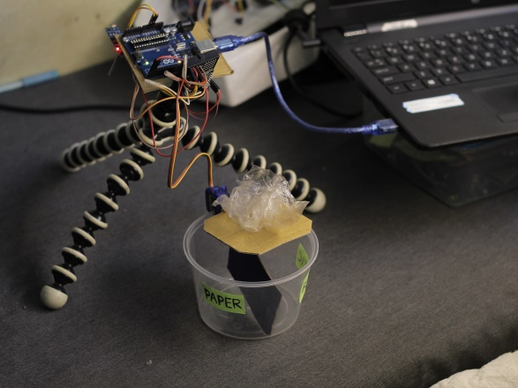

**Figure 7:** plastic material sorting in hardware setup

Three different models were trained and evaluated:

Model 1, based on a pre-collected dataset, served as a performance benchmark. Despite balanced class representation, moderate class overlap and mismatched data capture environments led to a relatively low F1 score of 73%. Misclassifications, especially into the background class, highlighted the limitations of deploying externally sourced datasets on ESP32 hardware. Model 2, developed using a custom ESP32-CAM dataset, incorporated three classes: metal, paper, and plastic. It demonstrated the highest practical value with an overall F1 score of 91.9%, minimal misclassifications, and reliable performance across all classes—especially plastic, which showed 98% precision and 97% recall. This model showcases the benefit of aligning training conditions with real-world deployment environments. Model 3, a two-class model (paper vs. plastic) trained on the same ESP32-CAM dataset, achieved perfect performance with 100% F1 score, precision, and recall. While this result indicates excellent model fit, it also raises the possibility of overfitting, especially given the smaller and imbalanced dataset. Additionally, this model had the highest inference time at 1222 ms, potentially limiting responsiveness in time-sensitive applications. All models were quantized to INT8 and deployed in a RAM-optimized configuration using Edge Impulse's EON Compiler, ensuring they operated within the ESP32-CAM’s memory constraints (119.4 KB RAM and 90.8 KB Flash). Despite excellent software-level results, hardware testing revealed several real-world constraints—such as inference delays, limited support for more than two classes in simpler models, and sensitivity to lighting and object orientation. These were partially mitigated through the use of custom datasets and hardware-based lighting adjustments. This project demonstrates that lightweight AI models, when combined with low-power, adaptive embedded systems, can offer scalable and cost-effective waste sorting solutions. With improvements in processing speed, image input (e.g., switching to RGB), and dataset diversity, the system has strong potential for expansion into more complex classification tasks, making it suitable for deployment in homes, offices, and community-level recycling infrastructure.

1. **CONCLUSION**

The ESP32-CAM-based garbage sorting system, enhanced by AI, presents a practical and scalable solution for small-scale waste segregation by integrating machine learning, computer vision, and embedded systems. Using Edge Impulse, three distinct image classification models were developed each demonstrating unique strengths based on their dataset source, class complexity, and real-world adaptability. Model 1, trained on a pre-collected dataset, served as a baseline with moderate performance (F1 score: 73%), revealing the limitations of using externally sourced data on embedded platforms. Model 2, developed using a balanced and custom ESP32-CAM dataset with three waste categories (metal, paper, plastic), achieved an overall F1 score of 91.9%, making it the most realistic and deployable option. Model 3, a binary classifier for paper and plastic using the same custom dataset, attained 100% precision, F1 score, and recall though with potential overfitting and the highest inference time (1222 ms). The hardware implementation successfully utilized grayscale image capture for memory efficiency and a digital LDR sensor for adaptive lighting. The LED-based illumination system maintained consistent image clarity across varying light conditions, significantly improving classification accuracy. A servo motor was integrated to physically route waste based on classification, validating the end-to-end functionality of the sorting system. While high classification accuracy was achieved, limitations such as inference delay, reduced detail in grayscale images, and scalability constraints for multi-class models highlighted areas for further development. Despite these challenges, the project demonstrates the feasibility of deploying low-cost, AI-powered embedded systems for autonomous waste sorting. Its compact design, low power consumption, and minimal need for user interaction make it highly suitable for homes, offices, and community bins. With continued refinement—such as support for RGB images, faster inference hardware, and more diverse datasets—the system holds strong potential for expansion into more complex waste classification tasks. It offers a sustainable approach to waste management and contributes meaningfully toward eco-friendly, automated recycling solutions aligned with future smart city and environmental goals.

**ACKNOWLEDGEMENT**

Firstly, I am grateful to the Almighty for giving me the strength to carry out this study. I sincerely thank my guide, **Dr. AZHA PERIYASAMY**, Associate Professor, whose unwavering support was instrumental in this project. I extend my gratitude to **Dr. J. VIJAYAKUMAR**, Associate Professor and Head of the Department, for his constant encouragement. I also thank **Dr. S. RATHINAVEL** and **Dr. K. G. PADMASINE**, Assistant Professors, for their motivation during my research. Special thanks to **Dr. R. MAHESHWARAN, Mrs. DEVI LALITHA, and Mrs. SANGEETHA**, Computer Operator, for their support.Finally, I deeply appreciate my family, friends, scholars, and lab members for their unwavering encouragement, and I am profoundly grateful to my parents and friends for guiding me throughout this journey.

1. **REFERENCES**
2. Badan, F., Sekanina, L. (2019). Optimizing Convolutional Neural Networks for Embedded Systems by Means of Neuroevolution. In: Martín-Vide, C., Pond, G., Vega-Rodríguez, M. (eds) Theory and Practice of Natural Computing. TPNC 2019. Lecture Notes in Computer Science(), vol 11934. Springer, Cham. <https://doi.org/10.1007/978-3-030-34500-6_7>
3. Pérez, I., & Figueroa, M. (2021). A Heterogeneous Hardware Accelerator for Image Classification in Embedded Systems. Sensors, 21(8), 2637. <https://doi.org/10.3390/s21082637>
4. M. M. H. Shuvo, S. K. Islam, J. Cheng and B. I. Morshed, "Efficient Acceleration of Deep Learning Inference on Resource-Constrained Edge Devices: A Review," in Proceedings of the IEEE, vol. 111, no. 1, pp. 42-91, Jan. 2023, doi: 10.1109/JPROC.2022.3226481.
5. Hirve, Ashvini, Vision Safe Using ESP32-CAM (December 28, 2023). Available at SSRN: https://ssrn.com/abstract=4867417 or <http://dx.doi.org/10.2139/ssrn.4867417>
6. W. Yu et al., "A Survey on the Edge Computing for the Internet of Things," in IEEE Access, vol. 6, pp. 6900-6919, 2018, doi: 10.1109/ACCESS.2017.2778504.
7. J. Pan and J. McElhannon, "Future Edge Cloud and Edge Computing for Internet of Things Applications," in IEEE Internet of Things Journal, vol. 5, no. 1, pp. 439-449, Feb. 2018, doi: 10.1109/JIOT.2017.2767608.
8. L. Jiao and J. Zhao, "A Survey on the New Generation of Deep Learning in Image Processing," in IEEE Access, vol. 7, pp. 172231-172263, 2019, doi: 10.1109/ACCESS.2019.2956508.
9. H. Mao, S. Yao, T. Tang, B. Li, J. Yao and Y. Wang, "Towards Real-Time Object Detection on Embedded Systems," in IEEE Transactions on Emerging Topics in Computing, vol. 6, no. 3, pp. 417-431, 1 July-Sept. 2018, doi: 10.1109/TETC.2016.2593643.
10. P. Karvelis et al., "Adopting and Embedding Machine Learning Algorithms in Microcontroller for Weather Prediction," 2018 International Conference on Intelligent Systems (IS), Funchal, Portugal, 2018, pp. 474-478, doi: 10.1109/IS.2018.8710520.
11. Ajani, Taiwo Samuel, Agbotiname Lucky Imoize, and Aderemi A. Atayero. 2021. "An Overview of Machine Learning within Embedded and Mobile Devices–Optimizations and Applications" Sensors 21, no. 13: 4412. <https://doi.org/10.3390/s21134412>
12. M. S. Diab and E. Rodriguez-Villegas, "Embedded Machine Learning Using Microcontrollers in Wearable and Ambulatory Systems for Health and Care Applications: A Review," in IEEE Access, vol. 10, pp. 98450-98474, 2022, doi: 10.1109/ACCESS.2022.3206782.
13. R. Chauhan, K. K. Ghanshala and R. C. Joshi, "Convolutional Neural Network (CNN) for Image Detection and Recognition," 2018 First International Conference on Secure Cyber Computing and Communication (ICSCCC), Jalandhar, India, 2018, pp. 278-282, doi: 10.1109/ICSCCC.2018.8703316.
14. Yu Han Liu 2018 J. Phys.: Conf. Ser. 1087 062032
15. Boukaye Boubacar Traore, Bernard Kamsu-Foguem, Fana Tangara,Deep convolution neural network for image recognition,Ecological Informatics,Volume 48,2018,Pages 257-268,ISSN 1574-9541, <https://doi.org/10.1016/j.ecoinf.2018.10.002>.
16. R B Salikhov et al 2021 J. Phys.: Conf. Ser. 2096 012109.DOI 10.1088/1742-6596/2096/1/012109
17. Dokic, K. (2020). Microcontrollers on the Edge – Is ESP32 with Camera Ready for Machine Learning?. In: El Moataz, A., Mammass, D., Mansouri, A., Nouboud, F. (eds) Image and Signal Processing. ICISP 2020. Lecture Notes in Computer Science(), vol 12119. Springer, Cham. <https://doi.org/10.1007/978-3-030-51935-3_23>
18. Minh Tri Lê, Pierre Wolinski, Julyan Arbel. Efficient Neural Networks for Tiny Machine Learning: A Comprehensive Review. 2023. ⟨hal-04296440⟩
19. J. Lin, L. Zhu, W. -M. Chen, W. -C. Wang and S. Han, "Tiny Machine Learning: Progress and Futures [Feature]," in IEEE Circuits and Systems Magazine, vol. 23, no. 3, pp. 8-34, thirdquarter 2023, doi: 10.1109/MCAS.2023.3302182.
20. Siang, Y. Y. ., Ahamd, M. R. ., & Zainal Abidin, M. S. (2021). Anomaly Detection Based on Tiny Machine Learning: A Review. Open International Journal of Informatics, 9(Special Issue 2), 67–78. [https://doi.org/10.11113/oiji2021.9nSpecial Issue 2.148](https://doi.org/10.11113/oiji2021.9nSpecial%20Issue%202.148)
21. L. Capogrosso, F. Cunico, D. S. Cheng, F. Fummi and M. Cristani, "A Machine Learning-Oriented Survey on Tiny Machine Learning," in IEEE Access, vol. 12, pp. 23406-23426, 2024, doi: 10.1109/ACCESS.2024.3365349.
22. S. A. R. Zaidi, A. M. Hayajneh, M. Hafeez and Q. Z. Ahmed, "Unlocking Edge Intelligence Through Tiny Machine Learning (TinyML)," in IEEE Access, vol. 10, pp. 100867-100877, 2022, doi: 10.1109/ACCESS.2022.3207200.
23. Hymel, Shawn ; Banbury, Colby ; Situnayake, Daniel ; Elium, Alex ; Ward, Carl ; Kelcey, Mat ; Baaijens, Mathijs ; Majchrzycki, Mateusz ; Plunkett, Jenny ; Tischler, David ; Grande, Alessandro ; Moreau, Louis ; Maslov, Dmitry ; Beavis, Artie ; Jongboom, Jan ; Janapa Reddi, Vijay. <https://doi.org/10.48550/arXiv.2212.03332>
24. Sharuiev, R. D. Research of the Characteriscs of a Convoluonal Neural Network on the ESP32-CAM Microcontroller / Sharuiev R. D., Popovych P. V. // Мікросистеми, Електроніка та Акустика : науково-технічний журнал. – 2023. – Т. 28, № 2(124). – С. 277487.1 - 277487.7. – Бібліогр.: 26 назв. https://ela.kpi.ua/handle/123456789/61337. <https://doi.org/10.20535/2523-4455.mea.277487>
25. Pinaso, G. R.;Figueiredo, L. M.;Rosa Júnior, O.;Richetto, M. R. S. Edge Impulse Potential to Enhance Object Recognition Through Machine Learning,doi: 10.5433/1679-0375.2024.v45.49197.