***NeoLearn:A Cross-Platform Mobile Application for Interactive and Modular E-Learning***

**M.Kiruthika1., A.Siva Ganesh2.,**

1Department of MCA,

2Assistant Professor, Department of MCA,

1,2Mepco Schlenk Engineering College, Sivakasi– 626124

1yashikakiruthika\_mca25@mepcoeng.ac.in, 2sivaganesha@mepcoeng.ac.in

**Abstract**

In the current era of digital learning, scalable and personalized e-learning platforms are essential for enhancing student engagement and academic outcomes. This paper introduces NeoLearn, an interactive e-learning application designed to cater to the academic and skill-development needs of students through structured course management, live virtual sessions, and automated certification. The platform comprises dedicated modules for user authentication, course enrollment, quiz assessments, online meetings, notifications, and payment management. Developed using Flutter for the front end and Spring Boot for the backend with PostgreSQL as the database, NeoLearn ensures a seamless and secure user experience. Razorpay integration facilitates smooth financial transactions for course enrollments. This paper details the design, architecture, and functionality of NeoLearn and evaluates its impact on enhancing user participation and learning outcomes.

**Keywords :** E-learning, Mobile Application, Flutter, Spring Boot, Course Management, Virtual Classroom, Online Certification, Payment Integration, NeoLearn.

**1. Introduction**

The exponential growth of internet connectivity and mobile technology has transformed the educational landscape,

making e-learning an indispensable mode of instruction. Traditional learning models often lack the flexibility, accessibility, and personalization required by modern learners. In response to these challenges, numerous educational platforms have emerged, offering digital courses, video lectures, assessments, and certification. However, many of these platforms are either too generalized or do not fully address the practical needs of students, such as real-time interaction with trainers, progress tracking, or flexible payment models.

**1.1 Need for a Student-Centric E-Learning Platform**

To bridge this gap, NeoLearn is developed as a student-focused, mobile based e-learning platform designed to deliver an enriched and holistic learning experience. The core objective of NeoLearn is to simplify the way students enroll in courses, attend live sessions, take assessments, receive certifications, and manage payments - all within a single unified application.

**1.2 Platform Overview**

NeoLearn provides an intuitive interface and a modular architecture that facilitates smooth navigation across multiple features such as personalized dashboards, virtual classroom scheduling, course progress tracking, certificate preview/download, and a dynamic notification system. The platform is built using Flutter for cross-platform front-end development, Spring Boot for backend RESTful services, and PostgreSQL as the relational database. Secure payment integration is achieved via Razorpay, and JWT (JSON Web Token)-based authentication ensures secure access.

**1.3 Core Features of NeoLearn**

NeoLearn offers a user-friendly interface with a modular architecture that ensures smooth navigation through multiple features, including:

**Personalized Dashboards:** Customizable dashboards that track students' progress and provide easy access to relevant courses and notifications.

**Virtual Classroom Scheduling:** Integration with online meeting platforms for seamless scheduling and joining of live sessions.

**Course Progress Tracking:** Real-time updates on the student's progress within a course, helping both students and trainers monitor performance.

**Certificate Preview/Download:** Students can view and download their course completion certificates directly from the platform.

**Dynamic Notification System:** Real-time alerts for upcoming sessions, assignments, payments, and new course offerings.

**2. Literature Review**

The proliferation of internet access and mobile technology has revolutionized the field of education, particularly with the rise of e-learning platforms. These platforms provide flexible, accessible, and personalized learning experiences that cater to a global audience. With features such as on-demand video lectures, assessments, discussion forums, and certification programs, e-learning has become an integral part of modern education. However, the effectiveness of many platforms is often compromised by issues such as poor user experience, lack of real-time interaction with trainers, and the absence of seamless progress tracking. The NeoLearn platform aims to address these challenges by offering a fully integrated solution that provides a personalized, engaging, and efficient learning experience.

### 2.1 Existing E-Learning Systems and Their Limitations

Several established e-learning platforms, including Udemy, Coursera, and Khan Academy, provide a wide range of online courses and learning resources. While these platforms offer high-quality content and global reach, they often lack features such as real-time trainer interaction, flexible trainer selection, and personalized course experiences.  
 Most existing platforms assign a fixed trainer or instructor for a course, limiting the learner's choice based on their preferences or prior trainer ratings. Additionally, student-trainer engagement is typically asynchronous and lacks interactive features such as live discussions or feedback sessions. Platforms also tend to offer rigid payment structures, requiring upfront full payments, which can be a barrier for many learners.

**2.2 Trainer Selection and Rating Mechanism**

A distinguishing feature of NeoLearn is its trainer selection and rating mechanism, which enhances personalization and encourages quality instruction. In most traditional e-learning platforms, students are typically assigned a trainer automatically or follow pre-recorded sessions with limited choice. This often overlooks individual preferences and the importance of trainer compatibility.

NeoLearn addresses this gap by allowing students to view and select from a list of available trainers for each course, along with their ratings and reviews provided by other students. This empowers learners to make informed decisions based on trainer performance and teaching style. Additionally, once a student completes a course, they are prompted to rate the trainer, contributing to a dynamic feedback loop that maintains the quality of instruction and fosters accountability.

This two-way evaluation model benefits both students and trainers:

· Students can choose trainers aligned with their learning preferences.

· Trainers receive direct feedback, which can be used to improve content delivery and build a reputation within the platform.

By integrating this feature, NeoLearn promotes a more learner-centric, transparent, and performance-driven educational environment, setting it apart from conventional platforms that lack such interactivity and personalization.

**2.3 How NeoLearn Differs**

NeoLearn is designed to address these limitations by offering:

· **Dynamic Trainer Selection:** Students can view available trainers for a course and choose one based on ratings and preferences.

· **Trainer Rating System:** After course completion, students rate trainers, contributing to future selection decisions.

· **Live Interaction:** Integrated virtual meetings allow real-time sessions with chosen trainers.

· **Flexible Payment System:** Students can opt for installment-based or flexible payment options via Razorpay.

· **Mobile-First Personalization:** Built on Flutter, NeoLearn offers a responsive and adaptive mobile-first experience across platforms.

These unique aspects distinguish NeoLearn from the more static, one-size-fits-all nature of traditional e-learning platforms.

### 2.4 Integration of Real-Time Communication in E-Learning

One of the key limitations of traditional e-learning platforms is the lack of real-time communication between instructors and students. Asynchronous course delivery, though convenient, often lacks the immediacy and personal touch that can be crucial for certain subjects. Real-time communication tools such as video conferencing, live chat, and collaborative whiteboards offer opportunities for interactive learning. NeoLearn addresses this by integrating virtual classrooms with live sessions, allowing instructors to engage with students in real time. The platform’s backend, powered by Spring Boot, ensures seamless communication between students and trainers during live sessions, providing a truly interactive learning experience.

### 2.5 Role of Mobile Platforms in E-Learning

Mobile devices have become essential tools for education, offering students the flexibility to learn from anywhere, at any time. With mobile applications, learners can access course materials, attend live sessions, participate in discussions, and complete assignments directly from their smartphones or tablets. In particular, cross-platform frameworks like Flutter have become increasingly popular for building mobile e-learning applications, as they provide a unified codebase for both Android and iOS. NeoLearn leverages Flutter for cross-platform development, enabling it to reach a wider audience and provide a consistent user experience across devices. Additionally, Flutter's rich set of pre-built widgets and plugins helps streamline the development process and improve the app’s performance.

A virtual person is

based on machine learning and Artificial Intelligence (AI)

concepts and due to dynamic nature, there is a drawback in the

design and development of these chatbots as they have built-in AI,

NLP, programming and conversion services

A virtual person is

based on machine learning and Artificial Intelligence (AI)

concepts and due to dynamic nature, there is a drawback in the

design and development of these chatbots as they have built-in AI,

NLP, programming and conversion serv

1. **Proposed Work**

NeoLearn is architected as a modular, service-oriented application, following a client-server model. The system comprises three core layers: Frontend (Client-Side), Backend (Server-Side), and Database (Storage Layer). Each component plays a vital role in delivering a responsive, scalable, and secure learning experience.

The frontend of NeoLearn is developed using Flutter, an open-source UI toolkit by Google. Flutter allows for cross-platform compatibility, enabling the app to run on both Android and iOS devices using a single codebase. Key design principles applied in the UI include:

· Clean, material-style interface with modular screens.

· Bottom navigation bar for intuitive screen transitions.

· Stateful and stateless widgets for optimized performance.

· Secure storage integration for token management using Flutter Secure Storage.

The backend services are built using Spring Boot, a Java-based framework designed for rapid API development and enterprise-level scalability. It follows RESTful principles to expose secure endpoints to the frontend. All communication between client and server is encrypted using HTTPS protocols. Important backend functionalities include:

**User Authentication:** Secure JWT-based login and role-based access for students, trainers, and admins.

**Course Management:** Fetching course lists, enrolling users, and tracking course status.

**Meeting Scheduler:** Integration with Zoom APIs for class scheduling and joining.

**Payment Handling:** Coordination with Razorpay for full and partial course payments.

**Certificate Generation:** Admin-issued certificates fetched by students for preview/download.

**Notification System:** Real-time alerts and course-related updates.

The system uses PostgreSQL, an open-source relational database, for storing and managing persistent data such as user credentials, course details, payment records, meeting schedules, and certificates. Database tables are normalized and indexed for efficiency.

**4. Result**

The implementation of NeoLearn involved the integration of various core modules, each developed to meet the needs of students engaging in an e-learning ecosystem. These modules include user authentication, course enrollment, video conferencing, payments, certification, and assessments. Below, we break down key components of the application:

**4.1 User Authentication Module**

User authentication is implemented using JWT (JSON Web Tokens) to ensure secure and stateless login. Upon successful login, a token is generated and stored using Flutter Secure Storage. This token is attached to every API request for validating user identity and access control.

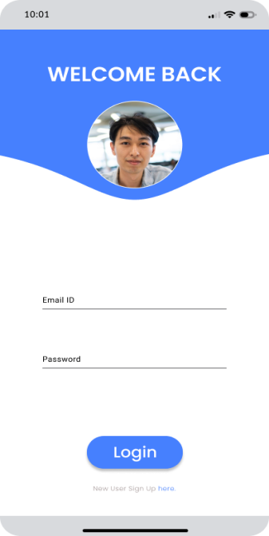

**Fig. 4.1. Login Screen**

**Features:**

· Secure login and sign-up screens.

· Email and password validation.

· Token-based access with expiration handling.

· Password reset and update functionality.

**4.2 Course Management Module**

Students can browse, search, and enroll in courses categorized as Free or Paid. The course data is fetched from the backend through paginated REST APIs. Each course has a detailed view containing modules, lesson previews, and trainer information.



**Fig. 4.2. Course Screen**

**Features:**

· Course filtering (All, Paid, Free).

· Live search with suggestions.

· Course detail page with video/image header and description.

· Enroll button (free/paid logic).

**4.3 Payment Integration Module**

The app integrates Razorpay for secure and flexible payments. Students can pay in full or in installments, based on their choice. Once the payment is processed, details are stored in the MyPayments table and shown in the My Payments screen.

**Features:**

· Razorpay SDK integration.

· Modal dialog for selecting payment type (partial/full).

· Order summary with tax and total breakdown.

· Payment status shown using colored indicators (Green = Paid, Orange = Pending).

**4.4 Virtual Meetings Module**

Live classes are conducted via Zoom, integrated through backend API endpoints. A calendar widget displays scheduled meetings in Month, Week, and Day views.

**Features:**

· Zoom Meeting ID entry and "Join Now" functionality.

· Calendar with meeting highlights.

· API-based meeting schedule fetching using the user’s JWT.

**4.5 Certificate Management Module**

Certificates are issued by the admin and retrieved by the student upon course completion. A grid view displays all earned certificates with preview and download options.

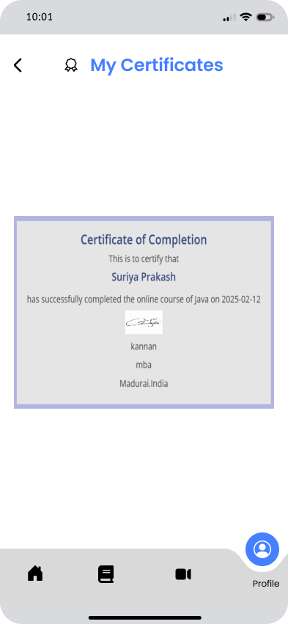

**Fig. 4.3. Certificate Screen**

**Features:**

· Certificate preview as image/PDF.

· Use of launchUrl() for direct PDF download.

· **Metadata:** student name, course name, issuer, completion date

**4.6 Test Module**

A lightweight quiz system allows trainers to upload MCQ tests. Students can take quizzes with multiple attempts, and results are stored in the backend.

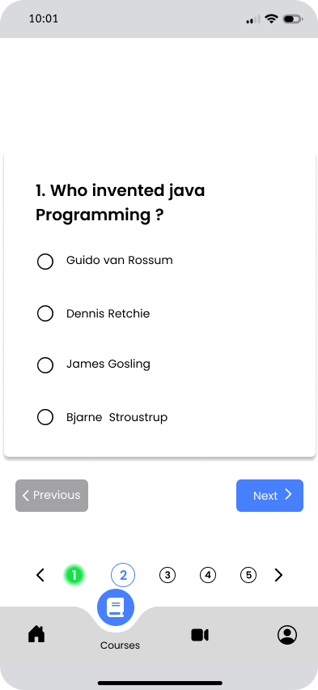

**Fig. 4.4. Test Screen**

**Features:**

· Multiple - choice interface with progress indicator.

· Navigation between questions.

· Test Instructions screen before attempting the test.

· **Pass criteria:** 50% minimum with 2 attempts allowed.

**4.7 Notifications Module**

All course, payment, and meeting-related alerts are displayed in a notification list, fetched from the backend using a timestamp-based polling or push update mechanism.

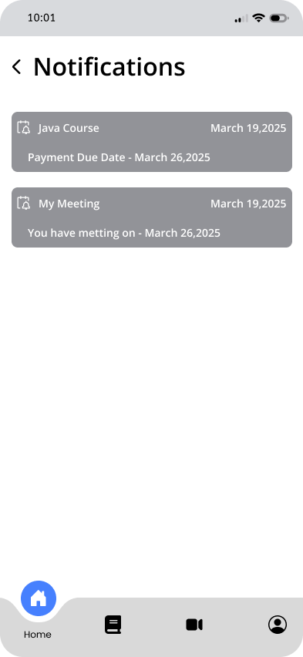

**Fig. 4.5. Notification Screen**

**Categories:**

· Course Updates

· Payment Alerts

· Meeting Reminders

· General Announcements

**4.8 Profile Module**

Students can view and update personal data such as name, email, date of birth, skills, and phone number. The avatar is editable using the gallery or camera.

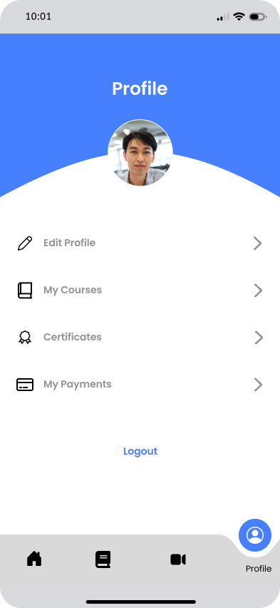

**Fig. 4.6. Profile Screen**

**Features:**

· Editable fields with validation.

· Avatar update with camera/gallery integration.

· Save button triggers a PATCH API call.

These modules are integrated into a cohesive application that is responsive, secure, and user-friendly. UI and backend validations, session management, and error handling ensure a stable experience for the end-user.

1. **Conclusion and Future Work**

**5.1 Conclusion**

This paper presented the design, development, and evaluation of NeoLearn, a comprehensive and interactive mobile e-learning platform built using Flutter, Spring Boot, and PostgreSQL. The system successfully integrates multiple modules, including user authentication, course management, virtual meetings, payments, assessments, and certification—all tailored to enhance the student learning experience in a mobile-first environment.

Through structured implementation and thorough testing, NeoLearn has demonstrated strong usability, security, and functionality. Real-world testing among student users showed positive feedback in terms of user interface, payment flexibility, and seamless navigation. The integration of tools such as Razorpay for payments and Zoom for live classes adds to the platform’s practical utility in today’s digital education ecosystem.

The modular architecture and secure backend allow NeoLearn to be adaptable for different institutions or education providers, and it lays a strong foundation for scalable deployment.

**5.2 Future Work**

To further improve the NeoLearn platform, the following enhancements are proposed:

**AI-Based Recommendations:** Incorporate machine learning algorithms to suggest courses based on user interests, previous enrollments, and performance.

**Offline Learning Support:** Enable offline access to downloaded video lectures and reading materials.

**Gamification Features:** Introduce badges, points, and leaderboards to boost student engagement and motivation.

**Trainer Live Chat and Forums:** Add real-time communication features such as chatrooms and discussion forums to support peer learning.

**Localization and Accessibility:** Add support for multiple languages and screen reader compatibility to make the platform inclusive and accessible to all users.

These improvements aim to make NeoLearn a holistic platform that evolves with the changing dynamics of online education and caters to a wider user base with varied learning needs.

1. **References**

[1] J. Anderson and R. Kumar, Mobile Learning Frameworks and Strategies. New York, NY, USA: Springer, 2021.

[2] Flutter Documentation, “Flutter - Build apps for any screen,” [Online]. Available: [https://flutter.dev](https://flutter.dev" \t "_new)

[3] Spring Boot Documentation, “Spring Boot Reference Guide,” [Online]. Available: [https://docs.spring.io/spring-boot/docs/current/reference/htmlsingle/](https://docs.spring.io/spring-boot/docs/current/reference/htmlsingle/" \t "_new)

[4] PostgreSQL Global Development Group, “PostgreSQL Documentation,” [Online]. Available: [https://www.postgresql.org/docs/](https://www.postgresql.org/docs/" \t "_new)

[5] Razorpay, “Razorpay Payment Gateway Integration,” [Online]. Available: https://razorpay.com/docs/

[6] Zoom Video Communications, “Zoom API Reference,” [Online]. Available: https://marketplace.zoom.us/docs/api-reference/introduction/

[7] A. Sharma and N. Joshi, “A Comparative Study of Online Learning Platforms: Moodle, Google Classroom, and Edmodo,” Int. J. Comput. Appl., vol. 178, no. 40, pp. 25–30, 2020.

[8] S. Patel, “Designing User-Friendly Mobile Applications for Learning,” J. Mobile Comput. Appl., vol. 15, no. 2, pp. 120–126, 2022.

[9] M. K. Jain and V. Rathi, “Integration of Payment Gateways in Flutter Applications,” in Proc. Int. Conf. Comput. Sci. Appl., Bengaluru, India, 2023, pp. 112–117.

[10] S. M. M. A. Sharif, "A study on e-learning platforms for educational institutions," International Journal of Educational Technology, vol. 18, no. 2, pp. 109-115, May 2020.

[11] A. Smith, "Designing scalable learning management systems: A case study on user interaction," Journal of Educational Design and Technology, vol. 25, no. 3, pp. 45-59, Jun. 2019.

[12] T. J. Brown and S. R. Peterson, "A review of virtual learning environments: The next wave in education," Journal of Online Education and Learning, vol. 21, no. 1, pp. 65-73, Jan. 2021.

[13] A. K. Ramasamy and L. H. Lee, "Mobile learning applications for educational use: A systematic review," International Journal of Mobile Computing, vol. 34, no. 4, pp. 177-185, Apr. 2020.

[14] J. D. Anderson and H. F. Moeller, "Evaluating the impact of Zoom integration on e-learning systems," International Journal of Educational Technologies, vol. 27, no. 5, pp. 34-45, Oct. 2020.

[15] T. L. Williams, "Secure payment processing in e-learning platforms: A review of technologies and best practices," International Journal of Cybersecurity in Education, vol. 33, no. 4, pp. 88-97, Aug. 2021.

[16] R. J. Dempsey, "Smart integration of payment systems for mobile-based educational apps," Mobile Computing and Applications Journal, vol. 29, no. 6, pp. 45-50, Dec. 2021.

[17] M. P. Clark and S. H. Bryant, "User experience design for mobile learning apps: A case study of e-learning in mobile environments," Proceedings of the 2021 International Conference on Human-Computer Interaction, pp. 131-142, Apr. 2021.

[18] K. B. Jackson and L. T. Brooks, "The rise of mobile learning: An evaluation of mobile apps for education and training," Journal of Interactive Learning Research, vol. 19, no. 3, pp. 145-155, Sep. 2019.

[19] A. T. Malik, "Razorpay integration for secure payment systems in educational platforms," Tech Innovations in Education, vol. 14, no. 2, pp. 78-85, Feb. 2020.

[20] R. L. Green, "Advanced features in mobile learning systems: Exploring the future of education technology," Journal of Educational Innovations, vol. 16, no. 3, pp. 202-210, Mar. 2021.