**SMART LIVESTOCK MANAGEMENT: REAL-TIME CATTLE DETECTION AND CLASSIFICATION**

**ANAND K AJITH¹, DR.S.RATHINAVEL²**

1Student, Electronics and Instrumentation, Bharathiar University, Coimbatore, Tamil Nadu, India

2Assistant Professor, Electronics and Instrumentation, Bharathiar University, Coimbatore, Tamil Nadu, India

**ABSTRACT**

Efficient livestock management is required for sustainable agriculture, especially in rural areas where dairy farming supports the economy. This study introduces a real-time cow-counting system using computer vision and YOLO object detection models ( YOLOv11) for automated farm monitoring. The models are trained and optimized using RoboFlow, with OpenCV facilitating real-time image processing. The model performance metrics indicate that the YOLOv11 object detection model, trained for cattle detection, has achieved a mean Average Precision (mAP) of 86.6%, which suggests strong overall accuracy in detecting and classifying cattle in aerial images. The model's recall of 81.6% shows that it is also effective in detecting the bulk of animals in the dataset. Future enhancements may include farm management software integration and livestock health monitoring, contributing to the advancement of smart agriculture.

**Keywords:** Livestock Management, Dairy Farming, Object Detection, YOLO, RoboFlow, OpenCV.

1. **INTRODUCTION**

**Growing AI and computer vision has entirely transformed livestock management as far as automatic cattle identification and counting is concerned. Manual livestock monitoring is definitely slow and prone to human errors hence, there is a need for AI-oriented solutions. This proposes a real-time cow counting and classification system that uses highly accurate, deep learning model YOLOv11-together with OpenCV and RoboFlow to drive efficiency and accuracy for effective farm management. The system is designed to process aerial images imported from drones, identifying and counting cattle, basically in real time. OpenCV will deal with frame pre-processing while RoboFlow will aid in data augmentation, training, and optimization. The results will be stored into a database, enabling the farmers to track the livestock numbers over time with minimum human intervention. The system is also adaptable to different farm sizes and various livestock types.**

**Out of the existing literature regarding existing deep learning models used in livestock monitoring, an optimized model of YOLOv2, for an embedded system, was advocated with a balance between accuracy and computational efficiency [1]. UAVs, aerial photography, and YOLO and ENVI-based deep learning models were effective in cattle detection, thereby limiting man-hours involved for very large-scale monitoring [2].** **A Mask YOLOv7-drone vision system was proposed to achieve great accuracy in detecting and counting cattle in feedlots and open-range settings [5].** Plans have also been discussed regarding using UAV images for livestock population estimation, and addressing challenges like clustering and illumination variance [6]. Drones have been used in many scenarios for livestock management. Past reviews on the role of drones in tracking and monitoring cattle have employed AI models, including YOLO and R-CNN [4]. Whereas Mask R-CNN has been successfully applied for automated cattle counting and reported excellent results through occlusions and differences in environmental conditions [8]. Also, deep learning models such as YOLOv4 and SSD have been applied for automated animal detection in UAV images demonstrating the promise of AI in livestock monitoring research [9].

The efficiency of detection will thus be increased while labour force dependence will decrease. The project automates the detection and classification of cattle, enabling a broader precision agriculture vision for resource management and farm productivity.

1. **METHODOLOGY**

This study presents a structured approach to cattle counting and data logging using YOLO-based object detection models. In this UAV-based high resolution image analysis, where cattle are detected and counted using a specialized YOLO model. The dataset is taken from multiple sources and processed using Roboflow, incorporating annotation, augmentation techniques such as rotation, flipping, and brightness adjustments, and dataset splitting for training, validation, and testing. Software tools such as Roboflow for dataset management, Python 3.10.8 for GUI and video processing, VS Code for development, and Arduino IDE for microcontroller programming ensure smooth system operation. The system undergoes rigorous testing through unit tests for individual components, and performance validation by comparing detected counts with manual counts.

* 1. **Block diagram:**

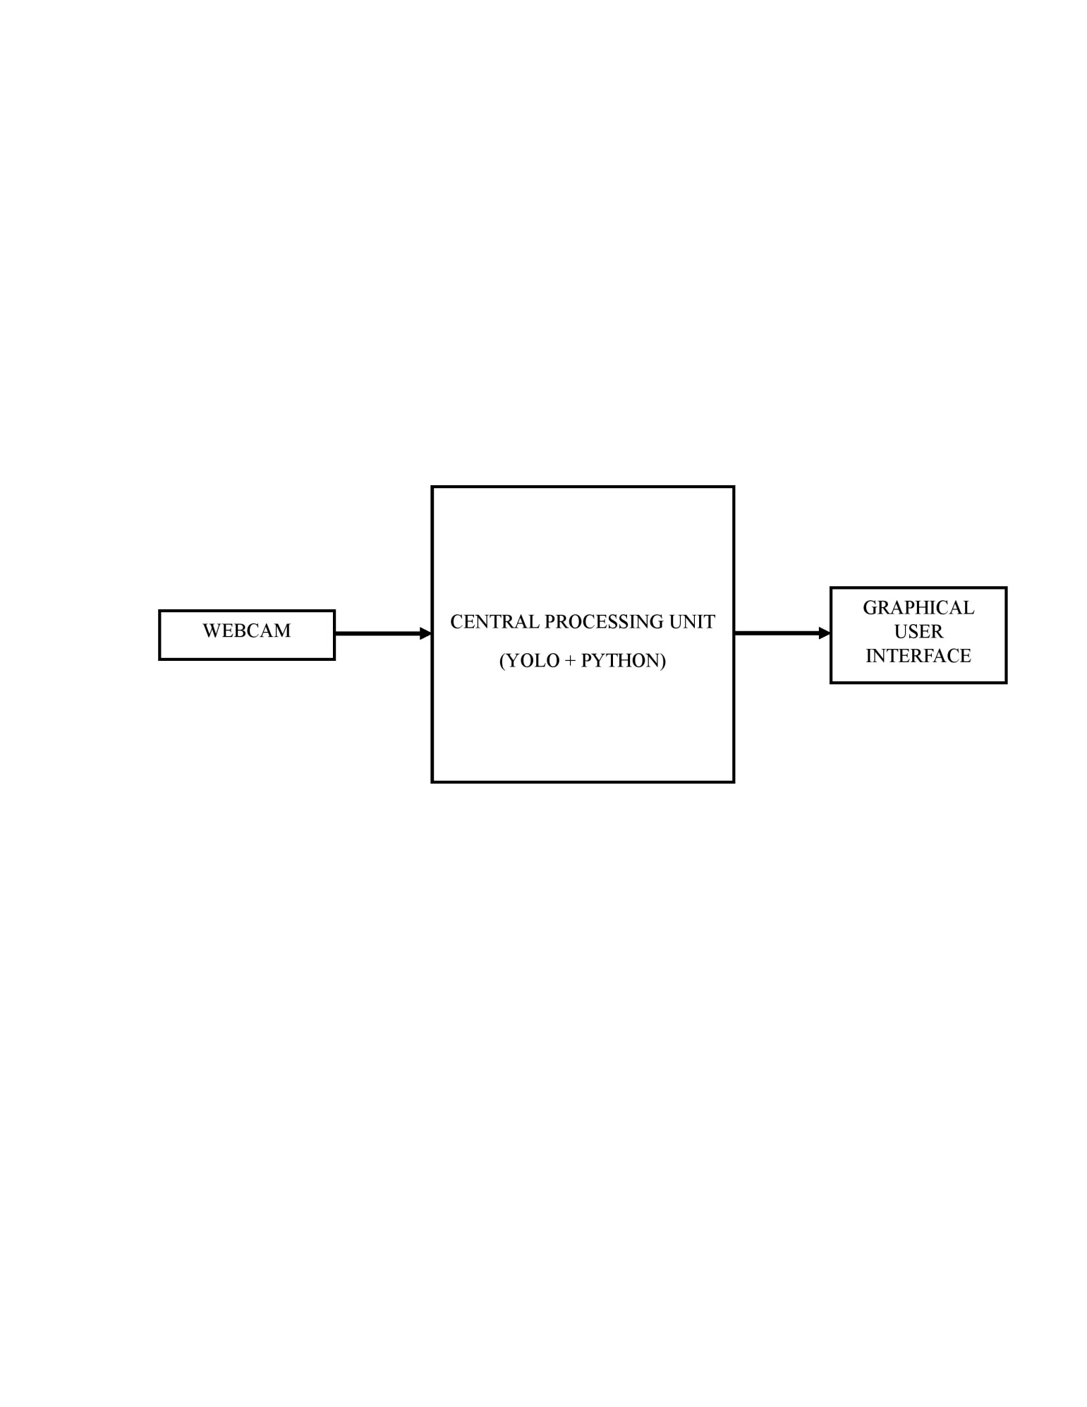

**Figure 1:** Overview of hardware setup

* 1. **software configuration:**

**Roboflow website**

Roboflow is used for model training and data collection. It provides an efficient way to preprocess datasets by allowing annotation, augmentation, and conversion to various formats compatible with deep learning models. Roboflow’s cloud-based training capabilities reduce the computational burden on local machines and allow for faster and optimized model development. The platform supports various object detection models, including YOLO, making it ideal for training cattle detection models.

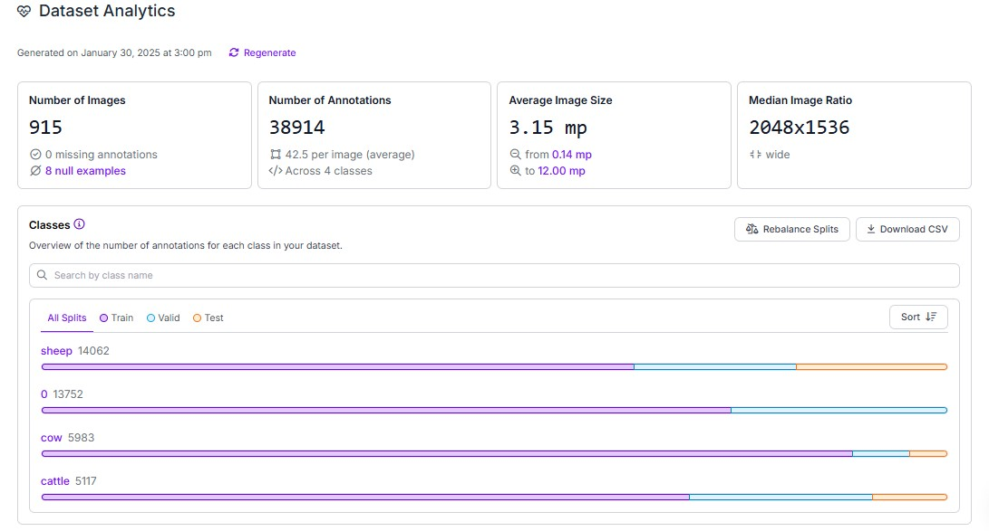

**Figure 2:** Dataset details

The dataset consists of 915 images with a total of 20,045 relevant annotations across two classes: **sheep (14,062 annotations)** and **cow (5,983 annotations)**. On average, each image contains multiple annotations, with an average image size of **3.15 megapixels**, ranging from **0.14 MP to 12.00 MP**. The median image ratio is **2048x1536**, indicating a wide aspect ratio. The annotations are divided into validation, training, and test splits, as shown by the colour - coded bars. Additionally, **there are 8 null examples** in the dataset that may need review. This dataset is well-structured for training the model focused on detecting sheep and cows from aerial images.

**Python-3.10.8-amd64**

The main programming language for creating the graphical user interface, analyzing video frames with OpenCV, and controlling data logging in Excel is Python. Python 3.10.8, the version that was selected, guarantees compatibility with the necessary libraries and offers enhanced performance while carrying out machine learning tasks. Numerous facets of data processing and deep learning model integration are supported by Python's vast ecosystem of libraries, including NumPy, Pandas, and Tensor Flow.

**Visual studio code**

Visual Studio Code is the development environment used for GUI creation, integrating OpenCV for video processing, and handling Excel data logging. Its extensive support for extensions and debugging features enables efficient software development. VS Code’s user-friendly interface, integrated terminal, and version control support make it an ideal choice for writing and managing the Python scripts used in the project.

**Arduino ide**

Arduino IDE is employed for programming the Arduino Uno, specifically for handling serial communication between the microcontroller and other components such as the IR sensor and I2C LCD display. The IDE supports writing, compiling, and uploading code to the microcontroller, allowing seamless integration of hardware components with the software system. The built-in serial monitor helps in debugging communication issues.

1. **RESULTS AND DISCUSSION**
   1. **Result**

This chapter presents the outcomes of the project, focusing on model training and evaluation. UAVs capture high-resolution images analyzed through a Python-based GUI with adjustable threshold values for accurate cattle detection. These methods enhance efficiency in cattle monitoring through real-time and aerial-based detection techniques.

**Training progress**

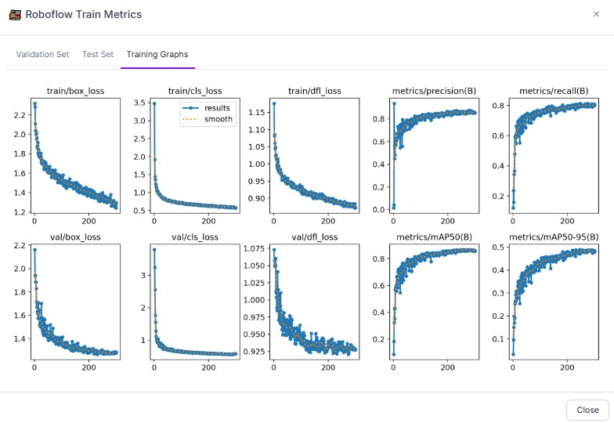

**Figure 3:** Training Metrics

The training metrics graphs provide a detailed insight into the model's performance throughout the training process. The loss curves, including train/box_loss, train/cls_loss, and train/dfl_loss, exhibit a consistent downward trend, indicating effective weight updates and convergence of the YOLOv11 object detection model. The validation losses (val/box_loss, val/cls_loss, val/dfl_loss) also show a similar decline, confirming that the model is not over fitting and maintains generalizability across the dataset. The precision and recall metrics progressively improve, with metrics/precision (B) and metrics/recall (B) stabilizing, suggesting the model is becoming more confident in its detections while minimizing false positives and false negatives. The mAP50 and mAP50-95 curves demonstrate an increasing trend, with the model achieving higher average precision across different IoU thresholds, reflecting its ability to accurately localize and classify objects. The smooth curves indicate stability, and the lack of sharp fluctuations suggests a well-tuned training process with no major instabilities.

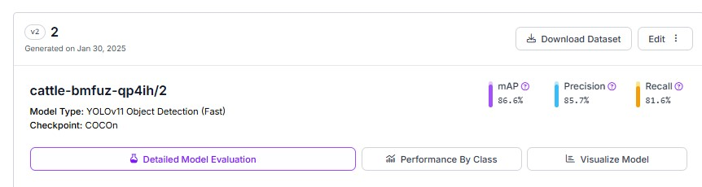

**Figure 4:** Model Evaluation

The model performance metrics indicate that the **YOLOv11 object detection model**, trained for cattle detection, has achieved a **mean Average Precision (mAP) of 86.6%**, which suggests strong overall accuracy in detecting and classifying cattle in aerial images. The **precision of 85.7%** implies that the model will definitely minimizes false positives, ensuring that most detected objects are indeed cattle. Although some cases might still go unnoticed, the model's recall of 81.6% shows that it is also effective in detecting the bulk of animals in the dataset. A well-optimized model with few trade-offs is suggested by the balance between precision and recall, which qualifies it for use in actual livestock monitoring applications.

**GUI image analysis**

Using UAVs (Unmanned Aerial Vehicles) take high-resolution pictures of cattle in order to process the photographs for cow counting. Threshold settings are changed for precise object detection when these photos are uploaded to a Python-based GUI for image analysis. Cattle in the image are identified and counted by the model, and the count is compared to predetermined threshold values. The count is saved in an Excel document.

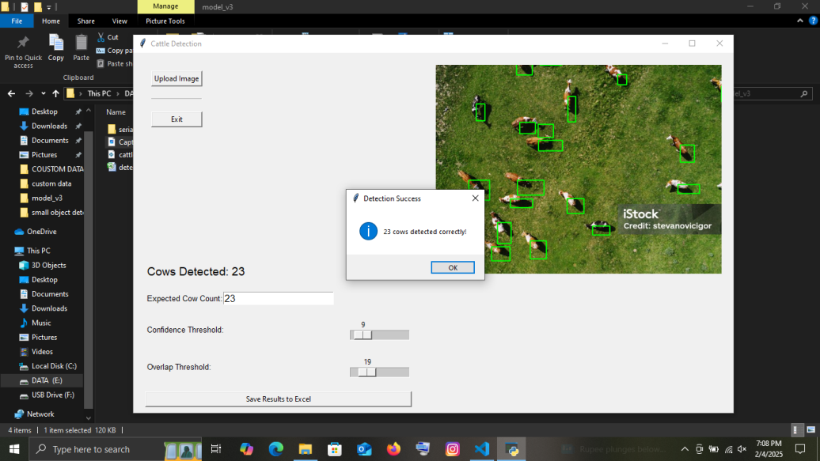

**Figure 5:** Counting cattle using UAV images

In this image it successfully detecting 23 cows in an aerial image using a YOLO-based model, with bounding boxes drawn around the detected cows and a confirmation message indicating correct detection.

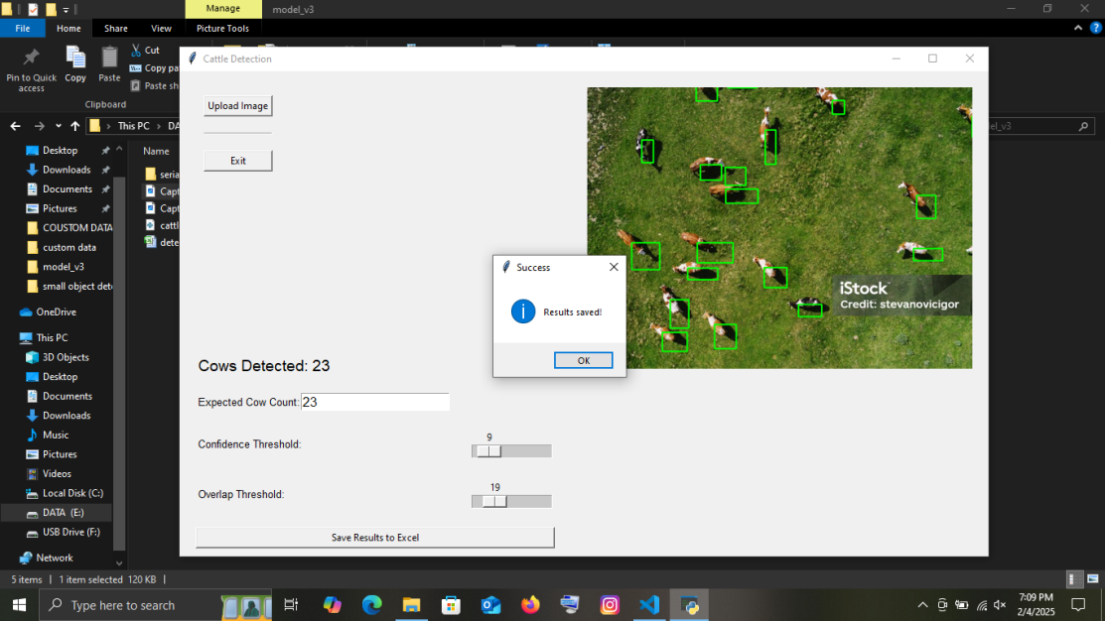

**Figure 6:** Saving result

A pop-up message confirms that the detection results have been successfully saved, ensuring that the data is recorded for further analysis or monitoring.

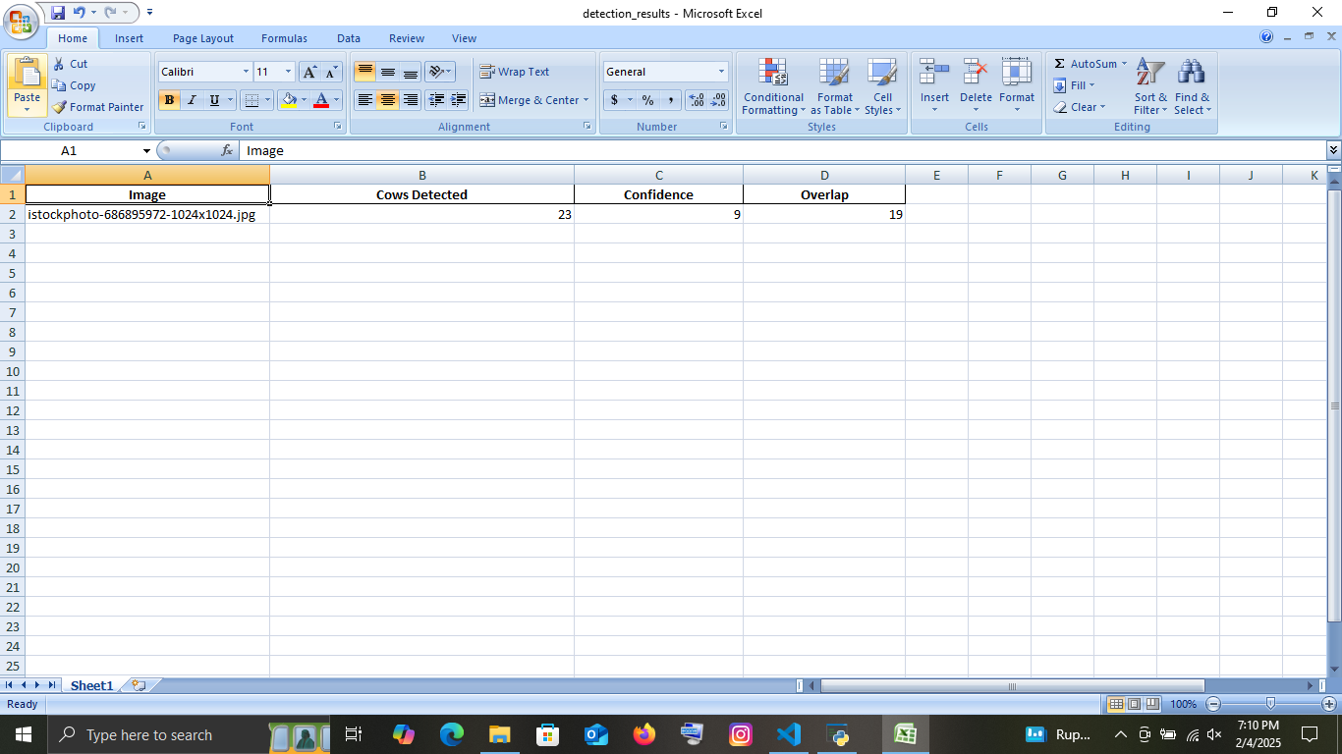

**Figure 7:** Data logging

The image shows an Excel sheet, which contains data from a cattle detection application. The table records information about the analyzed image, including its file name, the number of cows detected (23), the confidence threshold (9), and the overlap threshold (19).

**Table 1 .** Performance in different threshold values

|  |  |  |  |  |  |  |
| --- | --- | --- | --- | --- | --- | --- |
| **SL NO** | **IMAGE** | **CONFIDENCE** | **OVERLAP** | **COWS DETECTED** | **EXPECTED COUNT** | **ERROR IN**  **%** |
| 1 | wmremove-transformed.jpeg | 9 | 19 | 23 | 23 | 0 % |
| 2 | wmremove-transformed.jpeg | 50 | 50 | 22 | 23 | 4.35 % |
| 3 | wmremove-transformed.jpeg | 25 | 29 | 23 | 23 | 0 % |
| 4 | wmremove-transformed.jpeg | 29 | 66 | 17 | 23 | 26.09 % |
| 5 | wmremove-transformed.jpeg | 78 | 86 | 14 | 23 | 39.13 % |

The table presents the performance of a cattle detection model applied to aerial images, showcasing the number of cows detected, confidence scores, overlap values, and the correctness of the results. Each row represents a test case where the model identified a certain number of cows within an image. The confidence score indicates the model's certainty in its detections, while the overlap value represents the extent of bounding box intersections, which can impact accuracy. In cases where confidence was either too low or too high, or where overlap was significant, the model's predictions were deemed incorrect. For instance, in the first and third test cases, where the confidence scores were 9 and 25 with overlap values of 19 and 29, the detections were accurate. However, in test cases where confidence was higher, such as 78 with an overlap of 86, the detection was incorrect. Similarly, moderate confidence scores like 50 with an overlap of 50 also led to in accurate results. Some cases show minimal error (0%), while others have a higher error rate, such as 26.09% and 39.13%, this occur due to the interplay between these two factors. A **balanced confidence and overlap setting** is essential to minimize detection errors and ensure accurate cow counting.

* 1. **Discussion**

The cattle detection system developed in this project leverages YOLO-based deep learning models for accurate aerial imagery detection. The system effectively identifies and counts cattle from UAV-captured images. The YOLOv11 model achieves a mean Average Precision (mAP) of 86.6%, with precision and recall values of 85.7% and 81.6%, respectively. Enhancements in dataset diversity can further improve accuracy under varying conditions.

A pop-up warning system in the GUI enhances user interaction, while Excel-based data storage facilitates trend analysis. The aerial detection requires fine-tuning of confidence and overlap thresholds to optimize accuracy. Adjusting these parameters ensures better detection of smaller or partially visible cows while reducing false positives. Overall, this system presents a robust and practical solution for livestock monitoring, with potential improvements in dataset quality.

1. **CONCLUSION**

The cattle counting and classification system developed in this project successfully integrates YOLOv11 -based object detection models for aerial image processing. The technology guarantees effective and precise livestock monitoring in a variety of scenarios by utilizing deep learning algorithms. The aerial detection model, trained with YOLOv11, achieves strong performance metrics, including a mean Average Precision (mAP) of 86.6%. However, further improvements in dataset diversity, model parameter tuning, and computational optimization are necessary to enhance detection accuracy. Future enhancements, such as automated threshold adjustments and cloud-based analytics, could further improve the system’s effectiveness for livestock management.

**ACKNOWLEDGEMENT**

Firstly, I would like to thank the mighty to have been given me such courage and destiny to carry out my work without many hurdles throughout the study period. Secondly, I am very much honored to thank my guide, **Dr. RATHINAVEL.S,** Assistant Professor Department of Electronics and Instrumentation, Bharathiar University, Coimbatore, without his support the compendium of the essence of the project would not have been achieved. I am also privileged to thank **Dr. J. VIJAYAKUMAR**, Associate Professor and Head of the Department, Bharathiar University, Coimbatore, who has always been concrete support to get going the project without any obstructions. I also thank **Dr. AZHA PERIASAMY**, Associate Professor, **Dr. KG PADMASINE**., Assistant Professor, Department of Electronics and Instrumentation, Bharathiar University, Coimbatore, encourage me during my research work. Furthermore, I would like to thank all my family members, friends, scholars, and lab members for being with me alongside to give me the valor and grit to carry out all the immense works that have led me to this position. I wish to extend my sincere thanks to **Dr. R MAHESHWARAN, Mrs. DEVILALITHA**, and **Mrs. SANGEETHA** Computer operator, Department of Electronics and Instrumentation, Bharathiar University, Coimbatore. Last but not the least; I memorably thank my parents and friends for always keeping engaged on the right path throughout this coursework.

1. **REFERENCES**
2. M. Ibraheam, K. F. Li and F. Gebali, "An Accurate and Fast Animal Species Detection System for Embedded Devices," in IEEE Access, vol. 11, pp. 23462-23473, 2023, doi: 10.1109/ACCESS.2023.3252499.
3. Mücher, C. A., Los, S., Franke, G. J., & Kamphuis, C. (2022). Detection, identification and posture recognition of cattle with satellites, aerial photography and UAVs using deep learning techniques. International Journal of Remote Sensing, 43(7), 2377–2392. <https://doi.org/10.1080/01431161.2022.2051634>
4. Gupta, H., Jindal, P., Verma, O. P., Arya, R. K., Ateya, A. A., Soliman, N. F., & Mohan, V. (2022).Computer Vision-Based Approach for Automatic Detection of Dairy Cow Breed. Electronics, 11(22), 3791. <https://doi.org/10.3390/electronics11223791>
5. M. A. Alanezi, M. S. Shahriar, M. B. Hasan, S. Ahmed, Y. A. Sha’aban and H. R. E. H. Bouchekara, "Livestock Management With Unmanned Aerial Vehicles: A Review," in IEEE Access, vol. 10, pp. 45001-45028, 2022, doi: 10.1109/ACCESS.2022.3168295
6. Barbedo, J. G. A., Koenigkan, L. V., Santos, T. T., & Santos, P. M. (2019). A Study on the Detection of Cattle in UAV Images Using Deep Learning. Sensors, 19(24), 5436. <https://doi.org/10.3390/s19245436>
7. Bello, R.-W., & Oladipo, M. A. . (2024). Mask YOLOv7-Based Drone Vision System for Automated Cattle Detection and Counting. Artificial Intelligence and Applications, 2(2), 115-125. <https://doi.org/10.47852/bonviewAIA42021603>
8. Barbedo, J. G. A., Koenigkan, L. V., Santos, P. M., & Ribeiro, A. R. B. (2020). Counting Cattle in UAV Images—Dealing with Clustered Animals and Animal/Background Contrast Changes. Sensors, 20(7), 2126. <https://doi.org/10.3390/s20072126>
9. Barbedo, J. G. A., Koenigkan, L. V., & Santos, P. M. (2020). Cattle Detection Using Oblique UAV Images. Drones, 4(4), 75. <https://doi.org/10.3390/drones4040075>
10. B. Xu, W. Wang, G. Falzon, P. Kwan, L. Guo, G. Chen, A. Tait, and D. Schneider, ‘‘Automated cattle counting using mask R-CNN in quadcopter vision system,’’ Comput. Electron. Agricult., vol. 171, Apr. 2020, Art. no. 105300, doi: 10.1016/j.compag.2020.105300
11. J. Redmon and A. Farhadi, "YOLO9000: Better, Faster, Stronger," 2017 IEEE Conference on Computer Vision and Pattern Recognition (CVPR), Honolulu, HI, USA, 2017, pp. 6517-6525, doi: 10.1109/CVPR.2017.690.
12. Qi Ye, Mingtao Ma, Xin Zhao, Bichong Duan, Lifen Wang, Deyin Ma, ADD-YOLO: An algorithm for detecting animals in outdoor environments based on unmanned aerial imagery, Measurement, Volume 242, Part D, 2025, 116019, ISSN 0263-2241, <https://doi.org/10.1016/j.measurement.2024.116019>.
13. Rančić, K., Blagojević, B., Bezdan, A., Ivošević, B., Tubić, B., Vranešević, M., Pejak, B., Crnojević, V., & Marko, O. (2023). Animal Detection and Counting from UAV Images Using Convolutional Neural Networks. Drones, 7(3), 179. <https://doi.org/10.3390/drones7030179>
14. Brahm Dave, Meet Mori, Anurag Bathani, Parth Goel, Wild Animal Detection using YOLOv8, Procedia Computer Science, Volume 230, 2023, Pages 100-111, ISSN 1877-0509, <https://doi.org/10.1016/j.procs.2023.12.065>.
15. F. Sarwar, A. Griffin, P. Periasamy, K. Portas and J. Law, "Detecting and Counting Sheep with a Convolutional Neural Network," 2018 15th IEEE International Conference on Advanced Video and Signal Based Surveillance (AVSS), Auckland, New Zealand, 2018, pp. 1-6, doi: 10.1109/AVSS.2018.8639306.
16. Viswanatha, V., ChandanaR, K., & A.C, R. (2022). Real Time Object Detection System with YOLO and CNN Models: A Review. ArXiv, abs/2208.00773. <https://doi.org/10.48550/arXiv.2208.00773>