**A Study on the Advancement of Bill Splitting and Expense Management Applications**

**Bushra Shaikh1, Arshi Khan2, Ayesha Shaikh3, Neha Yadav4**

1Student- M.H. Saboo Siddik College of Engineering, India

2Guide- M.H. Saboo Siddik College of Engineering, India

3,4Student- M.H. Saboo Siddik College of Engineering, India

**ABSTRACT**

The rapid growth of mobile applications has improved the effectiveness of managing both individual and group spending. Many of the expense-sharing apps that are now available are either poorly designed or unstable. The primary characteristics, approaches, and special features of the current Android-based expense-splitting apps are examined in this survey. Applications such as Snap and Split, Separate Bills, and Android-Based Expense Split Applications are thoroughly examined to identify their advantages and disadvantages. Also, we evaluate user requirements, data consistency issues, and the integration of Optical Character Recognition (OCR) for automated bill input. Findings highlight the key features for effective expense management applications and point to potential areas for development, like predictive analytics or payment gateways.

**Keywords:** – Bill splitting, expense management, mobile applications, OCR, payment gateways, data consistency, user privacy, predictive analytics.

1. **INTRODUCTION**

The huge spread of mobile applications has transformed everyday financial management, making tasks like expense tracking and bill splitting more accessible and efficient. Managing expenses in shared social or domestic contexts, often becomes challenging, especially when several individuals contribute to various shared costs like for travel, meals or residential utilities [1]. Time-consuming and error-prone methods like spreadsheets, notes, or ledgers were used traditionally to track expenses but the development of various mobile applications has alleviated these issues by simplifying the process of expense tracking, splitting, and management.

By automating computations of shared expenses, keeping a track of them and integrating with payment gateways to speed up settlements, mobile-based bill-splitting applications seek to improve user experience.

These applications provide flexible splitting choices, including equal and customizable splits, in order to accommodate a variety of group situations. Also, features like Optical Character Recognition for automation of bill scanning, in-app chat, and real-time notifications help improve user convenience and lower the probability of errors. But even though these apps are convenient, they often have issues with security, data quality, and user experience, especially when they include sensitive financial data.

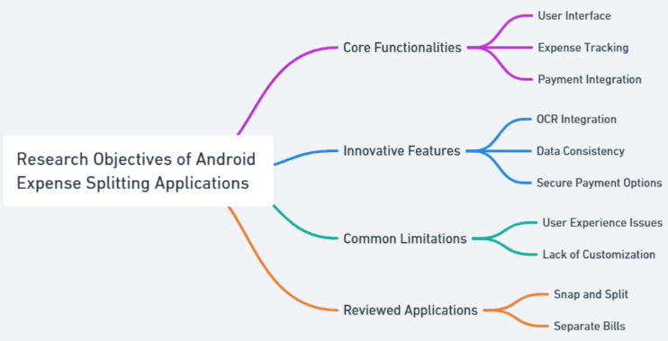

Fig. 01. Research Objectives of Android Expense Splitting Applications

Existing Android-based applications such as Snap and Split, Separate Bills, and Android-Based Expense Split Application are examined in this survey. Through an analysis of these applications, we find core functionalities and novel features while highlighting some of the common limitations.

Key insights clarify important details that improve user experience, like data consistency, integration of OCR, and safe payment methods. We also examine the challenges faced by these systems such as issues with data accuracy and privacy. Along with potential future development paths and emphasizing the need for a reliable, user-friendly, and secure solution for mobile expense management, we also highlight advanced functionalities and emerging market trends.

1. **BACKGROUND AND RELATED WORK**

Mobile applications have transformed the way of handling shared expenses, especially in social and cooperative settings. Emerging of several noteworthy applications has helped with addressing distinct challenges in expense splitting:

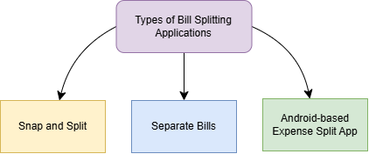

Fig. 02. Types of Bill Splitting Applications

**2.1 Snap and Split**

This program uses Tesseract, a type of optical character recognition (OCR) technology [6], to automate the bill recognition process. The program allows users to take pictures of their receipts and then analyzes them to extract pertinent spending data.

It makes communication easier and increases user involvement by tagging peers for shared costs. Users may swiftly settle bills thanks to the real-time notifications and rapid payment features, which greatly lessen the hassle that comes with using more conventional expense tracking techniques [2]. Examples include Snap & Split applications.

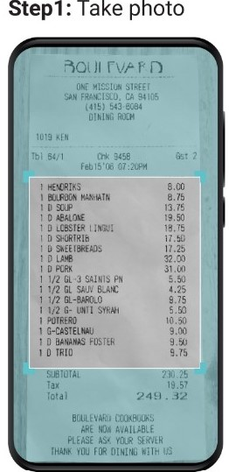 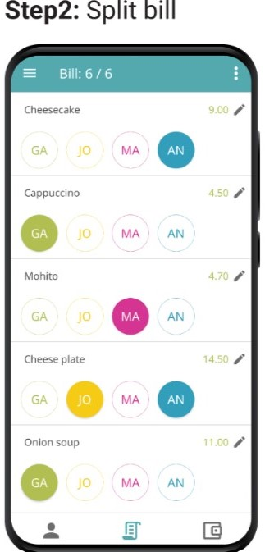 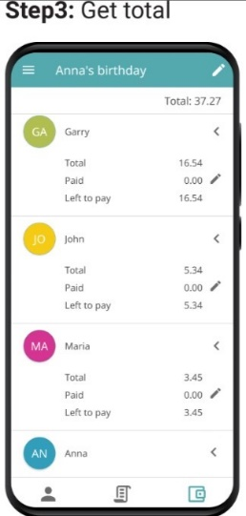

Fig. 03. Steps 1, 2 & 3 of Snapping and Splitting Bill

**2.2 Separate Bills**

This app's design is user-centric since it views shared costs as "events." Users can start distinct chats for discussions and select various splitting arrangements (e.g., shares or percentage-based) because each event might contain a sequence of transactions.

In addition to making managing several expenses easier, this model encourages user transparency by making sure that everyone is aware of their contributions. The unified view of outstanding bills facilitates efficient financial planning and budgeting. Splitwise, for instance.

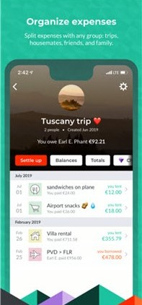 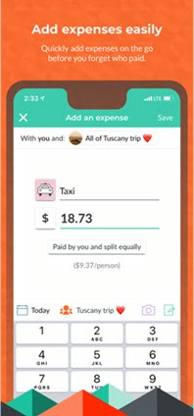 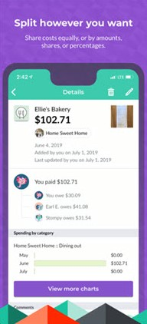

Fig. 04. Splitwise Group & Transaction Details Screenshot

**2.2 Android-based Expense Split Application**

Putting an emphasis on core functions, this application lets users add, edit, and view group spending. It aims to replace conventional techniques like spreadsheets or handwritten notes by including notification systems for pending payments[8]. By automating these operations, it decreases human errors and boosts the accuracy of spending tracking. such as Paypal, Venmo, etc.

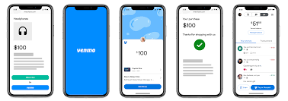

Fig. 05. Venmo Transaction Screenshot

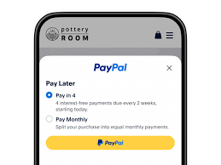

Fig. 06. Paypal Screenshot

1. **FEATURES AND CHALLENGES**

**3.1 Features**

**A) OCR Integration**

OCR Integration Optical Character Recognition (OCR) technology plays a crucial role in minimizing manual work and enhancing accuracy in bill-splitting applications [7]. Text from receipts is frequently extracted using sophisticated OCR technologies like Tesseract. The procedure entails:

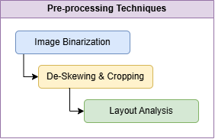

Fig. 07. Pre-processing Techniques in OCR

* Image Binarization: Simplifies text extraction by converting receipts into black-and-white formats.
* De-Skewing and Cropping: Fixes scanned picture alignment problems for more precise data capture.
* Layout Analysis: Separates the receipt's several components, including the totals, prices, and item names.

Post-OCR Processing: Maps extracted data to predetermined spending categories (e.g., food, utilities) and uses machine learning models to detect and fix recognition problems.

OCR is efficiently used by apps like Snap and Split to scan receipts, providing automated parsing and requiring less user input.

**B) Event-based Expense Management**

Structures for event-based management divided costs into distinct groups or "events." This method makes tracking across several activities or events easier and offers clarity. Important techniques consist of:

* Expense Categorization: Users can create events (e.g., "Dinner Out" or "Weekend Trip") and assign associated bills to them.
* Real-Time Collaboration: Members of an event can contribute expenses, view balances, and settle payments collectively.
* Visual Dashboards: Intuitive dashboards present summaries of individual and group-level expenses, enhancing transparency and ease of use.

This methodology is prevalent in Separate Bills, enabling users to manage expenses effectively for diverse group activities.

**C) Flexible Splitting Options**

Bill-splitting flexibility is crucial for user satisfaction. Modern applications provide several advanced options:

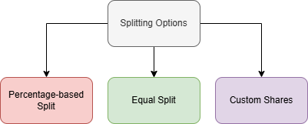

Fig. 08. Splitting options

* Equal Splits: Default functionality that divides expenses equally among group members.
* Percentage-Based Splits: Allows users to allocate costs proportionally based on individual contributions.
* Custom Shares: Enables users to manually specify how much each member owes, catering to scenarios where individuals share different portions of the expense.

By offering multiple splitting methods, applications like Separate Bills cater to a broad range of use cases.

**D) Integrated Payment Systems**

Instant expense settlement within the app is made possible by the seamless integration of payment channels, which improves user convenience [3].

* E-Wallet Integration: The apps include direct connections to well-known digital wallets like PayPal, Venmo, and Paytm, which lowers transactional friction.
* Secure Gateways: Sensitive financial information is transferred securely thanks to the use of encryption technologies like SSL/TLS.
* Transaction Logs: Detailed records of payments and settlements give users an open window into their financial dealings.

Applications that provide end-to-end payment solutions for group spending management, such as Separate Bills, are excellent in this area.

**3.2 Challenges**

Despite the rise in popularity of mobile-based bill-splitting and expenditure management apps, there are still a number of issues with their usability, design, and design. An examination of the main problems these systems confront is provided below.

**A) Data Inconsistency and Input Errors**

Data entry errors and inconsistencies are among the biggest problems with current systems.

* Manual Data Entry: Users must manually enter expense details in systems lacking strong OCR integration, which might result in inaccurate or partial inputs.
* OCR Limitations: Complex bill layouts, badly scanned receipts, or unreadable handwriting can all lead to errors, even with OCR-enabled programs.
* Duplicate Entries: Inadequate validation procedures could lead to redundant costs, which would complicate group computations.

Impact: These discrepancies frequently cause arguments between users and erode confidence in the application's reliability.

**B) Limited Flexibility in Splitting Options**

Many applications fail to offer sufficient flexibility in how expenses are split among group members [4].

* Basic Equal Splits Only: Applications with fixed equal-split functionality cannot accommodate diverse scenarios such as shared meals where individuals contribute differently.
* No Custom Adjustments: Absence of features like custom percentages or exact share adjustments restricts usability in real-world scenarios.

Impact: Users seeking advanced options often resort to manual calculations or alternative tools, undermining the app’s value.

**C) Payment Integration Challenges**

While integrating payment systems enhances functionality, it also introduces complications:

* Limited Gateway Options: Some applications support only a narrow range of payment providers, leaving users without their preferred methods.
* High Transaction Fees: Payment gateways may impose fees that discourage in-app transactions.
* Settlement Delays: Processing times for payments can result in delays, especially in international transactions.

Impact: Users may opt for external payment methods, reducing the app's appeal and convenience.

**D) Lack of Group Transparency and Accountability**

Group expense management relies on clear communication and accountability among members:

* No Activity Logs: Applications without detailed transaction histories or audit trails make it difficult to verify past entries.
* Conflict Resolution Tools: Few apps provide mechanisms to handle disputes, such as an option to flag incorrect entries or propose edits.

Impact: Ambiguity in expense records creates misunderstandings and affects user trust.

1. **TRENDS AND FEATURES IN BILL SPLITTING APPLICATIONS**

**4.1 Predictive Analytics and AI Integration**

* High-Accuracy Scanning: By ensuring accurate data extraction from receipts, even in intricate layouts or dimly lit environments, modern OCR technology—like Google Vision API—minimizes user error.
* Contextual Analysis: By comprehending the extracted text in its context, NLP approaches enhance OCR. For instance, they can recognize totals, taxes, and itemized lists to improve automation.
* Multilingual and Regional Adaptability: These apps can reach a wider audience by supporting several languages and localized formatting, which increases their usefulness and appeal.

**4.2 Real-Time Collaboration and Payment Security**

* Group Transparency: Tools like in-app messaging, comprehensive activity logs, and real-time notifications enhance group members' communication and help them avoid miscommunications regarding costs[5].
* Blockchain Technology: Applications that employ blockchain guarantee tamper-proof records of every transaction, increasing user confidence and transparency.
* Secure Payment Gateways: Support for multi-currency transactions and encrypted payment methods make financial settlements easier and safer, especially in situations involving cross-border groups.

**4.3 Localization, Sustainability, and Fraud Detection**

* Localized Features: To increase accessibility, applications feature real-time currency conversion for multinational groups, local payment mechanisms (like UPI in India), and interfaces in localized languages.
* Eco-Friendly Options: Users that care about the environment are drawn to features like digital receipts and spending monitoring connected to sustainability measures (like carbon footprint tracking).
* AI-Powered Fraud Prevention:By identifying irregularities like duplicate entries or exaggerated amounts, sophisticated algorithms alert users for verification, minimizing conflicts and promoting system confidence.

1. **CONCLUSION**

Applications that divide expenses have become essential for handling joint finances in both personal and business contexts. The main advantages are highlighted in this poll, including various dividing possibilities, real-time cooperation, and OCR technology for automated bill entries. But there are also problems like inconsistent data, privacy concerns, and a lack of tool integration. These apps have the potential to develop into complete financial management solutions thanks to emerging trends like blockchain for safe transactions, AI-driven customisation, and predictive analytics. Future advancements will concentrate on gamification, eco-friendly features, and support for several currencies. These apps have the potential to further streamline financial administration while encouraging openness and cooperation with sustained innovation and an emphasis on user demands.

1. **REFERENCES**
2. T. Mohana Mahindre, Swaraj et al. “Secure Splitting of Bills and Managing Expenditure Using Blockchain.” 2023 IEEE 3rd International Conference on Technology, Engineering, Management for Societal impact using Marketing, Entrepreneurship and Talent (TEMSMET) (2023): 1-7.
3. Agrawal, R. (2019). BILL SPLITTING AND EXPENSE MANAGING ASSISTANT. In INTERNATIONAL JOURNAL OF CURRENT ENGINEERING AND SCIENTIFIC RESEARCH (IJCESR) (Vol. 6, Issue 10, pp. 16–17).
4. Naaman, N., & Inc, E. (2010, December 22). US20120166332A1 - Bill splitting system - Google Patents. https://patents.google.com/patent/US20120166332A1/en
5. Guo, R. (n.d.). Designing an Android Application for Bills Segregation. https://github.com/ma2808203259/SplitBill
6. Kata, S., Pabboju, S., Babu, V., & Medishetti, A. (2018). Snap and split: an android application for bill payment using tesseract OCR. International Journal of Engineering & Technology, 7(4.5), 634. https://doi.org/10.14419/ijet.v7i4.5.21175
7. Srivastava, S., Verma, A., & Sharma, S. (2022). Optical Character Recognition Techniques: A Review. 2022 IEEE International Students' Conference on Electrical, Electronics and Computer Science (SCEECS), 1-6.
8. Bhatia, N.S., & Kumar, D. (2014). Recognizing Cursive Number Handwritten Character Paper.
9. Maulian, R.F., & Juwono, R. (2023). ANDROID-BASED MOBILE APPLICATION DEVELOPMENT EXPENSIFY: PERSONAL EXPENSE MANAGER. IT for Society.
10. SplitAbility™, “Point of sale - Bill splitting,” [Online]. Available: https://www.splitability.com/pos-split-bills/
11. T. Weatherby, “Why do some restaurants or cafes refuse to split bills?,

https://www.quora.com/ Why-do-some-restaurants-or-cafes-refuse-to-split bills

1. K.Jagota,“Medium,”2019.[Online].Available:

https://medium.com/@karan.02031993/7-programming-concepts-everyone-should know-with-code-99066039e800.

1. Google, “Fragments,” 2020. . Available:

https://developer.android.com/guide/fragments