**THE ROLE OF PREDICTIVE ANALYTICS IN ENHANCING EMPLOYEE RETENTION IN INDIA’S START-UP ECOSYSTEM**

**by**

Prof Bratati Kundu,

Prof Sankha Chatterjee,

Prof Ayan Chatterjee,

Prof Debanjan Joarder,

NSHM Business School, NSHM Knowledge Campus Durgapur.

**Abstract**

One of the biggest issues that have been observed with start-ups in India is that of employee attrition which currently stands at an average of 18%-25%. This paper aims to examine these identified retention challenges, in the view of answering how predictive analytics can help start-ups to avoid high levels of employee turnover. Conducted from an interpretivist perspective, the study takes an inductive and exploratory stance, that involves analysing secondary qualitative data gathered from reputable databases.

Predictive analytics has been identified to enhance the rates at which employees are retained due to risk analysis and follow-up intervention. For example, where companies use predictive instruments, they are likely to see up to 25% less staff turnover. However, financial barriers, poor availability of data, and lack of sophisticated skills are the problems that prevent global use, especially among new start-ups.

Recommendations are more likely to be in the form of multi-tenanted, cloud-based, predictive analytics models, building HR’s analytics capability and including predictive insights into more people-oriented processes such as career management. These steps are designed to improve relative stability in the workforce while tackling particularities in the Indian start-up environment. Thus, the findings of this study should be followed by the primary data collection for further elucidation of the discussed topic and the broadening of the usage of predictive analytics in various organisational environments.

**Keywords**: Employee Retention, Predictive Analytics, Indian Start-Ups, Workforce Attrition, HR Analytics, Risk Analysis, Employee Turnover, Cloud-Based Models, Organizational Stability, Talent Management.

**Table of Contents**

Chapter 1: Introduction 4

1.1 Background of the Study 4

1.2 Research Aim and Objectives 4

1.3 Research Question 4

1.4 Research Rationale 5

Chapter 2: Literature Review 5

2.1 Introduction 5

2.2 Employee Turnover in Start-Ups 5

2.3 Predictive Analytics in Human Resource Management 6

2.4 Application of Predictive Analytics in Employee Retention 7

2.5 Challenges in Implementing Predictive Analytics in Start-Ups 8

2.6 Gaps in the Existing Literature 8

2.7 Summary 9

Chapter 3: Methodology 10

3.1 Research Philosophy 10

3.2 Research Approach 10

3.3 Research Design 10

3.4 Data Collection Method 10

3.5 Data Analysis Technique 11

3.6 Ethical Considerations 11

Chapter 4: Data Analysis 12

4.1 Theme 1: Factors Contributing to Employee Turnover in Indian Start-Ups 12

4.2 Theme 2: Effectiveness of Predictive Analytics in Employee Retention 13

4.3 Theme 3: Challenges of Implementing Predictive Analytics in Start-Ups 13

4.4 Summary of Key Findings 14

4.5 Discussion 14

Chapter 5: Conclusion and Recommendations 15

5.1 Conclusion 15

5.2 Recommendations 16

5.3 Limitation 16

5.4 Future Scope of the Study 17

References 18

# Chapter 1: Introduction

## 1.1 Background of the Study

India has also become the third-largest start-up country in the world and had over 100 unicorns in early 2023 with more than $340 billion worth (Business-standard, 2024). However, one of the biggest problems of new start-ups is employee turnover. The National Association of Software and Services Companies (Nasscom) in the year the report, indicated that new start-ups have an average employee turnover of 18-25%, which is slightly higher than the rest of the industries (Nasscom, 2023). In addition, it deforms organisational productivity because high turnover leads to increased costs of replacing the turnover employees and training the new employees.

Predictive analytics, a sub-discipline in artificial intelligence, provides a solution to anticipating employees' actions. All tools can be used to determine various risks that contribute to identifying customer attrition risks including poor customer engagement, unfulfilled expectations, and poor career progression. These technologies entail that start-ups can prevent retention issues since they are fully equipped with information and knowledge on how to deal with them. This paper aims to identify how predictive analytics can respond to the retention requirement peculiar to the evolving structure of start-ups in India.

## 1.2 Research Aim and Objectives

The research aims to explore the role of predictive analytics in improving employee retention strategies within India’s start-up ecosystem.

**Objectives**

1. To identify key factors contributing to employee turnover in Indian start-ups.
2. To evaluate the effectiveness of predictive analytics tools in forecasting employee attrition.
3. To propose actionable strategies for integrating predictive analytics into retention frameworks.

## 1.3 Research Question

What is the impact of predictive analytics tools on employee retention strategies in India’s start-up ecosystem?

## 1.4 Research Rationale

According to Ghani et al. (2022), employee retention is paramount for any start-up as they usually have a small capital base, are challenged by small market share, and constantly depend on their staff for fresh ideas. Alarming, few prior studies focused on the usage of predictive analytics in the Indian start-up environment despite the technological progression. This research therefore seeks to fill this gap by questioning how predictive analytics for start-ups can facilitate talent management, to enhance organisational stability in volatile markets.

# Chapter 2: Literature Review

## 2.1 Introduction

The present literature reviews and analyses empirical work and theory on employee retention in the literature and the use of the brewery’s predictive analytics. This chapter aims to address important issues of employee turnover in start-up organisations, the application of predictive analytics in the human resources department, and the issue of applying AI-driven tools in the practice of employee turnover management.

## 2.2 Employee Turnover in Start-Ups

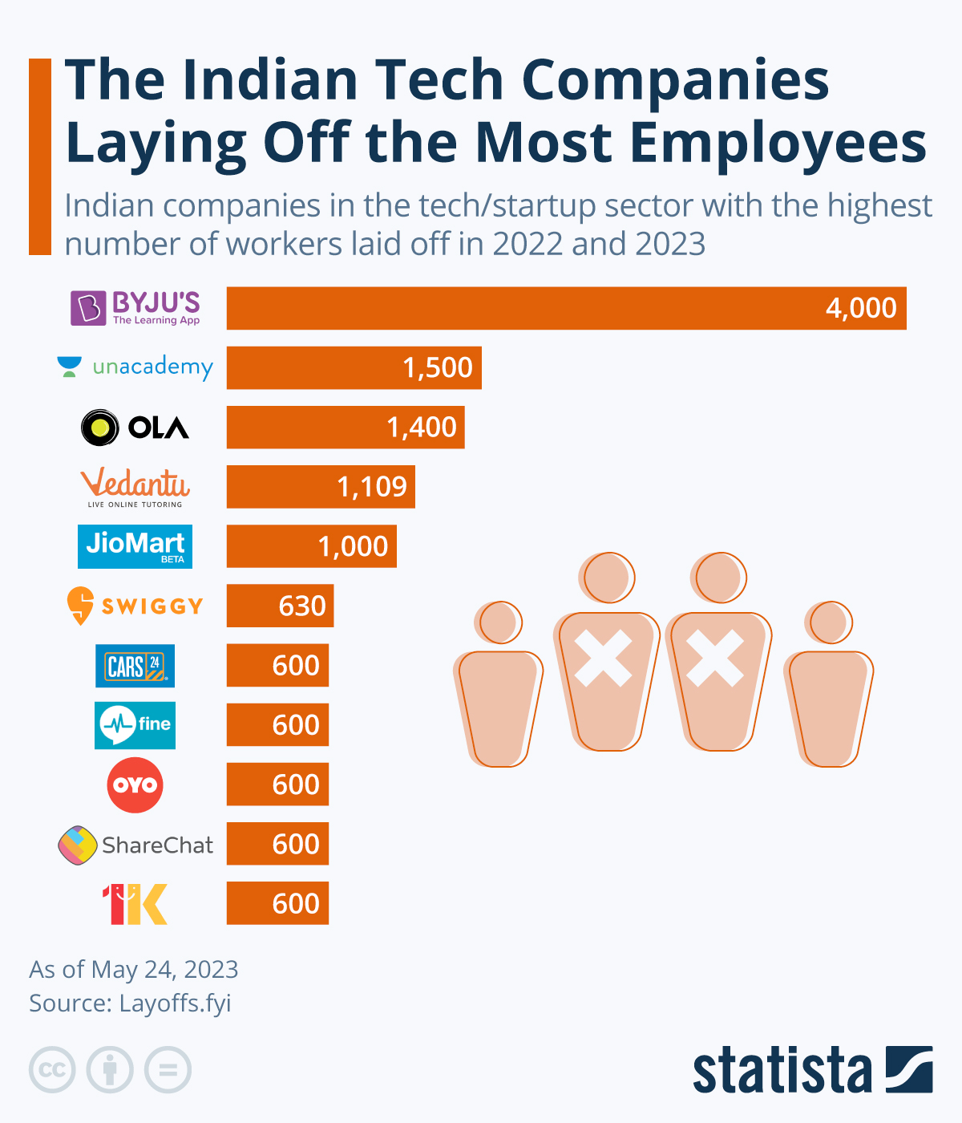

**Figure 2.1: Tech startups in India and their laid-off rate**

(Source: Buchholz, 2023)

It is well understood that the concept of employee turnover is substantially high in start-ups, and comparatively less in the organisational world because of the dynamism at the organisational level along with limited career mobility entailing unpaid wage facilities. An Economic Times report revealed that 78% of the employees of start-ups in India quit within two years, driven by burnout, no proper work-life balance or career progression (Economictimes, 2024).

Irabor & Okolie (2019) criticised that nonpecuniary motivators such as job satisfaction and involvement outweigh others such as compensation in retaining employees. However, Suraihi et al. (2021) argued that due to weak structural development, start-ups tend to have less well-developed HR systems, which increases the level of turnover. Jamarani et al. (2024) suggested that there is a need to find solutions that are easily scalable like predictive analytics to deal with these issues ahead of time.

## 2.3 Predictive Analytics in Human Resource Management

According to Kumar & Garg (2018), decision-making can be made easier through the use of real-time and historical data to predict future trends and behaviours is referred to as predictive analytics. This is according to a McKinsey report of 2023 that revealed that companies that have adopted predictive analytics on the human resource department enjoyed a 15% increase in the retention level within the first year (McKinsey, 2023). As mentioned by Hamilton & Sodeman (2020), solutions such as Workday and Visier incorporate algorithms for patterns that regard employee performance, satisfaction, and engagement.

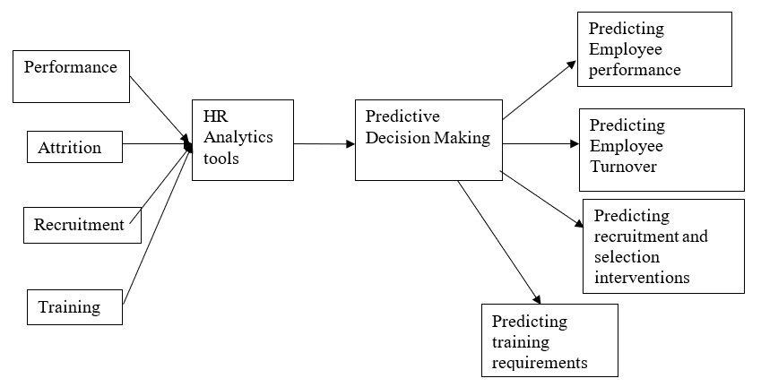

**Figure 2.2: Predictive analytics in resource management**

(Source: Mohammed, 2019)

However, McCartney & Fu (2022) argue that predictive analytics taken independently do not encompass problems as complex as organisational culture or leadership. Cho et al. (2023) counted that the quality of insights is a function of the type and quality of data that is available and this can be problematic with small start-ups that may not have robust human resource systems in place. Nonetheless, the prospects of using predictive analyses to reinvent retention are very much real.

## 2.4 Application of Predictive Analytics in Employee Retention

The data enables management to detect “flight risk” employees for instance through assessing their performance, level of engagement, and attendance. Research by Deloitte (2023) shows that organisations employing PM can cut employee attrition by about 20 per cent by providing early interventions (Deloitte, 2024). Singhal (2023) put the example of HDFC Bank and opined that it went for the analytics the attrition ratio of the high performers came down to 12%.

These tools can help in gaining data-driven strategic insights into the diverse problems that could arise in dynamic start-up work environments in India. Nevertheless, Cheryl & Ng (2022) argued that the problems exist: Consumers’ reluctance to accept new technology, lack of skilled and qualified personnel, and the issue of data security. For instance, it is common to observe that most start-ups could not properly deploy these tools owing to resource constraints and lack of expertise, thus degrading their usefulness.

## 2.5 Challenges in Implementing Predictive Analytics in Start-Ups

Although predictive analytics as a solution provides an impressive number of advantages, how it works in start-ups has multiple issues. These include:

* *Data Scarcity:* The success of such start-ups is that they have little historical data to work with when creating these models.
* *Cost Constraints:* Tomy & Pardede (2018) opined that issues such as big data analytics being capital intensive are another challenge where many start-ups can ill afford the expense levels needed to support such solutions.
* *Technical Expertise:*Lack of personnel with skilled expertise to manage and interpret analytics results makes such a tool a disappointment (Giermindl et al., 2021).

A study conducted by Gartner (2022) showed that 67% of all small and mid-size firms struggle with AI tool implementation because of the lack of infrastructure (Gartner, 2024). These are areas we have to address by coming up with solutions like cheap analytics cloud solutions.

## 2.6 Gaps in the Existing Literature

On the other hand, Singh et al. (2022) argued that despite rapid growth in interest and literature on predictive analytics and, particularly, employee retention, much of it is underpinned by research on large, mature organisations in developed countries. Sghir et al. (2022) counted that lack of literature is the next factor that has not analysed the special features and potential of the use of predictive analytics in the Indian start-up environment. This gap justifies exploring how retention of talent can be met by the circulating predictive tools based on the strict resource constraint and high attrition rate unique among the Indian start-ups.

## 2.7 Summary

The literature shows the prospect of predictive analytics in improving employee retention where there is high turnover and in organisations like start-ups. Despite the listed barriers, these tools provide a scalable and evidence-based solution to tackle attrition. The review reveals the research gaps in applying predictive analytics in the Indian start-up context wherein the subsequent analysis of this study will be advanced.

# Chapter 3: Methodology

This chapter discusses the methodological approach utilised in this research with a special focus on the philosophical, methodological, and, indeed, ethical issues underpinning the research.

## 3.1 Research Philosophy

The research is based on the interpretive philosophy that seeks to capture organisational manners and subjective contexts that support employee retention in the start-up environment of India. Interpretivism applies to this study because it aims at understanding how predictive analytics is viewed and applied in start-ups, where human understanding and context matter most when compared to quantification.

## 3.2 Research Approach

The research approach used is inductive because the goal is to construct meaning from observations and categorical data. Proudfoot (2022) argued that while deductive research seeks to validate theories and hypotheses there is an opportunity for fresh frameworks and themes to be innovated out of analysing recurrent themes from a body of secondary data.

## 3.3 Research Design

The research is exploratory, as it seeks to investigate an under-researched area: the role of predictive analytics in employee retention within the Indian start-up ecosystem. This design is particularly suited for understanding the evolving dynamics of technology adoption and its impact on human resource practices in start-ups (Davenport et al., 2023).

## 3.4 Data Collection Method

The sources of data collection for this study are books, peer-reviewed journals, authentic websites, and articles. These sources give a clear background of theories, trends, and practices, concerning predictive analytics and employee turnover. Baldwin et al. (2022) opined that the rationale for using secondary data is the ease of access, high reliability, and the advantage of being able to capture a wider range of ideas possible especially when the current study is exploratory.

## 3.5 Data Analysis Technique

There is the use of thematic analysis to analyse and comprehend patterns of the data that has been collected. Lepenioti et al. (2020) mentioned that it provides a more structured way of arranging and sorting out the insights it has gathered into broad areas of concern like the efficiency of prescriptive business analytics, concerns of start-ups, and recommendations towards appropriate approaches to use in retention management. This approach would help in an organised and systematic manner to see the various facets of the research problem.

## 3.6 Ethical Considerations

The study aligns itself with the Data Protection Act 2018, meaning all sources of secondary data will be appropriately accredited, thus avoiding plagiarism. Additionally, Chiruvella & Guddati (2021) added that the only available open-source data is used, which does not lead to violations of ethical norms regarding confidentiality or data abuse. To uphold reliability and ethical consideration in the entire research process it is essential to assess sources appropriately.

# Chapter 4: Data Analysis

## 4.1 Theme 1: Factors Contributing to Employee Turnover in Indian Start-Ups

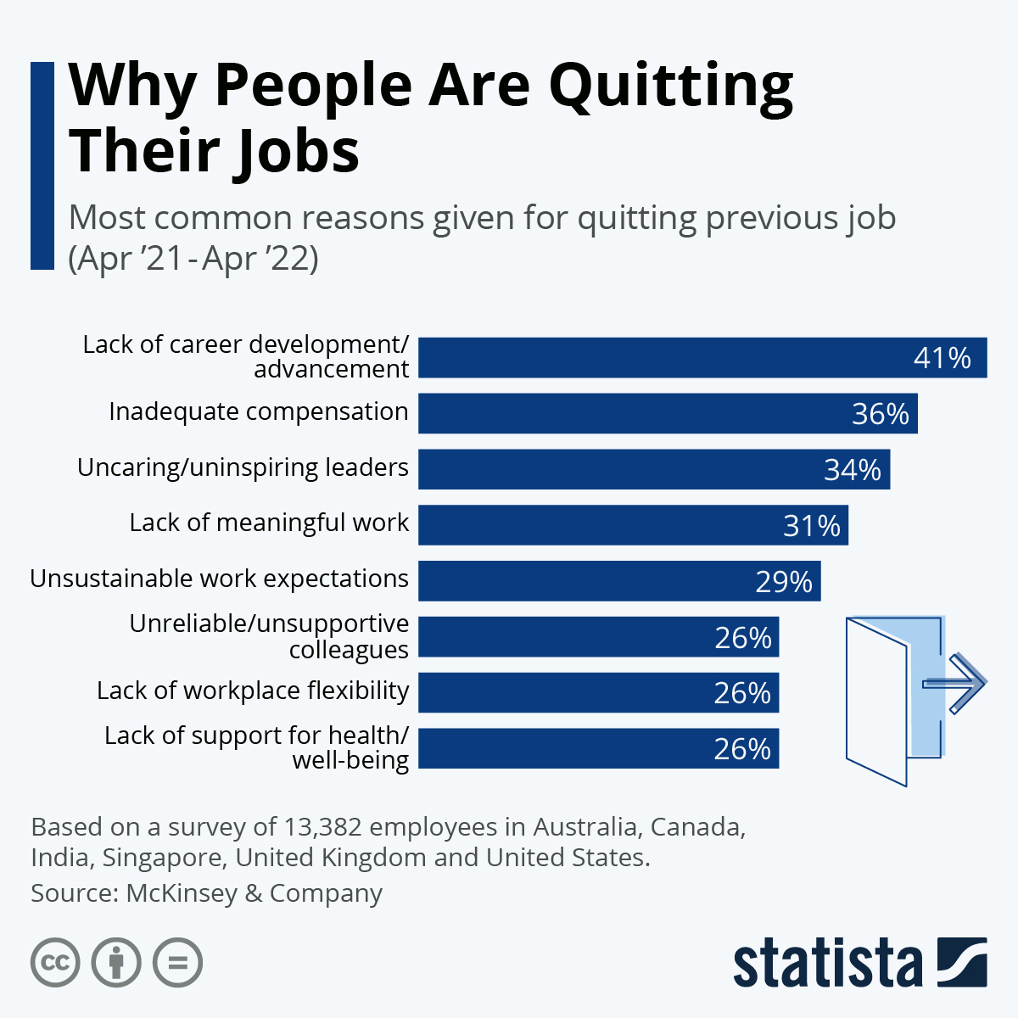

**Figure 4.1: Factors contributing to the job changes of people**

(Source: Armstrong, 2022)

According to Solihat & Salendu (2023), one of the primary factors contributing to high attrition rates in Indian start-ups is the lack of career growth opportunities. A report by PwC (2023) highlights that 45% of employees in Indian start-ups cite stagnant career paths as their reason for leaving (PwC, 2023). Other significant factors include excessive workload (38%), inadequate compensation (28%), and misalignment with organisational culture (15%) (PwC, 2023).

There is an opportunity in predictive analytics to know which employees should be retained before they consider leaving. For example, digital tools such as Retensa help to observe the satisfaction and engagement indices of employees so that the problem can be prevented (Susanto & Rony, 2023). Nevertheless, Usman & Vanhaverbeke (2017) argued that in the industry points out that start-up managers are not able to fully capitalise on these insights due to various restraints within the available resources leading to low optimal results.

## 4.2 Theme 2: Effectiveness of Predictive Analytics in Employee Retention

Research has revealed that the accuracy of prediction enhances employee retention by large margins. In the event of executive adoption of predictive tools, companies recorded a 25% decrease in turnover as estimated within a year, a 2023 Deloitte report illustrates (Deloitte, 2024a). In the context of start-ups in India, retention of talent has been brought out by using analytics where organisations like Flipkart have used analytics where lower performing talents can be observed and consequently tightly controlled leading to a 20% improvement (Bhatt & Nagvadia, 2021).

However, França et al. (2023) argued that challenges are still felt as explained in the following sections. Fernandez & Gallardo-Gallardo (2020) counted that another challenge that makes the use of predictive tools in HR processes challenging for start-ups is the high cost and lack of experience. Krishna et al. (2017) opined that small start-ups usually fail to have a wealth of information to construct ideal prediction algorithms. This shows that there is a need for an enhanced approach to mid and small-sized organisations since normally they cannot afford the above challenges.

## 4.3 Theme 3: Challenges of Implementing Predictive Analytics in Start-Ups

Nevertheless, forecasting is promising although its implementation in start-ups encounters the following difficulties. Budget caps come out as the leading challenge with 62% of start-ups stating that budget limitations are a barrier to implementing AI tools (Nasscom, 2022). In addition, there is a perception that data is not safe and they are not in compliance with the regulation, particularly since the passage of India’s Digital Personal Data Protection Act 2023 (Gov, 2023).

Ra et al. (2019) argued that another equally crucial factor is the technological skills deficit. Lutkevich (2020) counted that start-ups do not normally have their own data scientists written in their business plans, meaning that they resort to outsourcing and usually they have to turn to third-party vendors, which makes the procedure more expensive and less flexible. For instance, a survey conducted by the Indian HR Tech Association of start-ups (2023) reveals that 70% of organisations that use predictive tools rely on such consultants for support, which is not sustainable in the long run.

## 4.4 Summary of Key Findings

* The quality of people in Indian start-ups areas chasing career growth, job overload, and culture fit.
* Predictive analytics can be used to decline attrition rates as this means employee loss by pointing out the employees that could potentially leave.
* Some of the challenges to the implementation of the plan are; funding constraints, low technical capacity, and dilemmas on the management of data.
* Large start-ups with strong, well-developed HR infrastructures perform better in their deployment of the predictive tools while smaller start-ups and firms have issues in its adoption.

## 4.5 Discussion

The results suggest that although Predictive analytics could revolutionise the retention approaches, subtlety, its effectiveness in the Indian startup context is contingent upon the key issue. Through such tools and examples of relatively big start-ups like Flipkart, and Paytm, business observers can visualise indications of tangible improvements in values like retention and engagement of the company’s staff resources (Mathur & Singh, 2019). However, (Assisi et al. (2019) countered that such organisations also enjoy privileges that new start-up organisations cannot afford to undertake.

To overcome these disparities industry members, need to find feasible and efficient approaches. Gupta & Sharma (2023) mentioned that cloud-based predictive analytics platforms could pose lower costs and have much better access for small start-ups. More so, Ali et al. (2024) pined that government policies that offer ‘financial incentive and training’ in the uptake of intelligent technologies could go a long way in closing the technical skills divide.

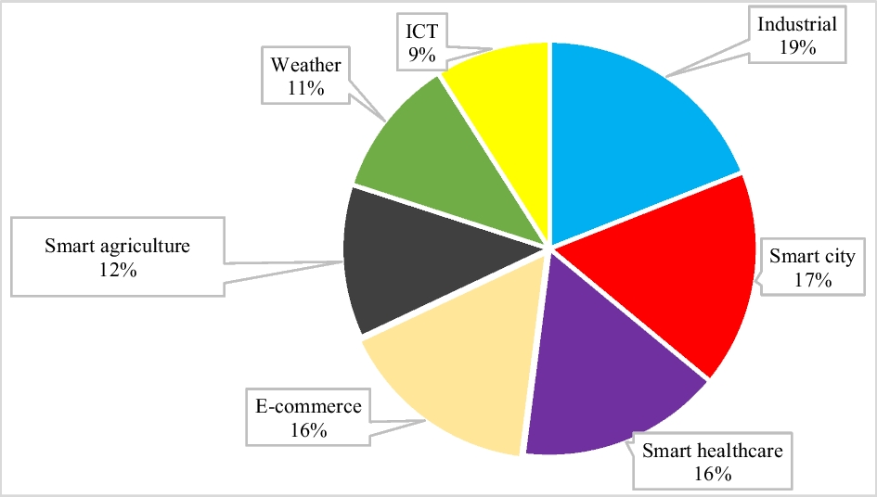

**Figure 4.2: Use of big data and predictive analytical tools based on the industries**

(Source: Jamarani et al., 2024)

Figure 4.2 pointed out a need for developing organisation-specific and context-specific retention strategies for employees that should include the use of big data and predictive analytical tools vis-à-Vis Indian start-up industry’s peculiarities. Thus, the use of prediction models will remain the key to the further development of sustainable workforce management approaches when the impacts of the ecosystem constantly change.

# Chapter 5: Conclusion and Recommendations

## 5.1 Conclusion

The focus area of this research was thus to assess how predictive analytics work as a means of improving the retention rate of employees of Technopreneurs in India. Some of the key issues recognized included high turnover rates in most of the Indian start-ups occasioned by issues such as career stagnation, high workload, and lack of cultural fit was also noted. They also established those other methods, such as using data to make forecasts on the behaviour of employees, known as predictive analytics, were a useful solution to the problem of attrition. However, some challenges have prevented dump and implementation from gaining ground, some of them are financial risks, lack of data, and lack of personnel with the technical know-how, especially among new start-ups. These factors drive the intent of the paper towards identifying relevant and practical lessons that offer appropriate solutions concerning time, cost, and context for start-ups in India.

## 5.2 Recommendations

***Recommendation 1: Implementation of Affordable Cloud-Based Predictive Analytics Tools***

They should therefore embrace the use of cloud-based systems such as Zoho People Analytics or BambooHR because they are cheaper for start-ups especially those with small populations. These can aid start-ups in tracking not only how engaged employees are but also when they are planning to leave and what can be done. For instance, a start-up, BambooHR, helped to retain its first batch of employees by cutting down the turnover level to 18% by trying to address the complaints or grievances of unsatisfied workers (Bamboohr, 2024).

***Recommendation 2: Upskilling HR Professionals in Data Analytics***

According to Cappelli et al. (2018), focusing on training the HR teams in the use of predictive analytics while relying less on outsiders may turn out to be a good change. For instance, firms like Flipkart have incorporated internal analytics to organise their retention approaches and have achieved an increased satisfaction rate of 20% among their employees (Upadhyay & Mishra, 2023).

***Recommendation 3: Developing Tailored Retention Programs Using Predictive Insights***

García-Madurga et al. (2024) suggested that startups should buy predictive insights to build custom career progression plans as well as employee well-being solutions. For instance, using tools of predictive analytics, the firm implemented personalised training interventions for risky performers at Swiggy and curtailed Attrition in critical sections by 15% (Raval, 2019).

## 5.3 Limitation

The research working with the secondary data sources only may lack rich details of the most recent changes or the specificity of the particular start-ups. Also, the emphasis on qualitative analysis restricts the generalisation of the results to the remarkably heterogeneous Indian start-up ecosystem (Panakaje et al., 2024).

## 5.4 Future Scope of the Study

Future research work may include a qualitative study by conducting interviews/sending questionnaires to the HRM of firms in the Indian start-ups to fetch the real-life issues and prospects. Some more benefits arising from comparison: Zweig et al. (2021) added that, unlike Asian start-ups that are entirely different from Indian start-ups, comparative analyses could also establish international benchmarks that are transferable to India. Subsequently, expanding knowledge in AI and, more importantly, investigating the implementation of these developments in smaller start-ups may improve the value of subsequent research.

# References

Ali, O., Murray, P. A., Momin, M., Dwivedi, Y. K., & Malik, F. T. (2024). The effects of artificial intelligence applications in educational settings: Challenges and strategies. *Technological Forecasting and Social Change*, *199*, 123076–123076. https://doi.org/10.1016/j.techfore.2023.123076

Armstrong, M. (2022, July 25). *Infographic: Why People Are Quitting Their Jobs*. Statista Infographics. https://www.statista.com/chart/27830/reasons-for-quitting-previous-job/

Assisi, C., Raghava, A., & Ramnath, N. (2019). The rise of the Indian start-up ecosystem. *Communications of the ACM*, *62*(11), 82–87. https://doi.org/10.1145/3344432

Baldwin, J. R., Pingault, J.-B., Schoeler, T., Sallis, H. M., & Munafò, M. R. (2022). Protecting against Researcher Bias in Secondary Data analysis: Challenges and Potential Solutions. *European Journal of Epidemiology*, *37*(1), 1–10. https://doi.org/10.1007%2Fs10654-021-00839-0

Bamboohr.com. (2024). *What is a Retention Strategy? | BambooHR Glossary*. Www.bamboohr.com. https://www.bamboohr.com/resources/hr-glossary/retention-strategy

Bhatt, V., & Nagvadia, J. (2021). *-FACTORS INFLUENCING CONSUMER’S ONLINE BUYING BEHAVIOR: AN EMPIRICAL STUDY‖ Doctor of Philosophy in Management*. ResearchGate; unknown. https://www.researchgate.net/publication/355396679_-FACTORS_INFLUENCING_CONSUMER

Buchholz, K. (2023). *Infographic: The Indian Tech Companies Laying Off the Most Employees*. Statista Infographics. https://www.statista.com/chart/29558/indian-tech-startup-layoffs/

Business-standard.com. (2024, March 20). *India has world’s third largest startup ecosystem: PM at Startup Mahakumbh*. @Bsindia; Business Standard. https://www.business-standard.com/industry/news/india-has-world-s-third-largest-startup-ecosystem-pm-at-startup-mahakumbh-124032000287_1.html

Cappelli, P., Tambe, P., & Yakubovich, V. (2018). Artificial Intelligence in Human Resources Management: Challenges and a Path Forward. *SSRN Electronic Journal*, *61*(4). https://doi.org/10.2139/ssrn.3263878

Cheryl, B.-K., & Ng, B.-K. (2022). Protecting the Unprotected Consumer Data in Internet of Things: Current Scenario of Data Governance in Malaysia. *Sustainability*, *14*(16), 9893. https://doi.org/10.3390/su14169893

Chiruvella, V., & Guddati, A. K. (2021). Ethical Issues in Patient Data Ownership. *Interactive Journal of Medical Research*, *10*(2). https://doi.org/10.2196/22269

Cho, W., Choi, S., & Choi, H. (2023). Human Resources Analytics for Public Personnel Management: Concepts, Cases, and Caveats. *Administrative Sciences*, *13*(2), 41. https://doi.org/10.3390/admsci13020041

Davenport, S., Campbell-Hunt, C., & Solomon, J. (2023). The dynamics of technology strategy: an exploratory study. *R and D Management*, *33*(5), 481–499. https://doi.org/10.1111/1467-9310.00312

Deloitte.com. (2024a). *Automation with intelligence Reimagining the organisation in the “Age of With”* (pp. 1–28). https://www2.deloitte.com/content/dam/Deloitte/tw/Documents/strategy/tw-Automation-with-intelligence.pdf

Deloitte.com. (2024b). *Deloitte India Talent Outlook 2023 | Press release*. Deloitte India. https://www2.deloitte.com/in/en/pages/about-deloitte/articles/deloitte-india-talent-outlook-2023-press-release.html

Economictimes.indiatimes.com. (2024, March 27). Nearly 78% employees in India experience job burnout, says UKG study. *The Economic Times*. https://economictimes.indiatimes.com/jobs/hr-policies-trends/nearly-78-employees-in-india-experience-job-burnout-says-ukg-study/articleshow/108826598.cms?from=mdr

Fernandez, V., & Gallardo-Gallardo, E. (2020). Tackling the HR digitalization challenge: key factors and barriers to HR analytics adoption. *Competitiveness Review: An International Business Journal*, *31*(1), 162–187. https://doi.org/10.1108/cr-12-2019-0163

García-Madurga, M.-Á., Gil-Lacruz, A.-I., Saz-Gil, I., & Gil-Lacruz, M. (2024). The Role of Artificial Intelligence in Improving Workplace Well-Being: A Systematic Review. *Businesses*, *4*(3), 389–410. https://doi.org/10.3390/businesses4030024

Gartner.com. (2024). *Gartner Survey Finds Generative AI is Now the Most Frequently Deployed AI Solution in Organizations*. Gartner. https://www.gartner.com/en/newsroom/press-releases/2024-05-07-gartner-survey-finds-generative-ai-is-now-the-most-frequently-deployed-ai-solution-in-organizations

Ghani, B., Zada, M., Memon, K. R., Ullah, R., Khattak, A., Han, H., Montes, A. A., & Castillo, L. A. (2022). Challenges and Strategies for Employee Retention in the Hospitality Industry: A Review. *Sustainability*, *14*(5), 2885. Mdpi. https://doi.org/10.3390/su14052885

Giermindl, L. M., Strich, F., Christ, O., Leicht-Deobald, U., & Redzepi, A. (2021). The dark sides of people analytics: reviewing the perils for organisations and employees. *European Journal of Information Systems*, *31*(3), 1–26. https://doi.org/10.1080/0960085X.2021.1927213

Gov.in. (2023, August 11). *Ministry of Electronics and Information Technology, Government of India | Home Page*. Www.meity.gov.in. https://www.meity.gov.in/writereaddata/files/Digital%20Personal%20Data%20Protection%20Act%202023.pdf

Gupta, U., & Sharma, R. (2023). A Study of Cloud-Based Solution for Data Analytics. *Internet of Things*, 145–161. https://doi.org/10.1007/978-3-031-33808-3_9

Hamilton, R. H., & Sodeman, W. A. (2020). The questions we ask: Opportunities and challenges for using big data analytics to strategically manage human capital resources. *Business Horizons*, *63*(1). http://dx.doi.org/10.1016/j.bushor.2019.10.001

Irabor, I. E., & Okolie, U. C. (2019). A Review of Employees’ Job Satisfaction and its Affect on their Retention. *Annals of Spiru Haret University. Economic Series*, *19*(2), 93–114. Researchgate. https://doi.org/10.26458/1924

Jacob Fernandes França, T., São Mamede, H., Pereira Barroso, J. M., & Pereira Duarte dos Santos, V. M. (2023). Artificial intelligence applied to potential assessment and talent identification in an organisational context. *Heliyon*, *9*(4), e14694. https://doi.org/10.1016/j.heliyon.2023.e14694

Jamarani, A., Haddadi, S., Sarvizadeh, R., Kashani, M. H., Akbari, M., & Moradi, S. (2024). Big data and predictive analytics: A sytematic review of applications. *Artificial Intelligence Review*, *57*(7), 1–77. Springer. https://doi.org/10.1007/s10462-024-10811-5

Krishna, A., Agrawal, A., & Choudhary, A. (2017, December 1). *Predicting the Outcome of Startups: Less Failure, More Success*. IEEE Xplore. https://doi.org/10.1109/ICDMW.2016.0118

Kumar, V., & Garg, M. L. (2018). Predictive Analytics: A Review of Trends and Techniques. *International Journal of Computer Applications*, *182*(1), 31–37. Researchgate. https://doi.org/10.5120/ijca2018917434

Lepenioti, K., Bousdekis, A., Apostolou, D., & Mentzas, G. (2020). Prescriptive analytics: Literature review and research challenges. *International Journal of Information Management*, *50*(1), 57–70. Sciencedirect. https://doi.org/10.1016/j.ijinfomgt.2019.04.003

Lutkevich, B. (2020, May). *What is Outsourcing and How Does it Work?* Techtarget. https://www.techtarget.com/searchcio/definition/outsourcing

Mathur, S., & Singh, A. (2019). *Entreprenuership and Innovation: A Case Study Of Paytm*. https://www.researchgate.net/publication/337928586_Entreprenuership_and_Innovation_A_Case_Study_Of_Paytm

McCartney, S., & Fu, N. (2022). Promise versus reality: a systematic review of the ongoing debates in people analytics. *Journal of Organizational Effectiveness: People and Performance*, *9*(2). https://doi.org/10.1108/joepp-01-2021-0013

McKinsey. com. (2023, August 1). *The state of AI in 2023: Generative AI’s breakout year*. Www.mckinsey.com. https://www.mckinsey.com/capabilities/quantumblack/our-insights/the-state-of-ai-in-2023-generative-ais-breakout-year

MOHAMMED, A. Q. (2019). HR ANALYTICS: A MODERN TOOL IN HR FOR PREDICTIVE DECISION MAKING. *JOURNAL of MANAGEMENT*, *10*(3). https://doi.org/10.34218/jom.6.3.2019.007

Nasscom.in. (2022). *NASSCOM AI Adoption Index 2022*. Nasscom | the Official Community of Indian IT Industry. https://community.nasscom.in/communities/ai/nasscom-ai-adoption-index-2022

Nasscom.in. (2023, February 15). *Weathering the challenges: The Indian Tech Start-up Landscape Report 2023*. Nasscom. https://nasscom.in/knowledge-center/publications/weathering-challenges-indian-tech-start-landscape-report-2023

Panakaje, N., Bhagwath, A. A., Riha Parvin, S. M., K, M., & Kambali, U. (2024). Accelerating entrepreneurship: Evidence from the incubation centers of management institutes of Dakshina Kannada. *Heliyon*, *10*(14), e34312. https://doi.org/10.1016/j.heliyon.2024.e34312

Primadi Candra Susanto, & Zahara Tussoleha Rony. (2023). Analysis of Employee Retention Programs and Talent Engagement to Prevent Employee Turnover in Organizations (Systematic Literature Review). *Asian Journal of Community Services*, *2*(6), 489–500. https://doi.org/10.55927/ajcs.v2i6.4560

Proudfoot, K. (2022). Inductive/Deductive Hybrid Thematic Analysis in Mixed Methods Research. *Journal of Mixed Methods Research*, *17*(3), 308–326. Sagepub. https://doi.org/10.1177/15586898221126816

Pwc.in. (2023). *Indian Workforce Hopes & Fears Survey 2023:What’s The Future?* PwC. https://www.pwc.in/india-workforce-hopes-and-fears-survey-2023.html

Ra, S., Shrestha, U., Khatiwada, S., Yoon, S. W., & Kwon, K. (2019). The Rise of Technology and Impact on Skills. *International Journal of Training Research*, *17*(1), 26–40. Tandfonline. https://doi.org/10.1080/14480220.2019.1629727

Raval, A. (2019, December 24). *Swiggy uses AI and Data Science to grow its order value by over 200%*. Express Computer. https://www.expresscomputer.in/news/ai-and-data-science-models-are-at-the-heart-of-all-the-systems-that-we-build-at-swiggy/44566/

Sghir, N., Adadi, A., & Lahmer, M. (2022). Recent advances in Predictive Learning Analytics: A decade systematic review (2012–2022). *Education and Information Technologies*, *28*. https://doi.org/10.1007/s10639-022-11536-0

Singh, R., Sharma, P., Foropon, C., & Belal, H. M. (2022). The Role of Big Data and Predictive Analytics in the Employee retention: a resource-based View. *International Journal of Manpower*, *43*(2). https://doi.org/10.1108/ijm-03-2021-0197

Singhal, T. (2023, November 9). *A growing concern in the banking industry: Here’s how HDFC Bank is tackling high attrition rates!* ETHRWorld.com; ETHRWorld. https://hr.economictimes.indiatimes.com/news/hrtech/talent-acquisition-and-management/a-growing-concern-in-the-banking-industry-heres-how-hdfc-bank-is-tackling-high-attrition-rates/105081619

Suraihi, W. A. A., Samikon, S. A., Suraihi, A.-H. A. A., & Ibrahim, I. (2021). Employee turnover: Causes, importance and retention strategies. *European Journal of Business and Management Research*, *6*(3), 1–10. Researchgate. http://dx.doi.org/10.24018/ejbmr.2021.6.3.893

Tomy, S., & Pardede, E. (2018). From Uncertainties to Successful Start Ups: A Data Analytic Approach to Predict Success in Technological Entrepreneurship. *Sustainability*, *10*(3), 602. https://doi.org/10.3390/su10030602

Upadhyay, A., & Mishra, P. (2023). A Study on Employee Job Satisfaction at Flipkart Raipur. *IRE Journals |*, *6*, 1–67. https://www.irejournals.com/formatedpaper/17048011.pdf

Usman, M., & Vanhaverbeke, W. (2017). How start-ups successfully organize and manage open innovation with large companies. *European Journal of Innovation Management*, *20*(1), 171–186. https://doi.org/10.1108/ejim-07-2016-0066

Widya Syayidatus Solihat, & Salendu, A. (2023). The relationship between career growth opportunity and turnover intentions in employees in startup companies x: career planning coaching program designed as an intervention. *Gema Wiralodra*, *14*(2), 1012–1025. https://doi.org/10.31943/gw.v14i2.480

Zweig, D., Tsai, K. S., & Singh, A. D. (2021). Reverse entrepreneurial migration in China and India: The role of the state. *World Development*, *138*, 105192. https://doi.org/10.1016/j.worlddev.2020.105192