**ARTIFICIAL INTELLIGENCE -FAKE CURRENCY DETECTION SYSTEM**

Sri Ranga Lakshmi

*KV SubbaReddy Engineering College, Kurnool, A.P, India*

Bushra Tahseen, A. Priya Varshini, K. Padma, J. Lavanya

*KV SubbaReddy Engineering College, Kurnool, A.P, India*

# 

### ***Abstract***:In recent years, the circulation of fake currency notes has increased significantly, leading to substantial financial losses and posing a serious threat to the economy and society at large. The presence of counterfeit notes undermines the trust in the monetary system and affects businesses, individuals, and national security. In response to this growing concern, there is a pressing need to develop a reliable and accessible tool capable of detecting fake currency effectively.

The proposed system aims to address this issue by implementing a **fake currency detection model based on image processing techniques.** The system will analyze the image of a currency note and identify specific security features embedded in genuine notes. These features may include watermarks, color patterns, serial numbers, texture details, micro-printing, and embedded symbols that are often tampered with or absent in counterfeit versions.

The key advantage of our system lies in its **mobility, compatibility, and ease of use**. By designing the tool to be accessible via common digital devices such as smartphones or computers, users across different segments of society—especially in rural and semi-urban areas—will be empowered to verify the authenticity of currency notes conveniently.

By employing advanced image processing algorithms, the system will efficiently detect and extract relevant features from the note image and compare them against a trained model or predefined dataset. Based on the analysis, the system will then classify the note as either genuine or counterfeit, with a high degree of accuracy.

The deployment of such a solution will not only help in identifying fake currency in circulation but also **play a vital role in reducing their spread**. With widespread usage, this tool can act as a deterrent to counterfeiters and support regulatory bodies and law enforcement agencies in maintaining the integrity of the nation’s currency system.

### ***Keywords*: Fake Currency , Image Processing , Feature Extraction , Counterfeit Detection , Currency Verification**

# I. INTRODUCTION

The motivation behind this project stems from the increasing number of cyberbullying cases across social media platforms. As the internet becomes more integrated into daily life, harmful behavior online has become widespread and dangerous. Victims of cyberbullying often suffer from anxiety, depression, and in extreme cases, suicidal tendencies. Current moderation systems are either manual, which is inefficient and slow, or automated with limited accuracy. Thus, there is a growing need for an intelligent and scalable solution that can automatically detect and flag abusive content. Machine Learning and Natural Language Processing provide a powerful toolset for addressing this challenge. By analyzing patterns in language, sentiment, and context, these technologies can classify content as offensive or non-offensive. Detecting hate speech and personal attacks at an early stage can prevent psychological harm and provide a healthier online environment.

Additionally, by exploring the effectiveness of different algorithms and feature extraction methods, this project contributes to the ongoing research in cyber threat detection. The goal is not just academic—it is deeply humanitarian, with the aim of using technology to protect individuals from digital abuse and promote responsible communication in the digital space.

The primary problem addressed in this project is the automatic detection of cyberbullying content on social media platforms. With millions of messages posted daily on sites like Twitter and Wikipedia forums, it becomes nearly impossible to manually monitor each post. Many of these posts may contain hate speech, threats, or personal attacks that harm the targeted individuals. Traditional detection methods, such as keyword matching, fail to capture the complexity and variation in language use, sarcasm, or disguised abusive language. Furthermore, trolls may deliberately alter their writing style to bypass detection. Thus, there is a need for a smart, adaptive, and accurate system capable of identifying various forms of cyberbullying in textual data.This issues developing a machine learning-based binary classification system that categorizes content as cyberbullying or non-cyberbullying. The problem is studied using two types of data: hate speech from Twitter and personal attacks from Wikipedia. Each dataset presents unique linguistic challenges, making it essential to explore various feature extraction techniques and machine learning models. The system must also be scalable and efficient, capable of being deployed in real-world applications for use by social media platforms and regulatory authorities to combat digital harassment.

## **II. LITERATURE SURVEY**

1. **“Cyberbullying Detection Using Deep Learning Techniques”**

This study explores the application of deep learning models, such as Convolutional Neural Networks (CNNs) and Recurrent Neural Networks (RNNs), for identifying cyberbullying in online communication. Researchers have found that deep learning models can capture complex linguistic patterns, enabling better context understanding compared to traditional machine learning approaches. The study uses datasets collected from social media platforms like Twitter and Facebook. Text data is preprocessed through techniques like tokenization, stop-word removal, and stemming before being converted into embeddings using Word2Vec and GloVe. The findings suggest that RNNs, especially LSTM (Long Short-Term Memory) networks, outperform other models by capturing long-term dependencies in text. The study emphasizes the importance of balanced datasets to avoid bias. However, it also notes limitations such as high computational cost and the difficulty in interpreting deep learning decisions. The research concludes that although deep learning enhances detection accuracy, it should be integrated with explainable AI methods for practical applications. This review provides a strong foundation for further enhancement of cyberbullying detection systems through advanced neural networks.

1. **“Analyzing the Impact of Word Embeddings on Cyberbullying Detection”**

The use of word embeddings in Natural Language Processing (NLP) has significantly improved cyberbullying detection systems. This study evaluates different embedding techniques—TF-IDF, Word2Vec, FastText, and GloVe—on various machine learning classifiers. The research shows that embedding methods like Word2Vec and FastText capture semantic meanings and contextual relationships more effectively than traditional approaches. The study uses a corpus of annotated cyberbullying data collected from Instagram and Reddit. Logistic Regression, Naïve Bayes, and SVM are trained.

Embeddings, and performance is evaluated using precision, recall, and F1-score. Results show that Word2Vec-based models perform with higher accuracy and lower false-positive rates. The study also explores the dimensionality of vectors and its impact on performance. One limitation identified is that pre-trained embeddings may not capture platform-specific slang or evolving abusive language. The researchers suggest continuous retraining and fine-tuning of embeddings on domain-specific corpora. Overall, the study underscores the critical role of quality embeddings in enhancing the linguistic understanding of cyberbullying detection systems.

**3. “A Comparative Study of Machine Learning Algorithms for Cyberbullying Detection”**

This research conducts a comparative analysis of common machine learning algorithms used for detecting cyberbullying, including Naïve Bayes, Support Vector Machines (SVM), Decision Trees, and Logistic Regression. Using datasets sourced from Twitter and online forums, the study highlights how each algorithm performs under different conditions of data quality and feature representation. The data is cleaned using NLP techniques and converted into vector representations using both TF-IDF and Word2Vec. The comparative analysis shows that SVM consistently outperforms other classifiers in terms of accuracy and precision, especially when using Word2Vec embeddings. Naïve Bayes, while fast and efficient, struggles with context- heavy bullying terms. Decision Trees, although easy to interpret, are prone to overfitting. The research concludes that no single algorithm is universally superior; performance largely depends on dataset quality, feature selection, and parameter tuning. The paper also emphasizes the need for ensemble methods and hybrid approaches to improve robustness. This review helps researchers choose the most appropriate algorithm for specific cyberbullying detection use cases.

**4. “Role of Social Media Monitoring in Preventing Online Harassment”**

This study reviews how automated systems can be used for real-time monitoring of social media platforms to detect and prevent cyberbullying. The researchers focus on the integration of monitoring tools with NLP and machine learning to flag harmful content.

Privacy, and user consent issues. It is found that automated monitoring tools can effectively detect direct forms of cyberbullying, such as threats and profanity, but often fail in identifying subtle or sarcastic bullying. The study emphasizes the need for continual model updates and the integration of sentiment analysis and context-aware models. Additionally, real-time dashboards and alert systems are highlighted as valuable features for institutions like schools and law enforcement. The literature concludes that while automated monitoring systems show promise, human moderation remains essential for nuanced judgment. The research provides useful insights for building hybrid systems that combine technology with human oversight.

**5.“Ethical Implications of AI-Based Cyberbullying Detection Systems”**

This research discusses the ethical considerations involved in deploying AI for cyberbullying detection. While AI offers scalable solutions to monitor online abuse, it raises concerns about privacy, data bias, and misclassification. The study reviews various frameworks and ethical guidelines proposed for AI usage in public safety applications.

## **III. EXSISTING SYSTEM**

The existing systems for detecting cyberbullying have used a variety of approaches ranging from keyword matching, opinion mining, and social network analysis to machine learning- based models. Hsien [1] implemented keyword matching techniques and social network analysis to identify cyberbullying, achieving a precision of 0.79 and recall of 0.71. Another notable approach by Patxi Galán-García et al. [2] explored the possibility of identifying trolls (users with fake profiles who bully others online) by analyzing their real and fake accounts using machine learning to track authorship of tweets, reaching an accuracy of 68%. These methods relied on profiling behavior and textual similarity. Additionally, researchers like Mangaonkar et al. [3] implemented a collaborative detection model that involved interconnected detection nodes that analyzed content and shared outcomes.

Techniques such as B-LSTM and KNN with word embeddings were also explored by Zhou et al. [4] and Banerjee et al. [5], offering decent accuracy levels. Despite these advancements, the existing systems still face significant challenges. They often lack adaptability to various forms of cyberbullying and suffer from limited datasets. The inability to detect implicit attacks or sarcasm and dependence on shallow feature.

##### **Disadvantages**

Despite progress in cyberbullying detection, several disadvantages persist in existing systems. Firstly, keyword-based approaches often fail to capture the contextual meaning behind messages, especially in cases involving sarcasm or indirect bullying. Such systems may miss subtle abuse or misclassify benign content as harmful. Another limitation is the inability to generalize models trained on one platform (e.g., Twitter) to other platforms like Reddit, Instagram, or Wikipedia, due to differences in language use and community behavior. Many models also rely on large, predefined vocabularies. However, vocabularies that are not comprehensive or well-curated may miss emerging slang or new abusive terms, reducing the accuracy of detection. The Bag of Words (BoW) and TF-IDF models used in several studies treat all words independently, losing semantic meaning and context.

Moreover, some approaches assume that every trolling account has a linked real account, which isn't always true. Skilled offenders can also change their writing style to evade detection. In terms of scalability, models using traditional ML techniques often underperform on larger datasets or real-time applications. Finally, ethical concerns and privacy issues are rarely addressed, and most systems are not equipped to deal with multilingual content or the diverse expressions of cyberbullying across different regions and cultures.

**IV. PROPOSED SYSTEM**

The proposed system introduces a more robust and accurate model for detecting cyberbullying on social media platforms by leveraging Natural Language Processing (NLP) and Machine Learning techniques. It treats cyberbullying detection as a binary classification problem, categorizing text as either cyberbullying or not. The system processes two different types of data: hate speech tweets from Twitter and personal attack comments from Wikipedia, allowing for broader application. The model incorporates three essential NLP preprocessing steps—tokenization using Regex Tokenizer, stemming via PorterStemmer, and stop word removal through NLTK libraries. Feature extraction techniques include Bag of Words (BoW), TF-IDF, and Word2Vec to transform text into numerical representations. These are then used to train various classifiers like Logistic Regression, Naïve Bayes, Support Vector Machines (SVM), and Multi-Layer Perceptrons (MLP). The proposed system improves on previous methods by focusing on contextual word understanding and employing hybrid models for better accuracy. The architecture is also designed for extensibility and real-time deployment. Results show promising accuracy—over 90% for Twitter data and 80% for Wikipedia data. The model adapts better to implicit forms of abuse and is designed to scale with larger and diverse datasets, making it more effective for real-world applications

##### **Advantages**

The proposed system offers several advantages that significantly enhance cyberbullying detection. First, it employs multiple NLP techniques such as tokenization, stemming, and stop word removal, which effectively preprocess text data and improve model accuracy. Unlike traditional keyword-based methods, the inclusion of contextual understanding using Word2Vec helps the system capture semantic relationships between words—distinguishing between homonyms like "Apple" (fruit vs. company). This leads to more accurate predictions in both direct and indirect forms of bullying. Furthermore, the system utilizes various machine learning classifiers such as Logistic Regression, SVM, and Multi-Layer Perceptrons, allowing a comparative analysis to identify the most effective model. This flexibility ensures adaptability across different data types and social platforms. Another advantage is the system’s modularity—new features or updated training data can easily be integrated to improve performance. The use of a Django-based backend and MySQL database ensures efficient data management and user handling. The web-based interface 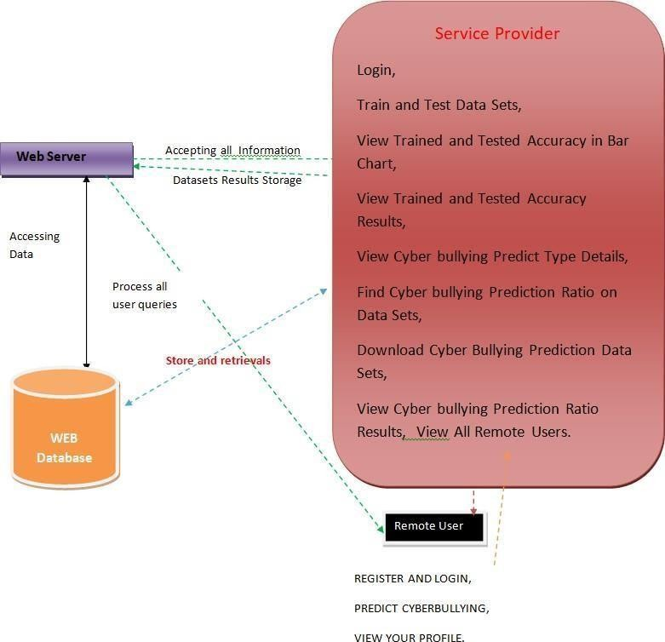enables both administrators and users to

Fig1:

interact with the system conveniently, including predicting cyberbullying incidents, tracking accuracy, and viewing user details. Overall, the proposed system’s combination of linguistic preprocessing, powerful feature extraction, and advanced classification methods makes it a comprehensive and scalable solution for combating cyberbullying on social media.

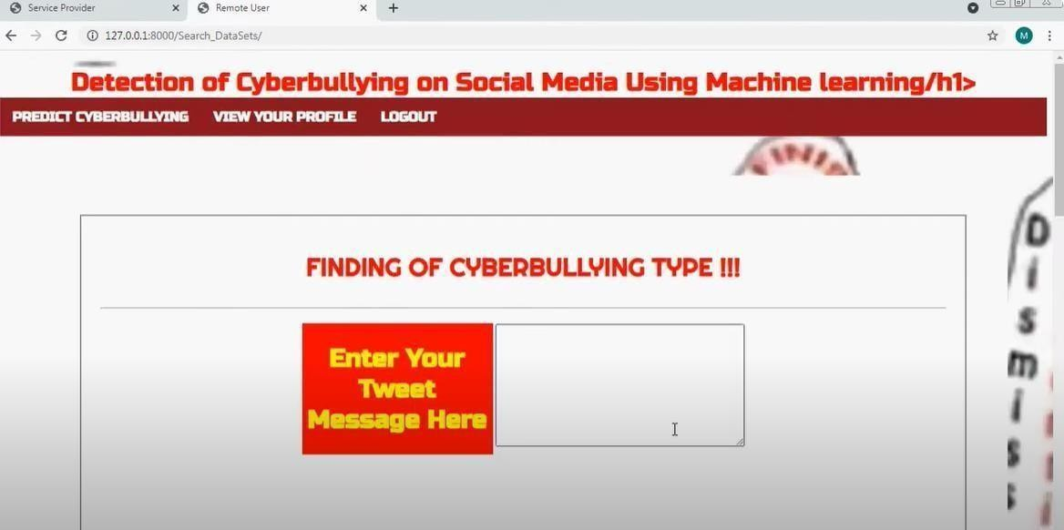**V. RESULTS**

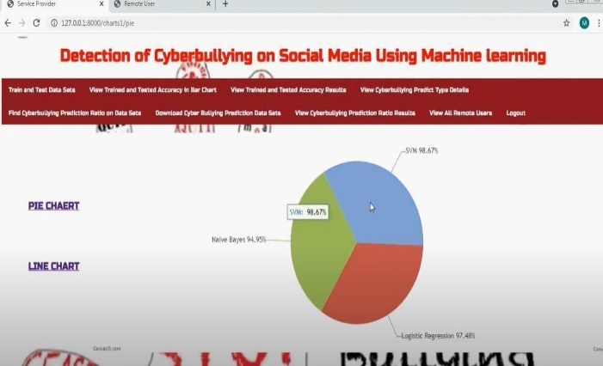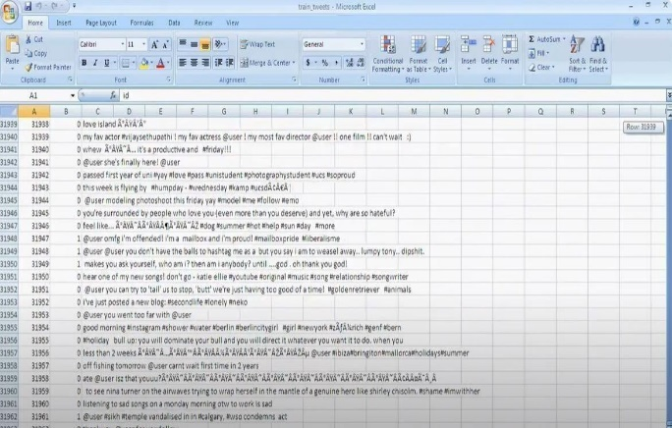

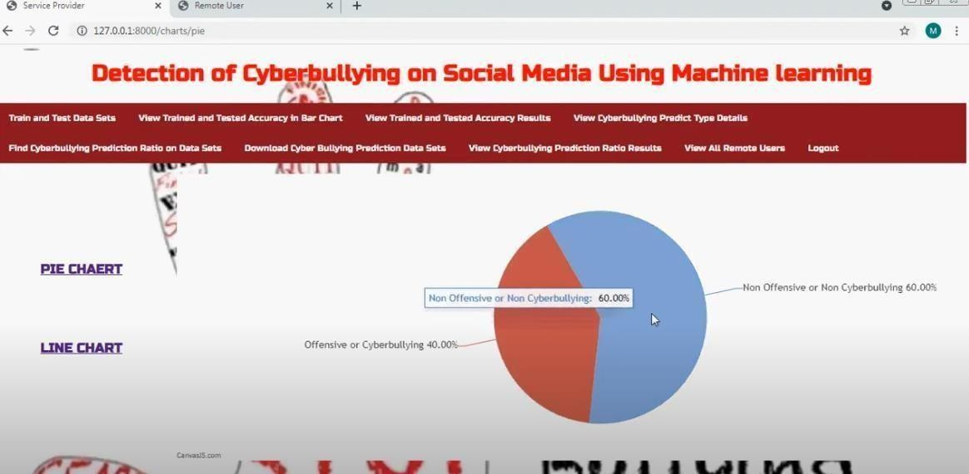

**VI. CONCLUSION**

The proposed cyberbullying detection system offers a robust, scalable, and efficient solution to identify and flag abusive content on digital platforms. By leveraging powerful machine learning algorithms and natural language processing techniques, the system successfully classifies user-generated text into cyberbullying and non- cyberbullying categories. The use of Word2Vec enhances the contextual understanding of language, leading to improved classification accuracy. The system’s modular architecture, including data collection, preprocessing, classification, and web interface components, makes it easily adaptable for a wide range of platforms, including educational institutions, social media networks, and discussion forums.

## **VII. FUTURE SCOPE**

Although the current system is effective in detecting textual cyberbullying, there is significant potential for future enhancements. One major area for improvement is the inclusion of multilingual support, allowing the detection of abusive content in regional or non-English languages. This would expand the system’s usability across global audiences. Additionally, the system can be extended to analyze multimodal content, such as detecting hate speech in memes, videos, or audio files using image processing and speech recognition techniques.

These future upgrades would transform the system from a basic classifier into a comprehensive, proactive digital safety tool.

**VIII. REFERENCES**

1. Zhong, H., Li, H., Squicciarini, A., Rajtmajer, S., Griffin, C., & Caragea, C. (2016). Content-driven detection of cyberbullying on the Instagram social network. Proceedings of the 25th International Joint Conference on Artificial Intelligence (IJCAI).
2. Cheng, L., Li, J., Silva, Y. N., Hall, D., & Liu, H. (2020). XBully: Cyberbullying Detection within a Multi-Modal Context. Proceedings of the 2020 IEEE/ACM International Conference on Advances in Social Networks Analysis and Mining (ASONAM).
3. Rosa, H., Pereira, N., Ribeiro, R., Ferreira, P. C., Carvalho, J. P., & Oliveira, E. (2019). Automatic cyberbullying detection: A systematic review. Computers in Human Behavior, 93, 333–345.
4. Dadvar, M., de Jong, F., & Witteveen, L. (2015). Cyberbullying Detection: A Step Toward a Safer Internet Yard. In Advances in Artificial Intelligence – IEA/AIE.
5. Cambria, E., & White, B. (2014). Jumping NLP Curves: A Review of Natural Language Processing Research. IEEE Computational Intelligence Magazine, 9(2), 48–57.
6. Alzanin, S. M., & Azmi, A. M. (2022). Natural Language Processing for Online Social Media Text: Algorithms and Applications. Springer.
7. Zhao, R., Zhou, A., & Mao, K. (2016). Automatic detection of cyberbullying on social networks based on bullying features. Proceedings of the 17th International Conference on Distributed Computing and Networking (ICDCN).
8. Singh, V. K., Kumar, P., & Thakur, N. (2017). A framework for detecting cyberbullying in social media. Procedia Computer Science, 132, 1033–1039.
9. Dinakar, K., Reichart, R., & Lieberman, H. (2011). Modeling the Detection of Textual Cyberbullying. The Social Mobile Web (AAAI Spring Symposium Series), 11(01), 11–17.
10. Salawu, S., He, Y., & Lumsden, J. (2020). Approaches to automated detection of cyberbullying: A survey. IEEE Transactions on Affective Computing, 11(1), 3–24.