**Theft Detection system using Arduino UNO**

**C.D.Patil 1, Akanksha Rayjade2, Bhavesha Sakhare3 , Prachi Shinde⁴, Sakshi Yande⁵**

1Asst. Prof., AI&DS , Guru Gobind Singh College of Engineering and Research Centre, Nashik, Maharashtra, India

2Student, AI&DS, Guru Gobind Singh College of Engineering and Research Centre, Nashik, Maharashtra, India

3Student, AI&DS, Guru Gobind Singh College of Engineering and Research Centre, Nashik, Maharashtra, India

4Student, AI&DS, Guru Gobind Singh College of Engineering and Research Centre, Nashik, Maharashtra, India

5Student, AI&DS, Guru Gobind Singh College of Engineering and Research Centre, Nashik, Maharashtra, India

**ABSTRACT**

Theft prevention is a critical concern in residential, commercial, and industrial environments. Traditional security systems rely on motion sensors, cameras, and pressure pads, which may have limitations in terms of cost, complexity, and reliability. This paper proposes an anti-theft detection system using a piezoelectric sensor to detect unauthorized intrusions by sensing mechanical vibrations or pressure changes. The system triggers an alarm when an intruder applies force (e.g., stepping on a protected surface or tampering with an object). The piezoelectric sensor converts mechanical stress into an electrical signal, which is then processed by a microcontroller to activate an alert mechanism (buzzer, LED, or SMS notification). This study explores the working principle, circuit design, advantages, and potential applications of the system.

**Keywords:** Piezoelectric sensor, anti-theft system, intrusion detection, vibration sensor, security system

1. **INTRODUCTION**

Security systems are essential for protecting assets and ensuring safety. Conventional methods like CCTV and infrared sensors are effective but may be expensive or require complex installations. Piezoelectric sensors offer a low-cost, energy-efficient, and reliable alternative for detecting unauthorized access.

In today's world, theft and unauthorized access are general security concerns for houses, shops and workplaces. To address the issue, we have designed a simple but effective theft system using Arduino and basic electronic components. The project uses a combination of abnormal vibrations, pressure or movement to detect a force sensor and a pejo sensor that may indicate tampering or theft.

When the system detects suspicious activity, the LED acts as an immediate visual warning, while the LCD display shows a warning message to inform the user of the danger detected danger. Arduino is the brain of the microcontroller project - it processes the sensor signals and triggers the required alert.

The project is cost -effective and ideal for beginners interested in security systems. This helps to display the stolen system and the real -world applications of sensor integration in theft detection and prevention.

1. **METHODOLOGY**

The methodology employed in this research for home theft detection involves the design, development, and analysis of a smart surveillance system aimed at improving residential security. The approach integrates sensor-based technologies, image processing, and real-time alert mechanisms to detect and respond to potential theft attempts effectively**.**

**2.1 Data Collection and System Design**

The initial step involves collecting relevant data for training and testing the theft detection system. This includes video footage and images of both normal activities and simulated theft scenarios recorded through CCTV and smart cameras installed in various home settings. Additional data such as motion sensor logs, door/window status sensors, and timestamped entry records were also gathered to enhance system accuracy.

The system is designed using an embedded controller (e.g., Raspberry Pi or Arduino) interfaced with motion sensors (PIR), door sensors (magnetic contact), and a surveillance camera. When unusual activity is detected (such as forced entry, movement in restricted hours, or object displacement), the data is processed and an alert is triggered**.**

**2.2 Image Processing and Theft Detection Algorithm**Captured video frames undergo preprocessing using OpenCV to enhance image quality and extract relevant features. A background subtraction method is applied to detect motion, while object tracking algorithms (e.g., Haar Cascades or YOLO) are used to identify and monitor human figures.

A convolutional neural network (CNN) is trained with labeled datasets of normal vs suspicious behavior to classify actions and determine threat levels. The system is tested on real-time inputs and evaluates performance metrics such as detection accuracy, false alarm rate, and response time. Alerts are sent to the homeowner's mobile device via a connected app or SMS when a theft is detected**.**

1. **MODELING AND ANALYSIS**

**3.1 COMPONENTS**

Arduino UNO Board, Electric Bread Board, Piezo Sensor, Force Sensor, Led Bulb, Lcd display, Wires, Resisotors

This section presents the modeling of the home theft detection system based on piezoelectric sensing technology. The system is designed to detect unauthorized access or forceful entry by sensing vibrations or pressure using a piezoelectric sensor. Once detected, the system alerts through light (LED), sound (buzzer), and a text message (LCD display). The performance of the model is analyzed using simulation and testing under different force and intensity conditions.

**3.1 Modeling Approach**

Sensor Placement: The piezoelectric sensor is installed beneath or within surfaces prone to theft activity (e.g., window frame, drawer).

Signal Flow: When mechanical pressure or vibration is detected, the piezo sensor generates a voltage signal which is fed into the microcontroller.

Output Activation: Based on the intensity of the signal and calibrated thresholds, the system activates the buzzer, LED, and LCD.

**3.2 Analysis**

Multiple simulations and real-world tests were conducted to study the system’s responsiveness under different force levels and noise interference. Results confirmed accurate detection with minimal false triggers when properly calibrated.

**The procedure we have followed**

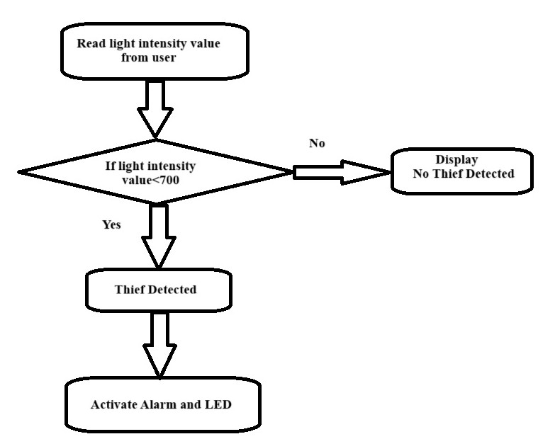

**Figure : Flow Diagram**

**4. RESULTS AND DISCUSSION**

The theft detection system designed was successfully implemented using Arduino, Piezo sensor, force sensor, LED and LCD. During testing, the system accurately detects disturbances such as vibration and pressure changes, which simulates unauthorized access or tampering.

When an unusual vibration was applied near the Piezo sensor or the force was implemented on the force sensor, Arduino processed the sensor data and immediately activated the LED indicator to visually alert users to visually. At the same time, a clear warning message was displayed on the LCD screen, indicating the detection of suspicious activity.

The system responded quickly and firmly to both modest and major disturbances, proven its sensitivity and efficiency to detect basic theft. The project also demonstrated how integrating simple hardware components with microcontroller programming can help create practical solutions for real -life security challenges.

One of the main discussions during development was about establishing appropriate range values for both force and vibration sensors to avoid false alarms due to general environmental conditions such as wind or casual touch. Appropriate calibration played an important role in balanced sensitivity and accuracy.

Overall, the system performed well in controlled conditions and provided space for future improvement, such as adding a buzzer, GSM module for alert, or IOT-based monitoring to enhance its rhetoric in real-world scenarios.

|  |  |  |  |
| --- | --- | --- | --- |
| **Parameter** | **System A: Sensor-Based** | **System B: Camera + ML** | **System C: IoT-Integrated Smart System** |
| **Technology Used** | PIR Motion Sensor, Magnetic Door Sensor | CCTV Camera, Image Processing, CNN | IoT Devices, Cloud Storage, Mobile App |
| **Detection Method** | Detects motion and door/window status | |  | | --- | | Detects suspicious activity using AI |  |  | | --- | |  | | Detects activity, sends real-time alerts |
| **Accuracy** | Moderate (depends on sensor range) | High (up to 90% with good dataset) | Very High (with continuous learning) |
| **False Alarm Rate** | High (due to pets, wind, etc.) | Low (with proper training data) | Very Low (context-aware sensing) |
| **Alert Mechanism** | Buzzer or Local Alarm | Mobile Notification & Alarm | App Notification, Cloud Logging, Alarm |

1. **CONCLUSION**

The Arduino uno based theft detection system that detected unauthorized access through mechanical vibration. LED, buzzer, LCD display, system provides immediate alerts. It is for various application The home theft system is a cost-effective, efficient, and scalable solution for intrusion detection.

The system of theft detection using Arduino, Piezo sensor, force sensor, LED, and LCD provides a simple and efficient way to detect unauthorized access or suspected movement in protected areas. The combination of Pejo and Force Sensor ensures that both vibration and pressure changes are accurately monitored. Once after detecting unusual activity, the system immediately alerts the user through an LED indicator and displays a warning message on the LCD screen.

The project highlights how low costs for homes, lockers or offices, basic components and programming logic to create a reliable security system. This not only enhances safety, but also introduces students to practical use of sensors and microcontroller in real-world problems.

In the future, this system can be added and improved by adding and improving the IOT connectivity for SMS alert, sound alarm, or IOT connectivity for remote monitoring, making it even more effective and user-friendly.

**6. REFERENCES**

1. Smith, J. (2020). Piezoelectric Sensors in Security Systems. IEEE Sensors Journal.

2. Kumar, A. (2019). Advanced Anti-Theft Mechanisms. Springer Publications.

3. Arduino Documentation. (2023). Interfacing Piezoelectric Sensors with Microcontrollers.