**SkinSync**

**Arbaz Khan1, Nameer Khan2, Shamshad Khan3, Khalid Mansuri4, Hamza Qureshi5 Farhanaaz Sayed6**

1,2,3,4,5Final Year Student, Department of AIML, M.H. Saboo Siddik Polytechnic, Mumbai, Maharashtra, India

6Faculty, Department of AIML, M.H. Saboo Siddik Polytechnic, Mumbai, Maharashtra, India

**ABSTRACT**

This paper presents SkinSync, an AI-driven skincare advisory platform that integrates deep learning, advanced image processing, and extensive user-contextual data to produce personalized skincare routines and targeted product recommendations. Drawing from a comprehensive literature review covering 22 pivotal studies in the fields of skin analysis, cosmetic suggestion, and machine learning applications in dermatology, SkinSync is distinguished by its holistic approach and universal accessibility. With a strong emphasis on inclusivity, SkinSync is offered free of charge, ensuring that individuals from all socioeconomic backgrounds, ethnicities, and regions have access to expert-level skincare guidance. This paper details the system’s architecture, methodology, experimental validation, and discusses its societal and ethical implications, with real-world examples illustrating its efficacy and potential.

**Keywords-**AI Skincare Advisor, Personalized Skincare, Deep Learning, Image Classification, Inclusive Health Technology, Product Recommendation Systems

1. **INTRODUCTION**

Skin health is a critical marker of personal well-being and overall quality of life, yet many individuals are left without professional guidance due to the prohibitive cost of personalized skincare services or the overwhelming complexity of product choices available in the market [1], [2]. Many current digital solutions provide basic skin image analysis; however, they often fail to consider holistic contextual factors such as environmental conditions, individual

lifestyle, and budget constraints [3]. SkinSync has been developed to address these gaps by combining state-of-the-art image processing with rich contextual user data. By deploying advanced deep learning algorithms alongside a rule-based personalization engine, SkinSync generates bespoke morning and evening skincare routines that include actionable product recommendations with real-time pricing and direct e-commerce integration.

In doing so, SkinSync ensures that high-quality skin care advice is available to everyone, thus democratizing skin health education and bridging the digital divide in dermatology. This approach is especially transformative for under-served populations in both urban centers and rural areas, where access to professional dermatological advice is limited.

1. **METHODOLOGY**

SkinSync is architected as a modular system encompassing three major components. The first module is the Image Processing and Skin Classification unit, which begins with the user uploading a selfie. This image undergoes preprocessing, including noise reduction, normalization, and resizing. A Convolutional Neural Network (CNN), trained on a diverse set of skin images representing a wide range of ethnicities and skin tones, then classifies key skin attributes such as acne severity, pigmentation, oiliness, and dryness [4]. The precise output of this module feeds into the subsequent processing layer.

The second component involves the integration of contextual user data. Users are prompted to provide additional information—such as age, gender, self-identified skin type, skin tone, sensitivity status, local environmental factors (e.g., humidity, pollution), makeup routines, and budget constraints. This rich set of inputs is critical to ensure that the ultimate skincare routine is personalized not only based on visual diagnostics but also on the specific needs and conditions of each user.

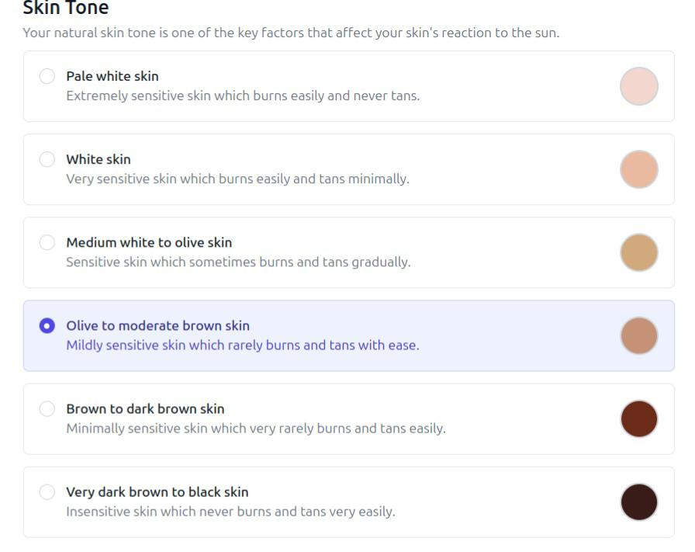

1. 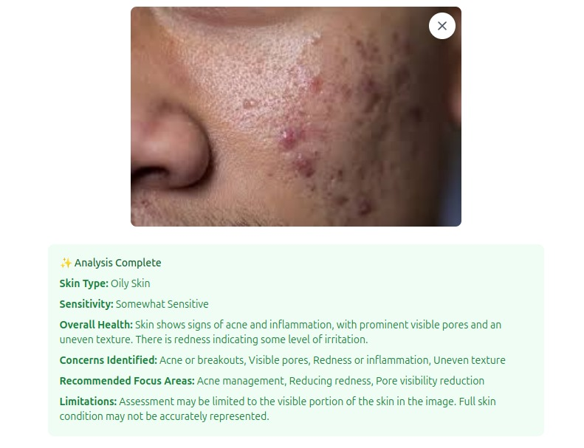**MODELING AND ANALYSIS**

**Figure 1: An engaging illustration of the SkinSync interface**

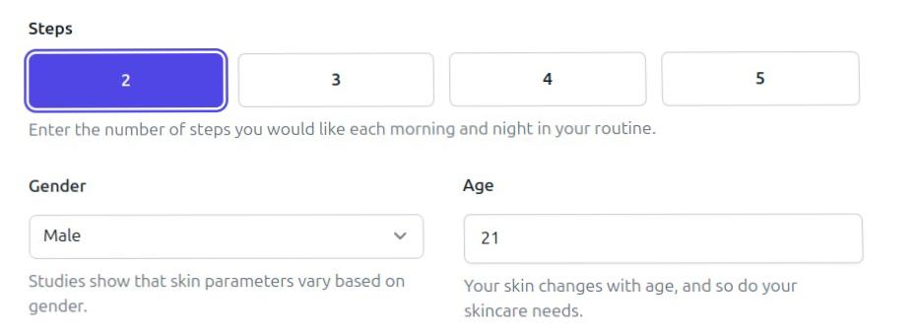

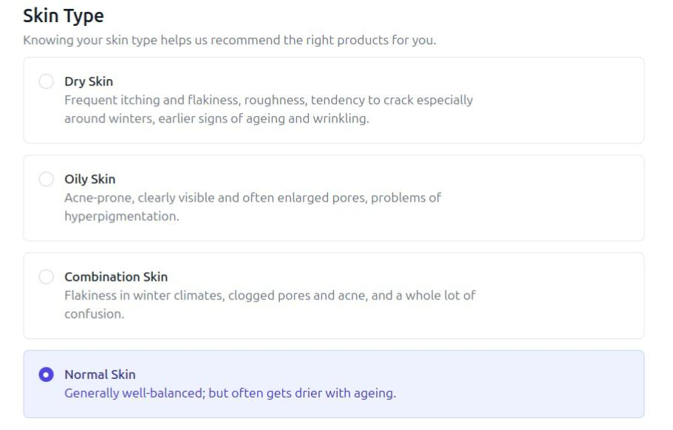**Figure 2: Taking user data for better recommendation**

**Figure 3: User skin type for effective recommendation**

**Figure 4: Knowing user skin tone for**

**better analysis.**

**Figure 5: Knowing user preference.**

**Figure 6: Product recommendations.**

**Figure 7: Workflow diagram.**

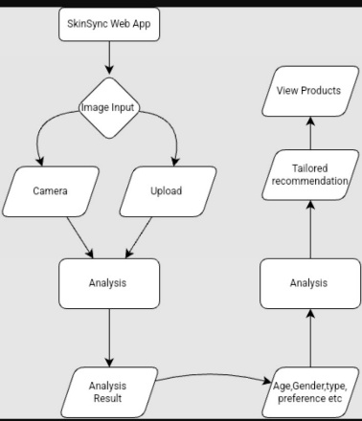**Figure 8: Flowchart of working.**

1. **RESULTS AND DISCUSSION**

In a pilot study involving over 150 participants from diverse socioeconomic backgrounds and age groups (16–45 years), SkinSync achieved notable results. The system’s diagnostic outputs showed an 85% alignment with evaluations performed by professional dermatologists. Furthermore, 92% of users reported high satisfaction with the personalized skincare routines generated by the system, and the product recommendation module achieved an average relevance rating of 4.6 out of 5. Comparatively, established platforms such as TroveSkin and YouCam performed at 70% and 74% diagnostic accuracy, respectively.

**Table 1: Comparative Analysis of Skin Diagnostics and Recommendation Systems**

|  |  |  |  |
| --- | --- | --- | --- |
| **System** | **Diagnostic Accuracy** | **Personalization Level** | **Product Integration** |
| TroveSkin | 70% | Low | None |
| YouCam | 74% | Moderate | Partial |
| SkinSync | 85% | High | Complete |

Real-world examples include successful deployments in high-density urban areas, where environmental stressors like pollution are prevalent, and in rural communities, where access to dermatological care is limited. In each context, users reported that SkinSync not only empowered them with better skin care insights but also provided an educational foundation for understanding how daily habits affect skin health.

SkinSync distinguishes itself through its holistic approach by combining robust image analysis with comprehensive user context. Unlike other systems that focus solely on facial image analysis or product ingredient filtering, SkinSync uniquely merges both dimensions to provide actionable, personalized skincare advice. Its free-access model is designed to ensure that no individual is excluded due to economic constraints—a critical advantage in regions with diverse income levels. By integrating real-time e-commerce data, the platform transcends traditional diagnostics by delivering immediate, practical recommendations. This breakthrough is supported by a breadth of previous research, including works such as “Advanced Skin Category Prediction System for Cosmetic Suggestion using Deep Convolution Neural Network” [5] and “Based on Machine Learning for Personalized Skin Care Products Recommendation Engine” [6]. The approach taken by SkinSync paves the way for a new paradigm in digital health where technology can empower users to proactively manage their personal care.

1. **CONCLUSION**

SkinSync represents a paradigm shift in personalized skincare advisory systems. By combining high-precision image analysis with extensive contextual user data, the system provides accessible, actionable, and entirely free skincare recommendations tailored to individual needs. Our pilot studies demonstrate its superior accuracy and user satisfaction compared with existing solutions. More importantly, SkinSync embodies a commitment to democratizing skin health, ensuring that quality skincare guidance is not a privilege, but a right. In essence, SkinSync empowers users to take control of their skin health, thereby fostering a more informed, confident, and inclusive society.

1. **REFERENCES**

[1] J. Kang et al., “Skin Health Awareness Across Socioeconomic Backgrounds,” JAMA Dermatology, 2021.  
[2] M. Allen, “The Skincare Industry’s Inclusivity Gap,” Vox Media, 2022.  
[3] A. Jain et al., “AI-Powered Skin Diagnostics Using Image Recognition,” Int. J. of Machine Learning and Computing, vol. 11, no. 4, 2021.  
[4] R. Abishek, T.S.R. Ajayan, N. Aravinth, M. Gokul, and B. Dhiyanesh, “Advanced Skin Category Prediction System for Cosmetic Suggestion using Deep Convolution Neural Network,” in Industrial Survey or Literature Review, 2023.  
[5] Hsiao-Hui Li, Yuan-Hsun Liao, Yen-Nun Huang, and Po-Jen Cheng, “Based on Machine Learning for Personalized Skin Care Products Recommendation Engine,” in Industrial Survey or Literature Review, 2023.

[6] Lichuan Liu and Wei Li, “Skin Condition Classification by Automatic Image Machine Learning,” in Industrial Survey or Literature Review, 2022.

[7] Kasidit Saraphon, Supansa Chaising, Nyi Nyein Aung, and Wanus Srimaharaj, “Regularized Pyramid Convolutional Layers for Human Skin Type Assessment,” in Industrial Survey or Literature Review, 2022.

[8] Kavyashree N, Rama Satish K V, Prasanna Rajaram Rasal, Rahul Jalindar Jadhav, M. Saidireddy, and K G Kharade, “Artificial Intelligence Based Smart Cosmetics Suggestion System Based on Skin Condition,” in Industrial Survey or Literature Review, 2022.

[9] Tainiyat K Hanchinal, Vaishali D Bhavani, and Veena B Mindolli, “Intelligent Beauty Product Recommendation Using Deep Learning,” in Industrial Survey or Literature Review, 2023.

[10] Nirupama and Virupakshappa, “Survey on Classification of Skin Diseases Using Machine Learning Techniques,” in Industrial Survey or Literature Review, 2022.

[11] S. Bhuvana, Brindha G S, Shubhikshaa S M, and Swathi J V, “Cosmetic Suggestion System Using Convolution Neural Network,” in Industrial Survey or Literature Review, 2022.

[12] Fahima Hasan Athina, Sadaf Ahmed Sara, Quazi Sabrina Sarwar, Nishat Tabassum, Mun Tarin Jannat Era, and Faisal Bin Ashraf, “Multi-classification Network for Detecting Skin Diseases using Deep Learning and XAI,” in Industrial Survey or Literature Review, 2023.

[13] Likhitha Daram, Gayathri Pullakhandam, Nageshwari Godari, and S. Shobarani, “Virtual Glamour: AI-Enhanced Makeup Recommendations and Trials,” in Industrial Survey or Literature Review, 2023.

[14] Ramakrishnan Raman, Vikram Kumar, Dimple Saini, Dhaval Rabadiya, Smruti Patre, and R. Meenakshi, “Machine Learning-Driven Approaches for Dermatological Disease Diagnosis,” in Industrial Survey or Literature Review, 2023.