IOT BASED CAR ACCIDENT PREVENTION SYSTEM

Sainath Aashanna, Bipin Gupta, Bhavesh Shelar, Vaibhav Shinde

ABSTRACT

This project presents a real-time accident detection and alert system, utilizing an ESP32 as the central controller. The system integrates a vibration/impact sensor (SW-420 or MPU6050) to detect sudden shocks, such as those experienced in a vehicle or bike accident. Upon detecting an impact, the system activates the NEO-6MGPS module to capture the exact location coordinates. These coordinates are then sent via SMS using the SIM800L GSM module to emergency contacts. This solution operates independently of the internet, making it ideal for areas with poor connectivity. The system is cost-effective, power-eﬃcient, and highly scalable, ensuring that emergency alerts are triggered quickly, improving the chances of prompt rescue and assistance.

INDEX TERMS

Internet of things(IOT), Accident Prevention, Smart Vehicle System, vehicle Safety, Real Time Monitoring, Sensor Network, Collision Detection, Road Safety.

**INTRODUCTION**

Accidents on the road are an unfortunate reality, and the timely response of emergency services can signiﬁcantly impact the survival and recovery rates of accident victims. One of the challenges in addressing this issue is the delayed notiﬁcation of emergency contacts and responders. Traditional systems rely on manual calls or internet-based applications, which may not always be available or reliable in remote areas.

This project focuses on providing an eﬃcient solution to this problem through an automatic, real-time accident detection system. The core idea is to leverage an ESP32 microcontroller along with various sensors and modules to detect an accident and immediately notify emergency contacts via SMS. This system is designed to be robust and independent of the internet, making it ideal for use in remote or rural areas where cellular network coverage may be the only option for communication.

The system relies on a vibration/impact sensor to detect sudden shocks that occur during an accident. Upon sensing an impact, the system activates the NEO-6MGPS module to obtain the exact location of the vehicle or bike.The location data is then transmitted via SMS to pre-conﬁgured emergency contacts using the SIM800L GSM module. This process happens instantly, ensuring that help can be dispatched without unnecessary delays.

In addition to addressing the immediate safety concerns, the system is designed to be low-cost and power-eﬃcient, making it accessible for a wide range of users. The easy scalability of the system further enhances its practical application, whether for individual vehicles or for ﬂeet management.The solution is particularly valuable in countries where road accidents are frequent, and quick access to emergency help can drastically improve outcomes.This system aims to bridge the gap between accident occurrence and emergency response, improving safety on the roads.

**LITERATURE REVIEW**

The Internet of Things (IoT) has emerged as a game-changing technology across various industries, including automotive safety. Car accident prevention systems based on IoT employ interconnected devices that enable vehicles, infrastructure, and other entities to transmit and share real-time data, thereby enhancing road safety. A fundamental aspect of these systems is Vehicle-to-Vehicle (V2V) communication, wherein vehicles share information regarding their speed, location, and braking status, aiding in accident prevention by alerting drivers about potential dangers ahead, such as abrupt braking or obstacles on the roadway. Meanwhile, Vehicle-to-Infrastructure (V2I) communication amplifies safety by facilitating interactions between vehicles and traffic signals, road signs, and other infrastructures, providing real-time updates on traffic situations or road dangers, which helps in minimizing the chances of accidents.

These systems are heavily dependent on sensors like radar, ultrasonic, and LiDAR, along with cameras to identify and track the surroundings of the vehicle. This information is analyzed in real time either by the vehicle’s onboard systems or cloud servers to enable swift decision-making. For instance, Automatic Emergency Braking (AEB) can engage the brakes upon detecting an impending collision, while Adaptive Cruise Control (ACC) can automatically modify the vehicle's speed to keep a safe distance from other vehicles. Moreover, systems such as Lane Departure Warning (LDW), which utilize cameras to track lane markings, alert drivers when they accidentally drift out of their lane. The incorporation of Vehicle-to-Everything (V2X) communication is also growing in popularity, broadening safety functionalities to include pedestrians, cyclists, and other road users.

Nonetheless, various challenges hinder the widespread implementation of IoT-based accident prevention systems. Concerns surrounding privacy related to the vast amounts of personal data, including vehicle location and driving habits, present a notable issue. Additionally, dependable connectivity, particularly in less populated areas or regions with limited network access, can restrict the effectiveness of these systems. The reliance on strong 5G or other high-speed communication networks is essential for the immediate exchange of data. Furthermore, guaranteeing the dependability of IoT systems in critical circumstances, such as system failures or false alerts, remains a primary concern.

Looking forward, advancements in Artificial Intelligence (AI) and Machine Learning (ML) are anticipated to enhance the accuracy and decision-making abilities of these systems. AI could empower vehicles to analyze and understand complex data more effectively, improving their capacity to foresee and avert accidents. The advancement of autonomous vehicles is also likely to hasten the integration of IoT in transportation, as self-driving cars rely significantly on IoT technologies for navigation and safety. Despite the obstacles, IoT-based car accident prevention systems offer considerable potential for increasing road safety, although technical, regulatory, and privacy challenges must be addressed for their broad deployment.

**METHODOLOGY**

Hardware Selection: Choose the ESP32 microcontroller for processing, along with a vibration sensor (SW-420 or MPU6050) for impact detection ,and the SIM800L for SMS functionality. The NEO-6M GPS module is selected for accurate location tracking.

Circuit Design: Design the connections between the ESP32, vibration sensor, GPS module, and GSM module, ensuring proper power and signal routing.

Software Development: Write a program in the Arduino IDE to detect vibrations, fetch GPS coordinates, and send SMS alerts via the GSM module when an impact is detected.

Testing: Perform tests in real-world conditions to ensure the system can detect impacts reliably , acquire accurate GPS data and send SMS alerts without delays.

Optimization: Fine-tune the system for better power eﬃciency ,reduce false triggers from the vibration sensor, and improve the reliability of SMS delivery.

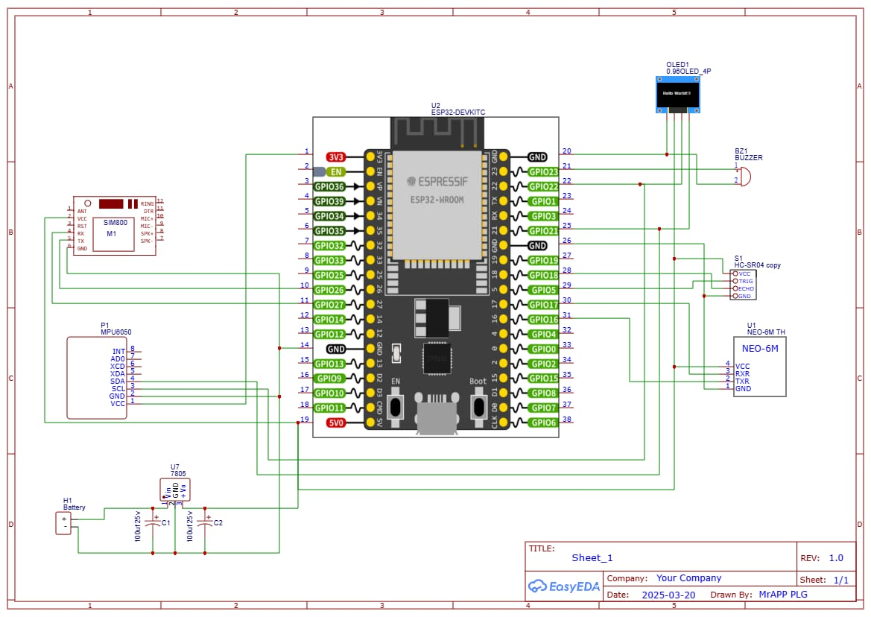

# 

# Basic Block diagram of System

# COMPONENT PARAMETER

# GSM Module (SIM800L) (5V) : For sending SMS alerts.

# ESP32 Microcontroller (5V) : Main processing unit.

# GPS Module (NEO-6M) (5V) : For real-time location tracking

# Ultrasonic Sensor (HC-SR04) (5V) : For distance measurement.

# MPU6050 Accelerometer (3.3V) : For detecting collisions and tilts.

# OLED Display (3.3V) : For displaying real-time data

# Buzzer (5V) : For generating audible alerts.

# Resistors and Capacitors (5V) : For signal stabilization and current limiting.

# Diode (1N4007) (5V) : For reverse current protection.

# 81054533-5733-4450-b03b-87b15ee48e09.jpgbf32fbb5-5e40-4cee-b3ed-0289c749697d.jpg

# REAL TIME DATA ACQUISITION

# 1.jpg

# 2.jpg

# 3.jpg

# WEB INTERFACE DEMONSTRATION

# CONCLUSION

# This project demonstrates an eﬃcient , low-cost , and reliable accident detection system that sends real-time location-based SMS alerts. It improves road safety by ensuring quick response times for emergency services. The system is scalable, power-eﬃcient, and adaptable for various use cases, making it a valuable tool for personal and public safety.

# REFRENCES

# 1. https://ieeexplore.ieee.org

# 2. https://www.researchgate.net/publication