**TRAFFIC SIGN CLASSIFICATION USING DEEP LEARNING**

PAVITHRA. B

Under the Guidance of

Mrs. S. BHUVANESWARI, MCA., M.Phil.,

Associate Professor of Computer Science

*Department of Computer Sciences and Computer Applications,*

*Vivekanandha College of Arts and Sciences for Women (autonomous), Tamilnadu, India.*

*Bachelor of Computer Application, Department of Computer Sciences and Computer Applications, Vivekanandha College of Arts and Sciences for Women (autonomous), Tamilnadu, India.*

The "Traffic Sign Classification using Deep Learning" project presents a cutting-edge approach to enhancing computer vision capabilities by recognizing and classifying traffic signs accurately. The project harnesses the potential of Python and employs two advanced deep learning models, MobileNet Architecture and YOLOv5, to address the intricacies of traffic sign classification. MobileNet demonstrated remarkable performance, achieving a training accuracy of 97.00% and a validation accuracy of 98.00%. This success was driven by a meticulously curated dataset comprising 4,170 images spanning 58 diverse traffic sign classes, including speed limits, directional indicators, prohibitory signs, and hazard warnings. These classes provide exhaustive coverage of traffic regulations, ensuring robust model training and evaluation. This project underscores the significance of deep learning in automating traffic sign recognition, with potential applications in autonomous vehicles, intelligent transportation systems, and road safety enhancement.

**PROBLEM STATEMENT**

          With the growth of intelligent transportation systems and the evolution of autonomous driving, real-time and robust recognition of traffic signs under various driving conditions is still an unsolved challenge. Nevertheless, traditional methods for traffic sign recognition are significantly affected by environmental factors such as lighting variations, visual obstructions, and inconsistencies in sign design, which may intermittently reduce system accuracy. I would not be able to cater to those voluminous requirements as there is currently no comprehensive, scalable, and flexible solution in the market today, hindering the safe and efficient operation of a self-driving vehicle or an advanced driver assistance system (ADAS). However, in the ever-changing climate of intelligent transport systems, it is essential to develop an advanced deep learning-based model capable of accurately identifying multiple traffic signs across various real-world conditions. Thus, the objective of this is to optimize MobileNet and YOLOv5 architectures to develop a real-time traffic sign classification and a high-measurement solution with the ability to significantly improve road safety and support the deployment of intelligent transportation technologies.

**OBJECTIVE**

· Ensure Safety: They are made to reduce the likelihood of accidents and to mitigate potential risks. They assist drivers in making educated decisions by issuing vital alerts regarding hazardous situations, speed limits, and restrictions.

· Promote Smooth and Efficient Traffic Flow: Traffic signs aid in maintaining a smooth and efficient traffic flow by offering guidance and information. Their purpose is to maintain orderly traffic at intersections and on highways by directing drivers on when to stop, merge, yield, or continue.

· Transmit Information: Route directions, destination distances, parking policies, and location identifiers are just a few data that traffic signs are capable of transmitting. This information helps drivers navigate through new territory.

· Regulatory traffic signs convey mandatory instructions for drivers, such as speed limits, restricted parking areas, and designated one-way routes. Adhering to these directives is vital to ensure both lawful operation and overall road safety.

· Accuracy Improvement: To provide dependable recognition in diverse environmental conditions, such as varying illumination, weather, and traffic conditions, the accuracy of detecting traffic signs and classification.

· Real-Time Performance: To achieve real-time performance on embedded devices or cars and make quick decisions in situations with dynamic traffic, optimize the deep learning model.

· Robustness: Increase the model's ability to recognize a wide range of traffic signs, including differences in shape, color, size, and orientation, to ensure consistent performance across regions and sign designs.

· Generalization: Train the model using diverse datasets collected from different geographic regions and traffic systems to improve its generalization ability, reduce overfitting, and ensure reliable performance in unfamiliar scenarios.

SCOPE

Traffic sign classification involves automating the identification of traffic signs from images or video streams by leveraging advanced neural network architectures. The Convolutional Neural Network (CNN) is a deep learning model well-suited to tasks such as traffic sign classification as it can learn hierarchical features from visual data. The technology has the potential to enhance road safety through real-time sign detection, assist autonomous vehicles in understanding and responding to traffic regulations, and facilitate intelligent city initiatives through efficient traffic management. In traffic sign classification, challenges include the diversity of datasets, robustness to environmental conditions ( weather and lighting), and real-time processing. Ongoing research focuses on improving model accuracy, efficiency, and generalization capabilities.

EXISTING SYSTEM:

The current system uses a Convolutional Neural Network (CNN) to classify traffic signs from static images with high accuracy. This earlier model achieved a commendable accuracy of 95.8%, proving its effectiveness in identifying traffic signs to a certain extent. However, it was limited in terms of scope and functionality.

Key Features of the Existing System:

* Utilized a CNN-based architecture.
* Focused only on static image classification.
* A Classification accuracy of 95.8% was achieved.

DISADVANTAGES

* Limited Accuracy: While the CNN achieved good results, modern architectures offer better performance.
* Restricted Class Coverage: Only a limited number of traffic sign classes were supported, excluding several crucial categories such as hazard warnings and regulatory signs.
* No Real-time Capability: The model couldn't process input from a webcam, limiting its use in dynamic environments like autonomous driving.
* Low Flexibility: Updating or expanding the dataset to include new traffic signs required extensive retraining.
* Lack of resilience: The system could not adjust to changing traffic scenarios, lighting conditions, and environmental conditions, making it unreliable for real-world applications.

**PROPOSED SYSTEM:**

The proposed solution integrates a more advanced and scalable model that combines MobileNet and YOLOv5, significantly enhancing performance and utility.

Key Improvements:

* YOLOv5 is integrated for real-time detection and classification from video or webcam feeds.
* The system is suitable for autonomous vehicles and intelligent traffic environments due to its ability to recognize objects instantly.

ADVANTAGES OF PROPOSED SYSTEM:

* Improved Accuracy: Achieved higher precision than the existing CNN model, ensuring more reliable classification.
* Real-Time Recognition: YOLOv5 supports dynamic sign detection through live webcam input, making it ideal for real-time applications.
* Comprehensive Class Coverage: Supports a broader range of signs, enhancing functionality and ensuring adherence to traffic regulations
* Scalability: The architecture allows for easy expansion of the dataset and model retraining with minimal resources.
* Adaptability: Designed for real-world applications such as autonomous vehicles, traffic management, and road monitoring systems.
* Robust Dataset: The dataset ensures diversity in traffic sign appearance, contributing to robust model training.

EXECUTIVE SUMMARY

"Traffic Sign Classification using Deep Learning" presents a forward-thinking solution aimed at improving road safety and supporting the development of intelligent transportation systems through accurate traffic sign recognition. Leveraging the power of deep learning, it integrates two cutting-edge models—MobileNet and YOLOv5—to address the challenges associated with identifying and classifying traffic signs in real-world scenarios.

The MobileNet model, known for its lightweight architecture and high efficiency, was trained on a carefully curated dataset of 4,170 images across 58 diverse traffic sign classes, including speed limits, prohibitory signs, hazard warnings, and directional indicators. The model achieved impressive results, with a training accuracy of 97.00% and a validation accuracy of 98.00%, demonstrating its effectiveness in handling classification tasks with high precision.

In parallel, the YOLOv5 model was employed for real-time object detection, allowing the system to classify and localize traffic signs in images or video streams. This dual-model approach guarantees robustness, scalability, and practical applicability in autonomous vehicles and intelligent transportation systems.

SYSTEM ARCHITECTURE:

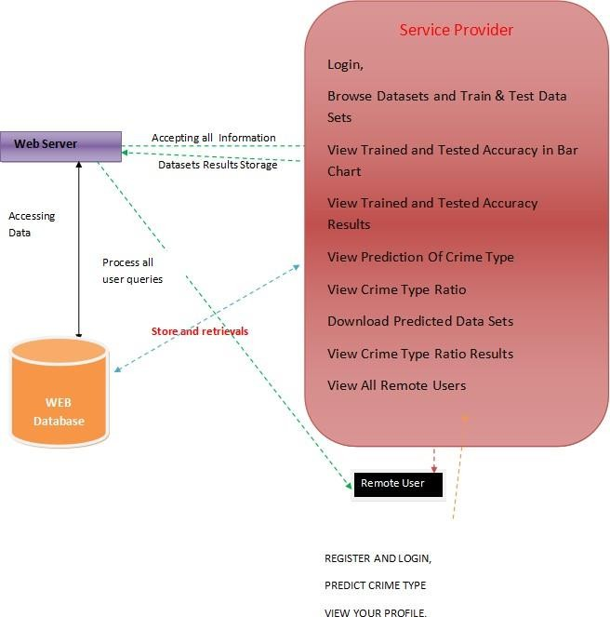

Figure 1: System Architecture

**USER INTERFACE WORKFLOW**

Activity diagrams visually represent workflows of sequential actions and tasks, incorporating options for choice, iteration, and concurrency. UML activity diagrams help depict the stepwise operations and the individual components within a business system. A control flow diagram displays the whole process.

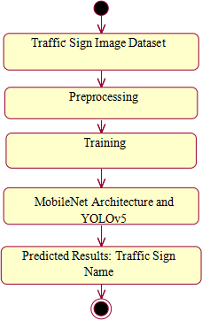Figure 2: User Interface

**RESULTS AND DISCUSSIONS**

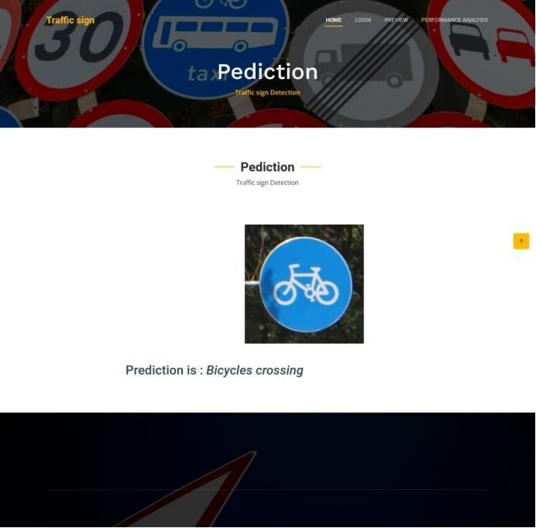

Figure 3: Prediction Output

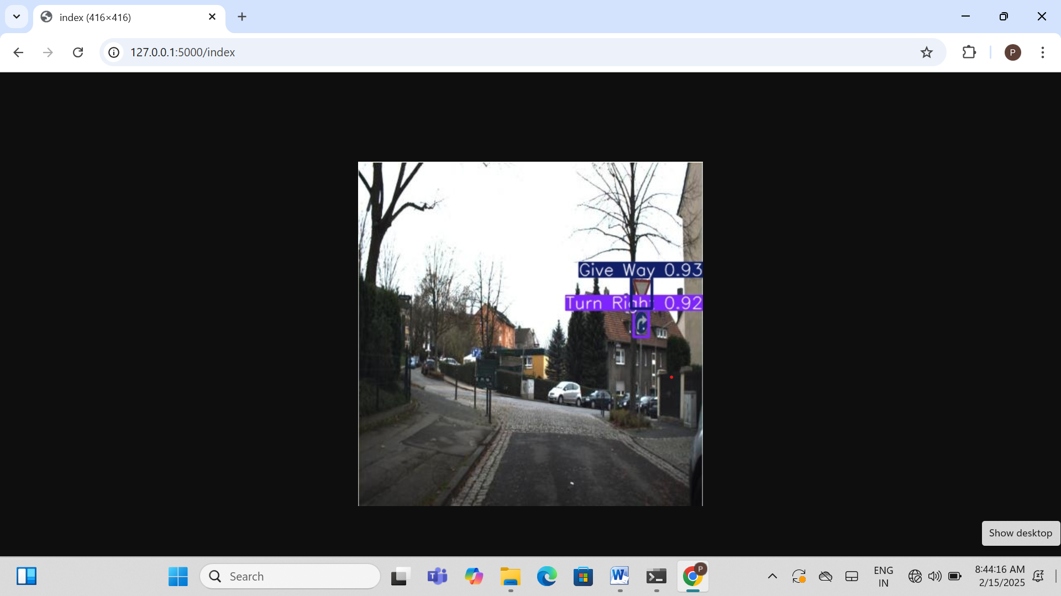

Figure 5: YOLOv5 Prediction Output

**FUTURE ENHANCEMENT**

While the 'Traffic Sign Classification using Deep Learning with MobileNet Architecture and YOLOv5' project has made notable advancements, numerous possibilities exist for further enhancement. Future efforts could focus on expanding the dataset with additional traffic sign classes and variations to boost recognition accuracy. Advanced fine-tuning of the deep learning models, especially under diverse environmental conditions, can enhance performance. Incorporating multimodal sensing technologies such as radar and lidar can provide superior detection in challenging weather conditions. Combining traffic sign recognition with localization and mapping will bolster navigation systems for autonomous vehicles.

Synthetic data generation can augment training sets, especially where real-world data is limited. Optimizing the models for edge computing will support real-time applications in resource-constrained environments. Additional use cases include predictive upkeep of traffic infrastructure and integration into Advanced Driver Assistance Systems (ADAS). Crowdsourced data can diversify training inputs while ensuring regulatory compliance, which is crucial for practical deployment. Improvements in human-machine interaction and energy efficiency will also contribute to usability. Finally, extensive real-world testing in various traffic conditions is essential to validate system robustness and reliability.

**CONCLUSION**

 This 'Traffic Sign Classification Using Deep Learning with MobileNet Architecture and YOLOv5' represents a significant advancement in computer vision and intelligent traffic systems. By overcoming the limitations of earlier CNN-based models, this approach enhances precision, supports real-time detection, and broadens the range of detectable traffic sign categories. By combining MobileNet and YOLOv5, the system effectively recognizes 58 and 39 types of traffic signs, respectively, covering regulatory, warning, and informational signs.

Real-time processing through webcam integration allows the system to respond dynamically to evolving traffic conditions, making it ideal for applications such as autonomous vehicles, intelligent traffic control, and road safety systems. Real-time processing through webcam integration allows the system to respond dynamically to evolving traffic conditions, making it ideal for applications such as autonomous vehicles, intelligent traffic control, and road safety systems. Its robustness in varying lighting and weather conditions further reinforces its practicality in real-world environments.

Overall, this system establishes a new standard for traffic sign recognition, combining deep learning, thoughtful dataset design, and real-time adaptability to create a scalable, intelligent, and reliable traffic management tool for the future.

**BIBLIOGRAPHY**

1. Vincent, K. R. Vidya, Merin Annie, and Santhosh P. Mathew. "Traffic sign classification using deep neural network." IEEE Recent Advances in Intelligent Computational Systems (RAICS), 2020, IEEE, Chapters 13–17 IEEE, 2020.
2. Jianming Zhang, Wei Wang, Jin Wang, Chaoquan Lu, and Arun Kumar Sangaiah. "Lightweight deep network for categorizing traffic signs." 2020; Telecommunications Annals75(7): 369–379.

In [3] Kumar, Dinesh Amara. "Novel for determining traffic signs using capsule networks." 2017; arXiv preprint arXiv:1805.04424. Sun, Ying, Dequan Liu, and Pingshu Ge

[4]. "Identification and detection of road signage according to convolutional neural network." Chinese Automation Congress (CAC), 2019; pages 2851–2854. The IEEE, 2019.

1. Yann LeCun, Geoffrey Hinton, and Yoshua Bengio. "Deep learning." No. 7553, 521(2015),

pp. 436-444.

1. "Recognition Using Cnn hybrid utilizing a twin support vector machine for Traffic Signs Model," by Sun, Yang, and Longwei Chen. Practical Physics and Mathematics Journal, Volume 9, Issue 12, 2021, pages 3122–3422.
2. Zhu, Yanzhao, and Wei Qi Yan. "Deep learning-based traffic sign recognition." 17779– 17791 in Multimedia Tools and Applications 81, no. 13 (2022).
3. Mehta, Smit, Bhaumik Vaidya, and Chirag Paunwala (2011) "CNN based Classification of road signs using Adam optimizer." Pages 1293–1298 of the Worldwide Conference on Intelligent Computing 2019 and Control Systems (ICCS). 2019 IEEE.
4. Weng Xiao Xiong, Xie, and Bangquan. "The term "real- integrated traffic sign recognition using efficient convolutional neural network." 2019 IEEE Access 7 (53330–53346-23466).
5. Reem, Abdel-Salam, Ahmed H. Abdel-Gawad, and Rana Mostafa. "RIECNN: actual time photo augmented Cctv with road sign identification." 34 years of age, no. 8 (2022): 6085-6096 Neural Computing and Applications.