**PAPER TITLE, FONT TYPE-Times New Roman 14**

**Suraj rakh*1 ,Arhan khan*2,Varad vhaval*3, Sanskar darade*4, Harshvardhan sawant*5,**

**ABSTRACT (The Cursed Escape)**

This horror game is a spine-tingling experience that plunges players into a world of fear and uncertainty. With a focus on atmospheric tension and psychological horror, the game follows the player's journey through dark and foreboding environments, where they must navigate through terrifying levels, avoid deadly enemies, and solve puzzles to uncover the mysteries of the game world.

The game features a range of terrifying enemies, immersive sound design and visuals, and themes of survival, sanity, and the human psyche. Players must manage their sanity and survival resources to stay alive while exploring dark environments, avoiding deadly enemies, and uncovering the game's secrets. This horror game promises to deliver a thrilling and terrifying experience that will keep players on the edge of their seats, making it perfect for horror game enthusiasts and fans of survival and psychological horror.

1. **INTRODUCTION (The Cursed Escape)**

### The Cursed Escape

Welcome to Ravenswood Manor, a foreboding mansion shrouded in mystery and terror. You are trapped within its walls, and the only way to survive is to uncover the dark secrets that haunt this cursed place.

### The Story Begins

As you awaken in the manor's dimly lit chambers, you realize that you're not alone. Unsettling whispers echo through the halls, and the shadows seem to move of their own accord. Your goal is to escape the manor, but the doors are locked, and the windows refuse to budge.

### Uncover the Horror

Explore the decaying mansion, solve puzzles, and unravel the mysteries that lie within. But be warned: the manor is home to malevolent spirits, and the darkness is alive with terror. Will you escape the cursed manor, or will you succumb to its horrors?

### Gameplay

* Explore the creepy mansion and uncover its dark history
* Solve puzzles and challenges to progress through the game
* Avoid the malevolent spirits and supernatural entities that haunt the manor
* Face your fears and make choices that determine your survival

## OBJECTIVE

To explore the psychological impact of fear and horror: Analyze how the game uses fear, tension, and anxiety to create a terrifying experience for players.

1. To examine the role of atmosphere and setting: Discuss how the game's environment, sound design, and visuals contribute to its eerie atmosphere and sense of dread.
2. To investigate the use of storytelling and narrative: Examine how the game's storyline, characters, and plot twists enhance the horror experience and engage players.
3. To evaluate the game's mechanics and gameplay: Assess the game's controls, puzzles, and challenges, and discuss how they contribute to the overall horror experience.
4. To discuss the themes and symbolism: Analyze the game's themes, such as survival, sanity, and the supernatural, and discuss their significance in the context of the game.

## LITERATURE REVIEW

1. A literature survey on escape games, particularly those with horror themes like The Cursed,
2. would examine research and case studies across several disciplines, including game
3. design, psychology, and horror storytelling. Here’s an overview of key areas in the
4. literature that inform the design and appeal of horror escape games.
5. Game Design and Immersion in Escape Rooms
6. Interactive Game Design: Literature on interactive game design provides insights into how puzzles, narrative, and physical
7. space can be used to engage players. Studies like Nicholson's work on escape room mechanics emphasize the
8. importance of designing puzzles that are challenging but accessible, which encourage team-based problem-solving and
9. create a satisfying player experience.
10. Environmental Storytelling: Research shows that immersive environments can heighten engagement. Authors like Jenkins
11. (2004) discuss how physical space and game environments can tell stories on their own, which is especially effective in
12. horror-themed escape rooms. Visual and auditory cues can create an atmosphere of suspense, making players feel like
13. part of a live-action narrative.
14. Psychology of Fear and Horror in Gaming
15. Fear Responses and Engagement: Studies in psychology explain why people enjoy horror and how fear enhances
16. engagement. Work by Clasen (2017) suggests that horror’s appeal lies in its ability to elicit strong emotions like fear and
17. excitement in a safe environment. Escape games tap into this by balancing safety with scares, creating a thrill-seeking
18. environment.
19. Suspense and Time Pressure: Research on suspense (Zillmann, 1996) highlights that time-limited scenarios create a
20. psychological effect that raises tension, making experiences more memorable. Horror escape games use countdowns and
21. "ticking clocks" to amplify suspense and push players to focus on problem-solving while under stress.
22. Narrative Techniques in Horror Storytelling

## .PROPOSED SYSTEM

(Figure 1: Proposed System Diagram)

The proposed system for "The Cursed Escape" horror game aims to enhance the player's experience by integrating more sophisticated AI-driven enemies, adaptive difficulty levels, and a dynamic atmosphere that responds to player actions. The system would utilize advanced sound design and visuals to create a more immersive environment, while incorporating player feedback mechanisms to tailor the experience to individual preferences. Additionally, the proposed system would include more complex puzzle-solving mechanics and a deeper narrative with branching storylines, allowing players to influence the game's outcome. By incorporating these features, the proposed system would provide a more engaging and terrifying experience for players.

## FEATURES AND WORKING

1. The Cursed Escape" is a spine-tingling horror game that immerses players in a world of terror and suspense. Key features include:
2. ​
3. - Immersive atmosphere: Creepy environments, eerie sound effects, and haunting music create a terrifying experience.
4. - Puzzle-solving: Players must solve puzzles to progress through the game, but beware – the puzzles are challenging, and time is running out.
5. - Stealth gameplay: Sneak past or evade terrifying enemies to survive.

- Dynamic lighting: Lighting effects enhance the atmosphere, making it harder to

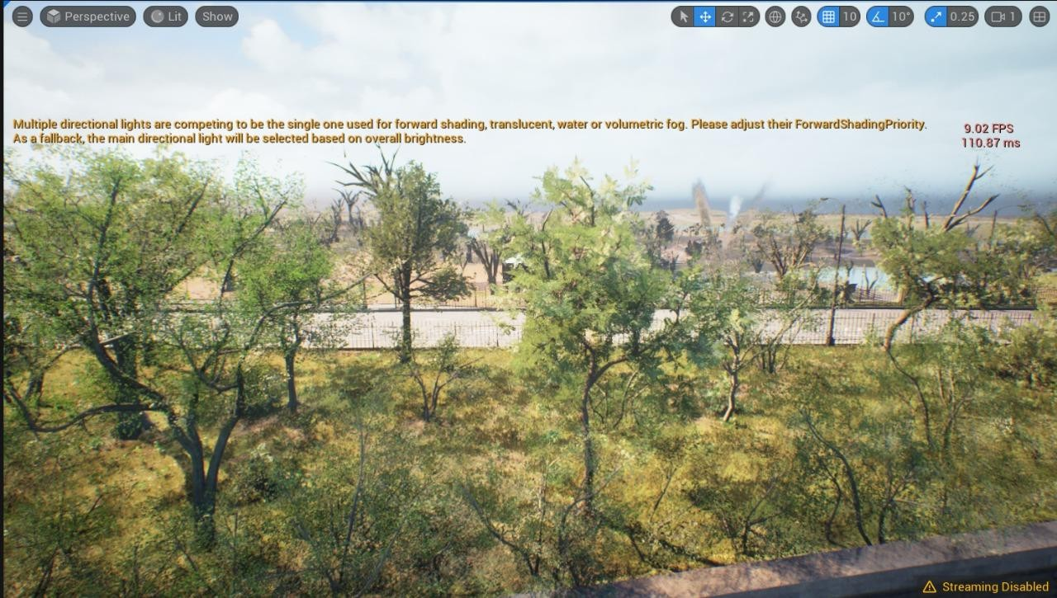

* How the Game Works

In "The Cursed Escape," players take on the role of a protagonist trapped in a haunted location. The goal is to escape by solving puzzles, avoiding enemies, and uncovering the dark secrets behind the curse.

* Exploration: Players explore creepy environments, searching for clues and items to aid in their escape.
* Puzzle-solving: Solve puzzles to unlock doors, activate mechanisms, or reveal hidden paths.
* Stealth: Use stealth mechanics to evade enemies, hiding in shadows or using distractions to throw them off your trail.
* Atmosphere and tension: The game's atmosphere and sound design create a sense of tension, making every creak and groan of the old building feel like a potential threat.

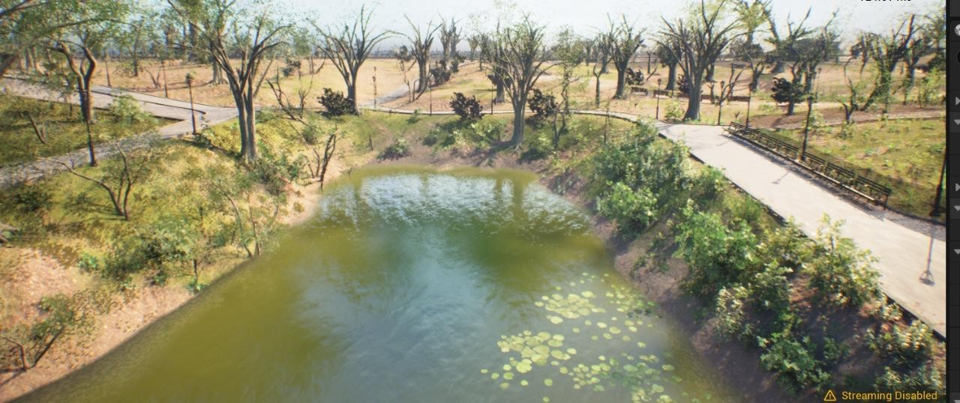

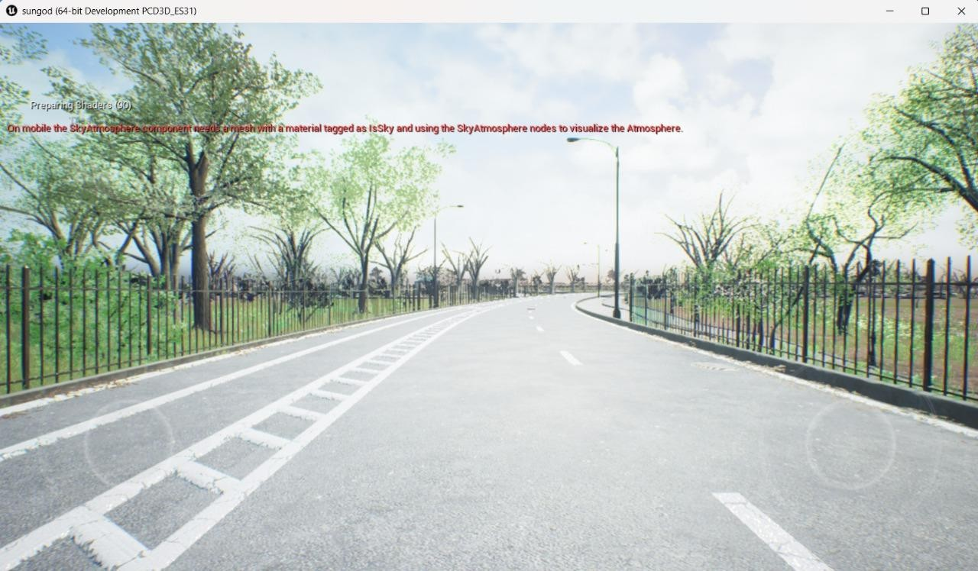

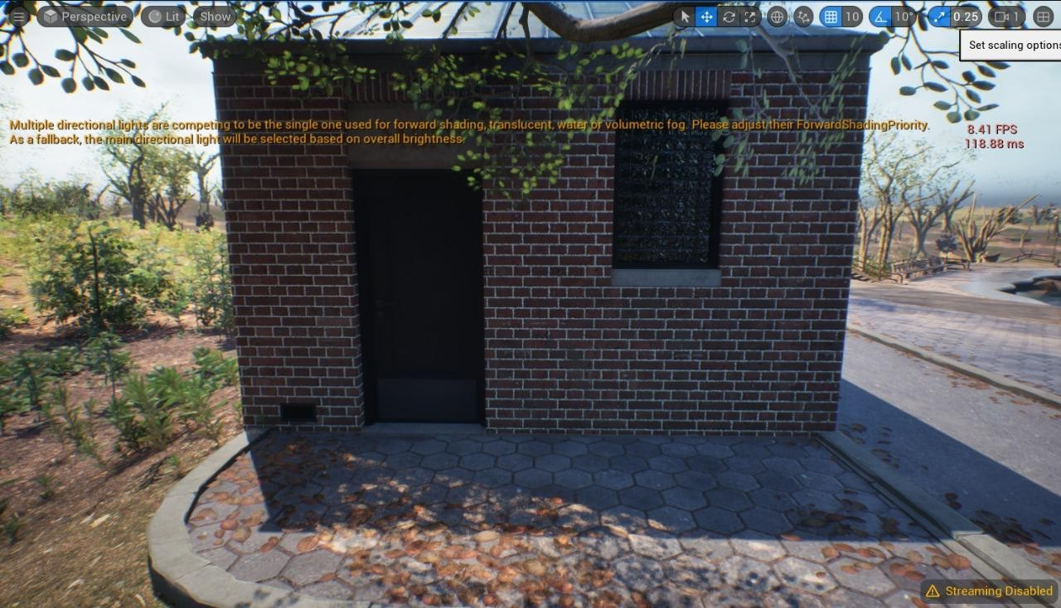

# Gameplay Mechanics

* Health and sanity: Manage your health and sanity as you navigate the haunted location. If your sanity drops too low, the game becomes even more challenging.
* Inventory system: Collect items and manage your inventory to solve puzzles and progress through the game.
* Enemy encounters: Face terrifying enemies, from ghosts to monsters, each with their own behaviors and weaknesses.

"The Cursed Escape" promises a thrilling experience for horror game fans, with its immersive atmosphere, challenging puzzles, and intense gameplay mechanics.

1. **FUTURE SCOPE**

# Gameplay Mechanics

* - **Health and sanity**: Manage your health and sanity as you navigate the haunted location. If your sanity drops too low, the game becomes even more challenging.
* **- Inventory system**: Collect items and manage your inventory to solve puzzles and progress through the game.
* **- Enemy encounter**s: Face terrifying enemies, from ghosts to monsters, each with their own behaviors and weaknesses.

The Cursed Escape promises a thrilling experience for horror game fans, with its immersive atmosphere, challenging puzzles, and intense gameplay mechanics.

## CONCLUSION

The Vehicle Service Automation App effectively bridges the gap between vehicle owners and service providers by digitizing and streamlining the entire service process. From booking a service to tracking its progress and providing feedback, the app enhances user convenience while offering garage owners powerful tools to manage their operations. By leveraging Firebase for authentication, real-time database management, and push notifications, the system ensures fast, secure, and scalable performance.

Overall, this solution not only modernizes the traditional vehicle service model but also lays a strong foundation for future innovations such as AI recommendations, contactless scheduling, and multi- vendor support. It contributes to improving customer satisfaction and operational efficiency, marking a significant step forward in automotive service management.

## REFERENCES

* **Classic Horror Games**
  1. Resident Evil series: Survival horror games known for their intense action and terrifying enemies.
  2. Silent Hill series: Psychological horror games that focus on atmosphere and storytelling.
  3. Amnesia: The Dark Descent: A first-person survival horror game that emphasizes exploration and sanity.

## Modern Horror Games

* 1. Outlast series: First-person survival horror games known for their intense stealth and hiding mechanics.
  2. Five Nights at Freddy's series: Survival horror games that challenge players to survive nights as a security guard in a haunted animatronic-filled environment.
  3. Alien: Isolation: A survival horror game set in the Alien universe, known for its intense atmosphere and AI-driven enemies.