Lumbar Spine A Machine Learning Approach

Ajay Singh Rajawat, Akash, Akshat Agrawal, Udbhav Ojha

Poornima Institute of Engineering and Technology, Computer Science, Jaipur, India

Poornima Institute of Engineering and Technology, Computer Science, Jaipur, India

Poornima Institute of Engineering and Technology, Computer Science, Jaipur, India

Poornima Institute of Engineering and Technology, Computer Science, Jaipur, India

[2021pietcsajay011@poornima.org, 2021pietcsakash012@poornima.org](mailto:2021pietcsajay011@poornima.org,%202021pietcsakash012@poornima.org), [2021pietcsakshat014@poornima.org](mailto:2021pietcsakshat014@poornima.org), [udbhav.ojha@poornima.org](mailto:udbhav.ojha@poornima.org)

Abstract

The lumbar spine has a very high importance for movement activity and overall health of an individual. It is reported that most of the disabilities and health expenditure incurred worldwide are due to disorders in this region. With the advancements in ML, there is a new promise for the diagnosis, treatment, and care of any condition related to the lumbar spine. Such a study can explore the application of ML approaches in various areas such as predictive modeling for injury risk assessment, automated imaging analysis, clinical outcome prediction, and personalized treatment planning. By using huge datasets made of clinical records, imaging modalities such as MRI, CT scan, biomechanical data, and patient-reported outcome, we build and validate strong ML models that are highly accurate and clinically relevant. Some of the noteworthy implementations include CNNs for automatic segmentation of lumbar spine images, ensemble learning methods to predict treatment responses, and reinforcement learning approaches to optimize rehabilitation protocols. This shows that tools based on machine learning will help the health professional use well-informed decision-making, make clinical workflow more efficient, and foster the early identification of patients and improve their care through patient-specific therapeutic strategies. Future work will include work on these refined models with prospective clinical data, as well as on aspects of ethical consideration that have been raised and on possible integration with existing healthcare systems. This research puts machine learning as one of the pathways to revolutionary improvements in lumbar spine healthcare, resulting eventually in better clinical functionality and improved quality of life for patients.

Keyword

Lumbar Spine Analysis, Machine Learning in Healthcare, Automated Medical Imaging, Predictive Modeling for Spine Disorders, Clinical Decision Support Systems (CDSS).

**I. Introduction**

The lumbar spine, Back pain is very common in individuals suffering from disc herniation, spinal stenosis, and degenerative disc disease. Such conditions account for considerable pain, disability, and health care costs. Conventional diagnostic and treatment procedures for lumbar spine disorders were primarily dependent on clinical opinion or imaging studies, both of which are time-consuming and susceptible to variance. Machine learning (ML) indeed has the capacity to transform this area by providing advanced data analytics, predictive modeling, and automation in the clinical workflow. ML technologies, including deep learning for medical image analysis, predictive analytics for analyzing the outcome of treatments, and natural language processing (NLP) to EHRs, could help health professionals make their decisions better and sooner than later. This study focuses on these aspects by involving many machine learning applications in lumbar spine health care, such as improving the accuracy of diagnostics, improving treatment planning, and improving patient outcomes from data-gathering perspectives and developing innovative clinical tools.

**II. Methodologies**

In the lumbar spine arena, machine learning (ML) methodologies are applied in a multidisciplinary approach with data acquisition, preprocessing, model development, and clinical validation of the methodology. Initially, different datasets, including medical imaging (e.g., MRI, CT), electronic health records (EHRs), biomechanics, and patient-reported outcomes, are collected and preprocessed for quality control and consistency purposes. Image processing interventions such as normalization, augmentation, and segmentation are implemented in particular with convolutional neural networks (CNNs) for fully automated analysis of lumbar spine images. For predictive modeling, supervised algorithms, such as Random Forest and Support Vector Machine, and deep learning architectures, such as CNNs and recurrent neural networks, learn from datasets in which outcomes such as injury risk, treatment appreciation, and surgical success are labeled. Natural language processing (NLP) methods help extract pertinent information from unstructured clinical notes. Models are evaluated for accuracy, sensitivity, specificity, and area under the curve (AUC) considering, in particular, cross-validation to avoid overfitting. Finally, clinical validation against real-world data guarantees that ML models must yield actionable insight into enhancing lumbar spine-related diagnosis, treatment, and patient care.

|  |  |  |
| --- | --- | --- |
| **Methodologies** | |  | | --- | | **Description** | |
| Data Collection & Preprocessing | Includes collection of datasets from medical imaging (MRI, CT), EHR, biomechanics, and patient-provided outcomes. Preprocessing entails cleaning, normalization, augmentation, and segmentation of data. |
| Image Analysis with CNNs | Convolutional Neural Networks (CNN) are applied on automated segmentation and classification of lumbar spine images to assist in diagnosis and treatment planning. |
| Predictive Modeling | Use of supervised learning algorithms (like Random Forest, SVM) to provide predictions on clinical outcomes, injury risks, and treatments based on structured data. |
| Natural Language Processing (NLP) | Extraction of relevant clinical insights from unstructured data of electronic health records (EHR) like entity recognition, text classification, etc. |
| Rehabilitation Reinforcement Learning | Developing adaptive rehabilitation protocols using reinforcement learning for personalized and optimized patient recovery strategies. |
| Feature engineering | Transforming and identifying relevant features that are pertinent to raw data to aid model performance and predictive power. |
| Model Validation & Evaluation | Measurement of model performance using accuracy, sensitivity, specificity, and AUC as metrics and cross-validation techniques to ensure reliability. |
| Clinical Validation & Integration | Testing the machine learning models in real-world clinical settings and integrating them within existing clinical workflows for decision support. |

**III. Process**

The lumbar spine domain applies machine learning to clinical challenges; it seeks to collect a varied pool of datasets (e.g., medical imaging, electronic health records, biomechanics) and preprocesses the data through cleaning, normalization, and segmentation. Enhanced data quality via feature engineering leads to the development stage with respective techniques such as deep learning (e.g., CNNs for Imaging) or supervised learning (e.g., Random Forest for Predictive Analytics). The models thus created are trained, validated through metrics such as accuracy and AUC, and clinically tested with real-world data. Models that pass the tests are integrated into clinical workflows for constant monitoring and evaluation of performance, compliance, and adaptability to changing clinical needs thereafter.

1. **Define and Describe Problems:** Lumbar spine disorders relate to clinical problems such as enhancing diagnostic accuracy, predicting rehabilitation outcomes, or automating imaging interpretation.
2. **Collect Data:** Relevant data would include medical imaging (possibly MRI, CT, X-ray), electronic health records (EHRs), physiological assessment data, biomechanical measurements, and patient-reported outcomes.
3. **Process Data:** Includes cleaning and preprocessing, normalization, augmentation and segmentation of medical images, and structuring formal data extraction from unstructured clinical notes using NLP (Natural Language Processing).
4. **Feature Engineering**: Select and transform relevant features from datasets to improve the performance of ML models and understandability.
5. **Model Development**: To develop the models using machine learning methods such as supervised learning (Random Forest, SVM), deep learning (CNNs for image analysis), and reinforcement learning (personalized rehabilitation).
6. **Model Training:** Training of the models with labelled datasets, assuring balance of the data and cross-validation in order to avoid overfitting.
7. **Model Evaluation**: Evaluation of model performance by different metrics like accuracies, sensitivity, specificity, F1 score, and area under the curve. Validation of model robustness by cross-validation and by a test dataset.
8. **Clinical Validation:** Carry out validation of the ML model under actual clinical conditions and utilizing data from the real world so the intention of which can be ascertained regarding clinical decisions, reliability, and safety.
9. **Integration and Deployment**: Integration of the ML model in clinical workflows for example as part of decision support systems, as a fully automated diagnostic tool, or as part of a rehabilitation application.
10. **Monitoring and Maintenance:** Allows continuous monitoring of performance, updating of datasets, and retraining when required, assuring that the standards and regulations of healthcare are maintained.
11. **Machine Learning (ML) and Data Analytics**

Machine Learning allows systems to improve by learning patterns in data while Data Analytics functions to obtain useful recommendations.

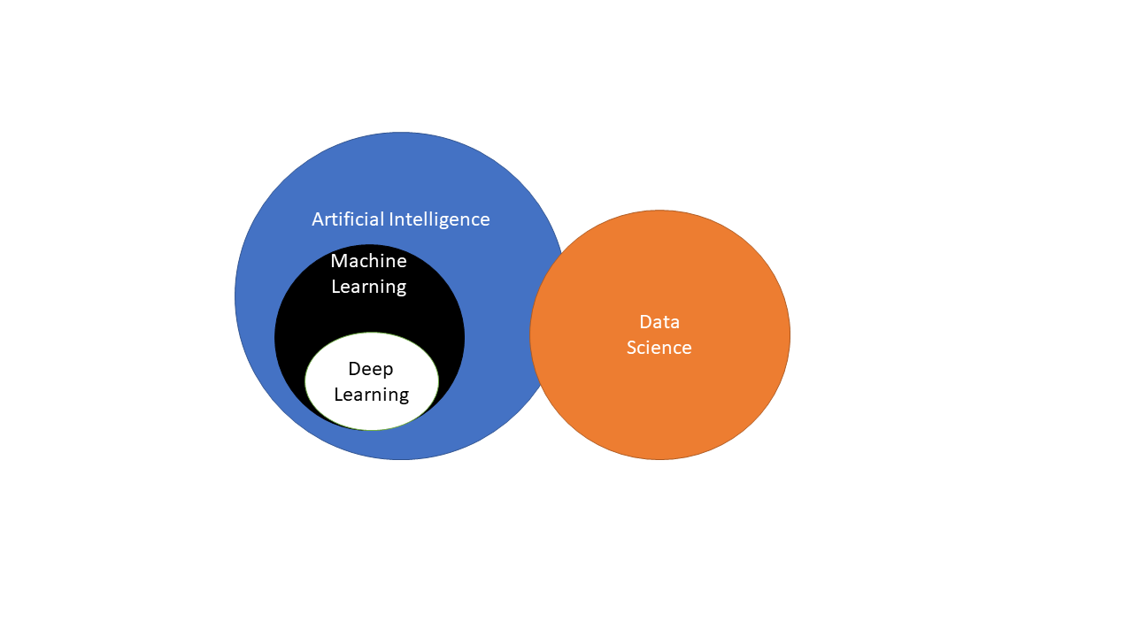

1. **Predictive Analytics**

The application of predictive analytics includes the assimilation of historical data, the utilization of various statistical models and the incorporation of artificial intelligence principles within such models in order to predict, more or less accurately, what might happen in the near or far future and the trends that are likely to be observable over the given and other time frames.

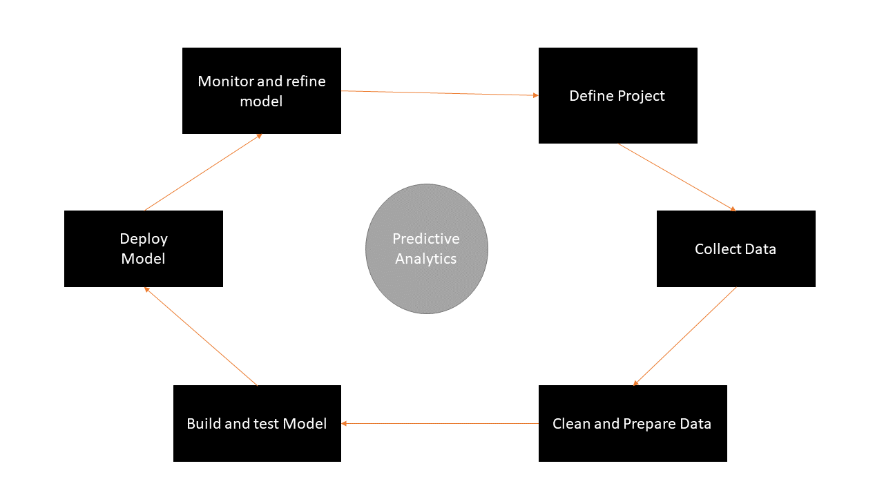

1. **Computer Vision and Image Processing**

Computer vision and image processing consider visual inputs for purposes of understanding, recognizing and detecting objects.

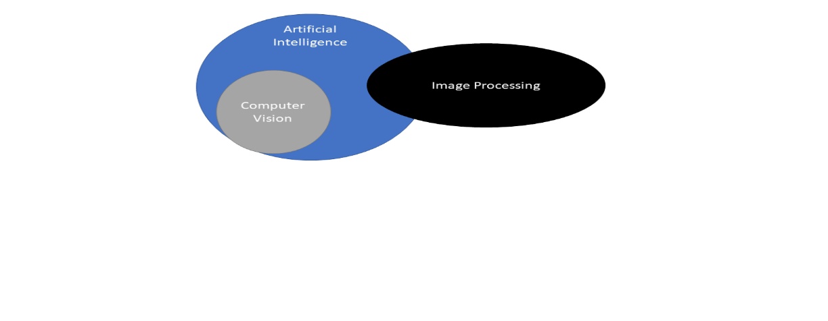

**IV. Lumbar spine in machine learning Tools and platforms**

When it is a matter of working with machine learning applications concerning the lumbar spine, a person has access to several tools and platforms, which may differ from person to person, depending on the applications (i.e., medical imaging, biomechanics, diagnosis, or predictive modeling). Here is what some of the best possible tools and platforms look like:

1. **Machine Learning Frameworks:**

* TensorFlow with Keras: This is, in general, suitable for really deep learning, especially for imaging tasks-such as segmentation or classification.
* PyTorch: Again, for deep learning, but what sets it apart is that dynamic computation graph and flexibility.
* scikit-learn: Best suited for classical machine learning methods such as regression, classification and clustering.

1. **Medical Imaging & Analysis:**

* MONAI (Medical Open Network for AI): A PyTorch-based network, it optimizes healthcare applications, especially for medical imaging.
* SimpleITK and ITK-SNAP: Useful for segmentation and visualization of images.
* 3D Slicer: Excellent tool for computing, visualizing, and analyzing medical images.

1. **Data Annotation & Labeling:**

* Labelbox: For annotating medical images, including DICOM images.
* Open-source and for image segmentation and object detection. CVAT (Computer Vision Annotation Tool).
* Roboflow: Preprocesses tools and supports medical imaging datasets.

1. **Cloud Platforms:**

* Gos.google AI Cloud endpoint: Connected to TensorFlow; AutoML is some tool in it that is also related to medical imaging.
* AWS SageMaker: Really all-inclusive resource for constructing, training, and deploying ML models.
* Azure Machine Learning: Helps to manage ML experiments and pipeline unit processes.

1. **Specialized in Medical Platforms**:

* NVIDIA Clara: Focused really more in healthcare and life sciences because they are more directed towards imaging and genomics.
* Qure.ai and Aidoc: These are more application-related, but they show what can be done with the lumbar spine and musculoskeletal imaging.

1. **Data Sources & Datasets:**

* Cancer Imaging Archive (TCIA): Probably contains specific imaging datasets.
* OASIS (Open Access Series of Imaging Studies): This is mainly about neuroimaging but may inspire a lumbar spine project.
* Public spine datasets: Check Kaggle, Zenodo, or an institutional repository for spine-specific datasets.

**V. Future Scope**

The future scope of machine learning for lumbar spine applications is vast and has the potential to revolutionize the entire spectrum from diagnostics to treatment planning to patient care. Imaging analysis can be improved by ML to deliver accurate segmentation and automated detection of conditions such as disc degeneration, spinal stenosis, and herniated discs. Predictive modeling may also help predict surgical outcomes and disease progression, which can direct personalized treatment plans. Robotic integration will allow enhanced surgical precision with ML applications, and wearable sensors and telehealth solutions can help with monitoring and rehabilitation remotely. Development further combining ML, augmented reality, digital twins, and big data analytics will facilitate spine innovation in research and clinics for a better patient outcome.

**VI.** **Conclusion**

In conclusion, machine learning in lumbar spine research promises to revolutionize health outcomes. Condition-diagnosing algorithms may be among the further advances in ML towards imaging diagnostics, predictive analytics, and individualized treatment plans, transforming the effective and precise diagnosis of lumbar spine conditions, including disc degeneration, spinal stenosis, and herniated discs. When combined with robotic surgery and rehabilitation technology and incorporated into big data analytics development, machine learning may begin creating new avenues for data-rich clinical innovation. As this work evolves, continuous clinical collaboration with data scientists and researchers will pivotally enhance the integration of such technologic advancements into routine clinical practice and the improvement of patient care and quality of life.

**References**

1. D’Antoni, F.; Russo, F.; Ambrosio, L.; Bacco, L.; Vollero, L.; Vadalà, G.; Merone, M.; Papalia, R.; Denaro, V. Artificial Intelligence and Computer Aided Diagnosis in Chronic Low Back Pain: A Systematic Review. *Int. J. Environ. Res. Public Health* 2022, *19*, 5971. [[Google Scholar](https://scholar.google.com/scholar_lookup?title=Artificial+Intelligence+and+Computer+Aided+Diagnosis+in+Chronic+Low+Back+Pain:+A+Systematic+Review&author=D%E2%80%99Antoni,+F.&author=Russo,+F.&author=Ambrosio,+L.&author=Bacco,+L.&author=Vollero,+L.&author=Vadal%C3%A0,+G.&author=Merone,+M.&author=Papalia,+R.&author=Denaro,+V.&publication_year=2022&journal=Int.+J.+Environ.+Res.+Public+Health&volume=19&pages=5971&doi=10.3390/ijerph19105971&pmid=35627508)] [[CrossRef](https://doi.org/10.3390/ijerph19105971)] [[PubMed](https://www.ncbi.nlm.nih.gov/pubmed/35627508)]
2. Wang, P.; Zhang, Z.; Xie, Z.; Liu, L.; Ren, G.; Guo, Z.; Xu, L.; Yin, X.; Hu, Y.; Wang, Y.; et al. Natural Language Processing-Driven Artificial Intelligence Models for the Diagnosis of Lumbar Disc Herniation with L5 and S1 Radiculopathy: A Preliminary Evaluation. *World Neurosurg.* 2024, *189*, e300–e309. [[Google Scholar](https://scholar.google.com/scholar_lookup?title=Natural+Language+Processing-Driven+Artificial+Intelligence+Models+for+the+Diagnosis+of+Lumbar+Disc+Herniation+with+L5+and+S1+Radiculopathy:+A+Preliminary+Evaluation&author=Wang,+P.&author=Zhang,+Z.&author=Xie,+Z.&author=Liu,+L.&author=Ren,+G.&author=Guo,+Z.&author=Xu,+L.&author=Yin,+X.&author=Hu,+Y.&author=Wang,+Y.&publication_year=2024&journal=World+Neurosurg.&volume=189&pages=e300%E2%80%93e309&doi=10.1016/j.wneu.2024.06.041&pmid=38878892)] [[CrossRef](https://doi.org/10.1016/j.wneu.2024.06.041)] [[PubMed](https://www.ncbi.nlm.nih.gov/pubmed/38878892)]
3. Wirries, A.; Geiger, F.; Hammad, A.; Bäumlein, M.; Schmeller, J.N.; Blümcke, I.; Jabari, S. AI Prediction of Neuropathic Pain after Lumbar Disc Herniation-Machine Learning Reveals Influencing Factors. *Biomedicines* 2022, *10*, 1319. [[Google Scholar](https://scholar.google.com/scholar_lookup?title=AI+Prediction+of+Neuropathic+Pain+after+Lumbar+Disc+Herniation-Machine+Learning+Reveals+Influencing+Factors&author=Wirries,+A.&author=Geiger,+F.&author=Hammad,+A.&author=B%C3%A4umlein,+M.&author=Schmeller,+J.N.&author=Bl%C3%BCmcke,+I.&author=Jabari,+S.&publication_year=2022&journal=Biomedicines&volume=10&pages=1319&doi=10.3390/biomedicines10061319&pmid=35740341)] [[CrossRef](https://doi.org/10.3390/biomedicines10061319)] [[PubMed](https://www.ncbi.nlm.nih.gov/pubmed/35740341)]
4. Fan, X.; Qiao, X.; Wang, Z.; Jiang, L.; Liu, Y.; Sun, Q. Artificial Intelligence-Based CT Imaging on Diagnosis of Patients with Lumbar Disc Herniation by Scalpel Treatment. *Comput. Intell. Neurosci.* **2022**, *2022*, 3688630. [[**Google Scholar**](https://scholar.google.com/scholar_lookup?title=Artificial+Intelligence-Based+CT+Imaging+on+Diagnosis+of+Patients+with+Lumbar+Disc+Herniation+by+Scalpel+Treatment&author=Fan,+X.&author=Qiao,+X.&author=Wang,+Z.&author=Jiang,+L.&author=Liu,+Y.&author=Sun,+Q.&publication_year=2022&journal=Comput.+Intell.+Neurosci.&volume=2022&pages=3688630&doi=10.1155/2022/3688630)] [[**CrossRef**](https://doi.org/10.1155/2022/3688630)]
5. Bekbolatova, M.; Mayer, J.; Ong, C.W.; Toma, M. Transformative Potential of AI in Healthcare: Definitions, Applications, and Navigating the Ethical Landscape and Public Perspectives. *Healthcare* **2024**, *12*, 125. [[**Google Scholar**](https://scholar.google.com/scholar_lookup?title=Transformative+Potential+of+AI+in+Healthcare:+Definitions,+Applications,+and+Navigating+the+Ethical+Landscape+and+Public+Perspectives&author=Bekbolatova,+M.&author=Mayer,+J.&author=Ong,+C.W.&author=Toma,+M.&publication_year=2024&journal=Healthcare&volume=12&pages=125&doi=10.3390/healthcare12020125)] [[**CrossRef**](https://doi.org/10.3390/healthcare12020125)]
6. Crawford, C. Biomechanical Features of Orthopedic Patients. Available online: [**https://www.kaggle.com/datasets/uciml/biomechanical-features-of-orthopedic-patients**](https://www.kaggle.com/datasets/uciml/biomechanical-features-of-orthopedic-patients) (accessed on 9 September 2024).
7. Chen, H.; Chen, J.; Ding, J. Data Evaluation and Enhancement for Quality Improvement of Machine Learning. *IEEE Trans. Reliab.* **2021**, *70*, 831–847. [[**Google Scholar**](https://scholar.google.com/scholar_lookup?title=Data+Evaluation+and+Enhancement+for+Quality+Improvement+of+Machine+Learning&author=Chen,+H.&author=Chen,+J.&author=Ding,+J.&publication_year=2021&journal=IEEE+Trans.+Reliab.&volume=70&pages=831%E2%80%93847&doi=10.1109/TR.2021.3070863)] [[**CrossRef**](https://doi.org/10.1109/TR.2021.3070863)]
8. Siebert, J.; Joeckel, L.; Heidrich, J.; Trendowicz, A.; Nakamichi, K.; Ohashi, K.; Namba, I.; Yamamoto, R.; Aoyama, M. Construction of a quality model for machine learning systems. *Softw. Qual. J.* **2022**, *30*, 307–335. [[**Google Scholar**](https://scholar.google.com/scholar_lookup?title=Construction+of+a+quality+model+for+machine+learning+systems&author=Siebert,+J.&author=Joeckel,+L.&author=Heidrich,+J.&author=Trendowicz,+A.&author=Nakamichi,+K.&author=Ohashi,+K.&author=Namba,+I.&author=Yamamoto,+R.&author=Aoyama,+M.&publication_year=2022&journal=Softw.+Qual.+J.&volume=30&pages=307%E2%80%93335&doi=10.1007/s11219-021-09557-y)] [[**CrossRef**](https://doi.org/10.1007/s11219-021-09557-y)]
9. Murphy, P.; Knight, S. Misdiagnosis in Sports Medicine. *Curr. Sports Med. Rep.* **2002**, *1*, 333–337. [[**Google Scholar**](https://scholar.google.com/scholar_lookup?title=Misdiagnosis+in+Sports+Medicine&author=Murphy,+P.&author=Knight,+S.&publication_year=2002&journal=Curr.+Sports+Med.+Rep.&volume=1&pages=333%E2%80%93337&doi=10.1249/00149619-200212000-00006)] [[**CrossRef**](https://doi.org/10.1249/00149619-200212000-00006)]
10. Jawad, B.N.; Pedersen, K.Z.; Andersen, O.; Meier, N. Minimizing the Risk of Diagnostic Errors in Acute Care for Older Adults: An Interdisciplinary Patient Safety Challenge. *Healthcare* **2024**, *12*, 1842. [[**Google Scholar**](https://scholar.google.com/scholar_lookup?title=Minimizing+the+Risk+of+Diagnostic+Errors+in+Acute+Care+for+Older+Adults:+An+Interdisciplinary+Patient+Safety+Challenge&author=Jawad,+B.N.&author=Pedersen,+K.Z.&author=Andersen,+O.&author=Meier,+N.&publication_year=2024&journal=Healthcare&volume=12&pages=1842&doi=10.3390/healthcare12181842)] [[**CrossRef**](https://doi.org/10.3390/healthcare12181842)]
11. Ahn, Y.; Hong, G.S.; Park, K.J.; Lee, C.W.; Lee, J.H.; Kim, S.O. Impact of diagnostic errors on adverse outcomes: Learning from emergency department revisits with repeat CT or MRI. *Insights Into Imaging* **2021**, *12*, 160. [[**Google Scholar**](https://scholar.google.com/scholar_lookup?title=Impact+of+diagnostic+errors+on+adverse+outcomes:+Learning+from+emergency+department+revisits+with+repeat+CT+or+MRI&author=Ahn,+Y.&author=Hong,+G.S.&author=Park,+K.J.&author=Lee,+C.W.&author=Lee,+J.H.&author=Kim,+S.O.&publication_year=2021&journal=Insights+Into+Imaging&volume=12&pages=160&doi=10.1186/s13244-021-01108-0)] [[**CrossRef**](https://doi.org/10.1186/s13244-021-01108-0)]
12. Dora, C.; Wälchli, B.; Elfering, A.; Gal, I.; Weishaupt, D.; Boos, N. The significance of spinal canal dimensions in discriminating symptomatic from asymptomatic disc herniations. *Eur. Spine J.* **2002**, *11*, 575–581. [[**Google Scholar**](https://scholar.google.com/scholar_lookup?title=The+significance+of+spinal+canal+dimensions+in+discriminating+symptomatic+from+asymptomatic+disc+herniations&author=Dora,+C.&author=W%C3%A4lchli,+B.&author=Elfering,+A.&author=Gal,+I.&author=Weishaupt,+D.&author=Boos,+N.&publication_year=2002&journal=Eur.+Spine+J.&volume=11&pages=575%E2%80%93581&doi=10.1007/s00586-002-0448-0)] [[**CrossRef**](https://doi.org/10.1007/s00586-002-0448-0)]
13. Adams, M.A.; Roughley, P.J. What is Intervertebral Disc Degeneration, and What Causes It? *Spine* **2006**, *31*, 2151–2161. [[**Google Scholar**](https://scholar.google.com/scholar_lookup?title=What+is+Intervertebral+Disc+Degeneration,+and+What+Causes+It?&author=Adams,+M.A.&author=Roughley,+P.J.&publication_year=2006&journal=Spine&volume=31&pages=2151%E2%80%932161&doi=10.1097/01.brs.0000231761.73859.2c&pmid=16915105)] [[**CrossRef**](https://doi.org/10.1097/01.brs.0000231761.73859.2c)] [[**PubMed**](https://www.ncbi.nlm.nih.gov/pubmed/16915105)]
14. Jordon, J.; Konstantinou, K.; O’Dowd, J. Herniated lumbar disc. *BMJ Clin. Evid.* **2009**, *2009*, 1118. [[**Google Scholar**](https://scholar.google.com/scholar_lookup?title=Herniated+lumbar+disc&author=Jordon,+J.&author=Konstantinou,+K.&author=O%E2%80%99Dowd,+J.&publication_year=2009&journal=BMJ+Clin.+Evid.&volume=2009&pages=1118)]
15. Qaraghli, M.I.A.; Jesus, O.D. Lumbar Disc Herniation. In *StatPearls [Internet]*; StatPearls Publishing: Treasure Island, FL, USA, 2024. [[**Google Scholar**](https://scholar.google.com/scholar_lookup?title=Lumbar+Disc+Herniation&author=Qaraghli,+M.I.A.&author=Jesus,+O.D.&publication_year=2024)]
16. Wiltse, L.L. The Etiology of Spondylolisthesis. *J. Bone Jt. Surg.* **1962**, *44*, 539–560. [[**Google Scholar**](https://scholar.google.com/scholar_lookup?title=The+Etiology+of+Spondylolisthesis&author=Wiltse,+L.L.&publication_year=1962&journal=J.+Bone+Jt.+Surg.&volume=44&pages=539%E2%80%93560&doi=10.2106/00004623-196244030-00011)] [[**CrossRef**](https://doi.org/10.2106/00004623-196244030-00011)]
17. Bydon, M.; Alvi, M.A.; Goyal, A. Degenerative Lumbar Spondylolisthesis. *Neurosurg. Clin. N. Am.* **2019**, *30*, 299–304. [[**Google Scholar**](https://scholar.google.com/scholar_lookup?title=Degenerative+Lumbar+Spondylolisthesis&author=Bydon,+M.&author=Alvi,+M.A.&author=Goyal,+A.&publication_year=2019&journal=Neurosurg.+Clin.+N.+Am.&volume=30&pages=299%E2%80%93304&doi=10.1016/j.nec.2019.02.003&pmid=31078230)] [[**CrossRef**](https://doi.org/10.1016/j.nec.2019.02.003)] [[**PubMed**](https://www.ncbi.nlm.nih.gov/pubmed/31078230)]
18. Ganju, A. Isthmic spondylolisthesis. *Neurosurg. Focus* **2002**, *13*, 1–6. [[**Google Scholar**](https://scholar.google.com/scholar_lookup?title=Isthmic+spondylolisthesis&author=Ganju,+A.&publication_year=2002&journal=Neurosurg.+Focus&volume=13&pages=1%E2%80%936&doi=10.3171/foc.2002.13.1.2)] [[**CrossRef**](https://doi.org/10.3171/foc.2002.13.1.2)]
19. Dydyk, A.M.; Massa, R.N.; Mesfin, F.B. Disc Herniation. In *StatPearls [Internet]*; StatPearls Publishing: Treasure Island, FL, USA, 2023. [[**Google Scholar**](https://scholar.google.com/scholar_lookup?title=Disc+Herniation&author=Dydyk,+A.M.&author=Massa,+R.N.&author=Mesfin,+F.B.&publication_year=2023)]
20. Bednar, D.A. Cauda equina syndrome from lumbar disc herniation. *Can. Med. Assoc. J.* **2015**, *188*, 284. [[**Google Scholar**](https://scholar.google.com/scholar_lookup?title=Cauda+equina+syndrome+from+lumbar+disc+herniation&author=Bednar,+D.A.&publication_year=2015&journal=Can.+Med.+Assoc.+J.&volume=188&pages=284&doi=10.1503/cmaj.150206)] [[**CrossRef**](https://doi.org/10.1503/cmaj.150206)]
21. KD, W. Spondylolisthesis. In *Campbell’s Operative Orthopaedics*, 14th ed.; Elsevier: Philadelphia, PA, USA, 2021; Chapter 40. [[**Google Scholar**](https://scholar.google.com/scholar_lookup?title=Spondylolisthesis&author=KD,+W.&publication_year=2021)]