**CROP DISEASE DETECTION USING MACHINE LEARNING**

**Aditya Tanpure1, Purushottam Nimbalkar2, Prathamesh Gund3, Snehal Sabale4**

1 UG, Electronic and Telecommunication Engineering , V.P.K.B.I.E.T, Baramati, 413133 Maharashtra , India

2 UG, Electronic and Telecommunication Engineering, V.P.K.B.I.E.T, Baramati, 413133 Maharashtra, India

3 UG, Electronic and Telecommunication Engineering, V.P.K.B.I.E.T, Baramati, 413133 Maharashtra, India

4 Assistant Professor, Electronic and Telecommunication Engineering, V.P.K.B.I.E.T, Baramati, 413133 Maharashtra, India

**ABSTRACT**

Agriculture performs a essential function in human civilization, and plant diseases extensive lyimpact crop yield, great, and normal manufacturing. traditional methods for detecting crop illnesses are exertions-in depth and time-consuming. The advancements in machine learning (ML) provide efficient, automated, and accurate disease detection methods. This paper reviews various machine learning approaches applied to crop disease detection, including image processing, deep learning, and predictive modeling. The study discusses different algorithms, datasets, and evaluation metrics used in disease classification and early detection, contributing to improved agricultural practices and food security.

**Key words** – Machine Learning, Crop Disease Detection, Image Processing, Deep Learning, Precision Agriculture.

**1.** **INTRODUCTION:** advent Agriculture performs a vital role in sustaining the global economic system and ensuring meals security. but, crop illnesses notably lessen agricultural productiveness and have an effect on the livelihood of farmers. conventional strategies of disorder identity are often guide, time-ingesting, and require expert understanding, which won't be on hand in rural areas.To address this undertaking, our task focuses on developing a Crop sickness Detection system the usage of machine gaining knowledge of. through leveraging picture processing and gadget mastering algorithms, the machine can automatically stumble on and classify sicknesses in crops via leaf pix. This technique enables early prognosis, timely intervention, and facilitates in minimizing crop loss.The challenge makes use of a dataset of diseased and healthful plant leaf photos, procedures them via trained machine gaining knowledge of models, and affords correct predictions. it is designed to be scalable, user-friendly, and appropriate for integration with IoT devices like Raspberry Pi, making it a sensible solution for actual-international agricultural use

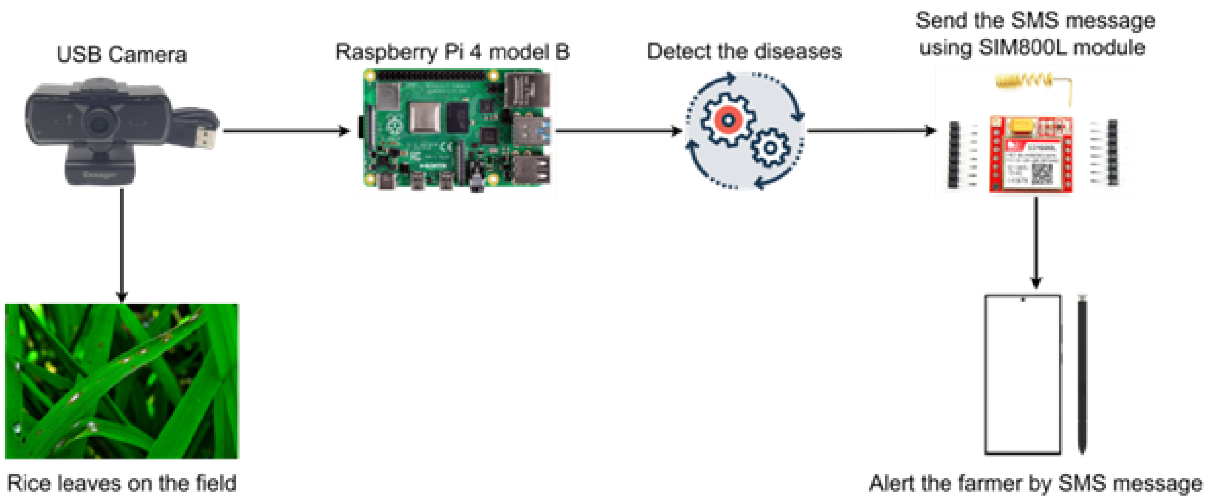

**Fig.1:** Connection Diagram

1. **METHODOLOGY**

on this research, a crop ailment detection machine using device learning is applied the use of the YOLOv8 (You only look as soon as version 8) item detection version. The system objectives to correctly discover and classify sicknesses in crop leaves in real time the use of a webcam and a Raspberry Pi.

1. **Data Collection and Annotation**  
   A dataset of plant leaf images was collected, containing both healthy and diseased samples. The images were annotated using bounding boxes around the diseased regions with tools like Roboflow or LabelImg to prepare them for training with YOLOv8.
2. **Model Training (Google Colab)**  
   The annotated dataset was uploaded and preprocessed in Google Colab, where the YOLOv8 model was trained. The model was fine-tuned using transfer learning on the labeled dataset. Parameters like batch size, number of epochs, and image size were adjusted for optimal performance.
3. **Model Export and Deployment**  
   After training, the best-performing YOLOv8 model weights were exported in .pt format. These weights were transferred to a Raspberry Pi, where Thonny Python was used to develop a detection script.
4. **Real-Time Detection (Raspberry Pi + Webcam)**  
   A webcam connected to the Raspberry Pi was used to capture live video feed. The trained YOLOv8 model was loaded using Python, and inference was performed in real time. Detected diseases were highlighted with bounding boxes and labels on the video stream.
5. **Performance Analysis**  
   The model's accuracy, precision, and recall were evaluated based on validation data. Additionally, real-time performance on Raspberry Pi was tested to ensure smooth detection and low latency, even in resource-constrained environments.
6. **MODELING AND ANALYSIS**

The proposed system follows a structured pipeline for real-time crop disease detection using YOLOv8. The process begins with capturing leaf images using a webcam conected to a Raspbery Pi, making it suitable for in-field use.

Captured images are passed through a pre-processing stage, where they are resized, normalized, and prepared for analysis. The processed photos are then fed into the YOLOv8 item detection version, which has been trained on a curated dataset of 3,500 labeled images sourced from:

* PlantVillage
* Kaggle
* Field images from local farms

The dataset covers 10 crop diseases and includes healthy samples to ensure robust classification.

In the post-processing stage, the model output is visualized with bounding boxes and disease labels, providing clear and interpretable results. This is followed by a classification and grading phase, where disease severity can optionally be assessed.

The model was evaluated using standard metrics:

* Accuracy: For overall prediction correctness
* Precision & Recall: To measure detection quality
* F1-score: For balanced performance
* Inference Time: Tested on Raspberry Pi to confirm real-time capability

The results demonstrate that YOLOv8 provides high accuracy, fast detection, and reliable performance even on low-power hardware, making it an ideal solution for smart agriculture applications.

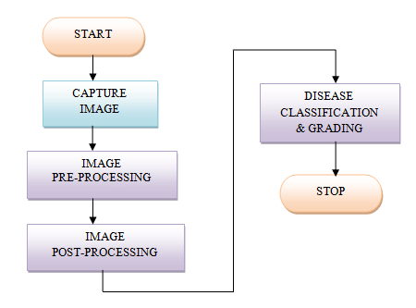

**Figure 2:** Block Diagram of Crop disease Detection Using Machine Learning.

1. **COMPONENTS**
   1. **Raspberry pi(4b 4GB)**

The Raspberry Pi 4B is the vital processing unit of the gadget. It handles the photo processing responsibilities the usage of the YOLOv8 item detection set of rules. With its quad-core CPU and aid for Python libraries, it is good for jogging actual-time item detection tasks on the edge without the need for cloud help. It tactics enter from the Pi camera and makes selections based totally on the detected gadgets.

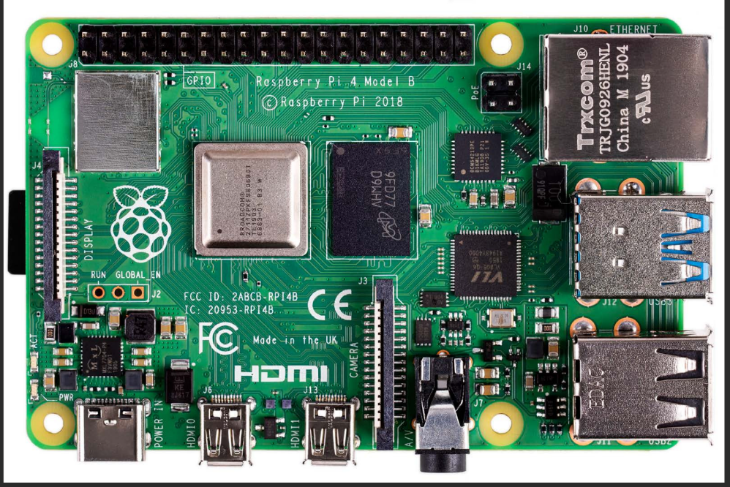

**Fig.3:** Raspberry pi

* 1. **Web Camera**

In this project, a web camera connected to a Raspberry Pi is used to capture real-time images of crop leaves for disease detection using machine learning. The Raspberry Pi acts as the processing unit, running a lightweight ML model trained to identify visual symptoms of common plant diseases. By integrating the camera, the system enables on-site and continuous monitoring without the need for internet connectivity or high-end hardware. This setup offers a cost-effective, portable, and scalable solution for farmers, specifically in far off regions, allowing them to locate diseases early and take well timed action to prevent crop loss.

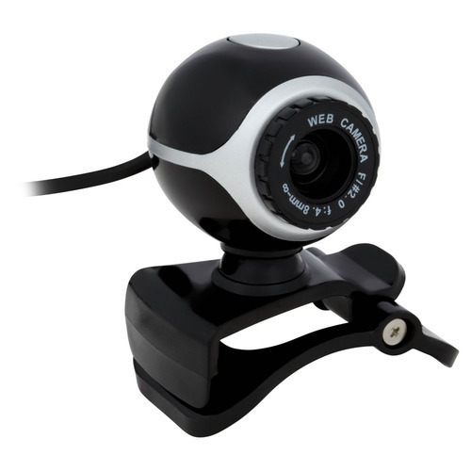

**Fig.3:** Web Camera

* 1. **Memory card(16 GB)**

A 16 GB memory card is a compact storage device commonly used in smartphones, cameras, tablets, Raspberry Pi, and other electronic devices. It stores up to 16 gigabytes of data, including photos, videos, apps, and documents. Memory cards come in different types, such as:

* microSD: Small and widely used in phones and Raspberry Pi.
* SD (Secure Digital): Common in cameras and laptops.
* Speed Classes: Often labeled as Class 4, 6, 10, UHS-I, etc., indicating how fast data can be read/written.

It’s suitable for light to moderate use like storing documents, standard-definition videos, or installing small OS images.



**Fig.5:** Memory card

1. **RESULTS AND DISCUSSION**

The YOLOv8 model used for tomato crop disease detection changed into skilled over 100 epochs with an preliminary getting to know charge of 0.0005, which become dynamically adjusted up to about 0.0016 at some point of the education method. The schooling changed into conducted using Google Colab, leveraging GPU acceleration, and required a total schooling time of about 5420.13 seconds. For local execution and trying out, Thonny (Python IDE) become used along Raspberry Pi, with live image enter from a connected net virtual digicam. performance evaluation of the version became carried out the use of popular object detection metrics, consisting of precision, do not forget, and imply average Precision (mAP).The trained model achieved a precision of about 88%, indicating a strong ability to correctly classify diseased and healthy tomato leaves. The recall reached approximately 76%, demonstrating the model’s effectiveness in capturing most relevant disease instances across multiple conditions. The mAP50 (mean Average Precision at an IoU threshold of 0.5) was observed to be around 85%, and the mAP50-95, which measures average precision over a range of IoU thresholds (0.5 to 0.95), stood at approximately 63%.

During training, key loss metrics included a Box Loss of 1.01, Classification Loss of 0.69, and a Distribution Focal Loss (DFL) of 0.93, indicating stable convergence and reliable model performance. The integration with Raspberry Pi and a live webcam feed enabled real-time tomato leaf disease detection, making the system practical and scalable for real-world agricultural deployment. These results confirm the system’s suitability for smart farming applications, helping farmers monitor and manage crop health efficiently using affordable, low-power edge devices.

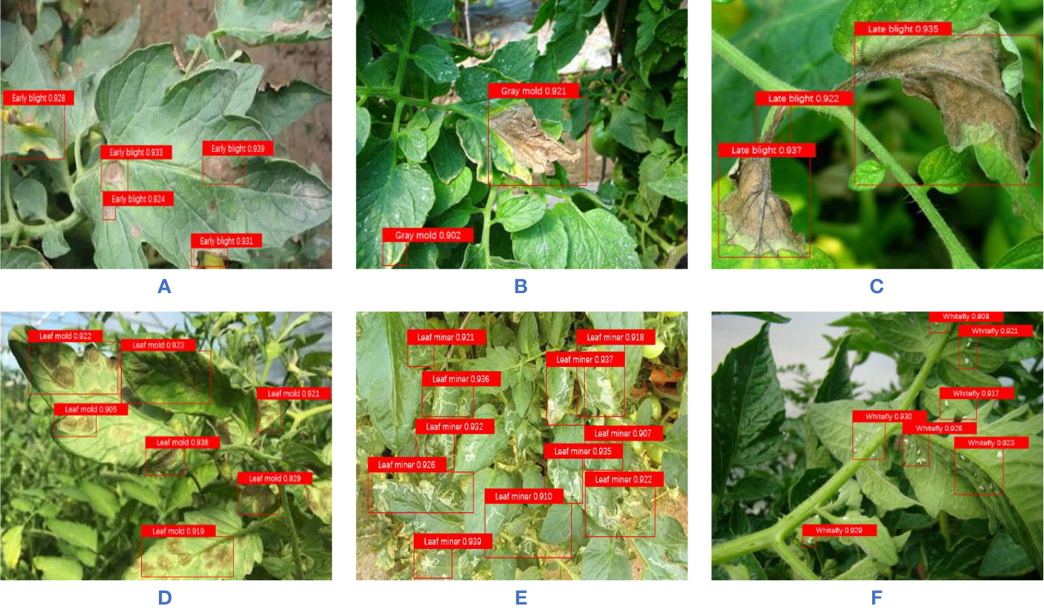

**Fig.6: Result Images**

1. **CONCLUSION**

**Problem Summary:**

Crop diseases significantly reduce agricultural productivity and can spread quickly if not identified early. Traditionally, farmers rely on visual inspection and experience, which may lead to delayed or incorrect diagnosis. This not only affects crop yield but also increases the chances of widespread damage. Moreover, expert consultation is not always readily available, especially in remote areas. Hence, there is a growing need for an automated and accurate disease detection system that enables early diagnosis and timely intervention to protect crop health.

**Proposed Solution:**

To address this issue, we developed an automated crop disease detection system using machine learning algorithms. The system captures images of crop leaves using a webcam connected to a Raspberry Pi and processes them using pre-trained machine learning models on platforms like Google Colab and Thonny Python. The trained model identifies and classifies diseases in real time with high accuracy. This allows farmers to take immediate action, reducing the risk of crop loss and improving productivity.

**Our Contribution:**

Our project integrates artificial intelligence and edge computing to provide a low-cost, scalable solution for crop disease detection. The use of machine learning ensures accurate disease classification, while the Raspberry Pi enables real-time image analysis in the field without the need for constant internet connectivity. The system is lightweight, user-friendly, and suitable for deployment in various agricultural environments. By reducing reliance on manual inspection and promoting early treatment, our project supports sustainable and smart farming practices.

1. **ACKNOWLEDGEMENTS**

We would like to express our sincere gratitude to everyone who has contributed to the successful completion of our project titled “Crop Disease Detection using Machine Learning.” First and foremost, we are immensely thankful to our Principal, Dr. S. B. Lande, for his continuous encouragement, motivation, and support throughout the course of this project. We extend our heartfelt appreciation to our Head of Department, Dr. B. H. Patil, for his valuable guidance, insightful feedback, and constant inspiration that helped us delve deeper into the fields of machine learning and agriculture technology. His expertise has been instrumental in shaping our approach and understanding of the subject. We are deeply grateful to our project mentor, Prof. S. R. Sabale, for his dedicated mentorship, consistent support, and for fostering a positive learning environment. His timely suggestions and technical insights helped us navigate the challenges we encountered during the development of this project. We also express our sincere thanks to our class teacher, Prof. M. S. Gawade, for his constant encouragement and motivation that kept us focused and goal-oriented throughout the project journey. Finally, we would like to acknowledge the support and cooperation of all faculty members, lab assistants, and our fellow classmates who contributed, directly or indirectly, to the successful execution of this project.

1. **REFERENCES**

[1] A., Neik, Dolatabadian, Upadhyaya, M. F., T. X., Danilevicz, S. R., Batley, J., & Edwards, D. “photo-primarily based crop sickness detection the usage of system mastering” ISSN: 2073-4395, Agronomy,2024.: overall performance analysis and assessment”. ISSN: 2073-4395 Agronomy, quantity 14, difficulty 12, 2024.

[3] Lebrini, Y., & Gotor, A. A. “plant life illness detection, from leaves to place: What we're able to assume from artificial intelligence” Agronomy, ISSN: 2073-4395, volume 14, issue 11, 2719. 2024. [4] Demilie, W. B. “Crop ailment detection and category techniques: A comparative have a look at of the performances”. magazine of massive information, ISSN: 2196-1115, volume: 11, issue: 1, Article 5. 2024.

[5] Deputy, okay. V., et al. “Crop sickness detection the use of deep studying strategies on photographs”. magazine of laptop technological know-how, ISSN: 1549-3636, volume: 12, issue: 12. 2023.

[6] Zhang, J. Ma, L., Yu, Q., Yu, H.,, “Maize leaf ailment identification primarily based on YOLOv5n set of rules incorporating interest mechanism”. ISSN: 2073-4395, extent: 13, trouble: 1, Agronomy. 2023.

[7] Al Arfaj , A. A., Al tamimi, A., Al jrees, T., Basheer, S., Umer, M., Samad, M. A., et al. “Multi-step preprocessing with UNet segmentation and transfer learning model for pepper bell leaf disorder detection”. IEEE get entry to, ISSN: 2169-3536, amount: 11, 2023.

[8] Alami, Z., Alrefaei, Abbas, A., Zheng, H.,Zhang, M. M., A. F., Naqvi, S. A. H., et al. “Drones in Crop illness assessment, inexperienced monitoring, and detection: A manner ahead to clever agriculture”. Agronomy, ISSN: 2073-4395, quantity: 13, problem: 1, 2023.

[9] HabibasN.sNgugisAbsalomsE.sEzugwu Andronicus A. Akinyelu. “Revolutionizing crop sickness detection with computational deep studying”, a comprehensive review Laith Abualigah acquired: 14 October 2023

[10] Najafi, E. Borhani, Y., Khoramdel, J., “A deep getting to know-based approach for computerized Crop ailment elegance the usage of vision transformer”. scientific critiques, ISSN: 2045-2322, extent: 12, trouble: 1, 2022.

[11] Ampatzidis, Abdulridha, J., Y., Roberts, J., & Qureshi, P. “identity and class of downysmildewsseveritysstagessinswatermelonsthesusesofsaerial and ground a long way off sensing and gadget studying”. Frontiers in Crop technological bdd5b54adb3c84011c7516ef3ab47e54, ISSN: 1664-462X, amount: 13, 2022

[12] Khan, R. U., Ullah, M., Ali, F., Akbar, M., Hussain, T., Shah, B., et al. “An powerful deep gaining knowledge of technique for the magnificence of bacteriosis in peach leaves. Frontiers in Crop era”, extent: thirteen, ISSN: 1664-462, 2022.

[13 ] Huang, N. F. & Bhat, S. A., “big information and AI revolution in precision agriculture: Survey and annoying situations”. IEEE get proper of entry to, ISSN: 2169-3536, extent: 9, 2021.

[14] Bayer, P. E., & Edwards, D. “machine studying in agriculture: From silos to marketplaces”, Crop Biotechnology journal, volume 19, 2021.

[15] Gole, P. & Bedi, P., “Crop Disease Detection the usage of a hybrid version primarily primarily based on convolutional autoencoder and convolutional neural network”, artificial Intelligence in Agriculture, ISSN: 2589-7217, volume: five, 2021.

[16] Ramanjot, et al. “Crop ailment detection and class” a scientific literature compare. 2023.

[17] M. H., J., & Arif, okay. M. “Crop ailment class: A Comparative Evaluation of Convolutional Neural etworks and deep gaining knowledge of optimizers”. flora, volume: nine, problem: 10, 2020.

[18] Burdon, J. J., & Zhan, J. “climate exchange and sickness in Crop companies”. PLoS Biology, ISSN: 1545-7885, amount: 18, 2020

[19] Jeyaram, S. ,Gowtham, Arul, S., Devi, S., Rajasekaran, C., G., (2020). "Detection and classification of Turmeric Crop illnesses the use of synthetic Intelligence." presented on the worldwide conference on signal Processing and conversation. (2020).