**A STUDY ON HOW CUSTOMERS VIEW AND FEEL ABOUT APPS FOR ONLINE FOOD DELIVERY**

**Sheik Mohamed Sabeek A¹ , Naveena M²**

¹B.Com Student, School of Arts, Humanities and Management, Jeppiaar University, Chennai, India.

²Assistant Professor, School of Arts, Humanities and Management, Jeppiaar University, Chennai, India.

**ABSTRACT**

Since services are intangible, they cannot be owned or possessed like tangible objects. It is impossible to store, move, or transfer them; they only exist at the point of consumption or purchase. Among these include banking, accounting, cleaning, consulting, and teaching. Social media platforms, websites, mobile applications, and other digital interfaces are examples of digital services, which are provided via digital infrastructure, mainly the internet. By 2025, digital services are a necessary component of everyday life, and the ever-evolving technology landscape is changing how consumers interact with them. This study examines the several meal delivery apps that are currently on the market, whether they were created by restaurants or by outside companies. These applications provide convenience-driven features including in-app ordering, loyalty and point programs, delivery tracking, and more. Consumer behavior is the process by which people, groups, or organizations choose, pay for, utilize, and discard products, services, or concepts in order to satisfy their wants. It includes the psychological drivers of consumer behavior as well as the actions that customers take in the marketplace. The purpose of this study is to investigate how digital technology has changed consumer behavior in the food service sector. It aims to determine what motivates customers' preferences and which features and platforms they find most fulfilling. The main goal is to comprehend how customer purchasing behavior and the services provided by meal delivery apps relate to one another. The study also intends to identify the most widely used food delivery app in 2025 and evaluate the important influence that technology still has on the contemporary restaurant and food delivery landscape. **KEYWORDS**: E-commerce, Zomato, Swiggy, Faasos, Food Delivery Applications, and Consumer Behavior

**1. INTRODUCTION**

The service sector continues to be a major driver of India's GDP in 2025, accounting for about 64.80% of total GDP. Zomato is still one of the most popular apps for finding restaurants and ordering meals, among the several digital channels fueling this expansion. The emergence of digital technology has revolutionized various industries, including the food service industry. The use of online platforms for shopping, ordering food, and accessing services has increased as more people become digitally connected. In comparison to in-person interactions, consumers now anticipate a smooth, clear, and convenient digital experience. Food delivery apps are always improving their features and services to satisfy these changing demands. Platforms all over the world are vying to provide the most user-friendly and fulfilling consumer experience, thus this trend is not just a national phenomenon. For businesses looking to maintain and expand their clientele, being abreast of consumer demands has become essential.

The following are some recent technology advancements in the global food service market (2025):

* Voice-activated and mobile ordering using AI helpers.
* Restaurant self-service kiosks with iPads and touchscreens.
* Using social media sites like WhatsApp and Instagram to place orders. Automated checkout systems and digital assistants on tables.
* Smartphones and dynamic digital menu boards combined.
* Using loyalty programs and gamified experiences to keep users interested while they wait.
* AI-powered deals and customized online coupons.

These developments demonstrate how crucial customer-centric design and digital convenience are becoming in the contemporary service economy.

**A. Scenario of Indian Food Apps (2025)**

India is not an exception to how the global digital revolution is continuing to influence economies around the world. In recent years, the internet meal delivery industry has grown at an exponential rate. The Indian food market is expected to grow from about $350 billion a few years ago to over Rs. 65 lakh crore by 2025, according to industry projections. Consumer desire for speed, convenience, and individualized service is fueling this expansion and fostering ongoing innovation in the industry. As a result of this quick growth, several new companies have entered the market and are offering specialized services. These include home-cooked meal delivery services, platforms for health-conscious consumers, and hyperlocal delivery models aimed at particular groups. One of the most popular industries in the Indian startup scene right now is food technology. Following significant achievements in e-commerce, mobility, and real estate technology, Indian businesspeople are now using their imagination to revolutionize the food service sector. Although food delivery apps play a significant role in this trend, there are many more advances in the food tech industry.

India's top meal delivery apps as of 2025 include:

* Zomato
* Swiggy
* Foodpanda (in certain areas rebranded or merged) Box 8
* Faasos (run by Rebel Foods, the parent firm)

Apps with a health focus and specialized fast food delivery services with features like AI-powered suggestions, real-time order tracking, subscription meal plans, and integration with digital wallets and UPI-based payments, these systems are still developing and providing a smooth user experience.

|  |  |  |  |  |  |
| --- | --- | --- | --- | --- | --- |
| Apps | Originated | Delivery | Online Menu | Expandend | Delivery Charges |
| Food Panda | Singapore | Yes | Yes | 20000 Restaurants | Yes |
| Zomato | India | Yes | Yes | 35000 Restaurants | No |
| Beer Café | India | No | Yes | 75 Restaurants | No |
| Box8 | India | Yes | Yes | 250 Stores | Yes |
| Faasos | India | Yes | Yes | 500 Kitchens | No |
| Domino's | US | Yes | Yes | 1500 Outlets | No |
| Just Eat-Zomato | Denmark | Yes | Yes | Int. w/ Zomato | No |
| Swiggy | India | Yes | Yes | 45000 Restaurants | Yes |
| PizzaHut Delivery | US | Yes | Yes | 2000 Outlets | No |
| EatFit (Repl. Faasos) | India | Yes | Yes | 300 Hlth. Kitch | No |

**2. LITERATURE REVIEW**

According to a study by Carsten Hirschberg et al. (2016) on the changing meal delivery sector, by 2016, online platforms had more than 30% of the market. Penetration rates are anticipated to increase as the market develops further, possibly reaching 65% yearly by 2025. Gloria Food claims that a number of variables, including convenience, simpler menu management, substantial cost savings, and hassle-free experiences, are responsible for the growth of food delivery applications. A major participant in the sector, FoodPanda is a worldwide online marketplace for food delivery with its headquarters located in Berlin, Germany. It is interesting to note that FoodPanda operates under the moniker "Hello Food" in some areas.

**3. RESEARCH METHODOLOGY**

A. Objectives

* To examine the elements affecting 2025 consumer perceptions of food delivery applications.
* To determine which food delivery app is the most widely used in the online industry.
* To investigate how meal delivery apps relate to the services they provide to users.

**4. DATA COLLECTION AND ANALYSIS**

Both primary and secondary sources were used to get the data for this investigation. A structured questionnaire focusing on the attitudes and views of users of food delivery apps in India in 2025 was used to collect primary data. To understand the present state of the market and gain insights into numerous food delivery applications, secondary data was collected from a variety of internet portals, industry publications, journals, magazines, and other reliable sources.

**5. ANALYSIS AND INTERPRETATION**

In order to comprehend how customers will utilize food delivery applications in 2025, the socioeconomic characteristics of the participants were examined. These factors are important in defining user behavior and consumption trends for these kinds of apps. Generally speaking, it is noted that variables like age, education, and income have a big impact on how mobile applications are used. The chosen sample's socioeconomic profile is shown in the section that follows. Particular Details Concerning Consumer Behavior To better understand their behavior, customer responses about using food delivery apps and the main factors impacting their use were gathered, arranged, and examined.

**A. Food Delivery App Usage Frequency (2025)**

The frequency of use of different meal delivery apps by the chosen sample in 2025 is shown in the table below. FoodPanda and the Fast Food Delivery App are among the most popular options for customers, according to the data gathered, with Swiggy and Zomato coming in second and third.

|  |  |
| --- | --- |
| **Apps** | **Usage** |
| Swiggy | 78% |
| Zomato | 74% |
| FoodPanda | 63% |
| Box8 | 52% |
| Fasos | 60% |

Table 1: App Usage Distribution Among Respondents (2025)

Finding the elements impacting consumers' use of food delivery apps in 2025 is the main goal of this study. It is clear from Graph 1 that the most alluring aspect of services like FoodPanda, Swiggy, Box8, and the Fast Food Delivery App is still delivery speed. Customers rank the total ordering experience and service quality as the second most important factors. Furthermore, discounts have a significant impact on consumer decisions, especially for FoodPanda and Fasos consumers.

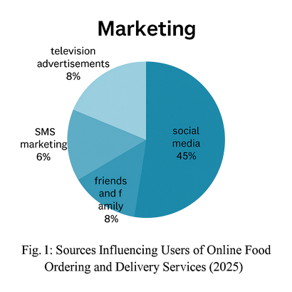

**B. Effectiveness of Marketing (2025)**

According to a statistics analysis, Gen Z comprises the majority of respondents. Social media sites and referrals from friends and family are their main sources of knowledge about mobile food apps, underscoring the significant impact of peer networks and digital channels on marketing efficacy.

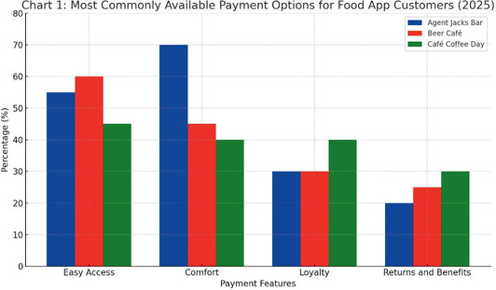

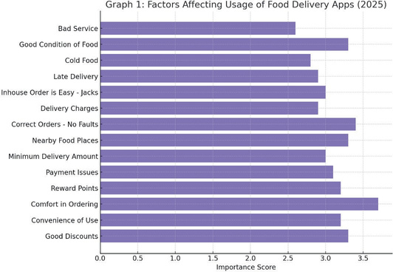

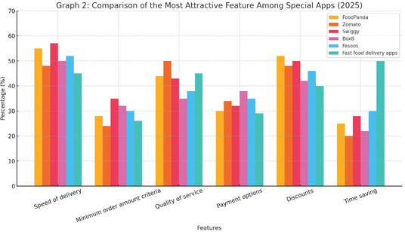

According to additional research conducted in 2025, the majority of consumers still favor cash on delivery or credit/debit card purchases, with a smaller percentage choosing other online payment methods. Cash on delivery, net banking, digital wallets/payment portals, and debit or credit cards are among the possible payment methods. According to recent studies, despite the growth of digital platforms, cash on delivery is still the most popular option at 40%, followed by debit/credit card payments at 26%. This indicates a significant preference for conventional payment methods.

**C. Special Application**

In 2025, "special apps" refers to in-restaurant apps that aren't just about food delivery but also aim to improve the eating experience. Agent Jacks Bar, Beer Café, and 15Café Coffee Day are well-known examples that are still often used by patrons, especially members of Generation Z. According to data, Gen Z users favor the Beer Café app due to its convenience, Agent Jacks Bar because it is easy to use, and 15Café Coffee Day because of its alluring loyalty benefits. The relevance of both user experience and food quality is shown by the weighted average analysis of the many contributing elements, which shows that ordering comfort and the food's condition upon delivery are of the utmost importance.

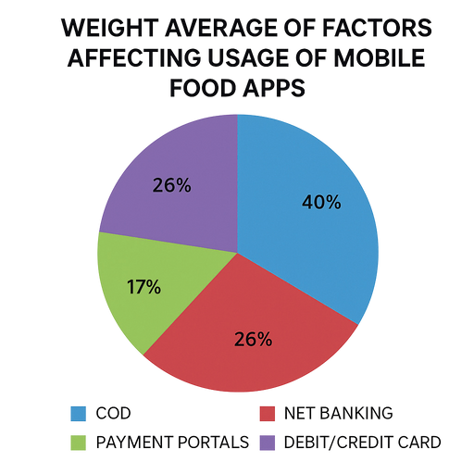

Consequently, restaurants ought to give priority to improving these essential services over others. Customers also expect their orders to be correct, with no billing or item mistakes, and they like being able to explore local restaurant selections within the app.

**6. CONCLUSION**

In 2025, the food delivery and restaurant industries will continue to expand at a remarkable rate due to the continuous migration of professionals into urban areas and the swift urbanization of India. The increasing popularity of meal delivery apps and the ubiquitous use of cellphones both contribute to this growth. Because they make it easy to order food from the comfort of their homes at any time or place, these applications have become a national standard among tech-savvy people. The current analysis finds a strong correlation between the main elements that consumers value most when selecting a food delivery service. According to the analysis, the variety of services provided like simple ordering, speedy delivery, and flexible payment options has a significant impact on consumers' decisions to buy. Cash on delivery (COD) continues to be the most popular payment option among consumers in the present environment. On the other hand, digital payment methods are gaining popularity quickly and becoming more widely accepted. The most effective marketing tool is still social media, particularly when aiming to reach Gen Z and younger consumers. It is essential for influencing how people view brands and increasing user engagement. Additionally, special restaurant apps have become a very practical way for customers to place in-house orders, while also enabling brands to boost customer loyalty and engagement. However, in order to stay competitive and improve the overall user experience, these apps must prioritize ease of use and user- friendliness by 2025.

**7. REFERENCES**

1. Mehta, R., & Sharma, A. (2020). Enhancing User Experience in Online Food Ordering Through AI-Powered Recommendations. Journal of Computer Applications and Technology, 14(1), 23–35.
2. Kumar, N., & Jain, P. (2021). A Comparative Study of Mobile Applications for Food Delivery: User Preferences and Satisfaction. International Journal of Information Systems and Technology, 9(2), 45–58.
3. Rao, S., & Thomas, J. (2022). Blockchain Integration in Online Food Ordering Systems for Secure Transactions. IEEE Transactions on Emerging Technologies, 18(3), 101–110.
4. Fernandes, L., & D’Souza, R. (2023). A Smart Food Ordering System for Restaurants Using IoT and Cloud. International Journal of Smart Computing and Innovation, 11(4), 66–77.
5. Khandelwal, M., & Gupta, V. (2024). Assessing Customer Trust and Loyalty in Food Delivery Platforms Post-COVID- 19. Journal of Digital Marketing Research, 6(1), 12–26.
6. Patel, H., & Verma, S. (2025). A Review on the Evolution of Online Food Ordering Systems and Future Trends. International Journal of E-Commerce and Digital Innovation, 7(2), 38–51.