**MARKETING AND DIPLOMACY: TWO SIDES OF THE SAME COIN**

J. Tejaswin

Department of Commerce

Loyola College,

Chennai-600034

**Abstract:**

As per Kotler & Keller Marketing is a process of identifying and forming social needs and human needs. One of the most basic marketing definition means “meeting profitable needs” – which is how to create a profitable business opportunity from a need.

Diplomacy by itself is an art and the practice of conducting negotiations between nations.

Far from being interlinked or overlapping concepts, marketing and diplomacy seem to be two separate entities. But that is not the case; these two are not two sides of the same Coin.

The globalised world has reduced all the barriers of both trade and culture and whatnot, connecting the world to another, allowing free movement of goods, services, ideas the people, diaspora, etc. Mentioning the term marketing in International Relations comes with a broader meaning having to do with trade, only a fraction placed to trade itself seems to be what marketing denotes in International Relations. Therefore, nations determine with whom they are going to be in a relationship, their ties and rapport with other nations depending on the marketing strategies of the countries whose name goes forward in diplomacy to bring welfare to the common on a broader sense. This paper, like all research papers, has an aim, whether he/she want to prove the point or state the point accordingly. The aim in this research paper was to find out how these countries market their ideology or their culture or schemes, etc, and how the latter attracted other countries, resulting in an overall welfare within the society.The main goal for which this research is set out is to prove that marketing and diplomacy a concept which is interconnected and hence goes hand in hand because these two things are usually seen as separate ones. In this study, the sources of data are almost international affairs, diplomacy; there are no reliable data to collect. An authentic secondary data has thus been collected through various government websites and from credible sources to prove that marketing is beyond ‘conventional goods and services’ and serves as an invisible tool in the field of diplomacy and international affairs.

Keywords- Diplomacy, soft power, welfare, marketing, ideologies, relationships.

**1. Introduction:**

Although marketing has been used to lure customers to go to an organisation’s goods and services, this isn’t a new thing marketing is believed to be; hence, many think that it is a current-day process. It is a practice that has also been applied to various habits, for example, religion. For the beautiful ideologies they all hold with respect to salvation, the religions such as Hinduism, Christianity, Islam, Buddhism, Jainism, Zoroastrianism, tantrism and others started to spread across the world. By an indirect way of marketing, through their practices, all these religions had taken hold of society. Indeed, then marketing was very important in bringing a practice to a cult, cult to a sect and a sect to a religion on a worldwide basis.

Thus, the term got developed and became a major part of diplomacy, which further developed into a major fraction of marketing and thus promoted the free flow of trade, ideology, etc. The Cold War (1947-91) between the mighty USA and the mighty USSR was one great example of this. The Cold War was a war between capitalism and communism, the US and the USSR, respectively. The two main things they wanted to achieve were to spread their very own ideology to the newly independent third-world nations. We can also clearly say that this marketing strategy of the USSR failed, since the USSR disintegrated in 1991 and only a few countries, to this date, like Cuba, North Korea and China, are following the Communist ideology. As previously said, though, the capitalist ideology was received by a huge market among Western nations and a huge fraction of third-world nations, and this has led to the globalisation of the modern world.

On a global stage, countries put up their stand through the UN, QUAD, ASEAN, SCO, SAARC, BIMSTEC, etc., to take a stand on a certain issue, and it forms a way of marketing since it gathers support from other nations. For example, QUAD is a platform for India, the US, Japan and Australia to maintain peace as well as cooperation in the Indo-Pacific region and also as a forum to counter China’s monopoly in the Indo-Pacific region. In this light, QUAD thus establishes that its members see the need for peace and stability in the Indo-Pacific and help them sell their capacities to bring security and support to the countries of that region.

2.**Review Literature:**

Based on ideology, Kireeva, A. A. [1] worked on the strengthening of today's relationship between Russia and China. This couple is the one who is promoting their point of view and the point of view of the other on everything else from the aspect of governance, anti-West ideologies and many more, as a fuss to prove the point that their point of view is better. [2], Carrai, M. A. (2023) explains that China is altering the governance mechanisms of countries using its Belt and Road Initiative (BRI). China has used the BRI to market its capabilities of bringing in top-notch infrastructure to countries in Asia and Africa at an almost reasonable price and thereby gaining a lot of goodwill. [3], Chauhan, P. S. (2023) also helped in understanding that regional organisations are in a position to take a stand to help this on the global stage. BIMSTEC and SAARC aid South Asian countries in developing themselves as an emerging economy with the capabilities across sectors put forward on the global stage, which in turn brings an abundance of development opportunities.

Mahaseth et al. (2023) [4] study helps us to understand how India exploited shared culture between the South Asian countries as soft power diplomacy. This research impressively asserts that India puts a surface endeavour of being a nucleus of common heritage between South Asian countries, a sense of commonality as a result, between the nations of the region. [5] And in the view of Blechman et al (1992), the US spends the most on its defence. In turn, this also markets the capabilities of the US when it comes to the hard power aspect in an unpleasant situation. The US’s policy of “war on terror” proved itself as a military power and as a world leader in counter terrorism and peace and security of the world, which has had an impact of these schemes on the Indian economy. [6] Mehta, et al, writers. Stakeholders in India and all over the world were attracted by these schemes, and they began to enter the markets of India. Thus, these schemes also brought in the concept of ‘ease of doing business in India’ to our economy and, in return, earned our country valuable foreign exchange.

**3.Objectives of this research:**

This research paper does not support the objectives with really facts but instead it supports with real-time examples from modern aspects of international affairs for understanding the concept which are as below:

* **To prove that diplomacy affects trade and other factors between nations**:

From the year 1991, there has been a mammoth increase in the quantum of trade in India post-LPG. India has been selling itself as a country which supports free and fair since the late 90s, and it has been done through soft power diplomacy. India’s LPG marketing strategy also attracted world nations, that international investors were inclined towards India’s economy with large FDIs to the economy from where India acquired a firm position as a major trade partner around the world and on the back of which it bolstered the diplomacy in its sleeve and became a popular player on the global stage.

* **To prove that marketing and diplomacy goes hand in hand:**

The hosting of the G20 summit for the year 2023 is being done in India. The European Union, 19 countries, and the Group of Twenty (G20). The global economy is defined by the presence of about 85% of the G20 members, which make up some 75% of global trade and more than 2/3 of the world population. Hosting the G20 in several major cities and towns in India, both as a diplomacy and to showcase its potential market tourism and hospitality capabilities to the sherpas of other countries, as well as attracting a large market from around the globe. It has also marketed its stand in this international forum of ‘vasudhaiva kutumbagam’ or ‘one earth one family, one future’ and has pushed its ideology of a society with no borders in the people’s mind.

* **To prove marketing has a wider perspective in today’s modern era rather than conventional linkage to just goods and services:**

India has been ‘marketed’ through the platform of QUAD although India – Russia relationship is on the premise of socialism, a preface to ours. Countries use various world forums as a stage to manifest their stances respectively. This is further on how marketing ideologies and stance on a global issue can be linked up to this.

* **To prove that all the schemes, expenditures and other efforts put forth by nations is a means for both welfare and to market their capabilities:**

Around $800 billion is spent in the US for defence, to protect its people from such external aggressions. In the case of Japan and Germany, they spend 19.74 trillion Yen (approximately) for research and development to provide world-class technology and help the development of various sectors. India showers about $26 billion on the concept of Atmanirbhar Bharat to make India a self-reliant country. All the expenses and schemes done in framing a country’s policy in a country are meant to be in the interest of society.

On the one hand, the US is spending the above-mentioned expenditures to market the US as world world-class leader when it comes to defence technologies, which it uses to bang the US drum about its capabilities to counter terror and violence at best.

However, on the other side, Japan and Germany want to promote themselves as Technology Giants, and then a worldwide demand is generated for their products, such as Volkswagen and Suzuki.

To market its stand on 'Atmanirbhar' i.e. Self reliant and its capability to export world class premium products in all sectors, India is attempting to spend on Atmanirbhar and in this way, India stands ready to export its indigenous fighter jet (Tejas) to 4 countries, which has inked agreements with Indonesia for export of BRAHMOS missiles, thus demonstrating its defense capabilities.

**4. Research Methodology**

In this study, the secondary source gathers authentic information from various government websites. This study has also integrated information from other sources, namely newspaper articles. This methodology has quoted some major events in the field of international affairs along with its marketing ideologies and the outcome of the same.

* **Event:** Signing of QUAD

**Year**: 2007

**What is marketed?**

Democracy has been marketed by the QUAD members – India, US, Australia and Japan.

**Outcome**:

Bilateral trade between India and Japan more than doubled between 2006-07 and 2012-13.

Since the signing of QUAD, the trade between the two QUAD members has increased multifold, however it did see its ups and down due to various external and internal factors.

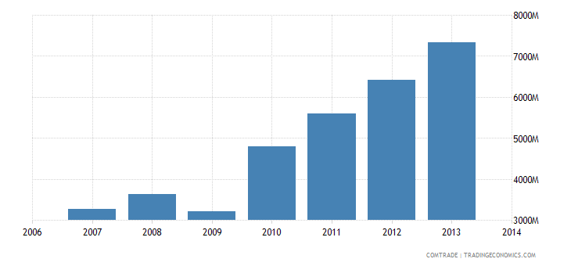

**Fig. 1 Bilateral trade between India and Japan**

* **Event:** Signing of BRICS

**Year**: 2006

**What is marketed?**

The BRICS- Brazil, Russia, India, China and South Africa joined hands to raise the need for a multipolar world order and to promote development and self-reliance among themselves.

**Outcome**:

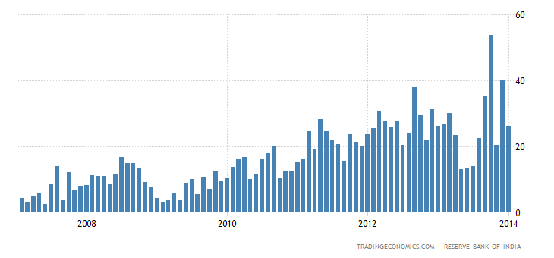

**Fig. 2: BRICS trade between Brazil and India**

The clear is that since the kick off of BRICS, the trade between Brazil and India has experienced a growth: from $17 to $55 billion in just 7 years.

* **Event**: NSG waiver

**Year:** 2009

**What is marketed?**

Therefore, on 6 September 2008, India was given a waiver from the NSG guidelines requiring comprehensive international safeguards as a condition of nuclear trade at an NSG meeting in Vienna. This could be a marketing strategy of the US to associate India with that of a world leader in nuclear trade for welfare and thus pull India more towards the US as a counter to the rising power – China.

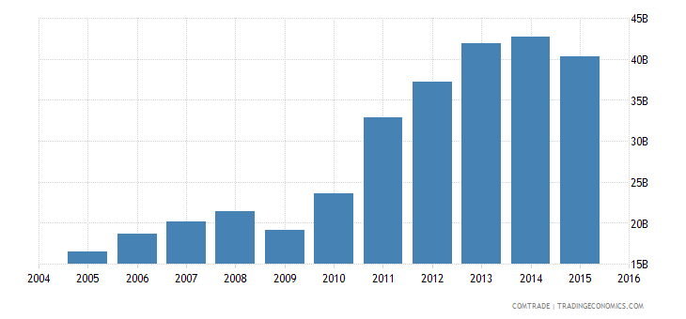

**Fig. 3: QUAD membership between the US and India**

We can clearly see, QUAD membership of both the US and India in 2007, coupled with the NSG waiver in 2008, compounded the US-India trade, showing signs of positive diplomacy.

* **Event**: UPI

**Year:** 2016

**What is marketed?**

To show the world that India’s payment services are turning out to be organised in nature, and we are a world leader in terms of online payments.

**Outcome:**  Singapore, UAE, Oman, Saudi Arabia, Malaysia, France, BENELUX markets (the Netherlands, the Netherlands and Luxembourg, and Switzerland; among others), are among the countries where Indian digital payment systems are available. In addition, it is also known that India has inked MoUs with 13 nations that want to go with UPI for digital payments, thereby leading to something like soft power diplomacy.

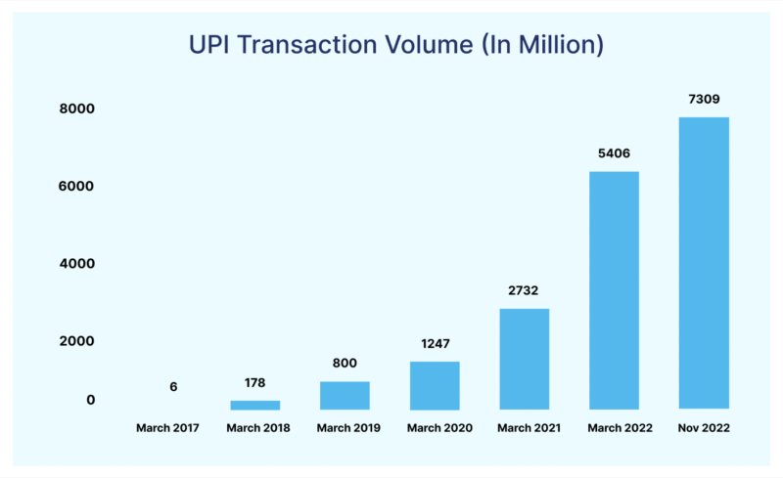

**Fig. 4: UPI Transaction per Million**

Source: NPCI

* **Event**: Russian-Ukrainian War

**Year**: 2022

**What is marketed?**

And on the other hand, Russia decided to take and propagate an anti-NATO stand for the loss of their sovereignty and security, and the West tied to propagate its pro-NATO stand to promote security in this region.

**Outcome**:

The US-Russian relationship saw an upward trend since 2015. However, a sharp drop in US-Russia trade can be seen since the start of the war. We can clearly notice there was a huge drop in this trade due to the sanctions imposed by the West.

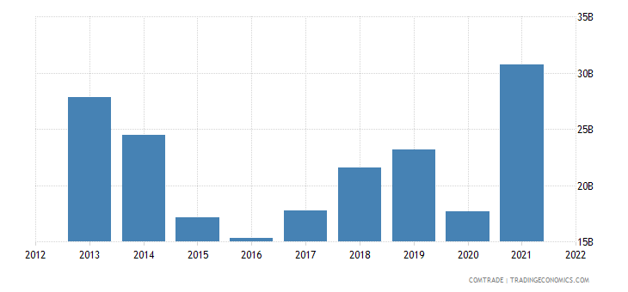

**Fig. 5: US-Russian Trade Relationship**

|  |  |  |
| --- | --- | --- |
| YEAR | EXPORTS FROM US | IMPORTS TO US |
| 2021 | $ 6,387.1 | $ 29,634.7 |
| 2022 | $ 1,715.1 | $ 14,457.8 |

* **Event**: Turkey’s earthquake

**Year**: 2023

**What was marketed?**

India carried out Operation Dost as a rescue measure for the affected communities in Turkey after a massive earthquake in the country. Through this, India is assuring welfare for the affected, at the same time, it is proving itself as a world leader by its presence whenever a difficult situation arises.

**Outcome**:

The India-Turkey relationship over the years wasn’t a significant one, while Turkey usually takes stands against India on many occasions on aspects like the Kashmir Issue. Despite this, India lent a helping hand to Turkey, showing its soft power diplomacy and marketing itself as a world leader, thus promoting future endeavours with Turkey and simultaneously earning valuable goodwill.

**5. Findings:**

• From the previous sections it is evident that any event on a global stage has some or other twist of marketing in one way or the other.

• Schemes and expenditures are undertaken by economies for welfare and to induce other countries to adopt the consumption, ideas and markets.

• A private organisation seeks profit, but profit is perceived in terms of money by a private organisation, whereas countries operate on a broader perspective, in the field of diplomacy, perceiving profit in terms of welfare to the commons. i.e. Diplomacy and marketing have a parasitic relationship, and they play a vital part when it comes to marketing.

• They offer, at the same time, both Marketing and diplomacy in foreign as well as local markets.

**6. Conclusion:**

With the help of this research paper, we this enables us to understand how diplomacy and marketing are interlinked forms, which are at opposite ends of the Rhine River. Accept clearly that in so many factors play the role of Diplomacy, for example that the formation of QUAD and the growth of trade between QUAD members since then, do not depend solely on the promoted ideology of Democracy. But it is recognised that the idea of democracy within the context of QUAD is centrally important to the fulfilment of the formation’s objective through soft power.

From this, we can stipulate that marketing and diplomacy are two sides of a same coin, and have a strong relation with each other, this relation is usually neglected though marketing is not taken by hearts and mind by the diplomat and vice versa the diplomat is not interested in marketing though for the diplomat, marketing is a very important part of diplomacy, it cannot be ignored or removed.

**7**. **Limitations of the study:**

Diplomacy and international relations are such a vast concept, so a huge nexus to crack, so the data, as a mostly mattered and dealt thing, is such a sought-after and needed one that its research paper relied on secondary authenticated data only.

**8**.**References:**

1. Kireeva, A. A. (2023). Theories of international relations and prospects of a military alliance between Russia and China. Russian Journal of World Politics and Law of Nations, 1(1-2), 98-130
2. Carrai, M. A. (2023). China, the BRI, and the New Vocabulary of Global Governance. In The Palgrave Handbook of Globalization with Chinese Characteristics: The Case of the Belt and Road Initiative (pp. 35-53). Singapore: Springer Nature Singapore.
3. Chauhan, P. S. (2023). Do SAARC and BIMSTEC Lead the World? —Regional Collaboration in South Asia. In 100 Years of World Wars and Post-War Regional Collaboration: How to Create'New World Order'? (pp. 177-185). Singapore: Springer Nature Singapore.
4. Mahaseth, H., Sarmah, U. K., & Qureshi, S. (2023). Temple diplomacy and India’s soft power: a cultural approach to diplomacy in Southeast Asian States. India Review, 22(1), 28-42.
5. Blechman, B. M. (1992). The politics of national security: Congress and US defense policy. Oxford University Press, USA.
6. Mehta, Y., & Rajan, A. J. (2017). Manufacturing sectors in India: Outlook and challenges. Procedia engineering, 174, 90-104.
7. Datas and graphs: Trading Economics
8. Newspaper articles referred: The Hindu.