STUDENT STUDY CENTER

**Aayush Patil, Akansha Kedare, Khushi Gosavi, Prof. V.A.Yeole**

***[patilaayush27@gmail.com](mailto:patilaayush27@gmail.com) ,*** [***luckygosavi88@gmail.com***](mailto:luckygosavi88@gmail.com) ***,*** [***akankshakedare476@gmail.com***](mailto:akankshakedare476@gmail.com)

*Department of Information Technology, MET’s Bhujbal Knowledge City, Nashik, Maharashtra, India.*

***Abstract–*** *The Student Study Center Project aims to design and implement a dedicated space that fosters academic excellence, collaboration, and personal growth among students. Recognizing the need for an environment that supports diverse learning styles and promotes focused study habits, this project envisions a modern, well-equipped study center that blends functionality with comfort.*

*The proposed center will include quiet study zones, group discussion areas, digital resource access points, and recreational corners to promote balance and well-being. Emphasis is placed on inclusivity, accessibility, and the integration of technology to support both traditional and digital learning approaches. The project also considers sustainable building practices and energy efficiency in its design and operation.*

*By providing a conducive learning atmosphere, the Student Study Center aims to enhance academic performance, encourage peer-to-peer learning, and contribute to the overall development of the student community.*

***Keywords:Student Study Center,Learning Environment***

***Academic Support, Higher Education,***

# I INTRODUCTION

In today’s fast-paced academic environment, students require more than just classrooms to succeed—they need spaces that inspire focus, collaboration, and creativity. A Student Study Center serves as a vital extension of formal education by providing a dedicated environment tailored to diverse study needs. Whether for individual concentration, group discussions, or accessing digital learning tools, such centers play a key role in shaping effective learning habits.

The increasing reliance on blended and self-directed learning methods calls for infrastructure that supports flexibility, comfort, and connectivity. The goal of this project is to conceptualize and develop a Student Study Center that integrates modern design, advanced technology, and student-friendly amenities. By addressing the challenges students face—such as lack of quiet spaces, limited access to resources, and inadequate collaborative zones—this center aims to enhance academic performance and well-being.

This project not only focuses on physical infrastructure but also emphasizes inclusivity, sustainability, and adaptability to future educational needs. It envisions a hub where students can learn, grow, and thrive both academically and personally.

# II LITERATURE REVIEW

The concept of dedicated student study spaces has evolved significantly over the past few decades, influenced by changes in pedagogical approaches, student behavior, and advancements in technology. Research highlights the importance of the physical learning environment in enhancing academic performance and student satisfaction (Oblinger, 2006). Traditional library settings, while valuable, often lack the flexibility and modern amenities needed to support today's dynamic learning methods.

Studies by Jamieson et al. (2000) emphasize the impact of space design on learning outcomes, noting that well-designed study centers improve engagement, collaboration, and academic confidence. Features such as noise control, ergonomic furniture, access to power and internet connectivity, and natural lighting are frequently cited as essential elements of productive study spaces (Scott-Webber, 2004).

Additionally, the integration of technology in study environments has been shown to improve student productivity and information access (Johnson et al., 2016). Collaborative workspaces that accommodate group learning, along with individual study zones, are recommended to support different learning preferences and tasks.

Sustainability and inclusivity are also emerging themes in the literature. Research by Shepley and Pasha (2017) suggests that environmentally friendly design not only reduces the ecological footprint but also improves mental health and concentration levels among students. Inclusive design, addressing accessibility for students with disabilities, is another critical component highlighted in current studies (Burgstahler, 2015).

In summary, existing literature underscores the importance of designing study centers that are student-centered, flexible, tech-enabled, and inclusive. These findings provide a foundation for the development of a modern Student Study Center that caters to the academic and personal growth of learners in diverse educational settings.

**III METHODOLOGY**

The methodology adopted for the Student Study Center Project involves a combination of **research, planning, design, and evaluation** stages. The project follows a systematic approach to ensure that the proposed study center meets the academic, social, and technological needs of students. The key phases of the methodology are outlined below:

**A] Literature and Case Study Review:-**

* Relevant academic literature and case studies of existing student centers were analyzed to identify best practices, design standards, and innovative features in modern study environments.

**B] Design Planning:-**

* Based on data collected, a conceptual layout was developed, incorporating both individual and collaborative study zones, digital access areas, and recreational spaces.

**Figure 1 System Architecture**

**eeeeee**

* 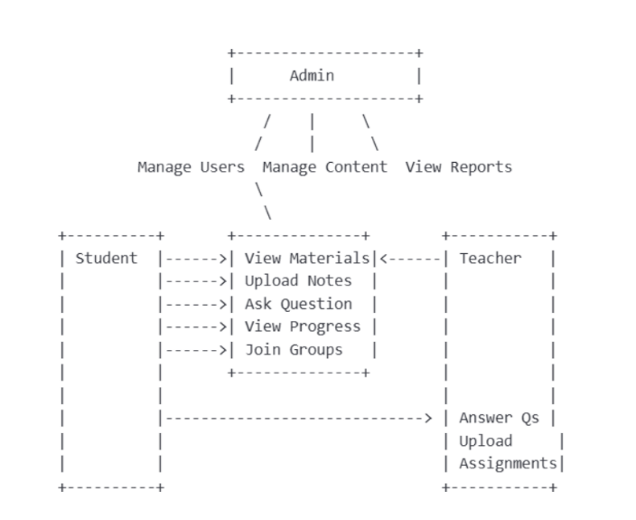Attention was given to environmental design principles including lighting, acoustics, furniture ergonomics, and ventilation.

**Figure 2 User- Case Diagram**

* Inclusivity and accessibility were prioritized to ensure the space is usable by all students, including those with disabilities.

**C] Feedback and Evaluation:-**

* A prototype model or 3D visualization of the center was presented to stakeholders for feedback.
* Feedback was analyzed and used to refine the final design and implementation plan.

**D] Flowchart of Methodology –**

* Showing steps like planning, research, design, implementation, testing, etc.

**E] Gantt Chart –**

* A project timeline showing each phase.

**F] Architecture Diagram –**

* If it's a software-based project (e.g., app or web platform for study center).

**G] Use Case Diagram / ER Diagram –**

* For understanding user interactions or database structure.

**H] Conceptual Layout –**

* 0f the physical space, if it’s about designing a real study center.

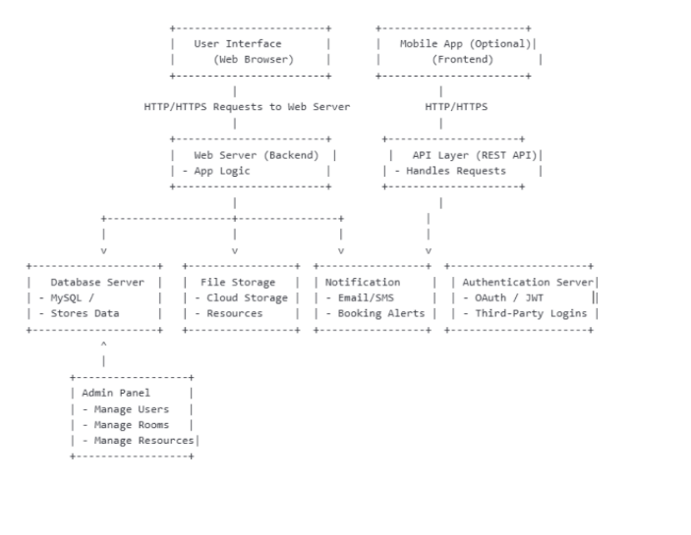

**IV IMPLEMENTATION**

**1.Requirement Analysis**

* Conducted meetings with students, faculty, and administrators to gather functional requirements (e.g., room booking, announcements, discussion forums, and resource sharing).
* Identified technical requirements such as hosting, database structure, user roles (admin, student, staff), and security protocols.

**A] System Design**

* Created wireframes and UI/UX prototypes using tools like Figma or Adobe XD.
* Designed the system architecture including:
* Frontend: HTML, CSS, JavaScript (React, Vue, or Angular)
* Backend: Node.js, PHP, or Python (Django/Flask)
* Database: MySQL, MongoDB, or Firebase
* Authentication: Email/password login, with optional integration for Single Sign-On (SSO) or Google login

**B] Development**

* Frontend Development: Created user interfaces for dashboard, study room booking, event calendar, resource access, and notifications.
* Backend Development: Implemented APIs, database interactions, admin panel controls, and scheduling logic.
* Testing Tools Used: Jest (unit testing), Postman (API testing), Selenium (UI automation)

**C] Testing and Debugging**

* Conducted functionality, usability, and performance testing.
* 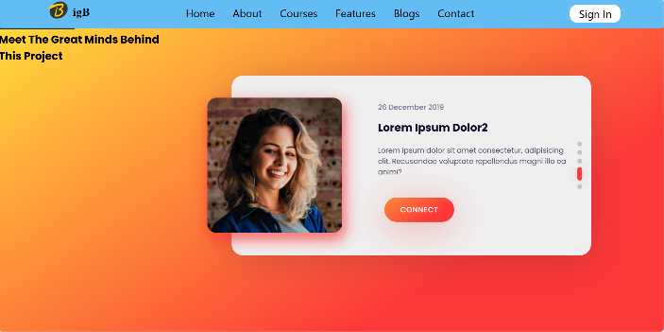Carried out User Acceptance Testing (UAT) with a group of students to gather real-user feedback.

**Figure 1 Home Page**

* Fixed bugs and optimized load time, database queries, and responsiveness.

**V APPLICATION**

* **Study Room Booking System**: Students can reserve individual or group study rooms in advance.
* **Digital Resource Access**: Upload and download study materials, notes, e-books, and lecture slides.

**Figure 2 About**

* **User Dashboard**: Personalized dashboard for students and admins with quick access to tools and statistics.
* **Feedback and Support**: Users can submit feedback or report technical issues through an integrated support system.

**VI CASE STUDY:-**

Background:-Greenfield University implemented the Student Study Center Website in response to student feedback about inefficient room booking processes and lack of centralized academic resources.

Implementation Highlights

* Developed using the MERN stack (MongoDB, Express.js, React.js, Node.js)
* Integrated with the university’s SSO for easy login
* Hosted on AWS with a custom domain and SSL certificat**e**

**CHALLENGES & SOLUTIONS**

* **Issue**: Initial server load delays during peak usage  
  **Solution**: Implemented load balancing and optimized database queries
* **Issue**: Accessibility concerns for students with disabilities
* **Solution**: Added screen reader support and adjustable font sizes.

**V RESULT:-**

The implementation of the Student Study Center Website resulted in a significant improvement in the accessibility, efficiency, and quality of academic support services available to students. The digital platform successfully met the project’s primary objectives by providing an organized, user-friendly, and interactive space for study-related activities.

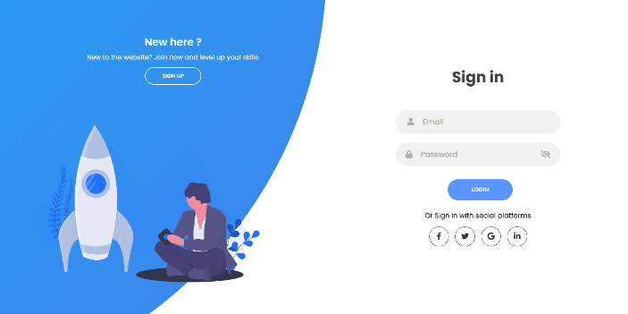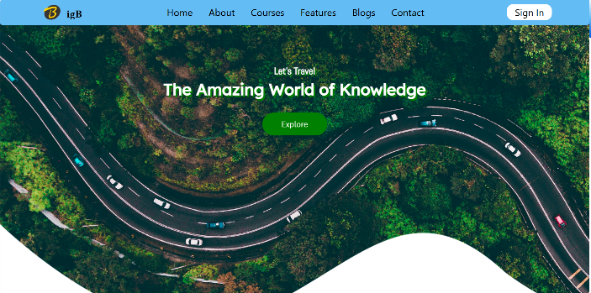

**Figure 8 Sign in**

**Figure 4 Blog**

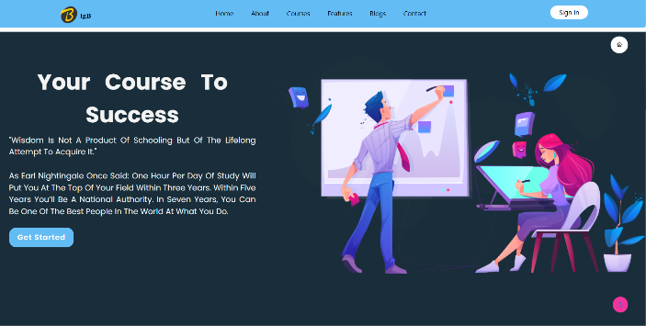

**Figure 5 Courses**

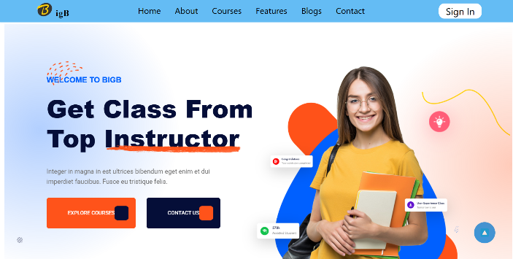

**Figure 6 Features**

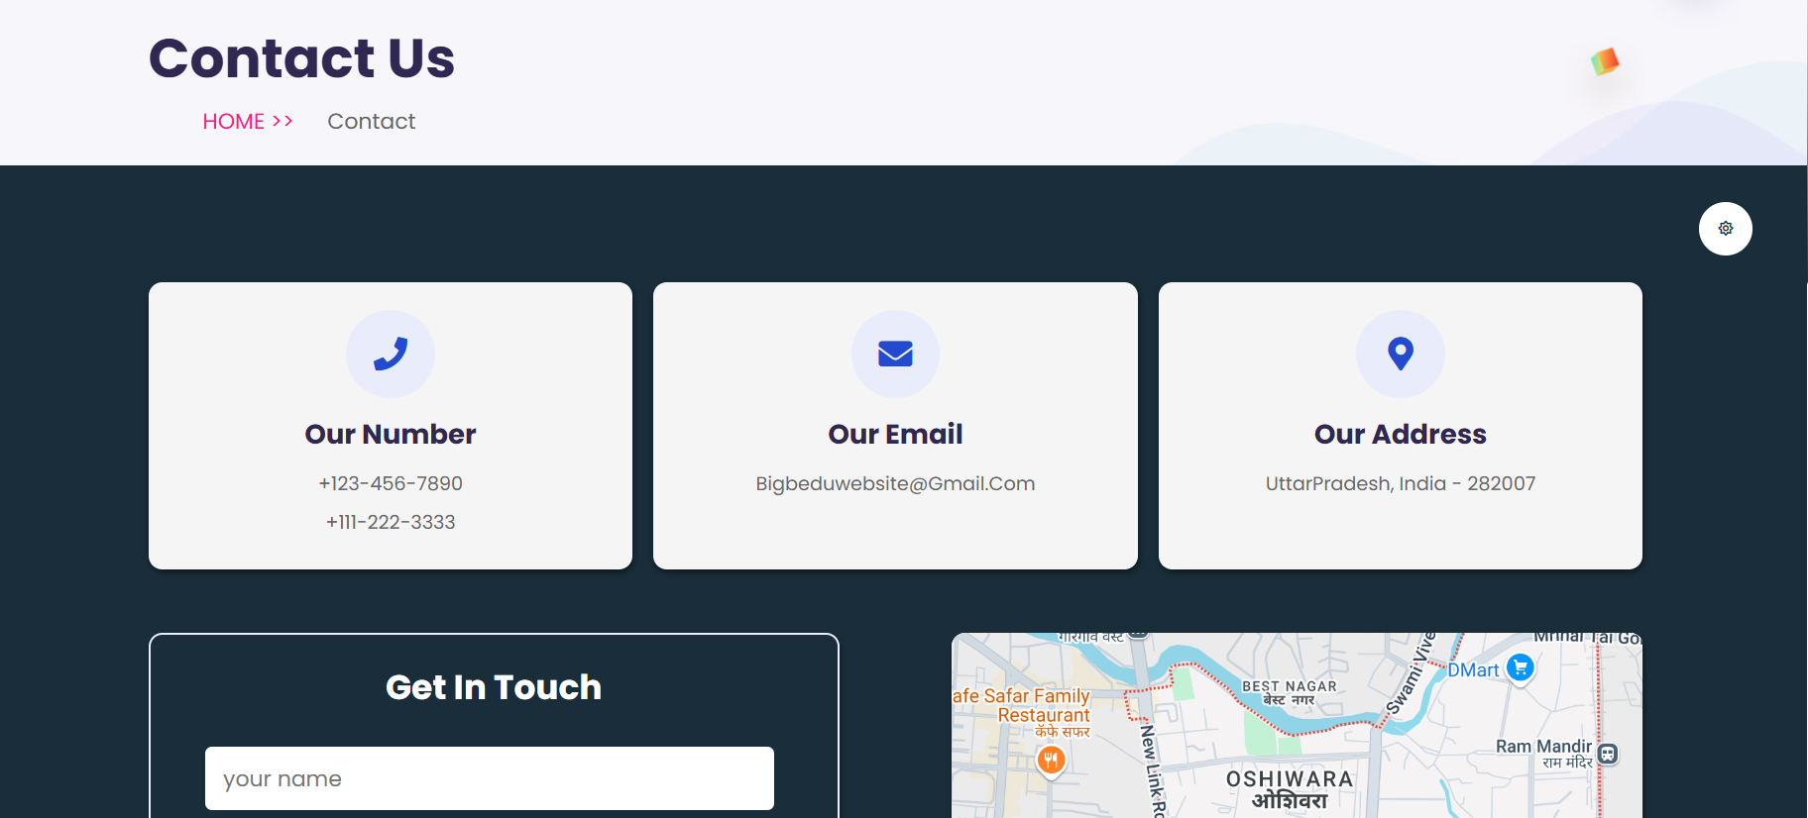

**Figure 7 Contact**

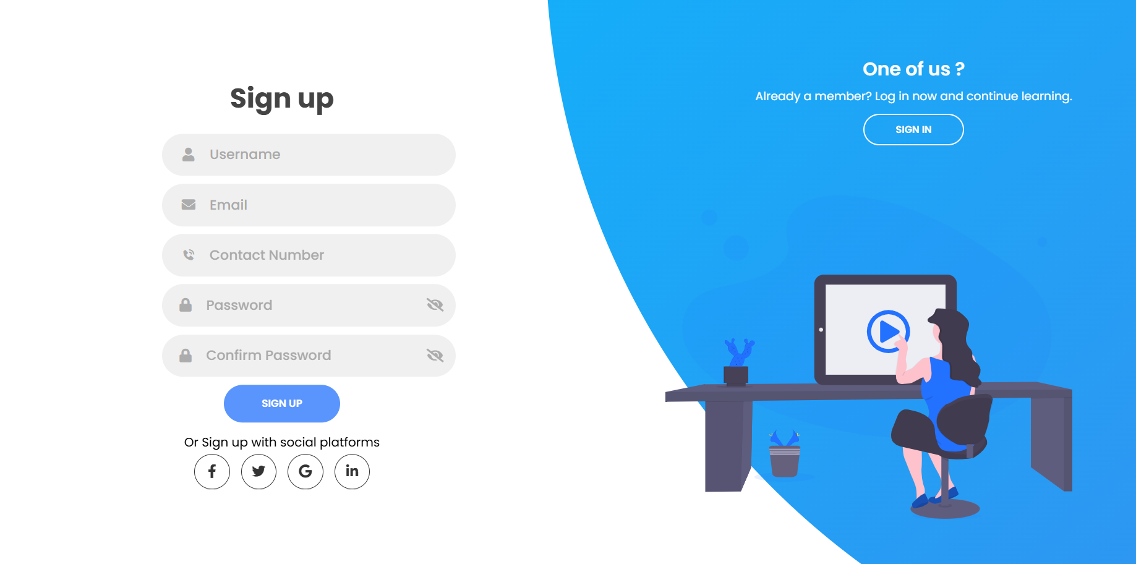

**Figure 9 Sign Up**

**VI CONCLUSION:-**

The work described here is a first step for improvements for students from underrepresented groups. For this part of the project, the aim is the development of a method to describe how the students experience their studies. The customer journey map is a valuable basis to identify weak points in processes. It shows where the expectations of the students are not fulfilled and which improvements need to be done. In future work, the expectations of the students at the different phases of their university studies and the evaluation of the touchpoints should be refined and evaluated. To achieve this goal, qualified interviews, surveys and discussions have to be done. Within the project “DiaMINT”, some tools are being developed to assist students before, during and after their programs of study. The tools developed within this project close the gap between expectations and the actual situation. An evaluation method to measure the benefit of these tools can be a revised customer journey map, with a new evaluation of the touchpoints. By comparison of the old and the new maps, the effects of the tools can be evaluated.

# VII ACKNOWLEDGMENT

We would like to convey our genuine appreciation to all the people who helped us complete this research project successfully. We begin by thanking our project guide, Mr. V.A.Yeole , Lecturer, Department of Information Technology, for his excellent guidance, unwavering encouragement, and valuable advice during the course of this project. His inputs and guidance significantly influenced the direction and conduct of our work.

We are also deeply thankful to Mr. S.B. Patil, Head of the Information Technology Department, for his support and motivation, which inspired us to explore innovative solutions to real-world problems. Our sincere appreciation goes to Dr. R. S. Narkhede, Principal of MET's Institute of Technology (Polytechnic), for providing us with the necessary infrastructure and academic environment to conduct our research effectively.

We acknowledge with gratitude the Innovation Hub, Ravivar Karanja, Nashik for providing industrial sponsorship and exposure, which greatly enhanced our knowledge and implementation of this project. Last but not least, we would like to thank our fellow students, family members, and college library staff for their support, encouragement, and guidance at each step of this project.

**VIII REFERENCES:-**

1. Found It! - Mapping the Students’ Journey to Develop StudentCentered Tools Heidi Schuhbauer, Patricia Brockmann , Teymur Mustafayev (25 June 2020)
2. Common configurations for Engineering Student Support Centers Walter C. Lee & Holly M. Matusovich (19 December 2013)
3. Engaging Engineering Students in Cultural Diversity and Unity Studies Julia Ziyatdinova, Olga Oleynikova , Elvira Valeeva, (25 June 2020)
4. Work-in-Progress: Analysis of engineering students’ preparation for active learning considering the study methods Fátima Monteiro , Helena Marto, Rita Pereira (25 June 2020)
5. Proposal for the Development of a Study to Determine the Effectiveness of a Creativity-Centered Unit of Study in the Advancement of Spatial Abilities of American and Japanese Female Engineering Students Susan G. Miller Publisher (06 August 2002)
6. Academic Success in 1st-year Engineering Students: Key Factors Rosa M. Vasconcelos , Leandro S. Almeida Publisher (15 October 2020).
7. Study to Determine the Effectiveness of a Creativity-Centered Unit of Study in the Advancement of Spatial Abilities of American and Japanese Female Engineering Students Susan G. Miller Publisher (06 August 2002)
8. Academic Success in 1st-year Engineering Students: Key Factors Rosa M. Vasconcelos , Leandro S. Almeida Publisher (15 October 2020).